Paper Title: Up to 12 Words or Two Lines

[Blank line]

Author First M. Last

Institutional Affiliation(s)

Course Number: Course Name

Author Note

Include any grant/funding information and a complete correspondence address.

Abstract

The abstract should be one paragraph of between 150 and 250 words. It is not indented. Section titles, such as the word Abstract above, are now to use bold heading format. References, Footnotes, and Figure section titles should also be written in bold. To do this, use the **Section Title** style. This style automatically starts your section on a new page, so you don’t have to add page breaks. Note that all of the styles for this template are available on the **Home** tab of the ribbon, in the Styles dropdown menu.

Keywords: Add keywords here.

Paper Title in Bold at the Top of Page 2

Begin your paper with the paper title at the top of the first page of text. Your title acts as a default Level 1 heading; therefore, it is centered and in bold. Don’t use “Introduction” as your heading as it’s assumed the introduction text will be at the beginning of your paper. The body uses a half-inch first line indent and should be double-spaced. APA style provides for up to five heading levels, shown in the paragraphs that follow.

# **Level 1 Heading**

Heading levels 1-3 get their own paragraph, as shown. Headings 4 and 5 are run-in headings used at the beginning of the paragraph. Include a period at the end of a run-in heading. Double-space all text, including headings. Use descriptive headings to help readers identify sections of your paper.

## Level 2 Heading1

To add a table of contents (TOC), apply the appropriate heading style to just the heading text at the start of a paragraph and it will show up in your TOC. To do this, select the text for your heading. Then, on the **Home** tab, in the **Styles** gallery, click the style you need.

### ***Level 3 Heading***

If needed, you can include consecutive paragraphs with their own headings, where appropriate. For APA Style formatting, type your own references. To correctly format a reference page according to APA Style guidelines, see page five.

Level 4 Heading. When using headings, don’t skip levels. If you need a heading 3, 4, or 5 with no text following it before the next heading, add a period at the end of the heading and start a new paragraph for your subheading and its text. When citing any quote or text that consists of three or more lines, APA guidelines call for block-quote format:

Create a new paragraph to begin the block-quote. Double-space each line of text, as you have done with headings, section labels, and paragraphs of paraphrased text. To correctly format a block-quote, indent each line of the text to one-half inch. Remember to always cite your source (Last Name, Year).

Last Name (Year) citations can be used when writing a paper in narrative form. Parenthetical citations are also appropriate (Last Name, Year).

Level 5 Heading. Like all sections of your paper, references start on their own page, like the page that follows this one. All in-text citations should also be included your references.

References

Last Name, A. B. (Year). Article Title. Journal Title, Pages #-#. URL. URL.

Last Name, C. D. (Year). Book TitleBook Title URL.

Last Name, D. E., Last Name, F. G. (Year). Report TitleReport Title URL.

Last Name, H. I. (Year, Month Day). Article Title/Headline. Periodical.Periodical.

Organization Name. (Year, Month Day).Webpage Title. URL.

Footnotes

1For APA reports, add footnotes manually on their own page following references. Do not use the **Insert** **Footnotes** method on the **References** tab as they will not be formatted correctly. For APA formatting requirements, it’s easier to type your own footnote references and notes. To format a footnote reference, select the number and then, on the **Home** tab, in the **Styles** gallery, click **Footnote Reference**. The body of a footnote, such as this example, uses the **Normal** text style. If you delete this sample footnote, don’t forget to delete its in-text reference at the end of the sample Heading 2 paragraph on the first page of body content in this template.

Tables

Table 1

Table Title

|  |  |  |  |  |
| --- | --- | --- | --- | --- |
| Column Head | Column Head | Column Head | Column Head | Column Head |
| Row Head | 123 | 123 | 123 | 123 |
| Row Head | 456 | 456 | 456 | 456 |
| Row Head | 789 | 789 | 789 | 789 |
| Row Head | 123 | 123 | 123 | 123 |
| Row Head | 456 | 456 | 456 | 456 |
| Row Head | 789 | 789 | 789 | 789 |

Note: Place all tables for your paper in a tables section, following references and footnotes. Start a new page for each table, include a table number and table title for each, as shown. All explanatory text appears in a table note that follows the table, like this one. Use the **Table/Figure** style, available on the **Home** tab, in the **Styles** gallery, to get the spacing between table and note. Tables in APA format can use single or 1.5 line spacing. Include a heading for every row and column, even if the content seems obvious. A default table style has been set up for this template that fits APA guidelines. To insert a table, on the **Insert** tab, click **Table**.

Figures Title

Figure 1.

Include all figures in their own section, following references, footnotes, and tables. Include a numbered caption for each figure. Use the Table/Figure style for easy spacing between figure and caption.

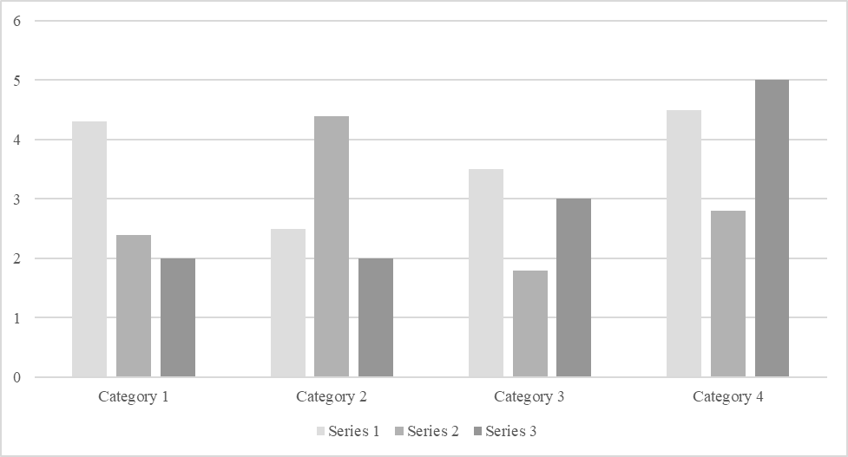

*For additional information on APA Style formatting, please consult the* [*APA Style Manual, 7th Edition*](https://apastyle.apa.org/style-grammar-guidelines)*.*