Rama Gokhale

Professor Jaipur

Humanities 101

14 September 20XX

Exploring the Symbolism of Birds in Classic Literature: A Comparative Study

If you're writing an academic paper, you're likely going to need to follow a specific formatting style. MLA (Modern Language Association) is one of the most common styles used in the humanities, such as literature, languages, and cultural studies. In this essay, we will provide a step-by-step guide on how to format an MLA paper in Microsoft Word.

To start, the basic formatting guidelines for MLA style include using 8.5 x 11-inch white paper and setting margins to 1 inch on all sides. Additionally, double-spaced text should be used throughout the document and a legible font such as Times New Roman, Calibri, or Arial should be used. Now, let's take a closer look at how to format your paper in MLA style using Microsoft Word.

To begin, open a new document in Microsoft Word. Then, go to the Page Layout tab and select Margins. From the drop-down menu, select Normal or set the margins to 1 inch on all sides. Next, choose your font style and size. MLA recommends using a legible font such as Times New Roman or Arial in size 12. Once your margins and font are set, double-space your entire document. To do this, go to the Home tab and select Line and Paragraph Spacing. Choose 2.0 to double-space the text.

Now it's time to add your heading. In MLA style, the heading should include your name, your instructor's name, the course number, and the date. Place this information in the top left corner of the first page, double-spaced. The title of your paper should be centered and capitalized. Do not use bold, italics, or underlining for the title. Finally, include a header with your last name and the page number in the top right corner of each page. To add a header in Microsoft Word, go to the Insert tab, select Header, and choose the desired header format.

In conclusion, formatting your paper in MLA style using Microsoft Word is relatively straightforward if you follow these basic guidelines. By setting your margins, choosing a legible font, double-spacing your text, adding a title, including in-text citations (Author’s Last Name Page), and including a header on each page, you can ensure that your paper meets MLA style requirements. See Figure 1 and Works Cited page for examples of how to format each of these essay elements to meet MLA standards.

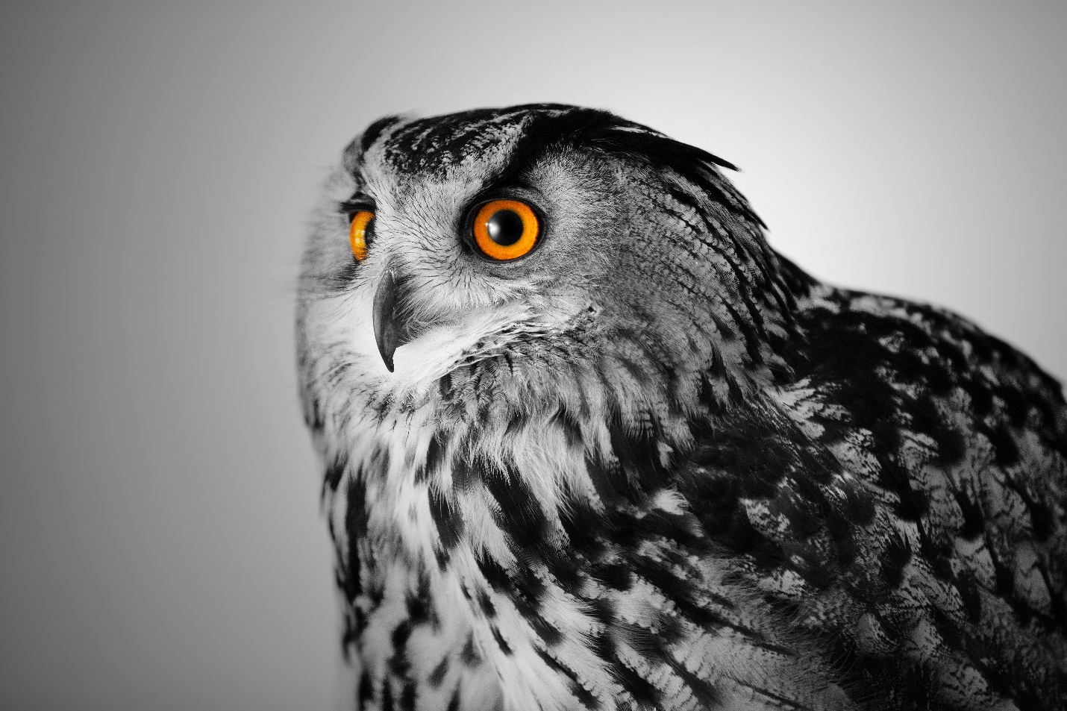

Fig. 1. Unknown artist. Black and white image of a hawk. Microsoft Word stock image, date unknown.  
Figure title. Creator last name, First name. Image Title or Description of image. Website Name, Day Month Year, URL.

Works Cited

MLA Handbook. 9th ed., Modern Language Association of America, 2021. "MLA Style Center." Modern Language Association, Modern Language Association of America, style.mla.org/.

Microsoft Word, version 365, Microsoft Corporation, 2022.

Author’s Last Name, First Name.Title of Book.Edition, Publisher, Year of publication.

*For additional information on MLA Style formatting, please consult the* [*MLA Handbook, 9th Edition*](https://style.mla.org/)*.*