VISVESVARAYA TECHNOLOGICAL UNIVERSITY
“JnanaSangama”, Belgaum -590014, Karnataka.

LAB REPORT
on
Object Oriented Java Programming (23CS3PCOOJ)
Submitted by
Riya Ann Mathews(1BF24CS254)
in partial fulfillment for the award of the degree of
BACHELOR OF ENGINEERING
in
B.M.S. COLLEGE OF ENGINEERING
(Autonomous Institution under VTU)
BENGALURU-560019
Aug-2025 to Jan-2026

B.M.S. College of Engineering,
Bull Temple Road, Bangalore 560019
(Affiliated To Visvesvaraya Technological University, Belgaum)
Department of Computer Science and Engineering

CERTIFICATE
This is to certify that the Lab work entitled “Object Oriented Java Programming (23CS3PCOOJ)” carried out by Riya Ann Mathews (1BF24CS254), who is bonafide student of B.M.S. College of Engineering. It is in partial fulfilment for the award of Bachelor of Engineering in Computer Science and Engineering of the Visvesvaraya Technological University, Belgaum. The Lab report has been approved as it satisfies the academic requirements in respect of an Object-Oriented Java Programming (23CS3PCOOJ) work prescribed for the said degree.

Dr. Seema Patil  Associate Professor  Department of CSE, BMSCE | Dr. Kavitha Sooda  Professor & HOD  Department of CSE, BMSCE

Index

Sl.  No. | Date | Experiment Title | Page No.
1 | 23/09/25 | Program 1:Implement quadratic equation | 4-5
2 | 14/10/25 | Program 2:Implement SGPA Calculator | 6-8
3 | 21/10/25 | Program 3:Implement toString() function | 9-10
4 | 04/11/25 | Program 4:Implement Abstract class | 11-12
5 | 11/11/25 | Program 5:Implement Bank account operations | 13-16
6 | 18/11/25 | Program 6:Implement Packages | 17-18
7 | 25/11/25 | Program 7:Implement Exception Handling | 19-20
8 | 09/12/25 | Program 8:Implement Thread | 21-22

Program 1:
Implement Quadratic Equation
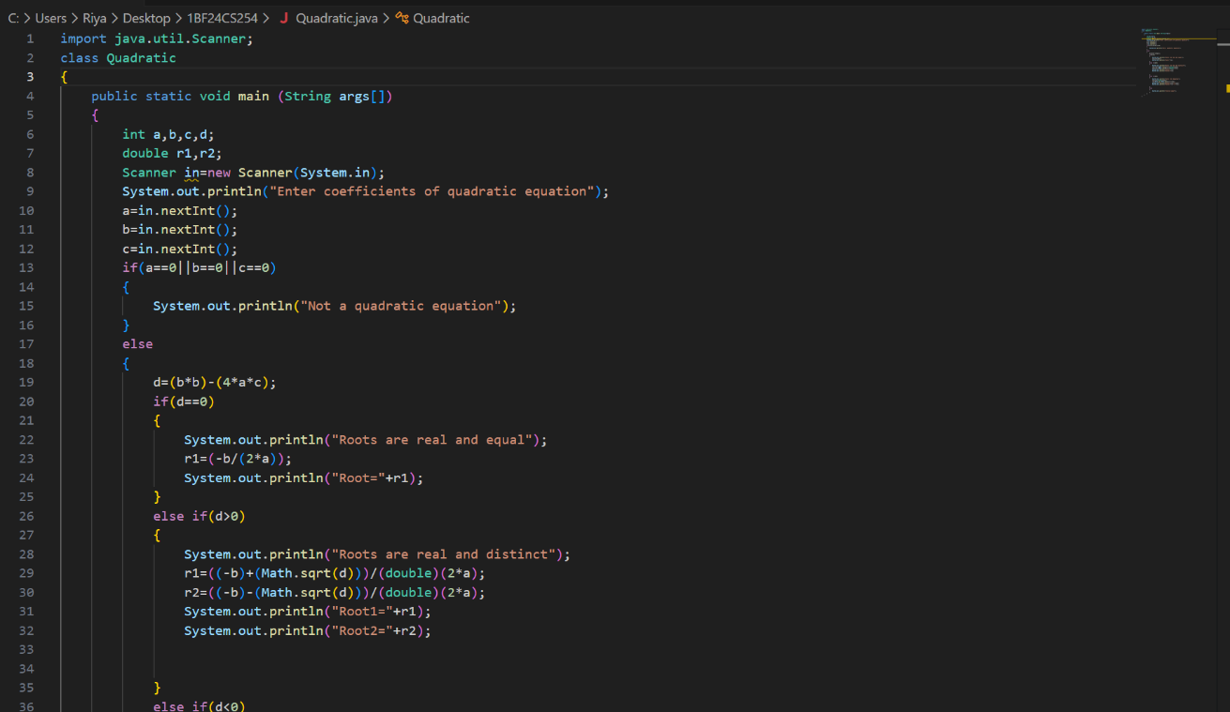

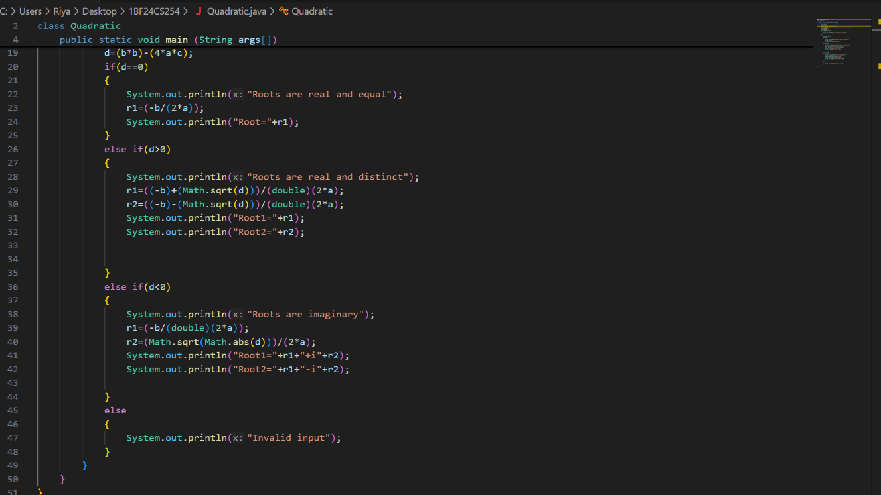

Output:
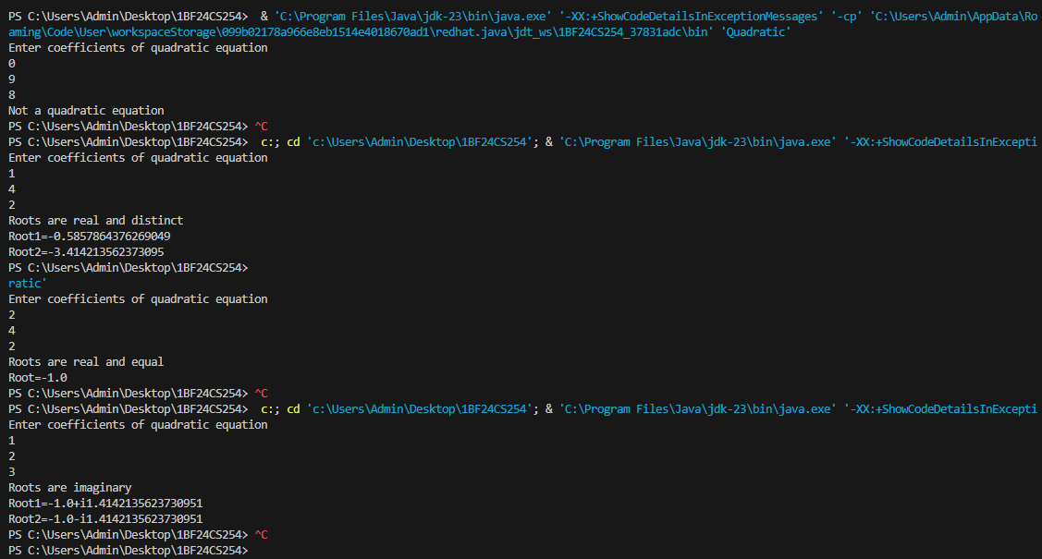

Program 2:
Implement SGPA calculator
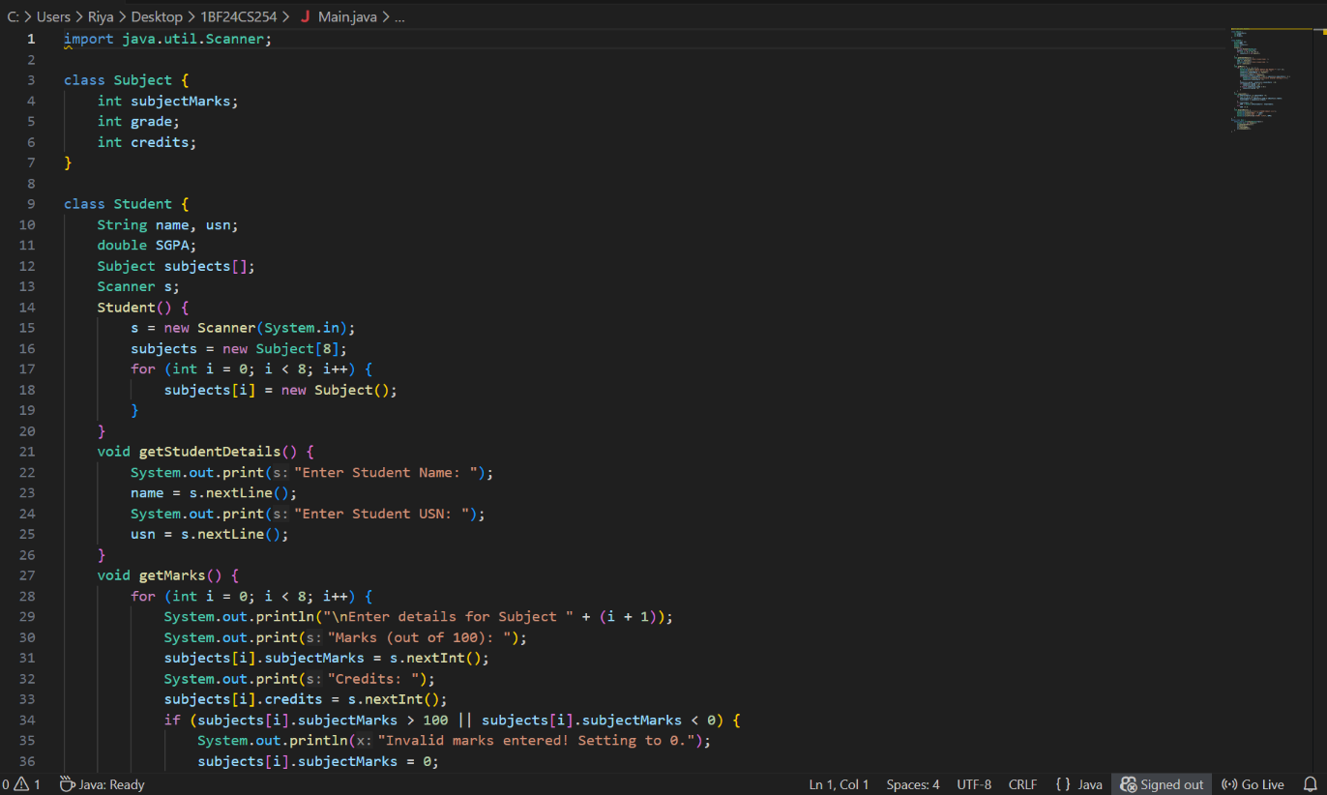

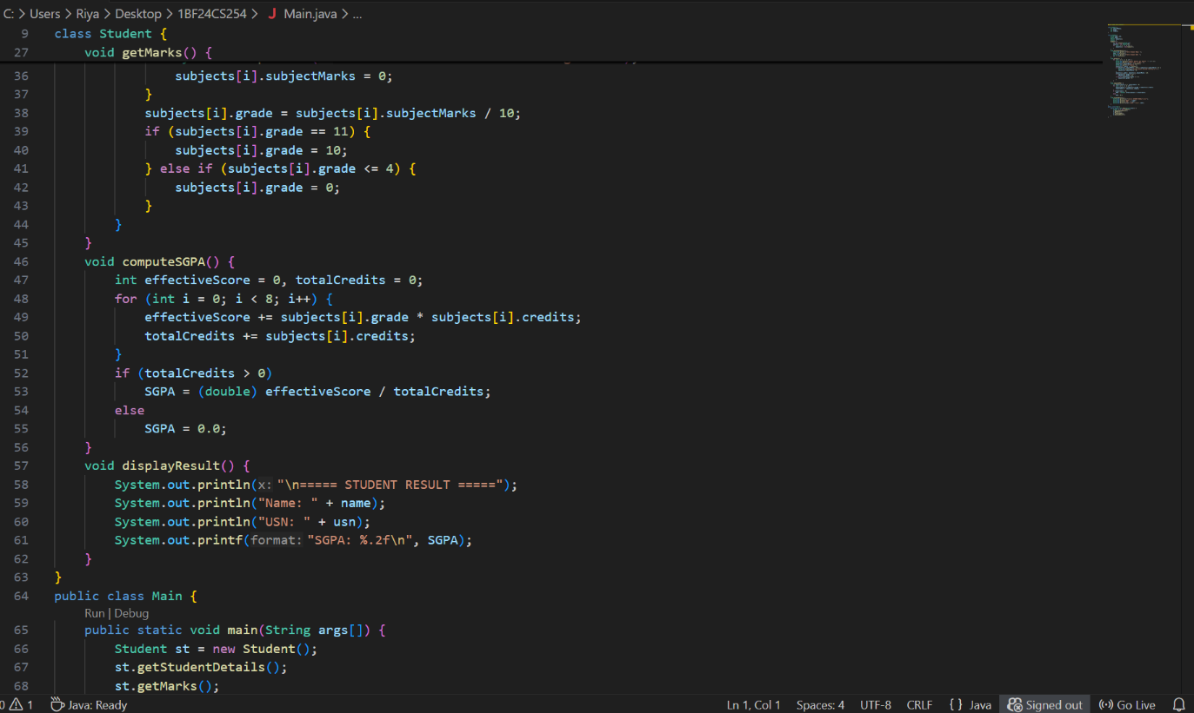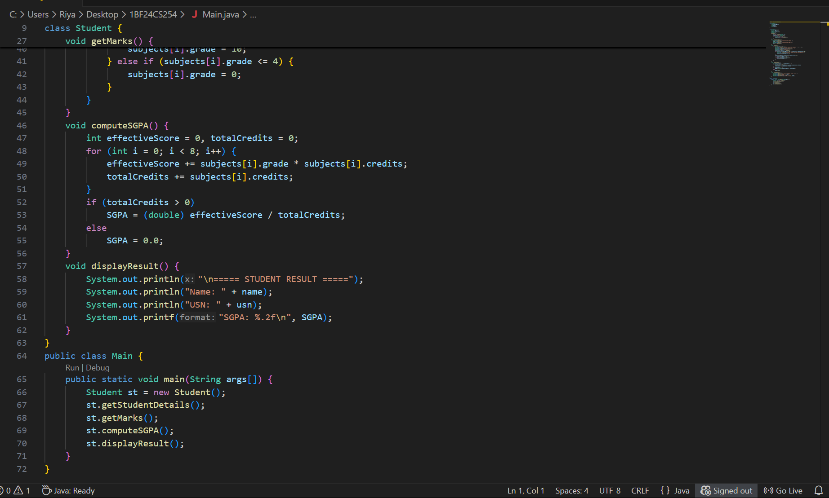

Output:
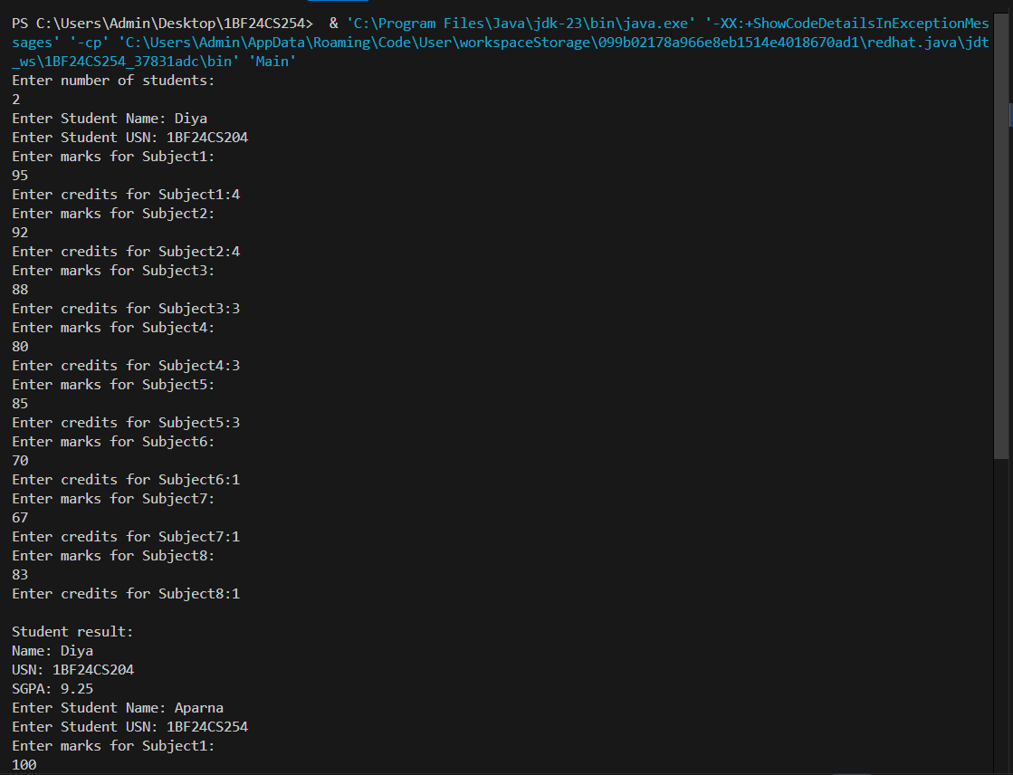
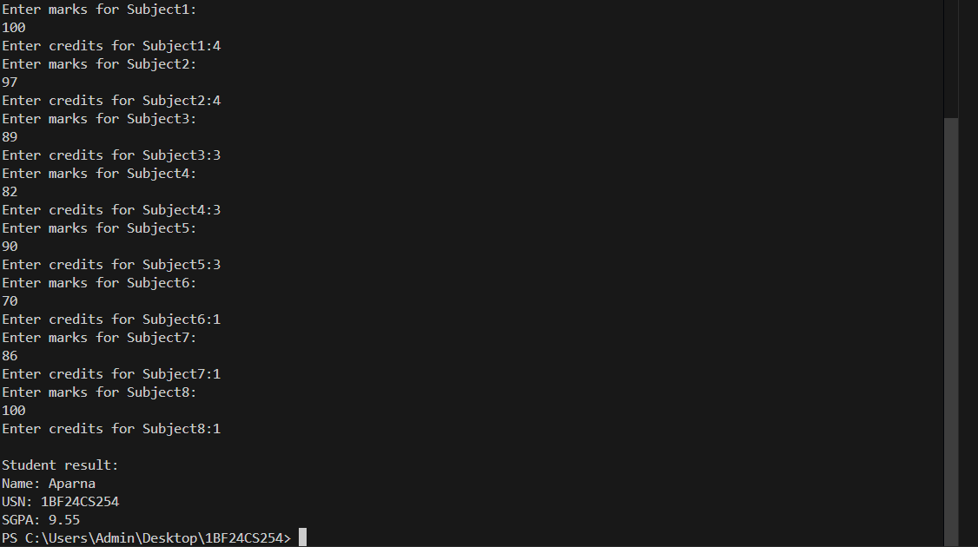

Program 3:
Implement toString() function
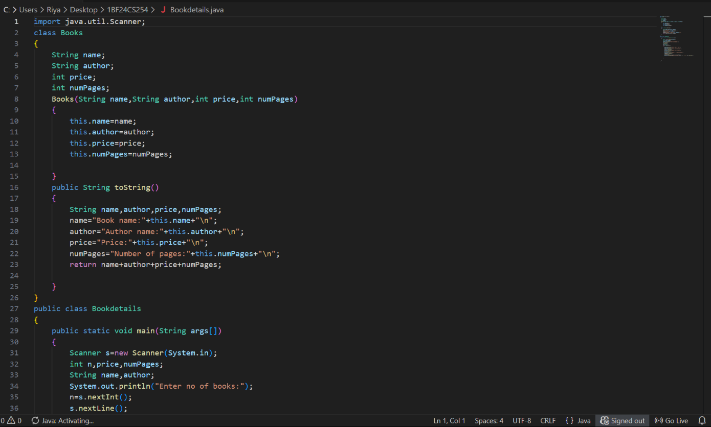

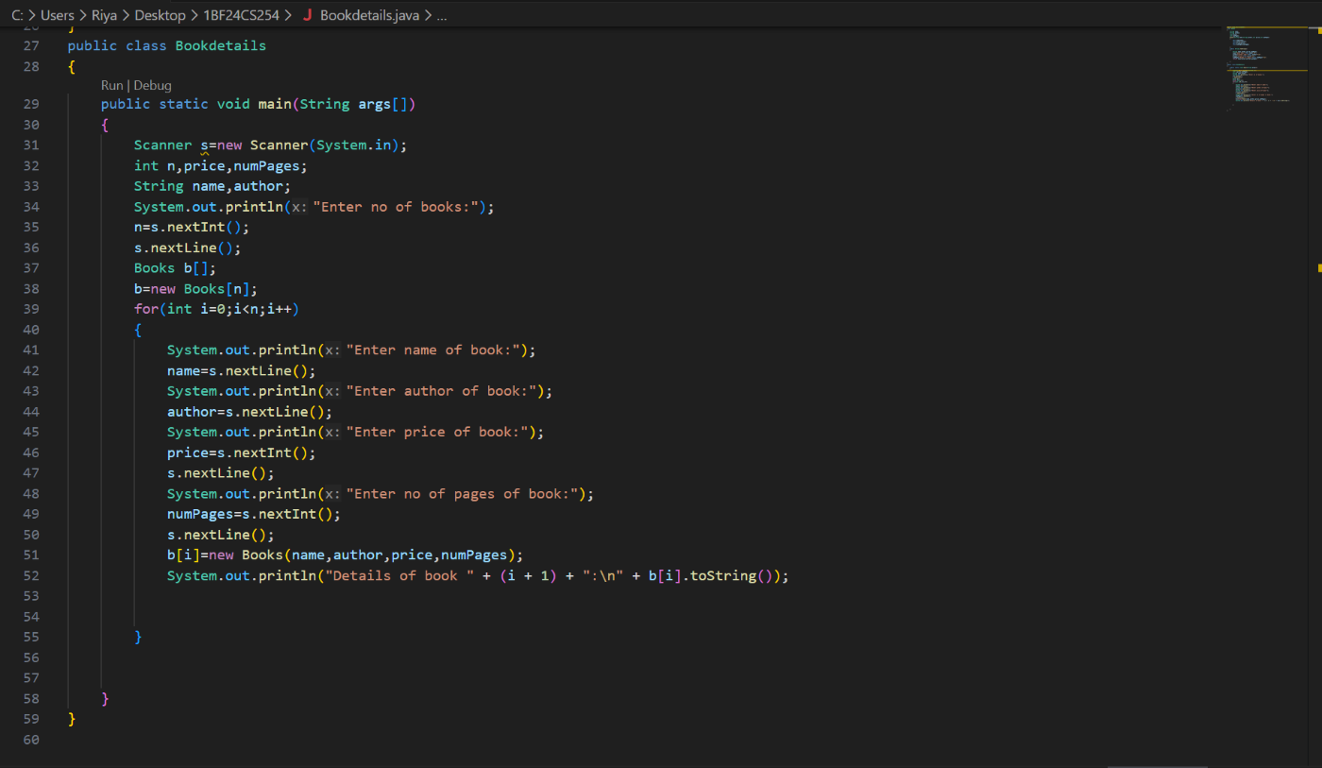

Output:
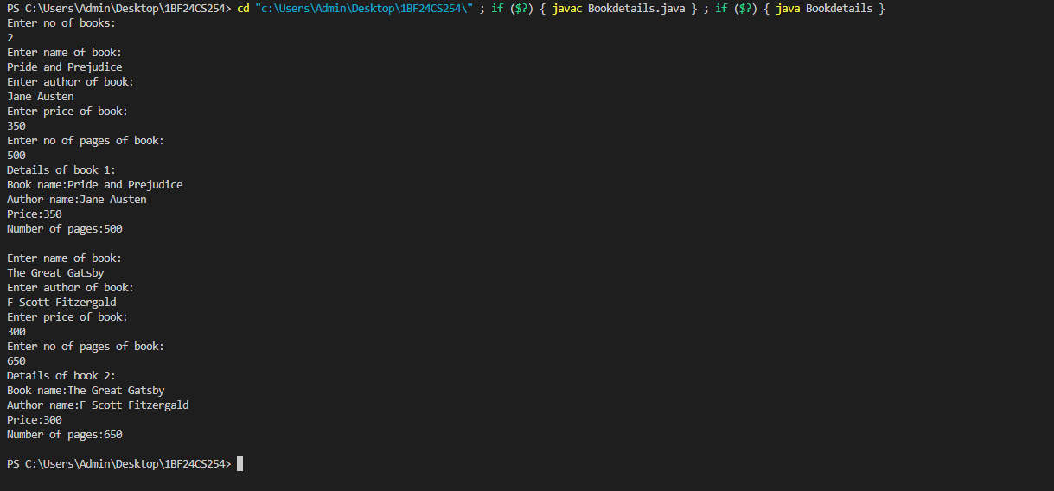

Program 4:
Implement Abstract class
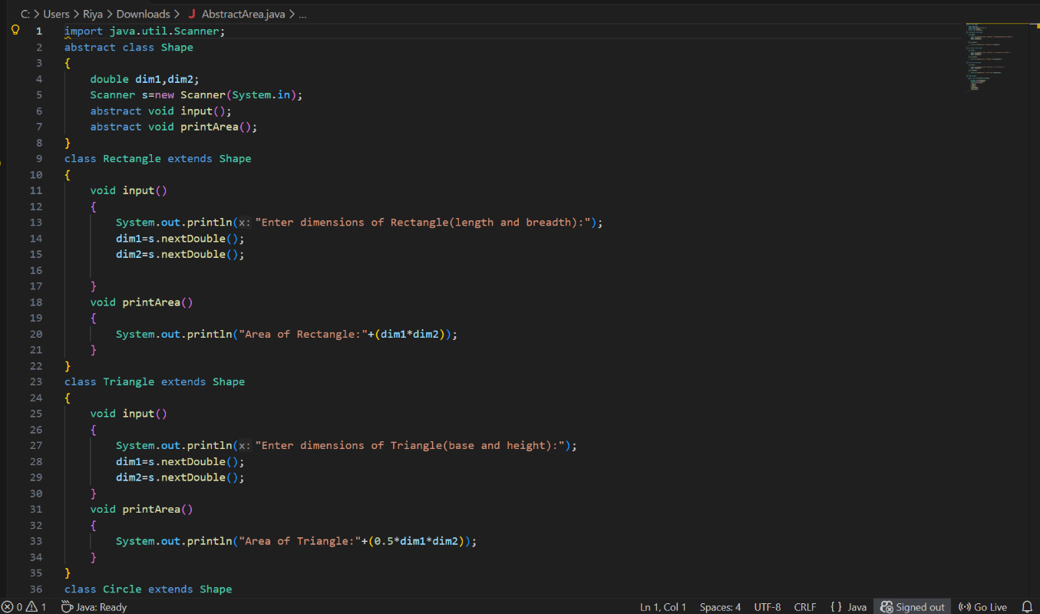

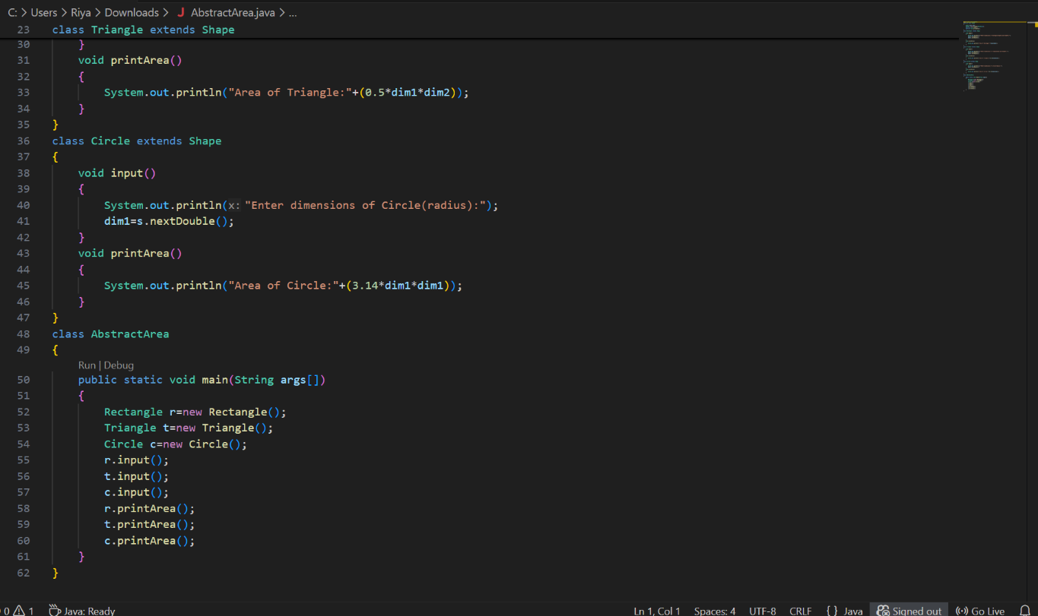

Output:
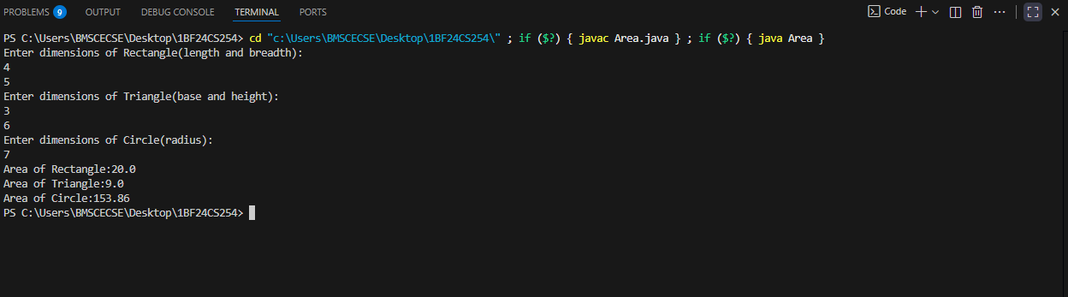

Program 5:
Implement Bank Account operations
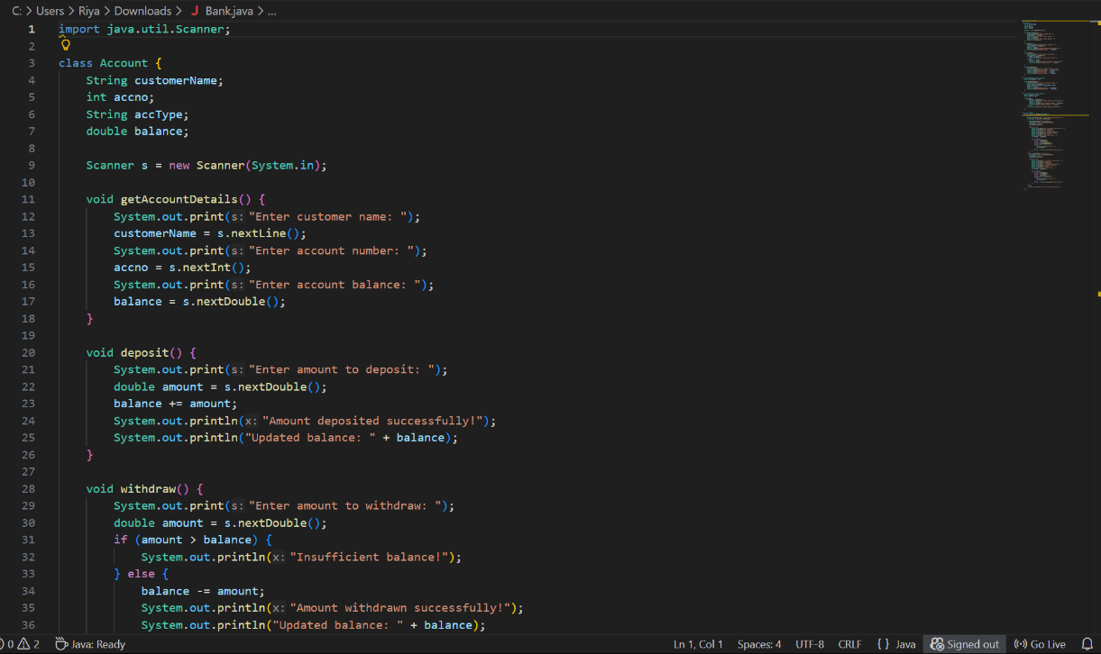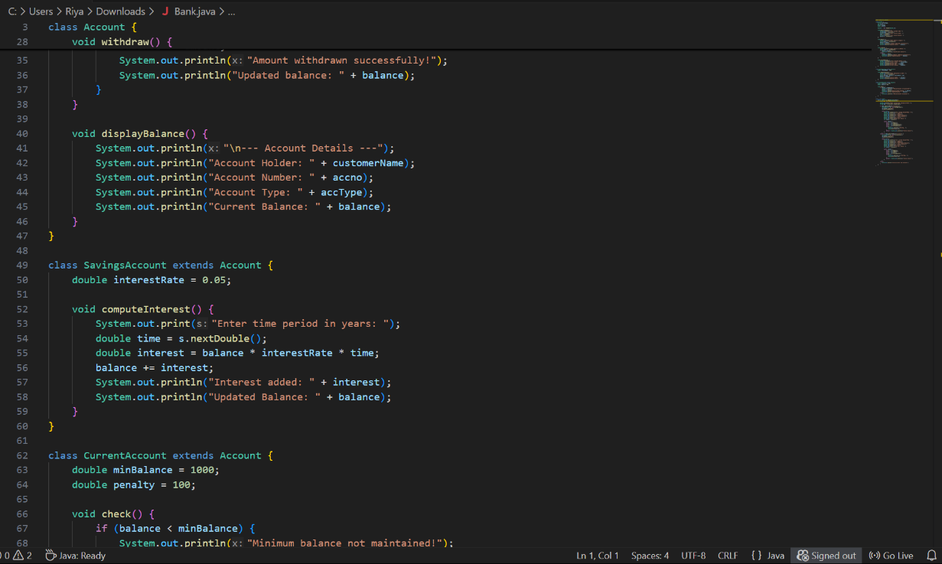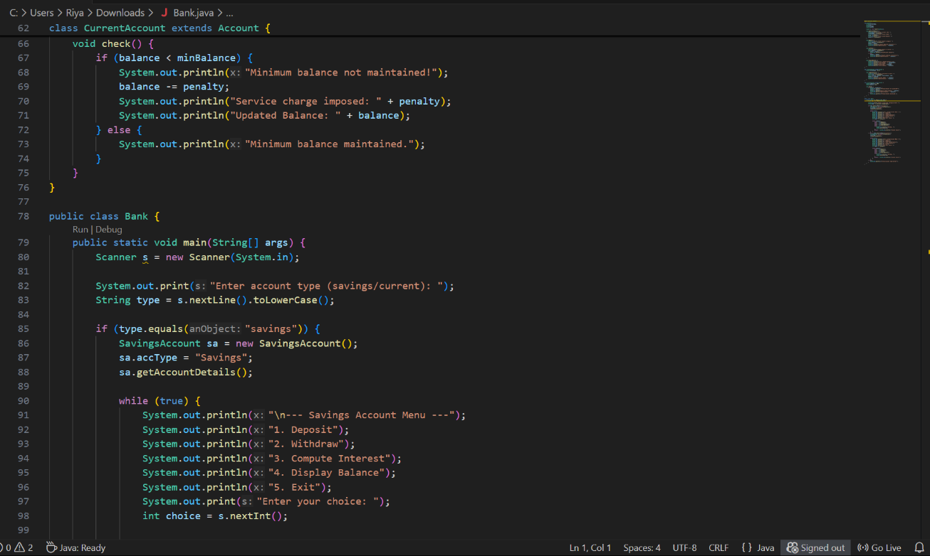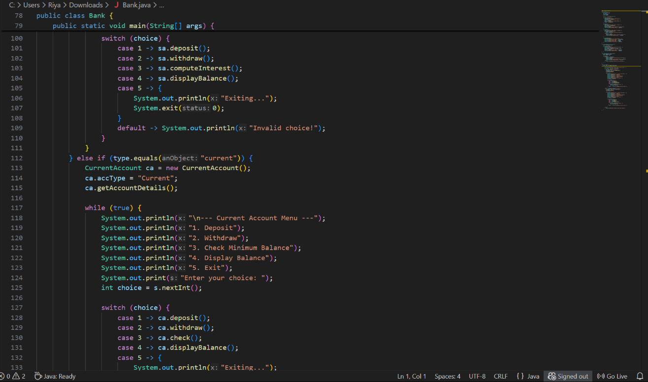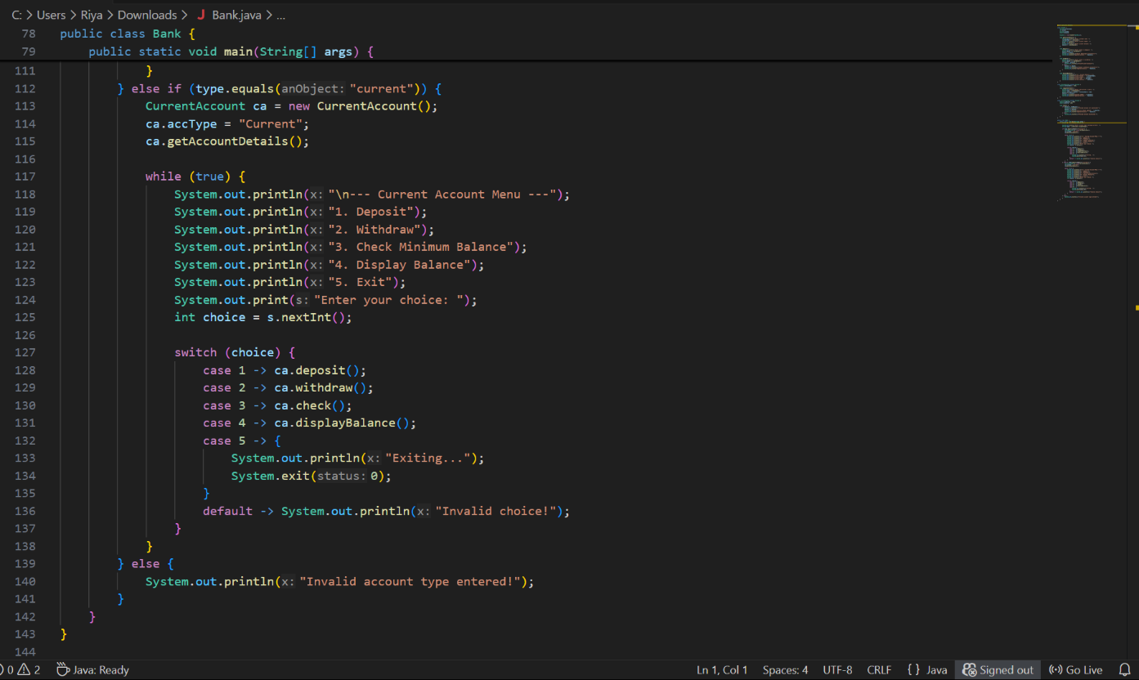

Output:
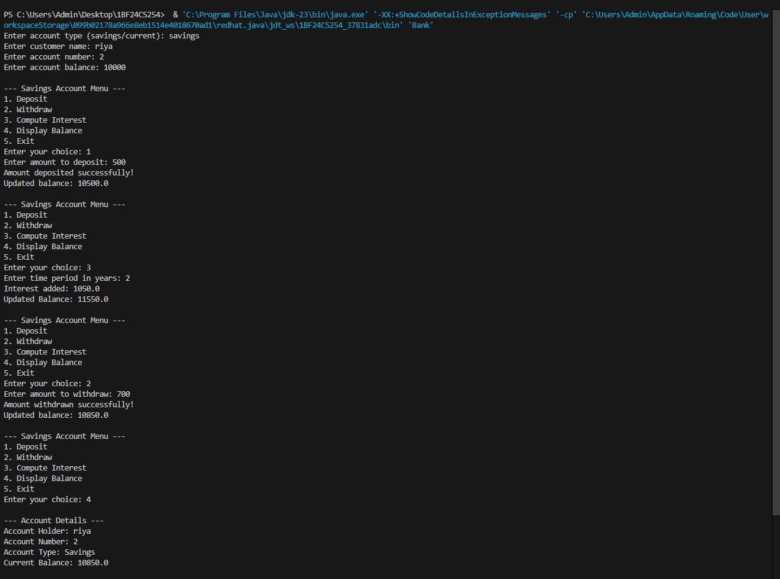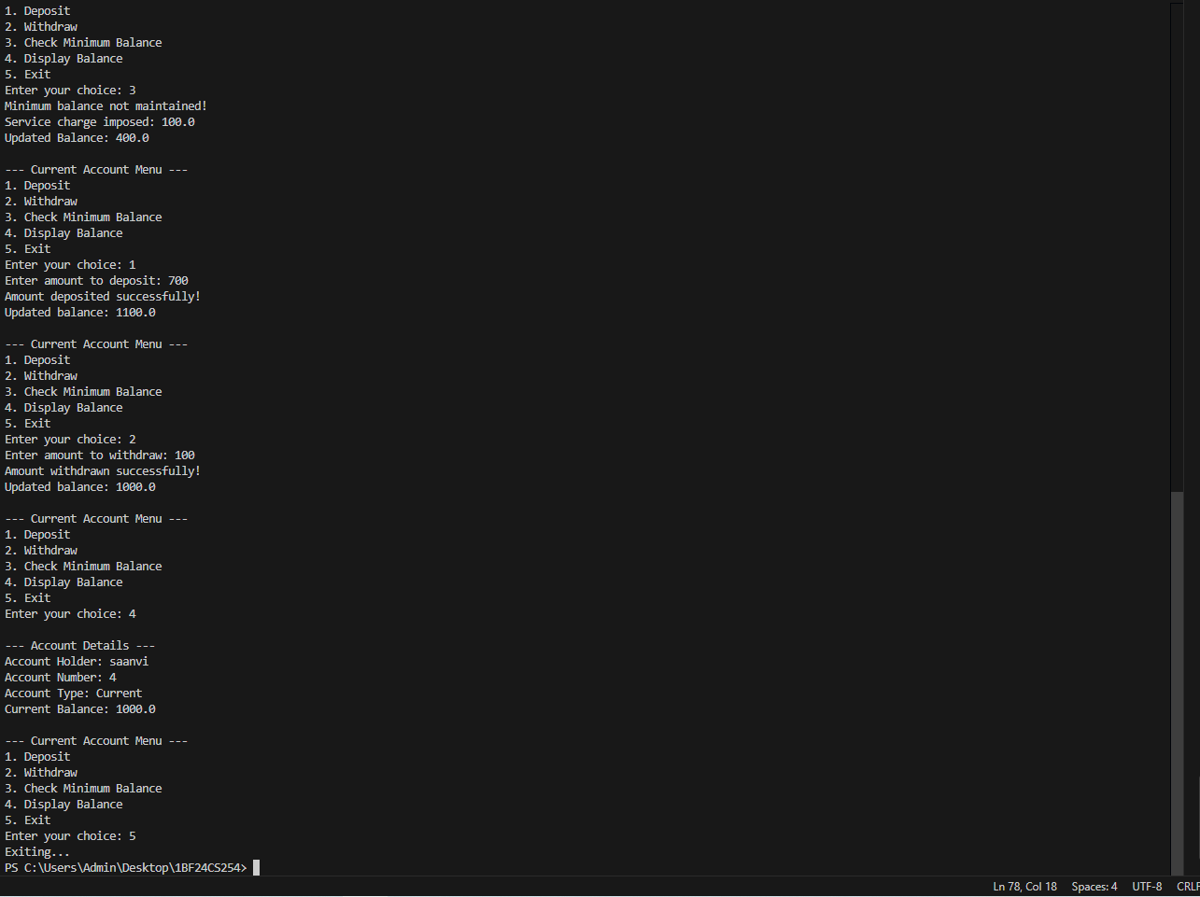

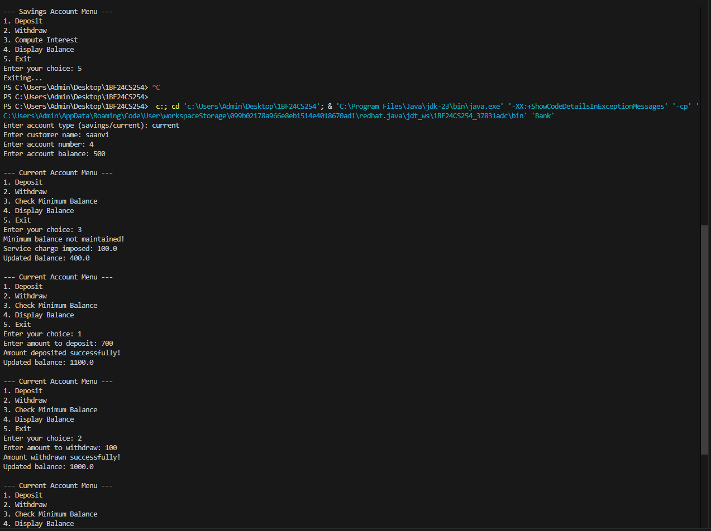

Program 6:
Implement Packages
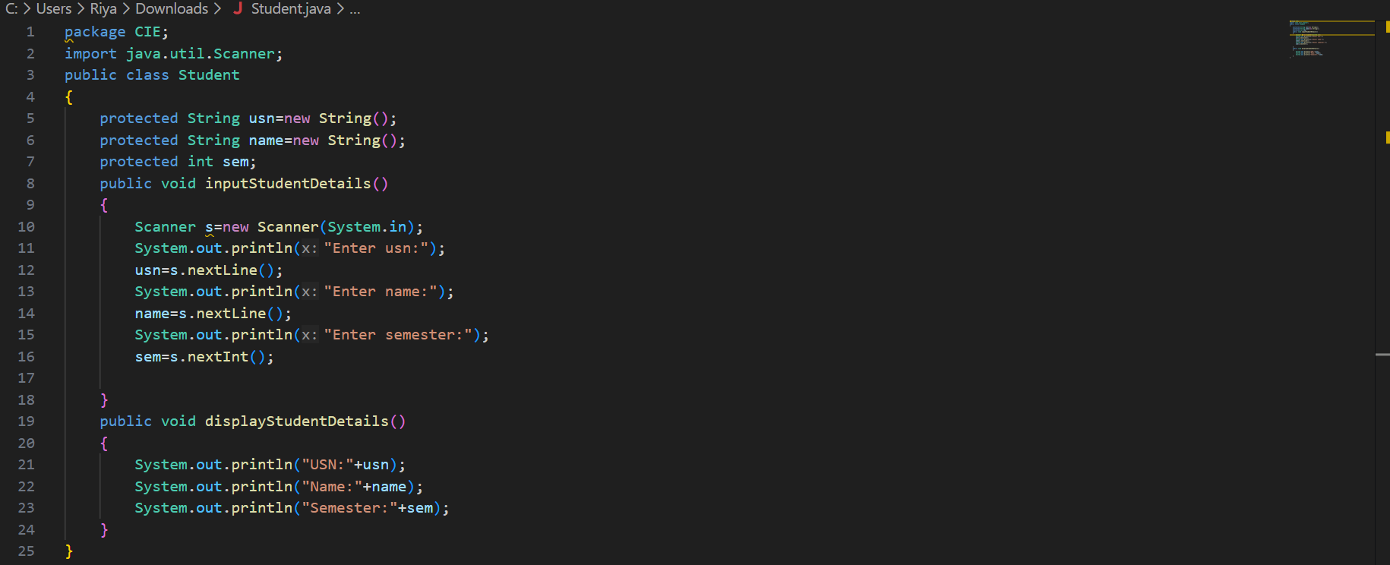
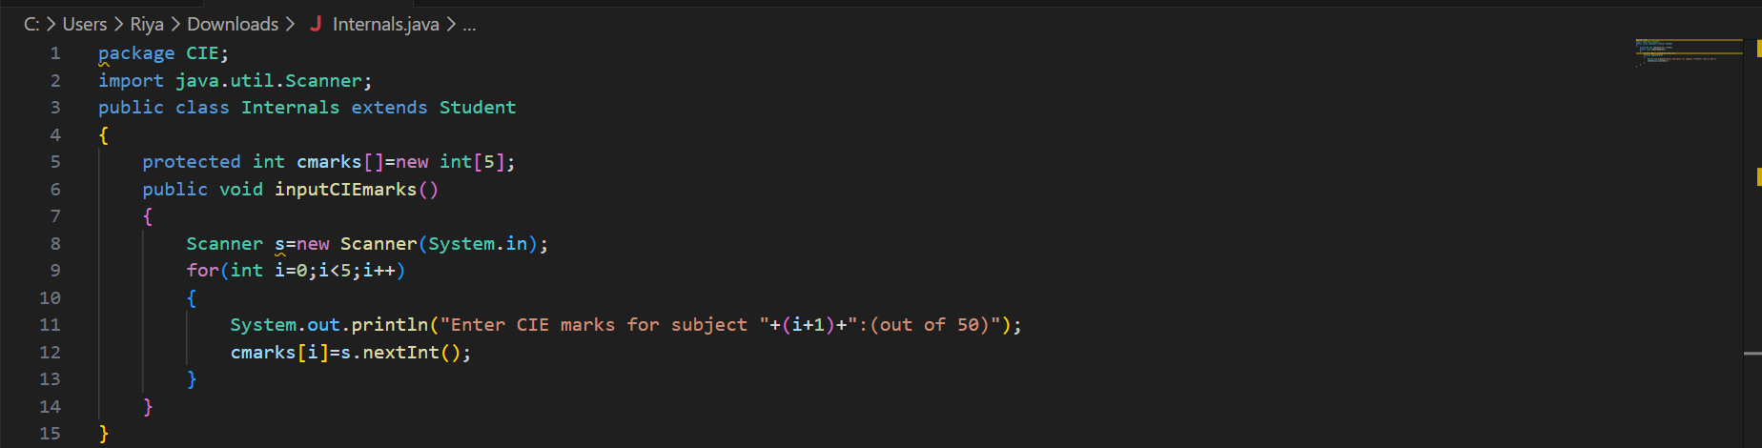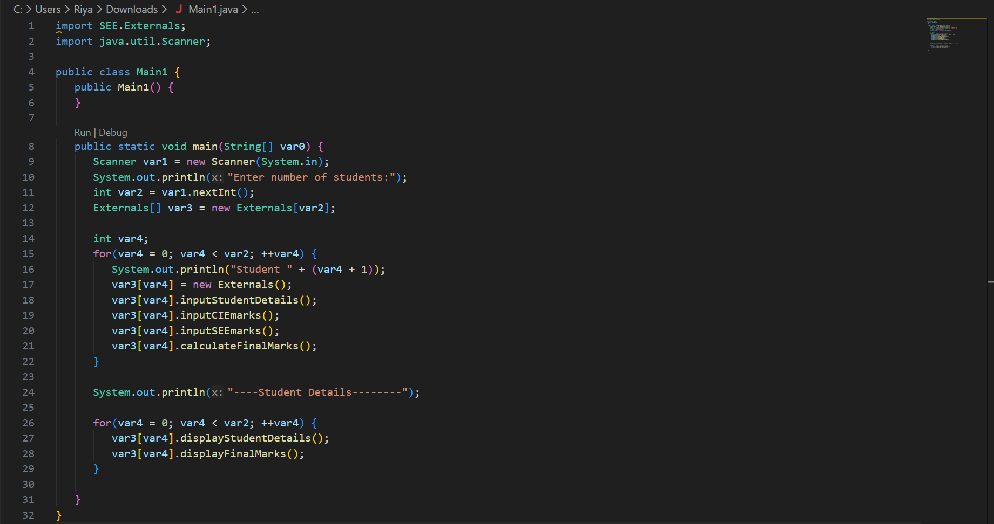

Output:
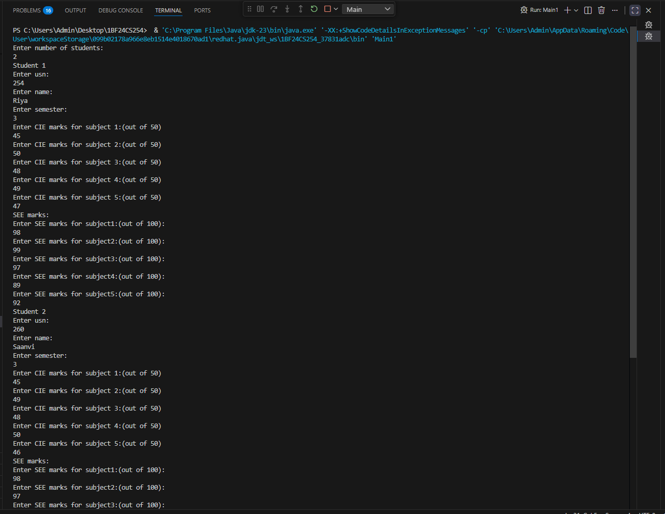

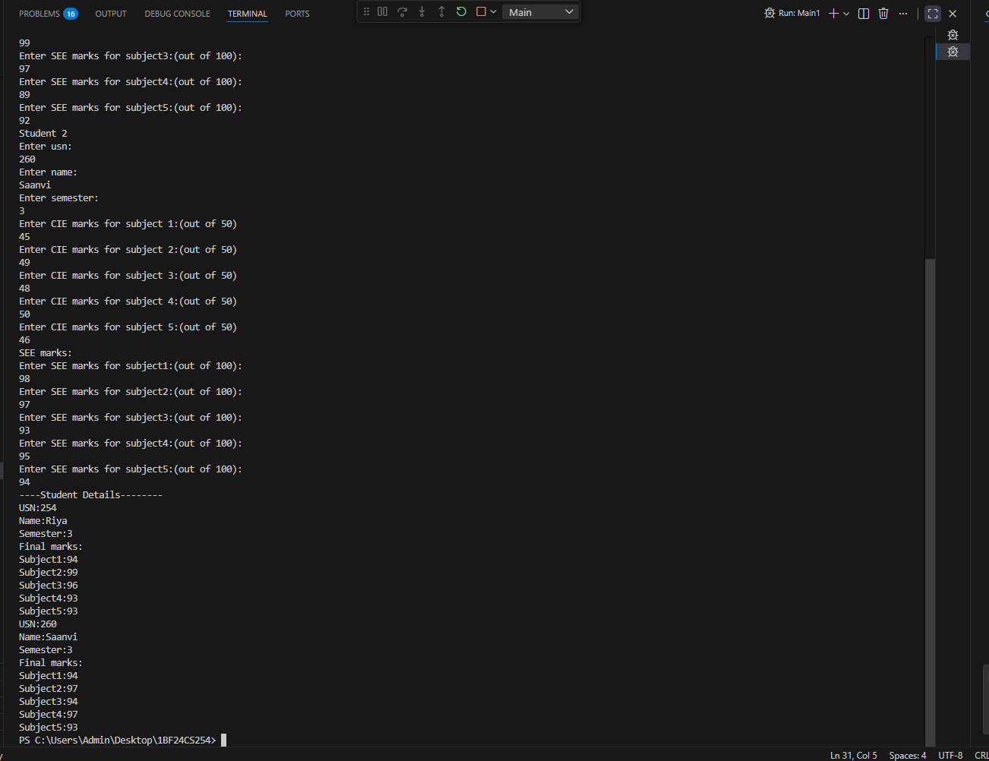

Program 7:
Implement Exception Handling
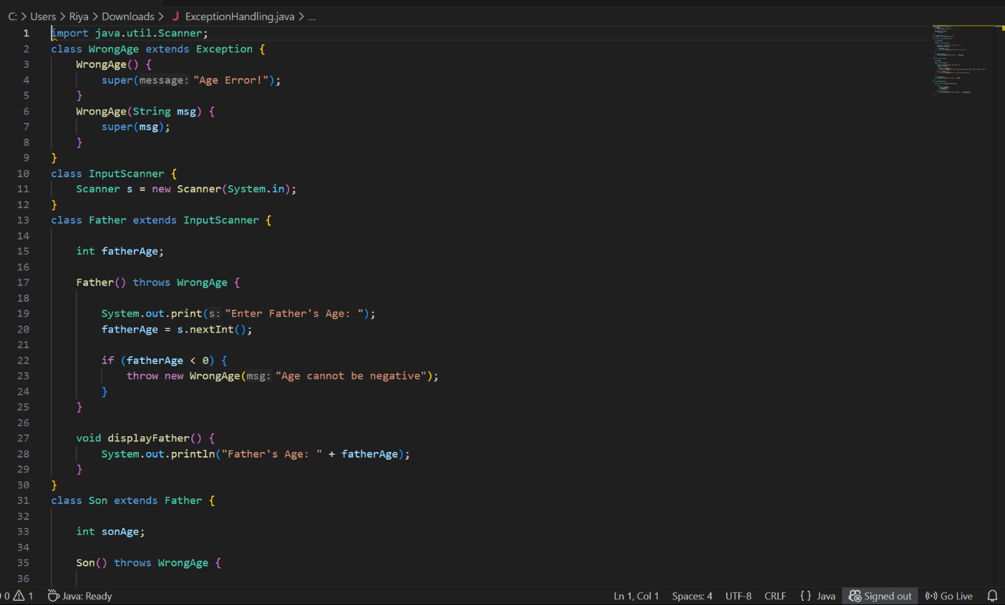

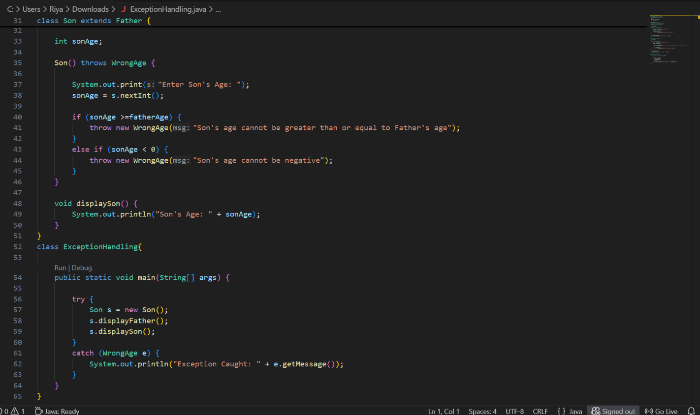

Output:
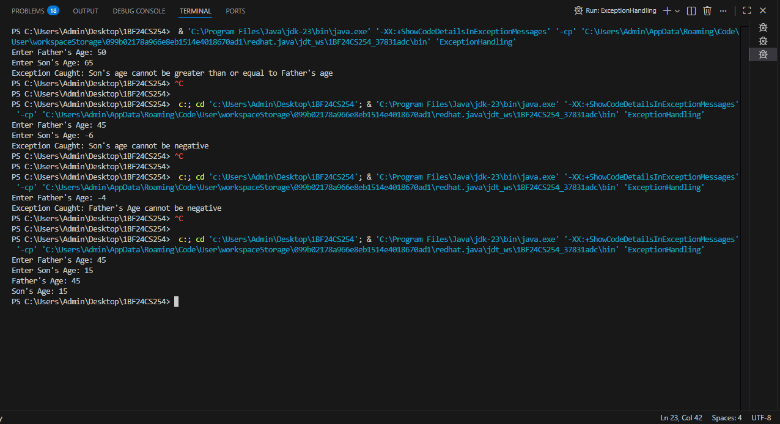

Program 8:
Implement Thread
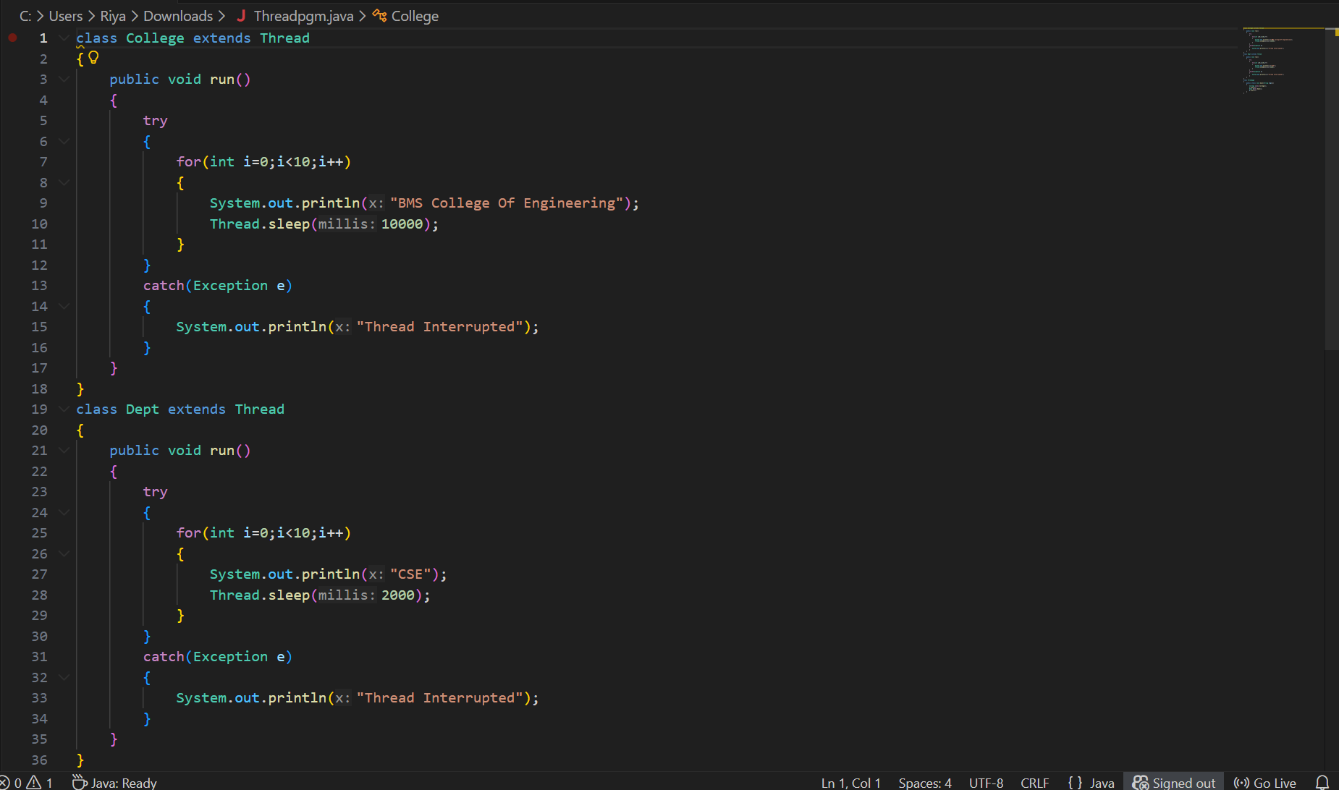

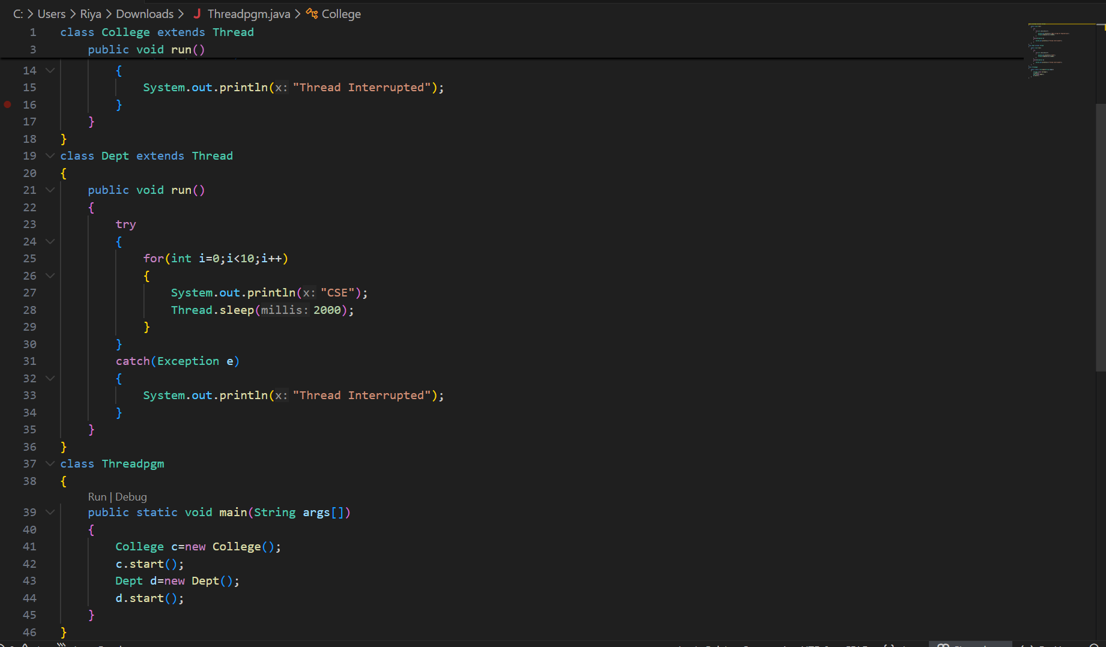

Output:
