PROJECT REPORT

On

File Sharing For User

From

ANALYZE INFOTECH

Towards partial fulfillment of the requirements
for the award of degree of

Bachelor of Computer Applications

From

Shri Ramswaroop Memorial University
Lucknow

Academic Session 2024 - 25

School of Computer Applications

PROJECT REPORT

On

File Sharing For User

From

ANALYZE INFOTECH

Towards partial fulfillment of the requirements
for the award of degree of

Bachelor of Computer Applications

From

Shri Ramswaroop Memorial University

Lucknow

Developed and Submitted by Under Guidance of
< Name of the Student> <Name of the Guide>
< University Roll No> <Designation>

Academic Session 2024 - 25

School of Computer Applications

Under taking

This is to certify that Project Report entitled

File Sharing For User
being submitted by

<Name of the Student>

Towards the partial fulfillment of the requirements
for the award of the degree of

Bachelor of Computer Applications
to
Shri Ramswaroop Memorial University
Lucknow
Academic Year 2024-25

is a record of the student’s own work carried out at

ANALYZE INFOTECH

and to the best of our knowledge the work reported herein does not form a part of any other thesis or work based on which degree or award was conferred on an earlier occasion to this or any other candidate.
Authorized Signatory Students’ Signature
Organization Name Name:
Roll No:

CERTIFICATE

DECLARATION

I, hereby declare that the report entitled “File Sharing For User
” submitted to the School of Computer Applications, Shri Ramswaroop Memorial University, SSRM Tindora, Uttar Pradesh, 225003, is submitted in partial fulfilment of the requirements for the award of the degree of Bachelor of Computer Applications in specialization with Data Science & Artificial Intelligence.
This report is the outcome of my own effort and has been completed under the guidance and supervision of K.K PANDEY SIR. I also declare that the contents of this report have not been submitted, either in full or in part, to any other university or institution for the award of any degree or diploma.

Place: Lucknow
Date: 17/06/2025

Signature of the Student
Students’ Name:
University Roll No.:

Acknowledgment

It gives us immense pleasure to express our sincere gratitude to all those who extended their support and guidance throughout the course of this project. The successful completion of this work would not have been possible without the encouragement and assistance of many individuals.
First and foremost, we would like to extend our profound gratitude to Dr. Reena Srivastava, Honourable Dean, School of Computer Applications, Shri Ramswaroop Memorial University, for her continued support, motivation, and encouragement. Her visionary leadership and guidance have always been a source of inspiration for us. We are also deeply thankful to Dr. Prabhas Chandra Pathak, Head of the Department, School of Computer Applications, for his constant support and valuable insights, which played a vital role in shaping our project and helping us stay focused on our objectives.
We extend our deep appreciation to our project guide, K.K Pandey Sir, for his unwavering support, expert guidance, and timely feedback throughout the duration of the project. His willingness to assist us at every step and address our queries with patience greatly contributed to the successful completion of this work. We would also like to express our gratitude to the Training and Placement Coordinators for their support, cooperation, and guidance during this project.
Last but not the least, we sincerely thank our families and friends for their constant support, understanding, and motivation. Their encouragement has been a strong pillar behind our consistent efforts.

Index
S.No. | Title | Page no.
I | Certificate | IV
II | Declaration | V
III | Acknowledgement | VI
IV | Index | VII-VIII
1 | Introduction | 1
2 | Problem Definition | 2
2.1 | Purpose | 2
2.2 | Scope | 2
3 | Objective | 3
3.1 | Functional requirements | 3
3.2 | Non-Functional requirements | 3-4
4 | Requirement Specifications | 5
4.1 | Hardware requirements | 5
4.2 | Software requirements | 5
5 | Module Description | 6-7
6 | Problem Formulation | 7
7 | Feasibility Study | 8-9
8 | Problem Specifications | 10-15
9 | System Architecture Design | 16-17
10 | System Analysis | 18
11 | E-R Diagram | 19-22
12 | Data Flow Diagram | 23-26
13 | Project Planning & Scheduling | 27-28
14 | Coding | 29-50
15 | Screenshot | 51
16 | Testing | 52-59
17 | Conclusion | 60
18 | Future Scope | 61
19 | Bibliography | 62

- INTRODUCTION
File Sharing Application: Collaborative Digital Platform
The File Sharing Application is an advanced digital platform designed to centralize, secure, and streamline file sharing, updating, and collaboration for users of all backgrounds. Acting as a robust knowledge and document hub, this application is built to empower individual users, professional teams, and communities with safe, seamless, and flexible file management capabilities.
Unlike traditional fragmented solutions, the application offers a unified environment where users can upload, view, update, and share files individually or with trusted collaborators, while also having control over privacy and access settings.
System Overview
The system is divided into two core modules:
- User Module
- Admin Module
User Module
Key Features:
- Account Registration & Secure Authentication:
Fast, intuitive sign-up and sign-in with modern authentication (email, OTP, SSO options), ensuring user data privacy and personalized experience.
- File Upload, Organization, and Update:
Users can upload various file types (documents, spreadsheets, images, presentations), tag files, create folders, and keep their file collections organized.
Files can be updated at any time—ensuring version control and easy retrieval of past edits.
- Viewing and Sharing:
  - Default visibility: Files can be set as public (visible to all users) or private (accessible only by the owner or authorized viewers).
  - Advanced sharing: Users can generate secure access keys for private files. Only users with the right key—either via email invitation or the supplied token—can view the file.
  - Instant previews and downloads for common file types.
  - Sharing via direct platform links, QR codes, or external integration (e.g., email, messaging apps).
- Privacy & Security Controls:
  - Toggle file privacy at upload or anytime after.
  - Manage shareable links: set expiration, revoke access, track usage.
  - Activity logs ensure users know who accessed their files and when.
- Community and Collaboration:
  - Public files can be browsed, searched, tagged, and filtered (by uploader, type, popularity, and more).
  - Users can comment on, rate, or recommend publicly shared files.
  - Collaborative editing capabilities for certain file formats (e.g., online docs, spreadsheets).
- Personal Dashboard:
  - View all owned, shared, and favorited files in one place.
  - Manage upload history, file versions, and access rights.
  - Notifications for comments, updates, share requests, or key-based access requests.
- Reporting & Feedback:
  - Report inappropriate or problematic files.
  - Submit platform feedback directly for further development or issue resolution.
Admin Module
Key Features:
- File Moderation & Approval:
Admins review new public file uploads, check for prohibited content, ensure compliance with platform policies, and maintain content quality.
- User Management:
Admins have the authority to monitor accounts, resolve disputes, handle flagged accounts/files, support or suspend users as necessary.
- Content Organization:
  - Curate featured documents or trending files to appear on the homepage.
  - Manage tagging, categories, and overall site taxonomy for easy navigation.
- Analytics & Reporting:
  - Generate in-depth reports on file uploads, downloads, most-accessed files, most active users, and sharing trends.
  - Track and analyze privacy settings and usage of access keys to ensure platform transparency.
- Notifications & Announcements:
  - Push updates on new features, policy changes, community events, and usage tips.
- Platform Security Assurance:
  - Periodic audits of access logs and security settings.
  - Implementation of encryption for sensitive private files and key-based sharing.
Problem Definition
In today's information-driven landscape, individuals and teams face significant obstacles around file sharing and management, such as:
- Scattered Storage: Files are distributed across personal devices, email threads, and multiple apps, leading to confusion, loss, or duplication.
- Privacy Control Limitations: Few platforms offer true privacy, strong access controls, and flexible sharing options for sensitive files.
- Restricted Collaboration: Lack of centralized, user-friendly systems makes co-editing, feedback, and discussion around files difficult.
- Inefficient Moderation: Without robust admin tools, false, duplicative, or inappropriate files often go unchecked.
- Security Risks: Unencrypted sharing and lack of audit logs make confidential data vulnerable.
There is a clear demand for a solution that replaces these issues with organized, secure, and collaborative file handling.
Purpose
The main objectives of the File Sharing Application are to:
- Empower Users:
Offer intuitive, secure, and customizable file sharing/control options to suit all needs—from openly sharing knowledge to maintaining privacy.
- Encourage Collaboration:
Enable co-authoring, version control, and instant feedback to accelerate productivity and learning.
- Enhance Usability:
Provide an engaging, reliable user interface—simplifying uploads, browsing, updating, and managing files.
- Support Community-Building:
Foster interaction around shared documents, knowledge bases, and resources.
- Ensure Robust Security & Oversight:
Equip admins with oversight tools for rapid moderation, policy enforcement, and user support.
- Streamline Knowledge Centralization:
Reduce fragmentation by becoming the single trusted repository for documents and files within the community or organization.
Scope
User Capabilities
- Register/login securely.
- Upload, update, and organize files.
- Set file privacy (public/private), manage access keys, and monitor access logs.
- Share files through platform links or third-party integrations.
- Discover, view, comment, and rate public files.
- Save favorites, manage personal collection, and track contribution history.
- Download, print, or export files.
- Provide feedback on files/platform and report abuse.
Admin Capabilities
- Moderate/approve public files and address user reports.
- Manage site and user accounts, including support and enforcement actions.
- Curate, categorize, and optimize content organization.
- Run analytics on user activity, popular files, access patterns, and keys usage.
- Communicate directly with users via announcements and direct notifications.
- Audit platform security, privacy control use, and resolve flagged incidents.
Advanced Features
- Key-based Private Sharing:
Private files remain invisible except to users who possess a unique access key, supporting secure, selective sharing of sensitive documents.
- Expiring/Revocable Access:
File owners can specify time-limited keys, automatically revoking access after a set duration or on demand.
- Role-Based Permissions:
Owners may assign read, comment, or edit rights to collaborators.
- Encrypted Storage & Transfer:
All private files are stored and transferred using industry-standard encryption.

OBJECTIVE
- To develop a centralized digital platform for uploading, sharing, updating, and managing user files of all types (documents, images, PDFs, etc.), contributed by users from all backgrounds.
- To enable users (uploaders and viewers) to register, browse, search, upload, update, set privacy, and manage their files efficiently and securely.
- To provide powerful administrative controls to oversee content authenticity, user activities, file categorization, security, and platform management.
- To deliver an exceptional user experience by ensuring files are organized, accessible, and protected according to user-specified permissions and privacy settings.
- To minimize issues such as duplicate, outdated, or improperly labeled files, and to simplify the discovery and safe sharing of content.
- To foster community interaction and trust through file reviews, ratings, comments, and advanced sharing options (public/private, key-based access).
Functional Requirements
User Functionalities
- User Registration/Login
  - Email and password-based account creation and login with password reset and secure authentication.
- Profile Management
  - Users can edit personal details, view/uploaded/shared files, manage file collections, and update contact info.
- File Upload and Update
  - Upload files of various formats with metadata (title, tags, description), set privacy (public/private), and update files (versioning).
- Browse/Search Files
  - Browse and search files by category (type, uploader, date added, popularity, recently updated), with advanced filters (tags, filename, file type).
- File Viewing
  - Preview supported files, view file details, comments, uploader info, and download options, based on access permissions.
- File Sharing
  - Share files via public links, social media, email; generate secure, key-based private links (only accessible to those with the key); set expiry/revocation.
- Privacy Settings
  - Make files private (only accessible to owner and authorized users with a key) or public (visible to all); manage access keys and permissions.
- Reviews & Ratings
  - Submit ratings and reviews for public files; comment or discuss file content or usage.
- Favorites/Bookmarks
  - Mark files as favorites for easy access later; manage and organize bookmarked/shared files.
- Community Engagement
  - Ask/answer questions about files, participate in collaborative sharing, and discussions.
Admin Functionalities
- Admin Login
  - Secure portal for authorized administrators (role-based access, authentication).
- File Moderation
  - Approve/edit/reject new public file uploads, flag and remove inappropriate/prohibited files, and enforce content policies.
- User Management
  - Monitor, block, or remove user accounts; resolve reports, handle violations and support queries.
- Category & Tag Management
  - Add/edit file categories, tags, and manage featured/trending/shared files or folders.
- Analytics & Reporting
  - Generate reports about user activity, file submissions/shares, most popular or most accessed files, and privacy setting usage.
- Notifications
  - Send platform updates, featured files/folders, alerts, and reminders to users or groups.
- Content Organization
  - Curate homepage, recommend trending or seasonal files, organize file/folder collections for easy access.
- Security Audits
  - Monitor data integrity, access logs, and file security; enforce encryption and privacy best practices.
Non-Functional Requirements
- Performance
  - Pages and dashboard load within 2–3 seconds under normal loads; efficient handling of concurrent file uploads/downloads.
- Scalability
  - System supports increasing numbers of users, simultaneous uploads/downloads, growing file and storage capacity.
- Security
  - All user passwords encrypted; strong, token-based authentication (e.g., JWT); role-based and key-based access control; file upload virus/malware scanning; secure file storage.
- Usability
  - Intuitive user interface, easily navigable; clear upload/update forms; accessible help tips.
- Reliability
  - High availability with minimal downtime; robust backup/restore, error-handling, consistent data protection.
- Compatibility
  - Fully responsive and functional across major browsers (Chrome, Firefox, Edge, Safari) and devices (desktop, tablet, mobile).
REQUIREMENTS SPECIFICATIONS
Hardware Specification
Component | Minimum Requirement | Recommended Requirement
Processor | Quad-Core (e.g., Intel i5/Ryzen 5) | 8-Core server/workstation CPU
RAM | 8 GB | 16–32 GB
Storage | 256 GB SSD | 512 GB SSD or NVMe
Network | 10 Mbps or above | 100 Mbps or above

Software Specification

Software | Description
OS | Windows 10+, Linux (Ubuntu 18+), or macOS
Browser | Google Chrome, Mozilla Firefox, Safari, Microsoft Edge
Frontend Framework | React.js, Bootstrap or Tailwind CSS UI library
Libraries | Axios (API requests), React Router (routing), Formik/Yup (form validation)
Backend | Node.js with Express.js
Database | MongoDB
File Handling | Multer (for file uploads), file virus scanning
Authentication | JWT (JSON Web Tokens) for user/session management
APIs | RESTful APIs for all operations
Version Control | Git, GitHub/GitLab
Encryption | Industry-standard encryption for file storage & transfer

PROBLEM FORMULATION
In today’s information-driven environment, individual users, teams, and organizations face multiple challenges when it comes to securely sharing, discovering, and managing digital files. Existing solutions, such as scattered cloud drives, email attachments, or informal messaging platforms, rarely offer a centralized, organized, or secure experience.
Users struggle to:
- Locate trusted, up-to-date documents from a single source.
- Manage access rights, privacy, and file updates effectively.
- Collaborate efficiently while safeguarding sensitive content.
Contributors—whether they are students, professionals, or organizations—lack a streamlined platform for uploading, updating, and distributing files with granular control over visibility and permissions. They also often do not receive feedback or have analytics on file access and engagement.
The absence of a unified platform leads to:
- Duplicated, outdated, or inaccessible information.
- Loss of control over who can view or update files (especially for sensitive or private data).
- Limited transparency around sharing activities and lack of accountability and oversight.
- Security vulnerabilities due to informal and unencrypted sharing channels.
Generic cloud storage or social file sharing services do not prioritize content quality, efficient organization, privacy control, or real-time collaboration features. Moderation and administrative oversight are also insufficient to prevent the dissemination of inappropriate, malicious, or redundant files.
To address these challenges, the File Sharing Application is designed with dedicated User and Admin modules that provide seamless file uploading, secure sharing (including key-based private access), orderly cataloging, collaborative features, community engagement (comments, ratings), and robust moderation for safety and content quality.
PROBLEM SPECIFICATION
The fundamental challenge that the File Sharing Application addresses is the lack of a centralized, efficient, and quality-controlled digital platform for secure file sharing and discovery.
Key Problems to be Solved
For Users (File Seekers & Collaborators):
- Fragmented Access to Reliable Files
Users are forced to depend on inconsistent, decentralized platforms or direct sharing, making it difficult to locate up-to-date, trustworthy, or officially distributed files tailored to their needs.
- No Unified File Management Platform
Absence of a system that merges diverse content from different contributors, while offering advanced options to search, filter, and organize by file type, owner, or custom tags.
- Cumbersome Discovery and Updating Process
Searching for new or updated files across multiple channels is time-consuming. Users also face difficulty in tracking revisions or updates to shared documents.
- Lack of Robust Feedback and Collaboration Tools
Most solutions lack built-in features for rating, commenting, or collaboratively editing files, hindering productive community interaction and trust in shared content.
- Limited Privacy and Sharing Controls
Existing platforms insufficiently support selective sharing (e.g., public vs. private), granular permission management, or secure key-based access for confidential files.
For Contributors / File Owners / Admins:
- Insufficient Moderation and Control Tools
There is no systematic workflow for reviewing new uploads, verifying accuracy, resolving reports, or swiftly removing harmful or redundant content.
- No Structured Categorization or Tagging System
Contributors and admins require mechanisms to organize files by project, department, type, or custom labels to improve organizational efficiency and user discovery.
- Lack of Real-Time Monitoring and Platform Management
Admins struggle to oversee user activity, monitor sensitive content access, generate analytics/reports, and respond to reported issues or policy violations promptly.
- Security Risks in Uncontrolled Environments
Without encryption, access tracking, or malware scanning, confidential files are at risk of unauthorized access or corruption, undermining trust and compliance.

COMPONENT DIAGRAM
The component diagram contains components and dependencies. Components represent the physical packaging of a module of code. The dependencies between the components show how changes made to one component may affect the other components in the system. Dependence in a component diagram are represented by a dashed line between two or more components. Component diagrams can also show the interfaces used by the components to communicate to each other.

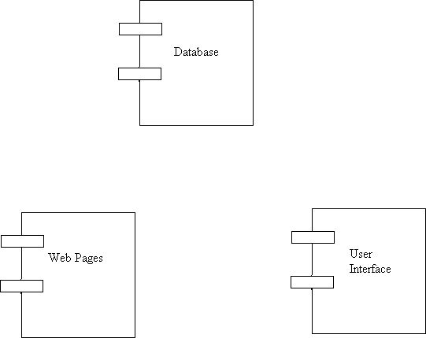

Figure of Component Diagram

Deployment Diagram:
Deployment and component diagram combines the features of both diagrams into one diagram.
The deployment diagram contains nodes and connections. A node usually represents a piece of hardware in the system. A connection depicts the communication path used by the hardware to communicate and usually indicates a method such as TCP/IP.

DB
UI
Web Server

Web pages

Figure of Deployment Diagram
- SYSTEM ARCHETECTURE DESIGN
Defining System:
Collection of components, which are interconnected, and work together to realize some objective, from a system. There are three components in every system, namely input, processing and output

Input Output
Processing

System Development of Life Cycle:
The System development life cycle (SDLC), or Software development process in systems engineering, information systems and software engineering, is a process of creating or altering information systems, and the models and methodologies that people use to develop these systems. In software engineering, the SDLC concept underpins many kinds of software methodologies. Broadly, the following are the different activities to be considered while defining the system development life cycle for the said project:
- Problem
- Definition
- System Analysis
- Study of existing system
- Drawback of the existing system
- Proposed system
- System Requirement study
- Data flow analysis
- Feasibility study
- System design
- Input Design (Database & Forms) Updating
- Query /Report
- Design
- Administration
- Testing
- Implementation
- Maintenance
- SYSTEM ANALYSIS
Systems analysis is the study of sets of interacting entities, including computer systems analysis. This field is closely related to requirements analysis or operations research. It is also "an explicit formal inquiry carried out to help someone (referred to as the decision maker) identify a better course of action and make a better decision than he might otherwise have made.
System development can generally be thought of having two major components: systems analysis and systems design. In System Analysis more emphasis is given to understanding the details of an existing system or a proposed one and then deciding whether the proposed system is desirable or not and whether the existing system needs improvement.
Systems design is the process of defining the architecture, components, modules, interfaces, and data for a system to satisfy specified requirements. If the broader topic of product development "blends the perspective of marketing, design, and manufacturing into a single approach to product development," then design is the act of taking the marketing information and creating the design of the product to be manufactured. Systems design is therefore the process of defining and developing systems to satisfy specified requirements of the user. Until the 1990s systems design had a crucial and respected role in the data processing industry. In the 1990s standardization of hardware and software resulted in the ability to build modular systems. The increasing importance of software running on generic platforms has enhanced the discipline of software
- ENTITY RELATION DIAGRAMS
The Entity Relation Model or Entity Relation Diagram (ERD) is a data model or diagram for high-level description of conceptual data model, and it provides a graphical notation for representing such data models in the form of entity relationship diagrams. Such models are typically used in the first stage of Management information management system design; they are used for example, to describe information needs and/ or the type of information that is to be stored in the Database during the requirement analysis. The data modeling technique, however, can be used to describe any ontology (i.e. an overview and classification of used terms and their relationships) for a certain universe of discourse (i.e. area of interest).
ER DIAGRAMS:
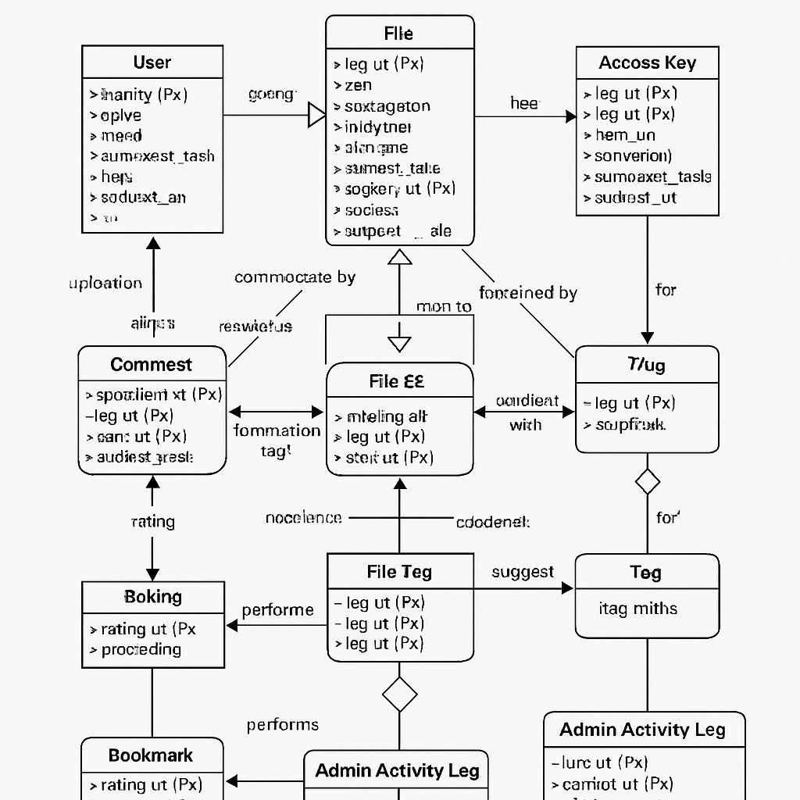

Activity Diagram:

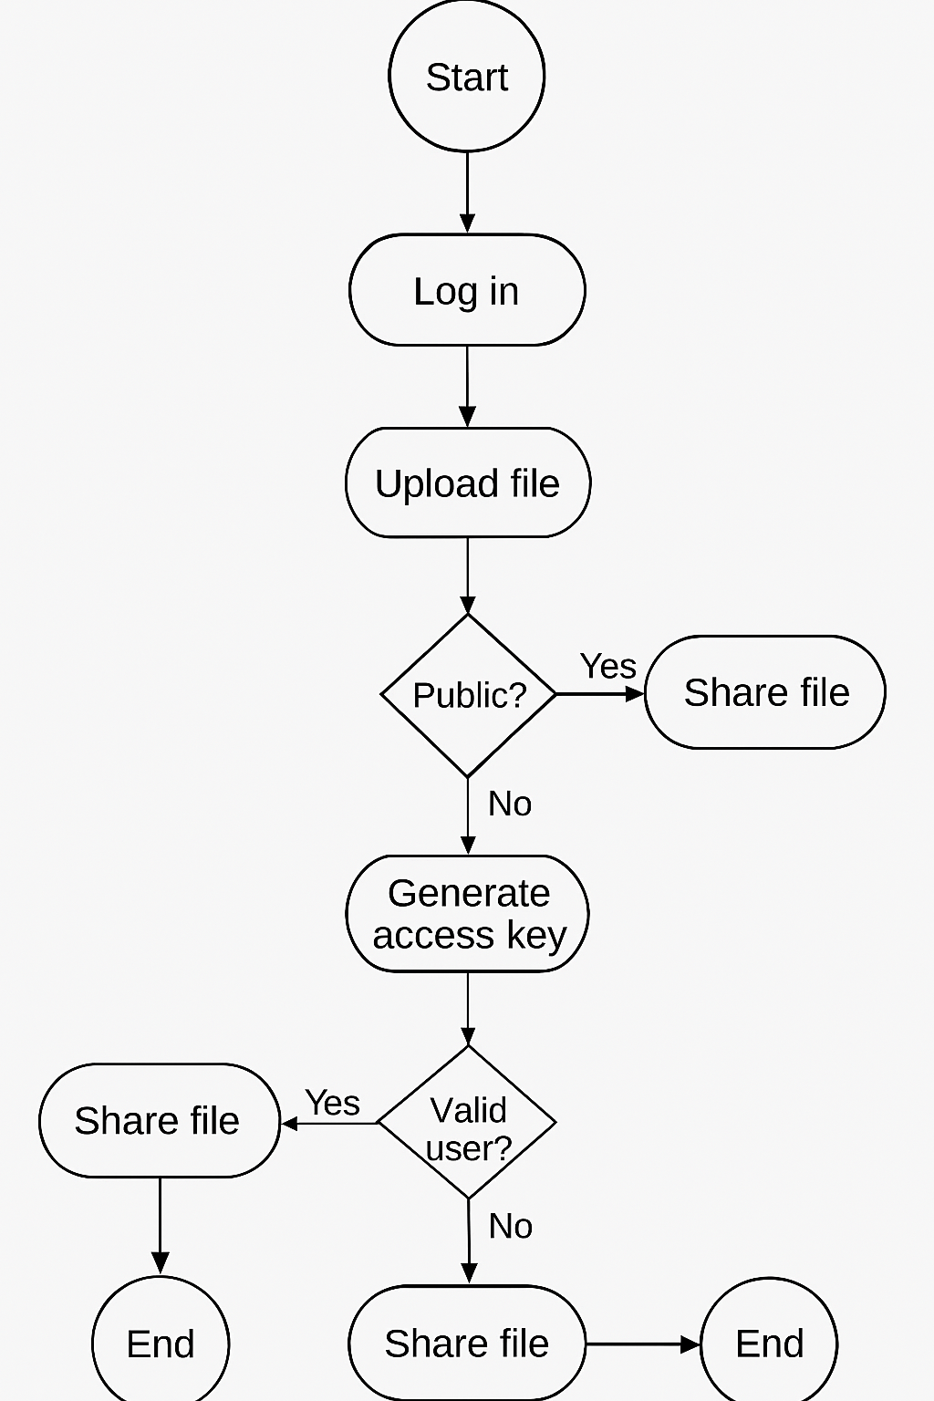

Event Diagram:

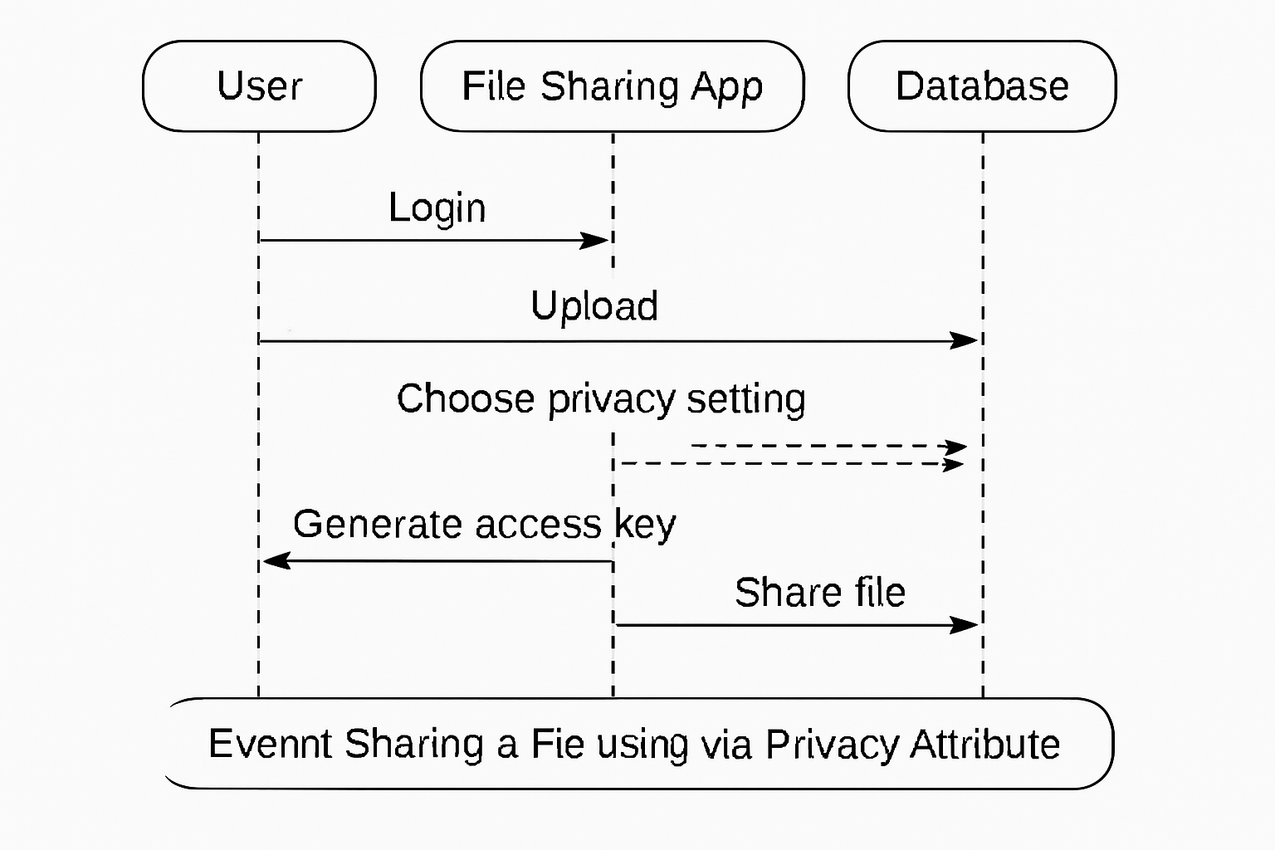

- DATA FLOW DIAGRAM
The data flow diagram shows the flow of data within any system. It is an important tool for designing phase of software engineering. Larry Constantine first developed it. It represents graphical view of flow of data. It’s also known as BUBBLE CHART. The purpose of DFD is major transformation that will become in system design symbols used in DFD.
In the DFD, four symbols are used and they are as follows.
- A square defines a source (originator) or destination of system data.

- An arrow identifies data flow-data in motion. It is 2a pipeline through which information flows.

- An open rectangle is a data store-data at rest, or a temporary Repository of data.

- A circle or a “bubble “(Some people use an oval bubble) represents a process that transfers informing data flows into outgoing data flows.

Context Level Data Flow Diagram:
This level shows the overall context of the system and its operating environment and shows the whole system as just one process. Online book store is shown as one process in the context diagram; which is also known as zero level DFD, shown below. The context diagram plays important role in understanding the system and determining the boundaries. The main process can be broken into sub-processes and system can be studied with more detail; this is where 1st level

DFD comes into play.

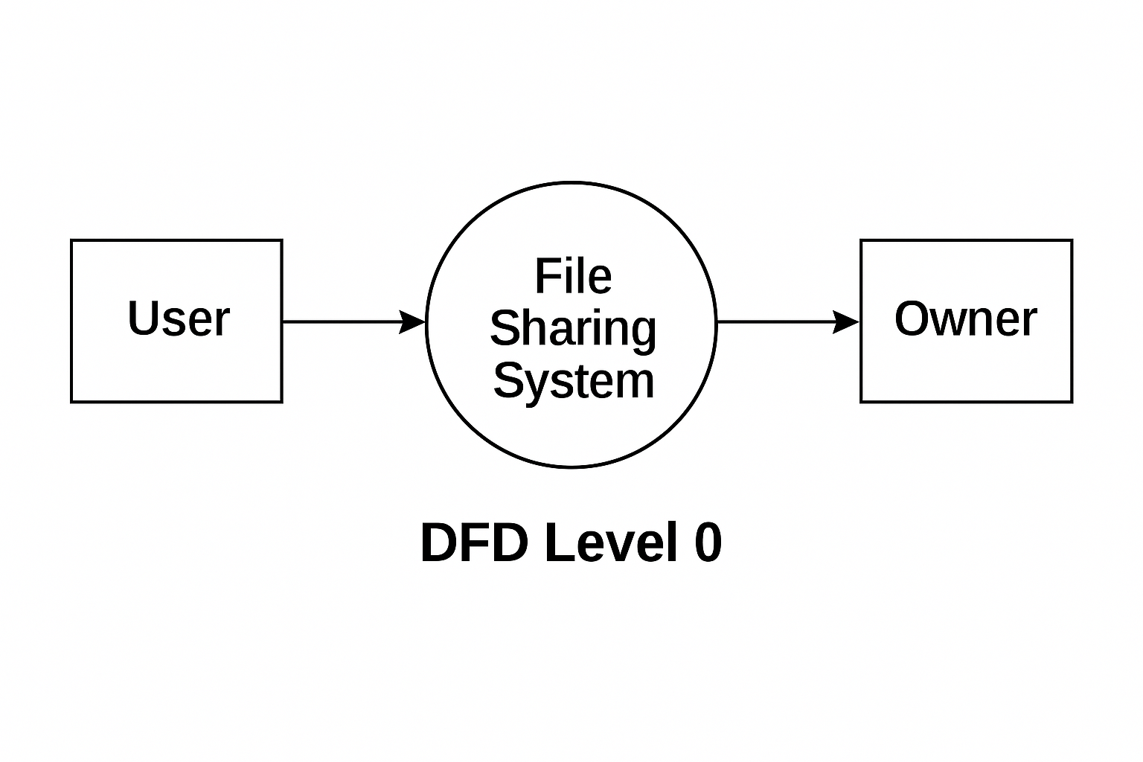

Zero Level Data Flow Diagram
First Level DFD:
This level (level 1) shows all processes at the first level of numbering, data stores, external entities and the data flows between them. The purpose of this level is to show the major high- level processes of the system and their interrelation. A process model will have one, and only one, level-1 diagram. A level-1 diagram must be balanced with its parent context level diagram,
i.e. there must be the same external entities and the same data flows, these can be broken down to more detail in the level 1.

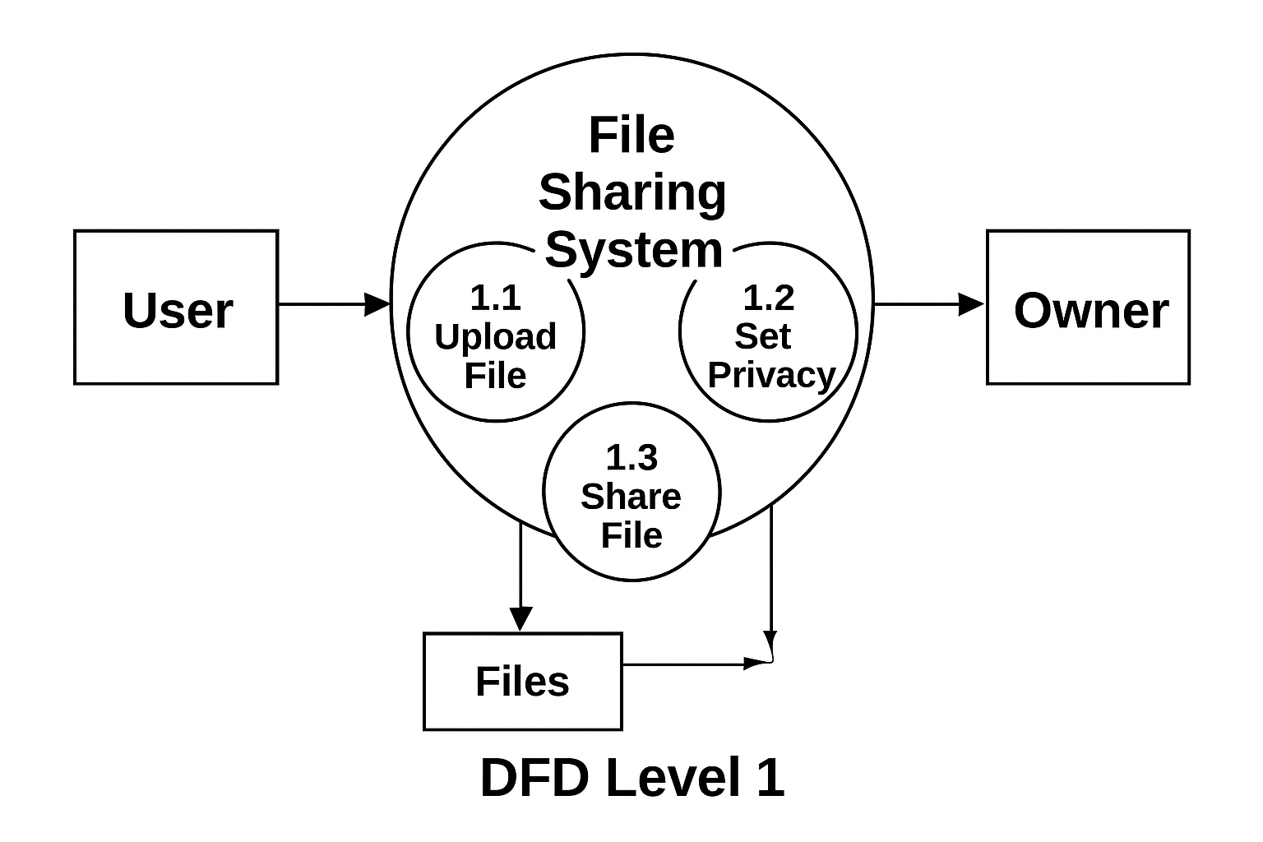

First Level Data Flow Diagram

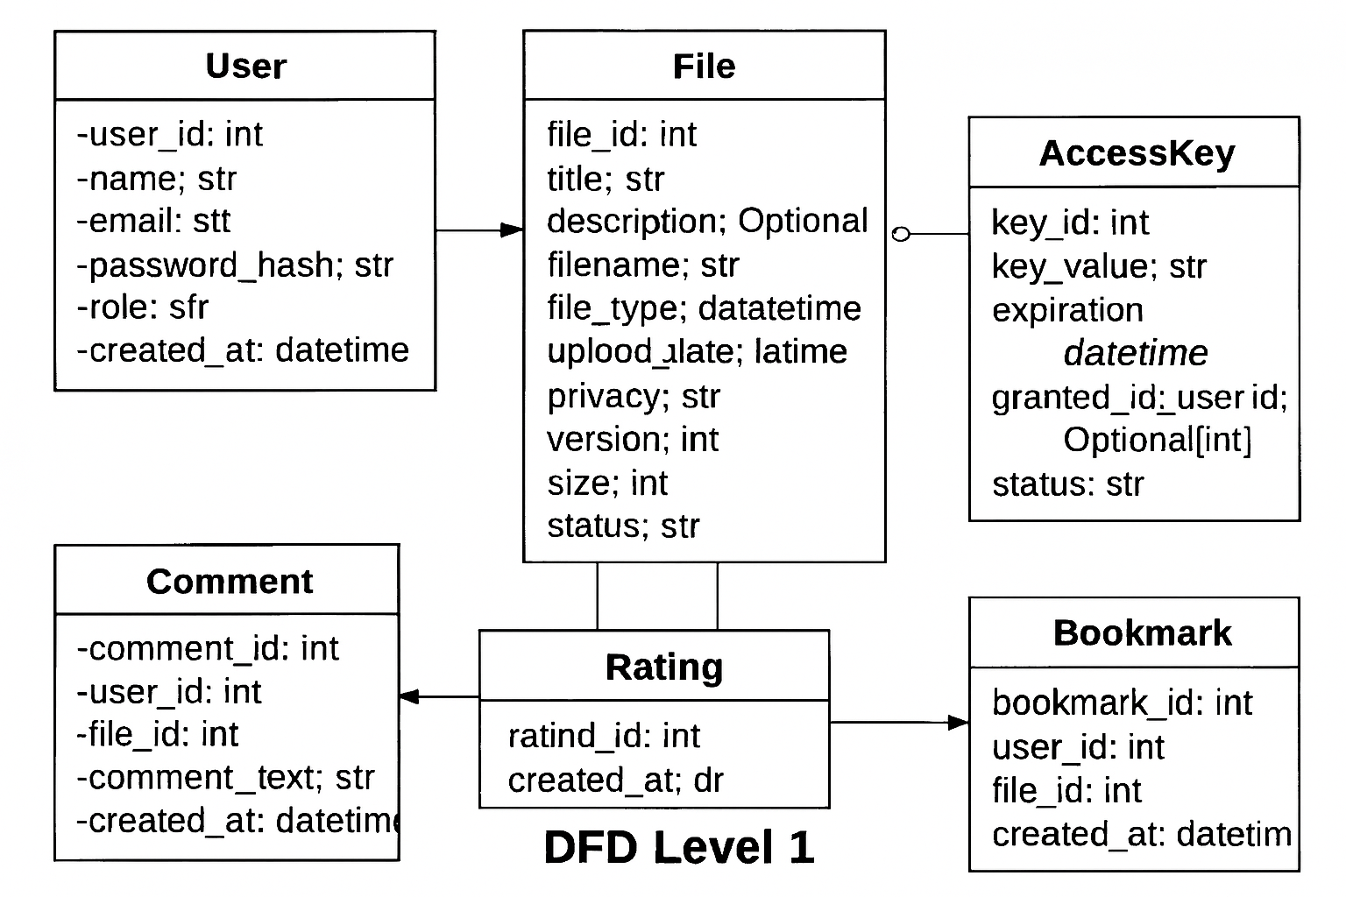

Class Diagram
- PROJECT PLANNING & SCHEDULING

Pert Chart:
A project plan needs to be created to ensure the timely completion of the project. As part of project analysis, we break the project down to a number of stages and use a Gantt chart and PERT chart to describe specific tasks and status.
The Work Breakdown Structure of our proposed system “E-Commerce” is shown below:

ID | Task Name | Duration | Start | Finish
1 | Project Initiation | 03 days | Tue  18/02/2025 | Fri  21/02/2025
2 | Draft Project Plan | 02 days | Sat  22/02/2025 | Mon  24/02/2025
3 | Analysis Phase | 09 days | Wed  26/02/2025 | Fri  07/03/2025
4 | Plan User Interviews | 02 days | Sat  08/03/2025 | Mon  10/03/2025
5 | Schedule users Interviews | 04 days | Tue  11/03/2025 | Sat  15/03/2025
6 | Conducting users Interviews | 03 days | Mon  17/03/2025 | Thu  20/03/2025
7 | System Design | 10 days | Fri  21/03/2025 | Mon  31/03/2025
8 | Modules Design | 09 days | Tue  01/04/2025 | Thu  10/04/2025
9 | Data Structure Design | 03 days | Fri  11/04/2025 | Mon  14/04/2025
10 | User Interface Design | 02 days | Tue  15/04/2025 | Thu  17/04/2025
11 | Coding Phase | 07 days | Fri  18/04/2025 | Fri  25/04/2025
12 | Testing Phase | 05 days | Fri  25/04/2025 | Wed  30/04/2025
13 | Integration Testing | 03 days | Wed  30/04/2025 | Fri  02/05/2025
14 | System Level Testing | 03 days | Fri  02/05/2025 | Mon  05/05/2025
15 | Implementation | 02 days | Tue  06/05/2025 | Wed  07/05/2025
16 | Post-Implementation Review | 04 days | Thu  08/05/2025 | Mon  12/05/2025

- CODING OF PROJECT

App.jsx

// File: App.jsx
import React from 'react';
import { BrowserRouter as Router, Routes, Route } from 'react-router-dom';
import Home from './pages/Home';
import About from './pages/About';
import Contact from './pages/Contact';
import Login from './pages/Login';
import Signup from './pages/Signup';
import Dashboard from './pages/Dashboard';
import AddExpense from './pages/AddExpense';
import Navbar from './components/Navbar';
import Upload from './pages/Upload';
import Profile from './pages/Profile';
import PublicFiles from './pages/PublicFiles';
import SearchPrivateFile from './pages/SearchPrivateFile';
export default function App() {
return (
<Router>
<Navbar />
<Routes>
<Route path='/' element={<Home />} />
<Route path='/about' element={<About />} />
<Route path='/contact' element={<Contact />} />
<Route path='/login' element={<Login />} />
<Route path='/signup' element={<Signup />} />
<Route path='/dashboard' element={<Dashboard />} />
<Route path='/add-expense' element={<AddExpense />} />
<Route path='/upload' element={<Upload/>}/>
<Route path='/profile' element={<Profile/>}/>
<Route path='/public' element={<PublicFiles/>}/>
<Route path='/search-private' element={<SearchPrivateFile/>}/>

</Routes>
</Router>
);
}

backend/index.js

// File: server/app.js
const express = require('express');
const cors = require('cors');
const mongoose = require('mongoose');
require('dotenv').config();

const app = express();
const PORT = process.env.PORT || 5000;

app.use(cors());
app.use(express.json());
app.use('/uploads', express.static('uploads'));

const authRoutes = require('./routes/auth');
const fileRoutes = require('./routes/files');

// MongoDB connection
mongoose.connect(process.env.MONGO_URI, {
useNewUrlParser: true,
useUnifiedTopology: true,
})
.then(() => console.log('MongoDB connected'))
.catch(err => console.error('MongoDB connection error:', err));

app.use('/api/auth', authRoutes);
app.use('/api/files', fileRoutes);

app.listen(PORT, () => {
console.log(`Server is running on port ${PORT}`);
})

Routes/auth.js
const express = require('express');
const router = express.Router();
const User = require('../models/User');

// Signup
router.post('/signup', async (req, res) => {
const {name,email, password } = req.body;
try {
const existingUser = await User.findOne({ email });
if (existingUser) return res.status(400).json({ message: 'User already exists' });
const newUser = new User({ name,email, password });
await newUser.save();
res.json({ message: 'Signup successful' });
} catch (err) {
res.status(500).json({ message: 'Server error', error: err.message });
}
});

// Login
router.post('/login', async (req, res) => {
const { email, password } = req.body;
try {
const user = await User.findOne({ email });
if (!user || user.password !== password)
return res.status(401).json({ message: 'Invalid credentials' });

res.json({ message: 'Login successful', user });
} catch (err) {
res.status(500).json({ message: 'Server error', error: err.message });
}
});

module.exports = router;

routes/files.js
const express = require('express');
const multer = require('multer');
const path = require('path');
const fs = require('fs');
const File = require('../models/File');
const { v4: uuidv4 } = require('uuid');

const router = express.Router();

// Multer setup
const storage = multer.diskStorage({
destination: (req, file, cb) => cb(null, 'uploads/'),
filename: (req, file, cb) => cb(null, Date.now() + '-' + file.originalname),
});
const upload = multer({ storage });

// ✅ POST /upload - Handle multiple file uploads
router.post('/upload', upload.array('files', 10), async (req, res) => {
try {
const { visibility, accessCode, uploadedBy } = req.body;
const uploadedFiles = [];

if (!req.files || req.files.length === 0) {
return res.status(400).json({ message: 'No files uploaded' });
}

for (const file of req.files) {
const fileDoc = new File({
filename: file.originalname,
filePath: file.filename,
uploadedBy,
visibility,
password: visibility === 'private' ? accessCode : null,
code: visibility === 'private' ? uuidv4().slice(0, 6) : null,
mimetype: file.mimetype,
});

await fileDoc.save();
uploadedFiles.push(fileDoc);
}

res.status(201).json({
message: 'Files uploaded successfully',
files: uploadedFiles,
});
} catch (err) {
console.error(err);
res.status(500).json({ message: 'Upload failed', error: err.message });
}
});

// ✅ GET /user/:userId - Get all files uploaded by user
router.get('/user/:userId', async (req, res) => {
try {
const files = await File.find({ uploadedBy: req.params.userId }).sort({ createdAt: -1 });
res.json(files);
} catch (err) {
res.status(500).json({ message: 'Failed to fetch user files' });
}
});

// ✅ PUT /:id - Update file info (visibility, access code)
router.put('/:id', async (req, res) => {
try {
const { visibility, accessCode } = req.body;

const updated = await File.findByIdAndUpdate(
req.params.id,
{
visibility,
password: visibility === 'private' ? accessCode : null,
code: visibility === 'private' ? uuidv4().slice(0, 6) : null,
},
{ new: true }
);

if (!updated) return res.status(404).json({ message: 'File not found' });

res.json({ message: 'File updated', file: updated });
} catch (err) {
res.status(500).json({ message: 'Update failed', error: err.message });
}
});

// ✅ DELETE /:id - Delete file from DB and disk
router.delete('/:id', async (req, res) => {
try {
const file = await File.findById(req.params.id);
if (!file) return res.status(404).json({ message: 'File not found' });

// Delete from disk
const filePath = path.join(__dirname, '..', 'uploads', file.filePath);
if (fs.existsSync(filePath)) fs.unlinkSync(filePath);

await file.deleteOne();

res.json({ message: 'File deleted successfully' });
} catch (err) {
res.status(500).json({ message: 'Delete failed', error: err.message });
}
});

// GET all public files
router.get('/public', async (req, res) => {
try {
const files = await File.find({ visibility: 'public' }).populate('uploadedBy', 'name email').sort({ createdAt: -1 });
res.json(files);
} catch (err) {
res.status(500).json({ message: 'Failed to fetch public files' });
}
});

router.get('/download/:filename', (req, res) => {
const filePath = path.join(__dirname, '../uploads', req.params.filename);

// Check if file exists
if (fs.existsSync(filePath)) {
res.download(filePath); // this sets headers for force download
} else {
res.status(404).json({ message: 'File not found' });
}
});

router.get('/private/:code', async (req, res) => {
const file = await File.findOne({ code: req.params.code, visibility: 'private' });
if (!file) return res.status(404).json({ message: 'Invalid code or file not found' });
res.json(file);
});

router.post('/verify', async (req, res) => {
const { code, password } = req.body;
const file = await File.findOne({ code, visibility: 'private' });

if (!file) return res.status(404).json({ message: 'File not found' });
if (file.password !== password) return res.status(401).json({ message: 'Incorrect password' });

res.json({ success: true });
});

module.exports = router;

Models/User.js
const mongoose = require('mongoose');

const userSchema = new mongoose.Schema({
name:{type:String},
email: { type: String, required: true, unique: true },
password: { type: String, required: true },
}, { timestamps: true });

module.exports = mongoose.model('User', userSchema);

Models/files.js

const mongoose = require('mongoose');

const fileSchema = new mongoose.Schema({
filename: {
type: String,
required: true,
}, // Original file name shown to user

filePath: {
type: String,
required: true,
}, // Saved filename on server (used for download)

uploadedBy: {
type: mongoose.Schema.Types.ObjectId,
ref: 'User',
required: true,
},

visibility: {
type: String,
enum: ['public', 'private'],
default: 'public',
},

password: {
type: String,
default: null,
}, // Only for private files

code: {
type: String,
unique: true,
sparse: true,
}, // Unique short code for private file access

mimetype: {
type: String,
required: true,
},

size: {
type: Number,
}, // Optional - you can include file size if needed

createdAt: {
type: Date,
default: Date.now,
},
});

module.exports = mongoose.model('File', fileSchema);

DATABASE Collections

User Collection:

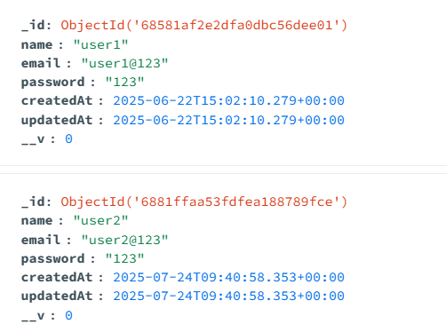

Files Collection
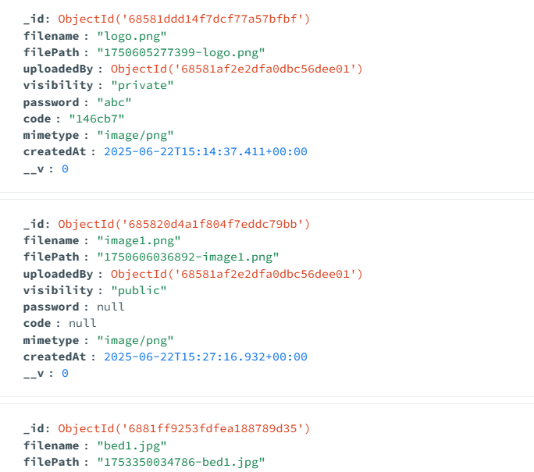

- PROJECT SCREENSHOT
Home Page

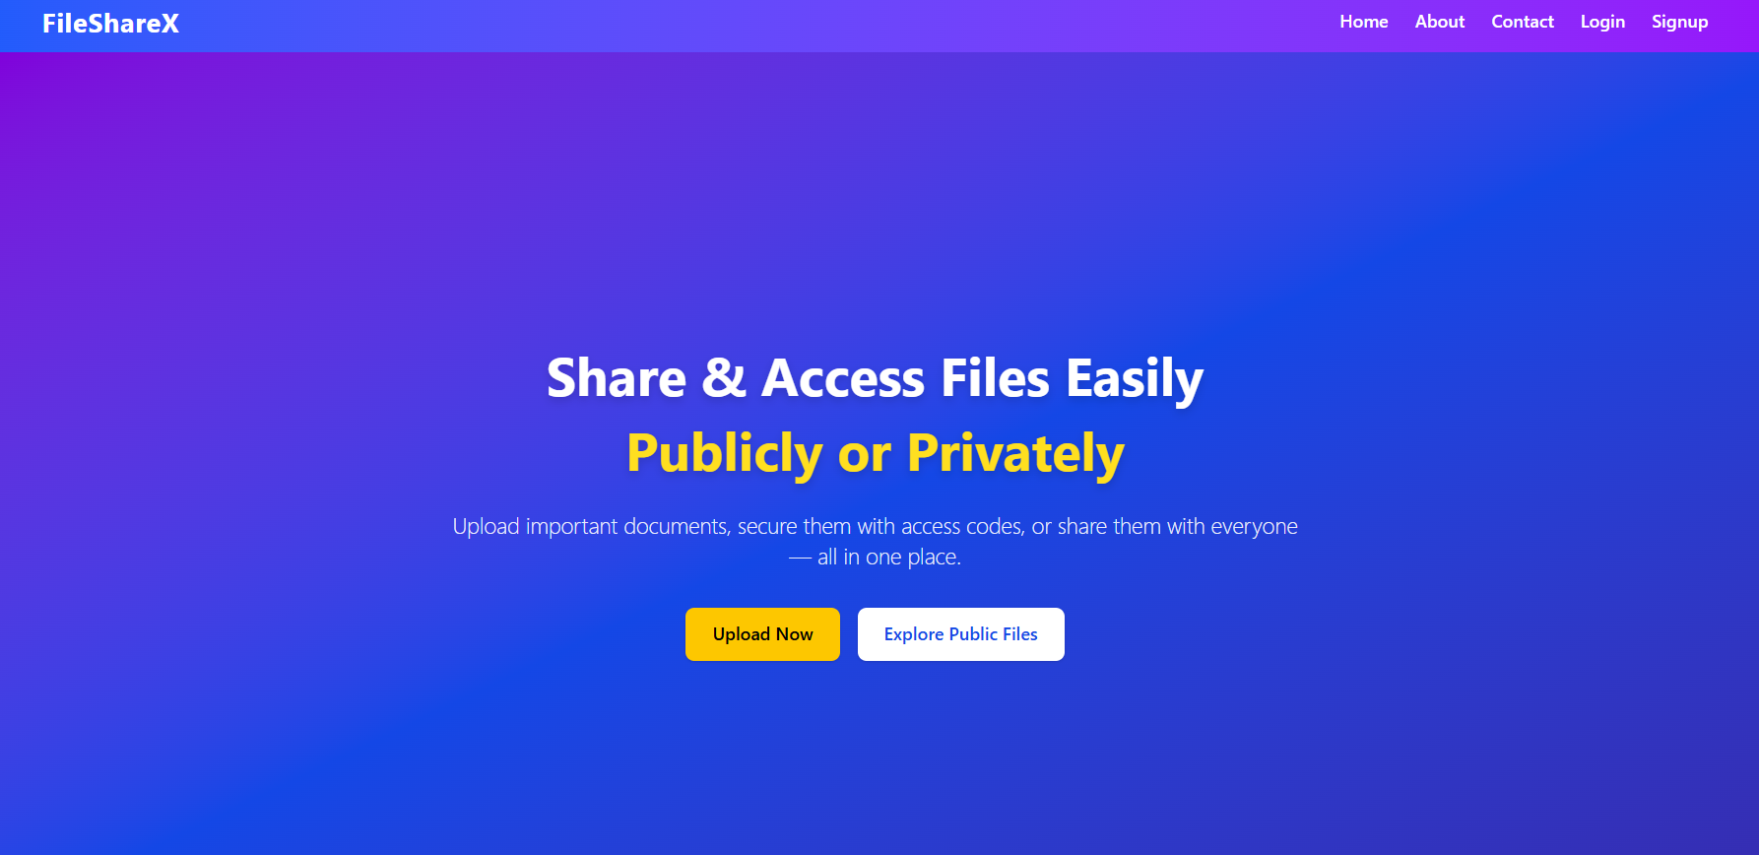

About Page
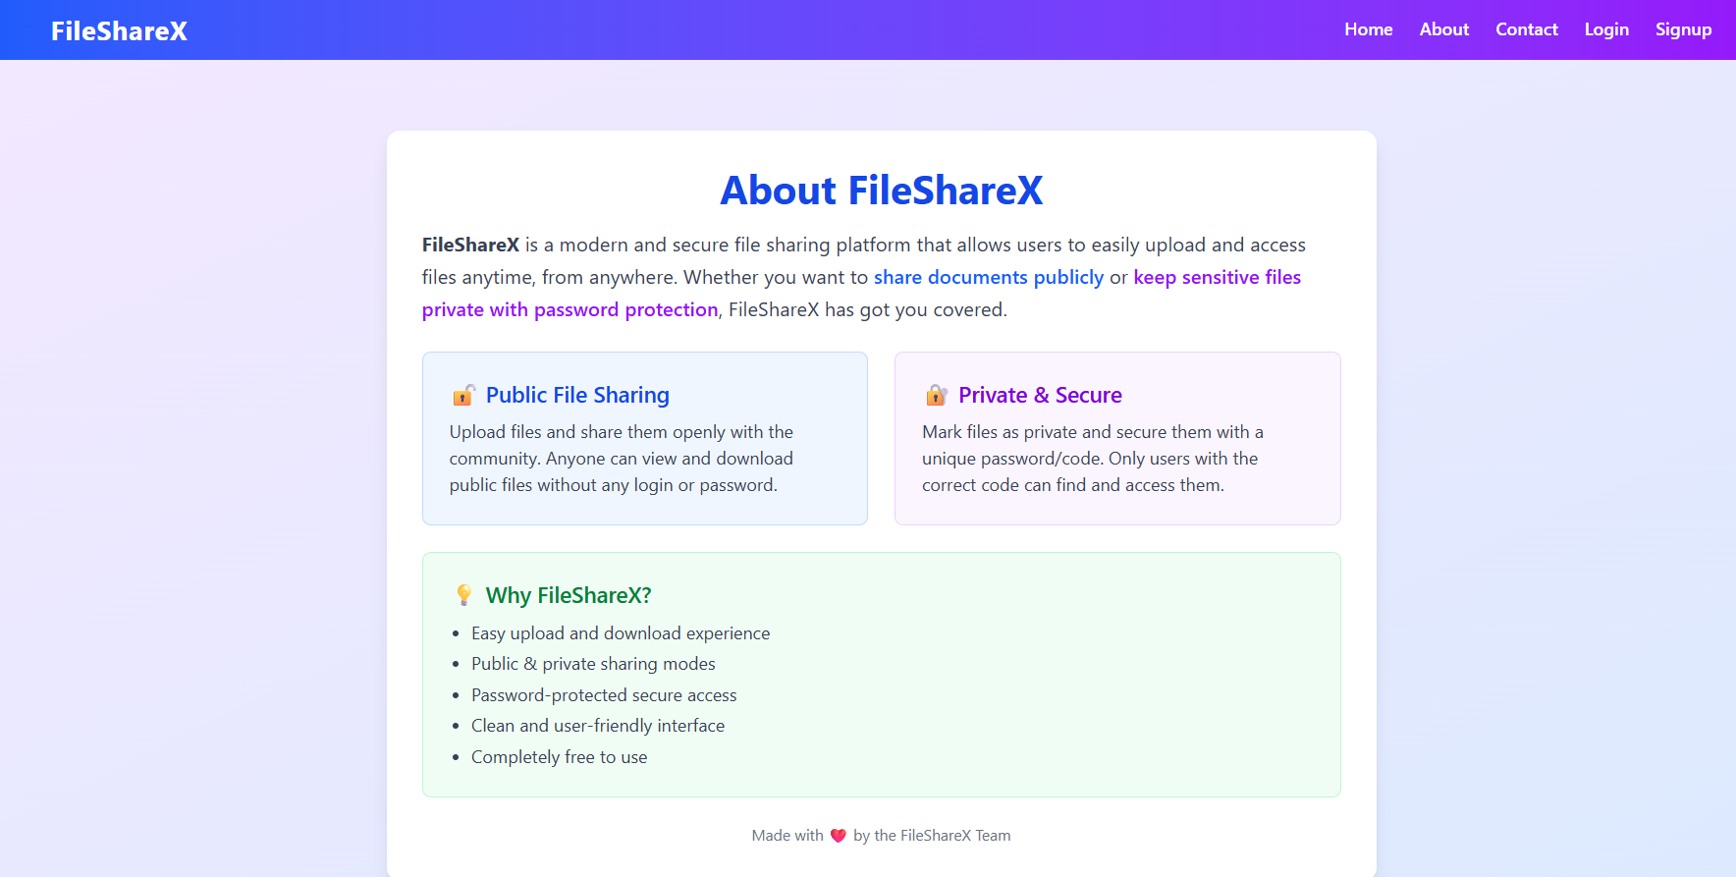
Contact Page
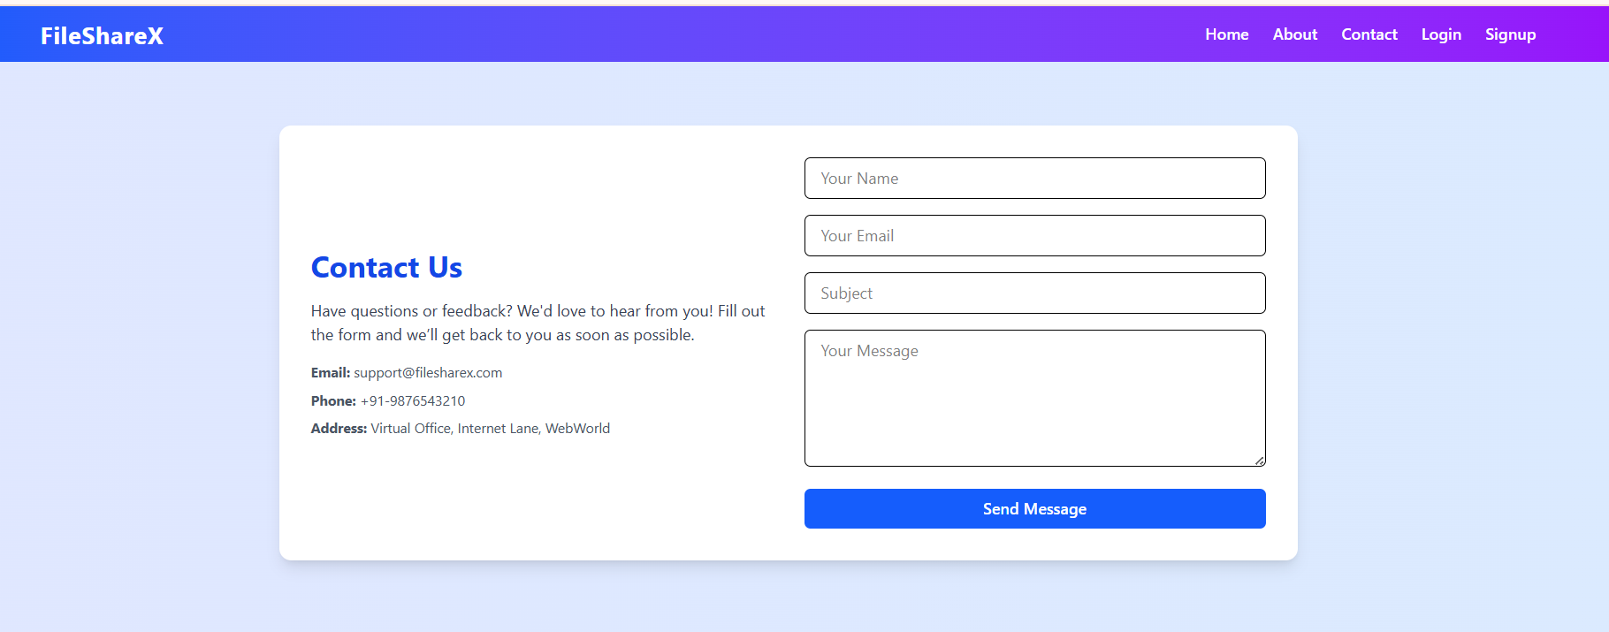
Login Page
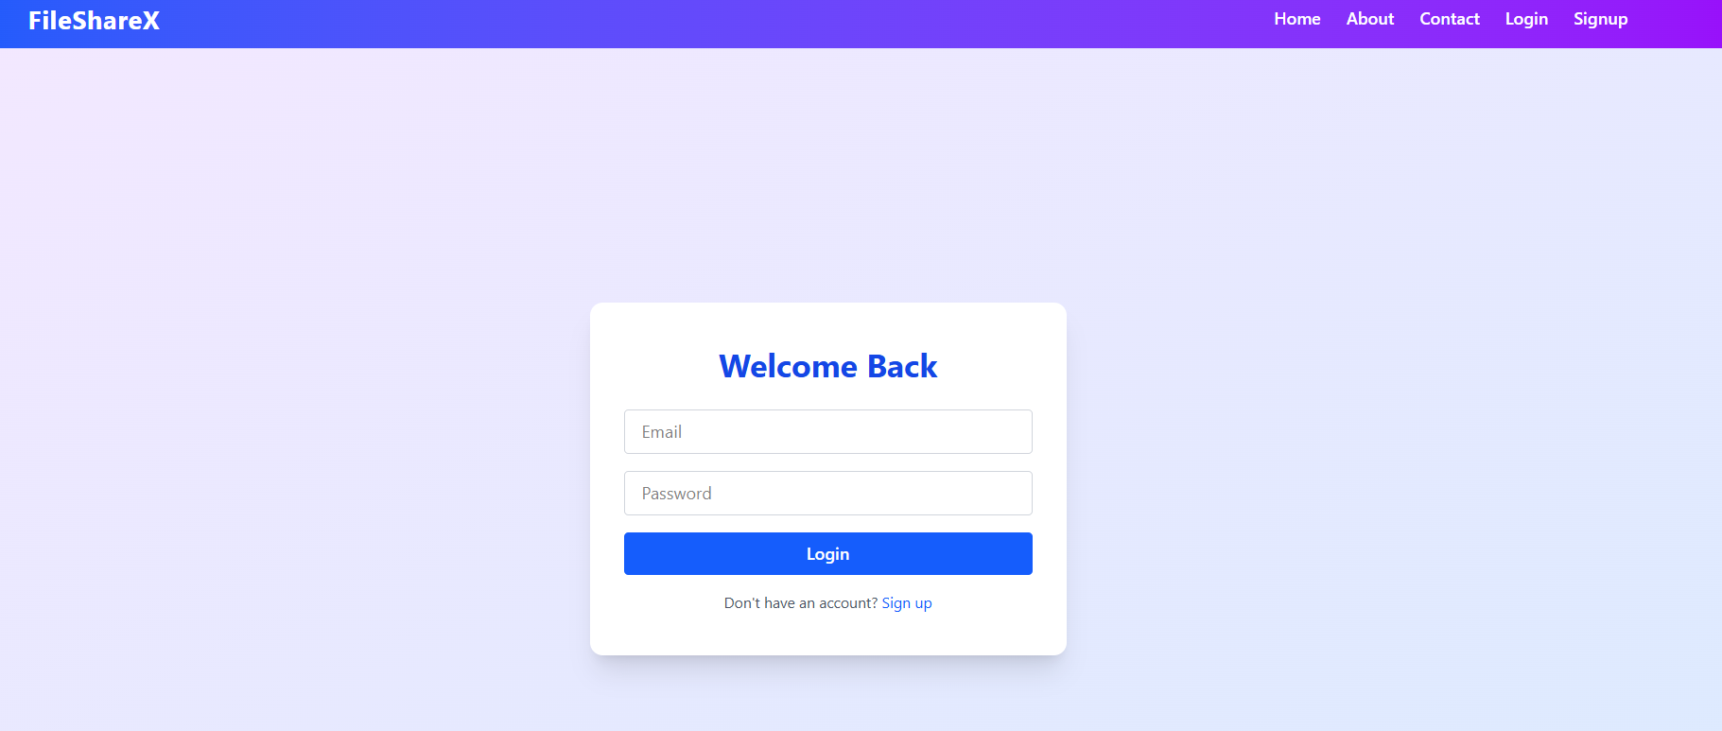

Signup Page
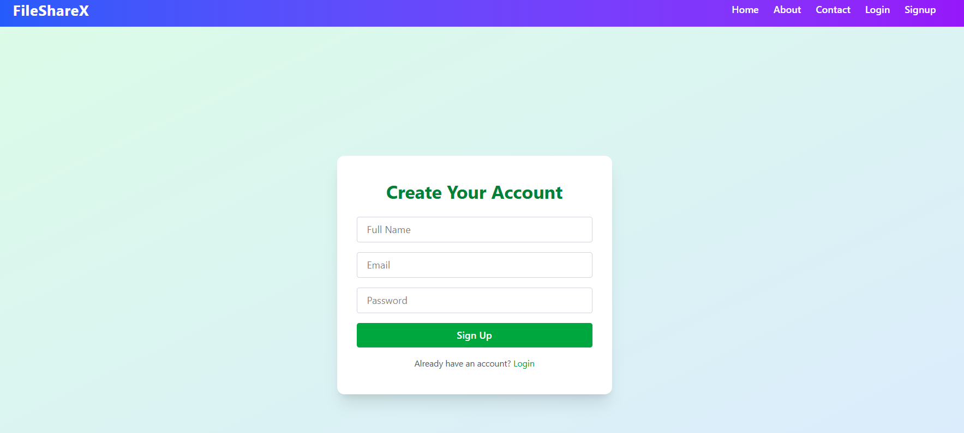

Upload Page
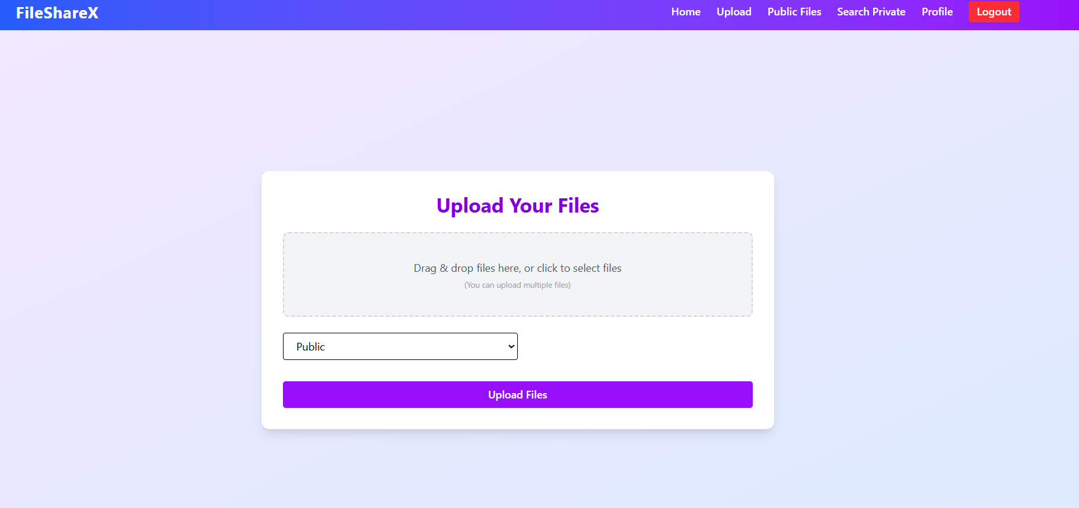
Public Files Page
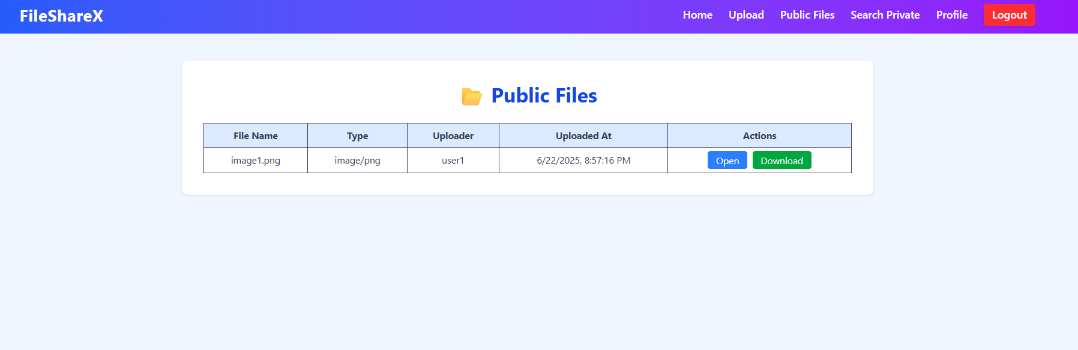
Search Page
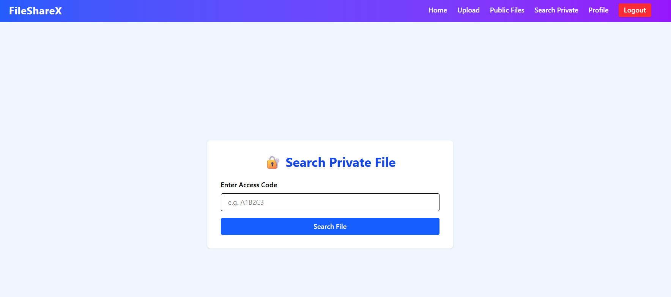

- TESTING
- Testing Plan
- Testing Strategy
- Testing Methods
- Test cases and results

Testing:
Generally, it has been specified thought for testing that: “Testing is the critical element of any software quality assurance and represents the ultimate review of specification, design and code generation.” Software testing has a dual function; it is used to establish the presence of defects in program and it is used to help judge whether the program is usable in practice. Thus software testing is used for validation and verification, which ensure that software conforms to its specification and meets the need of the software customer.
Developer resorted Alpha testing, which usually comes in after the basic design of the program has been completed. The project scientist will look over the program and give suggestions and ideas to improve or to correct the design. They also report and give after a program has been created.

Testability
Software Testability is simply how easily a computer program can be tasted. The check list that follows provides a set of characteristics that lead to testable software.
- Operability
- Observables
- Controllability
- Decomposability
- Simplicity
- Stability
- Understandability

The following are the attributes of the Good Test:-
- A good test has a high probability of finding an error.
- A good test is not redundant.
- A good test should be “Best of Breed”.
- A good test would be neither too simple nor too complex.

Compartmentalization: Project Activity Breakdown for File Sharing Application
To ensure an organized, scalable, and maintainable development process, the File Sharing Application project is divided into focused modules and tasks. Each module targets a specific area of the user journey or administrative workflow, simplifying implementation and supporting future maintenance or extension.
Key Modules & Tasks
1. User Registration & Authentication Module
- Manages user signup, login, password reset, and secure session handling.
- Implements role-based access (regular user, admin).
- Integrates two-factor authentication and activity logging.
2. Admin Data Management Module
- Enables system administrators to manage platform settings and user accounts.
- Includes approval, suspension, and auditing of activities.
- Provides dashboards for admin operations and oversight.
3. User File Management Module
- Allows users to upload, update, delete, and manage their own files.
- Supports file versioning, tagging, categorization, and personal organization.
- Enables batch operations for efficiency.
4. File Access & Sharing Module
- Lets users control file privacy (public/private), generate shareable links, create or manage access keys, and set permissions (view, edit, download).
- Supports key-based private sharing; only users with valid keys can access certain files.
- Handles link expiration, revocation, and usage tracking.
5. File Discovery & Search Module
- Implements advanced search and filtering by file type, uploader, date, tags, and privacy status.
- Provides recommendation features and populates trending or recent activity feeds.
6. Review, Comment & Rating Module
- Allows users to comment on, discuss, and rate public files.
- Offers feedback channels for files, users, and the platform itself.
- Provides moderation workflows for handling inappropriate content.
7. Tag & Category Management Module
- Enables administrators (or authorized users) to create, edit, and manage file tags and categories.
- Supports categorization for easy browsing and content organization.
8. Security & Privacy Module
- Handles secure file storage, encryption, virus/malware scanning, and compliance with privacy standards.
- Manages audit trails, access logging, and user notifications for sensitive actions.
9. Notification Module
- Sends notifications for shared file access, comments, admin updates, and system events.
- Supports both in-app and email notifications.
10. Analytics & Reporting Module
- Provides usage analytics, file access statistics, sharing trends, and activity reports to admins and users.
- Tracks access patterns and potential misuse.
11. Testing & Quality Assurance Module
- Encompasses unit, integration, API, and user acceptance testing.
- Ensures correct functionality, security, and performance across all modules.
12. Documentation Module
- Prepares technical and end-user documentation.
- Maintains up-to-date help guides, API references, and onboarding materials.
Interdependency Analysis
While each module is compartmentalized for clarity, several interdependencies must be observed:
- User Registration & Authentication is foundational; it must be developed first since nearly all other modules require secure user sessions.
- File Management (upload and update) must be in place before sharing, commenting, and analytics modules can be operational.
- File Access & Sharing depends on the completion of user and file management modules and feeds into notification and privacy controls.
- Review, Comment & Rating modules rely on the availability of files and user management.
- Tag, Category, and Admin Management modules may be built in parallel, enabling efficient content organization workflows before file uploads scale.
- Testing and Documentation occur continuously and escalate as features reach completion, but comprehensive system and integration testing is dependent on all primary modules being available.
Parallel development of independent modules (e.g., notification and analytics, security and admin management) optimizes the timeline and supports agile delivery.
Software Inspection
Robust software inspection processes are integrated at every development stage:
- Requirements Review: Ensuring all business needs and user stories for each module are thoroughly captured, clarified, and validated prior to development.
- Design & Diagram Validation: Continuous inspection of architecture diagrams, ER diagrams, API design docs, and module interaction flows for correctness and completeness.
- Source Code Analysis: Regular code reviews to enforce coding standards, modularity, and security best practices, with automated static analysis tools integrated into CI/CD pipelines.
- Continuous Evaluation: Agile iterations ensure that verification (inspection, code review, and testing) happens throughout both development and maintenance phases, enabling early detection and correction of issues, and alignment with evolving objectives.
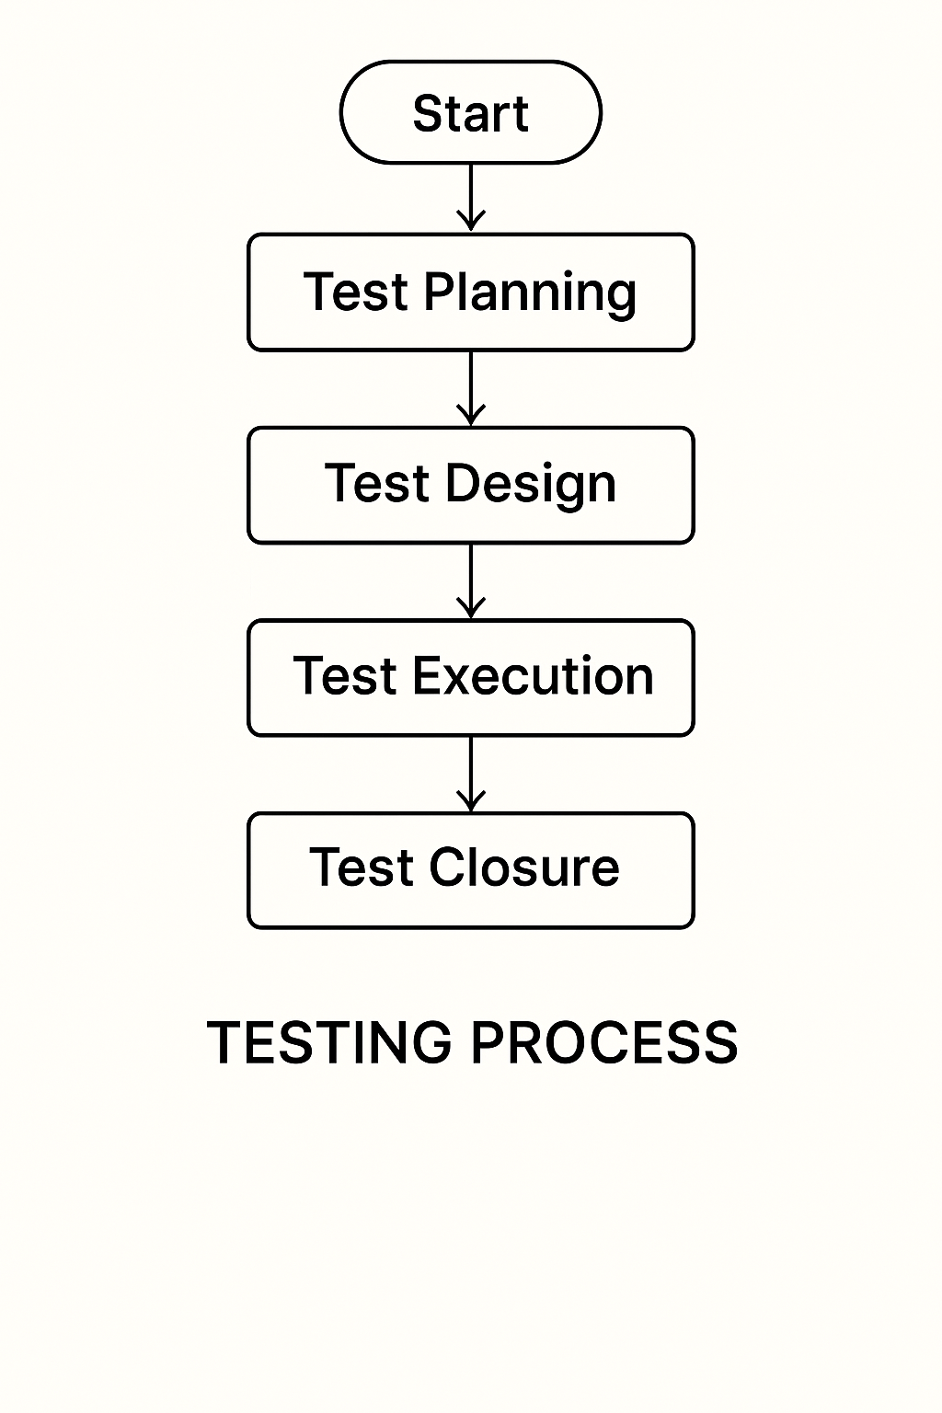
Figure for Testing Process
Test Plan:

The Testing Process: Developer tests the software process activity such as design, implementation and the requirement engineering. Because, design errors are very costly to repair when the system has been started to operate. Therefore, it is quite obvious to repair them at early stage of the system. So, analysis is the most important process of any project.
Requirements Tractability: As most interested portion is whether the system is meeting its requirements or not, for that testing should be planned so that all requirements are individually tested. Developer checked the output of certain combinations of input, which gives desirable results, or not. Strictly stick to our requirements specifications, give you the path to get desirable results from the system.
Tested Items
Our tested items are like:
- Data fetching from the database
- Data insertion, updating and deleting in the database
- Form access to login

Testing Schedule:
Developer has tested each procedure back to back so that errors and omissions can be found as earliest as possible. Once the system has been developed by fully developer tested it on other machines, which differs in configuration.
Testing Methods:
Software testing involves executing an implementation of the software which tests data and examining the outputs of the software and its operational behavior to check that it is performing as required.
Statistical Testing:
Statistical testing is used to test the program’s performance and reliability and to check how it works under operational conditions. Tests are designed to reflect the actual user inputs and their frequency. The stages involved in the static analysis for this system are follows:
Control Flow Analysis:
- Unreachable code
- Unconditional branches into loops
Data Use analysis:
- Variable used before initialization
- Variables declared but never used
- Variables assigned twice but never used between assignments
- Possible array bound violations
- Declared variables

Interface Analysis:
- Parameter type mismatches
- Parameter number mismatches
- Non-usage of the results of function
- Uncalled functions and procedures
Storage Management Faults:
- Data not stored in proper tables
- Data cannot be fetched from proper table
Defect Testing:
Defect testing is intended to find inconsistencies between a program and its specifications. These inconsistencies are usually due to the program faults or defects.
Unit Testing:
The Developer carries out unit testing to check if the particular module or unit of code is working fine. The unit testing comes at the very basic level as it is carried out as and when the unit of the code is developed, or a particular functionality is built. In this application we test one most important module as task allocation which is as follows:
Loop Testing:
The Tester has tested some conditions in a code of application. So, they test the looping in source code of application for finding miss route or any error or wrong direction of flow in code.
Black-Box Testing:
In black box testing or functional testing, the developer is concerned about the output of the module and software, i.e. whether the software gives proper output as per the requirements or not. In another words, this testing aims to test a program behavior against specification without making any reference to the internal structure of the program or the algorithms used.
This can be done in the following way:
- Input Interface
- Processing
- Output Interface
The tested program gets certain inputs. Then the program does its job and generates a certain output, which is collected by a second interface. This result is then compared to the excepted output, which was determined before the test.
Whitebox Testing:
It is also called ‘GLASS BOX’ or ‘STRUCTURAL’ testing. Tester has access to system design.
- Simple Loops
- Nested Loops
- Concatenated Loops
- Unstructured Loops
- Continuous Loops
Advantages of White box testing:
- As the knowledge of internal coding structure is prerequisite, it becomes very easy to find out which type of input / data can help in testing the application effectively.
- The other advantage of white box testing is that it helps with optimizing the code.
- It helps in removing the extra lines of code, which can bring in hidden defects.
Structure Testing:
Developer has done his path testing to exercise every independent execution path through a component or program. If every independent path is executed, then all statements in the components must have been executed at least once. The structure of our program is also checked.
Integration Testing:
After our individual modules the Developer tested out Developer go to the integrated to create a complete system. This integration process involves building the system for problems that arise from component interactions. Developer has applied a top-down strategy to validate high-level components of a system before design and implementations have been completed. Because our development process started with high-level components and Developer worked down the component hierarchy.
Performance Testing:
Performance testing is designed to test the runtime performance of the system within the context of the system. These tests Developer performed as module level as developer as system level. Individual modules developers tested for required performance.
Condition Testing:
Condition testing is a test case design method that exercises the logical conditions contained in a program module. If the condition is incorrect, then as least one part of the condition is incorrect. It may include:
- Boolean variable error
- String index out of Bound error
- Null pointer Assignment
- Input Output Connection Exceptions
- Arithmetic expression error
- Parsing (conversion) errors
- Image unloaded errors
Interface Testing:
Interface testing is an integral part of integration testing. Therefore, the developer checked for the following.
- Interface misuse
- Interface misunderstanding
Developer examined the code to be tested and explicitly list each call to an external component. In the system, standards tests for various modules have been performed, which are follows.
Object Testing:
Object testing is to test objects as individual components, which are often larger than single function. Here the following activities have taken place.
- Testing the individual operations associated with object.
- Testing individual object classes.
- Testing cluster of objects.
- Testing object-oriented systems.
Now we will discuss how testing and debugging is done of this application. Our application can be divided into parts like:
- To make queries to database and retrieve information from it.
- Reduce some memory requirements for the database.
- Maintain database so that unauthorized access can not affect.
Limitations
- It can run only on windows servers. It is not compatible with LINUX servers.
- It is not cent percent safe from professional hackers.
- Only registered user can buy and sell their items using this website.
- CONCLUSION

The File Sharing Application stands as a robust, flexible, and user-friendly digital platform designed to address the evolving needs of individuals, teams, and organizations in managing and sharing digital files. In an era where data exchange is critical for productivity and collaboration, this platform offers a centralized hub that simplifies file discovery, uploading, updating, privacy control, and seamless sharing while ensuring security and accessibility.
User Experience and Functionality
The platform empowers users—ranging from casual individuals to professional teams—with intuitive tools to upload files of any type and size, organize them using customizable folders and tags, and securely share them with others. Users can easily create public or private files, controlling access through granular permission settings and secure key-based sharing, which allows only authorized viewers to open private files.
Advanced search and filtering capabilities help users quickly find files based on various criteria such as file type, upload date, owner, or category. Users can also track different versions of a file, ensuring they always work with the latest content while maintaining a complete revision history. The platform supports collaborative features such as real-time commenting, file annotations, and ratings, fostering engagement, knowledge sharing, and feedback.
Sharing is simplified through secure, shareable links that can be distributed via email or messaging apps. Users can set expiration dates on links, revoke access whenever needed, and monitor who has accessed their files in real time. Additionally, integrated notifications inform users of important events such as comments, shared access, or administrative alerts.
Administrative and Security Controls
Administrators have access to comprehensive management tools to oversee the platform’s integrity and security. They can monitor user activities, moderate file submissions, approve or reject questionable content, and enforce policies to prevent misuse or inappropriate sharing. Advanced analytics dashboards provide insights into usage trends, popular content, and access patterns, helping admins make data-driven decisions to improve the platform.
Security remains a paramount focus. The system employs state-of-the-art encryption for files both in transit and at rest, robust authentication mechanisms including multi-factor authentication, and virus/malware scanning on all uploaded files. Role-based access controls ensure that users and admins operate within the boundaries of their permissions, safeguarding sensitive or confidential data. Comprehensive audit logs track all file activity to support accountability and compliance.
Scalability and Future-Proofing
Built with scalability in mind, the platform supports a growing user base and expanding file volumes without compromise on performance. Its modular architecture allows easy integration of future technologies such as AI-powered file recommendations, mobile app extensions for on-the-go access, and automated workflows for file approval and archival.
These capabilities ensure that the platform can evolve alongside user needs and emerging industry standards, maintaining its relevance and utility for diverse use cases—from personal file management to enterprise-level document collaboration.
Key Benefits
- Centralized file repository: Easy access and management from any device and location.
- Secure, flexible sharing: Control privacy with public links, private keys, permission levels, and expiration settings.
- Advanced collaboration: Real-time feedback, comments, file history, and ratings enhance teamwork.
- Powerful admin tools: Moderation, analytics, and user management keep the environment safe and productive.
- Robust security: Encryption, malware scanning, and multi-layer authentication protect critical data.
- User-friendly interface: Intuitive design with drag-and-drop uploads, smart search, and helpful notifications.
Future Scope of the File Sharing Application
While the current File Sharing Application addresses critical challenges in secure, flexible, and collaborative digital file management, there remains significant potential for innovation and expansion to meet future user needs:
- Mobile Application Development
Launch dedicated Android and iOS apps to enable seamless file uploading, management, sharing, and real-time notifications from mobile devices, ensuring users stay connected anywhere, anytime.
- AI-Powered File Recommendations and Automation
Implement AI algorithms to provide personalized file recommendations based on users’ access history, collaboration patterns, and preferences. Automate tasks such as file tagging, categorization, duplicate detection, and version conflict resolution.
- Enhanced Real-Time Collaboration Tools
Integrate live collaborative editing features for supported file types (documents, spreadsheets, presentations), allowing multiple users to work simultaneously with instant updates and conflict management.
- Granular Permission and Role Management
Extend permission models to include detailed roles, conditional access, and delegated administration, empowering organizations to finely tune file access policies and governance.
- End-to-End Encryption and Zero-Knowledge Privacy
Enhance security by supporting client-side end-to-end encryption where only file owners hold decryption keys. This would ensure even platform operators cannot access private file content, providing maximum privacy assurance.
- Blockchain-Based File Integrity and Audit Trails
Employ blockchain technology to maintain immutable logs of file versions, access events, and modifications, further strengthening data integrity and compliance verification.
- Integration with Enterprise Systems and Cloud Platforms
Support seamless integration with popular productivity suites (e.g., Microsoft 365, Google Workspace) and cloud storage services for unified file management across platforms.
- Advanced Analytics and Usage Insights
Provide users and admins with dashboards that track file access trends, collaboration metrics, and security incidents, enabling proactive management and optimization.
- Offline Access and Synchronization
Enable offline file access and editing with automatic sync upon reconnection, catering to users with unstable internet connectivity or mobile requirements.
- Support for Large-Scale and Media-Rich Files
Optimize performance and storage for handling large media files, 3D models, and complex data sets, with streaming previews and accelerated upload/download capabilities.
These enhancements will empower the platform to evolve continually, delivering richer, more secure, and efficient file sharing experiences aligned with advancing technology and user expectations.
Bibliography
Books:
- Dayley, Brad. Node.js, MongoDB, and React.js Full-Stack Development.
- Osmani, Addy. Learning JavaScript Design Patterns.
- Hoque, Shama. Full Stack Development with MERN.
Research Articles and Whitepapers:
- DocSend. What is File Sharing? Definition, Types & Benefits. (2024)
- Egnyte. File Sharing: A Guide to Secure Collaboration. (2021)
- Box Blog. What is file-sharing software and how does it work? (2024)
Web Resources:
- MongoDB Official Website
- Express.js Official Website
- React.js Official Website
- Node.js Official Website
- W3Schools Online Tutorials
- GeeksforGeeks
- Dropbox's File Sharing Guide
- Box Blog

