1. Question 1 = localhost:3000/question_one (post)

Request :

{

"input": [3,4,6,17,25,21,23]

}

2. Question 2 = localhost:3000/question_two (post)

Request:

{

"input":[

{"amount" :15000, "currency":"IDR"},

{"amount" :3.1, "currency":"EUR"}

]

}

3. Question 3 = localhost:3000/question_two (post)

Request:

{

"input": [23000,4]

}

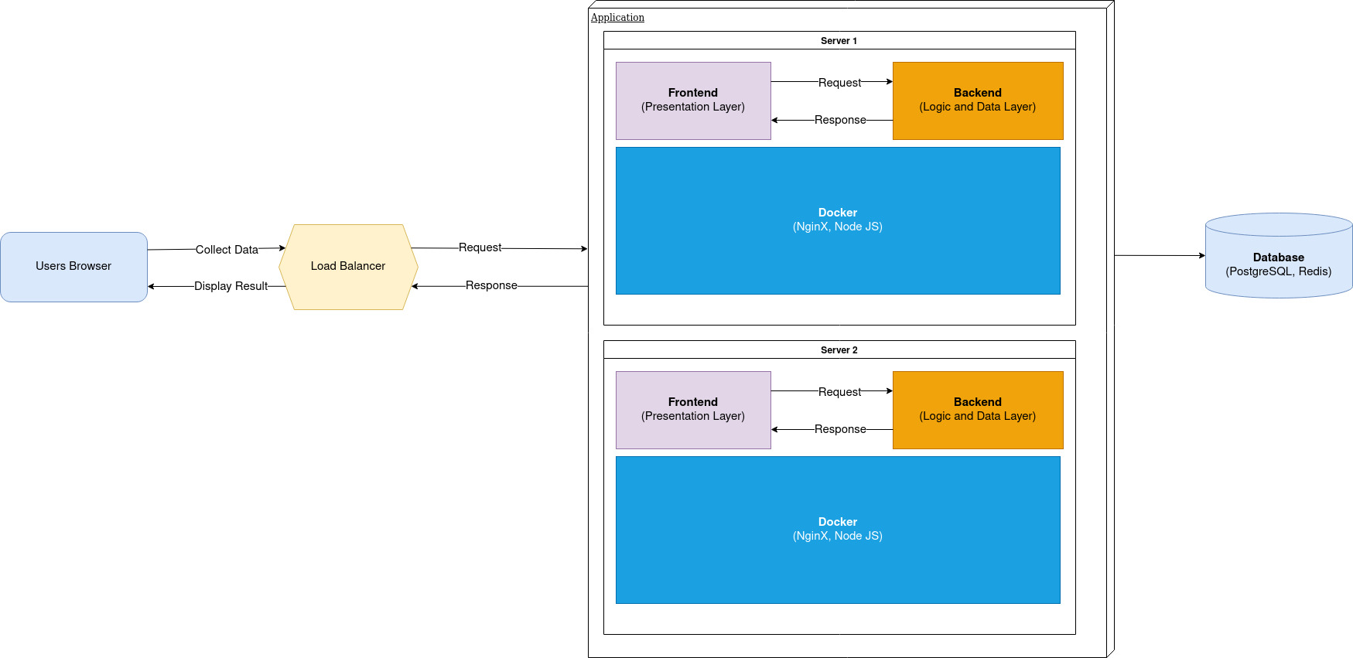4. Database Schema and Application Architecture

