**TECHNICAL REPORT**

**TITLE:** ACCIDENT LOCATIONS ON INDIAN ROADS

**AUTHORS:** RAHUL A, RIYAN M GEORGE, PRITHVI R

**DATE:** 10TH JULY 2023

**ABSTRACT**

The aim of this paper is to analyse the road accidents in Kerala, India at national, state, and metropolitan city level. Analysis shows that the distribution of road accidental deaths and injuries in Kerala. Moreover, road accidents are relatively higher in extreme weather and during working hours. Analysis of road accident scenario at state and city level shows that there is a huge variation in fatality risk across states and cities. Burden of road accidents in India is marginally lower in its metropolitan cities, almost **50% of the cities face higher fatality risk** than their mofussil counterparts. **In general, while in many developed and developing countries including China, road safety situation is generally improving.**

**INTRODUCTION**

Every week nearly **2,650** people get killed and **9,000** get injured due to road accidents. Fatalities and injuries resulting from road accidents are a major and growing public health problem in India. In **2021**, latest year for which data is available, **137,423 people died** and **469,900 people got injured** due to road accidents in India. Traffic Accidents have now earned India a dubious distinction; with nearly 140,000 deaths annually, the country has overtaken China to top the world in road fatalities. India is the only country in the world which faces more than 15 fatalities and 53 injuries every hour because of road crashes. While in many developed and developing countries including China, the situation is generally improving, India faces a worsening situation. **India is home to the second largest road network** in the world with a total road length of approximately **62.1 lakh kilometr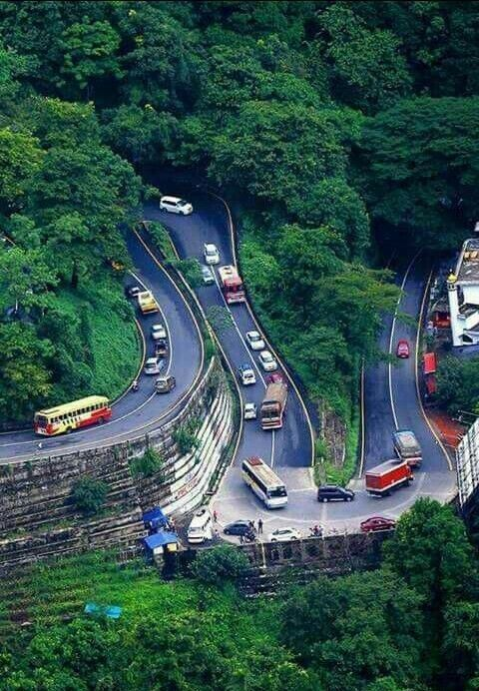es**. This massive network serves as the nation’s lifeline transporting over **64.5%** of all goods within the country in addition to being the preferred option for move of over **90%** of India’s passenger traffic. **In addition to careless driving and over-speeding, factors such as poor road conditions, lack of traffic signals, and drunk driving also contribute to accidents. Age group between 26-35 years** is the most vulnerable population group, though males face higher level of fatalities and injuries than their female counterparts.

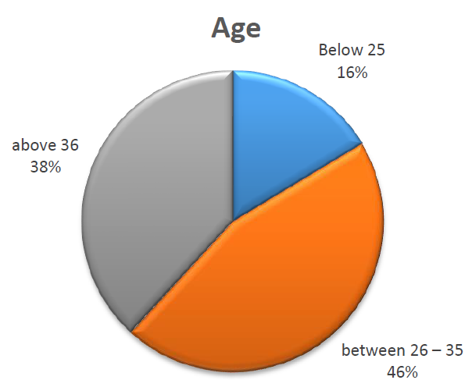 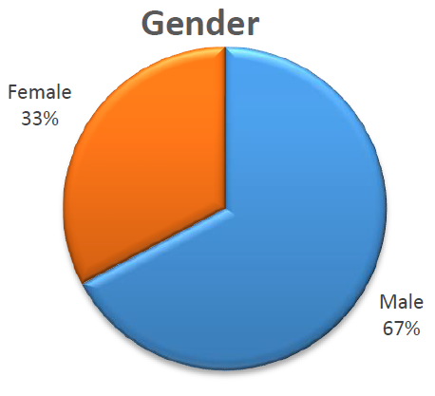

**REASONS FOR ROAD ACCIDENTS**

There are many reasons for accidents. Here we try to list out a few of them:

* Not following the traffic rules
* Using mobile phones while travel
* Wrong usage of indicators
* Chatting with others on road without noticing the vehicles
* Unexpected crossing of animals
* Drunk and drive
* Careless pedestrian crossers
* Not using the subways
* Opening the right-side door of the vehicle to walk out

**DATA SOURCES**

1. **Ministry of Road Transport and Highways (MORTH):** MORTH is a government body responsible for formulating and implementing policies for road transport in India. They maintain a database called "Road Accidents in India" that provides detailed information on road accidents across the country, including location data.
2. **National Crime Records Bureau (NCRB):** NCRB is an organization under the Ministry of Home Affairs in India. They collect and analyse crime-related data, including road accidents. NCRB's "Accidental Deaths and Suicides in India" report contains accident data, including location information.
3. **State Police Departments:** State police departments often maintain accident databases that include location details. Contact the respective state police departments in India, particularly the traffic police division, and inquire about their availability to provide accident data. They may have dedicated portals or departments for accessing accident data.
4. **National Highways Authority of India (NHAI):**  National Highways Authority of India was set up by an act of the Parliament, NHAI Act, 1988 “An Act to provide for the constitution of an Authority for the development, maintenance and management of national highways and for matter connected therewith or incidental thereto”.
5. **Open Data Platforms:** There are various open data platforms that aggregate and provide access to datasets, including accident data. Websites like Data.gov.in, Kaggle, and Open Government Data (<https://data.gov.in/>) may have datasets related to road accidents in India.

**WORK**

The figure represents the blackspots of Kerala state. These are the major areas of road accidents take place. The state government has taken various steps to prevent the accidents.

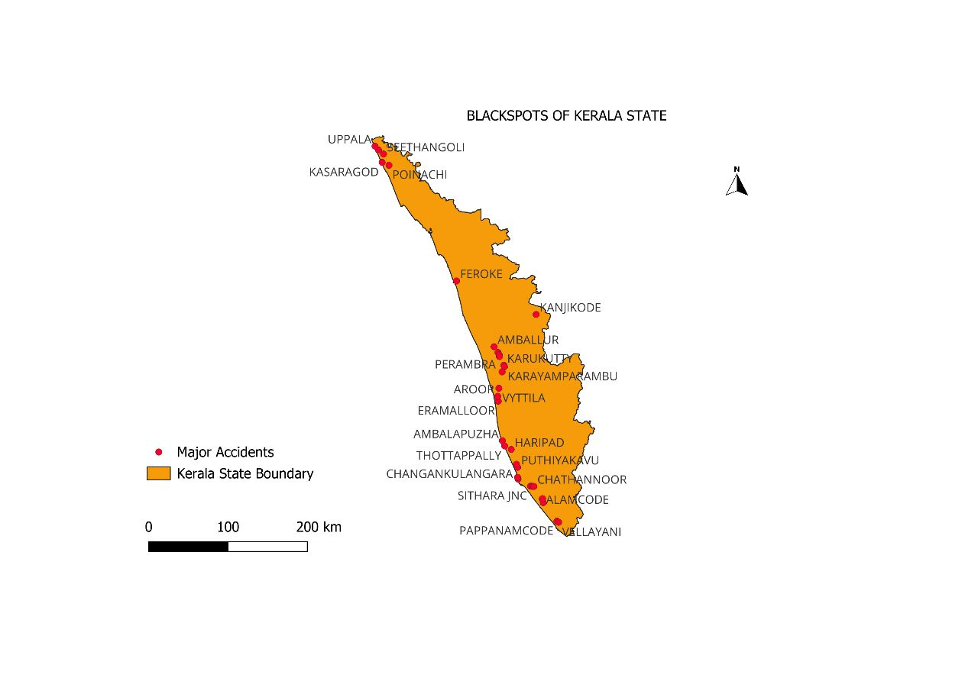

**Analysis:**

We have found that there are ups and downs in the number of accidents in the city. The **number of persons involved in the accident is almost found to be more than the number of accidents**. With respect to the fatal, grievous and major injury cases, the number of persons killed is almost greater than the number of accidents. We have chosen the National Highways that are prone to accidents. **National Highways such as 544, 66, 47 and 17 are prone to accidents**. There is no accident found in the village roads. But some accidents are found in district roads. The **Supreme Court Committee on Road Safety (SCoRS)** has urged the government to take appropriate steps to ensure that road accidents in the state are reduced. As part of it, the committee has directed the **state government to provide the police with appropriate equipment or devices for detecting drug or liquor content** in blood if the drivers are found inebriated during vehicle inspection. This data includes the **drunk and drive** cases too. About **3,764 cases** of driving under the influence of **alcohol** are registered and **Thrissur district tops the list**.

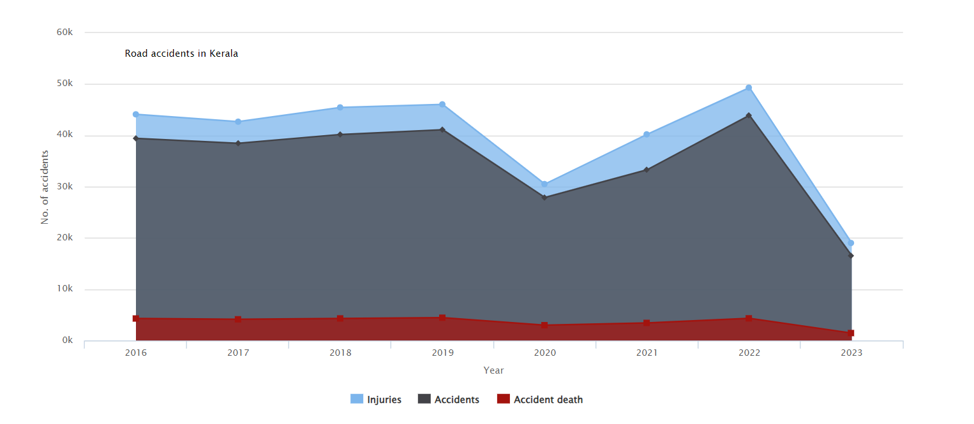

As part of the drive, from **February 6 to February 12**, about **3,764** cases were registered, **1,911 licences** **were cancelled** and **894 licences were confiscated** for driving while drunk, police said.

**CONCLUSION**

The marking of accident locations on Indian roads is a crucial step towards improving road safety and reducing the number of accidents. By accurately identifying and marking accident-prone areas, authorities can take targeted measures to enhance road infrastructure, increase awareness among motorists, and implement effective traffic management strategies. These markings serve as visual reminders to drivers and pedestrians to exercise caution, adhere to traffic regulations, and take necessary precautions while navigating these areas.

The benefits of accident location marking extend beyond immediate safety considerations. They provide valuable data for authorities to analyse accident patterns, identify common contributing factors, and develop evidence-based strategies to mitigate risks. This data-driven approach can lead to the implementation of specific interventions such as improved signage, traffic calming measures, enhanced lighting, and better enforcement of traffic laws.

**References**

1. <https://keralapolice.gov.in/crime/road-accidents>
2. <https://www.onmanorama.com/lifestyle/keralaspora/2023/03/13/kerala-road-safety-rise-accidents.html>
3. <https://www.outlookindia.com/national/special-drive-by-kerala-police-to-detect-drunk-driving-3-764-cases-lodged-across-state-news-264473>
4. <https://www.keralatravels.com/pages/trichur-map>
5. <https://www.publishoa.com/index.php/journal/article/download/475/411>
6. <https://www.nveo.org/index.php/journal/article/view/3250>