What is SDA

* Uses sdn technology to give use a single network fabric to simplifies configurations
* Instead of managing multiple devices, you can manage all of them as one
* ACI is data center SDN
* Sd wan is WAN SDN
* SDA is Campus SDN
* Similar ACI but with different deployment and management system
* Offers automation, security, and monitoring
  + Automation- reduces network provisioning time
  + Security- end to end segmentation
  + Monitoring- complete network visibility

Benefits of SDN Network

* Simplified operations
* Minimal broadcast traffic
* No layer2 loops
* Contextual insight
* Network mobility
* Increased security

SDA Components

* Dnac
  + Role in sda
    - Config management
    - Automation
    - Security policy
    - monitoring
* Border and control plan node
  + Considered the cors of an sda fabric
  + These roles can be on separate devices but most often are the same device
  + Border node
    - External routing for destinations outside of the fabric
  + Control plane node
    - Endpoint host routing within the fabric
    - Make decisions on how things are sent to devices in the fabric
    - Use the LISP protocol to advertise routes between fabric nodes
* Edge node
  + Provide wired endpoints connectivity into the fabric (similar to access switches in legacy networks)
  + Provide default gateway to endpoints (has the gateway for all networks)
  + Security enforcement
* Wireless
  + Wireless endpoint connectivity into the fabric
* ISE
  + AAA
  + Trustsec
  + Security policy
* Fusion router
  + Border node routes to for routing traffic in and out of the fabric

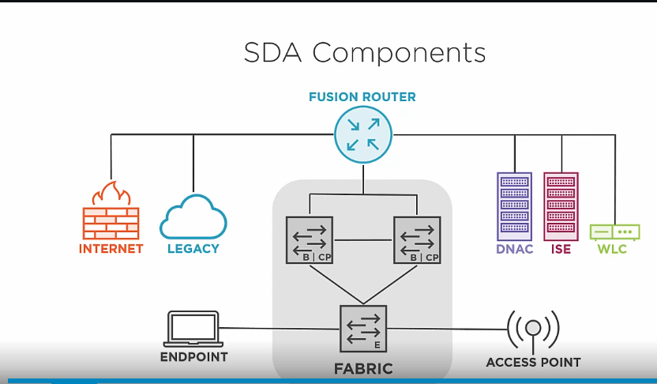

Intro to Underlay Networks

* The purpose of the underlay is to provide ip connectivity to devices running overlay protocols
* 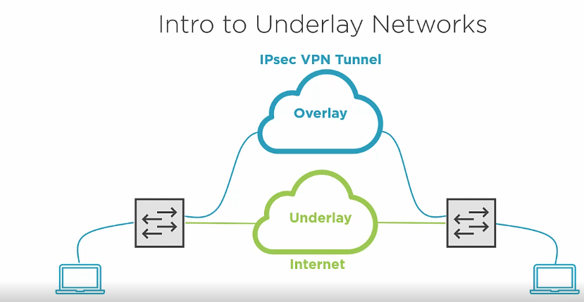
* 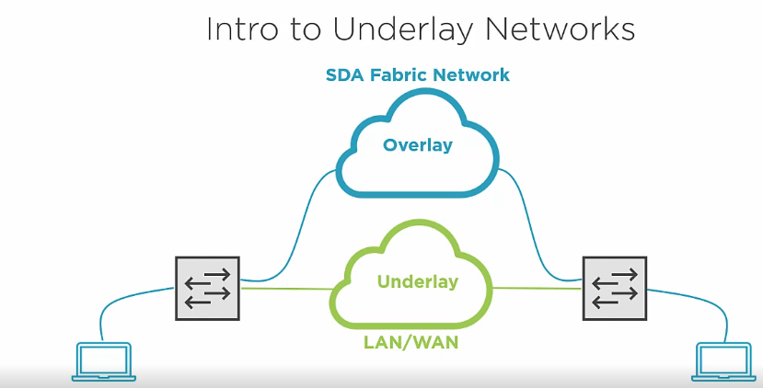
* Sda overlay communication is always formed between fabric node loopback 0
* 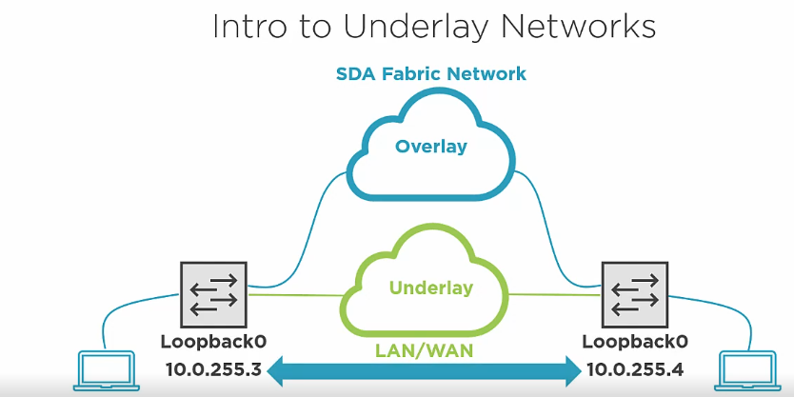
* Because of that the main purpose of underlay network is to advertise the loopbacks
* If fabric node don’t learn the loopbacks they can’t form overlay network

SDA Underlay Network

* Uses the global routing table (default)
* Routed point to point interfaces
  + /30 or /31 transit networks
* Should use a routing protocol to make it dynamic (static routes could be used
  + ISIS it the recommend protocol to use( other could also be used)
    - Easy to configure
    - Fast convergence
    - Protocol agnostic
    - It is a link state protocol
    - Similar to ospf