Intro to Overlay Networks

* 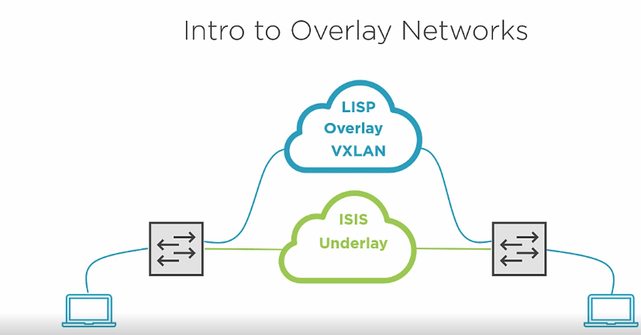

SDA Overlay Network

* Runs on top of an underlay network
* Virtualize network communication
* Control plan uses LISP routing
  + Highly scalable
  + Network virtualization
  + Subnet stretching
* Data plane use vxlan encapsulation
  + Sgt
  + Virtual network identifier (vni)

Flow

* A close up of a logo

  Description automatically generated
* A close up of a logo

  Description automatically generated
* A picture containing screenshot

  Description automatically generated
* A close up of a logo

  Description automatically generated
* A close up of text on a white background

  Description automatically generated
* A close up of a logo

  Description automatically generated

Intro to Anycast Gateways

* An ip address that is reachable from multiple locations in a network
* Common default gateway on edge nodes
* A picture containing map

  Description automatically generated

Understanding Fabric Border Connectivity

* Border routing
  + Routing between the fabric and external destinations
  + Going to push bgp config to border nodes
    - A picture containing clock

      Description automatically generated
    - This will allow this outside of the fabric to manage fabric devices
      * Ise
      * Dnac
      * Wlc
    - Endpoint connected to the fabric will need to communicate with devices outside the fabric
    - A screenshot of a cell phone

      Description automatically generated
* Border Switching
  + Switching between the fabric and external destinations
  + Can have border connection to legacy networks as a trunk
    - Migrations are a good reason to do this
  + A screenshot of a cell phone

    Description automatically generated