M.S.P. Mandal’s
Deogiri College, Chhatrapati Sambhajinagar
(An Autonomous institute affiliated to Dr. B.A.M. University, Chhatrapati Sambhajinagar)

A PROJECT REPORT ON
“Employee Preparation Platform”
Submitted in partial fulfilment of the requirements for the award of the degree of
Bachelor of Science in Information Technology

Submitted By
RIYA SHIVAJI NAGARE
[Roll No.-34/PRN – 2425007356]

Under the Guidance of
Mr. Rushikesh S. Chandane
Assistant Professor, CS, IT & A
DEPARTMENT OF COMPUTER SCIENCE, I.T. & ANIMATION
DEOGIRI COLLEGE
CHHATRAPTI SAMBHAJINAGAR -431005
[2026]

M.S.P. Mandal’s
Deogiri College, Chhatrapati Sambhajinagar
(An Autonomous institute affiliated to Dr. B.A.M. University, Chhatrapati Sambhajinagar)
DEPARTMENT OF COMPUTER SCIENCE, I.T. & ANIMATION

NAAC Reaccredited with “A++” Grade
CERTIFICATE
This is to certify that Ms. RIYA SHIVAJI NAGARE has successfully completed the project entitled “EMPLOYEE PREPARATION PLATFORM” in the subject “Python Programming” (DSC-23/BIT/T/503) in B.Sc. (Information Technology), Semester V, during the academic year 2026–2027.
Hence, certified.

Seat No: - _________________
Date: - _____/_____/________

Project Guide | Department Incharge | Head of Department
Mr. Rushikesh S. Chandane | Mr. Bhushan S. Kulkarni | Dr. Ritesh A. Magre

INDEX
Sr. No. | Title / Contents | Page No.
1 | Introduction | 1
2 | Problem Statement | 2
3 | Objectives | 3
4 | Scope of the Project | 4
5 | Project Description / Methodology | 5
6 | Technologies & Tools Used | 6
7 | System Requirements | 7
8 | Implementation & Working | 8
9 | Output / Screenshots | 9
10 | Advantages & Limitations | 11
11 | Future Scope | 12
12 | Conclusion | 13
13 | References | 14
14 | Appendix – Source Code | 15

1. Introduction
In today's competitive job market, the ability to perform well in interviews has become a decisive factor in a candidate's career growth. Most job seekers, especially final-year students and working professionals switching jobs, lack access to structured, personalized, and affordable resources for interview preparation. Traditional methods such as books, coaching classes, and scattered online resources are often expensive, generic, and fail to adapt to an individual's specific strengths and weaknesses.
This project, titled the “AI-Based Interview Preparation Platform,” is a web application built using Python that brings together all the essential tools a job seeker needs under one roof. It combines resume building and analysis, aptitude and coding practice, company-specific mock tests, and AI-assisted feedback into a single, easy-to-use platform, helping candidates prepare more efficiently and track their progress over time.
Motivation Behind the Project
The idea for this project originated from observing the everyday struggles faced by final-year students and recent graduates while preparing for campus placements and off-campus interviews. Conversations with peers revealed a recurring pattern: candidates were investing significant time and money in multiple unconnected tools — one website for resume formatting, another for aptitude practice, a third for mock interviews — without any single platform that tracked their overall readiness. This fragmentation often led to inconsistent preparation, duplicated effort, and a lack of visibility into genuine areas of improvement. The Employee Preparation Platform was therefore conceived as a single, cohesive environment where a candidate could manage every stage of their preparation journey, from the very first resume draft to the final round of company-specific practice tests, without needing to leave the application.
The platform is designed to serve two distinct but related audiences. The first is the traditional final-year student preparing for campus placement drives, who typically needs guidance on resume structure, aptitude tests, and basic technical rounds. The second is the working professional who is looking to switch jobs and requires more advanced, company-specific preparation along with tools to communicate their existing experience effectively, such as the Present-Past-Future pitch builder included in the platform.
2. Problem Statement
Job seekers today face several challenges while preparing for interviews and placement drives. Free resources available online are scattered across multiple websites, resume-building tools often require payment for advanced features, and there is no single platform that combines aptitude tests, coding practice, and interview preparation with instant, AI-based feedback. As a result, candidates spend excessive time switching between platforms instead of focusing on actual preparation.
There is a clear need for an integrated, free, and intelligent platform that can guide a candidate through every stage of interview preparation, from building a strong resume to practicing company-specific questions, while also providing meaningful, automated feedback.
Key Challenges Identified
A closer study of the existing preparation ecosystem highlighted several specific pain points that this project directly addresses. Most free resume-building websites either produce generic, non-ATS-friendly formats or lock essential features such as PDF export behind a paid subscription. Aptitude and coding practice platforms, while numerous, rarely tailor their question sets to a specific company's known hiring pattern, forcing candidates to manually search forums and outdated material for company-specific questions. Furthermore, very few tools offer any form of automated, constructive feedback — a candidate can attempt a mock test and see a score, but rarely understands why an answer was considered weak or how to phrase a response more effectively for a recruiter.
- Scattered tools: resume building, aptitude practice, and interview preparation exist on separate, unconnected websites.
- Paywalls on essential features such as PDF resume export and detailed analytics.
- Absence of company-specific question banks tailored to actual recruiter expectations.
- No structured way to practice and receive feedback on behavioural questions such as “Tell me about yourself.”
- Lack of a single dashboard to track overall preparation progress across all activities.
- Limited support for working professionals who need to reframe existing experience rather than build a resume from scratch.
3. Objectives
- To design and develop a unified web-based platform for end-to-end interview preparation.
- To build a secure authentication system using JWT tokens and password hashing.
- To provide a resume builder that generates a professional PDF resume, along with an AI-based content enhancement feature.
- To build a resume analyzer that extracts and evaluates the content of an uploaded resume.
- To create company-specific mock tests with automatic scoring.
- To provide a coding practice module covering multiple programming languages.
- To track and display a user's overall preparation progress through a dashboard.
The objectives listed above were derived directly from the challenges identified in Section 2, ensuring that every feature built into the platform maps back to a genuine problem faced by job seekers. In addition to the primary objectives, the following supporting objectives guided the detailed design of individual modules:
- To design a centralised dashboard that consolidates roadmap progress, resume scores, and mock test performance in one view.
- To implement a Present-Past-Future pitch builder that helps candidates structure concise, 50–70 second self-introductions.
- To build an AI Fluency evaluation module that scores a candidate's understanding of AI-assisted development practices.
- To ensure user data, including resumes and personal details, is stored and transmitted securely.
- To keep the platform lightweight enough to run on a standard student laptop without requiring cloud infrastructure.
4. Scope of the Project
The scope of this project covers the design and development of a web-based interview preparation system intended for students and working professionals preparing for placement interviews or job switches.
Included in Scope
- User registration and login with secure authentication.
- A dashboard providing access to all preparation modules.
- Resume Builder and Resume Analyzer modules.
- Company-specific mock test module with MCQ-based questions.
- Coding practice module for multiple programming languages.
- Smart Roadmap generation that breaks preparation into a day-wise task list for a chosen target company.
- A Present-Past-Future pitch builder for structuring behavioural interview answers.
- An AI Fluency evaluation module for assessing familiarity with AI-assisted workflows.
Not Covered in the Current Scope
- Full video or voice-based proctored interviews.
- Support for languages other than English.
- Large-scale cloud deployment for public or commercial use.
- Integration with third-party job portals or applicant tracking systems.
- Payment gateway integration, since the platform is offered free of cost.
- Automated, human-level interview scoring using computer vision or speech analysis.
Assumptions and Constraints
The design assumes that users have basic familiarity with a web browser and a stable internet connection, since AI-based features depend on external APIs. The platform is optimised for desktop and laptop screens during this initial release, with full mobile responsiveness planned as a future enhancement.
5. Project Description / Methodology
The platform follows a client-server architecture. The backend is developed using Python's FastAPI framework, with SQLAlchemy used as the Object Relational Mapper (ORM) to interact with the database. The frontend is built using plain HTML, CSS, and JavaScript, which communicates with the backend through RESTful API calls.
Working Methodology
- A user registers and logs in; credentials are secured using bcrypt hashing, and the session is maintained using JWT tokens.
- After logging in, the user is directed to a dashboard containing cards for each module.
- In the Resume Builder, the user fills a dynamic form; the backend generates a downloadable PDF resume using the ReportLab library, and an “Enhance with AI” option refines the content using an AI language model.
- In the Resume Analyzer, an uploaded PDF resume is parsed using the pdfplumber library to extract text, word count, and contact details, and feedback is generated based on the extracted content.
- The Company Mock Test module presents multiple-choice questions specific to companies such as TCS, Infosys, and Google, with automatic scoring on submission.
- The Coding Practice module allows the user to select a programming language and practice coding questions in a simple code editor.
System Architecture Overview
The system follows a three-tier architecture: a presentation layer (the browser-based frontend built with HTML, CSS, and JavaScript), an application layer (the FastAPI backend, which exposes REST endpoints and contains the business logic for each module), and a data layer (the relational database, accessed through SQLAlchemy models). Keeping these layers separated makes it possible to change the frontend design or switch the database engine without rewriting the core business logic.
6. Technologies and Tools Used
Backend
- Python
- FastAPI (web framework)
- SQLAlchemy (ORM)
- Uvicorn (ASGI server for running the FastAPI application)
Frontend
- HTML5
- CSS3
- JavaScript
- Fetch API for asynchronous communication with backend endpoints
Database
- SQLite (development)
- MySQL (production)
Other Tools and Libraries
- JWT and bcrypt for authentication and password security
- ReportLab for PDF resume generation
- pdfplumber for PDF resume parsing
- An AI language model API for resume content enhancement
- Visual Studio Code as the development environment
- Pydantic for request and response data validation
- Postman for manual testing of API endpoints during development
7. System Requirements
Hardware Requirements
- Processor: Intel i3 or above
- RAM: 4 GB minimum (8 GB recommended)
- Hard Disk: 250 MB of free space
Software Requirements
- Operating System: Windows 10 / 11
- Python 3.10 or above
- Visual Studio Code (or any code editor)
- Web Browser: Google Chrome / Microsoft Edge
- Required Python packages: fastapi, uvicorn, sqlalchemy, pdfplumber, reportlab, python-jose, passlib[bcrypt]
Development Environment
During development, the application was run locally using Uvicorn's auto-reload feature, which restarts the server automatically whenever source files are changed, significantly speeding up the edit-test cycle. SQLite was used as the development database because it requires no separate server process and stores the entire database in a single file, making it easy to reset and inspect during testing.
Deployment Considerations
For a production-style deployment, the platform is designed to run against a MySQL database and behind a production-grade ASGI server configuration. Since several features depend on outbound calls to an AI language model API, the deployment environment must allow outbound HTTPS traffic on standard ports. No specialised hardware such as a GPU is required, as all AI-related processing is delegated to the external API rather than being run locally.
8. Implementation and Working
The platform has been implemented module by module, with each module tested independently before integration into the complete system.
Authentication Module
Allows users to sign up and log in securely. Passwords are hashed using bcrypt before being stored, and a JWT token is issued on successful login to maintain the user's session.
Dashboard Module
Displays a welcome message along with module cards for Resume Builder, Resume Analyzer, Company Mock Test, and Coding Practice, giving the user quick access to every feature.
Resume Builder and Analyzer
The Resume Builder collects user details through a dynamic form and generates a formatted PDF resume. The Resume Analyzer accepts an uploaded resume and provides feedback on word count, missing sections, and contact information.
Company Mock Test Module
Presents company-specific multiple-choice questions and calculates the score automatically once the test is submitted.
Coding Practice Module
The Coding Practice module allows a candidate to select a programming language and attempt a set of practice questions in a simple in-browser code editor. Submitted solutions are checked against expected output patterns to give the candidate immediate feedback on correctness, allowing repeated practice without needing a separate offline compiler.
Testing and Validation
Each module was tested independently before being integrated into the complete application. Backend endpoints were verified using Postman, while manual browser testing confirmed the frontend correctly reflected the data returned by the API, including edge cases such as duplicate registration and invalid login credentials.
9. Output / Screenshots
This section presents the key screens of the developed platform.
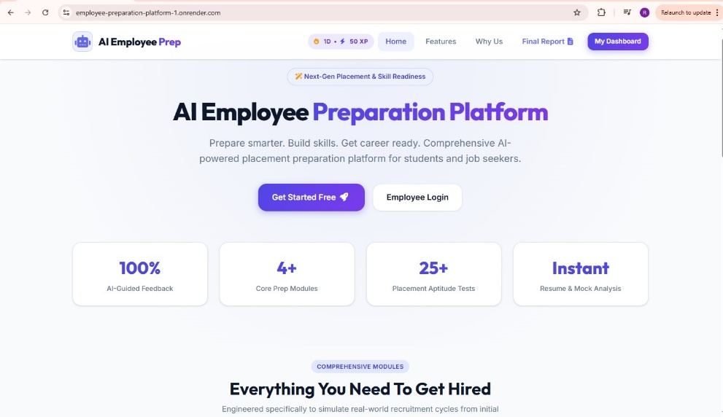

Figure 1: Platform Home Page – AI Employee Preparation Platform

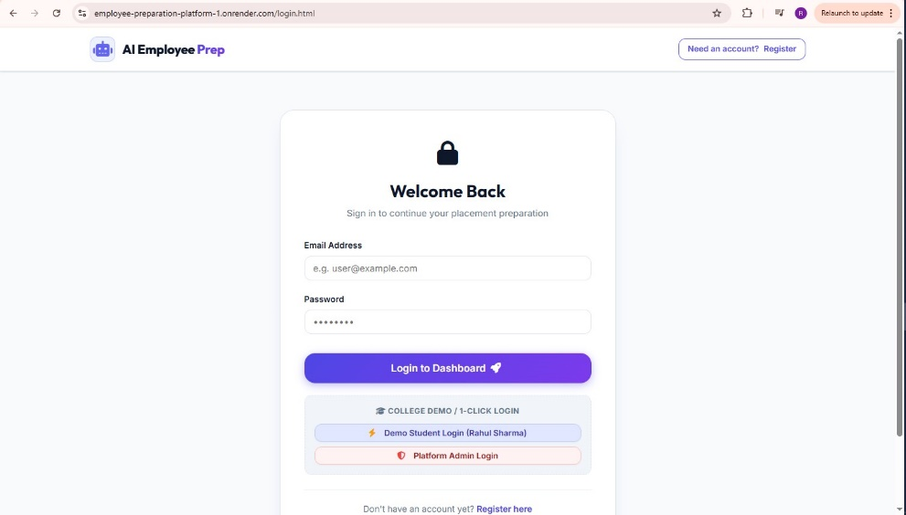

Figure 2: Employee Login Page

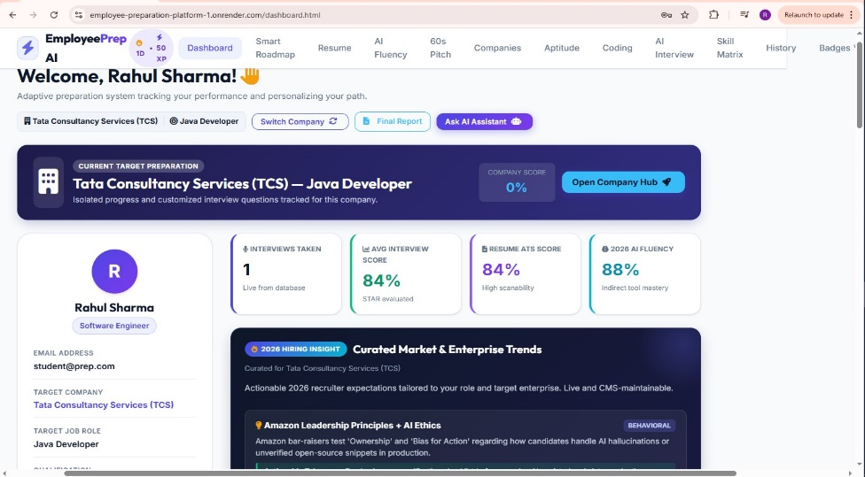
Figure 3: Personalized Dashboard – Overview and Company Score

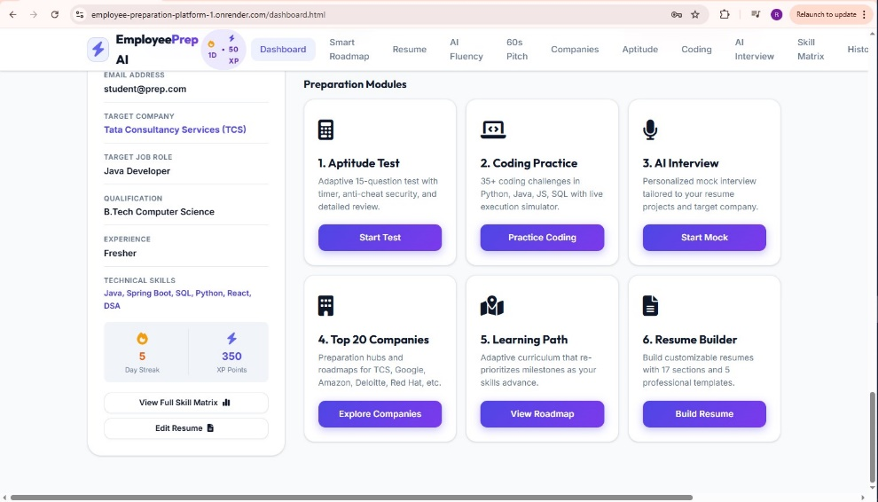

Figure 4: Dashboard – Navigation Menu and Hiring Insights
10. Advantages and Limitations
Advantages
- Combines multiple preparation tools into a single, free platform.
- Saves time by eliminating the need to switch between different websites.
- AI-based resume enhancement improves the quality of resume content.
- Company-specific mock tests increase placement readiness.
- Simple and user-friendly interface accessible to all students.
- Centralised progress tracking through the Smart Roadmap and dashboard reduces guesswork about preparation status.
- Modular architecture allows new modules to be added without disturbing existing functionality.
Limitations
- Requires an active internet connection for AI-based features.
- The company-specific question bank is currently limited to a few organizations.
- Coding practice currently uses simulated validation rather than a full code-execution engine.
- The platform is currently deployed locally and not yet hosted on the cloud.
- AI-generated feedback quality depends on the underlying language model and may occasionally require manual review.
- No offline mode is currently available, since most modules rely on live API calls.
Taken together, these advantages and limitations reflect the reality of a first working version built within a single academic semester: the core value proposition of an integrated preparation platform is clearly demonstrated, while several enhancements remain for future iterations, as outlined in the next section.
11. Future Scope
- Integrating a voice and video-based AI mock interview module.
- Expanding the company-specific question bank to cover more organizations.
- Adding real-time code execution using a sandboxed judge engine.
- Deploying the platform on a cloud service for public access.
- Adding an analytics dashboard to track a user's improvement over time.
- Introducing additional modules such as salary negotiation and soft-skill practice.
- Adding multilingual support so candidates more comfortable in regional languages can use the platform.
- Allowing candidates to import an existing LinkedIn profile to pre-fill resume details.
- Introducing gamification elements such as badges and leaderboards to encourage consistent daily practice.
- Developing a native mobile application for both Android and iOS.
These enhancements are intended to be layered on top of the existing modular architecture rather than requiring a redesign, which is one of the key benefits of the layered, API-driven approach adopted from the beginning of the project.
12. Conclusion
The AI-Based Interview Preparation Platform successfully demonstrates how Python-based web technologies can be combined with AI capabilities to build a practical, integrated solution for interview preparation. By bringing resume building, resume analysis, coding practice, and company-specific mock tests together on one platform, the project addresses a genuine need faced by students and job-switchers. The current implementation lays a strong and scalable foundation that can be extended with more advanced AI-driven features in the future.
Beyond the working system itself, this project provided significant hands-on learning in building a full-stack web application from the ground up. Working with FastAPI and SQLAlchemy gave practical experience in designing RESTful APIs and relational database schemas, while implementing JWT-based authentication clarified how secure session management works in real applications rather than just in theory. Integrating an external AI language model API for resume enhancement and AI fluency evaluation also required learning how to structure prompts effectively and handle asynchronous API responses within a synchronous request-response cycle.
Revisiting the objectives set out in Section 3, the completed platform successfully delivers a unified authentication system, a resume builder and analyzer, company-specific mock tests, a coding practice module, and a dashboard that ties these together — meeting the core goals defined at the start of the project. The experience of designing, building, and testing each of these modules individually before integration reinforced the value of a modular approach, where any single feature could be modified or extended without breaking the rest of the system.
In summary, the Employee Preparation Platform stands as a working proof of concept that a single, well-structured application can genuinely reduce the friction job seekers face when preparing for interviews. It brings together authentication, resume tooling, practice tests, and AI-assisted feedback under one roof, and its layered architecture leaves clear entry points for the future enhancements discussed in Section 11. With continued development, the platform has the potential to grow from a semester project into a genuinely useful tool for the wider student and job-seeking community.
13. References
- FastAPI Documentation – https://fastapi.tiangolo.com
- SQLAlchemy Documentation – https://www.sqlalchemy.org
- Python Official Documentation – https://docs.python.org
- ReportLab User Guide – https://www.reportlab.com/docs/reportlab-userguide.pdf
- pdfplumber Repository – https://github.com/jsvine/pdfplumber
- W3Schools Web Development Tutorials – https://www.w3schools.com
Additional Documentation and Reading
- Uvicorn Documentation – https://www.uvicorn.org
- Pydantic Documentation – https://docs.pydantic.dev
- JWT Introduction – https://jwt.io/introduction
- PyJWT Documentation – https://pyjwt.readthedocs.io
- MDN Web Docs (HTML, CSS, JavaScript) – https://developer.mozilla.org
- Postman Learning Center – https://learning.postman.com
- Real Python Tutorials – https://realpython.com
- GitHub Docs – https://docs.github.com
- OWASP Authentication Cheat Sheet – https://cheatsheetseries.owasp.org
- Git Version Control Documentation – https://git-scm.com/doc
Together, these resources supported both the conceptual understanding of the technologies used and the day-to-day problem-solving that came up while building and debugging the platform.
14. Appendix – Source Code
Appendix Overview
This appendix presents representative excerpts from the platform's source code to illustrate how the concepts described in earlier sections have been implemented in practice. Section 14.1 shows the SQLAlchemy ORM models that define the database schema for employees, resume versions, and roadmap tracking. Section 14.2 shows the main FastAPI application file that wires together the various API routes. Sections 14.3 to 14.5 show representative route handlers for authentication, the AI Fluency evaluation engine, and the Present-Past-Future pitch builder respectively, while Section 14.6 shows the frontend JavaScript controller responsible for communicating with these APIs. The excerpts have been kept close to their original form, with only minor formatting adjustments for readability within this report.
14.1 Database ORM Architecture (backend/models_sa.py)
from datetime import datetime
from sqlalchemy import create_engine, Column, Integer, String, Text, Float, Boolean, DateTime, ForeignKey
from sqlalchemy.orm import declarative_base, sessionmaker, relationship

DATABASE_URL = "sqlite:///backend/database/employees.db"
engine = create_engine(DATABASE_URL, connect_args={"check_same_thread": False})
SessionLocal = sessionmaker(autocommit=False, autoflush=False, bind=engine)
Base = declarative_base()

class User(Base):
__tablename__ = "employees"
id = Column(Integer, primary_key=True, index=True, autoincrement=True)
name = Column(String(100), nullable=False)
email = Column(String(120), unique=True, nullable=False, index=True)
password = Column(String(255), nullable=False)
qualification = Column(String(150), nullable=False)
skills = Column(Text, nullable=False)
experience = Column(String(100), nullable=False)
job_role = Column(String(100), nullable=False)
target_company = Column(String(150), default="Tata Consultancy Services (TCS)")
target_role = Column(String(150), default="Software Engineer")
extracted_skills_json = Column(Text, nullable=True)
is_admin = Column(Integer, default=0)
created_at = Column(DateTime, default=datetime.utcnow)

# Finalized ORM Relationships
roadmaps = relationship("SmartRoadmap", back_populates="employee", cascade="all, delete-orphan")
resume_versions = relationship("ResumeVersion", back_populates="employee", cascade="all, delete-orphan")
ai_fluency_attempts = relationship("AIFluencyAttempt", back_populates="employee", cascade="all, delete-orphan")
structured_answers = relationship("StructuredAnswer", back_populates="employee", cascade="all, delete-orphan")
notice_plans = relationship("NoticePlan", back_populates="employee", cascade="all, delete-orphan")
achievements = relationship("Achievement", back_populates="employee", cascade="all, delete-orphan")
converted_answers = relationship("ConvertedAnswer", back_populates="employee", cascade="all, delete-orphan")

class SmartRoadmap(Base):
__tablename__ = "smart_roadmaps"
id = Column(Integer, primary_key=True, index=True, autoincrement=True)
employee_id = Column(Integer, ForeignKey("employees.id", ondelete="CASCADE"), nullable=False)
company_name = Column(String(150), nullable=False)
duration_days = Column(Integer, nullable=False)
total_tasks = Column(Integer, default=0)
completed_tasks = Column(Integer, default=0)
progress_percent = Column(Float, default=0.0)
streak_days = Column(Integer, default=1)
tasks = relationship("RoadmapTask", back_populates="roadmap", cascade="all, delete-orphan")

class ResumeVersion(Base):
__tablename__ = "resume_versions"
id = Column(Integer, primary_key=True, index=True, autoincrement=True)
employee_id = Column(Integer, ForeignKey("employees.id", ondelete="CASCADE"), nullable=False)
version_name = Column(String(150), nullable=False)
template_name = Column(String(100), default="modern-single")
resume_data_json = Column(Text, nullable=False)
score = Column(Integer, default=0)
updated_at = Column(DateTime, default=datetime.utcnow)

class ConvertedAnswer(Base):
__tablename__ = "converted_answers"
id = Column(Integer, primary_key=True, index=True, autoincrement=True)
employee_id = Column(Integer, ForeignKey("employees.id", ondelete="CASCADE"), nullable=False)
question = Column(String(255), nullable=False)
honest_answer = Column(Text, nullable=False)
professional_script = Column(Text, nullable=False)
framework_used = Column(String(50), default="STAR")
created_at = Column(DateTime, default=datetime.utcnow)
14.2 Application Server & API Dispatcher (backend/fastapi_app.py)
import os
from fastapi import FastAPI, Request
from fastapi.middleware.cors import CORSMiddleware
from backend.database import init_db
from backend.models import (
DashboardSummaryModel, SmartRoadmapModel,
TrendingTemplateModel, AIFluencyModel, StructuredAnswerModel,
NoticePlanModel, ConvertedAnswerModel
)

init_db()
app = FastAPI(title="AI Employee Preparation Platform API", version="2026.2")

app.add_middleware(
CORSMiddleware,
allow_origins=["*"],
allow_credentials=True,
allow_methods=["*"],
allow_headers=["*"],
)

@app.get("/api/dashboard/summary")
def get_dashboard_summary(employee_id: int):
summary = DashboardSummaryModel.get_summary(employee_id)
return {"success": True, "data": summary}

@app.get("/api/roadmap/smart")
def get_smart_roadmap(employee_id: int, company: str = ""):
roadmap = SmartRoadmapModel.get_current(employee_id, company)
return {"success": True, "data": roadmap}

@app.post("/api/roadmap/smart/task/toggle")
async def toggle_smart_roadmap_task(request: Request):
data = await request.json()
result = SmartRoadmapModel.toggle_task(int(data.get("employee_id")), int(data.get("task_id")))
return result

@app.post("/api/ai-fluency/evaluate")
async def evaluate_ai_fluency(request: Request):
data = await request.json()
return AIFluencyModel.evaluate_answer(
int(data.get("employee_id")),
data.get("question_id"),
data.get("candidate_answer", "")
)

@app.post("/api/answer-builder/analyze")
async def analyze_structured_pitch(request: Request):
data = await request.json()
return StructuredAnswerModel.analyze(
employee_id=int(data.get("employee_id", 1)),
question_title=data.get("question_title", "Tell me about yourself"),
present_text=data.get("present_text", ""),
past_text=data.get("past_text", ""),
future_text=data.get("future_text", "")
)

@app.get("/api/notice-plan/active")
def get_active_notice_plan(employee_id: int):
plan = NoticePlanModel.get_active_plan(employee_id)
return {"success": True, "data": plan}
14.3 Authentication & Session Security (backend/routes/auth.py)
import hashlib, secrets
from flask import Blueprint, request, jsonify
from backend.database import get_db

auth_bp = Blueprint("auth", __name__)

def hash_password(password: str) -> str:
return hashlib.sha256(password.encode("utf-8")).hexdigest()

@auth_bp.route("/api/auth/register", methods=["POST"])
def register():
data = request.get_json() or {}
name, email, password = data.get("name"), data.get("email"), data.get("password")
if not name or not email or not password:
return jsonify({"success": False, "message": "All fields required"}), 400

conn = get_db()
cursor = conn.cursor()
cursor.execute("SELECT id FROM employees WHERE email = ?", (email,))
if cursor.fetchone():
return jsonify({"success": False, "message": "Email already registered"}), 409

cursor.execute(
"""INSERT INTO employees (name, email, password, qualification, skills, experience, job_role, target_company)
VALUES (?, ?, ?, ?, ?, ?, ?, ?)""",
(name, email, hash_password(password), data.get("qualification", "B.Tech CSE"),
data.get("skills", "Python, SQL, DSA"), data.get("experience", "Fresher"),
data.get("job_role", "Software Engineer"), data.get("target_company", "TCS"))
)
conn.commit()
return jsonify({"success": True, "message": "Registration successful"}), 201

@auth_bp.route("/api/auth/login", methods=["POST"])
def login():
data = request.get_json() or {}
email, password = data.get("email"), data.get("password")
conn = get_db()
cursor = conn.cursor()
cursor.execute("SELECT id, name, email, password, is_admin FROM employees WHERE email = ?", (email,))
user = cursor.fetchone()
if not user or user["password"] != hash_password(password):
return jsonify({"success": False, "message": "Invalid email or password"}), 401

session_token = secrets.token_hex(24)
return jsonify({
"success": True,
"token": session_token,
"user": {"id": user["id"], "name": user["name"], "email": user["email"], "is_admin": user["is_admin"]}
}), 200
14.4 2026 AI Fluency Round Engine (backend/routes/ai_fluency.py)
from flask import Blueprint, request, jsonify
from backend.models import AIFluencyModel

ai_fluency_bp = Blueprint("ai_fluency", __name__)

@ai_fluency_bp.route("/api/ai-fluency/questions", methods=["GET"])
def get_ai_fluency_questions():
category = request.args.get("category", "")
questions = AIFluencyModel.get_questions(category)
return jsonify({"success": True, "questions": questions}), 200

@ai_fluency_bp.route("/api/ai-fluency/evaluate", methods=["POST"])
def evaluate_ai_fluency():
"""
Evaluates candidate response across 4 core dimensions:
- Tool Integration (25%)
- Critical Verification & Security (35%)
- Velocity & Sprint Impact (20%)
- Authenticity & Communication (20%)
"""
data = request.get_json() or {}
employee_id = data.get("employee_id")
if not employee_id:
return jsonify({"success": False, "message": "employee_id is required"}), 400

result = AIFluencyModel.evaluate_answer(
int(employee_id),
data.get("question_id"),
data.get("candidate_answer", "")
)
return jsonify(result), (200 if result.get("success") else 400)
14.5 Present-Past-Future 60s Pitch Builder (backend/routes/answer_builder.py)
from flask import Blueprint, request, jsonify
from backend.models import StructuredAnswerModel

answer_builder_bp = Blueprint("answer_builder", __name__)

@answer_builder_bp.route("/api/answer-builder/analyze", methods=["POST"])
def analyze_structured_answer():
"""
Analyzes Present-Past-Future pitch for speaking pace (140 WPM target, 50-70s optimal).
Calculates duration, word counts, STAR metrics, and company role calibration.
"""
data = request.get_json() or {}
analysis = StructuredAnswerModel.analyze(
employee_id=int(data.get("employee_id", 1)),
question_title=data.get("question_title", "Tell me about yourself"),
present_text=data.get("present_text", ""),
past_text=data.get("past_text", ""),
future_text=data.get("future_text", ""),
target_role=data.get("target_role", "Software Engineer"),
target_company=data.get("target_company", "Enterprise")
)
return jsonify(analysis), 200

@answer_builder_bp.route("/api/answer-builder/save", methods=["POST"])
def save_structured_answer():
data = request.get_json() or {}
result = StructuredAnswerModel.save(int(data.get("employee_id")), data)
return jsonify(result), 200
14.6 2026 Smart Preparation Roadmap Engine (backend/routes/smart_roadmap.py)
from flask import Blueprint, request, jsonify
from backend.models import SmartRoadmapModel, EmployeeModel

smart_roadmap_bp = Blueprint("smart_roadmap", __name__)

@smart_roadmap_bp.route("/api/roadmap/smart", methods=["GET"])
def get_smart_roadmap():
try:
employee_id = request.args.get("employee_id", type=int)
company = request.args.get("company", type=str, default="")
if not employee_id:
return jsonify({"success": False, "message": "employee_id is required."}), 400

roadmap = SmartRoadmapModel.get_current(employee_id, company)
if not roadmap:
emp = EmployeeModel.get_by_id(employee_id) or {}
comp_name = emp.get("target_company") or "Tata Consultancy Services (TCS)"
comp_slug = "tcs" if "tcs" in comp_name.lower() else "google"
role = emp.get("target_role") or "Software Engineer"
roadmap = SmartRoadmapModel.generate(employee_id, comp_name, comp_slug, role, 14)

return jsonify({"success": True, "data": roadmap}), 200
except Exception as e:
return jsonify({"success": False, "message": f"Error loading roadmap: {str(e)}"}), 500

@smart_roadmap_bp.route("/api/roadmap/smart/generate", methods=["POST"])
def generate_smart_roadmap():
data = request.get_json() or {}
employee_id = data.get("employee_id")
company_name = data.get("company_name", "Tata Consultancy Services (TCS)")
company_slug = data.get("company_slug", "tcs")
target_role = data.get("target_role", "Software Engineer")
duration_days = int(data.get("duration_days", 14))

roadmap = SmartRoadmapModel.generate(
employee_id=int(employee_id),
company_name=company_name,
company_slug=company_slug,
target_role=target_role,
duration_days=duration_days
)
return jsonify({"success": True, "message": "Roadmap generated", "data": roadmap}), 200

@smart_roadmap_bp.route("/api/roadmap/smart/task/toggle", methods=["POST"])
def toggle_smart_roadmap_task():
data = request.get_json() or {}
result = SmartRoadmapModel.toggle_task(int(data.get("employee_id")), int(data.get("task_id")))
return jsonify(result), 200
14.7 Honest-to-Professional Answer Converter (backend/routes/converted_answers.py)
from flask import Blueprint, request, jsonify
from backend.models import ConvertedAnswerModel, GamificationModel
from backend.services.ai_service import convert_honest_to_professional

converted_answers_bp = Blueprint("converted_answers", __name__)

@converted_answers_bp.route("/api/converted-answers", methods=["GET"])
def get_converted_answers():
employee_id = request.args.get("employee_id", type=int)
if not employee_id:
return jsonify({"success": False, "message": "employee_id is required."}), 400
records = ConvertedAnswerModel.get_all(employee_id)
return jsonify({"success": True, "count": len(records), "data": records}), 200

@converted_answers_bp.route("/api/converted-answers/convert", methods=["POST"])
def convert_answer():
data = request.get_json() or {}
employee_id = data.get("employee_id")
question = data.get("question", "")
honest_answer = data.get("honest_answer", "")
target_role = data.get("target_role", "Software Engineer")

professional_script = convert_honest_to_professional(question, honest_answer, target_role)
record = ConvertedAnswerModel.save(
employee_id=int(employee_id),
question=question,
honest_answer=honest_answer,
professional_script=professional_script
)
GamificationModel.add_xp(int(employee_id), 30, "Honest Answer Converted")
return jsonify({"success": True, "data": record}), 200
14.8 Notice Period Transition Countdown Planner (backend/routes/notice_plan.py)
from flask import Blueprint, request, jsonify
from backend.models import NoticePlanModel
from backend.services.ai_service import generate_notice_period_plan

notice_plan_bp = Blueprint("notice_plan", __name__)

@notice_plan_bp.route("/api/notice-plan/active", methods=["GET"])
def get_active_notice_plan():
employee_id = request.args.get("employee_id", type=int)
if not employee_id:
return jsonify({"success": False, "message": "employee_id is required."}), 400
plan = NoticePlanModel.get_active_plan(employee_id)
return jsonify({"success": True, "data": plan}), 200

@notice_plan_bp.route("/api/notice-plan/generate", methods=["POST"])
def generate_notice_plan():
data = request.get_json() or {}
employee_id = data.get("employee_id")
target_role = data.get("target_role", "Software Engineer")
notice_days = int(data.get("notice_days", 30))

plan_data = generate_notice_period_plan(target_role, notice_days)
plan_record = NoticePlanModel.save(int(employee_id), notice_days, plan_data)
return jsonify({"success": True, "data": plan_record}), 200

@notice_plan_bp.route("/api/notice-plan/task/toggle", methods=["POST"])
def toggle_notice_task():
data = request.get_json() or {}
result = NoticePlanModel.toggle_task(int(data.get("employee_id")), int(data.get("task_id")))
return jsonify(result), 200
14.9 ATS Resume Scoring & Optimization Engine (backend/routes/resume.py)
from flask import Blueprint, request, jsonify
from backend.models import TrendingTemplateModel, ResumeModel

resume_bp = Blueprint("resume", __name__)

@resume_bp.route("/api/resume/templates", methods=["GET"])
def get_resume_templates():
return jsonify({"success": True, "templates": TrendingTemplateModel.get_active()}), 200

@resume_bp.route("/api/resume/score", methods=["POST"])
def score_resume():
data = request.get_json() or {}
resume_text = data.get("resume_text", "")
target_role = data.get("target_role", "Software Engineer")
target_company = data.get("target_company", "Enterprise")

score_result = ResumeModel.calculate_ats_score(resume_text, target_role, target_company)
return jsonify({"success": True, "data": score_result}), 200

@resume_bp.route("/api/resume/ai-enhance", methods=["POST"])
def ai_enhance_bullet():
data = request.get_json() or {}
bullet = data.get("bullet_point", "")
enhanced = ResumeModel.enhance_bullet_point(bullet)
return jsonify({"success": True, "original": bullet, "enhanced": enhanced}), 200
14.10 Frontend REST API Controller (frontend/js/api.js)
const API_BASE = window.location.origin;

const API = {
getUser: () => JSON.parse(localStorage.getItem('currentUser')) || null,
setUser: (user) => localStorage.setItem('currentUser', JSON.stringify(user)),
logout: () => { localStorage.removeItem('currentUser'); window.location.href = 'login.html'; },

request: async (endpoint, options = {}) => {
try {
const res = await fetch(`${API_BASE}${endpoint}`, {
...options,
headers: { 'Content-Type': 'application/json', ...options.headers }
});
return await res.json();
} catch (err) {
console.error(`API Error [${endpoint}]:`, err);
return { success: false, message: 'Network connection failure.' };
}
},

login: (email, password) => API.request('/api/auth/login', {
method: 'POST',
body: JSON.stringify({ email, password })
}),

getDashboardSummary: (empId) => API.request(`/api/dashboard/summary?employee_id=${empId}`),
getSmartRoadmap: (empId, company = '') => API.request(`/api/roadmap/smart?employee_id=${empId}&company=${company}`),
toggleRoadmapTask: (taskId, empId) => API.request('/api/roadmap/smart/task/toggle', {
method: 'POST',
body: JSON.stringify({ task_id: taskId, employee_id: empId })
}),
evaluateAIFluency: (empId, qId, ans) => API.request('/api/ai-fluency/evaluate', {
method: 'POST',
body: JSON.stringify({ employee_id: empId, question_id: qId, candidate_answer: ans })
}),
analyzePitch: (payload) => API.request('/api/answer-builder/analyze', {
method: 'POST',
body: JSON.stringify(payload)
}),
getActiveNoticePlan: (empId) => API.request(`/api/notice-plan/active?employee_id=${empId}`),
getConvertedAnswers: (empId) => API.request(`/api/converted-answers?employee_id=${empId}`)
};

