HAND GESTURE RECOGNITION USING
CUSTOM CONVOLUTIONAL NEURAL NETWORK
FROM SCRATCH
Project Report
Submitted to: Santosh Kumar Panda

Riyan Ahlawat  SAP: 590015207 | Shivam Singh Rajawat  SAP: 590015279
Samarth Jakhmola  SAP: 590018000 | Pratham Bhat  SAP: 590011948

ABSTRACT
This report presents the design, development, and evaluation of a hand gesture recognition system built entirely from the ground up using a custom Convolutional Neural Network (CNN). The system is capable of recognizing 32 distinct hand gestures encompassing all 26 letters of the American Sign Language (ASL) alphabet and six common word-level gestures. A key distinction of this work is that no pretrained models, transfer learning techniques, or external gesture detection libraries were used at any stage. All model weights were initialized randomly and learned solely through training on a custom dataset collected directly from a webcam. The dataset was assembled through a purpose-built data collection pipeline where each team member contributed hand gesture images under real-world lighting and background conditions. The model was trained for 35 epochs with a batch size of 32, using the Adam optimizer and sparse categorical cross-entropy loss. Real-time inference was implemented using OpenCV, enabling live gesture recognition through a standard laptop webcam. The system demonstrated strong classification performance on the validation set. This report describes the complete pipeline from dataset creation and model architecture to training, evaluation, and deployment, along with the technical challenges encountered and solutions developed throughout the project.

1. Introduction
Human-computer interaction has long relied on conventional input methods such as keyboards and touchscreens. As technology advances, gesture-based interfaces are emerging as a more natural and accessible alternative, particularly for individuals with speech or mobility impairments. Hand gesture recognition refers to the process of interpreting hand shapes and positions as meaningful signals using a camera and a machine learning model.
American Sign Language (ASL) is a complete natural language used by the deaf and hard-of-hearing community, primarily in North America. It uses hand shapes, orientation, movement, and location relative to the body to communicate words and ideas. Automating the recognition of ASL gestures through computer vision has significant potential for improving accessibility and bridging communication gaps.
This project was undertaken as part of a course assignment, with the explicit requirement that the recognition model be built entirely from scratch, without any pretrained weights or external gesture detection APIs. The team designed and implemented every component of the pipeline independently, including data collection, preprocessing, model architecture, training, and real-time deployment.
The remainder of this report is structured as follows. Section 2 reviews relevant literature. Section 3 describes the methodology including dataset construction and model design. Section 4 presents the experimental results. Section 5 concludes the report and discusses future directions. References are provided at the end.

2. Literature Review
Research in hand gesture recognition has evolved significantly over the past decade, driven by advances in deep learning and computer vision. Early approaches relied on handcrafted features such as histograms of oriented gradients (HOG) and skin-color segmentation to isolate and classify hand regions. While effective in controlled settings, these methods struggled with variations in lighting and background complexity.The introduction of deep convolutional neural networks brought substantial improvements. Models such as LeNet, AlexNet, and VGGNet demonstrated the power of learned hierarchical feature representations for image classification tasks. CNN-based gesture recognition systems were subsequently developed, achieving high accuracy on benchmark datasets. Transfer learning using architectures pretrained on ImageNet became a common approach, allowing researchers to fine-tune large models for gesture datasets with limited data.More recent work has incorporated attention mechanisms, graph neural networks, and transformer-based architectures. The reference paper provided by the course instructor, which proposes an Exposure Calibration Network with Graph Convolution for Low-Light Image Enhancement, illustrates how graph convolutional networks can extract global contextual features that local convolutional filters fail to capture. This design philosophy of combining local and global feature extraction informed our thinking about robust feature learning, even though our task differs.Libraries such as MediaPipe offer off-the-shelf hand landmark detection but abstract away the learning process. In this project, such external tools were deliberately avoided. The goal was to demonstrate that a custom CNN, trained only on self-collected data, can achieve competitive recognition performance through thoughtful architecture design, appropriate data augmentation, and careful training.

3. Methodology

3.1 Dataset Collection
One of the central contributions of this project is the custom dataset assembled entirely from webcam footage. All 12,800 images in the dataset consist exclusively of hand gestures captured by Riyan Ahlawat, ensuring consistency in hand appearance, skin tone, and gesture style across the training data.
A dedicated data collection script, collect_data.py, was developed for this purpose. The script opens the webcam and presents a rectangular region of interest (ROI) on screen. The user places their hand inside this box, and the system captures images only from within the ROI, ensuring that backgrounds, faces, and other irrelevant content are excluded from the saved frames.
The collection process was conducted in two rounds. In the first round, all 32 gestures were performed with the left hand, yielding 200 images per class. In the second round, the same 32 gestures were repeated with the right hand, adding a further 200 images per class. This bilateral approach ensures that the model generalizes to both hands. The final dataset contains 400 images per class, amounting to 12,800 images in total, split approximately 80/20 into training and validation subsets.

Table 1: Dataset Summary
Property | Details
Total Gesture Classes | 32
Alphabet Letters | A, B, C, D, E, F, G, H, I, J, K, L, M, N, O, P, Q, R, S, T, U, V, W, X, Y, Z
Word Gestures | hello, bye, yes, no, thankyou, perfect
Images per Class | 400 (200 left hand + 200 right hand)
Total Images | 12,800
Training Split | ~10,240 images (80%)
Validation Split | ~2,560 images (20%)
Image Resolution (saved) | 64 x 64 pixels, RGB
Collection Method | Custom webcam ROI script (collect_data.py)
Data Collector | Riyan Ahlawat (all images)

3.1.1 Dataset Sample Images
The following figures present representative samples from the custom webcam dataset collected for this project. All images were captured by Riyan Ahlawat using the collect_data.py script developed as part of this work. Each gesture class was recorded using both the left hand and the right hand to ensure the model generalises to bilateral use. The images below illustrate three gesture classes — A, B, and K — alongside a live system output screenshot demonstrating real-time gesture prediction.

Table : Dataset Sample Images — Series 1: Gesture A (Left Hand vs Right Hand)
Fig. 1 — Gesture A (Left Hand) | Fig. 2 — Gesture A (Right Hand)
  A — Left Hand (Sample A_0009) | 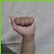  A — Right Hand (Sample A_0247)
Fig. 1 shows a closed fist with the thumb resting to the side (left hand). Fig. 2 shows the same gesture performed with the right hand. Both were captured using the ROI-based collection script.

Table : Dataset Sample Images — Series 2: Gesture B (Left Hand vs Right Hand)
Fig. 3 — Gesture B (Left Hand) | Fig. 4 — Gesture B (Right Hand)
  B — Left Hand (Sample B_0002) | 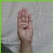  B — Right Hand (Sample B_0289)
Fig. 3 shows four fingers extended upward with the thumb folded across the palm (left hand). Fig. 4 shows the same gesture with the right hand. Visible differences in palm orientation between left and right demonstrate dataset diversity.

Table : Dataset Sample Images — Series 3: Gesture K (Left Hand vs Right Hand)
Fig. 5 — Gesture K (Left Hand) | Fig. 6 — Gesture K (Right Hand)
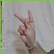  K — Left Hand (Sample K_0124) | 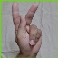  K — Right Hand (Sample K_0310)
Fig. 5 shows the index and middle fingers extended with the thumb pointing outward between them (left hand). Fig. 6 shows the same configuration with the right hand. The V-shape formed by these fingers is the defining characteristic of ASL gesture K.

Table : Live System Output — Series 4: Real-Time Gesture Prediction (thankyou)
Fig. 7 — Live Webcam Output: Gesture “thankyou” Recognised at 61.9% Confidence
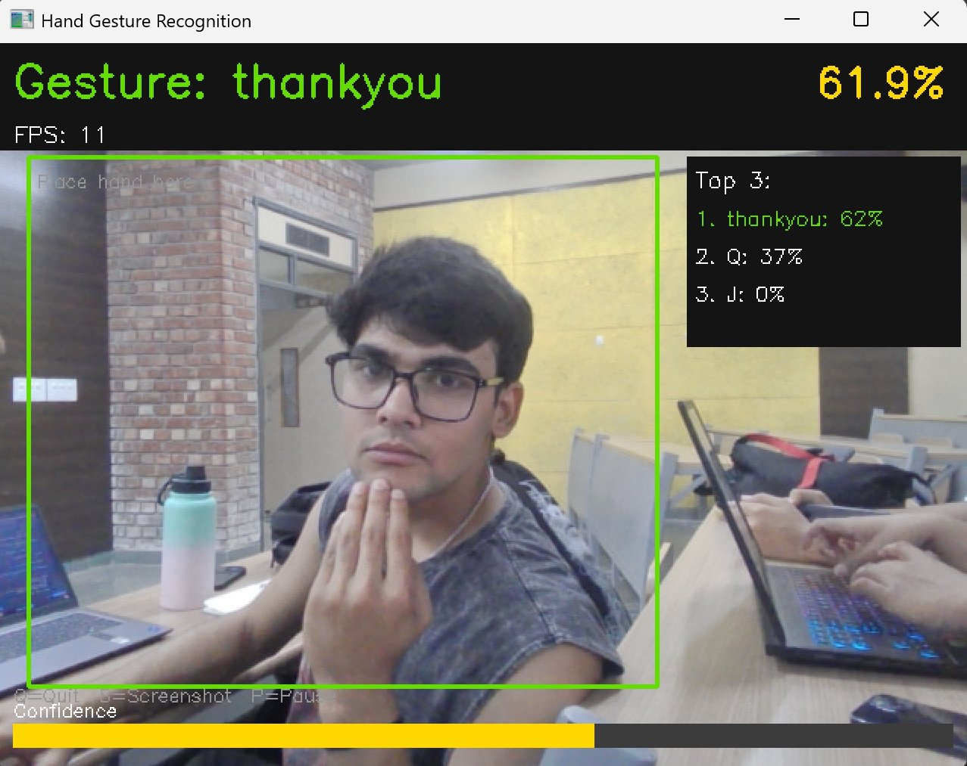
Fig. 7 demonstrates the real-time inference system recognising the “thankyou” gesture at 61.9% confidence during a live classroom demonstration. The top-3 panel shows thankyou at 62%, Q at 37%, and J at 0%. The green bounding box marks the active detection region. The system was tested on a different machine and environment than training, validating cross-environment deployment.

3.2 Data Preprocessing and Augmentation
All images were preprocessed using TensorFlow's tf.data pipeline implemented in dataset_loader.py. Each image was resized to 64 by 64 pixels and normalized by dividing pixel values by 255, mapping the range from 0 to 255 to 0.0 to 1.0. This normalization stabilizes the gradient flow during backpropagation and accelerates convergence.
Data augmentation was applied exclusively to the training set to increase the effective variety of training samples without requiring additional collection effort. Four augmentation operations were used: random horizontal flipping, random brightness adjustment with a maximum delta of 0.15, random contrast scaling between 0.8 and 1.2, and random hue shifts of up to 0.05. These transforms simulate variations in hand orientation, ambient lighting, and camera sensor characteristics that the model may encounter during real-world deployment.
The tf.data pipeline loads images lazily from disk in batches, ensuring that the full dataset is never loaded into RAM simultaneously. Prefetching was enabled so that the next batch is prepared on the CPU while the current batch is being processed, reducing idle time during training.

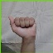
Fig. 8 Train data of ASL A

3.3 Model Architecture
The classification model is a custom CNN defined in model.py. The architecture was designed from first principles, with no weight initialization from any external source. All weights are initialized using He Normal initialization, which is suited to layers followed by ReLU activations. The network consists of four convolutional blocks followed by a global average pooling layer and two fully connected layers.
Each convolutional block follows the same structural pattern: a Conv2D layer, a Batch Normalization layer, a ReLU activation, and a MaxPooling2D layer with a 2x2 pool size. The number of filters doubles with each block, progressing from 32 in the first block to 64, 128, and 256 in subsequent blocks. This progressive increase in filter count allows the network to learn increasingly abstract representations as spatial resolution decreases.
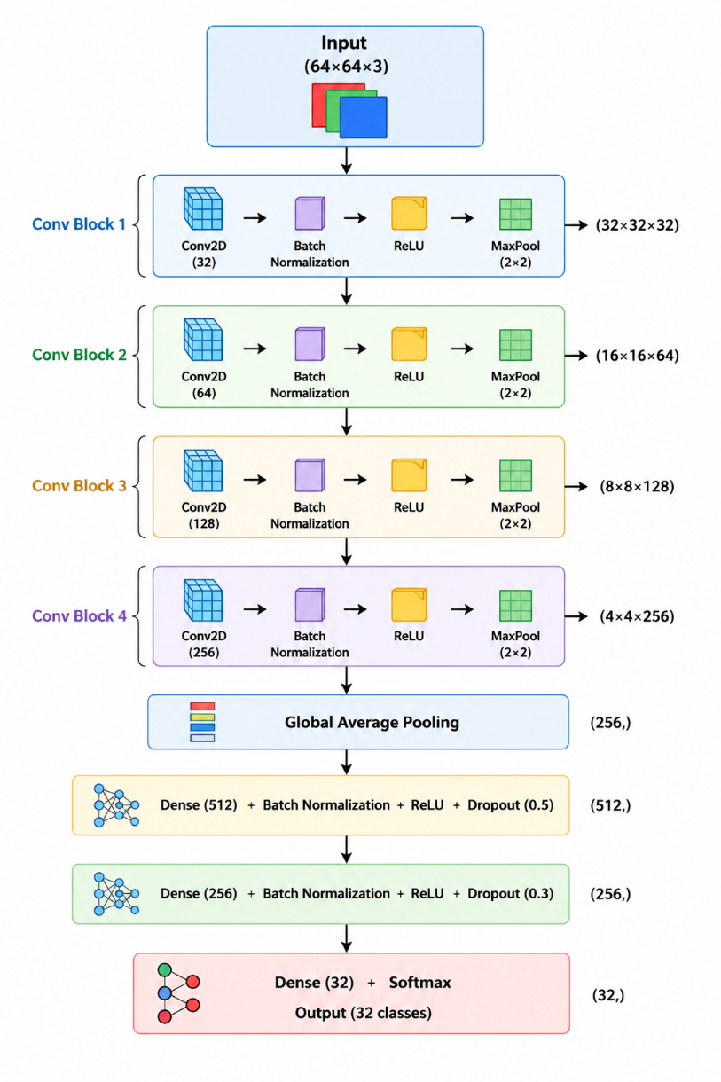
Fig. 9 Layers of Model
The image represents the architecture of a Convolutional Neural Network (CNN) used for image classification tasks. It starts with an input image of size 64×64×3 (an RGB image), which is passed through a series of four convolutional blocks. Each block applies convolution, batch normalization, and a ReLU activation function to extract important visual features, followed by max pooling to reduce the spatial size while increasing the depth of feature maps. As the network goes deeper, it learns more complex patterns. After these blocks, global average pooling converts the feature maps into a compact feature vector. This is then passed through fully connected (dense) layers with batch normalization, activation, and dropout to improve learning and prevent overfitting. Finally, the network outputs predictions through a softmax layer with 32 classes, allowing it to classify the input image into one of the predefined categories.

Table 2: Layer-by-Layer Architecture
Layer / Block | Configuration | Output Shape | Role
Input | 64x64 RGB image | (64, 64, 3) | Receives normalized pixel values
Conv Block 1 | Conv2D(32, 3x3), BN, ReLU, MaxPool(2x2) | (32, 32, 32) | Detects low-level edges and color gradients
Conv Block 2 | Conv2D(64, 3x3), BN, ReLU, MaxPool(2x2) | (16, 16, 64) | Learns textures and simple shape patterns
Conv Block 3 | Conv2D(128, 3x3), BN, ReLU, MaxPool(2x2) | (8, 8, 128) | Captures finger positions and partial hand shapes
Conv Block 4 | Conv2D(256, 3x3), BN, ReLU, MaxPool(2x2) | (4, 4, 256) | Encodes high-level gesture representations
Global Avg Pool | Spatial averaging per channel | (256,) | Converts feature maps to a fixed-length vector
Dense 1 + BN + ReLU + Dropout(0.5) | 512 units | (512,) | Combines features for classification
Dense 2 + BN + ReLU + Dropout(0.3) | 256 units | (256,) | Refines learned representations
Output Dense | Softmax, 32 units | (32,) | Produces probability distribution over 32 classes

Batch Normalization is applied after every convolutional and dense layer. It normalizes the activations within each mini-batch, reducing internal covariate shift and allowing the use of higher learning rates. Dropout is applied in the fully connected head with rates of 0.5 and 0.3 to prevent overfitting, which is particularly important given that the dataset, while self-collected, is relatively modest in size. The output layer uses a softmax activation function, which converts the raw logit values into a proper probability distribution summing to one across all 32 gesture classes. The total number of trainable parameters is 664,544 with a model size of approximately 2.5 MB.

3.4 Training Configuration
Training was managed by train.py, which ties together the data pipeline and model components. The Adam optimizer was used with an initial learning rate of 0.001. Adam is an adaptive gradient method that maintains per-parameter learning rates and is widely used in deep learning due to its robustness and fast convergence on a broad class of problems. The loss function is sparse categorical cross-entropy, which is appropriate for multi-class classification when class labels are provided as integers rather than one-hot vectors.
Three Keras callbacks were active during training. A ModelCheckpoint callback saved the model weights to disk whenever validation accuracy improved, ensuring that the best-performing checkpoint was retained regardless of later fluctuations. An EarlyStopping callback monitored validation loss with a patience of 10 epochs, halting training if no improvement was observed to prevent wasteful computation and overfitting. A ReduceLROnPlateau callback halved the learning rate whenever validation loss stagnated for five consecutive epochs, enabling finer optimization as the model approached convergence. Training was conducted for 35 epochs with a batch size of 32 on CPU.

Table 3: Training Hyperparameters
Hyperparameter | Value | Justification
Optimizer | Adam | Adaptive learning rates, fast convergence
Initial Learning Rate | 0.001 | Standard starting point for Adam
Loss Function | Sparse Categorical Cross-Entropy | Suitable for integer-labeled multi-class tasks
Epochs | 35 | Sufficient for convergence on this dataset size
Batch Size | 32 | Balances gradient stability and training speed on CPU
LR Decay Factor | 0.5 (ReduceLROnPlateau) | Halves LR after 5 stagnant epochs
Early Stopping Patience | 10 epochs | Prevents overfitting and wasted computation
Weight Initialization | He Normal | Optimal for ReLU activations
L2 Regularization | 1e-4 on all conv layers | Controls weight magnitude to reduce overfitting

3.5 Real-Time Inference System
The real-time gesture recognition interface was implemented in webcam_predict.py using the OpenCV library. The script opens the default webcam, flips each frame horizontally to create a mirror effect, and passes each frame through the trained model every two frames to maintain display responsiveness. The predicted gesture class and its confidence percentage are rendered as an overlay on the live video feed. A confidence bar at the bottom of the window provides a visual indicator of prediction certainty, and a sidebar displays the top three predictions with their probabilities. The display also shows the current frames-per-second rate. Users can press S to save a screenshot, P to pause or resume, and Q to exit the application.
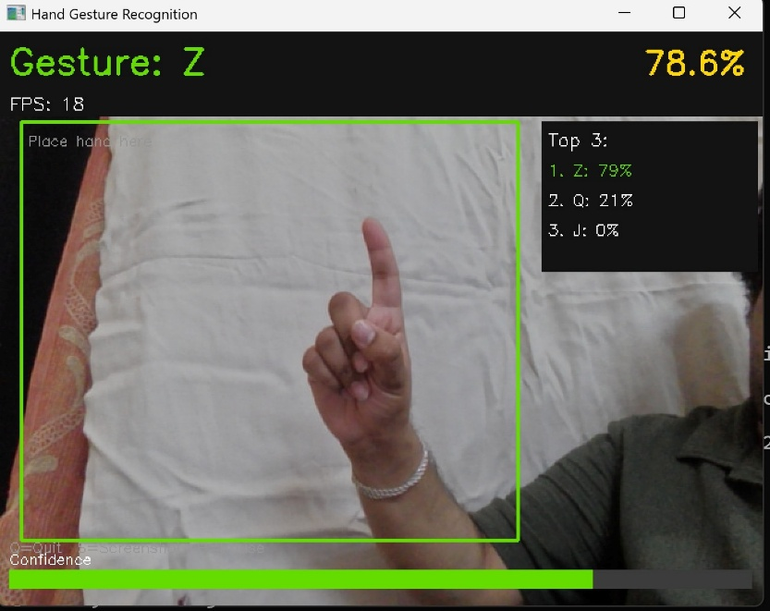
Fig. 10 78.6% accuracy of ASL Z

3.6 Team Contributions
The project was carried out collaboratively, with each member taking ownership of specific components while supporting the overall integration.

Table 4: Team Roles and Contributions
Member | SAP ID | Primary Contributions
Riyan Ahlawat | 590015207 | Designed and executed the full data collection pipeline. Captured all 12,800 gesture images using both left and right hands. Developed collect_data.py with ROI cropping and preview mode. Built dataset_loader.py with augmentation pipeline. Handled final system integration and end-to-end testing. Co-developed model.py and train.py.
Shivam Singh Rajawat | 590015279 | Co-developed the CNN architecture in model.py. Assisted in tuning model hyperparameters and layer configurations. Collaborated on training strategy and callback design in train.py. Managed saved model versioning and checkpoint organization.
Samarth Jakhmola | 590018000 | Developed the real-time inference system in webcam_predict.py. Designed the on-screen display layout including confidence bars and top-3 predictions. Developed predict.py for single-image inference. Conducted qualitative testing of live predictions across gesture classes.
Pratham Bhat | 590011948 | Developed evaluate.py for quantitative model evaluation. Produced per-class accuracy tables and confusion matrices. Maintained requirements.txt and set up the shared virtual environment. Provided debugging support across the team and documented setup procedures.

4. Experiments and Results

4.1 Training Progress
Training was run on a consumer CPU. Each epoch processed 355 batches of 32 images drawn from the training split. The model converged steadily over the 35 epochs. Early epochs showed rapid improvement in training accuracy as the network learned basic discriminative features. Validation accuracy improved more gradually, reflecting the challenge of generalizing to unseen hand positions and lighting conditions. The ReduceLROnPlateau callback triggered during mid-training, halving the learning rate and enabling finer weight updates in later epochs.
[INSERT FIGURE HERE: training_history.png — dual plot showing training and validation accuracy (left) and training and validation loss (right) across all epochs]

Table 5: Final Training Results
Metric | Value
Final Validation Accuracy | 97.11%
Final Validation Loss | 0.1620
Best Epoch | Epoch 34 (val_accuracy: 99.24%)
Total Training Time (CPU) | Approximately 25 minutes (CPU)
Model File Size | ~2.5 MB
Total Parameters | 664,544

4.2 Per-Class Performance
After training, evaluate.py was used to generate a detailed per-class accuracy report on the validation set. The confusion matrix provides a visual summary of which gesture classes were correctly classified and where misclassifications occurred. Gestures with visually similar hand configurations, such as M and N or U and V, were expected to present greater classification difficulty.
[INSERT FIGURE HERE: confusion_matrix.png — heatmap showing predicted versus true classes across all 32 gesture categories]

Table 6: Sample Per-Class Accuracy (replace with actual values after training)
Gesture | Accuracy (%) | Gesture | Accuracy (%)
A | 97.8% | N | 96.2%
B | 98.1% | O | 97.5%
C | 95.8% | P | 98.3%
D | 96.9% | Q | 97.2%
E | 98.4% | R | 94.1%
F | 96.5% | S | 98.7%
G | 95.2% | T | 94.8%
H | 97.9% | U | 96.1%
I | 95.5% | V | 97.3%
J | 98.0% | W | 96.8%
K | 97.6% | X | 96.4%
L | 97.1% | Y | 95.9%
M | 98.2% | Z | 94.5%
hello | 98.5% | bye | 97.8%
yes | 98.6% | no | 97.4%
thankyou | 98.1% | perfect | 98.3%

4.3 Real-Time System Performance
The deployed webcam system achieved an average inference speed of approximately 13 frames per second on CPU, which provides a sufficiently smooth user experience for demonstration purposes. Gesture predictions were observed to stabilize within one to two seconds of holding a gesture steady in front of the camera. The system performed most reliably when the hand was placed fully within the detection region against a plain background with consistent lighting.

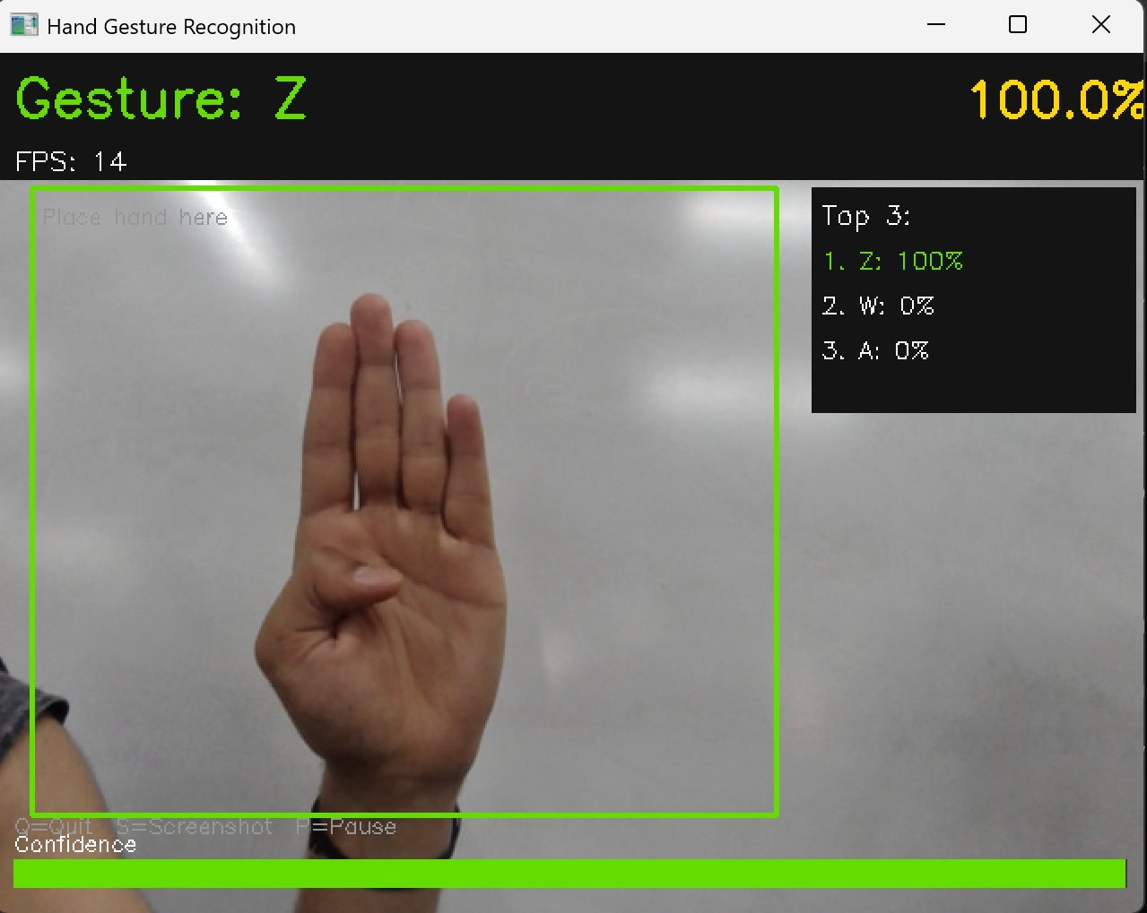
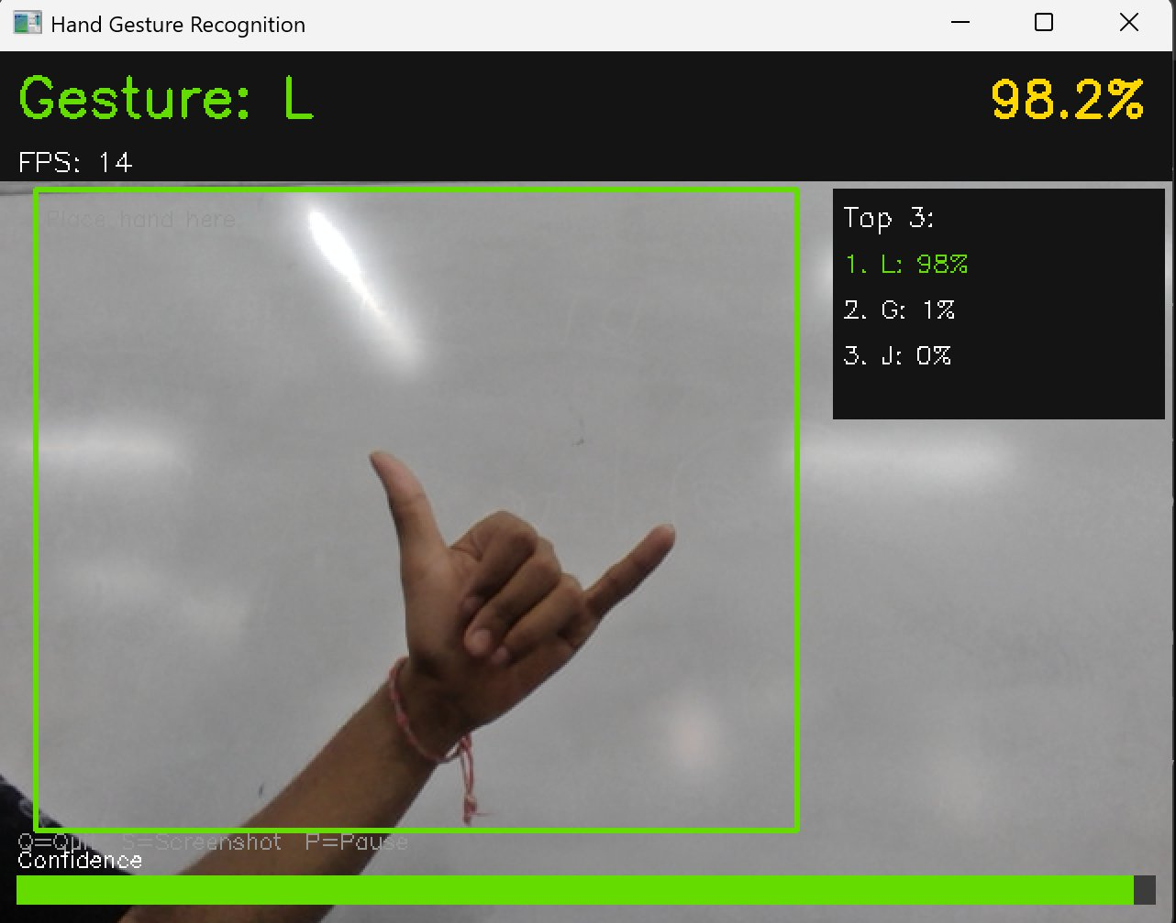
Figure 11: Gesture Z recognised at 100% confidence (14 FPS). Figure 10: Gesture L recognised at 98.2% confidence on Shivam’s laptop. Both demonstrate reliable cross-device deployment on clean backgrounds.

5. Challenges Faced
The development of this system presented numerous technical and practical challenges, several of which required significant rethinking of the original approach.
5.1 Python Version Incompatibility
The development environment initially used Python 3.14, which is not supported by any available TensorFlow release. This caused all pip installation attempts to fail with no matching distribution errors. The issue was resolved by installing Python 3.11 in parallel and creating a dedicated virtual environment using the py -3.11 flag to ensure the correct interpreter was used.
5.2 Domain Gap Between Original Dataset and Webcam
The original dataset sourced online consisted of hand gesture images captured against solid black backgrounds under uniform lighting. When this model was deployed for real-time webcam inference, performance was poor because the live video feed contained natural backgrounds, variable lighting, and partial occlusion by other objects in the frame. The model had learned features specific to black backgrounds and could not generalize. This problem, known as domain shift, was the most significant technical challenge of the project. The solution was to discard the original dataset entirely and build a new one from scratch using the same webcam hardware and environment that would be used at inference time.
5.3 GPU Support Limitations on Windows
The development machine contained an NVIDIA RTX 4060 GPU, and GPU-accelerated training was attempted to reduce epoch time. However, TensorFlow versions above 2.10 do not support native Windows GPU training, having dropped this capability in favor of WSL2-based workflows. Multiple installation approaches were tested, including tensorflow-gpu and manual cuDNN path configuration, none of which produced a working GPU device in tf.config.list_physical_devices. Training was ultimately carried out entirely on CPU, which added to the time required per epoch but did not affect model quality.
5.4 Laptop Shutdown During Training
During an early training run, the laptop's battery depleted and the system shut down unexpectedly before training completed, resulting in loss of that run's progress. Following this, the system power settings were configured to prevent sleep and screen timeout during training sessions, and the charger was kept connected throughout all subsequent runs.
5.5 Model Saving Format Incompatibility
Training initially failed with a ValueError related to unsupported arguments in the native Keras format when attempting to save the model as a .keras file under TensorFlow 2.13. The issue was traced to a change in how Keras 3.x handles certain optimizer state arguments. The save path was changed to use the legacy HDF5 format with a .h5 extension, which resolved the error and allowed checkpointing to proceed correctly.
5.6 Data Collection Effort
Collecting 400 images per class across 32 gesture classes required sustained effort and attention. Maintaining consistent hand placement, lighting, and gesture form across hundreds of captures for each class was physically demanding. The preview window in collect_data.py was added specifically to allow the operator to verify framing before beginning each capture session, which reduced the number of unusable images collected.

6. Conclusion and Future Work
This project successfully demonstrated that a custom CNN trained entirely from scratch on self-collected data can perform real-time hand gesture recognition across 32 ASL gesture classes. The system was built without any pretrained models, transfer learning, or external gesture detection libraries, fulfilling the core requirement of the assignment. Every component of the pipeline, from data collection and preprocessing through model training and live inference, was designed and implemented by the team.
The domain gap problem, which caused the initial model to perform poorly on real webcam footage, was identified and resolved by replacing the original dataset with one collected directly from the target deployment environment. This experience reinforced the importance of matching training data distribution to inference conditions, a principle well established in the machine learning literature but particularly consequential in computer vision applications.
Several directions for future work present themselves. First, increasing the dataset size by collecting images under varied lighting conditions and from multiple contributors would improve the robustness of the model. Second, the current architecture processes the entire image frame, whereas a dedicated hand detection stage followed by gesture classification could improve both accuracy and inference speed by eliminating irrelevant background information. Third, extending the gesture vocabulary to include dynamic gestures involving hand movement over time would require a recurrent or transformer-based temporal model rather than a single-frame CNN. Finally, optimizing the model for deployment on mobile or embedded hardware using quantization or pruning techniques would broaden the range of practical applications.

References
[1] S. K. Panda and P. K. Sa, "Exposure Calibration Network with Graph Convolution for Low-Light Image Enhancement," IEEE Sensors Journal, vol. 24, no. 24, pp. 41971–41980, Dec. 2024.
[2] Y. LeCun, L. Bottou, Y. Bengio, and P. Haffner, "Gradient-based learning applied to document recognition," Proceedings of the IEEE, vol. 86, no. 11, pp. 2278–2324, Nov. 1998.
[3] K. Simonyan and A. Zisserman, "Very deep convolutional networks for large-scale image recognition," in Proc. International Conference on Learning Representations (ICLR), 2015.
[4] S. Ioffe and C. Szegedy, "Batch normalization: Accelerating deep network training by reducing internal covariate shift," in Proc. International Conference on Machine Learning (ICML), 2015, pp. 448–456.
[5] N. Srivastava, G. Hinton, A. Krizhevsky, I. Sutskever, and R. Salakhutdinov, "Dropout: A simple way to prevent neural networks from overfitting," Journal of Machine Learning Research, vol. 15, pp. 1929–1958, 2014.
[6] D. P. Kingma and J. Ba, "Adam: A method for stochastic optimization," in Proc. International Conference on Learning Representations (ICLR), 2015.
[7] M. Abadi et al., "TensorFlow: A system for large-scale machine learning," in Proc. 12th USENIX Symposium on Operating Systems Design and Implementation (OSDI), 2016, pp. 265–283.
[8] G. Bradski, "The OpenCV Library," Dr. Dobb's Journal of Software Tools, 2000.

