Task 1:-

In first task, we have designed a calculator. The calculator is not responsive.

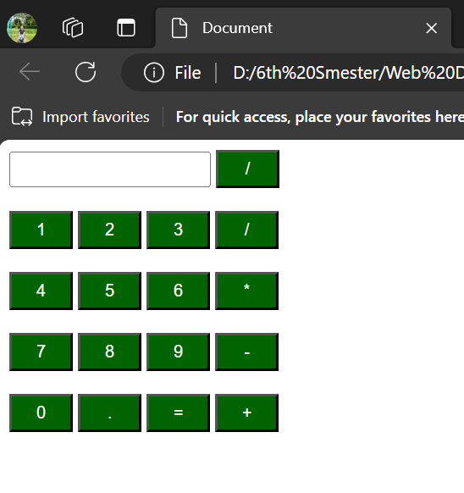

Task 2:-

In second task, we have designed a time table.

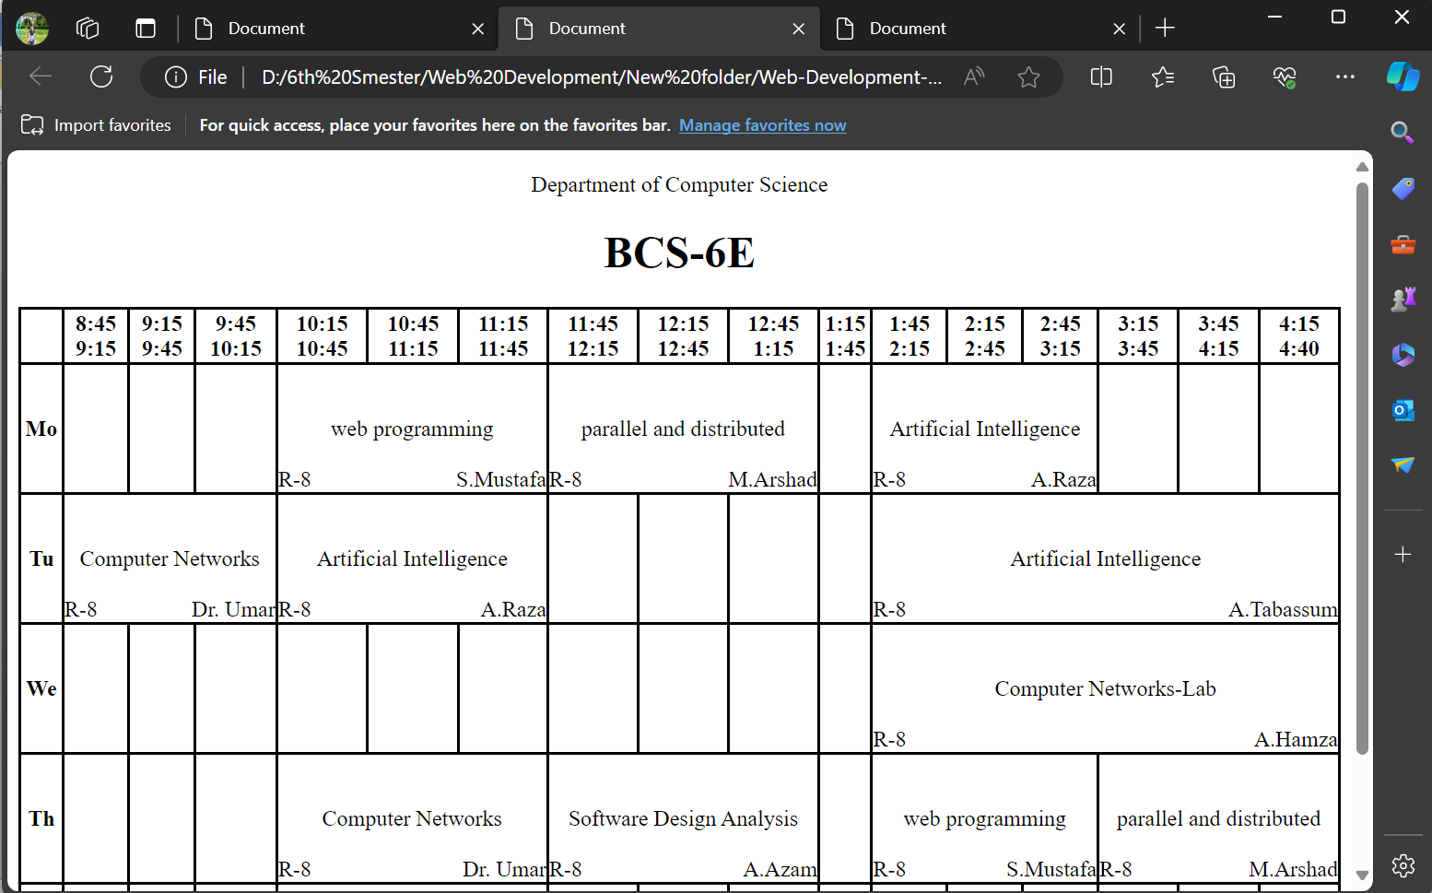

Task 3:-

In third task we have designed our portfolio.

