Tom DemarkTrend Lines

Trend lines are universally used by almost all traders. They are a common place for all traders to begin their technical analysis. The problem is that a trader becomes too subjective in their trend line drawing. Many traders will draw on separate occasions two totally different trend lines based on the identical information, depending on his inclination each time, thus consistency and uniformity are totally lacking. Not all trend lines are correct, in the end only one is. Throughout exhaustive research, I have arrived at an effective method to select the points essential to the proper construction of a trend line. Once learned and applied, trend line analysis is no longer subjective, it becomes completely mechanical. Trend line breakouts are precisely defined and price projections can easily be calculated.

Supply and demand create price movement. Specifically, should supply exceed demand, price declines; conversely should demand exceed supply, price advances. This is the basic economic theory accepted by all traders that creates the market. In order to illustrate this we construct an ascending line to represent demand and a descending line to represent supply. The difficulty in constructing trend lines becomes apparent when choosing the specific points to select and connect creating the trend line. As in many aspects of trading, human nature tends to interfere greatly in the proper construction of trend lines.

The first major error traders posses when creating trend lines is working from past to present, in other words working from left to right on the chart in their construction of the trend line. This is incorrect, for this reason alone; recent price activity is more significant than historical price activity. After all, the forex market is the most dynamic market in the world, meaning it is changing all the time. This approach will seem unorthodox to most trader at first, but in actuality, this is the number one mistake that traders make when creating trend lines. We are accustomed from children to read everything from left to right, correct? When drawing trend lines we must learn to read like the Japanese do, from right to left. Success in creating trend lines requires both an attention to detail and a pattern of consistency. Imprecision and disregard for detail are the common practice in creating trend lines, which will result in the construction of multiple trend lines forcing the trader to hope one of the trend lines will correctly define the trend.

The first step to trend line construction, and most important, is the selection of the two points to create the trend line with. As I stated above, when pursuing to construct a trend line we must read like the Japanese, from right to left. All trend line analysis will be done on the four hour chart compression. By process of elimination of all chart compressions, I have concluded that only the four hour compression is needed. The four hour compression generates less trend line breaks and more accurate price projections than any other time compression. All analysis shown of trend lines will be conducted of the four hour compression.

In order to create a trend line, it is necessary to locate the two points to create the trend line. In this example we will be talking about a demand trend line (uptrend). An uptrend is created when demand exceeds supply; this is where the name demand line is derived from. When choosing the points to create a demand line we are focusing on points of support. True points of support are only those which low has two candles to the left of it and two candles to the right of it which lows do not exceed the low you are using. See the examples below for reference of true support points.
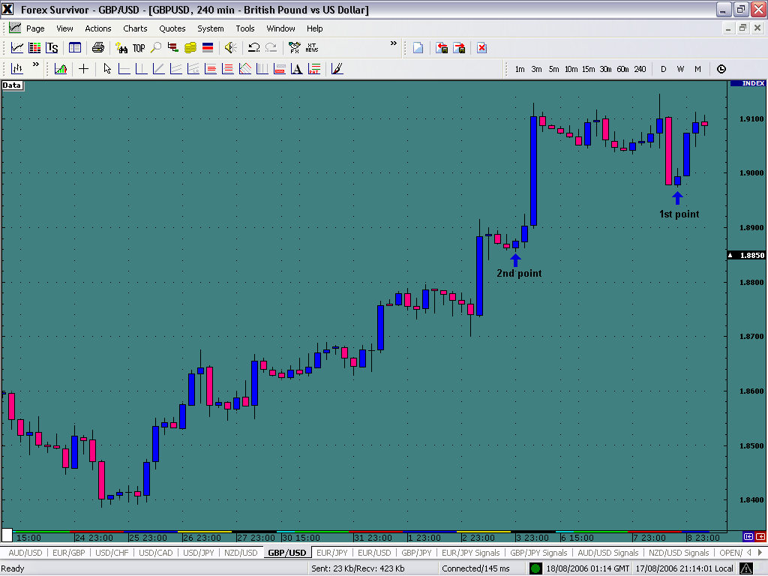

In the chart above, I have marked the two points that will be used to create the demand line, remember only two points are used to create our trend lines. Notice how I refer to the most recent point of support on the chart as the 1st point, remember we trade the most dynamic market in the world, right to left is the key. To find the second point of the demand line we look for the very next point of support that has two candles to the left and two to the right that do not exceed the low of the support point.

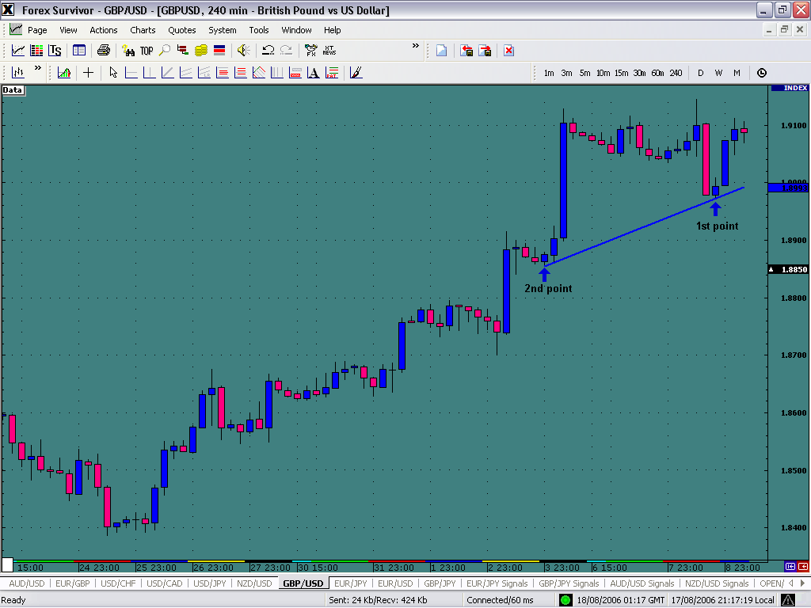

Once we have created of trend line, our next step is to use this trend line to create a downside price projection once the market opens a candle on the four hour chart below the demand line. Note I only say once the market opens a candle, mentioned nothing about close because only the open of a candle is necessary to create the price projection. The price projection is created this way; you take the highest high created above the demand line and mark it with a vertical line. As pictured in the example below:

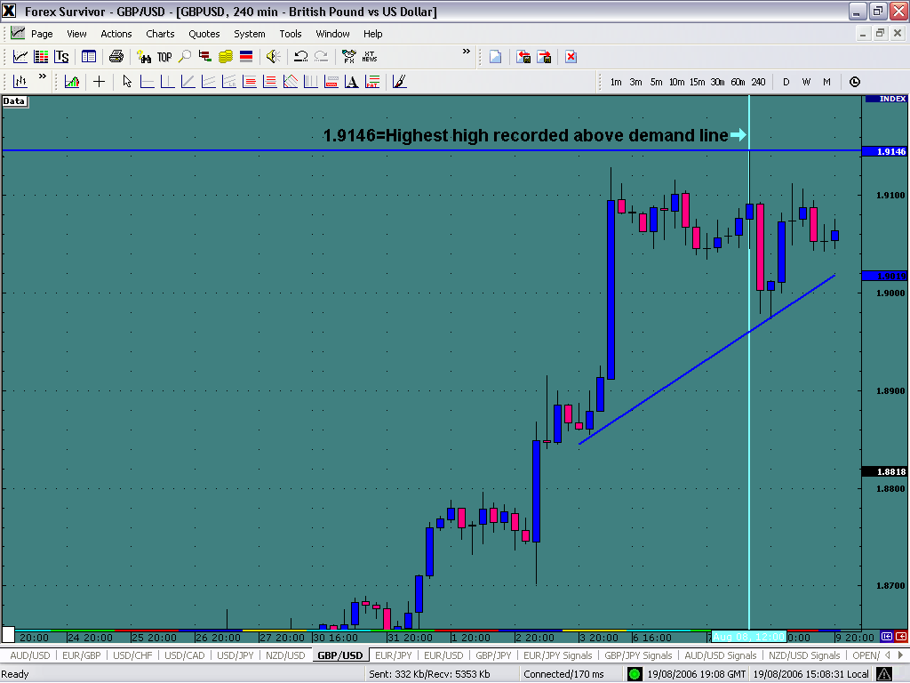
Next you need to take a horizontal line and mark the point where the vertical line coming from the highest high recorded above the trend line intersect with the trend line. What seems complicated at first will be much easier observed and understood in the example below.

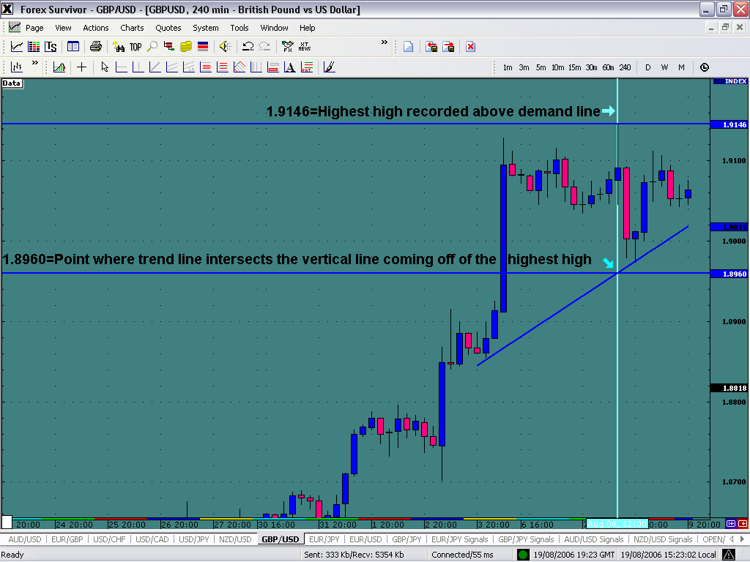

Note the two values listed on the chart. In the next step we take the difference between the highest high recorded above the demand line and the point where the demand line is intersected by the vertical line.

Highest High 1.9146
-
Point of intersection 1.8960
0.0186

We get a difference of 186 pips. This number becomes our price projection. The final step in the process is the point of application of the price projection. The price projection will be 186 pips to the downside once a four hour candle has opened below the demand line. It is key to become accustomed to this technique because price usually reacts quickly to the downside once a candle has opened beneath the demand line. Valuable pips will be lost if the trader does not react quickly in many cases.

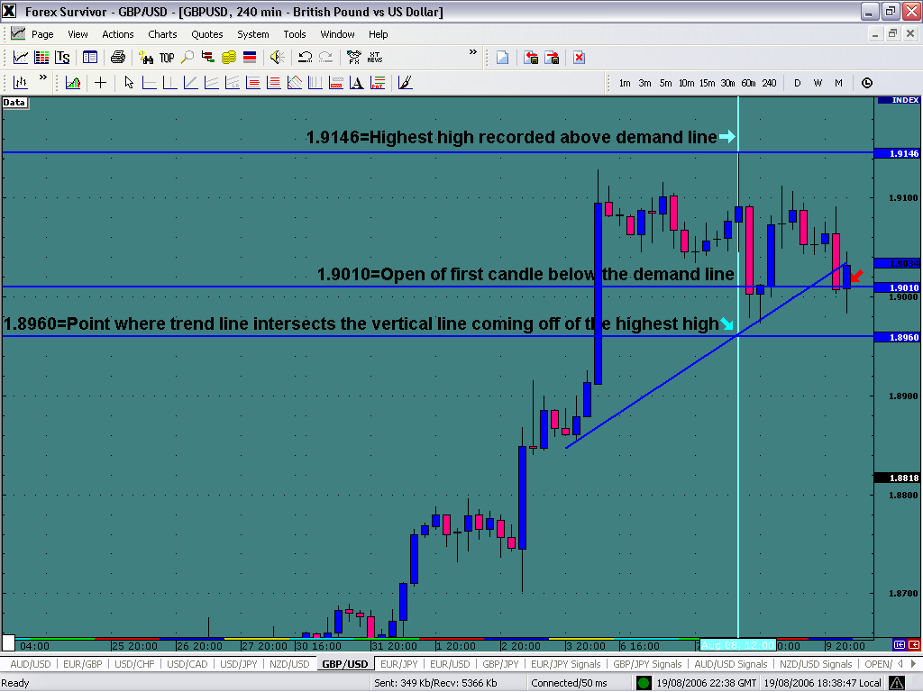

The price projection is made at the open of the first candle to open below the demand line. For visual reasons above the candle has closed also, but the price projection should be projected immediately following the open of the candle. Remember, we don’t need the candle to open and close below the demand line in order to make our price projection, only the open is needed. Above in the example, we have an open value of the first candle below the demand line at 1.9010. From this value we will subtract the 186 pip difference we got from step 2.

Open below demand line 1.9010
-
Difference from Step #2 0.0186
1.8824

1.8824 becomes our price projection to the downside from the open of 1.9010. This is a 186 pip potential trade.

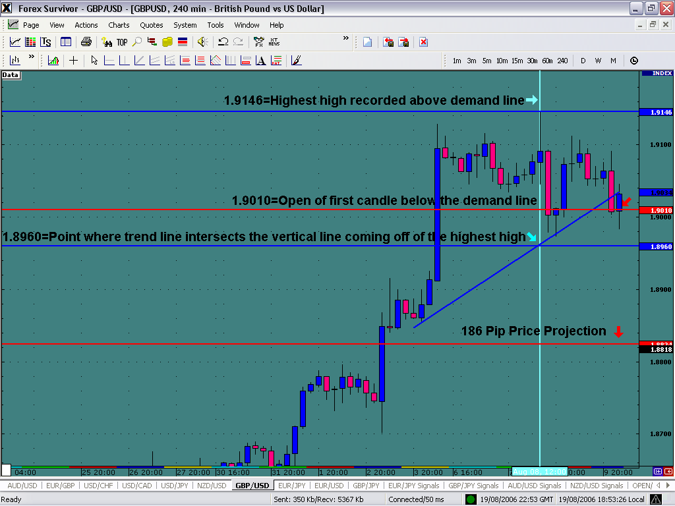

Notice the price projection marked at the bottom of the page. The line was place 186 pips below the open of the first candle below the demand line. Let’s see the trade just one candle after entry.

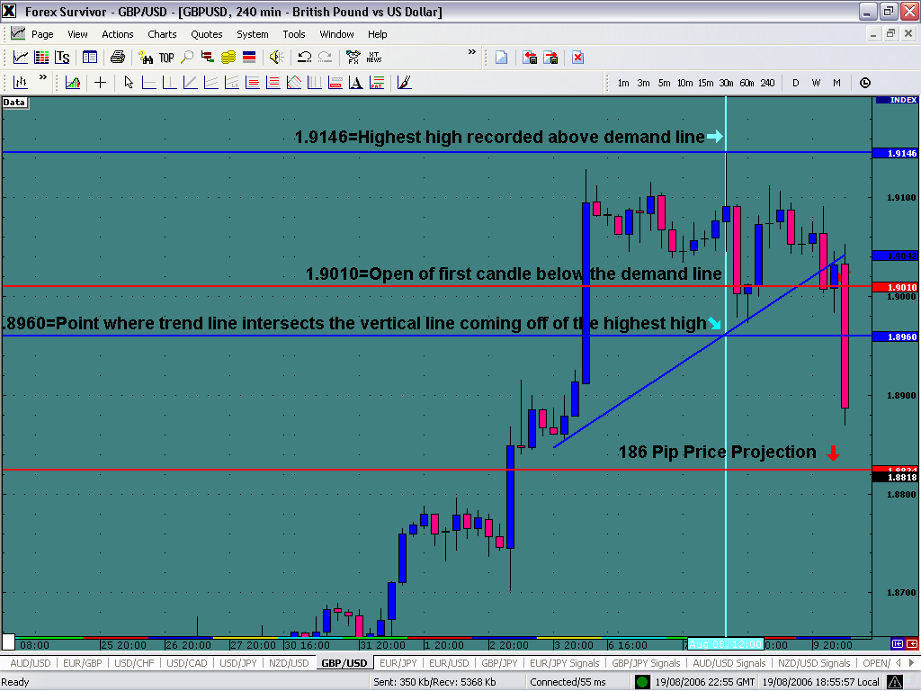

Note the rapid decline in the value of the currency once it breaks the demand line. Let’s see if it reaches the full price projection.
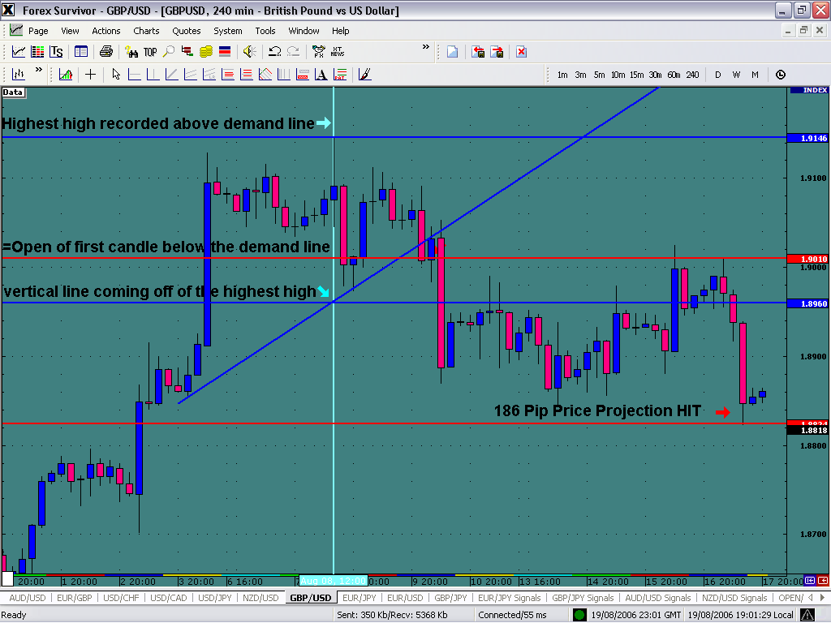

Notice how price fulfilled the 186 pip price projection. What may seem at first to be a complicated task, once reviewed and practiced by traders becomes a very easy and profitable way to trade. Trend line projections give the trader the best overall view of where the market will be going. In the above examples we have discussed demand lines and the downside price projections once the demand line is broken. In the next section we will discuss supply lines and the upside projections that are created from supply line breaks. The same technique is used in both instances except you are using know a supply line instead of a demand line and you will be projecting a upside breakout instead of a downside breakout.

You can now proceed to learning demark2.doc

