In order to create a supply line, it is necessary to locate the two points that create the supply line. Remember that a supply line is the same thing as a down trend line. A supply is created when supply exceeds demand; this is where the name supply line is derived from. When choosing the points to create a supply line we are focusing on points of resistance. True points of resistance are only those which high has two candles to the left of it and two candles to the right of it which highs do not exceed the high you are using as your point of resistance. See the examples below for reference of true resistance points.

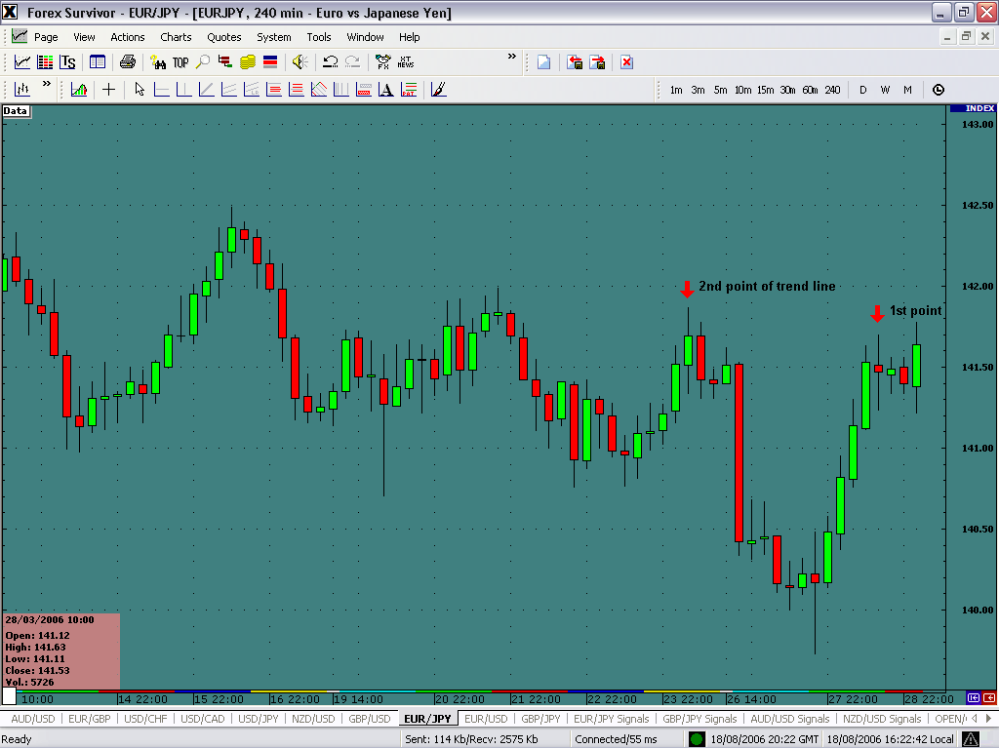

Notice how both points of resistance have two candles to the left and two candles to the right that do not exceed the high of the resistance point being used. Next we connect these two points of true resistance to create our supply line.

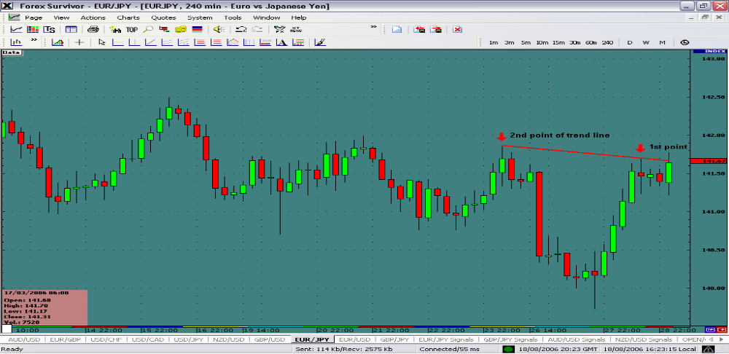
Once we have created the supply line we want to draw a vertical line through the candle that has the lowest recorded low below the supply line. From this line we want to record the value where the vertical line intersects the supply line and also the value of the lowest recorded low beneath the supply line.

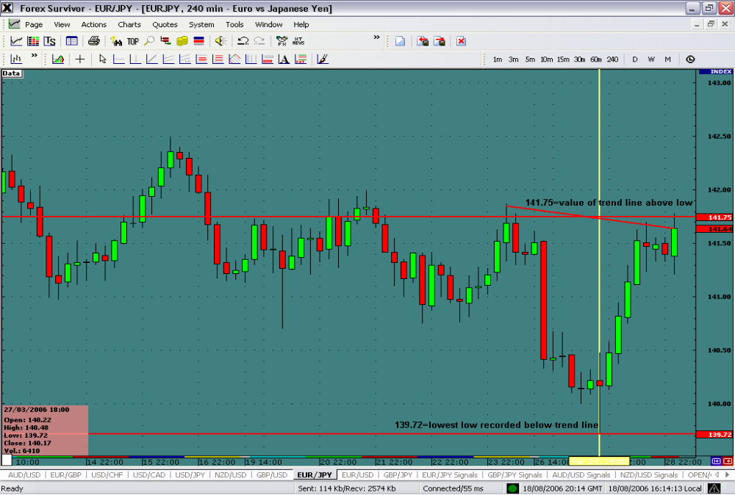

By calculating the difference of these two values we arrive at the price projection pip value. In this example we want to perform the following equation:

Value of trend line a lowest low intersection 141.75
-
Lowest recorded low beneath supply line 139.72
203 pips

We have now arrived at a projection point of 203 pips to the upside from the open of the first candle above the supply line.

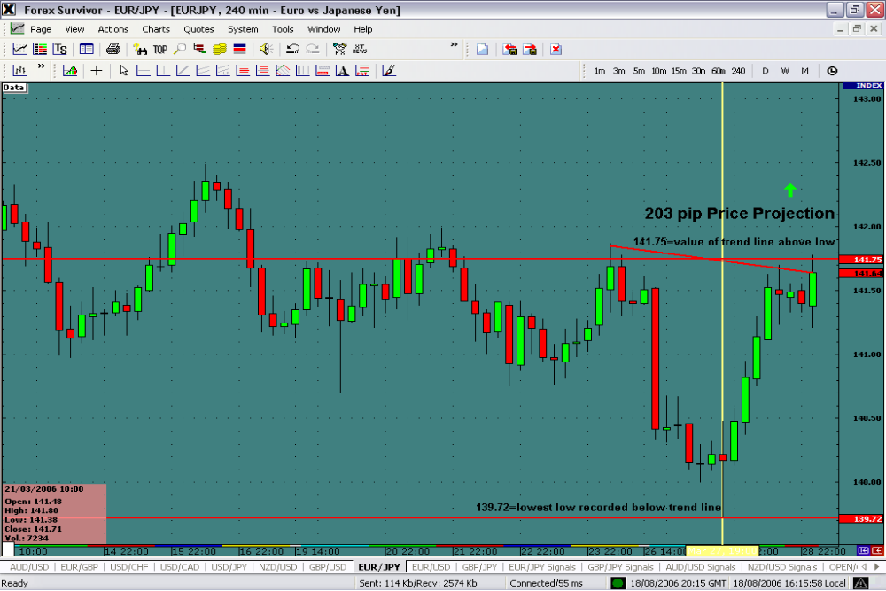

We are now waiting for the first candle to open above the supply line so we can add 203 pips to that to arrive at our exact price projection.

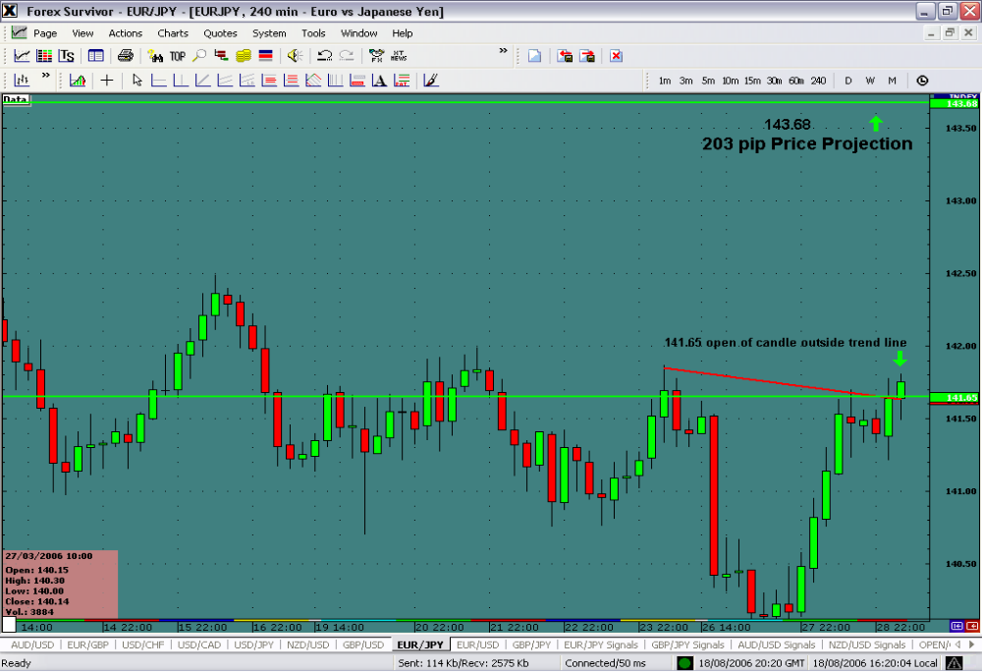
The first candle has opened above the supply line so it is possible to calculate the price projection by adding 203 pips to the open price.

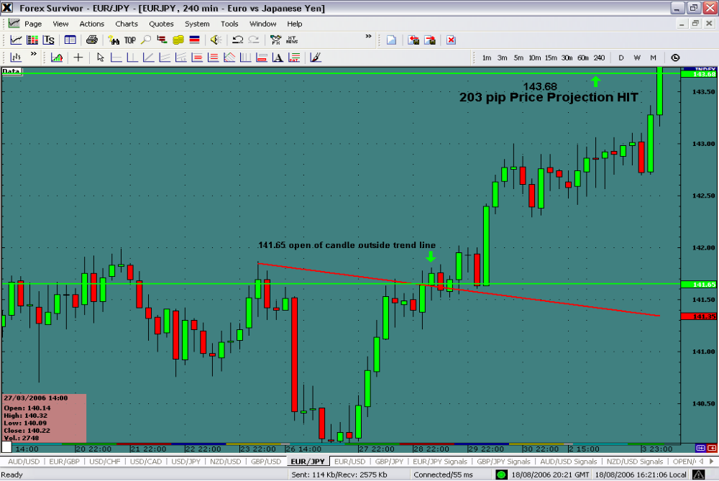

Price projection of 203 pips targeted. This concludes the section on supply and demand line breaks and price projections. Attached are several power point examples to help you better understand this technique.

You can now proceed to learning demark3.doc

