Stop Loss for Trades with less than 90 pip price projection

for trades with less than a 90 pip price projection a stop loss of 50% of the price projection is used. This creates a 2:1 reward/risk ratio. 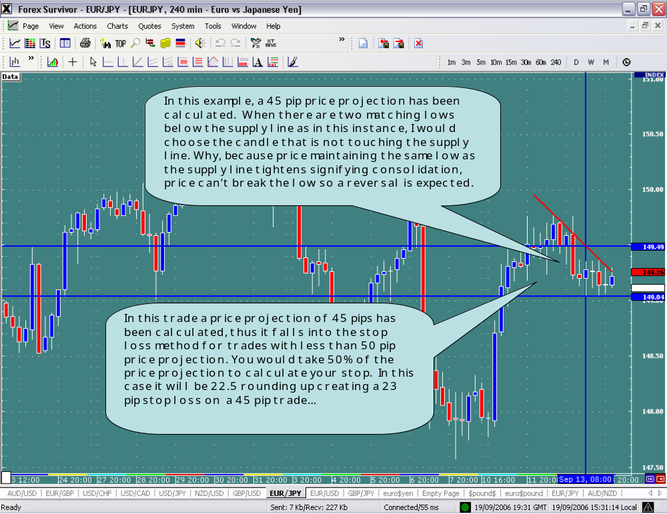
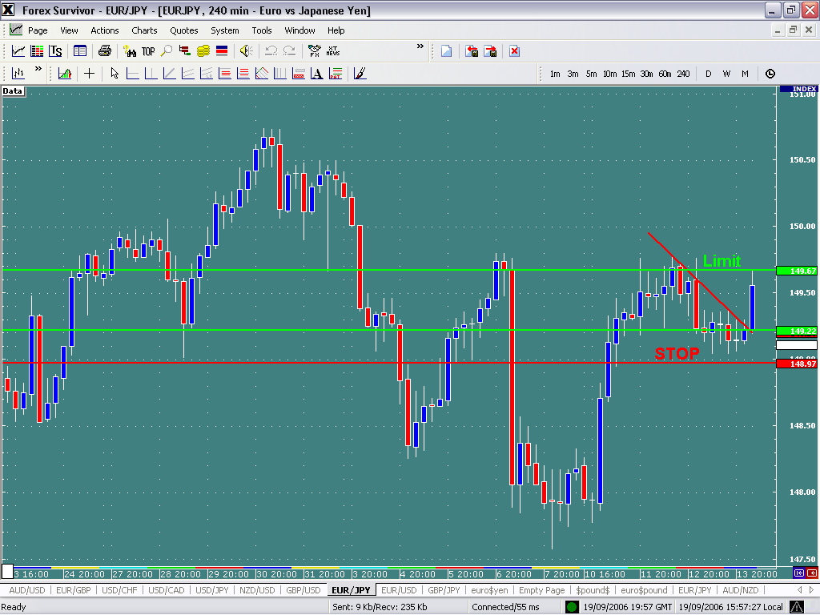

45 pip price projection paid out in the first 4 hour candle. From the open of the open of the 4 hour candle that broke the supply line to the upside @149.22 price didn’t even go one pip against in this case, but you can still notice the 23 pip stop placed on the chart.

Stop loss for trades with 90 and greater pip price projection

For trades with a price projection of 90 pips and greater a stop loss of 33% of the calculated price projection is used. This creates a 3:1 reward/risk ratio.

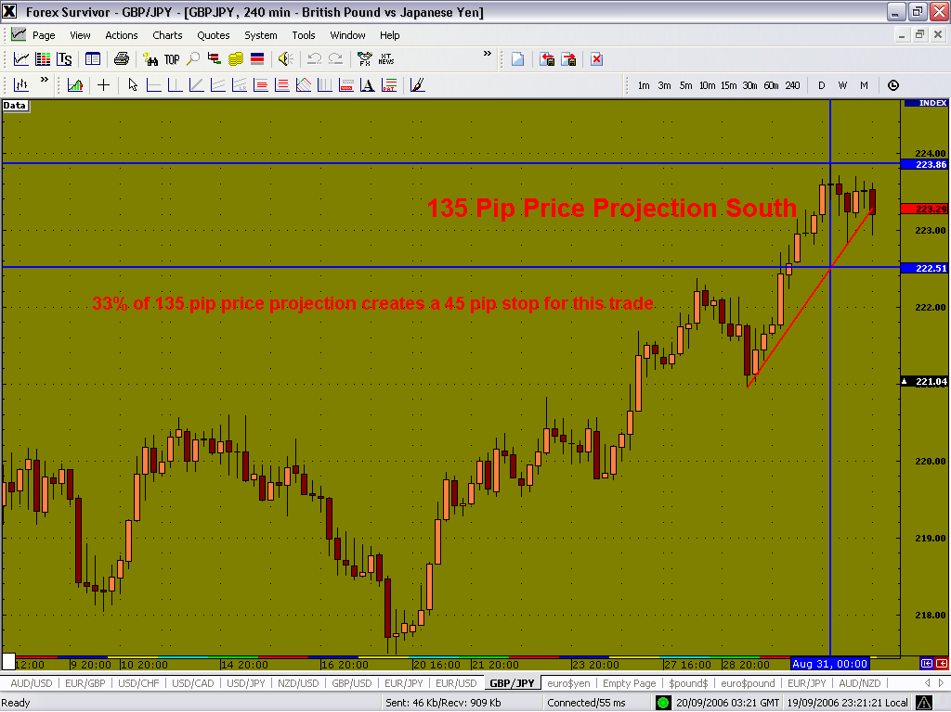

On this specific trade a 135 pip price projection has been calculated. By taking 33% of this price projection a 45 pip stop is calculated.

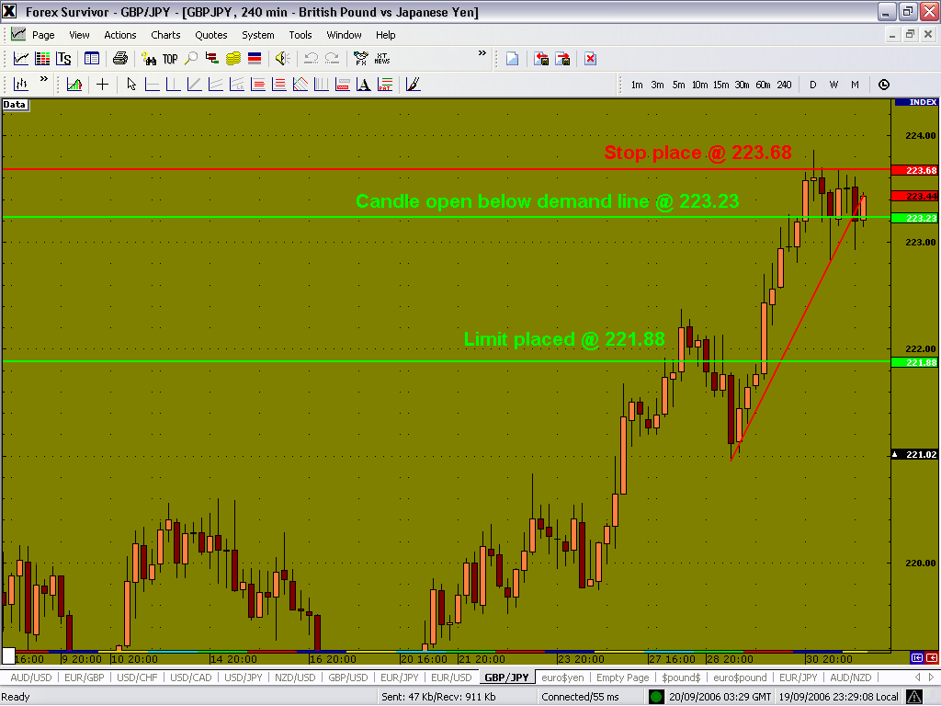

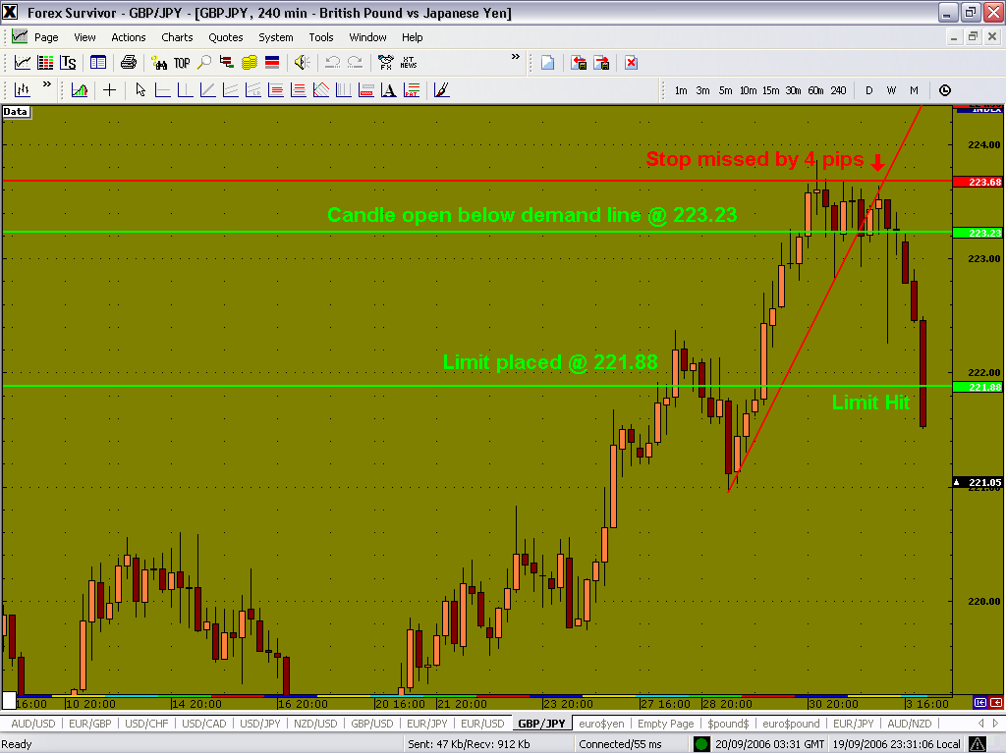

Additional Information

To protect winning positions, when any trade is 40 pips in profit, it is strongly advised to change your stop to 10 pips profit. This technique was derived after seeing several trades in large profits turn bad. The worst thing I believe for a trader to see, is a profitable position turn negative. This way you at least lock in 10 pips profit by moving your stop once in profit 40 pips

FILTERS:

If any of the four qualifiers are true, the trendline break is valid.

Upside breakout qualifiers

Qualifier 1: The price bar prior to an upside breakout must be a down close.
Qualifier 2: The current price bar’s open must be greater than both the current TD Supply Line and the previous price bar’s close and must then trade at least one tick higher.
Qualifier 3: The previous price bar’s close plus the previous bar’s “buying pressure” must be below the current price bar’s TD Supply Line price level.

First, we need to know how to calculate the “buying pressure” of the previous bar. It’s quite simple: We take the low of a bar and the close of the bar. Say it closed at 1.8559 and the low was 1.8531. We take the difference, and add that to the close. 1.8559-1.8531 = .0028. 1.8559 + .0028 = 1.8587. So we have 1.8587 as our “buying pressure” value. If our “buying pressure” value is above the trendline, then we do not take the trade, as, theoretically, the buying momentum has been “exhausted before the penetration of a TD line.” Similarly, if the buying pressure is below the TL, then watch for an opportunity of a trendline break.

Qualifier 4: The current price bar’s open must be above both the previous two price bars’ closes, and the current price bar’s TD Supply Line must be above the previous price bar’s high.

Downside breakout qualifiers

Qualifier 1: The price bar prior to a downside breakout must be an up close.
Qualifier 2: The current price bar’s open must be less than both the current TD Demand Line and the previous price bar’s close and must then trade at least one tick lower.
Qualifier 3: The previous price close minus the previous bar’s “selling pressure” must be above the current price bar’s TD Demand Line price level.
Qualifier 4: The current price bar’s open must be below both the previous two price bars’ closes, and the current price bar’s TD Demand Line must be below the previous price bar’s low.

• “Exit if the bar after the breakout bar opens below the breakout price level.”
• “Exit if the bar after the breakout bar opens below the close of the breakout bar and closes below the breakout price level.”
• “Exit if the bar after the breakout bar fails to exceed the high of the breakout price bar.

I hope this was helpful.
Please let me know if you need anything.

Sincerely Yours,
Austin Winston

