Riyanna Wilson
IT 214-DL1
Happy Learning Database ERD and Description
The following is an in-depth descriptions and image of the ERD of the Happy Learning Database Kindergarten school. The following design includes descriptions of all information stored including students, parents, classes, and teachers.
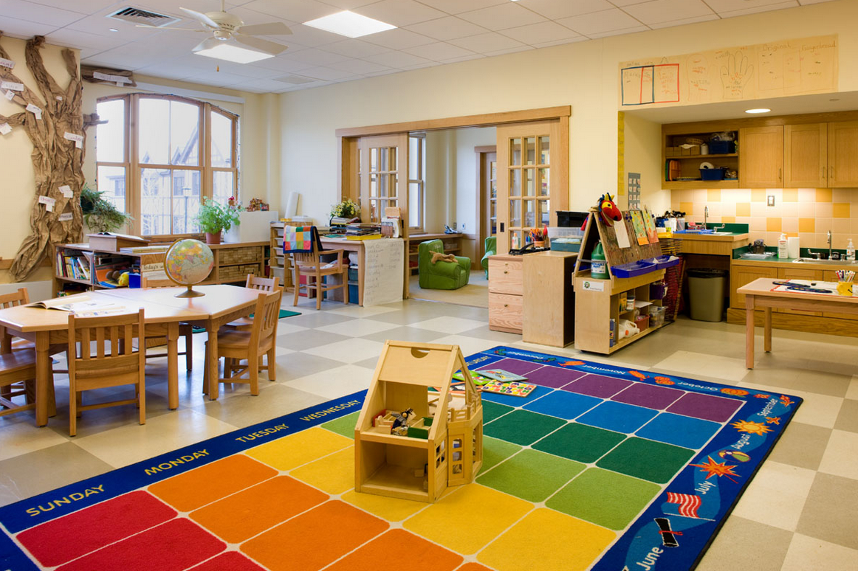

Conceptual Analysis
The main entities are class, teacher, parent, and student. The teachers teach the classes; the students are assigned to a class. The student parent bridge is what connects the students with their parents. The teacher and class entities have a one-to-many relationship because each class will have one teacher and teachers can have many classes. The class and student entities also have a one-to-many relationship because student is in one class and one class has many students. The student and parent entities have a many-to-many relationship because a student can have more than one parent, and parents can have more than one student. In order to demonstrate the many-to-many relationship between the students and parents the STUDENT_PARENT bridge is made that will have foreign keys from the parent and student entities.
Entities Analysis
CLASS_RW is the entity that stores information about the classes in Happy Learning. The information that is stored in this table includes class code, classroom number, phone, maximum capacity, directions, and the teacher code. Each class has one teacher. We have this in order to keep track of each class and always know where they are in the building and which staff is in charge of them.
Attribute Name | Attribute domain and size | Simple/Composite | Single/multi-value | Require/Optional | Unique/Duplicated
CLASS_CODE_RW | CHAR(2) | Simple | Single | Required | Unique
ROOM_NUMBER_RW | VARCHAR(10) | Simple | Single | Required | Duplicated
PHONE_RW | CHAR(14) | Simple | Single | Required | Duplicated
MAX_CAPACITY_RW | TINYINT | Simple | Single | Required | Duplicated
DIRECTIONS_RW | VARCHAR(130) | Simple | Single | Optional | Duplicated
TEACHER_ID_RW | INT | Simple | Single | Required | Duplicated

The primary key is the class code and it is a simple key. The foreign key is TEACHER_ID_RW and it references the TEACHER_ID primary code in the TEACHER table.
The STUDENT_RW entity stores all the information on the students that are enrolled in the school. Information includes first and last name, and middle name and nickname if the have one. Their date of birth and address information will also be included. This way we know every single child that is enrolled and their personal information in order to contact parents if need be.
Attribute Name | Attribute domain and size | Simple/Composite | Single/multi-value | Required/Optional | Unique/Duplicated
STUDENT_ID_RW | INT | Simple | Single | Required | Unique
FIRST_NAME_RW | VARCHAR(22) | Simple | Single | Required | Duplicated
MIDDLE_NAME_RW | VARCHAR(22) | Simple | Single | Optional | Duplicated
LAST_NAME_RW | VARCHAR(22) | Simple | Single | Required | Duplicated
NICKNAME_RW | VARCHAR(20) | Simple | Single | Optional | Duplicated
DATE_OF_BIRTH_RW | DATE | Simple | Single | Required | Duplicated
STREET_RW | VARCHAR(35) | Simple | Single | Required | Duplicated
CITY_RW | VARCHAR(15) | Simple | Single | Required | Duplicated
ZIP_CODE_RW | CHAR(5) | Simple | Single | Required | Duplicated
CLASS_CODE_RW | CHAR(2) | Simple | Single | Required | Duplicated
The primary key is the STUDENT_ID_RW and it is a surrogate key because it is artificial. The foreign key is CLASS_CODE_RW and it refers to the primary key CLASS_CODE_RW in the CLASS_RW table.
The PARENT_RW entity stores important information on the parents who have children enrolled at Happy Learning. Information includes their names, different phone numbers, and emails. This way we can contact any parent in case of emergencies or updates and know who their child is.
Attribute Name | Attribute domain and size | Simple/Composite | Single/Multi-value | Required/Optional | Unique/Duplicated
PARENT_ID_RW | INT | Simple | Single | Required | Unique
FIRST_NAME_RW | VARCHAR(22) | Simple | Single | Required | Duplicated
MIDDLE_NAME_RW | VARCHAR(22) | Simple | Single | Optional | Duplicated
LAST_NAME_RW | VARCHAR(22) | Simple | Single | Required | Duplicated
HOME_PHONE_RW | CHAR(14) | Simple | Single |  | Duplicated
MOBILE_PHONE_RW | CHAR(14) | Simple | Single | Optional | Duplicated
WORK_PHONE_RW | CHAR(14) | Simple | Single | Optional | Duplicated
PERSONAL_EMAIL_RW | VARCHAR(30) | Simple | Single | Optional | Duplicated
The primary key is PARENT_ID_RW and it is a surrogate key because it is artificial and assigned to all parents in the system. There are no foreign keys because of the STUDENT_PARENT_RW bridge that is used to connect the other entity. Even though the phone attributes are optional, at least one of them must be filled in in order to properly contact parents.
The TEACHER_RW entity stores all the information on each teacher that we have at Happy Learning. The information included will be things such as name, phone number, email. And some information on their prior education in order to establish their credibility. We have this entity included to keep track of each of our staff members and ensure we have the credentials on account in order reference at any given moment.
Attribute name | Attribute domain and size | Simple/Composite | Single/multi-value | Required/Optional | Unique/Duplicated
TEACHER_ID_RW | INT | Simple | Single | Required | Unique
FIRST_NAME_RW | VARCHAR(22) | Simple | Single | Required | Duplicated
MIDDLE_NAME_RW | VARCHAR(22) | Simple | Single | Optional | Duplicated
LAST_NAME_RW | VARCHAR(22) | Simple | Single | Required | Duplicated
HOME_PHONE_RW | CHAR(14) | Simple | Single | Required | Duplicated
WORK_EMAIL_RW | VARCHAR(30) | Simple | Single | Required | Duplicated
PERSONAL_EMAIL_RW | VARCHAR(30) | Simple | Single | Optional | Duplicated
GRADUATED_COLLEGE_RW | VARCHAR(100) | Simple | Single | Required | Duplicated
HIGHEST_DEGREE_RW | VARCHAR(5) | Simple | Single | Required | Duplicated
DEGREE_AREA_RW | VARCHAR(25) | Simple | Single | Required | Duplicated
The primary key is TEACHER_ID_RW and it’s a surrogate primary key because it is artificial. There are no foreign keys because the relationship is shown by TEACHER_ID_RW in CLASS_RW. All teachers must have a bachelor’s degree in order to teach at Happy Learning.
The STUDENT_PARENT_RW is a bridge entity that is used to connect the parents and students. We have this bridge because knowing which student belongs to which parent so we can contact them and let them know about their child’s performance. The explanation of the relationship between the two will also be stored in this table
Attribute name | Attribute domain and size | Simple/composite | Single/multi-value | Required/optional | Unique/duplicated
STUDENT_ID_RW | INT | Simple | Single | Required | Duplicated
PARENT_ID_RW | INT | Simple | Single | Required | Duplicated
RELATIONSHIP_TO_CHILD_RW | VARCHAR(20) | Simple | Single | Required | Duplicated
The primary key is STUDENT_ID_RW and PARENT_ID_RW and it is a composite primary key because it is made up of two attributes. The foreign keys are STUDENT_ID_RW which references STUDENT_RW table and PARENT_ID_RW which references the PARENT_RW table.
Entity Relationship Diagram
