BABU BANARASI DAS
UNIVERSITY

2026-2027

SCHOOL OF COMPUTER APPLICATIONS
No SQL Project On
Student Management System Using MongoDB

Submitted to: Submitted by:
Mr. Harendra Singh Riyanshi Tripathi
Department: BCA (DS & AI) Roll no: 50
Date: 25th September University Roll no: 1250258368

OBJECTIVES
- To understand the concept of NoSQL databases.
- To learn the basic features of MongoDB.
- To create a database and collection.
- To insert 50 student records.
- To perform CRUD operations.
- To use comparison operators.
- To perform sorting and filtering.
- To understand AND and OR operations.

1. CREATE DATABASE
MongoDB Query:
use Students
Explanation: Creates or switches to the Student database.

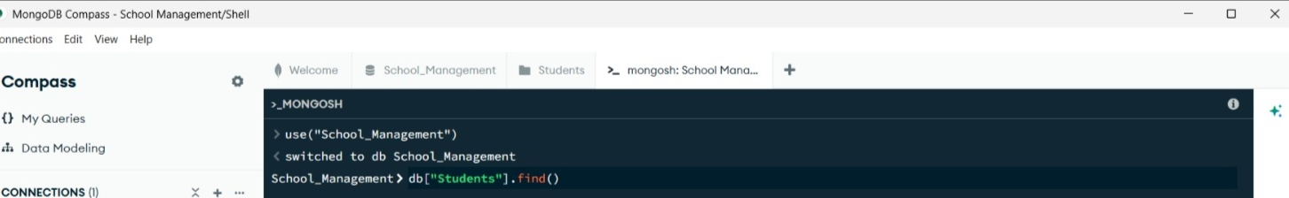

2. CREATE COLLECTION
MongoDB Query:
db. create Collection("students")
Explanation: Creates a collection named students.
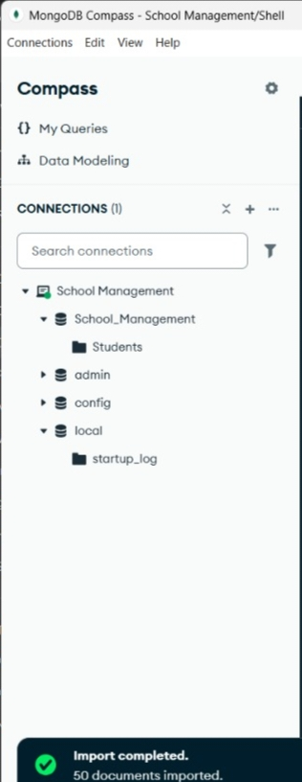
3. INSERT 50 STUDENTS
MongoDB Query:
db. students. Insert Many([ ])
{roll:1, name:"Riya", age:19, marks:87, city:"Lucknow"},
{roll:2, name:"Aarav", age:18, marks:74, city:"Kanpur"},
{roll:3, name:"Kavya", age:19, marks:93, city:"Lucknow"},
{roll:4, name:"Mohit", age:20, marks:68, city:"Agra"},
{roll:5, name:"Tanvi", age:19, marks:82, city:"Varanasi"},
{roll:6, name:"Yash", age:18, marks:88, city:"Prayagraj"},
{roll:7, name:"Ishita", age:19, marks:91, city:"Lucknow"},
{roll:8, name:"Sahil", age:20, marks:57, city:"Meerut"},
{roll:9, name:"Diya", age:18, marks:79, city:"Kanpur"},
{roll:10, name:"Karan", age:19, marks:64, city:"Gorakhpur"},
{roll:11, name:"Pooja", age:20, marks:85, city:"Lucknow"},
{roll:12, name:"Manav", age:18, marks:71, city:"Bareilly"},
{roll:13, name:"Simran", age:19, marks:96, city:"Lucknow"},
{roll:14, name:"Tushar", age:20, marks:76, city:"Varanasi"},
{roll:15, name:"Bhavna", age:18, marks:83, city:"Agra"},
{roll:16, name:"Rajat", age:19, marks:62, city:"Jhansi"},
{roll:17, name:"Muskan", age:20, marks:89, city:"Kanpur"},
{roll:18, name:"Deepak", age:18, marks:55, city:"Mathura"},
{roll:19, name:"Nikita", age:19, marks:92, city:"Lucknow"},
{roll:20, name:"Harsh", age:20, marks:70, city:"Prayagraj"},
{roll:21, name:"Palak", age:18, marks:86, city:"Ayodhya"},
{roll:22, name:"Vikas", age:19, marks:73, city:"Meerut"},
{roll:23, name:"Khushi", age:20, marks:94, city:"Lucknow"},
{roll:24, name:"Arjun", age:19, marks:88, city:"Varanasi"},
{roll:25, name:"Sneha", age:18, marks:67, city:"Gorakhpur"},
{roll:26, name:"Devansh", age:19, marks:81, city:"Kanpur"},
{roll:27, name:"Ritika", age:20, marks:78, city:"Lucknow"},
{roll:28, name:"Ashish", age:18, marks:59, city:"Bareilly"},
{roll:29, name:"Pallavi", age:19, marks:90, city:"Prayagraj"},
{roll:30, name:"Gaurav", age:20, marks:75, city:"Agra"},
{roll:31, name:"Komal", age:18, marks:84, city:"Lucknow"},
{roll:32, name:"Shivam", age:19, marks:66, city:"Jhansi"},
{roll:33, name:"Aditi", age:20, marks:95, city:"Lucknow"},
{roll:34, name:"Rishabh", age:18, marks:72, city:"Ayodhya"},
{roll:35, name:"Tanya", age:19, marks:87, city:"Kanpur"},
{roll:36, name:"Abhay", age:20, marks:61, city:"Mathura"},
{roll:37, name:"Mahima", age:19, marks:80, city:"Varanasi"},
{roll:38, name:"Kunal", age:18, marks:77, city:"Lucknow"},
{roll:39, name:"Payal", age:20, marks:91, city:"Prayagraj"},
{roll:40, name:"Sumit", age:19, marks:69, city:"Meerut"},
{roll:41, name:"Divya", age:18, marks:85, city:"Lucknow"},
{roll:42, name:"Lokesh", age:20, marks:58, city:"Gorakhpur"},
{roll:43, name:"Isha", age:19, marks:83, city:"Agra"},
{roll:44, name:"Piyush", age:18, marks:74, city:"Kanpur"},
{roll:45, name:"Garima", age:20, marks:89, city:"Lucknow"},
{roll:46, name:"Ankit", age:19, marks:65, city:"Bareilly"},
{roll:47, name:"Srishti", age:18, marks:93, city:"Varanasi"},
{roll:48, name:"Yogesh", age:20, marks:70, city:"Jhansi"},
{roll:49, name:"Nandini", age:19, marks:86, city:"Lucknow"},
{roll:50, name:"Faizan", age:18, marks:76, city:"Ayodhya"}
Explanation: Inserts multiple student documents into the collection.

4. DISPLAY ALL STUDENTS
MongoDB Query:
db. students. Find ()
Explanation: Retrieves documents from the students collection.
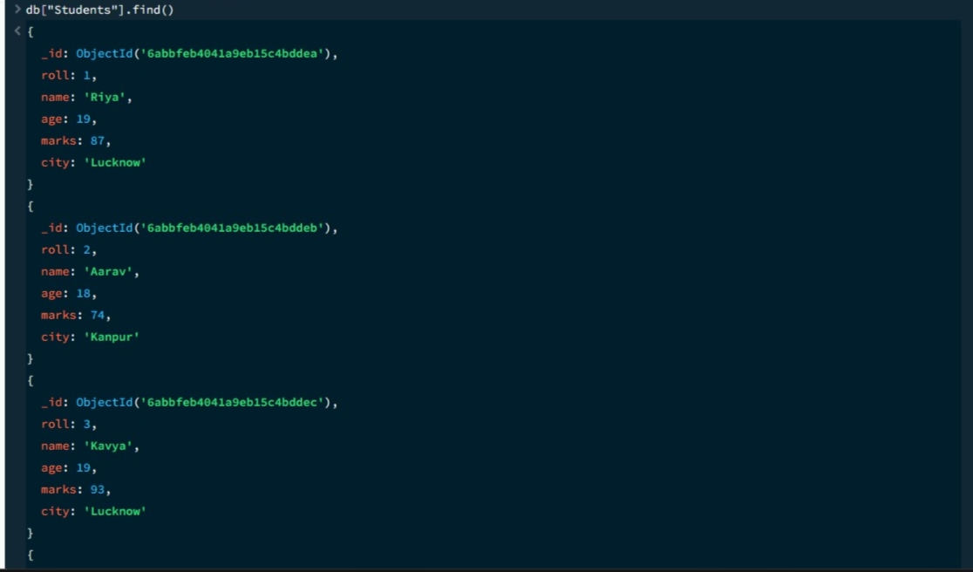
5. EQUAL TO — $eq
MongoDB Query:
db. students. Find ({marks: {$eq: 88}})
Explanation: Finds students whose marks are exactly 88.

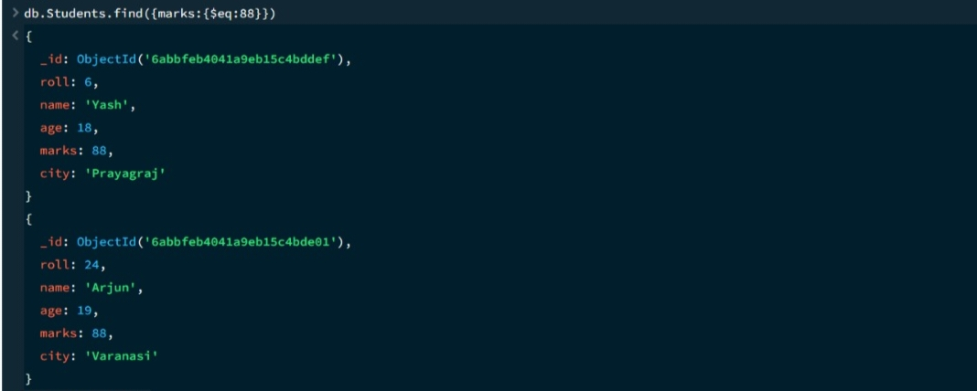
6. GREATER THAN — $gt
MongoDB Query:
db.students.find({marks: {$gt: 80}})
Explanation: Finds students whose marks are greater than 80.
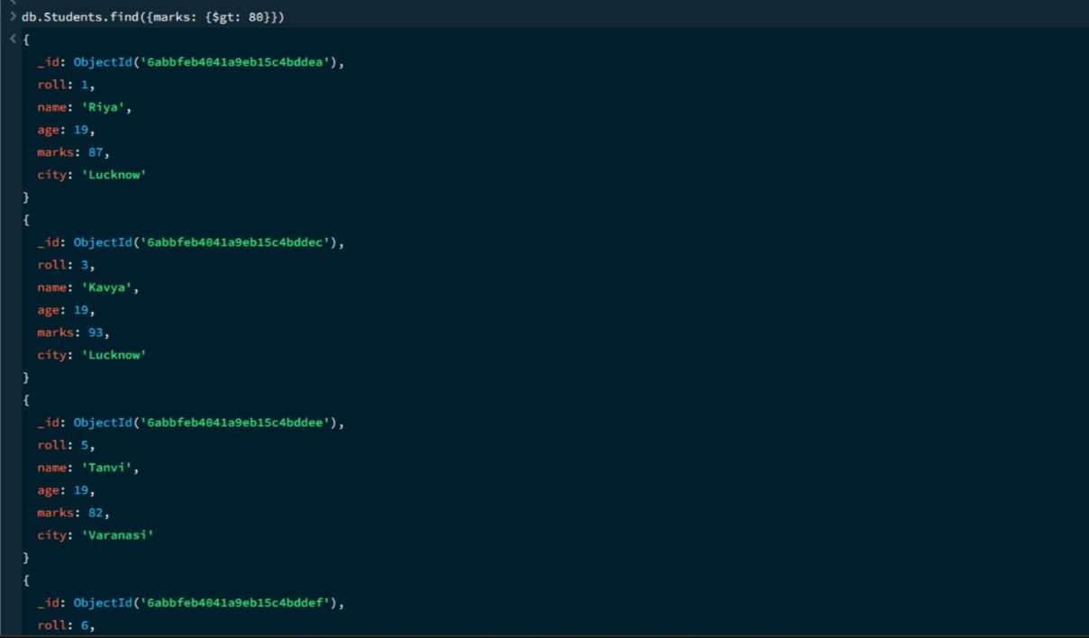

7. LESS THAN — $lt
MongoDB Query:
db. students. find ({marks: {$lt: 65}})
Explanation: Finds students whose marks are less than 65.

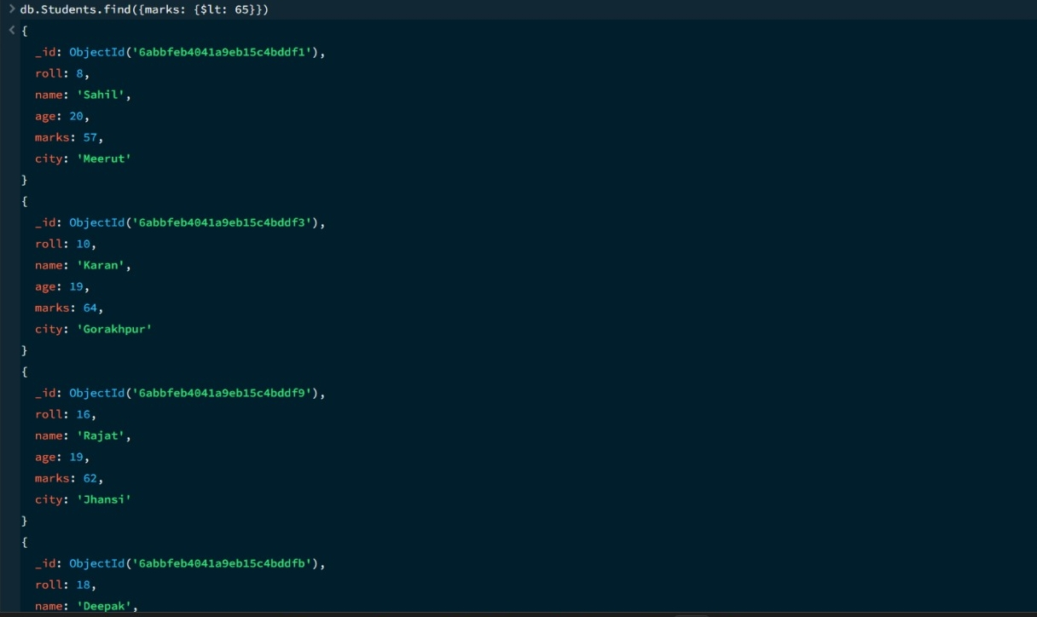
8. GREATER THAN OR EQUAL TO — $gte
MongoDB Query:
db. students. find({marks: {$gte: 92}})
Explanation: Finds students whose marks are 92 or above.

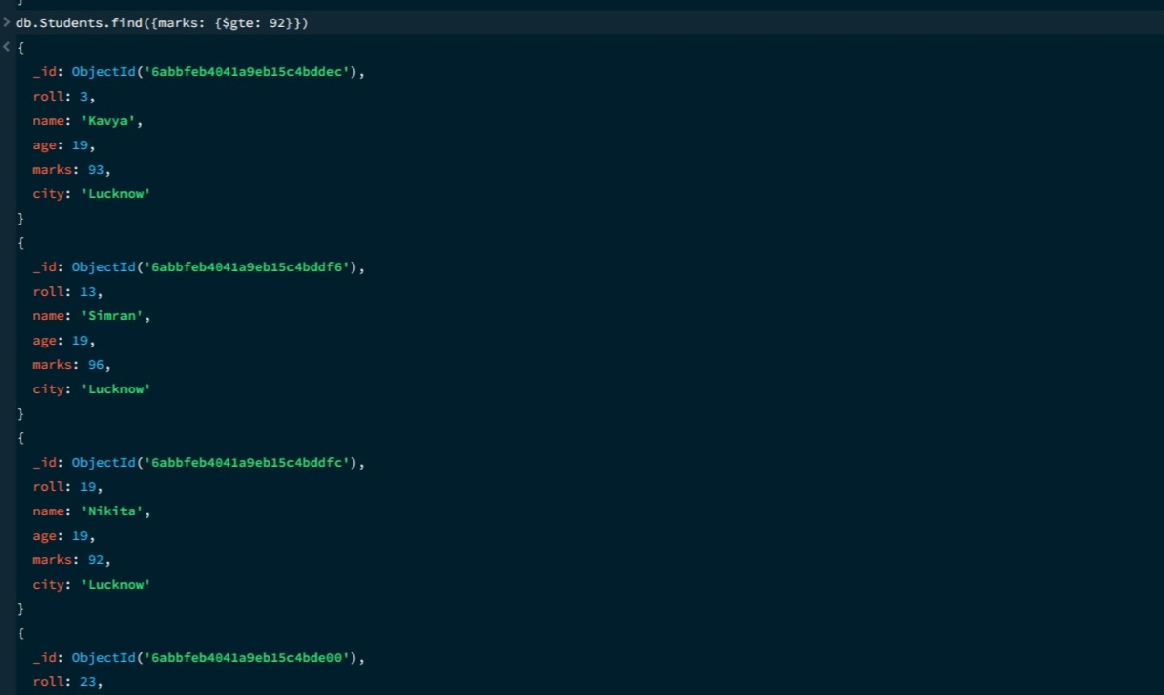

9. LESS THAN OR EQUAL TO — $lte
MongoDB Query:
db. students. find({marks: {$lte: 68}})
Explanation: Finds students whose marks are 68 or below.

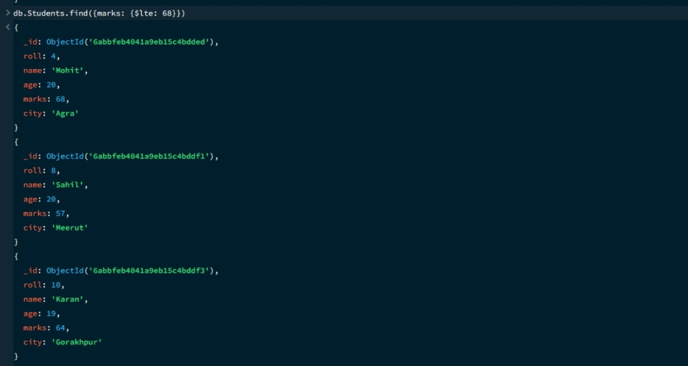

10. UPDATE OPERATION
MongoDB Query:
db.students.updateOne(
{roll:12},
{$set:{marks:90}}
)
Explanation: Updates the marks to 90 of the student with roll number 12.

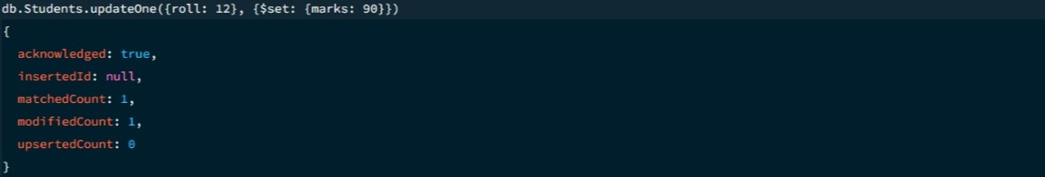

11. DELETE ONE OPERATION
MongoDB Query:
db.students.deleteOne({roll:20})
Explanation: Deletes one document matching roll number 20.

12. DELETE MANY OPERATION
MongoDB Query:
db.students.deleteMany({
marks: {$lt:62}
})
Explanation: Deletes all students having marks below 62.

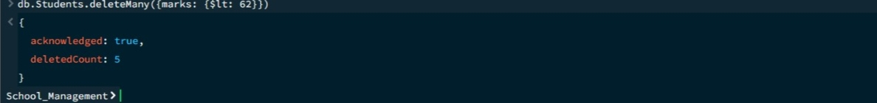

13. AND OPERATION — $and
MongoDB Query:
db. students. find({
$and:[
{marks:{$gt:75}},
{age:20}
]
})
Explanation: Finds students satisfying both conditions.
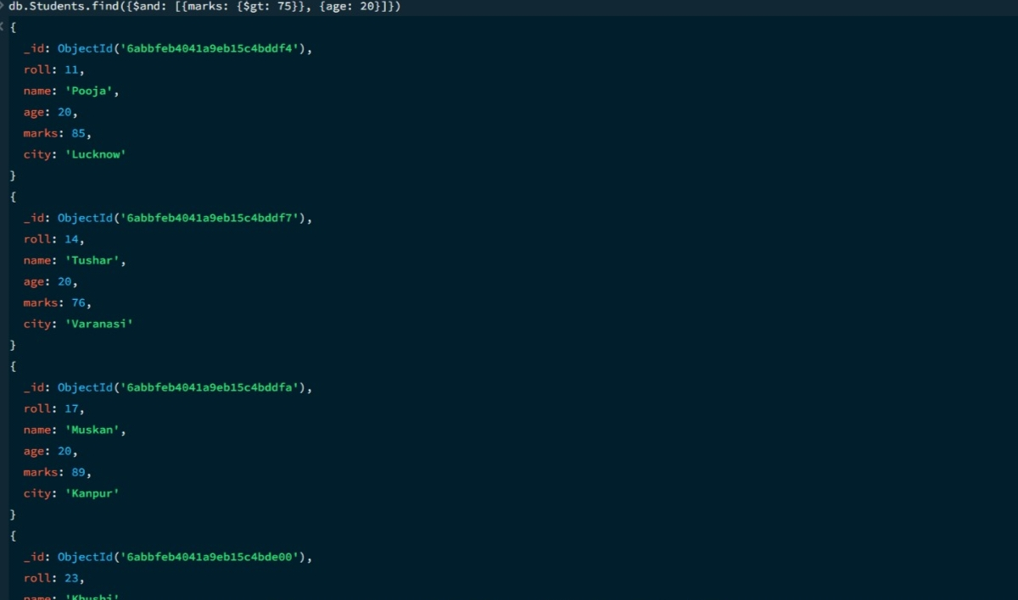

14. OR OPERATION — $or
MongoDB Query:
db.students.find({
$or:[
{city:"Agra"},
{city:"Varanasi"}
]
})
Explanation: Finds students from Agra or Varanasi.
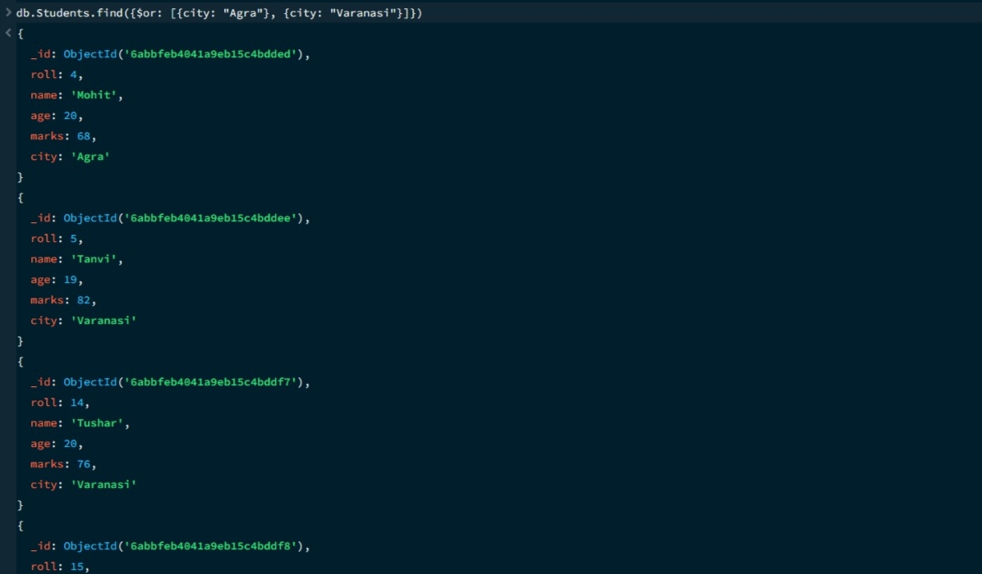

15. SORT OPERATION
A.MongoDB Query:
db. students. find (). sort({marks : 1})
Explanation: Sorts students by marks from lowest to highest. Use 1 for ascending order.
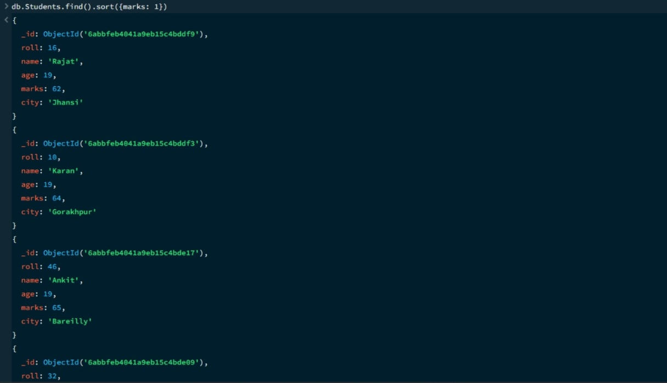

B. MongoDB Query:
db. students. find (). Sort ({marks: -1})
Explanation: Sorts students by marks from highest to lowest. Use -1 for descending order.
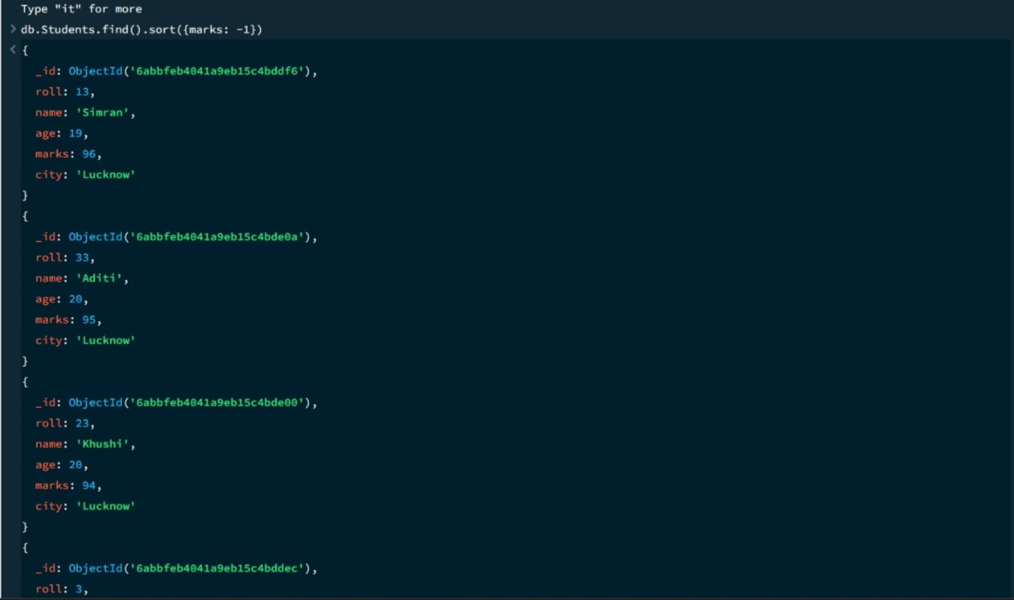
16. LIMIT OPERATION
MongoDB Query:
db. students. find (). limit (7)
Explanation: Displays only the first seven documents.

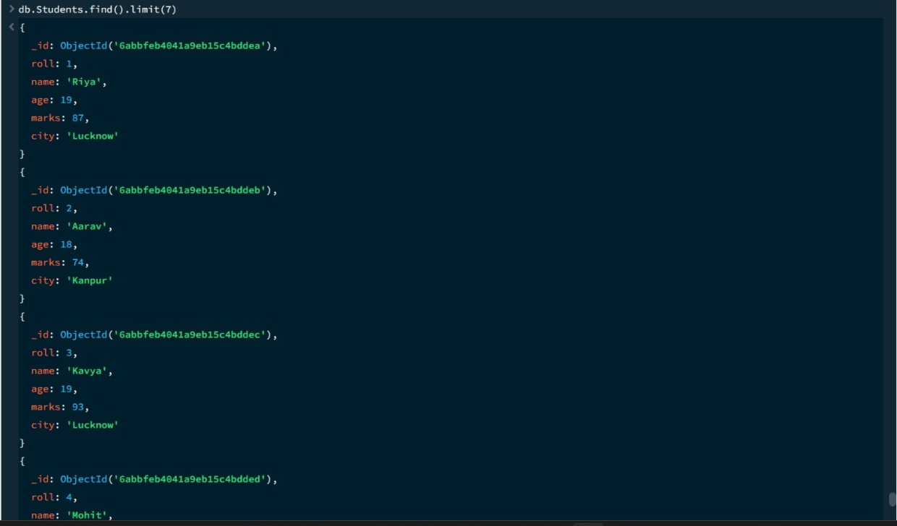

17. SEARCH BY CITY
MongoDB Query:
db.students.find({city:"Kanpur"})
Explanation: Finds all students whose city is Kanpur.
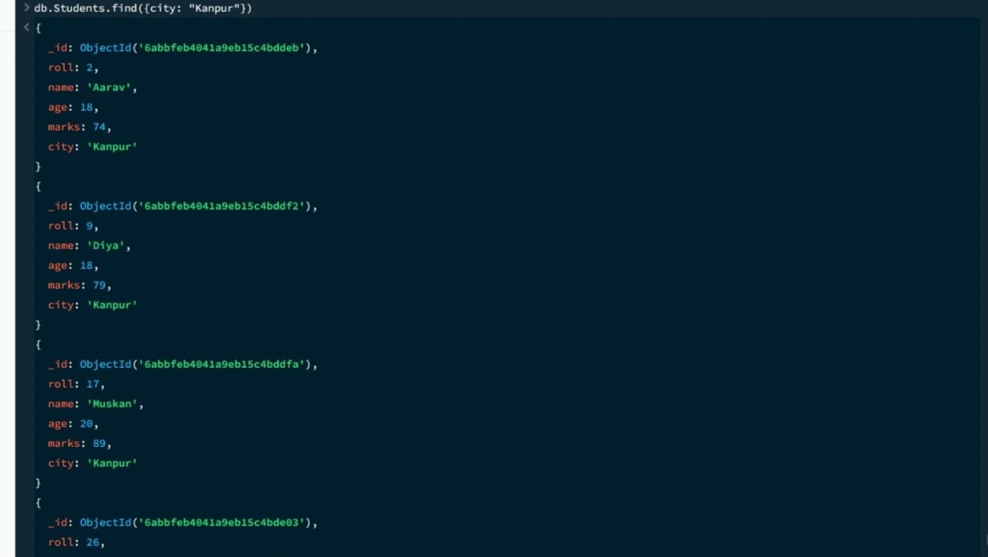

18. COUNT DOCUMENTS
MongoDB Query:
db. students. count Documents ()
Explanation: Counts documents currently present in the collection (performing after the delete function).

MONGODB OPERATORS USED:

Operator | Meaning | Example
$eq | Equal to | marks: {$eq:88}
$gt | Greater than | marks: {$gt:80}
$lt | Less than | marks: {$lt:65}
$gte | Greater than or equal to | marks: {$gte:92}
$lte | Less than or equal to | marks: {$lte:68}
$and | All conditions true | $and:[...]
$or | At least one condition true | $or:[...]

CONCLUSION
This project provided practical knowledge of NoSQL databases using MongoDB. A Student Management System containing student information was created and different MongoDB operations were performed on the data.
Through this project, I learned how to insert, retrieve, update, and delete documents. I also learned how to Ascending order & descending order data, comparison operators such as $eq, $gt, $lt, $gte, and $lte work, along with logical operators such as $and and $or.
Overall, this project helped me understand how MongoDB can be used to manage and query student data efficiently.

