Deliverable 2: Interim Progress Report
Cybersecurity Analytics Class Project
Deliverable | Deliverable 2: Interim Progress Report 1 | Selected Track | IDS (Intrusion Detection Systems)
Project Title | ScanShield: Detecting Network Port Scanning Using Flow-Level Traffic Analysis | Team Name | NetSentries
Team Members | Riya Sanjiv Pradhan; Ojas Prashant Suratkar | Submission Date | October 11, 2026
Repository | https://github.com/riyap3111/ScanShield | Dataset Link | https://www.kaggle.com/datasets/sateeshkumar6289/cicids-2017-dataset

Executive Status Snapshot
Item | Current status
Overall status | On track. Data audited, cleaned and split; EDA done; baselines trained on all 79 features; known-tester allowlist and slow-scan features implemented and tested. Random Forest and XGBoost next.
Most important accomplishment | Reproducible pipeline (286,467 → 213,602 flows); logistic regression on all features catches 99.8% of scans with 6 false alarms in 18,436 benign validation flows.
Most important risk | Scores may reflect tool-specific artifacts (1,024-byte TCP window in 49.6% of scans, 0.0% of benign); the allowlist and slow-scan controls need data with source IPs and timestamps to be evaluated.
Next milestone | Random Forest and XGBoost trained, tuned and tested for robustness by October 25, 2026; Status Report on November 8, 2026.

1. Project Status and Changes from Proposal
Since the proposal, the project has moved from planning to a working, reproducible pipeline. The team audited the CICIDS2017 PortScan file without modifying it, cleaned it in eight logged steps, completed the EDA, built the feature sets and splits, and trained four baselines. Two risk controls from the proposal, an allowlist for approved internal scanners and slow-scan features, are also now implemented; run_all.sh reproduces every result here in under two minutes (seed 42). Five changes were made:
• Class balance. The proposal expected benign traffic to dominate. The raw file is 55.5% PortScan, but after removing duplicates it is 57.5% benign and 42.5% PortScan. The imbalance is mild, so stratified splits and class weights replace resampling.
• All columns are kept. The proposal planned to narrow the 78 features. The team instead models on every column so no useful signal is lost; a pruned 43-feature set is kept only for comparison (validation false alarms: 17 pruned vs 6 all).
• Outside-day test data. The Monday file (529,918 benign flows) measures false alarms on another day; it is never used for training.
• Split strategy. The stratified 70/15/15 split remains primary; a time-ordered split was added because scans arrive in one burst.
• Risk mitigations moved into code. Internal scanners and slow scans, listed as risks in the proposal, now have tested solutions (Section 7, Appendix B).
Scope, success criteria (scan recall ≥ 0.90, benign FPR ≤ 5%), roles and schedule are unchanged and feasible; with both criteria already met, work shifts to robustness and deployment controls. No written instructor feedback on the proposal had been returned when this report was prepared.

2. Dataset Description and Data Dictionary
The data is CICIDS2017 from the Canadian Institute for Cybersecurity, University of New Brunswick (Sharafaldin et al., 2018; Canadian Institute for Cybersecurity, n.d.), obtained from a Kaggle mirror of the MachineLearningCVE release (sateeshkumar6289, n.d.). Simulated users generated benign traffic on a lab network from July 3 to 7, 2017, a separate network launched the attacks, and CICFlowMeter converted the captures into bidirectional flows (Lashkari et al., 2017). It is public for research with citation and holds no real user data.
The main file (Friday-WorkingHours-Afternoon-PortScan, the afternoon of July 7, 2017) has 286,467 records; each record is one network flow, the unit of analysis. It has 79 columns: 78 numeric features and a categorical Label. The features are integer counts, byte sizes and microsecond timings, plus floating-point rates, and fall into nine groups: packet and payload size (24), timing and inter-arrival times (15), TCP flags (12), active/idle periods (8), counts (6), bulk statistics (6), rates (4), TCP window (2) and port (1). The target is binary: BENIGN (127,537 raw rows, 44.5%) versus PortScan (158,930, 55.5%). After cleaning, 213,602 flows remain (122,908 BENIGN, 57.5%; 90,694 PortScan, 42.5%). The Monday file (July 3; 529,918 flows, all BENIGN) is used only to test false positives on another day. Splits are in Section 5; the data dictionary is in Appendix A.
Limitations: this release has no timestamp, IP or flow-ID columns, so temporal and host-grouped splits are not possible and the allowlist and slow-scan controls cannot be evaluated on it; traffic comes from one lab and one scanner (Nmap); and scans are far more common than on a real network, so deployed precision would be lower.

3. Data-Quality Assessment
Every check below was run on the raw file before any change (src/01_load_and_audit.py), and each fix is logged with row counts before and after (outputs/tables/cleaning_log.csv). The same cleaning function is applied to the Monday file (529,918 → 502,138 rows).
Table 1. Data-quality checks, evidence and treatment (PortScan file).
Issue checked | Evidence / magnitude | Treatment | Remaining risk
Missing / infinite values | 15 NaN and 727 inf cells in Flow Bytes/s and Flow Packets/s (zero-duration flows) | Dropped: 371 rows (245 benign, 126 scan) | Zero-duration flows need explicit handling in deployment
Invalid values | 176 rows with negative Flow IAT Min, incl. all 36 with negative Flow Duration (all benign) | Dropped as physically impossible | Low
Sentinel values | Init_Win_bytes = −1 (not observed): 60,210 forward, 76,942 backward rows | Kept; binary missing flags added | Linear models may read −1 as a number
Redundant columns | 10 constant; 8 exact copies (e.g. Fwd PSH Flags = SYN Flag Count) | Flagged but kept in the all-features sets; excluded only from the reduced comparison set | Copies split coefficient weight; SYN = Fwd PSH suggests a flag-extraction bug
Duplicates | 72,353 rows (25.3%): 68,111 scan (42.9% of scans), 4,242 benign (3.3%) | Removed before splitting | Near-duplicates remain, so random splits stay optimistic
Label quality | 0 identical feature vectors with conflicting labels | Check kept in pipeline | Known dataset label errors not detectable (Engelen et al., 2021)
Class imbalance | 55.5% scan raw; 42.5% after cleaning | Stratified splits; class weights; recall/FPR reported | Real networks have fewer scans
Outliers | Benign Flow Duration median 31 ms, 99th pct 118.2 s; 22.7% outside IQR fences | Kept (real flows); log transform | Low for tree models
Sampling bias | One lab network, one afternoon, one scanner | Monday outside-day test | High: may not transfer
Leakage / temporal validity | No timestamps; scan share across 20 file-order bins ranges 0.0%–99.4% (one burst) | Dedup before split; selection and scaling fit on train only; time-ordered split; with/without-port test | Random split places flows of one scan on both sides
What this means for modeling. Duplicates matter most: with almost half of scan rows repeated, a model would partly be scored on flows it had already seen, so de-duplication runs before any split. Invalid values affect under 0.2% of rows; −1 window values are kept because an unfinished handshake is informative. Label quality and sampling bias remain limitations, partly tested with the Monday file.

4. Exploratory Data Analysis
EDA used the 62 distinct, non-constant columns (src/03_eda.py). The median scan flow lasts 50 µs with one packet each way and no payload; the median benign flow lasts 31,370 µs (Appendix C, Figure C1). Six features reach a univariate AUC above 0.90 (best: Bwd Packets/s, 0.938), none perfect alone, and 35 pairs correlate above |r| = 0.95. A 1,024-byte forward TCP window, a value Nmap commonly uses in SYN probes (Lyon, 2009), marks 49.6% of scan flows and 0.0% of benign flows: a tool fingerprint.
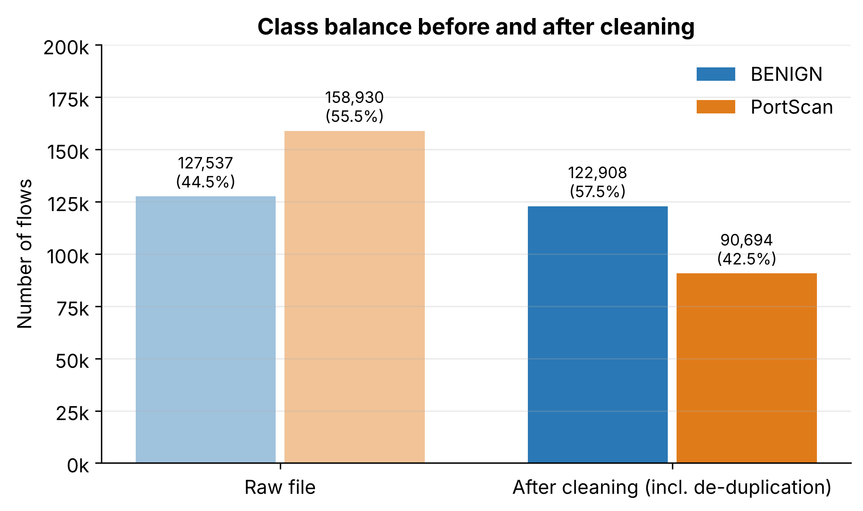
Figure 1. Flow counts by class in the raw PortScan file and after cleaning, with each class's share of the total. Takeaway: duplicates are concentrated in scan traffic, so cleaning turns benign into the majority class.
A scanner sends near-identical probes, so 42.9% of scan rows are exact repeats (3.3% of benign). Left in, copies would land in both training and evaluation data and inflate every metric, so de-duplication runs before splitting.
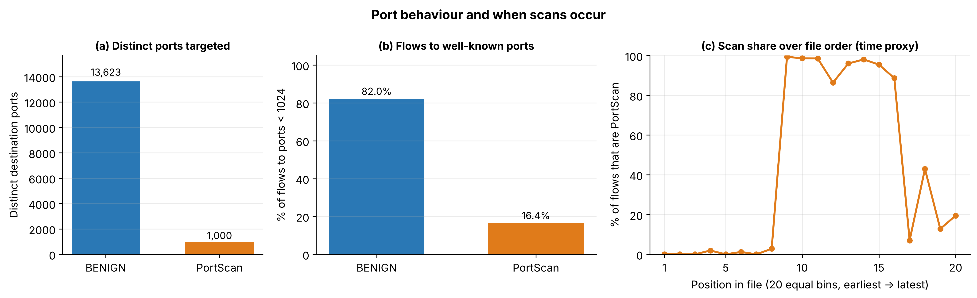
Figure 2. (a) Distinct ports per class, (b) share of flows to ports below 1024, (c) PortScan share across 20 bins of file order (time proxy). Takeaway: the scanner sweeps a fixed list of ports in one burst.
Scans touch exactly 1,000 ports almost evenly, consistent with Nmap's default top-1,000 list, while 82.0% of benign flows go to ports below 1024 (mainly 53, 443 and 80) versus 16.4% of scan flows. The port therefore partly identifies the tool, so Destination Port is kept out of the primary feature set and tested separately. Panel (c) shows scans arrive in one block, so a random split places flows of one scan on both sides; hence the time-ordered split. An authorized IT sweep of the same ports would look identical, which is why the known-tester allowlist (Section 7) is needed.

5. Data Preparation and Feature Engineering
Preparation is implemented in src/02_clean.py and src/04_features_and_split.py using scikit-learn (Pedregosa et al., 2011). Every step is deterministic and logged, and anything learned from data (feature ranking and scaling) is fit on the training split only.
Table 2. Preparation steps, feature sets and engineered features.
Step / feature | Implementation | Rationale | Leakage or bias control
Row cleaning | Strip names; drop inf/NaN (371) and negative-time (176) rows | Undefined or impossible values | Rule-based; same on Monday
Sentinel flags (created) | init_win_fwd_missing, init_win_bwd_missing | Dropping −1 rows would lose 21–27% of data | Rule-based
Column handling | All 78 original columns kept; 10 constant and 8 duplicate columns only flagged | Avoid losing any useful feature | No data-driven choice
De-duplication | 72,318 exact duplicate rows removed (68,110 scan) | Copies inflate scores | Done before splitting
Feature sets | all_no_port (primary): 77 original columns + 2 flags = 79; all_with_port adds Destination Port and is_well_known_port (81) | Full information; port tested separately | Port excluded from primary set
Reduced comparison set | Drop constant, duplicate and |r| > 0.95 features (ranked by train AUC): 43 features | Tests whether pruning loses signal | Fit on training split only
Transform and scaling | Signed log(1 + |x|) → StandardScaler in a Pipeline (logistic regression) | Heavy tails; −1 sentinel | Scaler fit on train only
Why all columns. Pruning assumes a highly correlated feature adds nothing, but correlation measures only overall linear agreement; two features can still differ on exactly the rare flows that are hard to classify. The team therefore trains on every column. The comparison supports this: several pruned columns receive large weights in the all-features model (Total Backward Packets, rank 7 of 79; Flow IAT Std, rank 10), and validation false alarms fall from 17 to 6 (Appendix C, Table C1). Constant columns receive zero weight, so keeping them costs nothing.
Split strategy. Stratified 70/15/15 (seed 42) after de-duplication: 149,521 train, 32,040 validation and 32,041 test flows, each 42.5% PortScan. A time-ordered split uses file row order (no timestamps); its scan share ranges from 41.6% (train) to 63.7% (validation) and 25.1% (test), confirming the burst, so random splits are optimistic. The time-ordered split and Monday file are the safeguards; host-grouped splits need IP columns. Both test sets stay locked until the Status Report.

6. Baseline Model or Analytical Benchmark
Baselines were trained on the training split and scored on validation (13,604 scan, 18,436 benign flows) and on Monday: (1) majority class; (2) a rule tuned on training data (Flow Duration ≤ 500 µs, Total Fwd Packets ≤ 1, Fwd Packet Length Max ≤ 2 bytes); (3) balanced logistic regression, the proposal's reference baseline, on all features (primary), all plus port, and the reduced set; (4) a depth-4 tree. The primary model reaches precision 0.9996, recall 0.9982, F1 0.9989, PR-AUC 0.9999 and ROC-AUC 0.9998 (plots: outputs/figures, fig6–fig9).

Table 3. Baselines on validation data (Strat. = stratified, Time = time-ordered split) and on 502,138 Monday benign flows.
Model | Split | Precision | Recall | False alarms | FPR | Monday FPR | Meets targets
Majority class | Strat. | 0.0000 | 0.0000 | 0 | 0.00% | 0.00% | No
Threshold rule | Strat. | 0.9541 | 0.9841 | 644 | 3.49% | 5.84% | No
Threshold rule | Time | 0.9716 | 0.9848 | 588 | 5.05% | 5.84% | No
LogReg, all features (primary) | Strat. | 0.9996 | 0.9982 | 6 | 0.03% | 0.13% | Yes
LogReg, all features (primary) | Time | 1.0000 | 0.9999 | 1 | 0.01% | 0.03% | Yes
LogReg, all features + port | Strat. | 0.9998 | 0.9987 | 3 | 0.02% | 0.04% | Yes
LogReg, reduced 43 features | Strat. | 0.9987 | 0.9982 | 17 | 0.09% | 0.12% | Yes
LogReg, reduced 43 features | Time | 1.0000 | 0.9999 | 0 | 0.00% | 0.02% | Yes
Decision tree, depth 4, all | Strat. | 0.9971 | 0.9979 | 40 | 0.22% | 0.73% | Yes
Interpretation. The majority-class model scores 57.5% accuracy yet catches no scans, so accuracy is the wrong headline metric. The rule catches 98.4% of scans but flags 5.05% of benign flows on the time-ordered split and 5.84% on Monday, failing the 5% target on unseen traffic. Logistic regression meets both targets everywhere. Adding the port lowers validation FPR only from 0.03% to 0.02%, so the model is not memorising ports. All features cut validation false alarms from 17 to 6 versus the reduced set at equal recall; on Monday (0.13% vs 0.12%) and the time-ordered split (1 vs 0) the two are effectively tied, so keeping all columns never costs accuracy.
Error analysis. The 24 missed scans mostly targeted ports 80 and 139 and had several forward packets but no reply, so they resemble failed ordinary connections. The 6 false alarms were long-lived flows (median about 24 s) with no reply, on port 443 or port 0. The criteria are reachable with a simple linear model, so the open question is robustness.

7. Challenges and Revised Plan
The proposal and the project review identified the problems below; each now has a concrete solution.
Table 4. Problems identified and their solutions (details in Appendix B).
Problem | Solution | Status
Internal scanners (IT running Nessus or Nmap) look identical to attacks | Known-tester allowlist: approved scanners with source IP, ports, schedule, owner and expiry; alerts suppressed only when all match and kept for audit | Implemented; 6 unit tests pass; needs source-IP data to evaluate
Slow scans spread over hours look normal flow by flow | Per-source features over 5 min, 1 h and 24 h: distinct ports, distinct hosts, share of unanswered connections | Implemented; test flags a 10-minute-interval scan only visible over 24 h
Pruning redundant columns might drop a useful feature | Model on all columns; reduced set kept only as a comparison | Done: validation false alarms 17 → 6
Port number may let the model memorise the scanner's port list | Primary set excludes Destination Port; with-port variant as a check | Done: FPR 0.03% without vs 0.02% with port
2017 data and one scanning tool; scores may reflect tool fingerprints | State the limitation; outside-day test; retrain without TCP-window features | Monday test done; ablation planned
No timestamps or IPs in this release | Obtain CIC's GeneratedLabelledFlows release (adds Timestamp and IPs) | Planned by Oct 25

Table 5. Work planned before the Status Report.
Task | Target date | Lead
Random Forest and XGBoost on all features; 5-fold CV tuning; threshold choice; SHAP | Oct 25 – Nov 1 | Ojas
Labelled-flows release: evaluate allowlist and slow-scan features; time/host splits | Oct 25 | Riya
Robustness: no TCP-window features; Tuesday–Thursday benign false-positive tests | Nov 1 | Riya
Score locked test sets once; write Status Report | Nov 8 | Both
Streamlit dashboard: ranked, explained alerts with allowlist status | Nov 22 | Riya

References
Canadian Institute for Cybersecurity. (n.d.). Intrusion detection evaluation dataset (CIC-IDS2017). University of New Brunswick. https://www.unb.ca/cic/datasets/ids-2017.html
Engelen, G., Rimmer, V., & Joosen, W. (2021). Troubleshooting an intrusion detection dataset: The CICIDS2017 case study. In 2021 IEEE Security and Privacy Workshops (SPW) (pp. 7–12). IEEE.
Lashkari, A. H., Draper-Gil, G., Mamun, M. S. I., & Ghorbani, A. A. (2017). Characterization of Tor traffic using time based features. In Proceedings of the 3rd International Conference on Information Systems Security and Privacy (ICISSP) (pp. 253–262).
Lyon, G. F. (2009). Nmap network scanning: The official Nmap project guide to network discovery and security scanning. Insecure.Com LLC.
NetSentries. (2026). ScanShield [Source code]. GitHub. https://github.com/riyap3111/ScanShield
Pedregosa, F., Varoquaux, G., Gramfort, A., Michel, V., Thirion, B., Grisel, O., et al. (2011). Scikit-learn: Machine learning in Python. Journal of Machine Learning Research, 12, 2825–2830.
sateeshkumar6289. (n.d.). CICIDS 2017 dataset [Data set]. Kaggle. https://www.kaggle.com/datasets/sateeshkumar6289/cicids-2017-dataset
Scarfone, K., Souppaya, M., Cody, A., & Orebaugh, A. (2008). Technical guide to information security testing and assessment (NIST Special Publication 800-115). National Institute of Standards and Technology.
Sharafaldin, I., Lashkari, A. H., & Ghorbani, A. A. (2018). Toward generating a new intrusion detection dataset and intrusion traffic characterization. In Proceedings of the 4th International Conference on Information Systems Security and Privacy (ICISSP) (pp. 108–116).

Team Contribution Statement
Team member | Responsibilities and completed work | Evidence / artifact
Riya Sanjiv Pradhan | Data acquisition and audit (01_load_and_audit.py), cleaning pipeline (02_clean.py), data dictionary, EDA and figures (03_eda.py), data-quality section, known-tester allowlist design (allowlist.py, known_scanners.csv); co-wrote the report. | src/01–03, src/allowlist.py, config/, tests/test_allowlist.py, outputs/tables/data_dictionary.csv, cleaning_log.csv, fig1–fig5
Ojas Prashant Suratkar | Feature sets and split design (04_features_and_split.py), baseline models, all-features vs reduced comparison and error analysis (05_baselines.py), slow-scan features (slow_scan.py), results summary and reproducibility script; co-wrote the report. | src/04–06, src/slow_scan.py, tests/test_slow_scan.py, run_all.sh, baseline_results.csv, excluded_feature_check.csv, fig6–fig9

Work was split by pipeline stage, as in the proposal: Riya led the data stages and the alerting side, and Ojas led features and modeling. The decision to keep all columns and the risk solutions in Section 7 were agreed jointly. Each member reviewed the other's scripts and outputs before they were merged, and both reviewed and edited the full report. Participation was even, and no coordination issues needed resolving.

AI-Use Disclosure

Tool | How it was used | What the team verified or changed
Claude (Anthropic) | Assisted with writing and debugging the Python analysis code and with drafting and editing report text. | The team specified the analysis and made all analytical decisions (cleaning rules, keeping all columns, splits, baselines, risk solutions), reviewed the code, re-ran the full pipeline from the raw data, and checked every reported number against the output tables in the repository.

Submission Checklist
Check | Requirement
[x] | Report reflects work completed by the deadline.
[x] | All tables and figures have numbers, captions, and interpretations.
[x] | Data-quality findings include quantitative evidence.
[x] | Baseline results use a clearly identified validation set.
[x] | Repository contains the code or notebooks referenced.
[x] | Contribution statement and AI-use disclosure are complete.

Rubric Self-Check
Criterion | Points | Where the evidence appears
Status, scope, and project management | 1 | Executive Status Snapshot and Section 1 (pp. 1–2)
Dataset description and data dictionary | 2 | Section 2 (p. 2); data dictionary in Appendix A (p. 8)
Data-quality assessment | 2 | Section 3 and Table 1, quantitative checks and treatments (pp. 2–3)
EDA and interpretation | 2 | Section 4, Figures 1–2 with interpretations (pp. 3–4); Figure C1 (p. 10)
Preparation, features, and baseline | 2 | Section 5 and Table 2 (p. 4); Section 6 and Table 3 (pp. 4–5); feature check in Appendix C (p. 10)
Challenges, plan, and report quality | 1 | Section 7, Tables 4–5 (p. 5); risk controls in Appendix B (p. 9); repository link (p. 1); contribution statement (p. 6)

Appendix A. Data Dictionary
Key fields of the PortScan file and engineered variables. The complete 79-field dictionary, with non-null counts, ranges and medians, is in outputs/tables/data_dictionary.csv.
Table A1. Data dictionary (key fields).
Variable / field | Type | Meaning | Role in analysis
Label → is_scan | Categorical → binary | Ground-truth class (BENIGN or PortScan), encoded as 1 = PortScan | Target
Destination Port | Integer (0–65535) | Port the flow was sent to | all_with_port only (leakage check)
Flow Duration | Integer (µs) | Time from first to last packet of the flow | Feature
Total Fwd Packets | Integer | Packets sent by the initiating host | Feature
Total Backward Packets | Integer | Packets sent back by the responding host | Feature (pruned from reduced set; LR rank 7 of 79)
Total Length of Fwd Packets | Integer (bytes) | Payload bytes sent by the initiator | Feature
Fwd Packet Length Max | Integer (bytes) | Largest forward payload in the flow | Feature
Flow Bytes/s, Flow Packets/s | Float | Throughput over the flow; undefined when duration is zero | Feature (inf/NaN rows removed)
Bwd Packets/s | Float | Packets per second from the responder | Feature (best single feature, AUC 0.938)
Flow IAT Mean / Std / Max / Min | Float (µs) | Time between consecutive packets in the flow | Feature
SYN / RST / ACK / PSH Flag Count | Integer | Packets carrying each TCP flag | Feature
Init_Win_bytes_forward / _backward | Integer (bytes); −1 = not observed | Initial TCP window size in each direction | Feature, plus engineered missing flags
Active / Idle Mean, Std, Max, Min | Float (µs) | Time the flow was active before going idle, and idle time | Feature
Bulk-rate fields (6), CWE/URG/Bwd PSH flags (4) | Numeric | Bulk-transfer and rarely used flag statistics; constant in this file | Feature in all-features sets (zero weight)
Subflow fields (4), Avg Fwd Segment Size, Fwd PSH Flags, ECE Flag Count, Fwd Header Length.1 | Numeric | Exact copies of other columns | Feature in all-features sets; excluded from reduced set
init_win_fwd_missing / init_win_bwd_missing | Binary (engineered) | 1 if the TCP window value is −1 | Feature
is_well_known_port | Binary (engineered) | 1 if Destination Port < 1024 | all_with_port only

Appendix B. Risk Controls: Known-Tester Allowlist and Slow-Scan Features
B.1 Known-tester allowlist. Organizations routinely run authorized scans, such as weekly Nessus vulnerability scans or Nmap inventory sweeps (Scarfone et al., 2008). Without special handling, ScanShield would raise an alert every time one runs, and analysts would learn to ignore the tool. The allowlist is a predefined list of these regular testers, stored in config/known_scanners.csv and applied by src/allowlist.py after the classifier has flagged a flow. Each entry records the fields in Table B1. An alert is suppressed only when the source address, destination port, day, time window and expiry date all match one entry. Suppressed alerts are never deleted: they are kept with status "suppressed" and the entry name, so the security team can audit what the allowlist hid. If an approved host probes a port outside its list or runs outside its window, the alert still fires. This matters because a compromised or spoofed scanner address is a real attack path, and an unconditional IP allowlist would hide it.
Table B1. Allowlist fields (example entries use reserved documentation addresses).
Field | Example | Purpose
name | Weekly Nessus vulnerability scan | Human-readable description of the approved activity
source | 192.0.2.10/32 | Source IP address or CIDR subnet of the scanner
allowed_ports | 1-65535 or 22,80,443 | Port range or list the scanner is approved to probe
days, start_time, end_time | Sat, 01:00–05:00 | Approved schedule; probes outside it still alert
owner, ticket | IT Security, CHG-1042 | Accountable team and change-management reference
expires | 2027-06-30 | Entry stops matching after this date, forcing periodic review
Six unit tests (tests/test_allowlist.py) confirm that an approved scan inside its window is suppressed, the same host outside its window or on an unapproved port still alerts, unknown sources always alert, subnet entries and expiry dates work, and suppressed alerts stay in the output for audit.
B.2 Slow-scan features. A patient attacker can pace a scan; Nmap's slowest timing templates wait minutes between probes (Lyon, 2009). Each flow then looks ordinary, and a per-flow classifier cannot see the pattern. src/slow_scan.py adds per-source context: for each flow, it counts over the same source's previous 5 minutes, 1 hour and 24 hours how many distinct destination ports and hosts were contacted, and what share of those connections received no reply. A starting rule flags sources with at least 50 distinct ports and at least 80% unanswered connections in 24 hours; the thresholds will be tuned on labelled data. In the unit test (tests/test_slow_scan.py), a synthetic scan of 120 ports at one probe every 10 minutes shows one distinct port in every 5-minute window, but 120 over 24 hours, and is flagged; a normal user making 200 web requests is not. These features will also be added to the classifier as inputs once the GeneratedLabelledFlows release, which has the required source-IP and timestamp columns, is in place.
B.3 Other open issues. Published re-analyses report labeling and flow-construction errors in CICIDS2017 (Engelen et al., 2021); results may be checked on the corrected release if time allows. Because duplicate columns share their weight in logistic regression, coefficients are read in groups rather than one by one, and permutation importance will be used for the tree models.

Appendix C. Supplementary EDA and Feature Check
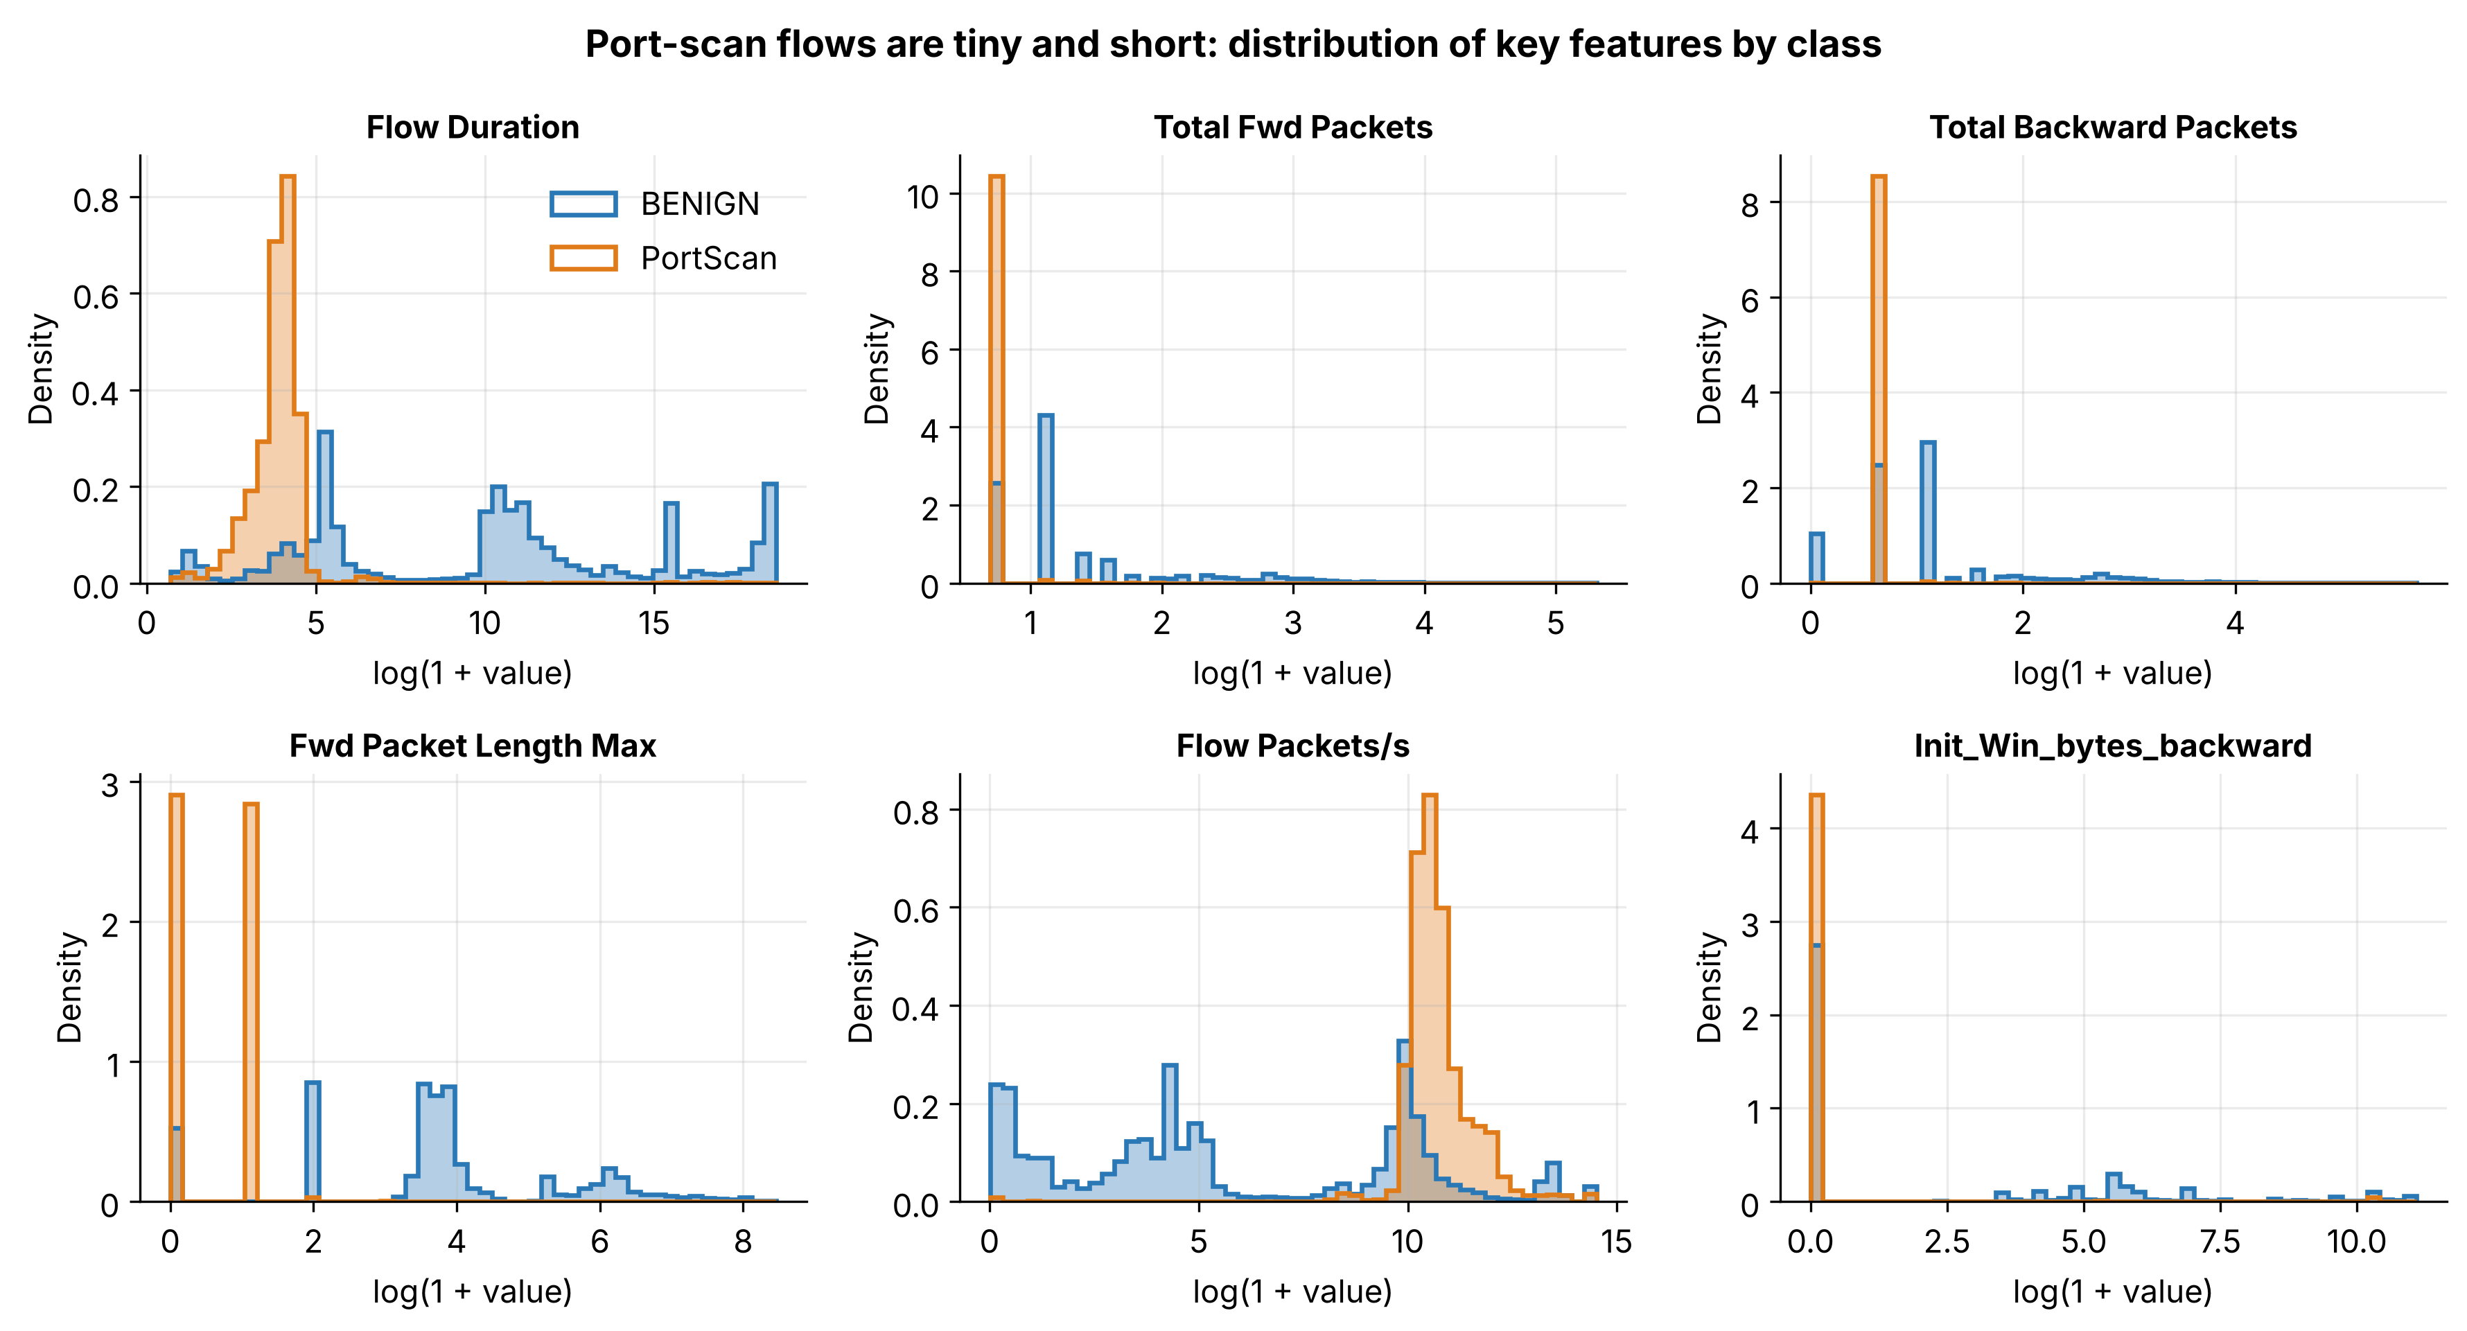
Figure C1. Distributions of six key flow features by class, shown as densities on a log(1 + value) scale. Takeaway: scan flows are tiny, fast and carry no payload; they overlap with benign traffic only among very short flows.
Scan flows form narrow spikes (one forward packet, no payload, about 50 µs, very high packet rates), while benign traffic spans several orders of magnitude. The overlap is among short, empty benign flows such as failed or idle connections, which is where false alarms should be expected, and is consistent with the error analysis in Section 6.
Table C1. The 12 highest-weighted columns that the reduced set would have removed (full list: outputs/tables/excluded_feature_check.csv).
Column pruned from the reduced set | Reason pruned | Univariate AUC | Weight rank in all-features LR | Used by tree
Total Backward Packets | |r| > 0.95 | 0.733 | 7 of 79 | No
Subflow Bwd Packets | copy of Total Backward Packets | 0.733 | 8 of 79 | No
Flow IAT Std | |r| > 0.95 | 0.828 | 10 of 79 | No
Bwd IAT Max | |r| > 0.95 | 0.792 | 11 of 79 | Yes
Fwd IAT Min | |r| > 0.95 | 0.864 | 12 of 79 | No
Flow IAT Mean | |r| > 0.95 | 0.851 | 13 of 79 | No
Bwd IAT Mean | |r| > 0.95 | 0.792 | 14 of 79 | No
Subflow Fwd Bytes | copy of Total Length of Fwd Packets | 0.931 | 18 of 79 | Yes
Fwd IAT Max | |r| > 0.95 | 0.868 | 20 of 79 | No
Idle Min | |r| > 0.95 | 0.583 | 21 of 79 | Yes
Total Length of Bwd Packets | |r| > 0.95 | 0.761 | 22 of 79 | Yes
Subflow Bwd Bytes | copy of Total Length of Bwd Packets | 0.761 | 23 of 79 | No
Several pruned columns rank among the 15 strongest weights in the all-features model, and 4 of the 12 shown are used by the depth-4 tree. The ten constant columns receive zero weight. This is the evidence behind the decision to keep all columns.

