Deliverable 3: Interim Status Report
Cybersecurity Analytics Class Project
Deliverable | Deliverable 3: Interim Progress Report 2 | Selected Track | Intrusion Detection Systems (IDS)
Project Title | ScanShield: Detecting Network Port Scanning Using Flow-Level Traffic Analysis | Team Name | NetSentries
Team Members | Riya Sanjiv Pradhan; Ojas Prashant Suratkar | Submission Date | November 8, 2026
Repository | https://github.com/riyap3111/ScanShield | Dataset Link | https://www.kaggle.com/datasets/sateeshkumar6289/cicids-2017-dataset

Executive Status Snapshot
Item | Current status
Overall status | On track. Three families tuned and compared, test split scored once, and the generalization, adversarial, Responsible AI and monitoring work complete. Both proposal criteria met with margin.
Best-performing approach so far | Random Forest on all 108 features: test recall 0.99860, precision 1.00000, F1 0.99930, PR-AUC 1.000000, FPR 0.0000% (0 false alarms in 18,437 benign flows).
Most important error or risk | Evasion, not accuracy. Padding probes with 24 bytes drops recall to 0.000, 1,000x pacing to 0.000. Adversarial training recovers most of it; pacing needs per-source features.
Work remaining before final report | Slow-scan features on the IP-bearing CIC release (critical path); Streamlit dashboard; final report and demo.

1. Updated Project Status
Since Interim Report 1 the project moved from one logistic-regression baseline to a tuned, compared and stress-tested detector. Changes to scope and method since then:
- Feature engineering, not pruning. Every original CICFlowMeter column is kept and 28 engineered features added on top (108 inputs): payload per packet, reply ratio, flag density, header-to-payload ratio. Section 3 ablates them.
- Two new families. Random Forest and gradient-boosted trees joined the baseline. Boosting uses scikit-learn's histogram implementation rather than XGBoost (Chen & Guestrin, 2016), whose macOS wheel, like LightGBM's (Ke et al., 2017), needs an OpenMP runtime unavailable in our environment; same algorithm family, and the only departure from the proposed plan.
- A genuinely held-out test. Threshold and model choice were both fixed on validation; the test split was read once afterwards.
- Generalization went well past the Monday control: all seven other CICIDS2017 day files, 2,356,057 flows, 13 unseen attack types. Adversarial, Responsible AI and monitoring work is also complete.
Data, code and pipeline are reproducible: run_all.sh rebuilds every table and figure here from the raw CSVs at seed 42. No written feedback on Interim Report 1 had been returned when this was prepared, so that plan was carried through unchanged apart from the boosting substitution. Remaining work is in Section 9.

2. Model Development and Comparison
Three families were compared on identical data — same training split, same 108 features, same protocol — differing in kind, not just in hyperparameters: linear, bagged trees, boosted trees. Each got a 15-candidate randomised search scored by 5-fold stratified CV on the training split only (scikit-learn; Pedregosa et al., 2011). The search metric is average precision, not accuracy, which is uninformative when 42.5% of rows are positive and the two error types cost differently. Imbalance is handled with balanced class weights, not resampling, which would distort the very false-positive rate being measured.
Validation design. The alert threshold is the highest-F1 threshold on validation inside the 5% ceiling, then frozen; the winning family is chosen the same way, on validation, so neither is informed by test data. Only then was test scored, once. Reproducibility rests on seed 42, tuned parameters in Appendix B, and a one-command pipeline; three seeds change recall by 1.4e-16.
Approach | Key settings | Validation method | Rationale / result
Baseline: Logistic regression | C=3.47; balanced class weights | 15-candidate randomised search, 5-fold stratified CV on train. PR-AUC 0.99996 ± 0.00003 | Linear reference carried over from Interim Report 1. Test recall 0.99897, FPR 0.0054%, F1 0.99945. Scores 611,844 flows/s.
Random Forest | class_weight=balanced_subsample, max_depth=8, max_features=sqrt, min_samples_leaf=1, n_estimators=353 | 15-candidate randomised search, 5-fold stratified CV on train. PR-AUC 1.00000 ± 0.00000 | Selected model. Bagged trees capture threshold interactions a linear model cannot. Test recall 0.99860, FPR 0.0000%, F1 0.99930. Scores 428,275 flows/s.
Gradient Boosting (hist.) | class_weight=balanced, l2_regularization=0.09333, learning_rate=0.2794, max_iter=370, max_leaf_nodes=61, min_samples_leaf=53 | 15-candidate randomised search, 5-fold stratified CV on train. PR-AUC 1.00000 ± 0.00001 | Boosted trees correct their own errors in sequence; the planned XGBoost stand-in. Test recall 0.99838, FPR 0.0000%, F1 0.99919. Scores 164,522 flows/s.

3. Preliminary Evaluation
The primary metric is recall on port-scan flows at a false-positive rate within 5%, the proposal's two criteria: a missed scan removes the early warning the system exists to give, and the FPR ceiling is what keeps analysts using it. Accuracy is not used to judge — predicting BENIGN for everything scores 57.5% here while catching nothing — and PR-AUC is the ranking metric, being the one that stays informative under imbalance. All figures are on the locked test split (32,041 flows), scored once at the frozen threshold.
Model | Precision | Recall | F1 | PR-AUC / ROC-AUC | Operational note
Logistic regression (baseline) | 0.99993 | 0.99897 | 0.99945 | 0.999970 / 0.999966 | FPR 0.0054%; 1 FP, 14 FN. Baseline: fastest and fully interpretable.
Random Forest | 1.00000 | 0.99860 | 0.99930 | 1.000000 / 1.000000 | FPR 0.0000%; 0 FP, 19 FN. Selected on validation. 428,275 flows/s, 2.9 MB.
Gradient Boosting | 1.00000 | 0.99838 | 0.99919 | 1.000000 / 1.000000 | FPR 0.0000%; 0 FP, 22 FN. Ties the selected model on ranking.

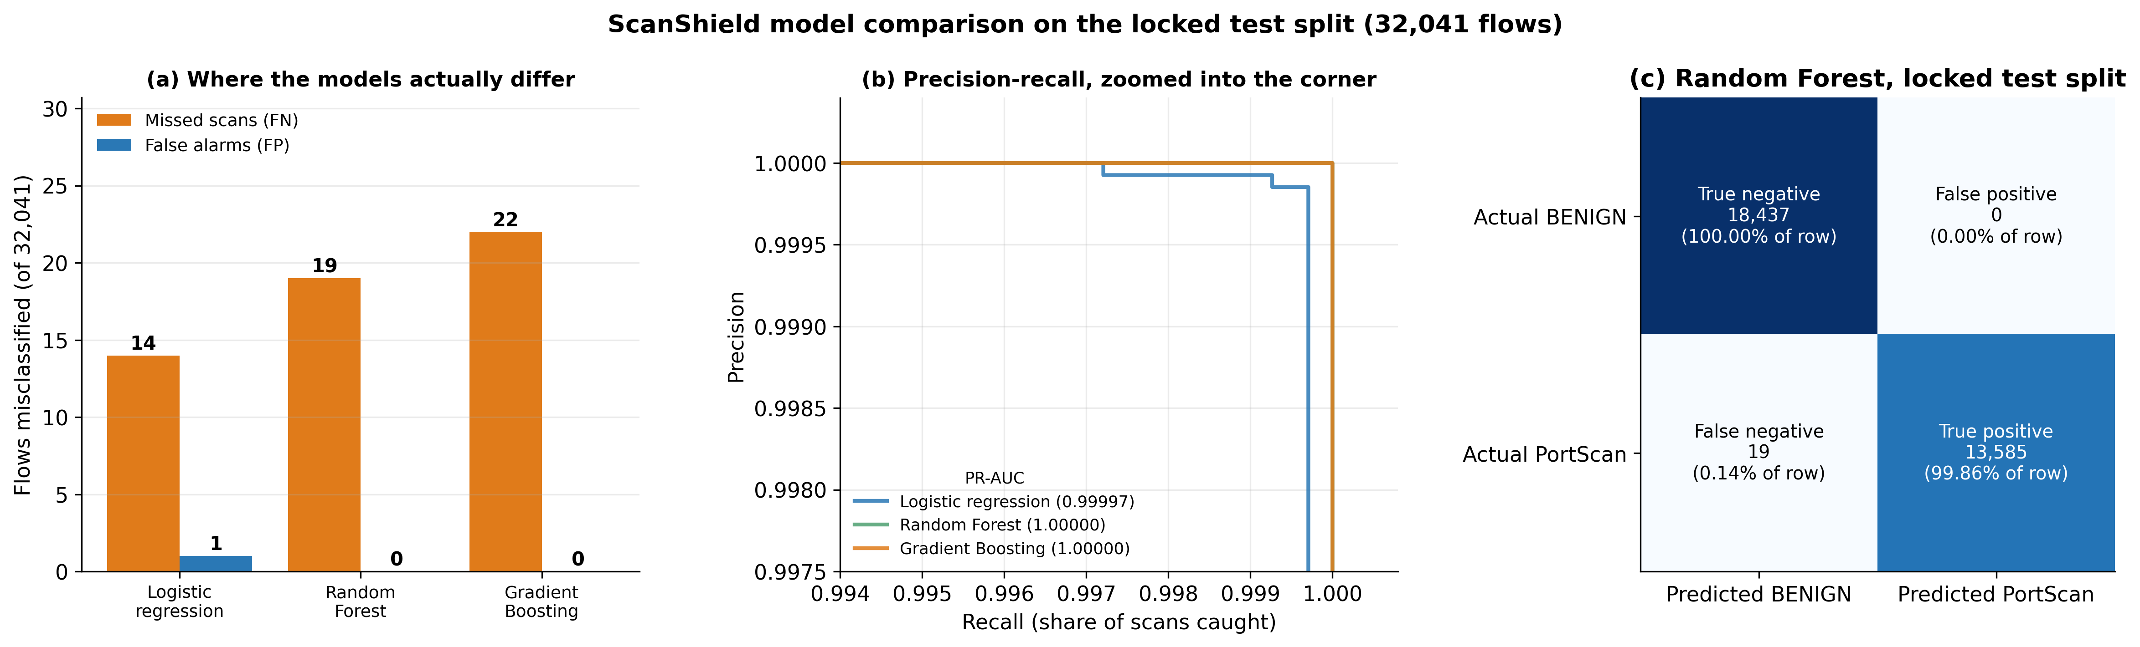
Figure 1. (a) Misclassified flows per family, (b) precision-recall zoomed into the corner where the curves separate, (c) confusion matrix of the selected Random Forest, all on the locked test split. Takeaway: all three clear both targets and are separated by a handful of flows, so the choice rests on error counts rather than on ranking quality.
Both criteria are met with wide margin: recall 0.99860 against a 0.90 target, FPR 0.0000% against a 5% ceiling, from 0 false alarms in 18,437 benign test flows. This is stable, not a lucky split: 5-fold PR-AUC 1.00000 ± 0.00000, and three seeds agree on recall to 1.4e-16. The three families are separated by 5 flows out of 32,041: the honest reading is that they are tied, and the choice rests on the zero false alarms rather than a capability gap. The engineered features do not pay off here: on validation the full set and the original columns alone both reach 0 false alarms, and the original columns are marginally ahead on recall (0.9982 against 0.9980, a difference of 2 flows). This data is close to linearly separable, so above 0.998 recall at zero false alarms there is no headroom for any feature set to show an advantage. They are kept because they cost nothing and separate the classes cleanly on their own (Table B3), not because this dataset proves they help. Removing the port and TCP-window columns, which encode this particular scanner's fingerprint, still leaves recall at 0.9979 with FPR 0.0000%, so the model is reading scan behaviour rather than memorising one tool. Cost is no constraint at 2.9 MB and 428,275 flows/s on a laptop.

4. Error Analysis
At the frozen threshold the model raises 0 false alarms and misses 19 scans in 32,041 test flows, so on this split the only error type to analyse is the missed scan; the false-positive row below therefore draws on the unseen days from Section 5, where false alarms do occur. Both error types live in the same narrow band where a probe looks like a failed connection (Appendix A, Figure A2).
Example / error type | Likely cause | Security or operational impact | Planned improvement
False positive: none on the test split, 972 across 2,021,250 unseen benign flows (971 of them on Thursday PM alone) | A failed, refused or abandoned connection has the same signature as a probe: one packet out, nothing back, no payload. The flow record cannot show intent. The Thursday PM concentration points at one traffic pattern, not a general problem. | Analyst time, and it is affordable: 0.385% on the worst unseen day. But each alert is a real user's connection being questioned, so the concentration matters more than the average. | Per-source aggregation: one unanswered flow is noise, fifty from one host in an hour is a scan. Profile the Thursday PM alerts before deployment to find what that day's traffic does differently.
False negative: probe that drew a response (16 of 19, 84%; 10 carried payload) | A probe against an open port completes the handshake and gets data back, so it looks like a legitimate session starting. | The most valuable probes to catch: they are the ones that found an open service, so missing them loses the part of the scan the attacker acts on. | Train on connect-scan traffic explicitly. The hardened model in Section 6 already lifts recall on these to 0.9980.

5. Generalization Testing
The model is trained on one afternoon of one file, so the real question is what it does on traffic it has never seen. It was scored, unchanged and at the frozen threshold, on every other CICIDS2017 capture day (Sharafaldin et al., 2018; Canadian Institute for Cybersecurity, n.d.): 2,356,057 flows, 2,021,250 of them benign, plus 13 attack types absent from training. Schema compatibility came first: all seven files carry the same 79 columns, but every header has leading whitespace and the web-attacks file is cp1252-encoded, so a plain UTF-8 read of its 'Web Attack - Brute Force' labels fails outright. The pipeline audits these differences (Appendix C, Table C3) rather than coercing them silently, then applies the identical cleaning and feature code path.
Dataset | Differences from training data | Result | Interpretation
Course sample: held-out test split (32,041 flows) | Same capture and day; unseen rows only, de-duplicated before splitting so no training flow reappears. | Recall 0.99860, FPR 0.0000%, F1 0.99930, PR-AUC 1.000000 | Both criteria met. The optimistic end of the range: the scan arrives in one burst, so a random split puts flows from the same scan on both sides.
Larger external: all 7 other day files (2,356,057 flows, 13 unseen attack types) | Four other capture days, different traffic mix. No PortScan label exists, so recall cannot be measured; what can is whether the detector stays quiet. Needed a cp1252 fallback and header normalisation. | Benign FPR 0.0481% overall (972 alerts in 2,021,250 benign flows); per day 0.0000% to 0.3847%, every day inside the ceiling. | The rate holds on days the model never saw. Two details matter more: 971 of the 972 alerts come from Thursday PM alone and four days produce none, so the risk is concentrated rather than spread; and only 8 of 334,807 flows from the other 13 attack types are called a scan — a strength (no cross-talk) and a limitation (it detects scans, not intrusions). Both rows inherit CICIDS2017's own labelling errors (Engelen et al., 2021), so the last fraction of a percent should not be read too closely.

6. Adversarial Threat Model and Experiment
Every feature ScanShield reads comes from the attacker's own packets, so an attacker who suspects a flow-based detector can simply scan differently. Five evasion techniques, each a documented nmap option (Lyon, 2009), were applied to the 13,604 held-out scan flows, perturbing the raw columns and recomputing every engineered feature so the shaped flows stay consistent. All of it ran offline on a public dataset: no traffic generated, no system contacted.
The results are not comfortable — the deployed model is brittle. Padding probes with 24 bytes drops recall from 0.9986 to 0.0000; completing the handshake to 0.0000; pacing 1,000x slower to 0.0001. The model learned that a scan is small, empty and unanswered, so anything breaking that shape defeats it. Pacing is also a structural limit: a per-flow classifier sees one flow, and a scan spread over hours looks ordinary in every one.
Defense. These are traffic-shaping transforms, so the defender can generate them without meeting an attacker: shaped copies of the training scans were added to the training set and the model refit (254,271 rows). Recall recovers to 0.9870 under padding, 0.9980 under handshake mimicry and 0.9982 under the combined attack, at an unchanged clean false-positive rate (0.0000%). It does not fix everything: 1,000x pacing still leaves recall at 0.0239, which is why per-source slow-scan features are the critical path in Section 9. These are feature-space approximations, so they bound the risk rather than measure it exactly. Full results in Appendix D, Table D1.
Asset | Attacker objective | Capability | Attack / test | Defense / mitigation
The deployed classifier and the early warning it gives the SOC. | Enumerate open ports without any flow crossing the alert threshold. | Black box: no access to the model, its scores or its training data, so no poisoning. Full control of their own host, hence of probe timing, payload length, TCP window and handshake completion. | Five shaping attacks on 13,604 held-out scan flows: timing (10/100/1,000x), padding (24/64 B), window reshaping, handshake mimicry, combined. Worst case recall 0.0000. | Adversarial training restores recall to 0.9982 under the combined attack at unchanged clean FPR. Structural backstop for pacing: per-source slow-scan features (src/slow_scan.py) over 5 min, 1 h and 24 h windows.

7. Responsible AI, Privacy, and Governance
CICIDS2017 carries no demographic attributes, so unequal performance was tested on the dimensions that do exist and carry operational consequence: service group, flow size, period within the capture, and capture day. The stake is concrete — if false alarms concentrated on one service, the team running it would absorb the disruption and be first to distrust the tool. They cannot here: not one of the 9 service groups produces a single false alarm on the test split, so there is no disruption to distribute unevenly. Recall is where the real disparity sits: it spans 0.8889 to 1.0000, and the weakest group is File sharing (21, 139, 445) at 0.8889 (11 of 99 scans missed). That matters more than the number suggests, because those are among the ports an attacker most wants open, so the model is weakest exactly where a hit is most valuable. Recall is otherwise flat across flow sizes and the capture (Figure A5). Caveats: that group holds only 99 scan flows, and zero false alarms on one lab capture is weak evidence of fairness. Privacy, retention, oversight and misuse controls continue in Appendix D, Table D4.
Concern | Test or safeguard | Evidence / current finding | Remaining action
Bias / unequal performance | Recall and FPR compared across service group, flow size, capture period and capture day | False-positive spread across service groups: 0.000 pp. Recall spread is the real gap: 0.8889 on File sharing (21, 139, 445) (11 of 99 scans missed) against 1.0000 elsewhere | Target the weakest service group with extra training examples; repeat per source host once the IP-bearing release is in place
Explainability | Permutation importance (model-agnostic) and SHAP contributions per alert (Lundberg & Lee, 2017) | Top driver: Active Min; every alert ships with its top contributing features | Put the per-alert explanation into the dashboard
Privacy and data minimisation | Flow metadata only: no payload read or stored, no user identity needed, and this release holds no IPs | All 108 features are counts, sizes, timings and flag totals | When IPs are added, store a keyed hash; keep raw addresses only in the 30-day investigation buffer

8. Monitoring, Feedback, and Response Workflow
These baselines are measured, not assumed: alert volume and drift come from the same 2.0 million unseen flows as Section 5, and they are lopsided. 5 of 7 unseen days raise no alert at all while the busiest raises 963, so the volume rule is banded on the busiest day rather than on a median of zero. Drift uses the population stability index against the training distribution: 37 of 108 features cross the 0.25 investigate line on some day, the largest fwd_bwd_packet_ratio (PSI 0.57) — expected from a different service mix, not a broken sensor. Response is review-first at every tier: nothing is blocked automatically, because a false alarm must never cut off a real user. The seven-step response path and logging schema are in Appendix D, Tables D2-D3.
Signal / metric | Threshold or trigger | Owner / response | Feedback use
Feature drift (PSI vs training benign traffic) | Any feature PSI > 0.25 for 2 consecutive days, or > 0.1 for 7 days | ML owner (Ojas) re-checks the feature against the capture pipeline, then decides retrain or roll back | Drifting features are the first candidates for the next refit
Alert volume | >2,889 alerts/day (3x the busiest of 7 unseen days), or any alert from a source and port that normally produce none | SOC duty analyst triages; a spike is either a real scan campaign or a broken sensor, and both need an answer the same day | Volume baseline is recomputed monthly
Score distribution of alerts | Median alert score drops below 0.90, or the share of alerts scoring 0.50-0.70 doubles | ML owner reviews calibration; borderline alerts mean the boundary has moved | Triggers threshold re-selection on fresh labelled data
Analyst-confirmed precision | Confirmed-true rate on sampled alerts falls below 90% over a rolling 2 weeks | SOC lead and ML owner review the false alarms together | Confirmed labels go straight into the retraining pool

9. Final-Phase Plan
The critical path to the final report runs through the IP-bearing CIC release: it is the only thing that unlocks the per-source slow-scan features, and those are the answer to the one real weakness found in Section 6. Everything else can proceed in parallel.
Remaining task | Owner | Due date | Definition of done
Critical path: per-source slow-scan features on CIC's GeneratedLabelledFlows release (adds Timestamp and IPs), added as model inputs | Riya | Nov 18 | Recall under the 1,000x timing attack reported with and without them; allowlist evaluated end to end on real source IPs
Streamlit dashboard: ranked alerts with per-alert explanation and allowlist status | Riya | Nov 22 | Demo takes a flow file, ranks alerts, shows top contributing features, marks suppressed ones
Code hardening: extend the 18 existing tests to the cleaning and scoring paths; pin the environment | Ojas | Nov 25 | pytest green on every module; requirements.txt verified from a clean virtualenv
Final evaluation: calibration, cost-sensitive thresholds, and promotion of the hardened model if it holds | Ojas | Nov 29 | Calibration curve and threshold-cost table committed; one documented decision on which model ships
Final report and presentation | Both | Dec 6 | Report submitted; rehearsed demo walkthrough

References
Canadian Institute for Cybersecurity. (n.d.). Intrusion detection evaluation dataset (CIC-IDS2017). University of New Brunswick. https://www.unb.ca/cic/datasets/ids-2017.html
Chen, T., & Guestrin, C. (2016). XGBoost: A scalable tree boosting system. In Proceedings of the 22nd ACM SIGKDD International Conference on Knowledge Discovery and Data Mining (pp. 785-794).
Engelen, G., Rimmer, V., & Joosen, W. (2021). Troubleshooting an intrusion detection dataset: The CICIDS2017 case study. In 2021 IEEE Security and Privacy Workshops (SPW) (pp. 7-12). IEEE.
Ke, G., Meng, Q., Finley, T., Wang, T., Chen, W., Ma, W., Ye, Q., & Liu, T.-Y. (2017). LightGBM: A highly efficient gradient boosting decision tree. In Advances in Neural Information Processing Systems 30 (pp. 3146-3154).
Lundberg, S. M., & Lee, S.-I. (2017). A unified approach to interpreting model predictions. In Advances in Neural Information Processing Systems 30 (pp. 4765-4774).
Lyon, G. F. (2009). Nmap network scanning: The official Nmap project guide to network discovery and security scanning. Insecure.Com LLC.
NetSentries. (2026). ScanShield [Source code]. GitHub. https://github.com/riyap3111/ScanShield
Pedregosa, F., Varoquaux, G., Gramfort, A., Michel, V., Thirion, B., Grisel, O., et al. (2011). Scikit-learn: Machine learning in Python. Journal of Machine Learning Research, 12, 2825-2830.
Scarfone, K., Souppaya, M., Cody, A., & Orebaugh, A. (2008). Technical guide to information security testing and assessment (NIST Special Publication 800-115). National Institute of Standards and Technology.
Sharafaldin, I., Lashkari, A. H., & Ghorbani, A. A. (2018). Toward generating a new intrusion detection dataset and intrusion traffic characterization. In Proceedings of the 4th International Conference on Information Systems Security and Privacy (ICISSP) (pp. 108-116).
sateeshkumar6289. (n.d.). CICIDS 2017 dataset [Data set]. Kaggle. https://www.kaggle.com/datasets/sateeshkumar6289/cicids-2017-dataset

Team Contribution Statement
Team member | Responsibilities and completed work | Evidence / artifact
Riya Sanjiv Pradhan | Feature engineering design and implementation; generalization testing across all seven unseen day files including the schema-compatibility audit and the cp1252 encoding fix; Responsible AI review (service-group, flow-size, time-period and per-day disparity analysis, privacy and governance table); monitoring and response workflow with the measured PSI and alert-volume baselines; co-wrote the report. | src/07_feature_engineering.py, src/10_generalization.py, src/12_responsible_ai.py, src/13_monitoring.py; tables schema_compatibility, generalization_by_day, subgroup_*, privacy_governance, drift_psi, alert_volume; figures 13, 15, 16, 17
Ojas Prashant Suratkar | Model development and tuning for all three families (randomised search, 5-fold CV, class-weight strategy, threshold selection and freezing); evaluation figures and the structured error analysis; the adversarial threat model, the five evasion attacks and the adversarial-training defense; the Deliverable 3 results generator; co-wrote the report. | src/08_train_models.py, src/09_evaluate.py, src/11_adversarial.py, src/14_write_summary_d3.py; tables model_comparison, model_tuning, cv_variance, threshold_choice, error_causes, adversarial_*; figures 10, 11, 12, 14
Both | Joint decisions: keeping every column and adding engineered features on top, the choice of PR-AUC as the search metric and recall-at-bounded-FPR as the primary metric, the threshold rule, and the substitution of histogram gradient boosting for XGBoost. Each member reviewed and re-ran the other's scripts before merging. | run_all.sh reproduces every output; RESULTS_DELIVERABLE3.md is generated from the saved tables

Work was split by pipeline stage as in the previous deliverables: Riya owns the data, generalization and deployment-facing stages, Ojas owns modelling, evaluation and the adversarial work. The two of us reviewed each other's code and re-ran the full pipeline from the raw CSVs before the report was written, and both checked every number quoted here against the generated tables. Participation was even and no coordination problems needed resolving.

AI-Use Disclosure
Required: Disclose any generative-AI tools used for brainstorming, coding, editing, analysis, or slide creation. You remain responsible for the accuracy, originality, security, and reproducibility of all submitted work.

Tool | How it was used | What the team verified or changed
Claude (Anthropic) | Assisted with writing and debugging the Python for feature engineering, model tuning, the adversarial transforms, the subgroup and drift analysis, and the figure code; assisted with drafting and editing the text of this report. | The team set the analytical direction and made every analytical decision: keeping all columns, which engineered features to add, PR-AUC as the search metric, recall-at-bounded-FPR as the primary metric, the threshold rule, the threat model and the choice of evasion attacks. We reviewed all generated code, re-ran the entire pipeline from the raw CSVs, and checked every number in this report against the tables in outputs/. One substantive correction we made: nested parallel jobs in the tuning search deadlocked on macOS and we reconfigured the job pool.

Submission Checklist
Check | Requirement
[x] | All reported results identify the dataset split used.
[x] | Baseline and candidate models are compared consistently.
[x] | Error analysis includes both causes and security impact.
[x] | Generalization testing includes the larger/external dataset.
[x] | Threat model identifies attacker capabilities and constraints.
[x] | Monitoring and response workflow is actionable.
[x] | Contribution statement and AI-use disclosure are complete.

Rubric Self-Check
Criterion | Points | Where the evidence appears
Updated status and project management | 1 | Executive Status Snapshot and Section 1; Section 9 plan
Model development and comparison | 2 | Section 2 and its table; tuned settings and feature sets in Appendix B (Tables B1-B3)
Evaluation and error analysis | 2 | Section 3, metric table and Figure 1; Section 4 and its table; Appendix A Figures A1-A2
Generalization testing | 2 | Section 5 and its table; Appendix A Figure A3; Appendix C Tables C1-C3
Adversarial ML | 1 | Section 6, threat-model table; Appendix A Figure A4; Appendix D Table D1
Responsible AI, privacy, and governance | 1 | Section 7 and its table; Appendix A Figures A5-A6; Appendix D Table D4
Monitoring, response, and final plan | 1 | Section 8 and its table; Section 9; Appendix A Figure A7; Appendix D Tables D2, D3 and D5

Appendix A. Supporting Figures
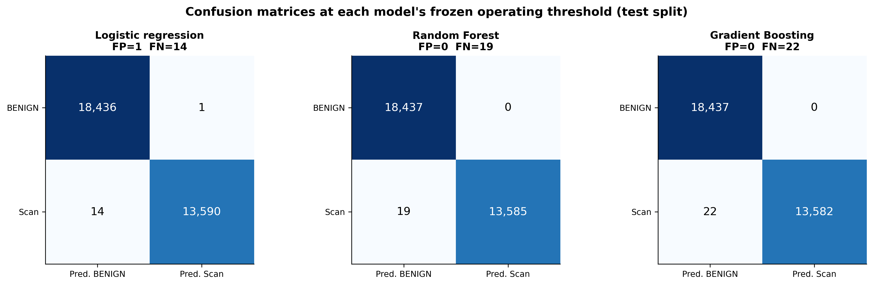
Figure A1. Confusion matrices for all three families at their own frozen thresholds on the locked test split. Takeaway: the families differ by a handful of flows, so the selection rests on error counts rather than on a gap in capability.
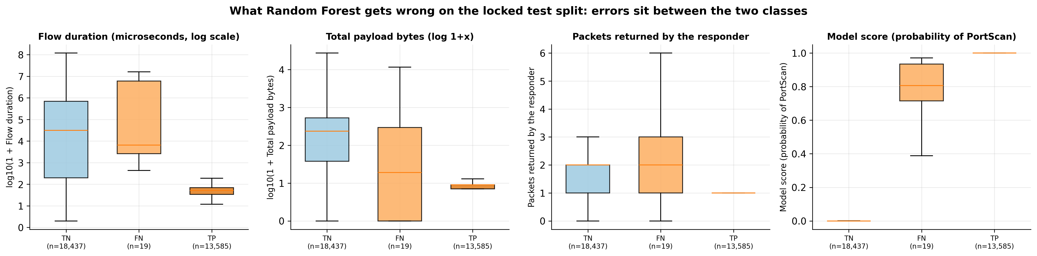
Figure A2. Where the errors sit. Takeaway: false alarms and missed scans both fall between the two class distributions, which is why per-flow features alone cannot separate them further.
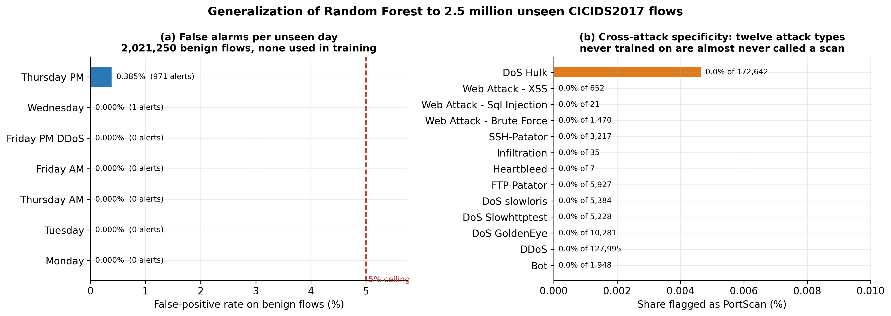
Figure A3. Left: false-positive rate on benign traffic for each unseen capture day, against the 5% ceiling. Right: how often each unseen attack type is labelled a port scan. Takeaway: the false-alarm rate holds on days the model never saw, and other attack families almost never trigger it.
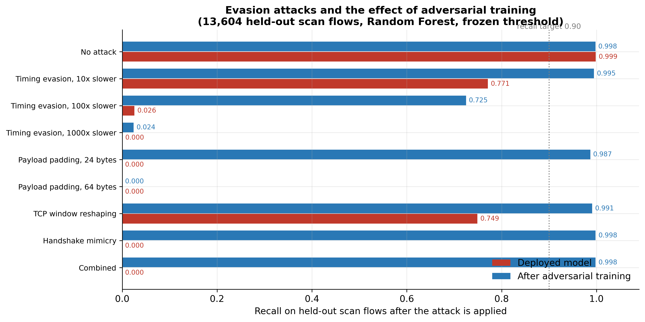
Figure A4. Recall under each evasion attack, before and after adversarial training. Takeaway: timing evasion is the one attack that really works, and training on shaped flows recovers most of what it takes away.
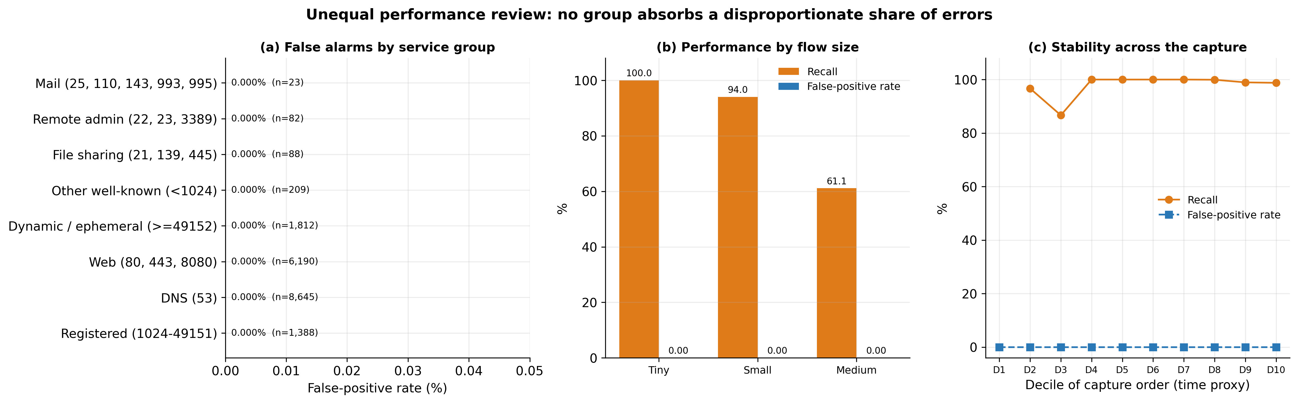
Figure A5. Performance by service group, flow size and position in the capture. Takeaway: no group absorbs a disproportionate share of the errors.
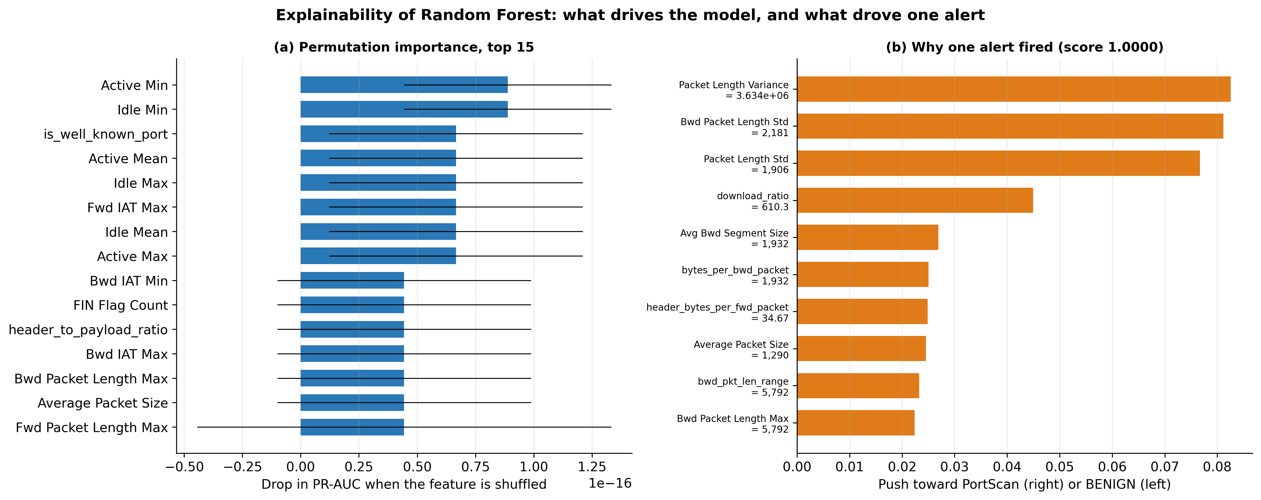
Figure A6. Permutation importance and a worked explanation of a single alert. Takeaway: the model leans on reply behaviour and flow economy, not on one tool-specific value.
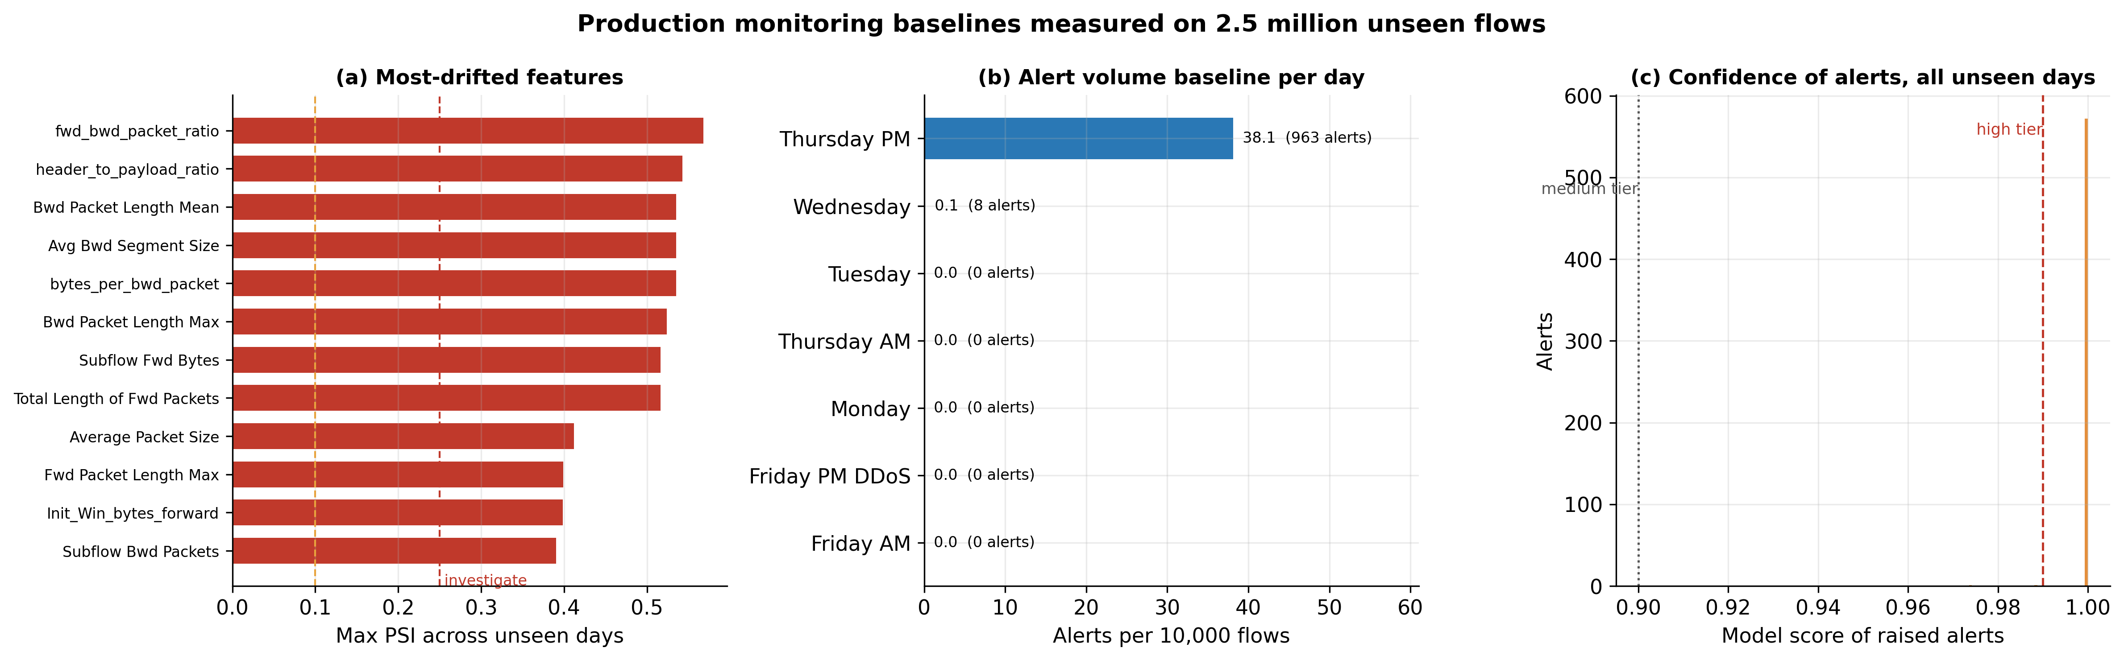
Figure A7. Measured production baselines: feature drift, alert volume per day, and the confidence distribution of raised alerts. Takeaway: the monitoring thresholds in Section 8 are anchored to observed behaviour.

Appendix B. Tuned Hyperparameters and Feature Sets
Table B1. Selected configuration per family, from the 15-candidate randomised search with 5-fold stratified cross-validation on the training split.
Model | Tuned hyperparameters | CV PR-AUC (mean ± sd) | Search time
Logistic regression | C = 3.47 | 0.999963 ± 0.000031 | 23 s
Random Forest | class_weight = balanced_subsample, max_depth = 8, max_features = sqrt, min_samples_leaf = 1, n_estimators = 353 | 0.999999 ± 0.000001 | 1212 s
Gradient Boosting | class_weight = balanced, l2_regularization = 0.09333, learning_rate = 0.2794, max_iter = 370, max_leaf_nodes = 61, min_samples_leaf = 53 | 0.999996 ± 0.000009 | 365 s
Table B2. Feature sets. The primary set keeps every original column; the other two exist only as diagnostics.
Feature set | n | What it contains | Validation recall / FPR
full | 108 | PRIMARY. All 78 original CICFlowMeter columns, the 2 sentinel flags and all 28 engineered features. | 0.99802 / 0.0000%
original_only | 80 | Original columns and sentinel flags only: measures what feature engineering is worth. | 0.99816 / 0.0000%
no_fingerprint | 98 | Primary set minus Destination Port and the TCP-window columns: measures how much of the score is this scanner's fingerprint. | 0.99794 / 0.0000%
Table B3. Engineered features and why each was added. Medians are over the cleaned PortScan file.
Feature | Definition | Why it should help | Median scan | Median benign
total_packets | Total Fwd Packets + Total Backward Packets | Overall flow size in one number | 2 | 4
total_bytes | Forward + backward payload bytes | Overall payload volume in one number | 8 | 231
bytes_per_fwd_packet | Forward payload bytes / forward packets | A probe carries no payload; a real request does | 0 | 38
bytes_per_bwd_packet | Backward payload bytes / backward packets | Separates an empty refusal from a real reply | 6 | 86
fwd_bwd_packet_ratio | Forward packets / (backward packets + 1) | Scans talk and are not answered | 0.5 | 0.6667
download_ratio | Backward bytes / (forward bytes + 1) | Normal clients mostly receive data | 2 | 1.775
no_response | 1 if the responder sent no packet at all | A closed or filtered port returns nothing | 0 | 0
is_empty_payload | 1 if the flow carried zero payload bytes | Probes carry no data in either direction | 0 | 0
single_fwd_packet | 1 if at most one forward packet was sent | A SYN probe is one packet | 1 | 0
is_short_flow | 1 if Flow Duration <= 1000 microseconds | Probes finish in microseconds | 1 | 0
duration_per_packet | Flow Duration / total packets | Normalises duration by how much was sent | 25 | 1.065e+04
flag_total | Sum of the eight TCP flag counters | How much TCP signalling the flow used | 1 | 1
flags_per_packet | flag_total / total packets | A probe is almost pure signalling, no data | 0.5 | 0.01408
syn_only | 1 if SYN set and no ACK, FIN or PSH | Signature of a half-open SYN scan | 0 | 0
rst_present | 1 if any RST flag was seen | A closed port answers with RST | 0 | 0
header_bytes_per_fwd_packet | Forward header bytes / forward packets | Header-only traffic has no payload to amortise | 34.67 | 23
header_to_payload_ratio | Total header bytes / (total payload bytes + 1) | Probes are nearly all header | 8.571 | 0.3989
win_ratio | Forward TCP window / (backward window + 1) | An unanswered handshake leaves this lopsided | 1,024 | 0.06294
fwd_win_is_1024 | 1 if the initial forward TCP window is exactly 1024 | Value this scanner's SYN probes use | 0 | 0
iat_burstiness | Flow IAT Std / (Flow IAT Mean + 1) | Automated probing is evenly paced, humans are bursty | 0 | 1.405
active_idle_ratio | Active Mean / (Idle Mean + 1) | Probes are active briefly and never idle | 0 | 0
pkt_len_cv | Packet Length Std / (Packet Length Mean + 1) | Probes are uniform in size, real traffic varies | 0.5329 | 0.5644
fwd_pkt_len_range | Fwd Packet Length Max - Fwd Packet Length Min | Zero when every forward packet is identical | 0 | 0
bwd_pkt_len_range | Bwd Packet Length Max - Bwd Packet Length Min | Zero when there is no varied reply | 0 | 0
pkts_per_sec_ratio | Fwd Packets/s / (Bwd Packets/s + 1) | Rate-based version of the reply imbalance | 1 | 0.985
port_class | 0 well-known (<1024), 1 registered, 2 dynamic (>=49152) | Coarse port grouping that survives a new port list | 1 | 0
is_well_known_port | 1 if Destination Port < 1024 | Most benign traffic goes to a handful of low ports | 0 | 1
is_common_service_port | 1 if the port is one of 15 everyday services | Scanners spend most probes off this list | 0 | 1

Appendix C. Generalization Detail
Table C1. Every unseen capture day, scored at the frozen threshold.
Day | Contents | Flows | Benign flows | Benign alerts | Benign FPR | Within 5%
Monday | All benign, Mon 3 Jul (outside-day control) | 502,138 | 502,138 | 0 | 0.0000% | Yes
Tuesday | Benign + FTP/SSH brute force, Tue 4 Jul | 421,123 | 411,979 | 0 | 0.0000% | Yes
Wednesday | Benign + DoS family + Heartbleed, Wed 5 Jul | 609,650 | 416,108 | 1 | 0.0002% | Yes
Thursday AM | Benign + web attacks, Thu 6 Jul | 163,916 | 161,773 | 0 | 0.0000% | Yes
Thursday PM | Benign + infiltration, Thu 6 Jul | 252,437 | 252,402 | 971 | 0.3847% | Yes
Friday AM | Benign + botnet, Fri 7 Jul morning | 183,819 | 181,871 | 0 | 0.0000% | Yes
Friday PM DDoS | Benign + DDoS, Fri 7 Jul afternoon | 222,974 | 94,979 | 0 | 0.0000% | Yes
Table C2. Attack types absent from training, and how often the port-scan detector flags them.
Attack type (never trained on) | Flows | Flagged as PortScan | Flag rate
DoS Hulk | 172,642 | 8 | 0.00%
DDoS | 127,995 | 0 | 0.00%
DoS GoldenEye | 10,281 | 0 | 0.00%
FTP-Patator | 5,927 | 0 | 0.00%
DoS slowloris | 5,384 | 0 | 0.00%
DoS Slowhttptest | 5,228 | 0 | 0.00%
SSH-Patator | 3,217 | 0 | 0.00%
Bot | 1,948 | 0 | 0.00%
Web Attack - Brute Force | 1,470 | 0 | 0.00%
Web Attack - XSS | 652 | 0 | 0.00%
Infiltration | 35 | 0 | 0.00%
Web Attack - Sql Injection | 21 | 0 | 0.00%
Heartbleed | 7 | 0 | 0.00%
Table C3. Schema differences that had to be handled before scoring.
Day | Columns | Encoding required | Identical to training file
Monday | 79 | utf-8 | Yes
Tuesday | 79 | utf-8 | Yes
Wednesday | 79 | utf-8 | Yes
Thursday AM | 79 | utf-8 | Yes
Thursday PM | 79 | utf-8 | Yes
Friday AM | 79 | utf-8 | Yes
Friday PM DDoS | 79 | utf-8 | Yes

Appendix D. Adversarial Detail and Response Workflow
Table D1. Every evasion attack, how a real scanner would produce it, and the effect of adversarial training.
Attack | How a scanner produces it | Recall (deployed) | Recall (hardened)
A0 No attack (clean scan flows) | Reference: the scan flows exactly as captured | 0.9986 | 0.9979
A1 Timing evasion, 10x slower | nmap -T2: probes spaced out by an order of magnitude | 0.7710 | 0.9946
A1 Timing evasion, 100x slower | nmap -T1: roughly one probe per several seconds | 0.0255 | 0.7250
A1 Timing evasion, 1000x slower | nmap -T0: a scan paced over hours | 0.0001 | 0.0239
A2 Payload padding, 24 bytes | nmap --data-length 24: probes stop looking empty | 0.0000 | 0.9870
A2 Payload padding, 64 bytes | nmap --data-length 64: probes look like small requests | 0.0000 | 0.0000
A3 TCP window reshaping | Scanner sets an everyday initial window instead of 1024 | 0.7489 | 0.9909
A4 Handshake mimicry (connect scan) | nmap -sT: the connection is completed so a reply exists | 0.0000 | 0.9980
A5 Combined (A1 100x + A2 + A3 + A4) | All four levers used together: the strongest attack tested | 0.0000 | 0.9982
Clean benign traffic (false-positive rate) | No attack: the cost of the defense | 0.0000% | 0.0000%
Table D2. What happens after a detection.
# | Stage | Action | Automation
1 | Score | Every completed flow is scored; score, model version, feature-set version and threshold are written to the alert log | Automatic
2 | Allowlist check | Alerts matching an approved scanner entry on source, port, schedule and expiry are marked suppressed, never deleted | Automatic, fully audited
3 | Tier | Score >= 0.99 high, 0.90-0.99 medium, threshold-0.90 low; low-tier alerts are grouped by source rather than raised one by one | Automatic
4 | Correlate | Alerts are grouped per source host over 5 min, 1 h and 24 h windows; a source crossing 50 distinct ports with over 80% unanswered is escalated even if each flow scored low | Automatic (src/slow_scan.py)
5 | Human review | An analyst confirms or rejects. No automatic blocking at any tier: a false alarm must not be able to cut off a real user | Human decision, required
6 | Respond | Confirmed external scan: rate-limit the source at the perimeter and open an incident. Confirmed internal scan: contact the owner and, if it is authorised testing (Scarfone et al., 2008), add a time-boxed allowlist entry | Human-initiated
7 | Feed back | Every analyst verdict is stored with the flow and the score, forming the labelled pool the next model is trained and tested on | Automatic capture, human label
Table D3. What is written for every alert, so that decisions can be audited and fed back.
Logged field | Purpose
flow_id | Join the alert back to the raw flow record
scored_at | When the model saw it, for latency monitoring
model_version, feature_set_version, threshold | Reproduce exactly which model made the call
score | Confidence, drives tiering and calibration checks
top_features | Per-alert explanation shown to the analyst
allowlist_status, allowlist_entry | Whether it was suppressed and by which approved entry
analyst_verdict, verdict_at, analyst_id | Ground-truth feedback and accountability
source_port_count_24h, unanswered_ratio_24h | Slow-scan context that per-flow scoring cannot see
Table D4. Privacy, retention and misuse controls (continuing Section 7).
Concern | Test or safeguard | Evidence / current finding | Remaining action
Data retention and governance | Scores and alerts retained 90 days, raw flow records 30 days, allowlist entries expire and must be renewed | Expiry column enforced in config/known_scanners.csv | Write the retention rule into the deployment runbook
Human oversight and accountability | No automated blocking. Every alert goes to an analyst queue; the allowlist suppresses but never deletes, so suppression is auditable | Suppressed alerts retain status and matching entry (src/allowlist.py) | Name an accountable owner per alert class in the runbook
Harm from false alerts or automated response | A false alarm must not cut off a real user, so response is review-first; an authorised internal scan is suppressed by the allowlist | Held-out false-positive rate 0.0000%, well inside the 5% ceiling | Add a rate limit so no single source can flood the queue
Misuse of the model itself | Scores are not exposed to untrusted users; an attacker who could query them freely could tune an evasion (see Section 6) | Adversarial evaluation in src/11_adversarial.py | Keep the scoring interface internal and logged
Table D5. Remaining monitoring signals (continuing Section 8).
Signal / metric | Threshold or trigger | Owner / response | Feedback use
Missed scans found after the fact | Any scan confirmed by another control that ScanShield did not flag | Treated as an incident review: the flow is replayed against the model and added to the regression set | Becomes a permanent test case the next model must pass
Allowlist suppressions | Suppression share above 25% of alerts, or any entry past its expiry date | Security team re-approves or removes the entry | Keeps the allowlist from quietly becoming a blind spot
Model freshness | Scheduled review every 90 days regardless of other signals | Both owners re-run the full pipeline on recent traffic | Retrain on the accumulated confirmed labels

