***A Mini Project Synopsis on***

**E-Diary**

**S.E. - I.T Engineering**

**Submitted By**

**Amogh Parulekar 21104001**

**Riya Patel 21104141**

**Kaushik Prabhu Nerurkar 21104016**

**Ajit Pawar 21104054**

**Under The Guidance Of**

**Prof. Roshna Sangle**



**DEPARTMENT OF INFORMATION TECHNOLOGY**

A.P.SHAH INSTITUTE OF TECHNOLOGY

G.B. Road, Kasarvadavali , Thane (W), Mumbai-400615

UNIVERSITY OF MUMBAI

**Academic year: 2022-23**

**CERTIFICATE**

This to certify that the Mini Project report on **E-Diary** has been submitted by Kaushik Prabhu Nerurkar (21104016), Riya Patel(21104141) , Amogh Parulekar (21104001) and Ajit Pawar(21104054) who are a Bonafede students of A. P. Shah Institute of Technology, Thane, Mumbai, as a partial fulfilment of the requirement for the degree in **Information Technology**, during the academic year **2022-2023** in the satisfactory manner as per the curriculum laid down by University of Mumbai.

Prof.Roshna Sangle

Guide

Dr. Kiran Deshpande Dr. Uttam D.Kolekar

Head Department of Information Technology Principal

External Examiner(s)

1.

2.

Place: A.P. Shah Institute of Technology, Thane

Date:

**ACKNOWLEDGEMENT**

This project would not have come to fruition without the invaluable help of our guide **Prof.Roshna Sangle.** Expressing gratitude towards our HoD, **Dr. Kiran Deshpande**, and the Department of Information Technology for providing us with the opportunity as well as the support required to pursue this project. We would also like to thank our teacher Ms. Rujata Chaudhari who gave us her valuable suggestions and ideas when we were in need of them. We would also like to thank our peers for their helpful suggestions.

**TABLE OF CONTENTS**

1. Introduction.......................................................................................................... 1
   1. Purpose..................................................................................................... 1
   2. Objectives................................................................................................. 1
   3. Scope........................................................................................................ 2
2. Problem Definition………………….................................................................... 3
3. Proposed System………....................................................................................... 4
   1. Features and Functionality…………………………………………………...4
4. Project Outcomes.................................................................................................. 7
5. Software Requirements ........................................................................................ 8
6. Project Design........................................................................................................9
7. Conclusion………..................................................................................................15

References

**Chapter 1:**

**Introduction**

E-Diary is a project that aims to provide a digital platform for users to manage their tasks. It is a comprehensive tool that allows users to track their progress, and manage their day-to-day activities.

The project focuses on providing an easy-to-use interface for the user to access their information. People often need information while on the go. Sometimes the information required is essential to the task at hand, people use a variety of strategies to find a way to do their tasks efficiently. The E-Diary System helps them to set down their tasks at a place and add notes to it

It helps them save time and effort by organizing their tasks and activities in one place. It also helps them track their progress and stay on top of their goals.

The system would be having a login system for user login. User can log in and update/delete/create notes.

**Purpose**

The main need of the system is to help the user manage their daily tasks/help users to set goals for the day/create notes for their tasks according to their needs. The system will have an easy-to-interact interface so that even a novice user can use it without any problems.

**Objectives**

* To be designed with the aim of providing a user-friendly, intuitive experience for all users, regardless of their level of technical knowledge.
* To have a platform that will be optimized to ensure the best possible performance and user experience, while also providing a modern and aesthetically pleasing layout.
* To have an attractive, user-friendly, and Secure Login page.
* The primary goal of the E-Diary is to improve productivity and help them reach their goals.

**Scope of the project.**

* To provide a comprehensive and user-friendly interface for users to track their progress all in one place.
* To have secure usage for the user.
* To have an attractive interface for the user.
* To create a handy website for the user.

**Chapter 2:**

**Problem Definition**

Storing the tasks/notes manually using a diary is a difficult task, as managing or searching in it or editing/updating it. It is a very time-consuming and laborious process. The diary can be lost or gets dirty then it can be an issue for the person to find the needy things for it.

**Proposed solution**

* + This project system excludes the need of maintaining paper and thus saves paper.
  + It helps users to electronically create the notes/update/delete
  + The system will be user-friendly so that it can be of ease for the user
* Thus, it saves human efforts and resources.

**Chapter 3:**

**Proposed System**

The conventional method of writing a diary is not so effective; one must write it then if it’s lost it’s the writings are gone. Our System helps the user to manage their diary in an electronic manner. Thus it saves time in managing, bookmarking, searching, and updating. This helps increase the productivity of the user and thus overcomes the conventional issues of managing a diary. It helps the user to create a virtual diary. In order to solve this issue, a web-based computerized system is essential.

This proposed E-Diary System project overcomes all these drawbacks with the features. It is beneficial to the users. The working speed and performance of the software is faster with high performance which saves time.

**Features / Functionality**

* E-Diary offers a range of features that make it a powerful tool for users.
* The design of it will be modern with a focus on simplicity and ease of use. All features will be easy to find and use.
* It helps the user to create a note to set goals or help track their progress.
* It offers a secure login to the user.
* The E-Diary can be accessed by multiple users.
* The user can create a category and add their tasks to it.
* The E-Diary has themes like dark, semi-dark, and light to comfort your eyes as per use.

**Chapter 4**

**Project outcomes**

* The platform will give users a powerful tool to track their progress.
* The E-Student Diary project enables users to easily access and organize their data and achieve their goals.
* The project should have a secure login.
* Users can access the features provided to ease their task.
* To help increase efficiency.

**Chapter 5**

**Software Requirements**

**Development: PyCharm IDE**

PyCharm is used for the development

**Frontend: HTML, CSS, Python**

HTML, CSS, Python was used for frontend development.

**Backend: SQLITE3**

SQLITE3 is used for storing data.

**Chapter 6:**

**Project Design**

The Following are the snapshots of the GUI of the project:

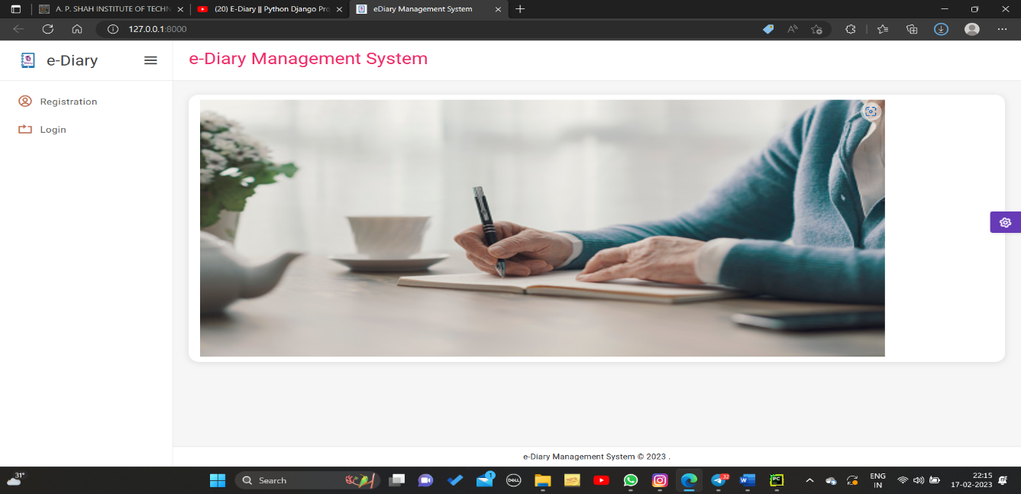

Fig 1.1 Registration/Login Page

Here the user can choose to register if he is new to the system or else login using the credentials.

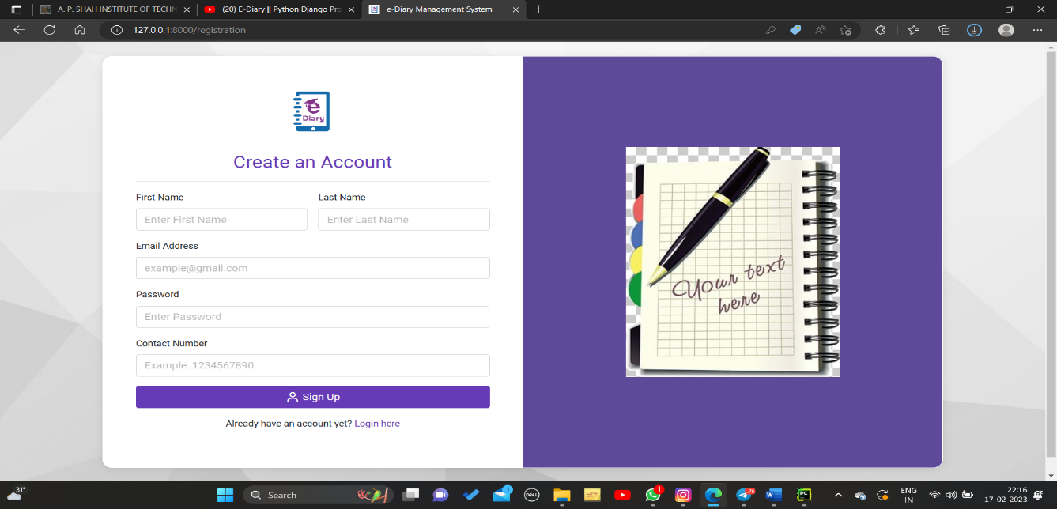

Fig 1.2 Registration Page

Here the User can register themselves

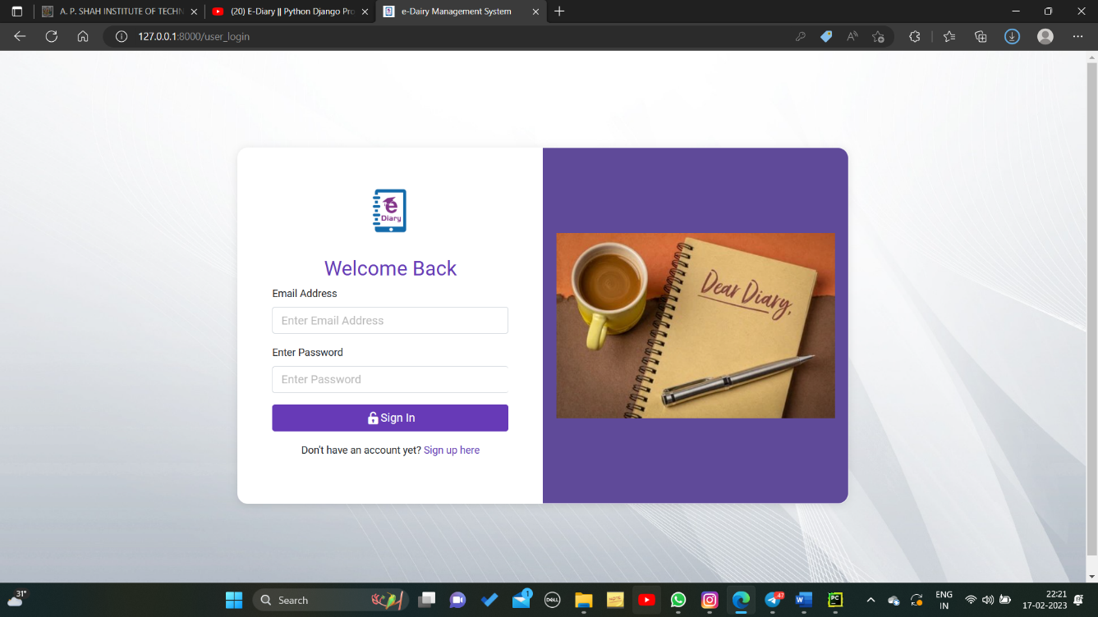

Fig 1.3 Login Page

Here, the user can log in using their credentials.

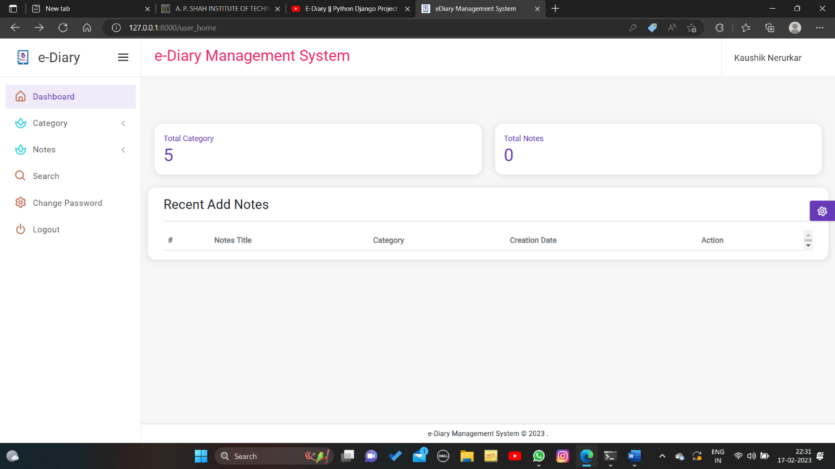

Fig 1.4 User’s Home Page

User Lands on this page after login.

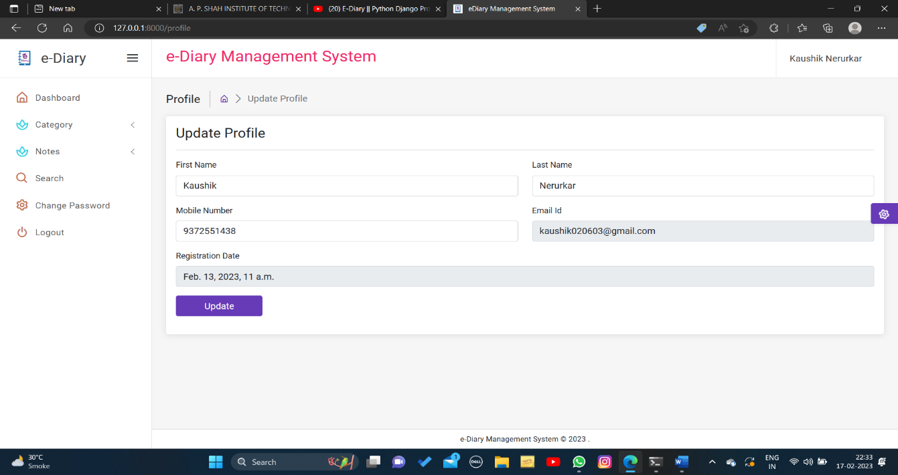

Fig 1.5 Update Profile Page

Here the user can update their profile

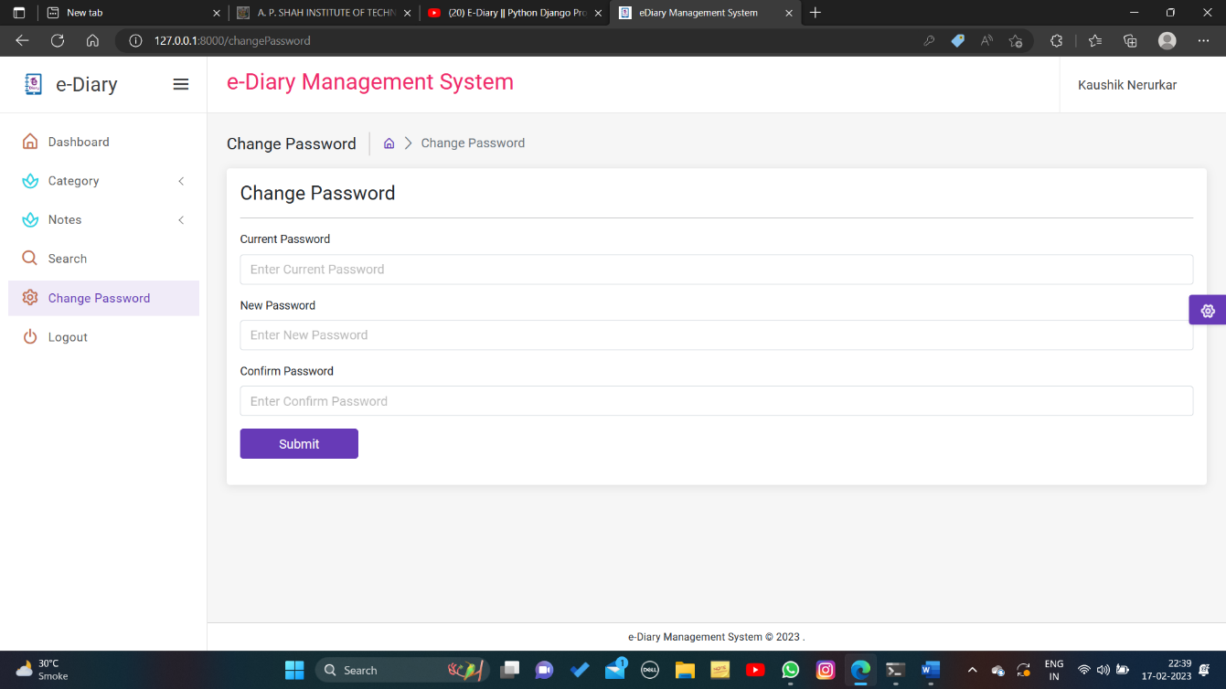

Fig 1.6 Change Password Page

Here, the user can change their password.

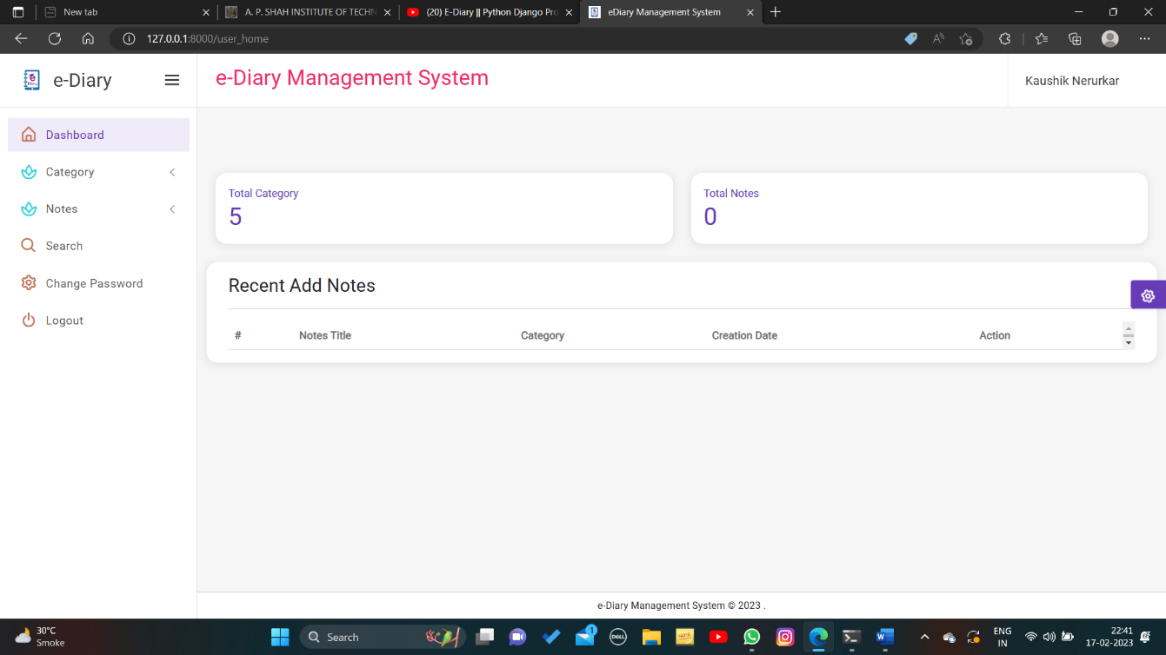

Fig 1.7 Dashboard Page

This is the Dashboard page for the user

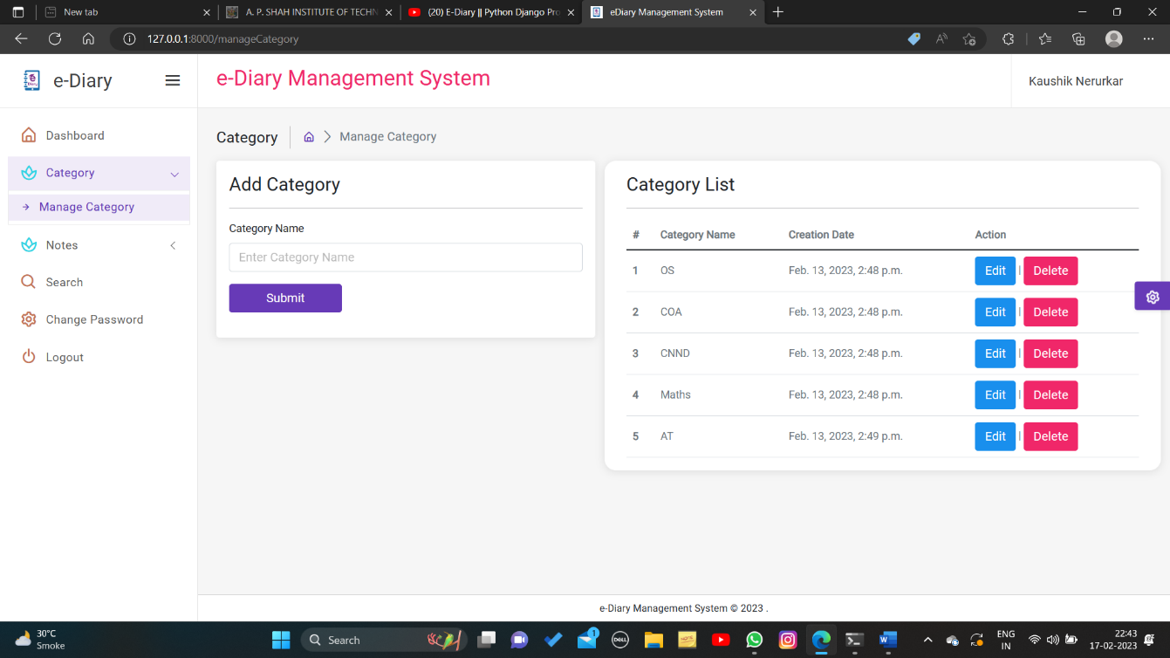

Fig 1.8 Add/Manage Catergory Window

Here,the user can add/manage catergory for the notes

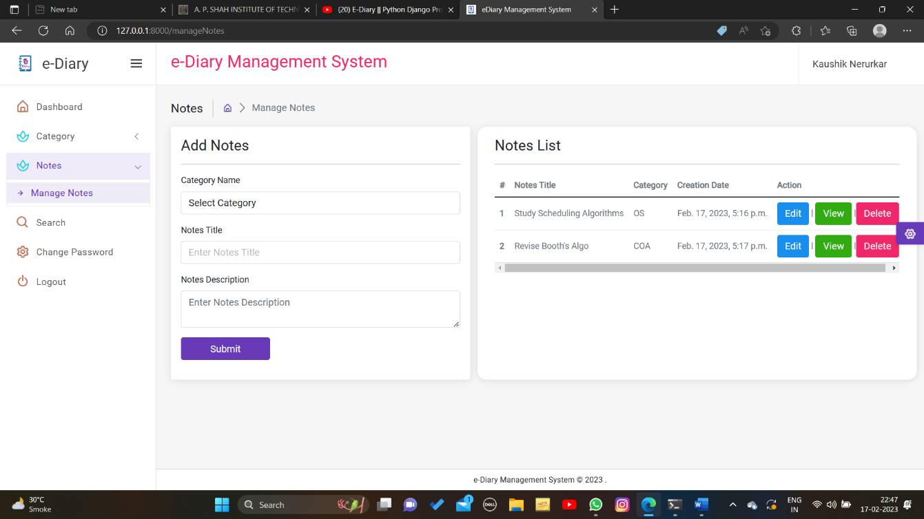

Fig 1.9 Add/Manage Notes Window

Here,the user can add/manage/view their notes

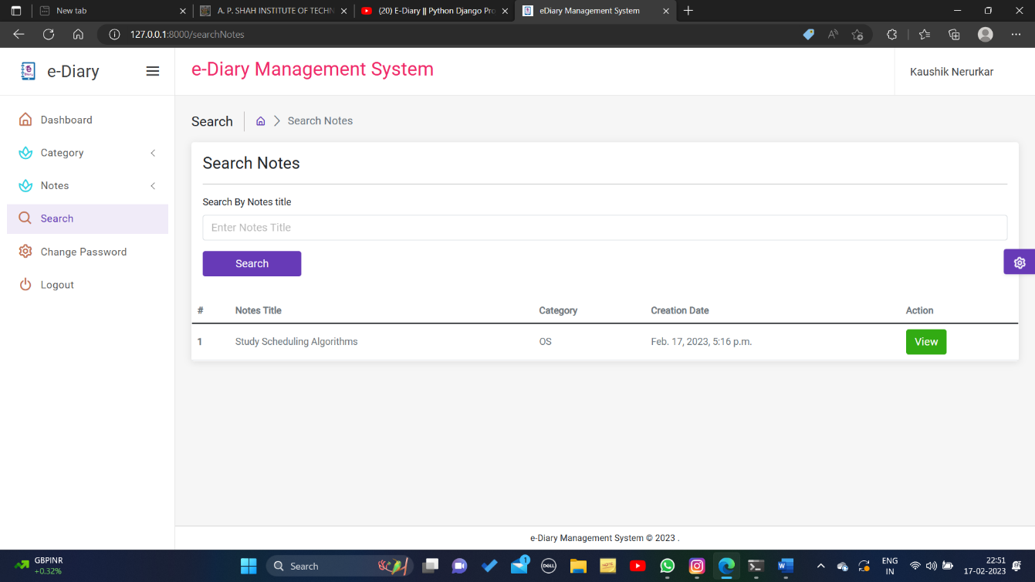

Fig 1.10 Search Notes Window

Here,the user can search notes they have added.

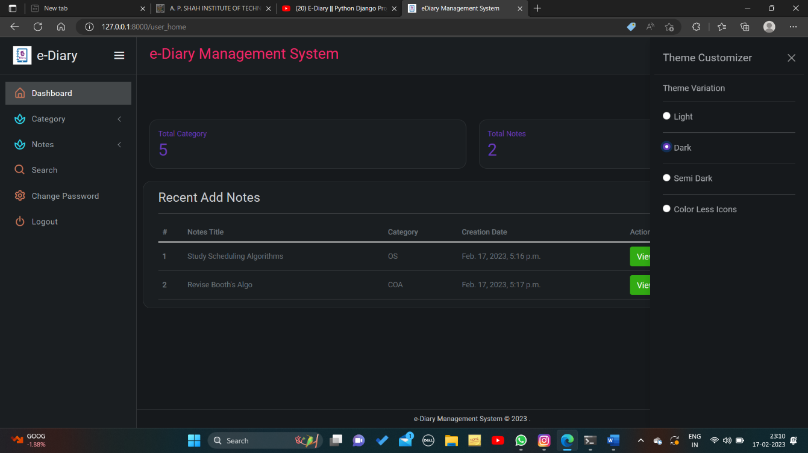

Fig 1.11 Change Theme Button

Here,the user can change the theme according to their eye comfort level so it doesn’t hurt their eyes for much use.

**Chapter 7:**

**Conclusion**

E-Diary is a powerful tool that helps users to manage their academic and personal life. It provides a range of features to helps users track their progress, plan their goals, and manage their day-to-day activities.

The project also takes security and privacy seriously, and includes a range of safety and privacy features to ensure the security of data and information.

**References**

[1] [A secure electronic diary and data collection tool | IEEE Conference Publication | IEEE Xplore](https://ieeexplore.ieee.org/document/5191207/similar#similar)

[2] [Create and run your first Python project | PyCharm Documentation (jetbrains.com)](https://www.jetbrains.com/help/pycharm/creating-and-running-your-first-python-project.html)

[3] [IEEE Digital Diary.docx (engpaper.com)](https://www.engpaper.com/download/digital-diary.pdf)

[4][How to Build your own website using Django in Python (tutorialspoint.com)](https://www.tutorialspoint.com/how-to-build-your-own-website-using-django-in-python)

[5] [Adding CSS styling to your website (pythonhow.com)](https://pythonhow.com/python-tutorial/flask/Adding-CSS-styling-to-your-website/)