AGILE PROCESS MODEL  Ruchita Shah | Chapter 4

Objectives
The objective of this chapter is to introduce concept of Agile software process. When you will read this chapter you will :
- Understand concept of agility;
- Learn about principles of agile development;
- Gain knowledge about various agile process models.

Introduction
Agile process models adopt principle of agility. Agility is the ability to create and respond to change. Agile process model adopts iterative and incremental approach. Process model employs all the stages of waterfall model. To build the project, Iterative approach is taken and working software build is delivered after each iteration. Each build is incremental in terms of features; the final build holds all the features required by the customer. Its main focus remains on process adaptability to ever changing customer requirements. Customer satisfaction is achieved by rapid delivery of working software product.
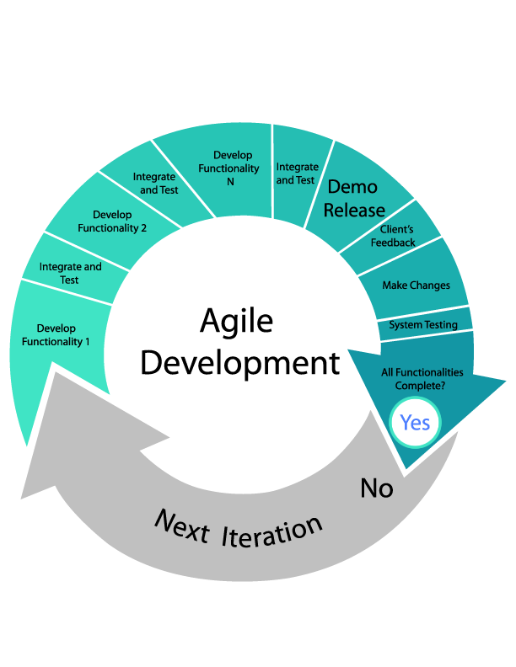
Fig.-Agile Process

Following are the principles of agile process :
- Communication and collaboration − There is a constant need for interactions between team members. This will disseminate information regarding change in the team.
- Responding to change − Agile Development is focused on quick responses to change and continuous development.
- Self-organizing - In Agile development, self-organization and motivation of team members are important. Team also organizes process to accommodate requirements. Team organizes work schedule to deliver working product on time.

- Customer collaboration − Customer Interaction is the backbone of this Agile methodology, and open communication with minimum documentation are the typical features of Agile development environment .
- Working software − Working software is considered the best means of communication with the customers to understand their requirements, instead of just depending on documentation. Team works to deliver working software built at frequent interval.
- customer satisfaction - With early and continuous working software delivery and with accommodating ever changing customer requirements, customer satisfaction are achieved.
- Progress - progress is measured in terms of working software.
- Simplicity - Implementation of simple but best design and architecture.
Agile process make use of an adaptive approach. Planning is done based on what functions and features are to be implemented. There is feature driven development and the team adapts to the changing product requirements dynamically. The product is tested very frequently, through the release iterations, minimizing the risk of any major failures in future. Agile process model is being widely accepted throughout software community.
Advantage
- Agile development is a realistic approach for software development
- Promotes teamwork and cross training
- Functionality can be developed rapidly and demonstrated
- Delivers early partial working solutions
- Accommodates changes at any stage of development
- Decrease in time as vary less planning is required

Disadvantage
- Not suitable for highly complex software
- Depends heavily upon customer interaction, so if customer is not clear about requirements than development may take a wrong direction
- Very less documentation may lead to confusion

Agile process models
There are number of different process models for agile development.
Extreme programming
Extreme programming is a lightweight and flexible model for agile process. It is employed to implement software projects being developed by small teams. Extreme programming is based on five rules
Communication – There is a constant need for communication between fellow developers and with customers.
Simplicity – Design and implementation are simple and to the point
Feedback – For each release customer feedback is taken. This helps in improving next release and boost customer satisfaction.
Respect – Team members have continuous communication and collaboration which improve respect among themselves.
Courage – Extreme programming require courage to accept change at any stage of development and commit.
Extreme programming uses object-oriented approach. It has following stages for software development :
Planning : A story is created describing required features and functions. These functions are prioritized based on their business value.
Design: A good quality design is important to develop a good quality software. Extreme programming follows simplicity. It uses no-notations and very few work product are produced.
Incremental development: Incremental development releases software in increments every few days. Customer feedback on the release are included in next iteration. Thus new increment s released with improvised requirements.
Testing: Testing helps to remove errors and improves software’s reliability. Each increment are tested thoroughly. Release are again tested by customer known as acceptance test.
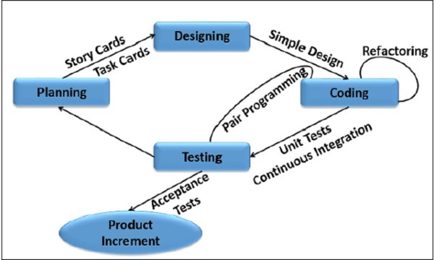
Fig. – Extreme Process
Advantage
- It ensures timely delivery through achievable development cycle
- Continuous customer involvement
- Extensive testing ensures less defects are released
- Changes are accommodated at any stage of development
Disadvantage
- It requires constant involvement of customer
- Less documentation may lead to problem at the time of staff turnover

Adaptive Software Development

Adaptive software development is proposed by Jim Highsmith in 2000. It is a technique to build complex software. It applies practices of RAD model. Model focuses on communication and team self-organization. It is a cyclic model having three stages:

Speculate: It represents adaptive cycle planning. This stage initiates project by gathering information from customer which includes primary requirements, constraints and mission statement. A rough planning is done and iteration begins.

Collaborate : Communication and collaboration is proportional to size and complexity of the project. To handle complex and large volume of information collaboration is necessary. To solve complex problem, knowledge in diverse fields are required. This leads to team collaboration. Thus collaborate is the ability to work together to produce results, share knowledge or make decisions.

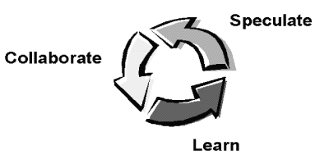
Fig. – Adaptive Software Development Cycle

Learn : As the components are being developed, team focuses on enhancement of their knowledge. Learning helps software developers to improve their understanding. Learning is carried out through:
- Focus groups : consists of customers and end users. They provide feedback on the increments. This indicates if customer requirements are being fulfilled or not.
- Technical reviews : Reviews are performed after each iteration. Team members review software components so as to improve its quality.
- Postmortem: Team must review and reflect upon its performance and process. Team must identify changes in required direction.
Advantage
- This process focuses on users which leads to product being more user-centric
- Thrives for on-time delivery
- More communication and transparency between developer and customer
Disadvantage
- Requires extensive customer involvement which is sometimes difficult to facilitate
- Extensive testing leads to cost increase
Dynamic systems development method
An agile development approach, Dynamic System Development Method (DSDM) provides a framework for building and maintaining time-constrained systems. It combines best practices of prototyping, incremental and Rapid Application Development (RAD) approach. DSDM life cycle consists of 5 stages:
Feasibility Study: This stage identifies business requirements for the software being developed and business constraints imposed on it. Based on it, viability of the product is assessed.
Business study : Identifies functional and information requirements for building the software. Creates basic architecture of the application
Functional model iteration : A number of prototypes are produced. These prototypes demonstrate fulfillment of customer requirements through implementation of functionality. Through user feedback, additional requirements are gathered.
Design and Build Iteration: After prototyping stage, all the functional requirements will be gathered. In this stage, software is designed and build anew.
Implementation : Software increments are tested in operation environment. Project falls into next iteration.
Advantage
- End-user are more involved, leading to better understanding and implementation of functions.
- Software is developed in increments. Through collecting customer feedback, it can be improvised in next iteration
- Budget and schedule remains in check

Disadvantage

- Needs expertise to implement the model
- Not applicable for small budget projects

Scrum
Scrum is an Agile Development Process Model, developed by Jeff Sutherland and team in 1990. It works on following principles:
- Scrum relies on a small and self-organizing team. The scrum team is self-organizing in a manner that there is no overall team leader. Issues and problem are solved by team as a whole.
- Team is cross functional. Every developer must take a feature from idea up to its implementation.
- Process adopts to changes in technical and business requirements
- Software is produced in increments. These increments are reviewed and adjusted.
- Low coupling between work products and developers
- Constant testing and documentation is performed throughout the project.
- Project can be declared complete at any given time

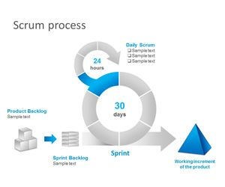

Scrum process is applied through framework activities: Requirements, Analysis, Design, Evolution and delivery. Within an activity, a process pattern is applied to each work tasks known as Sprint. Work conducted during Sprint is adapted for the problem at the hand and also modifies during work tasks. Scrum stresses on use of proven and effective software patterns. These patterns can accommodate tight schedules and changes in requirements. Following activities are carried out during the process:
Backlog – A priority list containing important business requirements to be developed are created. This list can be updated anytime by project managers.
Sprint – Sprint is project team’s to-do list. The requirements from backlog that need to be finished first are being developed. During sprint, the backlog items which are being developed are frozen. No changes are allowed in them. This allows team members to work in a stable environment.
Scrum meetings – They are of short duration and held daily. Team members are asked 3 key questions : (1) What did you do since last meeting? (2) What obstacles you faced? (3) What do you plan to complete before next meeting? Scrum meeting helps uncover potential problems at early stage. This meeting leads to dissemination of information in team members. Scrum Master is the team leader who leads the meeting and evaluates responses of all team members.
Demos – They are software increments delivered to customers. Customers evaluate them and provide feedback. Demo may not contain full functionality.
Advantage
- Projects are delivered within bound of time and money
- Large and complex projects are divided into smaller components and achieved
- Each release are evaluated by customers. They give feedback on it
- Feedback are adopted in next release. This leads to user requirement satisfaction
- During scrum meeting each member has chance to put their work forward

Disadvantage
- Planning is difficult for this model
- If team members are not committed, chances of project failure is high
- Needs experienced developers to implement scrum model
- Due to less wait on testing, quality may be questionable
- Not to be used for large projects
Crystal
Crystal model was developed by Alistair Cockburn and Jim Highsmith. It is a lightweight and adaptive approach for agile software development. Crystal is a set of agile methods namely : Crystal clear, Crystal orange, Crystal yellow and many more. Each method is applicable to certain project and environment. The characteristics addressed by crystal methods are team size, criticality of project etc. models of Crystal family thrives on flexibility. Development process framework are followed for the development. Development team selects base method at the beginning of the project. Developers are allowed to use techniques borrowed from other methodologies. To monitor and tune he development, reflection workshops are organized.
Advantages
- It delivers software in increments which is reviewed by customer and provided with feedback. Feedback is used to improve next increment.
- It is a flexible process
Disadvantage
- Not suitable for high risk projects
- High degree of communication in team are required

Feature Driven Development
This model was conceived by Peter Coad and team. It is applicable for object oriented software engineering. This model was extended by Stephen Palmer and John Felsing. This model follows practical approach to fulfill customer requirements. it is a client centric model. Work tasks are produced in a short time.
The feature is a small portion of customer requirements for example “ calculate total sales”. A feature is expressed in the form <action><result><object>. Where <action> can be Calculating, Making etc. <object> can be a person or thing such as sales, product etc. <action> is applied on <object> to obtain <result>.
The Feature Driven Development model have 5 framework activities. The first activity leads to Develop An Overall Model. Initial result of this activity will be an object model. During second activity, A Features List are built. These lists are grouped according to their subject areas. Next step performs planning by feature. This activity identifies of class owners and feature set owners. Fourth and fifth activities are about detailed modeling, programming, testing, and packaging of the system.

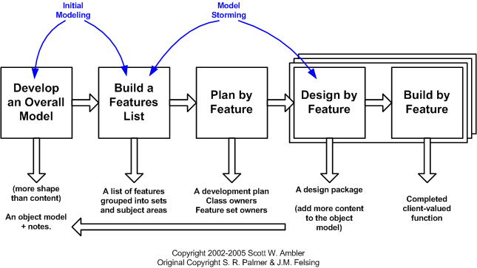
Fig. – Feature Driven development Process

Advantages
- Features are small portion of a functionality, customers easily describe and evaluate them
- A hierarchical function related grouping of the features are possible
- It needs less time to develop a feature making possible to release features in a short time
- It is easy to design and develop features
- Project planning and scheduling is easy
- Supports multiple teams working in parallel
Disadvantage
- Not a good method for small projects
- Less documentation may lead to confusion

Agile Modeling
For developing large and complex systems, Agile model is applied. Agile modeling is also a combination of incremental and iterative process model. Customer satisfaction and process adaptability are its main focus. Agile method divides software into small manageable tasks. Each tasks are divided among team members. Quality of the software being built is monitored sharply. Following are the Agile modelling manifesto:
Purposeful model : Developer shall have clear goal for using the model for example communication with customer regarding constraints on software. Notation and level of details depend on model to be used.
Use alternatives : there are many models and various notations for designing. Each model identifies different feature of software system. Developer must identify the model which will describe features of software to be developed the best.
Less is beautiful : Do not mix multiple models for different activities. Apply only those model that have long-term value for the software.
Trade-off: Trade-off between content and its representation. Content are always more important than its presentation. Apply those model that can convey information to users.
Knowledge: Developers must have knowledge about model and tools they are using. Every model and tool has its own strength and weakness.
Adaptation: Model being applied must adapted according to software being developed and the team working on it.

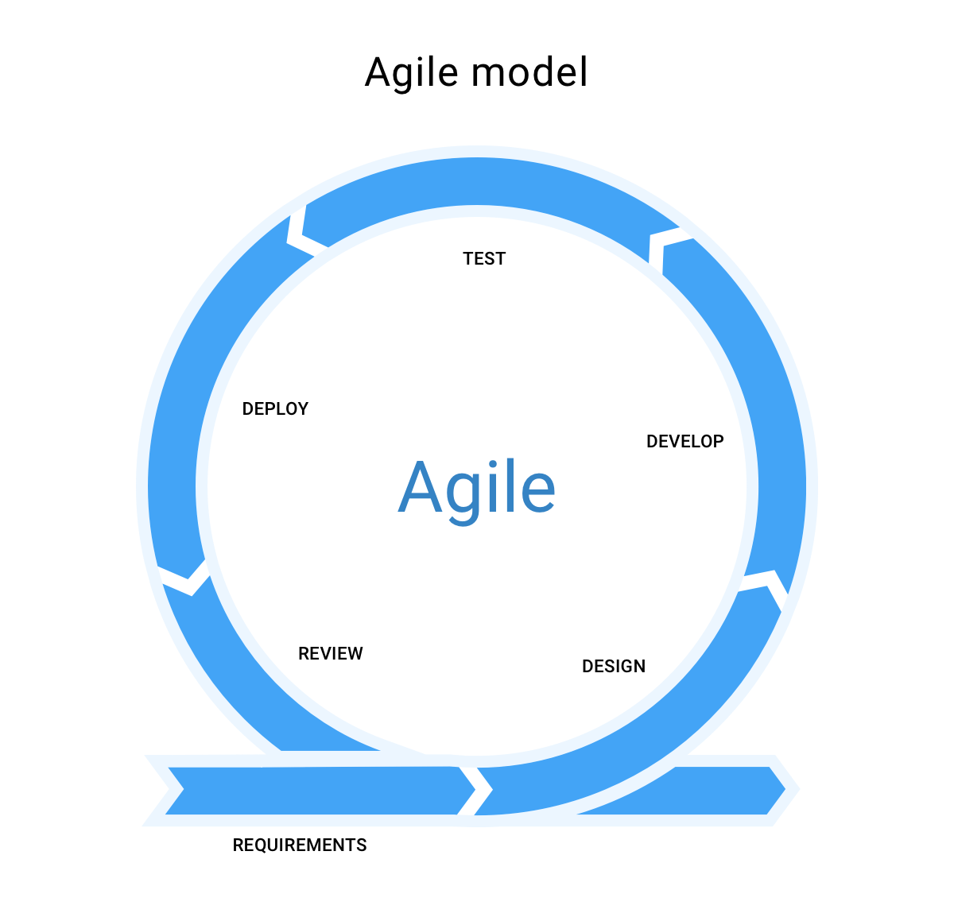

Advantages
- It is a realistic model for software development
- Quick development and fast release
- Suitable for any type of requirements
- Supports team work
- Easy to manage
- Gives flexibility to developers
Disadvantage
- Very less planning leads to schedule overrun, may effect maintainability
- Not suitable for projects having complex dependencies between its components
- Less documentation leads to confusion during staff turnover

Activity 1

Fill in the blanks with suitable option.

- Agile development stresses on _______________
- Interaction b. working software c. customer involvement d. all the three
- ___________ is not an agile model.
- Scrum b. XP c. SAP d. ASD
- How many phases are there in Scrum? ___________
- None b. two c. three d. four
- Adaptive software development consists of _____________________________ framework activities.
- Analysis, design and coding c. speculate, collaborate and learn
- Requirements, planning and coding d. object model and feature model
- Define Agility: _______________________________________
- quick development c. Customer collaboration
- response to change d. Iterative process

Summary

Agile models stresses on : Ready to accommodate change at any stage of development, rapid delivery of software increments, self-organizing teams, and heavy communication and collaboration between team members as well as with customer. In this chapter, models which support agile development principal are discussed.

Extreme programming is widely used model.it follows common framework activities of planning, design, coding and testing. It delivers features and functionality of software in increments at a frequent rate. Adaptive Software Development emphasizes on communication and collaboration between team members and also with customer. Process is organized in three activities – speculate, collaborate and learn. This model is iterative and adaptive in nature. Dynamic system development model(DSDM) develops software using 3 iterative cycles – functional model iteration, design and build iteration and implementation iteration. Each increment of work product sufficient implementation so as to move forward in next iteration.

Scrum make use of process patterns that are proven effective for time-constrained projects. Each process have their defined set of tasks which need to be adapted to software. Crystal is a family of agile process models. it is iterative and can be applied to projects with different sizes and complexities. Feature driven development model focuses on project team and features to be developed. Functions that are specified by customers are implemented in a short time. Agile model stresses on tuning of process model according to software complexity and size.

Answers to Activity 1

Fill in the blanks with suitable option.

- Agile development stresses on _all the three___
- Interaction b. working software c. customer involvement d. all the three
- _SAP_______ is not an agile model.
- Scrum b. XP c. SAP d. ASD
- How many phases are there in Scrum? __three____
- None b. two c. three d. four
- Adaptive software development consists of __speculate, collaborate and learn__ framework activities.
- Analysis, design and coding c. speculate, collaborate and learn
- Requirements, planning and coding d. object model and feature model
- Define Agility: ___ response to change__________________________
- quick development c. Customer collaboration
- response to change d. Iterative process

