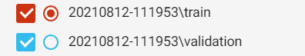

**Accuracy of training and test data set:**

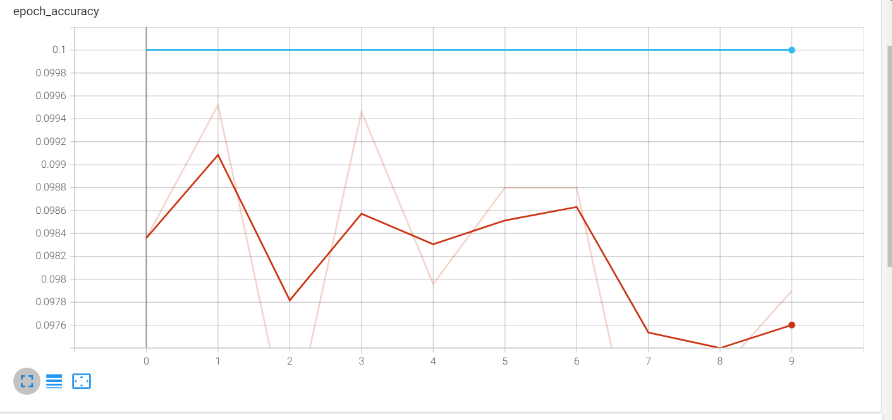

**Loss of training and test dataset:**

