# Talent Analytics Hub

## Project Overview

This Power BI dashboard provides an in-depth analysis of employee attrition, helping organizations understand the reasons behind employee turnover. It utilizes various HR analytics metrics, such as attrition by department, salary levels, job roles, age group, and education field. The dashboard enables HR professionals to make data-driven decisions to reduce attrition and improve employee retention.

## Data Preprocessing

To ensure accuracy and usability of the dataset, the following preprocessing steps were conducted:

• Data Cleaning: Removed duplicate records and handled missing values.

• Data Transformation: Applied appropriate data types to numerical and categorical fields.

• Data Profiling: Verified data consistency across various attributes, such as department, salary, and job role.

• DAX Calculations: Used Power BI’s DAX functions to calculate key HR metrics such as attrition rate, average salary, and attrition by job roles.

## Key Findings & Insights

### Employee Attrition Overview

Total Employees: 1,470

Total Attrition: 237 employees (16.1% Attrition Rate)

Average Employee Age: 37 years

Average Years at Company: 7.0 years

Attrition Rate by Gender: Male: 150 employees, Female: 87 employees

### Attrition by Education Field

Life Sciences: 38% attrition (Highest)

Medical: 27%

Marketing: 15%

Figure: Attrition by Education Field

### Attrition by Age Group

Ages 26-35: 116 employees (Highest attrition)

Ages 18-25: 44 employees

Ages 36-45: 43 employees

Ages 46-55: 26 employees

Ages 55+: 8 employees

Figure: Attrition by Age Group

### Attrition by Salary Slab

Up to 5K: 163 employees (Highest attrition)

5K - 10K: 49 employees

10K - 15K: 20 employees

15K+: 5 employees

Figure: Attrition by Salary Slab

### Attrition by Job Role

Laboratory Technician: 62 employees

Sales Executive: 57 employees

Research Scientist: 47 employees

Sales Representative: 33 employees

Figure: Attrition by Job Role

### Attrition by Years at Company

Highest attrition occurs within the first 2 years of employment.

Attrition gradually declines as employees stay longer in the company.

Figure: Attrition by Years at Company

### Data Validation and Profiling

Checked for missing values and inconsistencies in HR attributes.

Ensured all data types were correctly formatted.

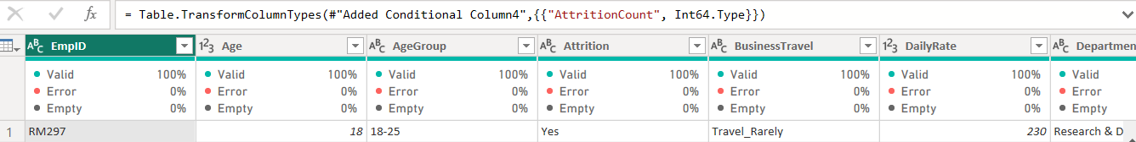

Figure: Data Validation and Profiling

## Dashboard Features

• Interactive Filters – Allows users to drill down attrition data by age, department, salary, and education field.

• Dynamic Visualizations – Includes bar charts, donut charts, and line graphs for better data interpretation.

• Real-Time Insights – Enables HR teams to forecast attrition trends and implement retention strategies.

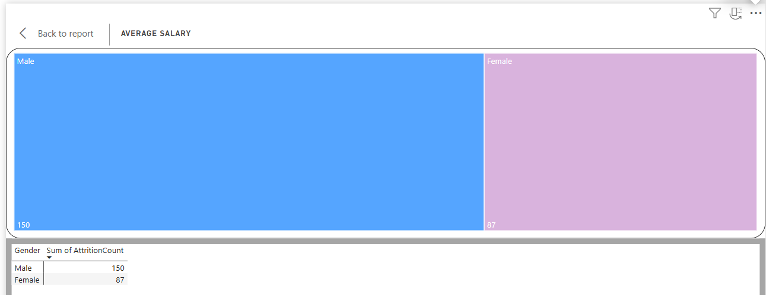

## How to Use

1. Download the dataset: Talent Analytics Dataset File

2. Open Power BI file: Load dataset and explore interactive dashboards.

3. Analyze Trends: Use filters to gain deeper insights into attrition patterns.

4. Make Data-Driven Decisions: Use findings to improve HR strategies and reduce turnover rates.

## Repository Contents

• Power BI Dashboard – Talent Analysis Hub.pdf

• Dataset File – Talent Analytics Dataset File

## Conclusion

This HR Analytics Dashboard serves as a valuable tool for HR professionals, providing actionable insights into employee attrition trends. By leveraging data visualization, DAX calculations, and Power BI analytics, companies can enhance retention strategies and workforce management effectively.