# Power BI Financial Analysis Report

## Data Preprocessing

1. The dataset was cleaned and transformed to improve visualization in Power BI.

2. Unnecessary missing rows and columns were removed to maintain data integrity.

3. Data profiling was conducted to detect anomalies, including missing values, duplicate records, and outliers.

4. DAX calculations were applied for advanced financial analysis, such as profit margins, discount impact, and revenue trends.

## Patterns and Knowledge Discovery from the Dashboard

1. Year-over-year sales growth indicates significant revenue expansion in key market segments.

2. Discounting strategies directly impact profit margins, with higher discounts leading to reduced profitability.

3. The Enterprise segment shows negative profit margins, indicating potential pricing inefficiencies.

4. The top-selling products include Paseo, VTT, and Velo, contributing the highest revenue across all customer segments.

5. Regional analysis highlights Canada and the U.S. as the largest contributors to total sales volume.

## Data Analytics Methods

### Anomaly Detection

• Identified discrepancies in financial transactions, including unusual fluctuations in sales and profit margins.

• Verified missing or duplicate values affecting order accuracy.

• Detected inconsistencies in discount allocations across different product categories.

### Financial Trend Analysis

The dashboard leverages Time Intelligence functions in Power BI to analyze trends, helping businesses track revenue fluctuations, discounting patterns, and sales seasonality.

• Month-over-month and year-over-year comparisons provide insights into financial performance trends.

• Segment-level profitability analysis allows for better decision-making in pricing and discount strategies.

• Cumulative sales tracking helps businesses assess long-term revenue growth.

## Business Problem

Understanding financial performance is critical for optimizing business operations. Key challenges include:

• Evaluating the impact of discounts on overall profitability.

• Identifying high-revenue customer segments for better sales targeting.

• Tracking year-over-year sales trends to forecast future performance.

## Solution

This Power BI dashboard provides comprehensive insights into financial performance. Businesses can use interactive visualizations to:

• Track profit trends and sales growth using DAX-powered calculations.

• Optimize discount strategies by analyzing their impact on revenue and profitability.

• Identify the best-performing products and customer segments to drive strategic decision-making.

## Dashboard Visuals

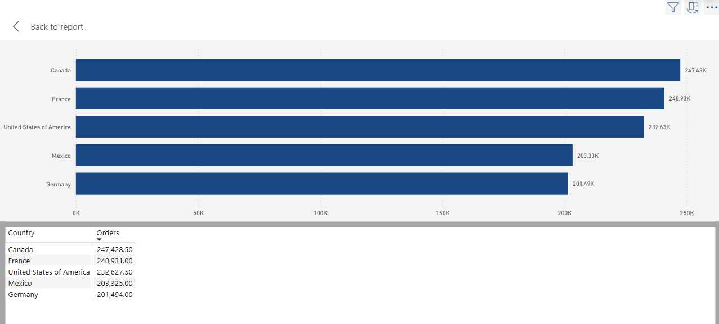

Figure: Dashboard Analysis

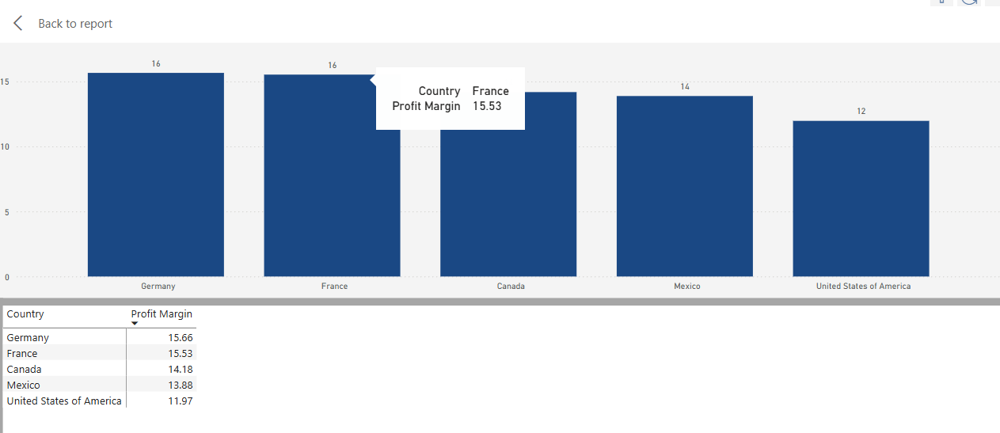

Figure: Dashboard Analysis

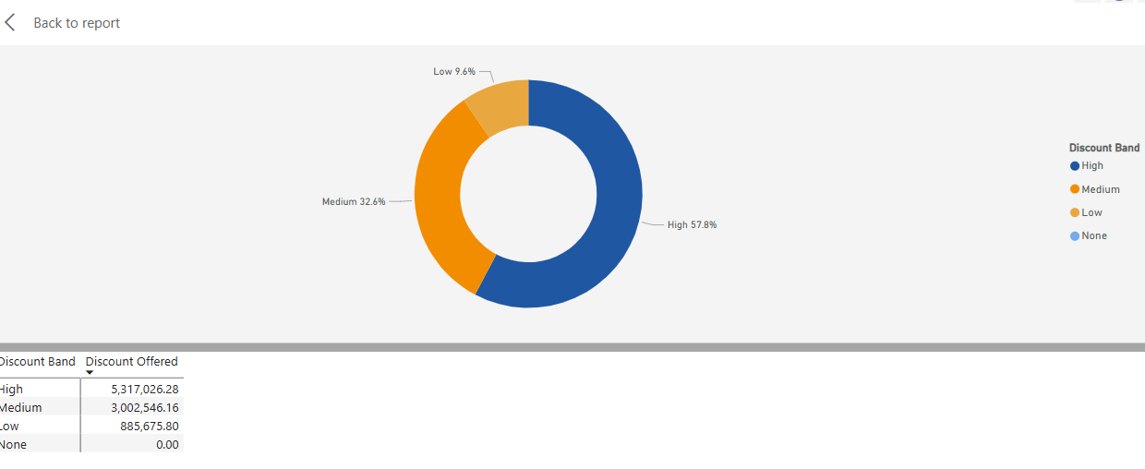

Figure: Dashboard Analysis

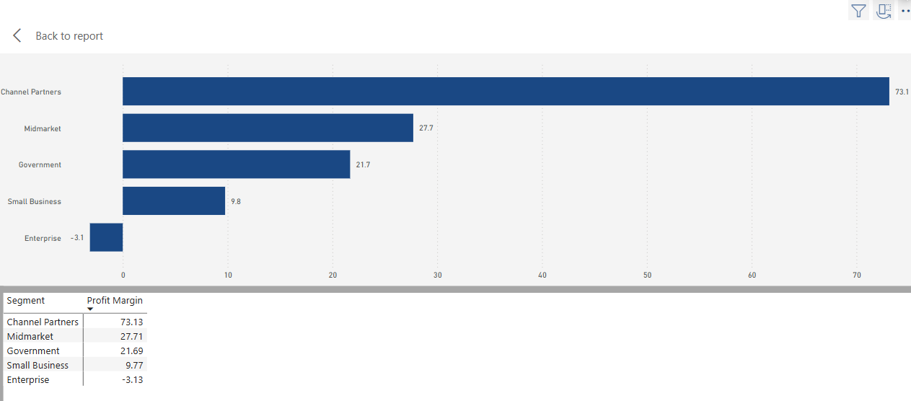

Figure: Dashboard Analysis

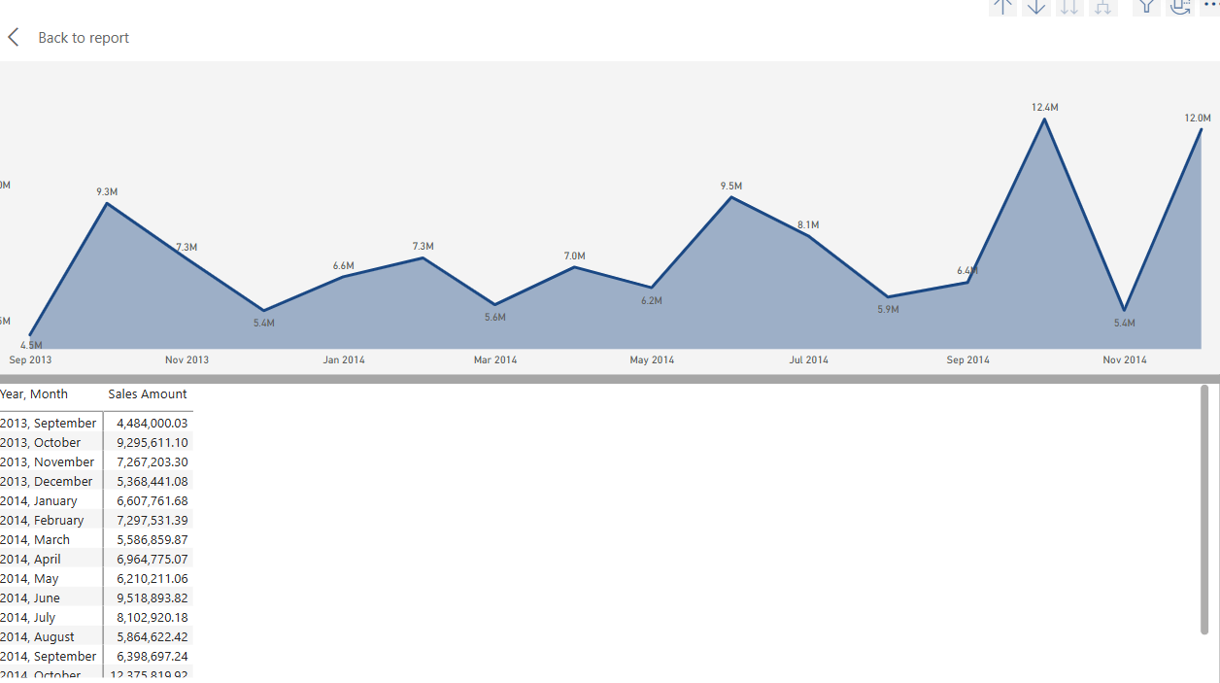

Figure: Dashboard Analysis

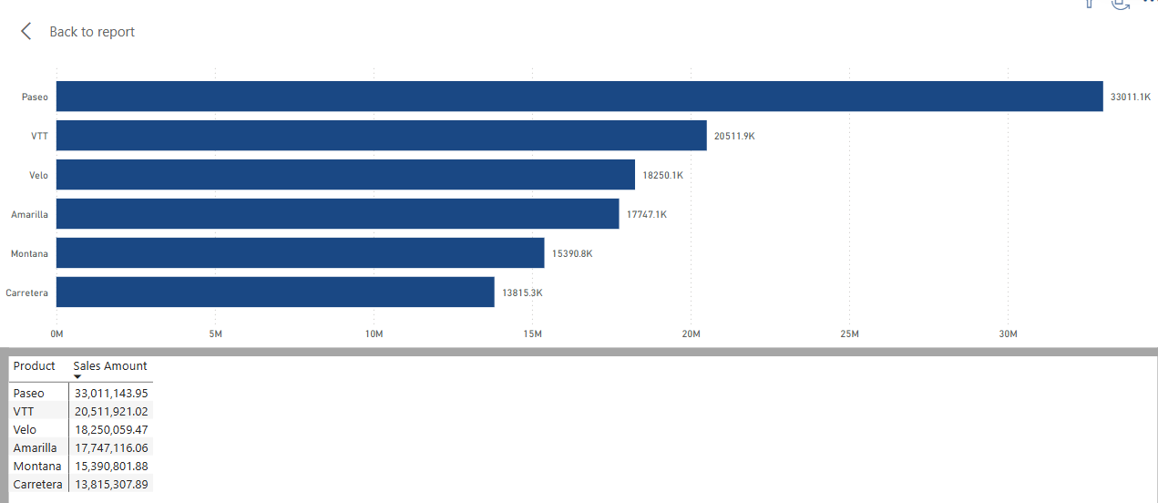

Figure: Dashboard Analysis

