NETFLIX CUSTOMER
CHURN ANALYSIS
A Python-Based Exploratory Data Analysis Capstone Project

Prepared by: Riya Ripson Kennedy Kottukkal
Course: Data Analytics

Index
1. Abstract 3
2. Introduction 3
3. Problem Statement 3
4. Project Objectives 3–4
5. Scope and Research Questions 4
6. Dataset Overview 4–5
7. Tools and Technologies 5
8. Methodology 5–6
9. Data Quality Assessment and Cleaning 6
10. Outlier Analysis 6–7
11. Exploratory Data Analysis 7–12
12. Key Findings 12–13
13. Business Recommendations 13
14. Limitations 13
15. Conclusion 14
16. References 14

1. Abstract
This capstone project examines a customer churn dataset using Python in Google Colab. The supplied CSV contains 5,001 records and 14 columns describing customer demographics, subscription type, viewing behaviour, recent login activity, region, device, monthly fee, payment method, profile count, favourite genre, and churn status. The workflow includes data inspection, missing-value and duplicate checks, investigation of unusual numerical values, and exploratory data analysis (EDA). Visualizations are used to summarize churn distribution and compare churn rates across customer segments. In the raw data, 2,515 records are labelled as churned (50.29%), and 2,486 are labelled as not churned. Segment-level comparisons show notable differences by subscription type, payment method, watch hours, and recency of login. These are descriptive associations rather than proof of causation. The project demonstrates data preparation, statistical exploration, visualization, interpretation, and the translation of findings into cautious business recommendations.

2. Introduction
Customer churn refers to customers discontinuing a service or subscription. For subscription-based businesses, understanding churn can help teams investigate retention risks, customer engagement, and the experience of different customer segments. Exploratory data analysis provides a first step by summarizing the data, checking its quality, identifying distributions, and examining relationships between variables.
This project uses a dataset labelled as Netflix customer churn for learning and analytical practice. The analysis is performed in Python using Google Colab. The dataset is treated as the supplied project dataset; the report does not assume that it is an official internal Netflix dataset because its provenance has not been independently established.

3. Problem Statement
Customer churn can reduce recurring subscription revenue and make long-term customer retention more difficult. The project investigates how the churn label varies across the available customer attributes, including subscription type, payment method, region, device, viewing hours, and days since last login. It also assesses whether data-quality issues or unusual values may affect interpretation. The goal is to identify descriptive patterns and develop recommendations for further investigation, not to claim that the observed variables cause churn.

4. Project Objectives
- Inspect the dataset structure, variables, data types, and summary statistics.
- Identify missing values, duplicate records, and possible data-quality concerns.
- Investigate numerical outliers using the Interquartile Range (IQR) method.
- Perform univariate, bivariate, and selected multivariate exploratory analyses.
- Compare churn rates across subscription, payment, regional, engagement, and other customer segments.
- Create charts that communicate the results clearly.
- Summarize findings and propose evidence-based next steps.

5. Scope and Research Questions
The scope is descriptive analysis of the supplied CSV using Python. The project does not build a predictive churn model, test causal effects, or validate the dataset against real Netflix systems.
- How is churn distributed in the dataset?
- Do churn rates differ across subscription types, payment methods, regions, and devices?
- How does churn vary across viewing-hour and last-login intervals?
- What missing, duplicate, or unusual values require attention?
- Which patterns warrant deeper analysis or business investigation?

6. Dataset Overview
The raw file loaded for this report is “netflix customer churn(2).csv”. It contains 5,001 rows and 14 columns. There are 2 missing values in the age column and 1 exact duplicate row(s) in the raw dataset.
Item | Description
Rows / columns | 5,001 rows × 14 columns
Target variable | churned (0 = not churned, 1 = churned, based on the encoding in this file)
Missing data | 2 missing values in age; no missing values in the other columns
Exact duplicate rows | 1
Data source | Supplied CSV; original provenance/source URL should be added if known
Analysis environment | Google Colab / Python

6.1 Variable dictionary
Column | Description | Type / note
customer_id | Customer identifier | Identifier; exclude from numeric relationship analysis
age | Recorded customer age | Numerical
gender | Recorded gender category | Categorical
subscription type | Subscription plan category | Categorical
watch hours | Recorded watch-hour total | Numerical; confirm time window/unit
last_login_days | Days since last login | Numerical
region | Recorded geographic region | Categorical
device | Device category | Categorical
monthly_fee | Recorded monthly fee | Numerical; currency
churned | Churn indicator | Binary numeric (0/1)
payment_method | Recorded payment method | Categorical
number_of_profiles | Number of profiles | Discrete numerical
avg_watch_time_per_day | Average daily watch time as stored | Numerical; verify unit and calculation
favorite_genre | Favourite genre category | Categorical

7. Tools and Technologies
Tool / library | Purpose
Google Colab | Cloud notebook environment for running Python code
Python | Core programming language for data analysis
Pandas | Loading CSV data, data inspection, cleaning, grouping, and summaries
NumPy | Numerical operations
Matplotlib | Charts and visual presentation
Seaborn | Statistical plotting, if used in the notebook

Only tools actually used should be retained in the final submission. The work described here is Python/Google Colab-based; no Power BI dashboard is claimed as part of this report.

8. Methodology
- Load the CSV into a Pandas DataFrame.
- Inspect shape, column names, data types, sample records, and descriptive statistics.
- Check missing values and exact duplicate records.
- Calculate IQR bounds for numerical variables and flag potential outliers for review.
- Compare churn rates across categorical groups and binned numerical variables.
- Create visualizations to communicate the observed distributions and differences.
- Interpret the results cautiously, noting data limitations and avoiding causal claims.
The analysis is exploratory and descriptive. Segment churn rates are calculated as the mean of the binary churn indicator multiplied by 100. For each segment, the denominator is the number of records in that segment.

9. Data Quality Assessment and Cleaning

9.1 Missing values
The raw dataset contains 2 missing values in age, out of 5,001 rows. The median of the available age values is 44 years

9.2 Duplicate records
One exact duplicate row was detected in the raw data. The duplicated row was reviewed and removed. The raw dataset contains 5,001 rows; removing one confirmed duplicate would leave 5,000 rows.

9.3 Data types and validation
The churn field is encoded as 0/1. Customer ID is an identifier and should not be treated as a meaningful numeric feature. The report also recommends verifying the definitions and units of watch hours and average daily watch time before treating extreme values as valid or invalid.

9.4 Cleaning log
Issue | Raw-data evidence | Recommended / recorded handling
Missing age | 2 missing values | Choose and document a justified treatment; if imputed, record method and resulting values.
Exact duplicate | 1 duplicate row | Review and remove if confirmed redundant; document row count before/after.
Possible impossible daily time | 10 rows have avg_watch_time_per_day > 24 | Investigate units, calculation, and source; do not automatically delete.
Extreme watch-hour values | Maximum watch hours = 110.40 | Review against the intended observation period and business meaning.
Dataset provenance | Source not verified from file alone | Add the original source URL and dataset description if available.

10. Outlier Analysis
Potential outliers were identified using the Interquartile Range method. For each numerical variable, IQR = Q3 − Q1; the lower fence is Q1 − 1.5 × IQR and the upper fence is Q3 + 1.5 × IQR. Values outside these fences are flagged for investigation, not automatically classified as errors.
Numerical variable | IQR flags | Lower fence | Upper fence | Minimum | Maximum
age | 0 | -12.000 | 100.000 | 18.00 | 70.00
watch hours | 238 | -15.695 | 35.065 | 0.01 | 110.40
last_login_days | 0 | -30.000 | 90.000 | 0.00 | 60.00
monthly_fee | 0 | -4.510 | 31.490 | 8.99 | 17.99
number_of_profiles | 0 | -1.000 | 7.000 | 1.00 | 5.00
avg_watch_time_per_day | 549 | -0.805 | 1.635 | 0.00 | 98.42

The IQR method flags 238 values in watch hours and 549 values in avg_watch_time_per_day. The latter variable has 10 records above 24. If the field represents hours per day, values above 24 are not physically plausible and should be checked against the source, units, and calculation. The high number of IQR flags in this variable may also reflect a strongly right-skewed distribution. Outlier flags are screening signals; treatment should be based on data meaning and source validation.

11. Exploratory Data Analysis

11.1 Univariate analysis
The churn field contains 2,515 churned records and 2,486 non-churned records. The overall churn rate in the raw file is 50.29%. The age distribution ranges from 18 to 70 among non-missing values, with a mean of 43.84.

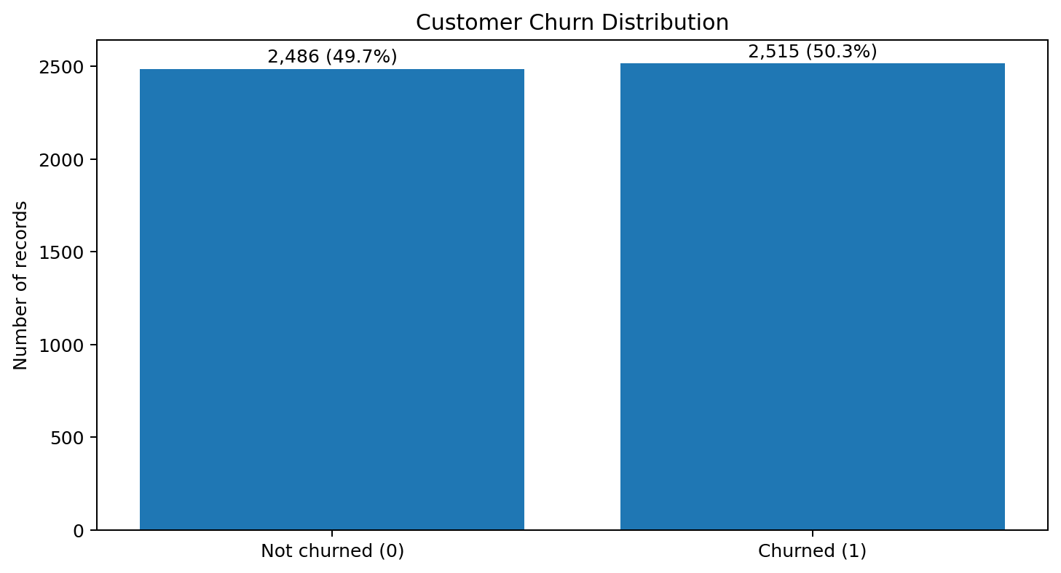
Figure 1. Distribution of the churn label in the supplied raw dataset.
Interpretation: the churn and non-churn classes are close to evenly represented. This baseline is useful for comparing subgroup rates, but it should not be interpreted as a verified real-world Netflix churn rate.

11.2 Bivariate analysis: subscription type
Subscription type | Customers | Churn rate
Basic | 1661 | 61.83%
Standard | 1647 | 45.42%
Premium | 1693 | 43.71%

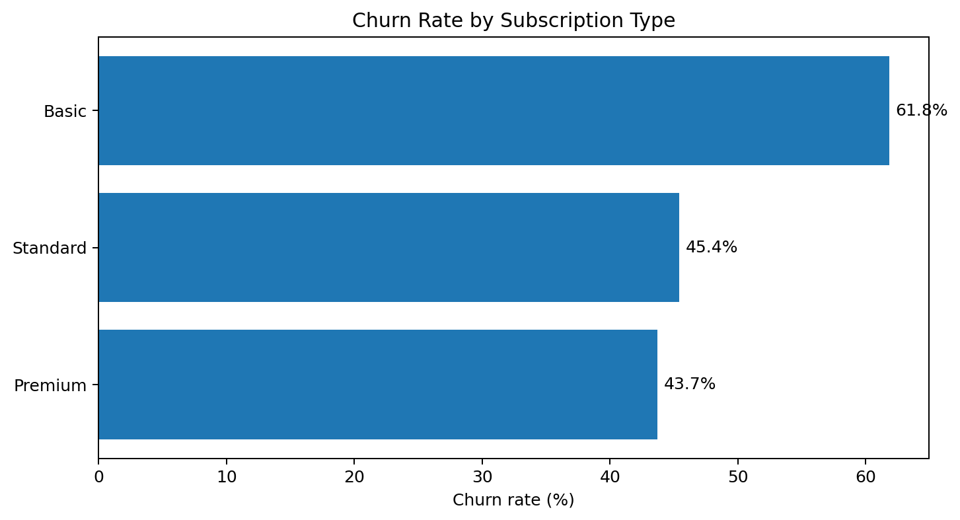
Figure 2. Churn rate by subscription type.
The Basic plan has the highest observed churn rate (61.83%), while the lowest rate is observed for Premium (43.71%). These differences may justify further investigation, but the dataset does not establish why they occur.

11.3 Bivariate analysis: payment method
Payment method | Customers | Churn rate
Crypto | 996 | 59.64%
Gift Card | 976 | 57.79%
PayPal | 1026 | 47.08%
Debit Card | 1030 | 43.69%
Credit Card | 973 | 43.58%

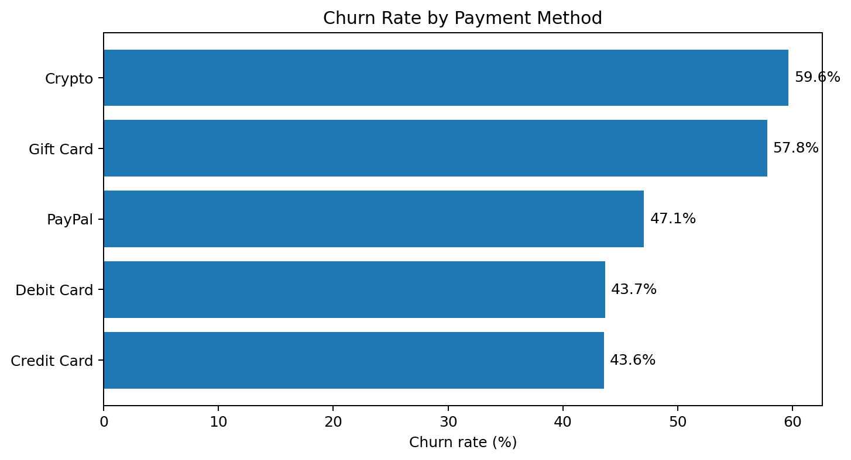
Figure 3. Churn rate by payment method.
The highest observed payment-method churn rate is for Crypto (59.64%), and the lowest is for Credit Card (43.58%). Payment method may be associated with other factors such as customer segment or data-generation rules, so these results should be validated before operational decisions.

11.4 Bivariate analysis: region
Region | Customers | Churn rate
Europe | 867 | 51.67%
South America | 874 | 51.37%
Asia | 841 | 50.65%
Oceania | 765 | 50.07%
North America | 851 | 49.47%
Africa | 803 | 48.32%

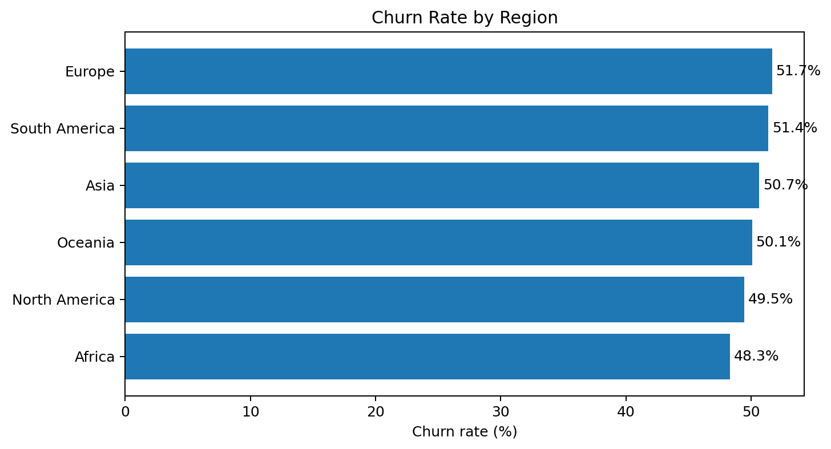
Figure 4. Churn rate by region.
Regional churn rates range from 48.32% to 51.67%. The difference is modest compared with some other segment comparisons. Regional results should be interpreted in light of group sizes and the unknown data provenance.

11.5 Bivariate analysis: watch hours
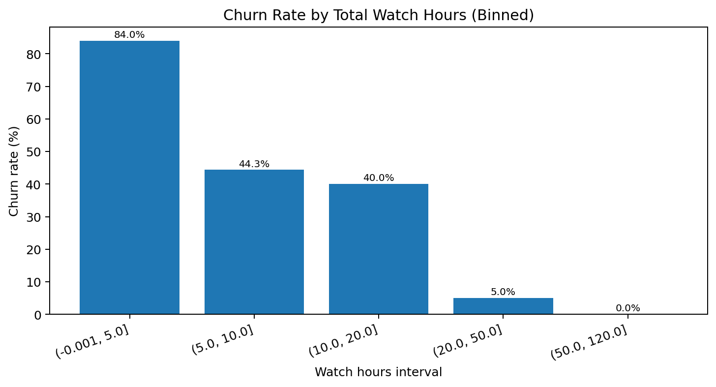
Figure 5. Churn rate across watch-hour intervals.
Churn varies substantially across the watch-hour intervals used in this analysis. The 0–5 watch-hour group has an observed churn rate of 83.95%, while the 20–50 group has an observed rate of 4.99%. This strong pattern suggests that viewing behaviour is closely associated with the churn label in this file. However, unusual distributions or synthetic data-generation rules may contribute to the relationship.

11.6 Bivariate analysis: days since last login
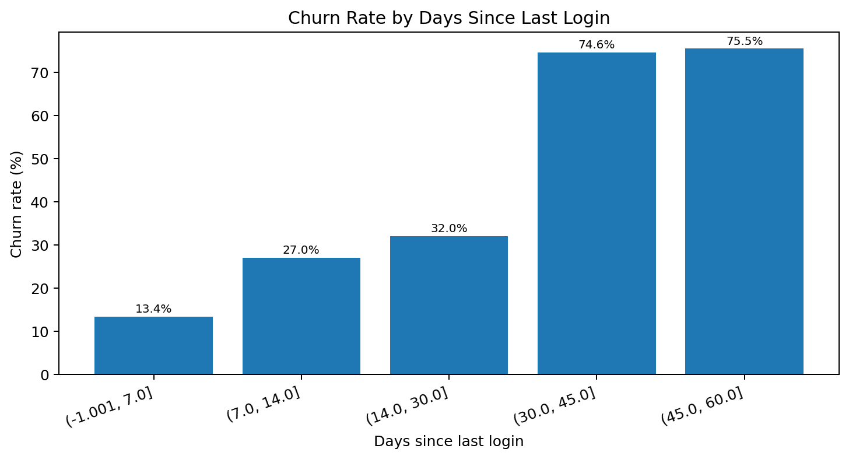
Figure 6. Churn rate by days since last login.
The churn rate increases across the later last-login intervals in this dataset. In the 0–7 day interval, the observed churn rate is 13.38%; in the 45–60 day interval, it is 75.53%. This is consistent with inactivity being a useful signal to investigate, but the analysis is descriptive and does not prove that inactivity causes churn.

11.7 Multivariate analysis: numerical relationships
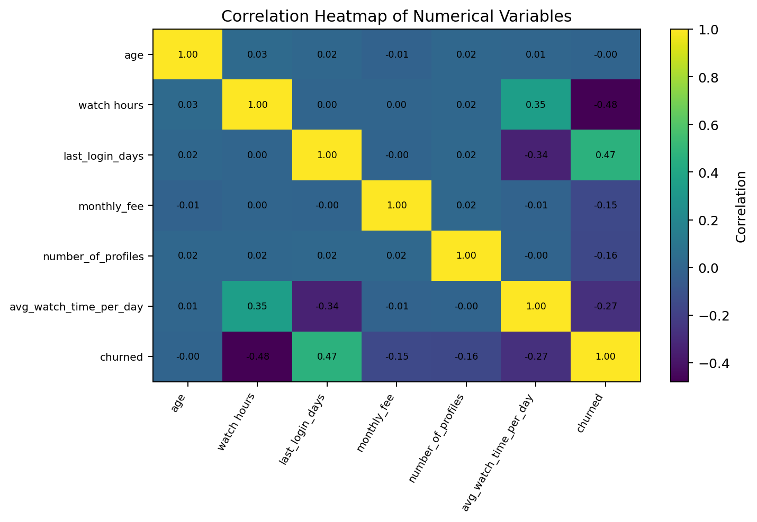
Figure 7. Correlation heatmap for numerical variables and the churn indicator.
A correlation heatmap summarizes linear relationships between numeric variables. Correlation is not causation, and it may not capture non-linear relationships. Customer ID is excluded because it is an identifier rather than a meaningful measurement. Because some viewing variables have extreme values, correlation results should be checked against distributions and data definitions.

11.8 Churn-group comparison
Group | Mean age | Mean watch hours | Mean days since login | Mean monthly fee | Mean profiles | Mean daily watch time
Not churned | 43.89 | 17.45 | 21.78 | 14.25 | 3.25 | 1.59
Churned | 43.79 | 5.92 | 38.31 | 13.13 | 2.80 | 0.16

The table compares group averages for the churn label. In the supplied data, churned records have lower average watch hours and lower average daily watch time, and a higher average number of days since last login than non-churned records. These differences align with the segment-level patterns above. Extreme viewing values and data provenance remain important caveats.

12. Key Findings
- The raw dataset contains 5,001 records and 14 columns; one exact duplicate and two missing age values were identified.
- The overall churn label rate is 50.29% (2,515 of 5,001 records).
- Subscription type differs by churn rate: Basic is 61.83%, compared with 43.71% for Premium.
- Payment-method rates vary; Crypto is 59.64% and Credit Card is 43.58%.
- Viewing activity is strongly associated with the churn label in this dataset: the 0–5 watch-hour group has an 83.95% churn rate, compared with 4.99% in the 20–50 group.
- Days since last login also shows a pronounced difference: churn is 13.38% in the 0–7 day group and 75.53% in the 45–60 day group.
- Outlier screening flagged 238 watch-hour values and 549 average daily watch-time values; 10 average daily watch-time records exceed 24.
These findings describe patterns in the supplied dataset. They should not be generalized to Netflix's actual customer population unless the dataset's authenticity, sampling method, and definitions are verified.

13. Business Recommendations

- Investigate low-viewing and long-inactivity segments as potential retention-risk groups; validate the pattern with time-based or customer-level evidence.
- Review churn differences by subscription plan and payment method, while controlling for possible confounding variables before recommending plan or payment changes.
- Check the definition and calculation of avg_watch_time_per_day, especially records above 24, and document whether they are unit errors, calculation errors, or valid differently defined values.
- Use churn rates rather than raw counts when comparing groups of different sizes; include group counts alongside percentages.
- After validation, consider tracking churn over time and testing retention interventions with a suitable experimental design
- Do not treat statistical outliers as errors automatically; use business rules and source checks to decide whether to correct, retain, or exclude observations.

14. Limitations
- The original source and representativeness of the supplied CSV have not been verified; it should not be presented as confirmed official Netflix internal data.
- The data dictionary does not fully define the observation period for watch hours or the unit/calculation of average daily watch time.
- The analysis is descriptive and does not establish causality.
- No predictive model, cross-validation, or formal hypothesis testing was performed in this project report.
- Segment-level patterns may be influenced by confounding variables, data-generation rules, or unusual values.
- Two age values are missing and one duplicate row was present in the raw data; final cleaning actions should be confirmed against the notebook.

15. Conclusion
This project applied a Python-based exploratory workflow to a customer churn dataset. It covered data inspection, data-quality checks, IQR-based outlier screening, segment-level churn comparisons, and visualizations. The strongest descriptive differences in the supplied data appear in viewing activity and recency of login, with additional differences across subscription type and payment method. These patterns can guide further investigation, but they should not be interpreted as causal evidence or as verified statements about Netflix's actual customer base. The project highlights the importance of combining clear visual communication with careful data validation and cautious interpretation.

16. References
Dataset: “netflix customer churn.csv”, supplied for this capstone project- kaggle
Python Software Foundation. Python documentation. https://docs.python.org/
Pandas development team. pandas documentation. https://pandas.pydata.org/docs/
Matplotlib development team. Matplotlib documentation. https://matplotlib.org/stable/
Google. Google Colab. https://colab.research.google.com/

