**Experiment No.: 1 Date: 28-10-2022**

**Aim:**

Finding the area of rectangle

**CO1:**

Understand the basics of Python Programming Language including input/output functions,operators,basic and collection data types.

**Procedure**

l=int(input("Enter the length: ")) #lengthofrectangle

b=int(input("Enter the Breadth: ")) #breadthofrectangle

area =l*b #area

print("The area of rectangle :" ,area , "sq.units")

**Output Screenshot**

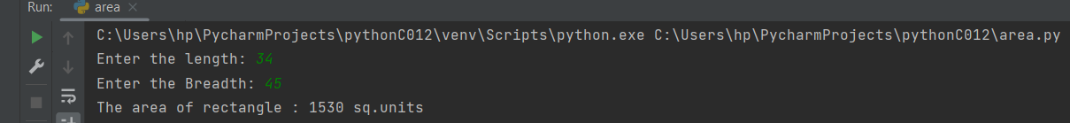

**Result**

The program was executed and the result was successfully obtained. Thus CO1 was obtained.

**Experiment No.: 2 Date: 28-10-2022**

**Aim:**

Find the area & perimeter of circle ,using proper commands in the program

**CO1:**

Understand the basics of Python Programming Language including input/output functions,operators,basic and collection data types

**Procedure**

radius=int(input("Enter the radius of circle :")) #taking input for radius ofcircle

perimtr=2*3.14*radius #perimetrOfCircle

area=3.14*radius*radius #areaOfCircle

print("The Perimeter of Circle : ",perimtr,"units") #perimetrofcircle

print("The Area of Circle : ",area,"sq. units") #area of circle4

**Output Screenshot**

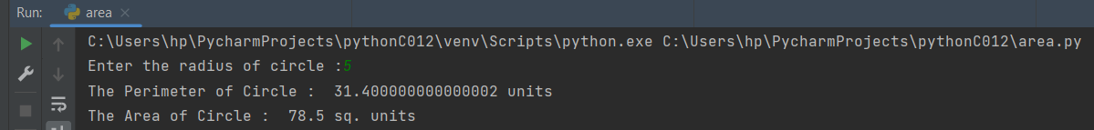

**Result**

The program was executed and the result was successfully obtained. Thus CO1 was obtained.

**Experiment No.: 3 Date: 28-10-2022**

**Aim:**

Converting the temperature from Celsius to Fahrenheit

**CO1:**

Understand the basics of Python Programming Language including input/output functions,operators,basic and collection data types

**Procedure:**

tem=int(input("Enter the temperature in Celsius :")) #temeprature in Celsius

con=9/2*tem+32 #conversion of temeprature to Fahrenheit

print("The Temperature in fahrenheit is :",con,"F") #printing the converted temperature

**Output Screenshot:**



**Result:**

The program was executed and the result was successfully obtained. Thus CO1 was obtained.

**Experiment No.: 4 Date:28-10-2022**

**Aim:**

Converting the distance from kilometers to miles

**CO1:**

Understand the basics of Python Programming Language including input/output functions,operators,basic and collection data types

**Procedure:**

distance=int(input("Enter the distance in kilometers : ")) #distance in kilometers

miles=distance*0.62137 #conversion of distance from km to miles

print("The distance in Miles is :",miles,"miles") #printing of converted distance

**Output Screenshot:**

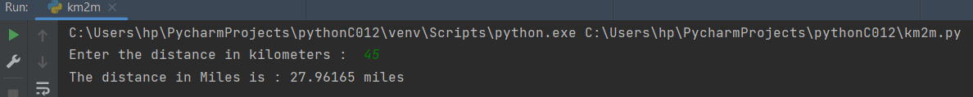

**Result**

The program was executed and the result was successfully obtained. Thus CO1 was obtained.

**Experiment No.: 5 Date: 28-10-2022**

**Aim:**

Swapping of 2 variables

**CO1:**

Understand the basics of Python Programming Language including input/output functions,operators,basic and collection data types

**Procedure**

#taking input from user

x=input("Enter the first value : ")

y=input("Enter the second value : ")

temp=x

x=y

y=temp

print('The first value after swapping : ',format(x))

print('The second value after swapping : ',format(y))

**Output Screenshot**

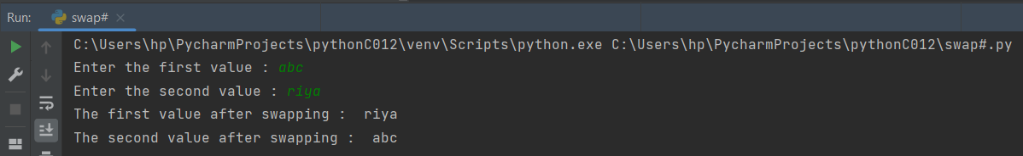

**Result**

The program was executed and the result was successfully obtained. Thus CO1 was obtained.

**Experiment No.: 6 Date: 28-10-2022**

**Aim:**

Enter the name of student,marks of five subjects and calculate the total & percentage

**CO1:**

Understand the basics of Python Programming Language including input/output functions,operators,basic and collection data types

**Procedure:**

name=input("Enter the name of the student: ") #nameofstudent

maths=int(input("Enter the marks of Mathematics : ") )#marksofmathematics

eng = int(input("Enter the marks of English : ") )#marksofEnglish

sc = int(input("Enter the marks of Science : ") )#marks0fScience

sst= int(input("Enter the marks of Social Science : ")) #marks of social science

hindi = int(input("Enter the marks of Hindi : ") )#marks of hindi

total=maths+eng+sc+sst+hindi #totalofALLSubject

print("The Total Marks of all subject scored by ",name," : ",total) #printing total of all subjects

percentage=(total/500) *100 #Percentage of all subjects

print("The percentage scored by ",name," :",percentage ,"%") #printing percentage of all sujects

**Output Screenshot:**

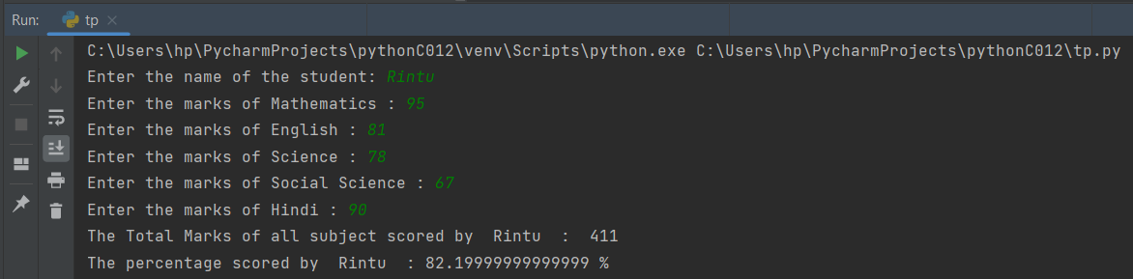

**Result**

The program was executed and the result was successfully obtained. Thus CO1 was obtained.

**Experiment No.: 7 Date: 28-10-2022**

**Aim:**

Converting the distance from foot to inches**.**

**CO1:**

Understand the basics of Python Programming Language including input/output functions,operators,basic and collection data types

**Procedure:**

foot=int(input("Enter the distance in foots:")) #entering the value of distance in foot

con=foot*12 #conversion Of foot to inches by multiplying by 12

print("The value of distance in inches :",con,"inches") #printing the value in inches

**Output Screenshot:**

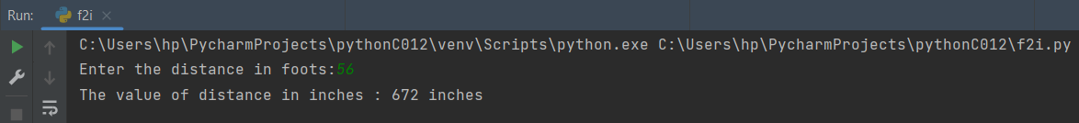

**Result**

The program was executed and the result was successfully obtained. Thus CO1 was obtained.

**Experiment No.: 8 Date: 28-10-2022**

**Aim:**

Finding the total surface area and volume of Cyclinder

**CO1:**

Understand the basics of Python Programming Language including input/output functions,operators,basic and collection data types

**Procedure:**

radius=int(input("Enter the radius of Cyclinder : ")) #radius of cyclinder

height=int(input("Enter the Height of Cyclinder : ")) #heightof cyclinder

volume=3.14*height*radius*radius #calcuting volume

area=2*3.14*radius*height #calculating area

print("The Area Of Cyclinder :",area,"sq.units") #printing the area of cyclinder

print("The Volume Of Cyclinder :",volume,"cubic.units") #printing volume of cyclinder

**Output Screenshot:**

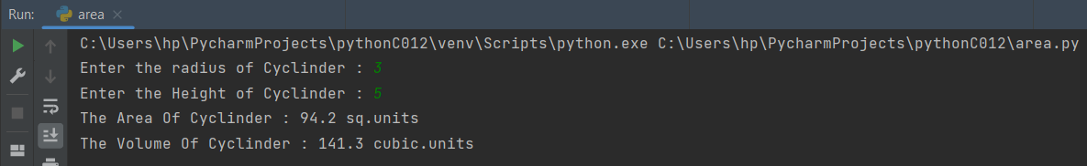

**Result**

The program was executed and the result was successfully obtained. Thus CO1 was obtained.

**Experiment No.: 9 Date: 28-10-2022**

**Aim:**

Calculating the area and volume of Cone

**CO1:**

Understand the basics of Python Programming Language including input/output functions,operators,basic and collection data types

**Procedure:**

radius=int(input("Enter the radius of Cone : ")) #radius of cone

sheight=int(input("Enter the slant Height of Cone : ")) #heightof cone

volume=(3.14*sheight*radius*radius)/sheight #calcuting volume

area=3.14*radius*(radius+sheight) #calculating area

print("The Area Of Cone :",area,"sq.units") #printing the area of cone

print("The Volume Of Cone :",volume,"cubic.units") #printing volume of cone

**Output Screenshot**

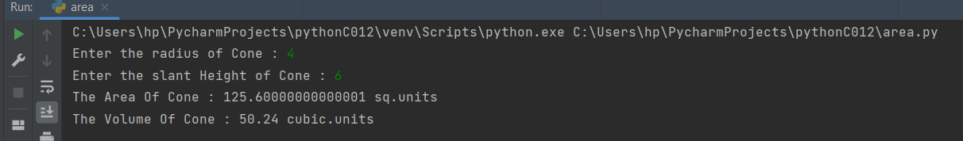

**Result**

The program was executed and the result was successfully obtained. Thus CO1 was obtained.

**Experiment No.: 10 Date:28-10-2022**

**Aim:**

Generate Simple Calculator

**CO1:**

Understand the basics of Python Programming Language including input/output functions,operators,basic and collection data types

**Procedure:**

e1=int(input("Enter the first value : ")) #taking input from user for 1st value

operator=input("Enter the operation :") ##taking input from user for which operation to be performed

e2=int(input("Enter the second value : ")) #taking input from user for 2nd value

if operator =="+": #checking for addition

print("the answer is :", e1+e2) #printing the operation

if operation=="*"; #checking for addition

print("the answer is :" ,e1*e2) #printing the operation

elif operator =="-": #checking for subraction

print("the answer is :",e1-e2) #printing the operation

elif operator=="*": #checking for multiplication

print("the answer is :",e1*e2) #printing the operation

elif operator =="/": #checking for division

print("the answer is :",e1/e2) #printing the operation

else:

print("Incorrect Operation") #printing incorrect if operation is wrong

**Output Screenshot**

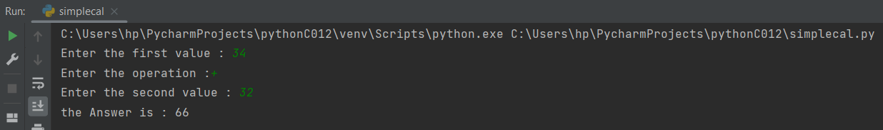

**Result**

The program was executed and the result was successfully obtained. Thus CO1 was obtained.

**Experiment No.: 1 1 Date: 31-10-2022**

**Aim:**

Create a string ,from a given string where first & last character exchange

**CO1:**

Understand the basics of Python Programming Language including input/output functions,operators,basic and collection data types

**Procedure:**

# swap first and last character  
string=input("Enter the string: ")  
x=list(string)  
# storing the first character  
start = string[0]  
# storing the last character  
end = string[-1]  
swapped_string = end + string[1:-1] + start  
print(swapped_string)  
print("The original string is",string)  
print("The swapped string is :",swapped_string )

**Output Screenshot**

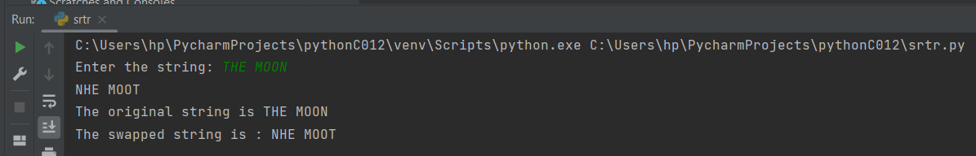

**Result**

The program was executed and the result was successfully obtained. Thus CO1 was obtained.

**Experiment No.: 12 Date: 31-10-2022**

**Aim:**

Find the biggest of 3 numbers,using max function & if

**CO1:**

Understand the basics of Python Programming Language including input/output functions,operators,basic and collection data types

**Procedure:**

first=int(input("Enter the first number: "))  
second=int(input("Enter the second number: "))  
third=int(input("Enter the third number: "))  
if (first >= second) and (first >= third):  
 largest = first  
elif (second >= first) and (second >= third):  
 largest = second  
else:  
 largest = third  
  
print("The largest number is", largest)

**Output Screenshot:**

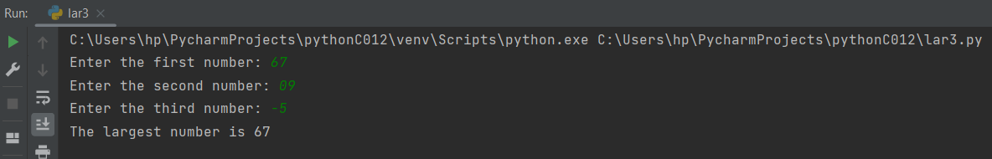

**Result**

The program was executed and the result was successfully obtained. Thus CO1 was obtained.

**Experiment No.: 13 Date: 31-10-2022**

**Aim:**

Accept file name from user & print extension of the file

**CO1:**

Understand the basics of Python Programming Language including input/output functions,operators,basic and collection data types

**Procedure:**

file=input("Enter the file name with Extensions: ")  
ext=file.split(".")  
print(ext[-1],"is the the extension of the file ")

**Output Screenshot:**

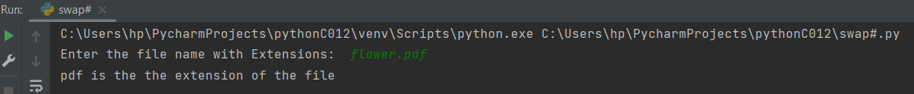

**Result**

The program was executed and the result was successfully obtained. Thus CO1 was obtained.

**Experiment No.: 14 Date: 31-10-2022**

**Aim:**

Accept an integer n & n+nn+nnn

**CO1:**

Understand the basics of Python Programming Language including input/output functions,operators,basic and collection data type

**Procedure:**

n=int(input("Enter the number: "))  
sum=n+(n*n)+(n*n*n )  
print("The answer is ",sum)

**Output Screenshot:**

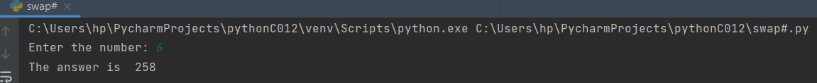

**Result**

The program was executed and the result was successfully obtained. Thus CO1 was obtained.

**Experiment No.: 15 Date: 31-10-2022**

**Aim:**

Swaping the first Character of two Strings

**CO1:**

Understand the basics of Python Programming Language including input/output functions,operators,basic and collection data type

**Procedure:**

n1=input("enter the first string: ")  
a=n1[0]  
n2=input("Enter the second string: ")  
b=n2[0]  
n_n1=n2[0]+n1[1:]  
n_n2=n1[0]+n2[1:]  
print("The new string is: ", n_n1+" "+n_n2)

**Output Screenshot:**

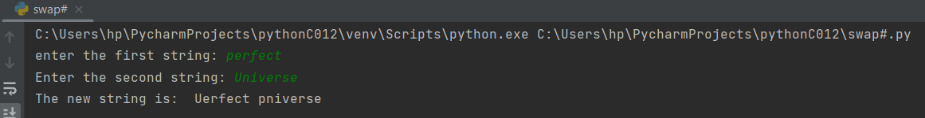

**Result**

The program was executed and the result was successfully obtained. Thus CO1 was obtained.

**Experiment No.: 16 Date: 31-10-2022**

**Aim:**

To check whether a number is odd or even

**CO1:**

Understand the basics of Python Programming Language including input/output functions,operators,basic and collection data type

**Procedure:**

num = int (input("Enter the number: "))  
if (num % 2) == 0:  
 print("The number is even")  
else:  
 print("The number is odd")

**Output Screenshot:**

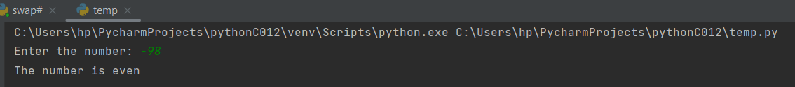

**Result**

The program was executed and the result was successfully obtained. Thus CO1 was obtained.

**Experiment No.: 17 Date: 31-10-2022**

**Aim:**

To check whether a number is posistive or negataive

**CO1:**

Understand the basics of Python Programming Language including input/output functions,operators,basic and collection data type

**Procedure:**

num = int (input("Enter the number: "))  
if num > 0:  
 print("The number is positive")  
elif num == 0:  
 print("The number is zero")  
else:  
 print("The number is negative")

**Output Screenshot:**

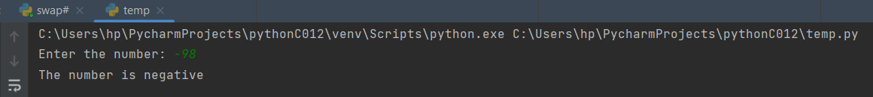

**Result**

The program was executed and the result was successfully obtained. Thus CO1 was obtained.

**Experiment No.: 18 Date: 31-10-2022**

**Aim:**

Create a list of colours , from comma separated colour-name entered by user, display 1st & last colour-name

**CO1:**

Understand the basics of Python Programming Language including input/output functions,operators,basic and collection data type

**Procedure:**

colour=input("Enter the colour & separated by, : ")  
clr_list=colour.split(",")  
print(clr_list)  
print("The First Colour is:",clr_list[0])  
print("The First Colour is:",clr_list[-1])

**Output Screenshot:**

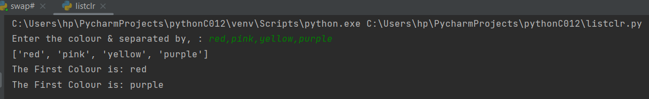

**Result**

The program was executed and the result was successfully obtained. Thus CO1 was obtained.

**Experiment No.: 19 Date: 04-11-2022**

**Aim:**

Finding the sum of Even Numbers

**CO2:**

Implement decision making,looping constructs and functions

**Procedure:**

#sum of even numbers  
n=int(input("Enter the number: "))  
i=1  
sum=0  
while(i<=n):  
 if(i%2==0):  
 sum=sum+i  
 i=i+1  
 print(i)  
print("The sum of even numbers is :",sum)

**Output Screenshot:**

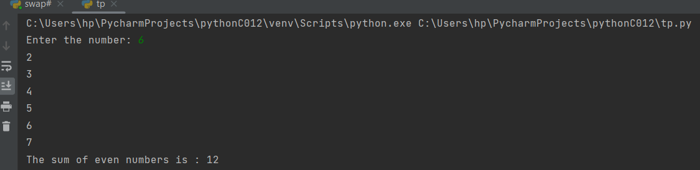

**Result**

The program was executed and the result was successfully obtained. Thus CO2 was obtained.

**Experiment No.: 20 Date: 04-11-2022**

**Aim:**

Finding the sum of Odd Numbers

**CO2:**

Implement decision making,looping constructs and functions

**Procedure:**

#sum of odd numbers  
n=int(input("Enter the number: "))  
i=1  
sum=0  
while(i<=n):  
 if(i%2==1):  
 sum=sum+i  
 i=i+1  
   
print("The Sum of Odd Numbers is: ",sum)

**Output Screenshot:**

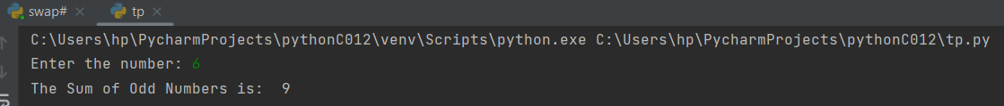

**Result**

The program was executed and the result was successfully obtained. Thus CO2 was obtained.

**Experiment No.: 21 Date: 04-11-2022**

**Aim:**

Factorial of a Number

**CO2:**

Implement decision making,looping constructs and functions

**Procedure:**

num=int(input("Enter a number: "))  
f=1  
i=1  
while i<=num:  
 f=f*i  
 i=i+1  
print("Factorial of ",num,"is",f)

**Output Screenshot:**



**Result**

The program was executed and the result was successfully obtained. Thus CO2 was obtained.

**Experiment No.: 22 Date: 04-11-2022**

**Aim:**

Check whether the number is palindrome or not

**CO2:**

Implement decision making,looping constructs and functions

**Procedure:**

num=int(input("Enter a value: "))  
temp=num  
rev=0  
while(num>0):  
 dig=num%10  
 rev=rev*10+dig  
 num=num//10  
if(temp==rev):  
 print("This value is a palindrome number!!")  
else:  
 print("This value is not a Palindrome number!!!")

**Output Screenshot:**

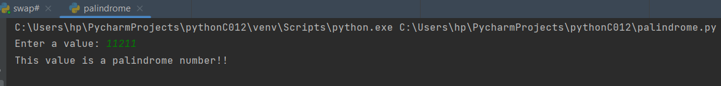

**Result**

The program was executed and the result was successfully obtained. Thus CO2 was obtained.

**Experiment No.: 23 Date: 04-11-2022**

**Aim:**

Check whether a number is armstrong

**CO2:**

Implement decision making,looping constructs and functions

**Procedure:**

num=int(input("Enter 3-digit Number: "))  
sum=0  
temp=num  
while temp>0:  
 digit=temp%10  
 sum+=digit*digit*digit  
 temp=temp//10  
if sum==num:  
 print("It is an Armstrong Number")  
else:  
 print("It is not an Armstrong Number")

**Output Screenshot:**

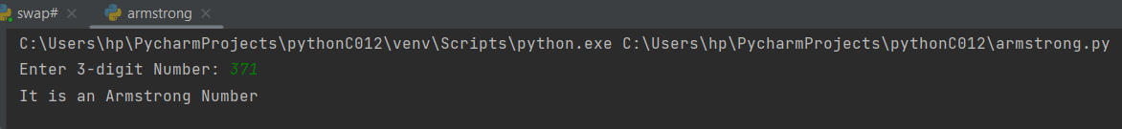

**Result**

The program was executed and the result was successfully obtained. Thus CO2 was obtained.

**Experiment No.: 24 Date: 04-11-2022**

**Aim:**

Fibonacci Series

**CO2:**

Implement decision making,looping constructs and functions

**Procedure:**

nterms=int(input("How many terms?: "))  
n1,n2=0,1  
count=0  
if nterms<=0:  
 print("Please eneter a positive Integer")  
elif nterms==1:  
 print("Fibonacci Sequence upto",nterms,":")  
 print(n1)  
else:  
 print("Fibonacci Sequence:")  
 while count<nterms:  
 print(n1)  
 nth=n1+n2  
 n1=n2  
 n2=nth  
 count+=1

**Output Screenshot:**

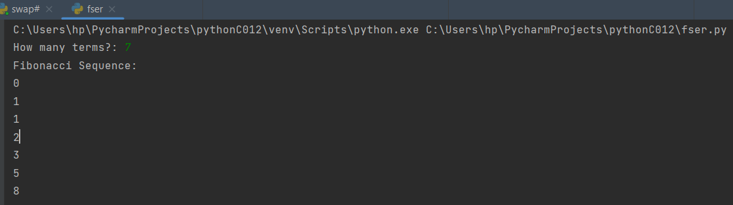

**Result**

The program was executed and the result was successfully obtained. Thus CO2 was obtained.

**Experiment No.: 25 Date: 04-11-2022**

**Aim:**

Check Whether a number is prime or not

**CO2:**

Implement decision making,looping constructs and functions

**Procedure:**

n=int(input("\n Enetr whole number to check: "))  
i=2  
while i<=(n/2):  
 if(n%i)==0:  
 flag=1  
 break  
 i+=1  
if n==1:  
 print("1 is neither prime nor Composite")  
elif flag==0:  
 print(n,"is a prime number")  
elif flag==1:  
 print(n,"is a not a prime number")

**Output Screenshot**

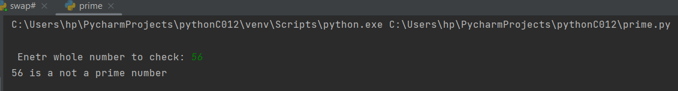

**Result**

The program was executed and the result was successfully obtained. Thus CO1 was obtained.

**Experiment No.: 26 Date: 04-11-2022**

**Aim:**

Reverse of a Number

**CO2:**

Implement decision making,looping constructs and functions

**Procedure:**

num=int(input("Enter the number: "))  
reversed_num=0  
while num!=0:  
 digit=num%10  
 reversed_num= reversed_num*10+ digit  
 num//=10  
print("Reversed Number: "+str(reversed_num))

**Output Screenshot:**



**Result**

The program was executed and the result was successfully obtained. Thus CO2 was obtained.

**Experiment No.: 27 Date: 04-11-2022**

**Aim:**

To print the Sum of Digits

**CO2:**

Implement decision making,looping constructs and functions

**Procedure:**

def getSum(n):  
 sum=0  
 for digit in str(n):  
 sum+=int(digit)  
 return sum  
  
n=int(input("Enter the digits: "))  
print("The Sum is : ",getSum(n))

**Output Screenshot:**



**Result**

The program was executed and the result was successfully obtained. Thus CO2 was obtained.

**Experiment No.: 28 Date: 04-11-2022**

**Aim:**

Print out all colour from color list not contained in color list 2

**CO2:**

Implement decision making,looping constructs and functions

**Procedure:**

list1=[]

n=int(input("Enter the number of elements in the lsit 1: "))

for i in range(0,n):

   value=eval(input("Enter the element: "))

   list1.append(value)

print("The First list is :",list1)

list2=[]

n2=int(input("Enter the number of elements in the lsit 2: "))

for i in range(0,n2):

   value2=eval(input("Enter the element: "))

   list2.append(value2)

print("The Second list is :",list2)

r=set(list1)

p=set(list2)

diff=p.difference(r)

print("The difference of boththe list is : ",diff)

**Output Screenshot:**

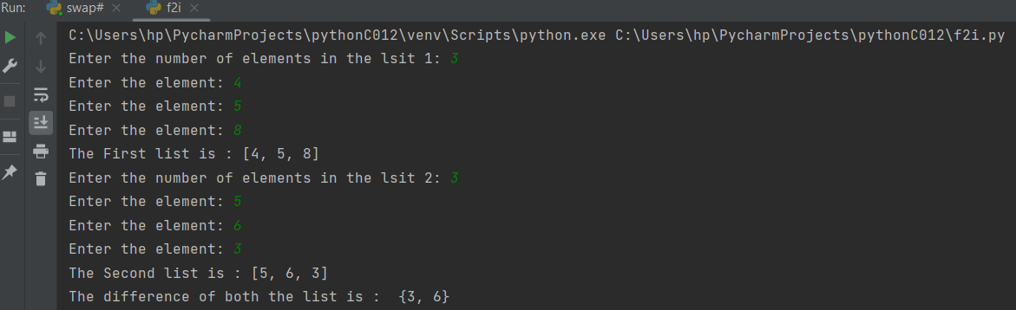

**Result**

The program was executed and the result was successfully obtained. Thus CO2 was obtained.

**Experiment No.: 29 Date: 04-11-2022**

**Aim:**

GCD of two Numbers

**CO2:**

Implement decision making,looping constructs and functions

**Procedure:**

num1=int(input("Enter the First Number: "))

num2=int(input("Enter the Second Number:  "))

i=1

while i<=num1 and i<=num2:

   if(num1%i==0 and num2%i==0):

       gcd=i

   i=i+1

print("\n The GCD of two Numbers is: ",gcd)

**OutputScreenshot:**

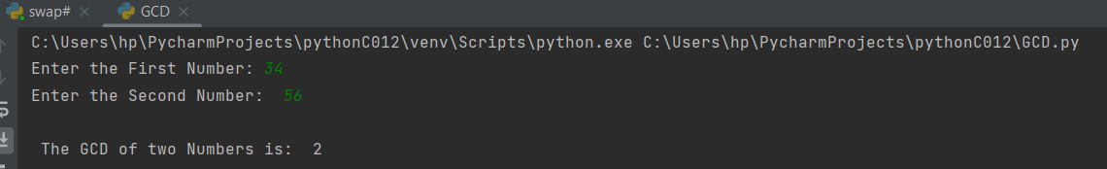

**Result**

The program was executed and the result was successfully obtained. Thus CO2 was obtained.

**Experiment No.: 30 Date: 04-11-2022**

**Aim:**

List of integers creating a list removing even numbers , printing odd numbers

**CO2:**

Implement decision making,looping constructs and functions

**Procedure:**

list1=[]  
n=int(input("Enter the number of elements in the lsit of Integer : "))  
for i in range(0,n):  
 value=int(input("Enter the integer: "))  
 list1.append(value)  
print("The First list is :",list1)  
list2=[]  
for i in list1:  
 if i%2!=0:  
 list2.append(i)  
 print("The list after removing even numbers is : \n",list2)

**Output Screenshot:**

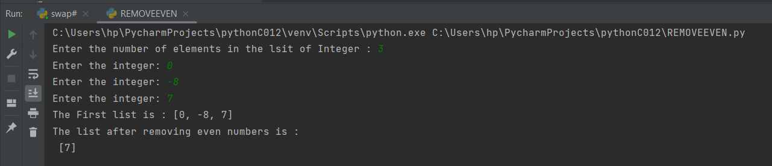

**Result**

The program was executed and the result was successfully obtained. Thus CO2 was obtained.

**Experiment No.: 31 Date: 04-11-2022**

**Aim:**

Display future leap years from current year to a final year entered by user.

**CO2:**

Implement decision making,looping constructs and functions

**Procedure:**

start=int(input("Enter the Starting Year: "))  
end=int(input("Enter the Ending Year: "))  
while start>=end:  
 print("Check your input again")  
 start = int(input("Enter the Starting Year: "))  
 end = int(input("Enter the Ending Year: "))  
  
print("Here is a list of leap year between",str(start),"and",str(end),":")  
  
leapy=[]  
while start<=end:  
 if start%4==0 and start%100!=0:  
 leapy.append(str(start))  
 if start%100==0 and start%400==0:  
 leapy.append(str(start))  
 start+=1  
  
for i in range(0,len(leapy),10):  
 print("{0}.".format(",".join(leapy[i:i+10])))

**Output Screenshot:**

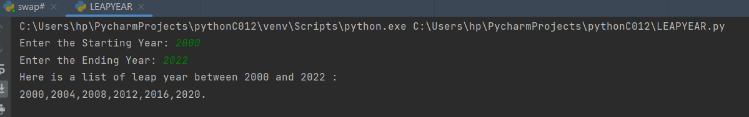

**Result**

The program was executed and the result was successfully obtained. Thus CO2 was obtained

**Experiment No.: 32 Date: 04-11-2022**

**Aim:**

Square of N numbers

**CO2:**

Implement decision making,looping constructs and functions

**Procedure:**

list=[]  
n=int(input("Enter the number of elements in the lsit: "))  
for i in range(0,n):  
 value=int(input("Enter the Integer: "))  
 list.append(value)  
  
list1=[i*i for i in list]  
print("The Squares are :",list1)

**Output Screenshot:**

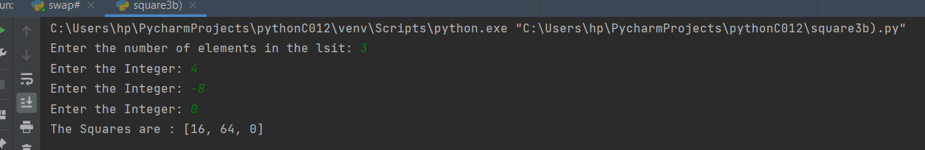

**Result**

The program was executed and the result was successfully obtained. Thus CO2 was obtained

**Experiment No.: 33 Date: 04-11-2022**

**Aim:**

Enter 2 lists of integers. Check

 (a) Whether list are of same length

**CO2:**

Implement decision making,looping constructs and functions

**Procedure:**

list1=[]

n=int(input("Enter the number of elements in the lsit 1: "))

for i in range(0,n):

   value=eval(input("Enter the element: "))

   list1.append(value)

print("The First list is :",list1)

list2=[]

n2=int(input("Enter the number of elements in the lsit 2: "))

for i in range(0,n2):

   value2=eval(input("Enter the element: "))

   list2.append(value2)

print("The Second list is :",list2)

if len(list1)==len(list2):

   print("Both the list are of same size!!!")

else:

   print("Both the list are of different size!!!")

**Output Screenshot:**

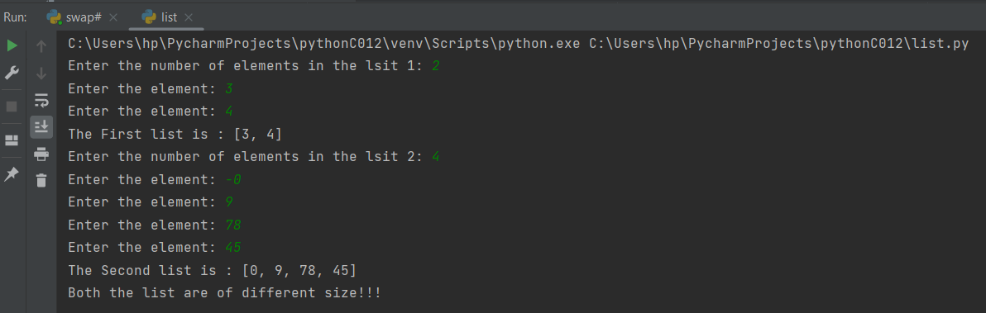

**(b) whether list sums  to same value**

#TAKING INPUT FOR FIRST LIST

list1=[]

n=int(input("Enter the number of elements in the lsit 1: "))

for i in range(0,n):

   value=int(input("Enter the integer: "))

   list1.append(value)

print("The First list is :",list1)

#PRINTING THE SUM OF FIRST LIST

Sum=sum(list1)

print("The sum of list 1 is :",Sum)

#TAKING INPUT FOR SECOND LIST

list2=[]

n2=int(input("Enter the number of elements in the lsit 2: "))

for i in range(0,n2):

   value2=int(input("Enter the integer: "))

   list2.append(value2)

print("The Second list is :",list2)

#PRINTING THE SUM OF SECOND LIST

Sum1=sum(list2)

print("The sum of list 2 is :",Sum1)

if Sum==Sum1:  
 print("The Sum value is equal")  
else:  
 print("The sum value is Diffdrent")

**Output Screenshot:**

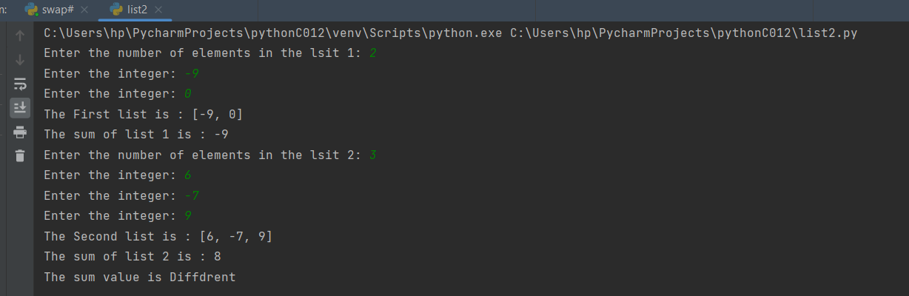

**(c) whether any value occur in both**

list1=[]  
n=int(input("Enter the number of elements in the lsit 1: "))  
for i in range(0,n):  
 value=eval(input("Enter the element: "))  
 list1.append(value)  
print("The First list is :",list1)  
  
list2=[]  
n2=int(input("Enter the number of elements in the lsit 2: "))  
for i in range(0,n2):  
 value2=eval(input("Enter the element: "))  
 list2.append(value2)  
print("The Second list is :",list2)  
list3=[]  
for i in list1:  
 if i in list2 :  
 list3.append(i)  
print("The same values are: ",list3)

**Output Screenshot:**

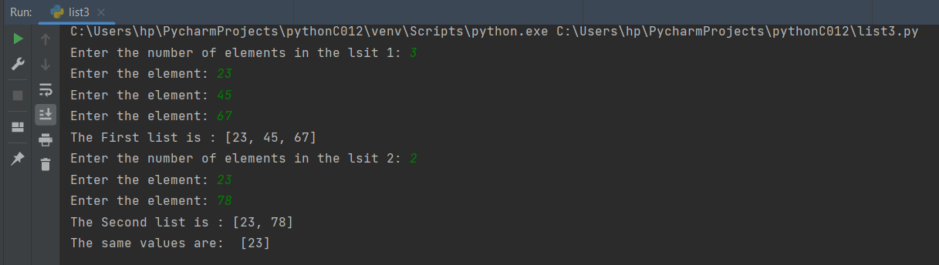

**Result**

The program was executed and the result was successfully obtained. Thus CO2 was obtained

**Experiment No.: 34 Date: 04-11-2022**

**Aim:**

Get a string from an input string where all occurrences of first character replaced with ‘$’, except first character. [eg: onion -> oni$n]

**CO2:**

Implement decision making,looping constructs and functions

**Procedure:**

str1=str(input("Enter the String: "))

#replacing the second repeated character

char=str1[0]

str1=str1.replace(char,"$")

str1=char+str1[1:]

print("The changed String is : ",str1)

**Output Screenshot:**

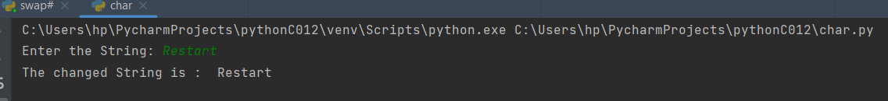

**Result**

The program was executed and the result was successfully obtained. Thus CO2 was obtained

**Experiment No.: 35 Date: 04-11-2022**

**Aim:**

Count the number of characters (character frequency) in a string

**CO2:**

Implement decision making,looping constructs and functions

**Procedure:**

str1 = input("Enter the String: ")

# using set() + count() to get count

# of each element in string

countchar = {i:str1.count(i) for i in set(str1)}

# printing result

print("The count of all characters in string  is :\n "

     + str(countchar))

**Output Screenshot:**

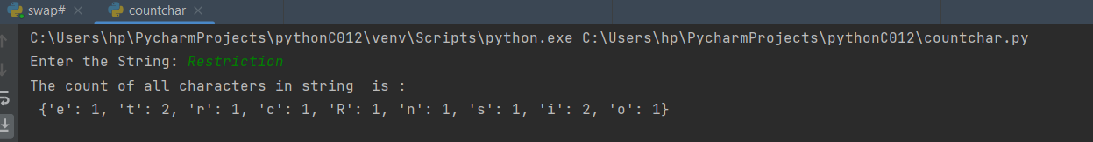

**Result**

The program was executed and the result was successfully obtained. Thus CO2 was obtained

**Experiment No.: 36 Date: 04-11-2022**

**Aim:**

Add ‘ing’ at the end of a given string. If it already ends with ‘ing’, then add ‘ly’

**CO2:**

Implement decision making,looping constructs and functions

**Procedure:**

str1=input("Enter the String: ")

if str1[-3:] == 'ing':

     str1+='ly'

else:

     str1 += 'ing'

print("The Converted string is : ",str1)

**Output Screenshot:**

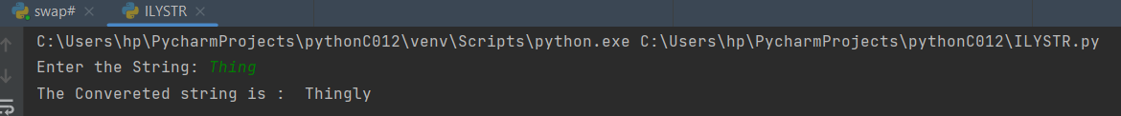

**Result**

The program was executed and the result was successfully obtained. Thus CO2 was obtained

**Experiment No.: 37 Date: 04-11-2022**

**Aim:**

Generate the factors

**CO2:**

Implement decision making,looping constructs and functions

**Procedure:**

def factors(x):  
 print("The factors of",x,"are:")  
 for i in range(1, x + 1):  
 if x % i == 0:  
 print(i)  
  
num=int(input("Enter the Number: "))  
  
factors(num)

**Output Screenshot:**

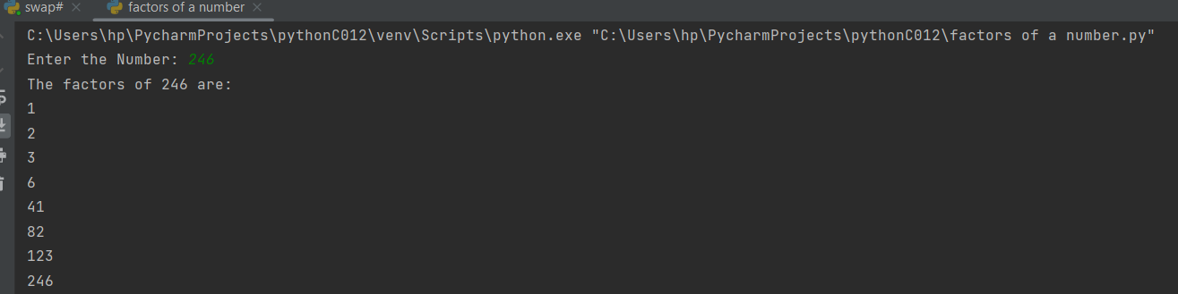

**Result**

The program was executed and the result was successfully obtained. Thus CO2 was obtained

**Experiment No.: 38 Date: 04-11-2022**

**Aim:**

Accept a list of words and return length of longest word.

**CO2:**

Implement decision making,looping constructs and functions

**Procedure:**

a=[]  
n= int(input("Enter the number of elements in list:"))  
for x in range(0,n):  
 value=input("Enter element" + str(x+1) + ":")  
 a.append(value)  
max1=len(a[0])  
temp=a[0]  
for i in a:  
 if(len(i)>max1):  
 max1=len(i)  
 temp=i  
print("The word with the longest length is:")  
print(temp)

**Output Screenshot:**

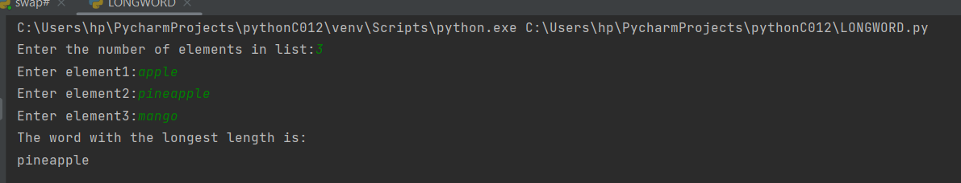

**Result**

The program was executed and the result was successfully obtained. Thus CO2 was obtained

**Experiment No.: 39 Date: 04-11-2022**

**Aim:**

Construct following pattern using nested loop

**CO2:**

Implement decision making,looping constructs and functions

**Procedure:**

n=int(input("Enter number of rows: "))  
i=1  
while i<=n:  
 j=1  
 while j<=i:  
 print("*",end=" ")  
 j+=1  
 print()  
 i+=1  
  
i=1  
while i<=n:  
 j=n  
 while j>=i:  
 print("*",end=" ")  
 j-=1  
 print()  
 i+=1

**Output Screenshot:**

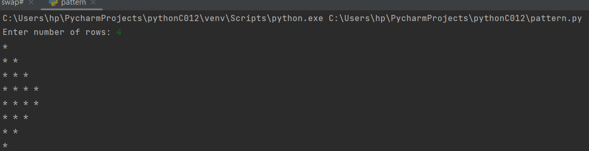

**Result**

The program was executed and the result was successfully obtained. Thus CO2 was obtained

**Experiment No.: 40 Date: 04-11-2022**

**Aim:**

Display the given pyramid with step number accepted from user.

**CO2:**

Implement decision making,looping constructs and functions

**Procedure:**

n=int(input("Enter number of rows: "))  
i=1  
while i<=n:  
 j=1  
 while j<=i:  
 print(i*j,end=" ")  
 j+=1  
 print()  
 i+=1

**Output Screenshot:**

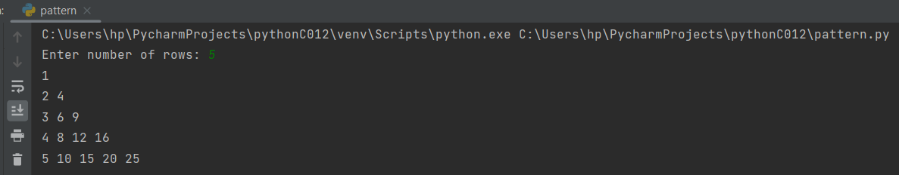

**Result**

The program was executed and the result was successfully obtained. Thus CO2 was obtained

**Experiment No.: 41 Date: 04-11-2022**

**Aim:**

Factorial of a number using for loop

**CO2:**

Implement decision making,looping constructs and functions

**Procedure:**

num=int(input("Enter a number: "))  
f=1  
for i in range(1,num+1):  
 f=f*i  
print("Factorial of ",num,"is",f)

**Output Screenshot:**

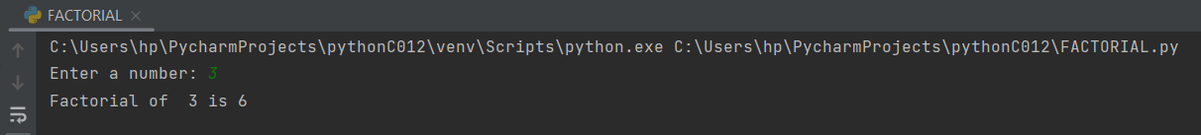

**Result**

The program was executed and the result was successfully obtained. Thus CO2 was obtained

**Experiment No.: 42 Date: 16-11-2022**

**Aim:**

Factors of a number using for loop

**CO2:**

Implement decision making,looping constructs and functions

**Procedure:**

num =int(input("Enter a number: "))  
print("The factors of ",str(num),"is")  
for i in range(1, num+1):  
 if num % i == 0:  
 print(i,end="")

**Output Screenshot:**

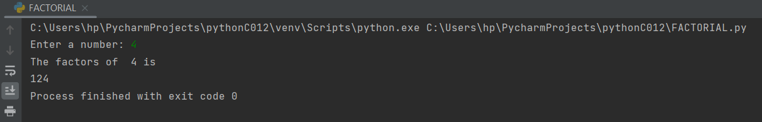

**Result**

The program was executed and the result was successfully obtained. Thus CO2 was obtained

**Experiment No.: 43 Date: 16-11-2022**

**Aim:**

Reverse of a number using for loop

**CO2:**

Implement decision making,looping constructs and functions

**Procedure:**

num = int(input("Please provide the number to be reversed: "))  
revnum = 0  
temp = revnum  
remainder= 1  
for i in range(0,len(str(num))):  
 remainder = num %10  
 revnum = (revnum*10) + remainder  
 num = num //10  
print("Reverse of the provided number is = %d" %revnum)

**Output Screenshot:**

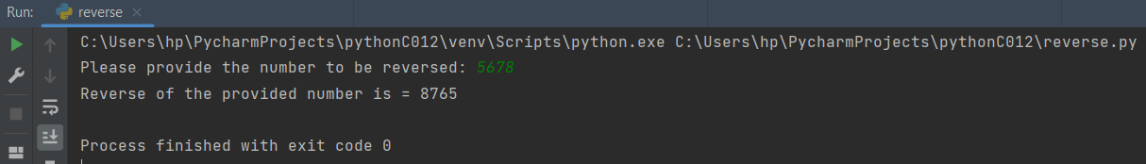

**Result**

The program was executed and the result was successfully obtained. Thus CO2 was obtained

**Experiment No.: 44 Date: 16-11-2022**

**Aim:**

Fibonacci Series using for loop

**CO2:**

Implement decision making,looping constructs and functions

**Procedure:**

nterms=int(input("How many terms?: "))  
n1,n2=0,1  
count=0  
if nterms<=0:  
 print("Please eneter a positive Integer")  
elif nterms==1:  
 print("Fibonacci Sequence of",nterms," terms :")  
 print(n1)  
else:  
 print("Fibonacci Sequence:")  
 for count in range(nterms):  
 print(n1)  
 nth = n1 + n2  
 n1 = n2  
 n2 = nth  
 count += 1

**Output Screenshot:**

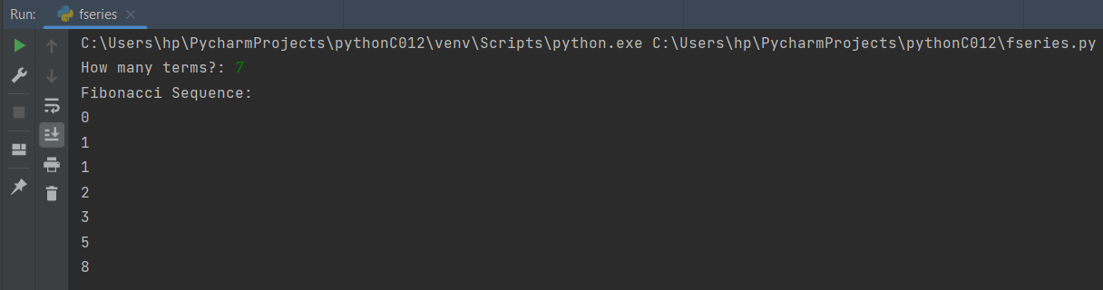

**Result**

The program was executed and the result was successfully obtained. Thus CO2 was obtained

**Experiment No.: 45 Date: 16-11-2022**

**Aim:**

Check whether the number is Palindrome or not using for loop

**CO2:**

Implement decision making,looping constructs and functions

**Procedure:**

num=int(input("Enter a Number: "))  
sum=0  
temp=num  
for i in range(0,len(str(num))):  
 digit=num%10  
 sum=sum*10+digit  
 num=num//10  
if temp==sum:  
 print("{} is a Palindrome Number".format(temp))  
else:  
 print("{} is not a Palindrome Number".format(temp))

**Output Screenshot:**

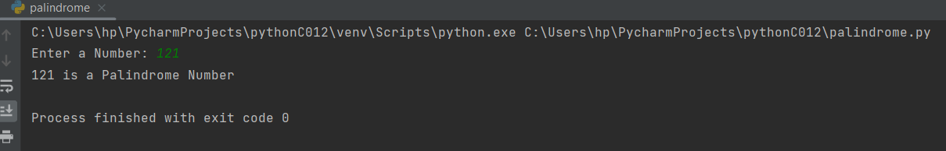

**Result**

The program was executed and the result was successfully obtained. Thus CO2 was obtained

**Experiment No.: 46 Date: 16-11-2022**

**Aim:**

Check whether the number is Armstrong or not using for loop

**CO2:**

Implement decision making,looping constructs and functions

**Procedure:**

num=int(input("Enter 3-digit Number: "))  
sum=0  
temp=num  
for i in range(num):  
 digit=num%10  
 c=digit*digit*digit  
 sum=sum+c  
 num=num//10  
if temp==sum:  
 print("{} is an Armstrong Number".format(temp))  
else:  
 print("{} is not an Armstrong Number".format(temp))

**Output Screenshot:**

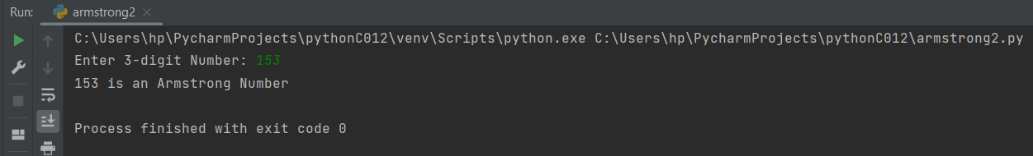

**Result**

The program was executed and the result was successfully obtained. Thus CO2 was obtained

**Experiment No.: 47 Date: 16-11-2022**

**Aim:**

Count Prompt the users for a list of integers.For all values greater than 100 ,store ‘over’ instead

**CO2:**

Implement decision making,looping constructs and functions

**Procedure:**

list1=[]  
n=int(input("Enter the number of elements in the lsit 1: "))  
for i in range(0,n):  
 value=eval(input("Enter the element: "))  
 list1.append(value)  
print("The original List is :",list1)  
  
for i in range(0, int(len(list1))):  
 if list1[i] >= 100:  
 list1[i]="over"  
  
print("The edited list is : ")  
print(list1)

**Output Screenshot:**

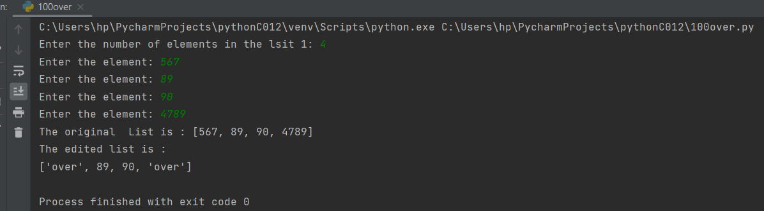

**Result**

The program was executed and the result was successfully obtained. Thus CO2 was obtained

**Experiment No.: 48 Date: 16-11-2022**

**Aim:**

Store a list of first names.Count the occurance of ‘a’ within the list

**CO2:**

Implement decision making,looping constructs and functions

**Proce dure:**

name=str(input("Enter the name: "))  
list1 = list(name.strip(" "))  
count=0  
for i in list1:  
 if i=="a":  
 count+=1  
print("The total count of a in the name is : ",count)

**Output Screenshot:**

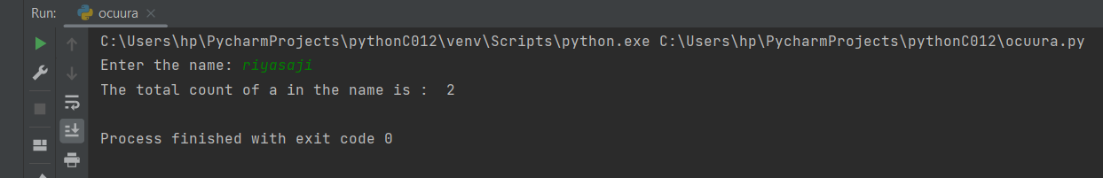

**Result**

The program was executed and the result was successfully obtained. Thus CO2 was obtained

**Experiment No.: 49 Date: 16-11-2022**

**Aim:**

Form a list of vowels selected from a given word

**CO2:**

Implement decision making,looping constructs and functions

**Procedure:**

#vowels  
elem = input("Enter any statement : ")  
vowels =['a','e','i','o','u']  
list1=[]  
for x in elem:  
 if (x in vowels and x not in list1):  
 list1.append(x)  
print("Vowels present in given statement : ",list1)

**Output Screenshot:**

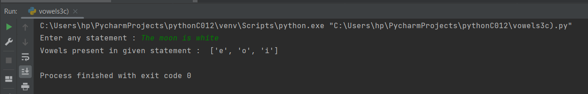

**Result**

The program was executed and the result was successfully obtained. Thus CO2 was obtained

**Experiment No.: 50 Date: 16-11-2022**

**Aim:**

Generate a list of four digit numbers in a given range with all their digits even and the number is a perfect square.

**CO2:**

Implement decision making,looping constructs and functions

**Procedure:**

**Output Screenshot:**

**Result**

The program was executed and the result was successfully obtained. Thus CO2 was obtained

**Experiment No.: 51 Date: 1811-2022**

**Aim:**

Write a lambda function for area of Square.

**CO2:**

Implement decision making,looping constructs and functions

**Procedure:**

a=int(input("Enter the side of a square: "))  
area=lambda a:a*a  
print("The area of square is :",area(a),"sq. units.")

**Output Screenshot:**

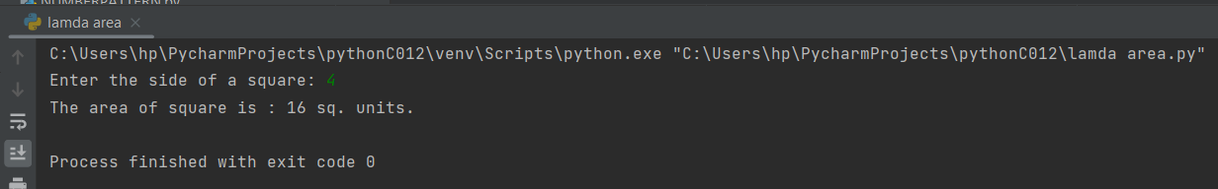

**Result**

The program was executed and the result was successfully obtained. Thus CO2 was obtained

**Experiment No.: 52 Date: 18-11-2022**

**Aim:**

Write a lambda function for area of Rectangle.

**CO2:**

Implement decision making,looping constructs and functions

**Proce dure:**

a=int(input("Enter the length of a Rectangle: "))  
b=int(input("Enter the breadth of Rectangle: " ))  
area=lambda a,b:a*b  
print("The area of square is :",area(a,b),"sq. units.")

**Output Screenshot:**

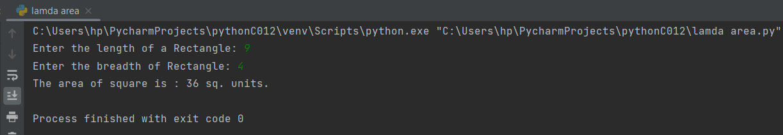

**Result**

The program was executed and the result was successfu lly obtained. Thus CO2 was obtained

**Experiment No.: 53 Date: 18-11-2022**

**Aim:**

Write a lambda function for area of Triangle.

**CO2:**

Implement decision making,looping constructs and functions

**Procedure:**

a=int(input("Enter the Height of a Triangle: "))  
b=int(input("Enter the breadth of Triangle: " ))  
area=lambda a,b:1/2*a*b  
print("The area of Triangle is :",area(a,b),"sq. units.")

**Output Screenshot:**

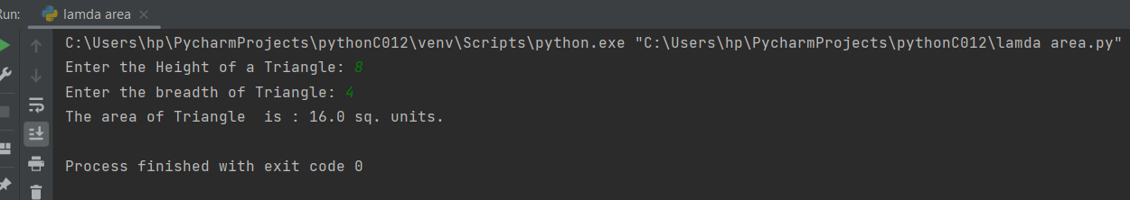

**Result**

The program was executed and the result was successfu lly obtained. Thus CO2 was obtained

**Experiment No.: 54 Date: 18-11-2022**

**Aim:**

Factorial of a number using functions.

**CO2:**

Implement decision making,looping constructs and functions

**Procedure:**

def factorial(num):  
 f=1  
 for i in range(1, num+1):  
 f=f*i  
 print(f,end=" ")  
  
num1=int(input("Enter a number: "))  
print("Factorial of ",num1,"is :")  
factorial(num1)

**Output Screenshot:**

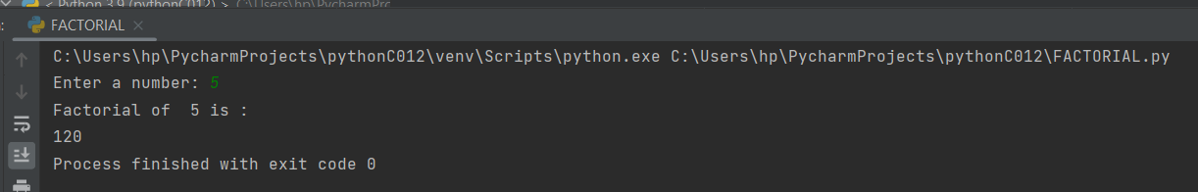

**Result**

The program was executed and the result was successfu lly obtained. Thus CO2 was obtained

**Experiment No.: 55 Date: 18-11-2022**

**Aim:**

Factors of a number using functions.

**CO2:**

Implement decision making,looping constructs and functions

**Procedure:**

def factors(num):  
 for i in range(1,num+1):  
 if num% i==0:  
 print(i, end =" ")  
  
num1=int(input("Enter a number: "))  
print("The factors of are ",str(num1),":")  
factors(num1)

**Output Screenshot:**

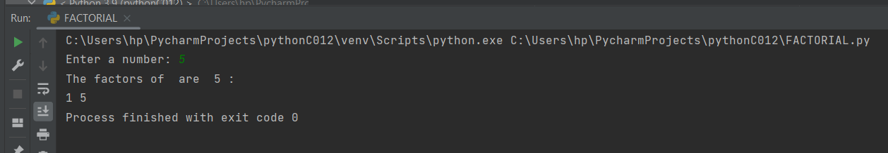

**Result**

The program was executed and the result was successfu lly obtained. Thus CO2 was obtained

**Experiment No.: 56 Date: 18-11-2022**

**Aim:**

Generate a list of four digit numbers in a given range with all their digits even and the number is a perfect square using functions.

**CO2:**

Implement decision making,looping constructs and functions

**Procedure:**

**Output Screenshot:**

**Result**

The program was executed and the result was successfu lly obtained. Thus CO2 was obtained

**Experiment No.: 57 Date: 28-11-2022**

**Aim:**

Merge Two Dictionary.

**CO2:**

Implement decision making,looping constructs and functions

**Procedure:**

def mergeDict(dict_1, dict_2):  
 result = dict_1 | dict_2  
 return result  
  
name= {'Jenny': 3, 'Sara': 29, 'Sanila':27}  
name2 = {'Riya': 24, 'Tinu': 45, 'Matt': 16}  
dict_3 = mergeDict(name, name2)  
print("The First Dictionary is : {'Jenny': 03, 'Sara': 29, 'Sanila':27}")  
print("The Second Dictionary is : {'Riya': 24, 'Tinu': 45, 'Matt': 16}")  
print("The merged Dictionary is : ", dict_3)

**Output Screenshot:**

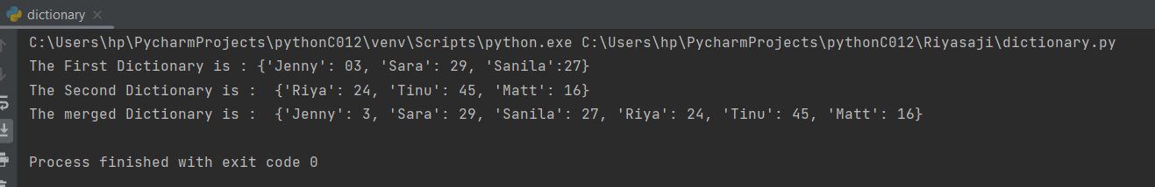

**Result**

The program was executed and the result was successfully obtained. Thus CO2 was obtained

**Experiment No.: 57 Date: 28-11-2022**

**Aim:**

Sort Dictionary in Ascending and Descending order (keys&values)

**CO2:**

Implement decision making,looping constructs and functions

**Procedure:**

def sort_dict_by_value(d, reverse = False):

return dict(sorted(d.items(), key = lambda x: x[1], reverse = reverse))

print("Original dictionary elements:")

colors = {'Red': 1, 'Green': 3, 'Black': 5, 'White': 2, 'Pink': 4}

print(colors)

print("\nSort (ascending) the said dictionary elements by value:")

print(sort_dict_by_value(colors))

print("\nSort (descending) the said dictionary elements by value:")

print(sort_dict_by_value(colors, True))

**Output Screenshot:**

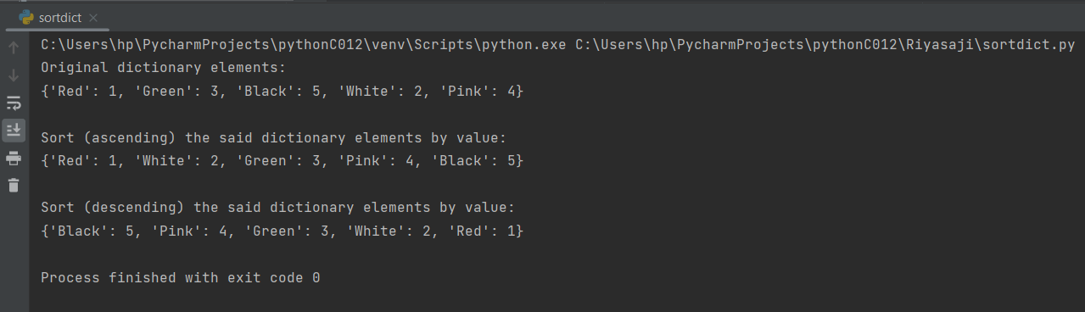

**Result**

The program was executed and the result was successfully obtained. Thus CO3 was obtained

**Experiment No.: 60 Date: 18-11-2022**

**Aim:**

Write a Python program to select a random element from a list, set, dictionary (value) and a file from a directory. Use random.choice()

**CO3:**

Design modules and packages - built in and user defined packages

**Procedure:**