***DreamDress: Online Dress Shop for Women.***

***UML DAIGRAM***

* **Class Diagram**

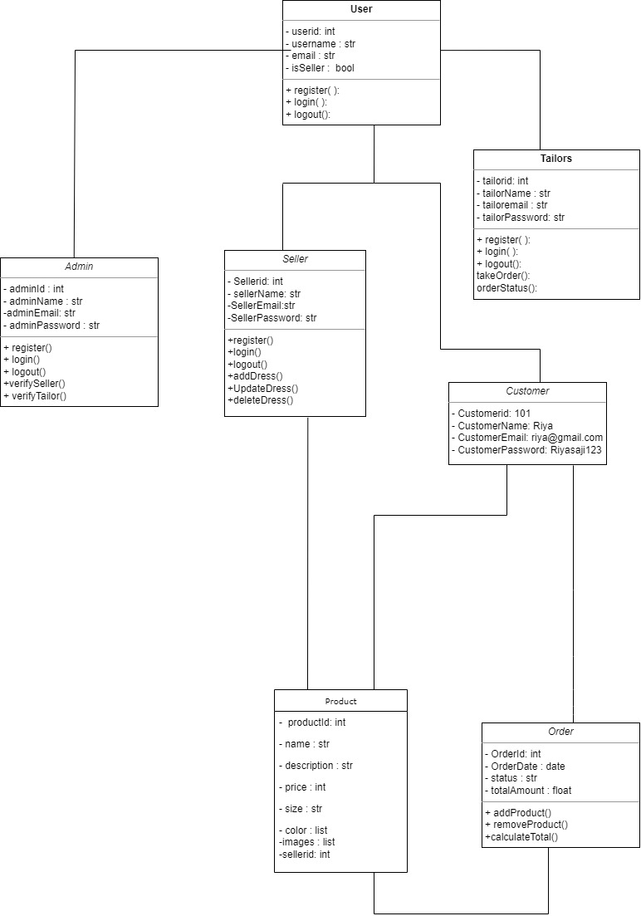

* **Component diagram**

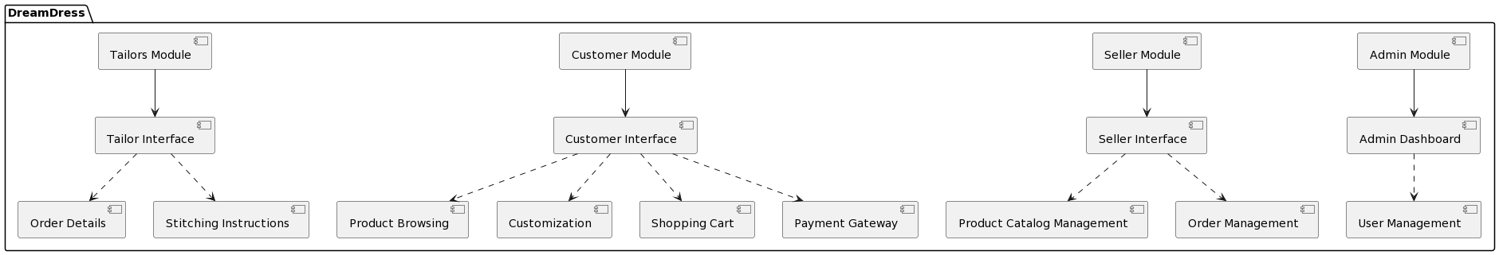

* **Deployment diagram**

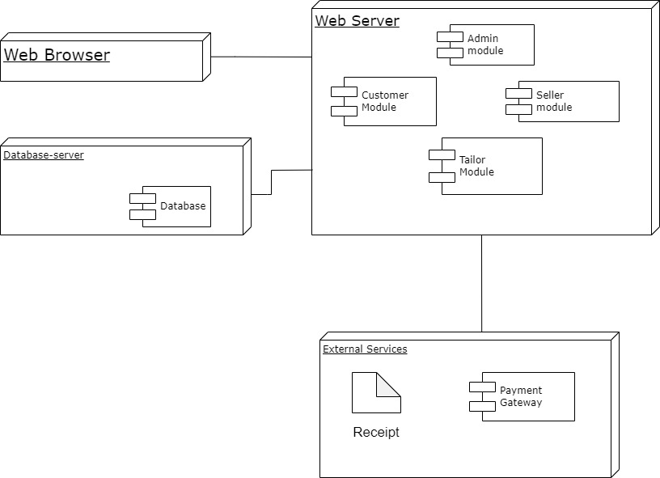

* **Use case diagram**

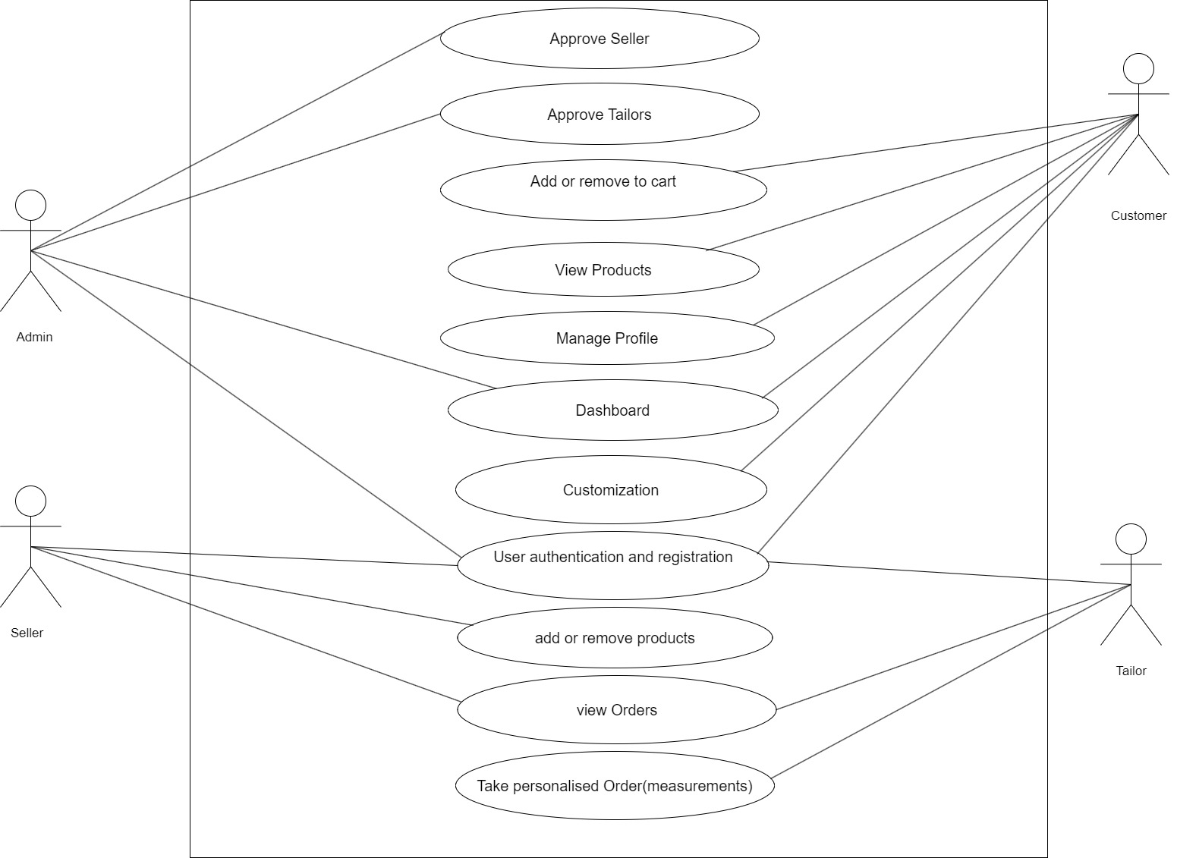

* **Sequence diagram**

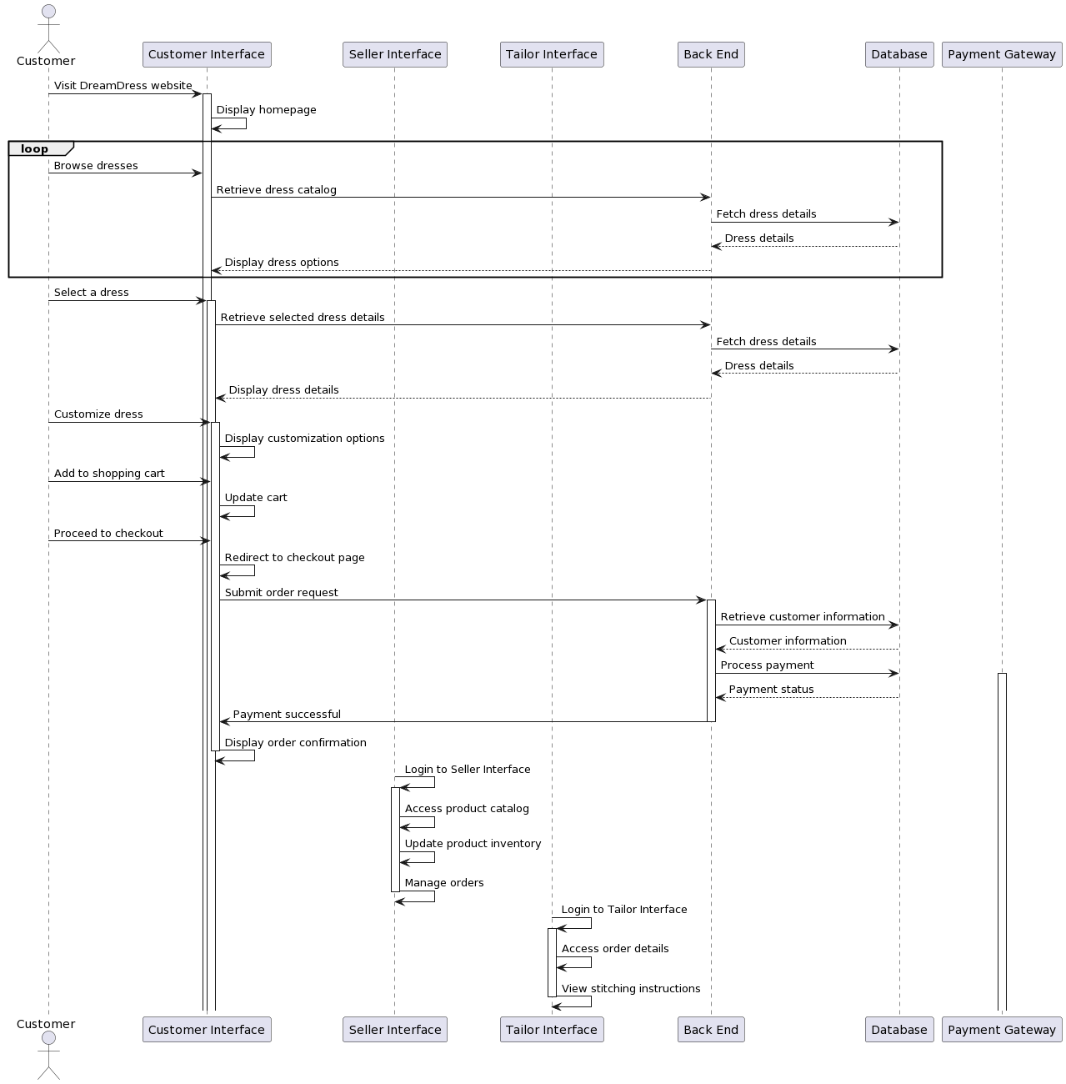

* **State chart diagram**

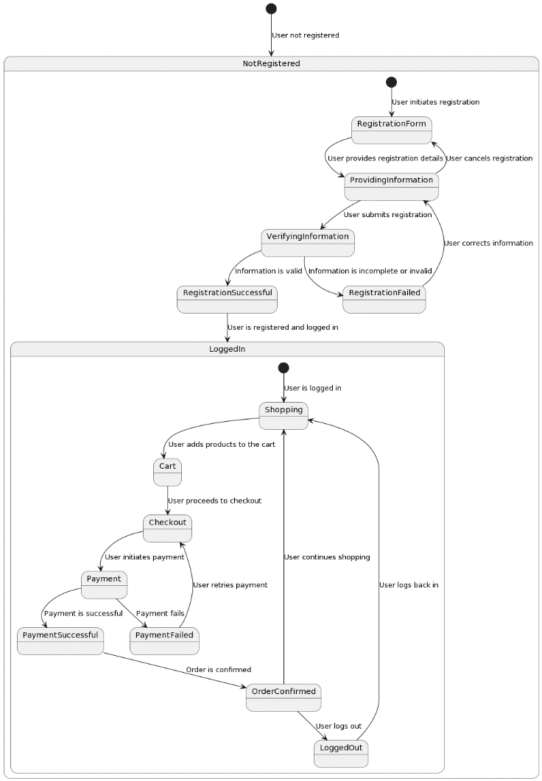

* **Activity diagram**

