RIYA SAXENA

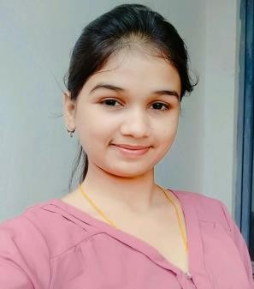

Strong Team Member, able to motivate others to achieve optimal production rates while maintaining safety methods & practices. Reliable follow through skills, clear communication, both oral & written. Strong Interpersonal skills, interface effectively with coworkers, managements, clients & customers. Excel in unpredictable hectic environment & can lead any size of team.

# CONTACT DETAILS

+91-6398888414

[riyasaxenabdn2002@gmail.com](mailto:shivambhadur48@gmail.com) Subhash chowk, Mustafagunj, Budaun

Uttar Pradesh – 243601, INDIA

# ACADEMIC QUALIFICATION

* BRB MODEL SCHOOL (CBSE BOARD NEW DELHI) HIGH SCHOOL (85%) - 2018
* BRB MODEL SCHOOL (CBSE BOARD NEW DELHI) INTERMEDIATE (**90.6%)- 2020**
* Bachelors’s in Computer Application (BCA) (Fresher)

# PERSONAL DETAILS

**Fathers name** -Yogesh Saxena **Mothers name -**Jyoti Saxena **DOB** - 09-04-2003

**Marital status** - Single

**Nationality** - Indian

# LANGUAGE

Hindi & English

* + Read
  + Write
  + Communicate

# SOFTWARE SKILLS

* Knowledge of C++
* Knowledge of HTML, CSS & JS
* Expert in MS Excel/Office

# ACCOMPLISHED PROJECTS

|  |
| --- |
| * Making the Expense tracker with local storage integration. * Integrating Rest API |