**TCP Chat Application with File Transfer - Project Report**

**Synopsis:**This report details a chat application project comprising a server and a client module. The application facilitates real-time communication between users in a secure manner. Users can join groups, send messages, manage group memberships, **and transfer** **files**. The server handles connections, group management, and message routing, while the client module provides the interface for user interactions.

**Feature Descriptions:***Group Management:*Groups are central to the application. Users can create groups, join existing ones, view and approve join requests, and change group admins. The Group class on the server manages these functionalities, maintaining details of all members, both online and offline, as well as the group admin.

***Group creation:*** (Client and Server sides respectively)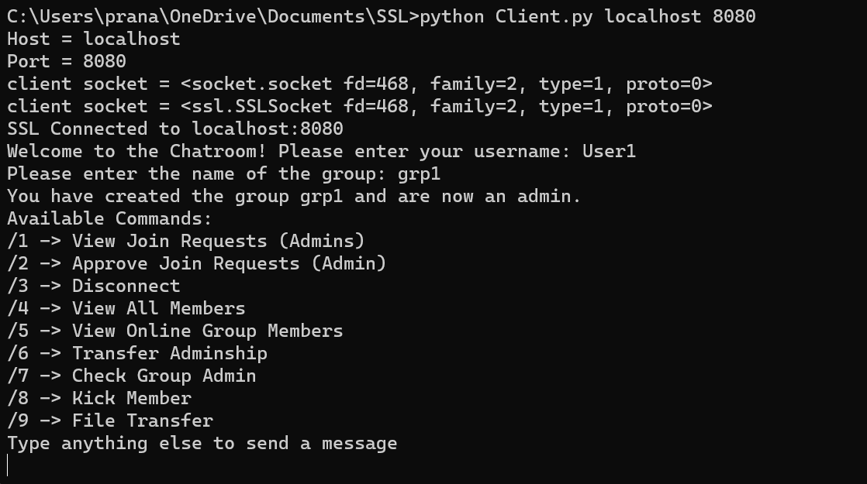

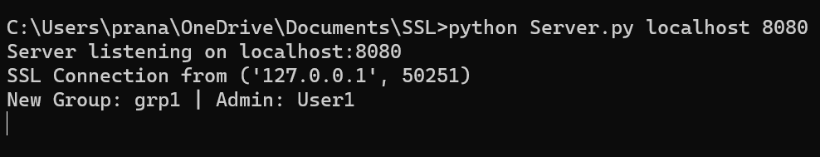

***Joining group:*** (Client and server sides respectively)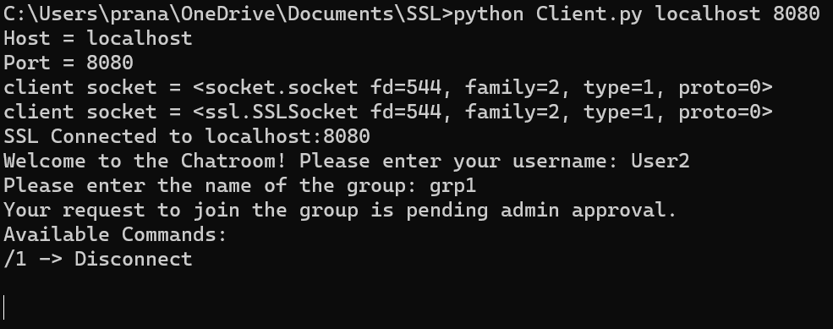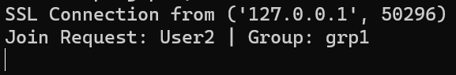

***view and approve join requests***: (User1 and User2’s windows)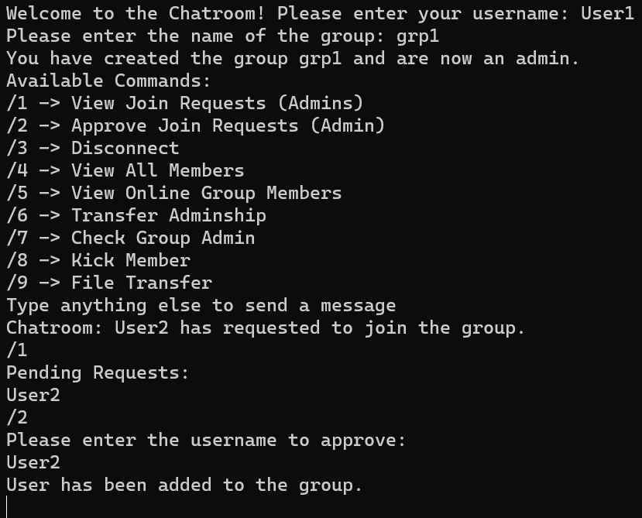 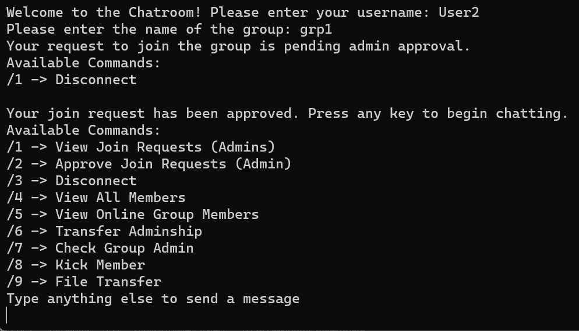

***Disconnecting, View all and online members:*** (Clients and Server logs respectively)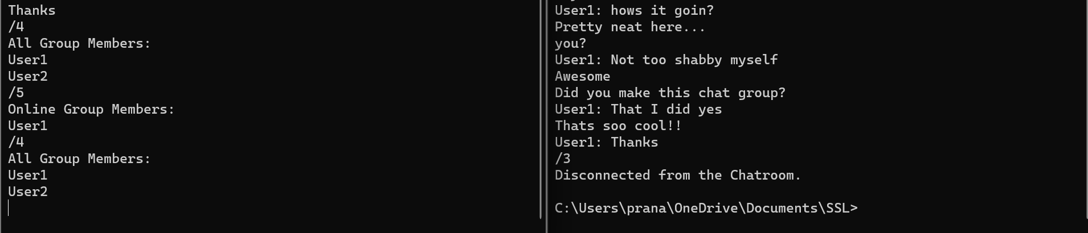 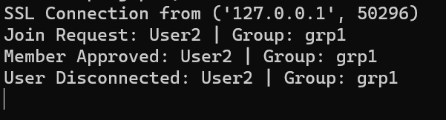

***Check for admin and Transfer of adminship:*** (Clients and Server logs respectively)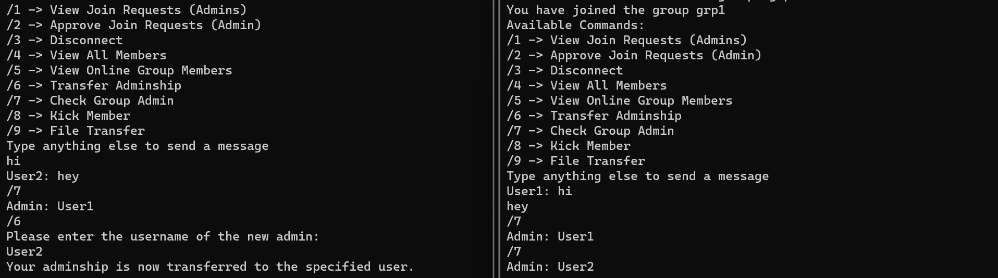 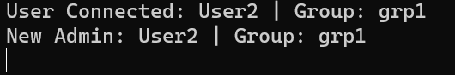

*Messaging:*The application supports real-time messaging within groups. Users can send messages to all online group members. Messages from users not currently online are queued as offline messages. The server routes messages to the appropriate clients. 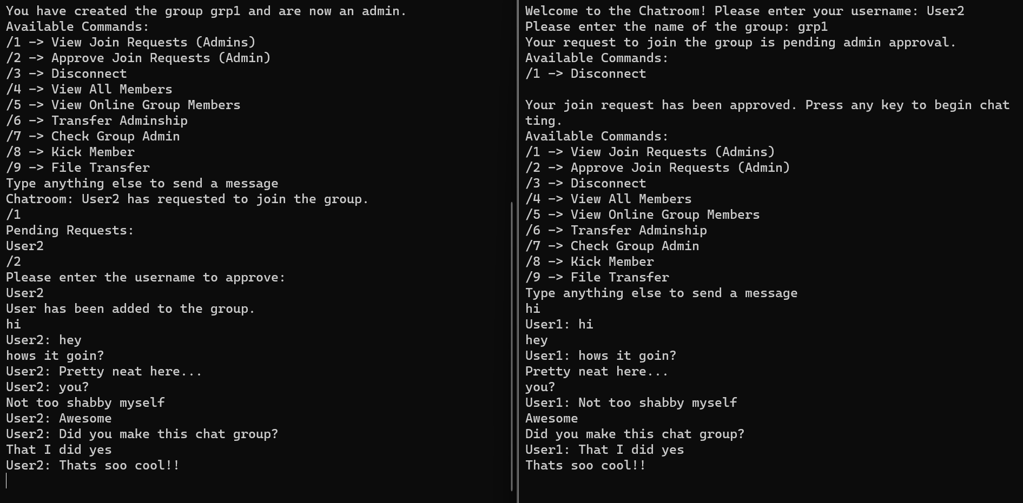

*File Transfer:*File transfer is another key feature. Users can share files with other group members. The server handles the distribution of these files to online members. Files are temporarily stored on the server before being forwarded to other clients. 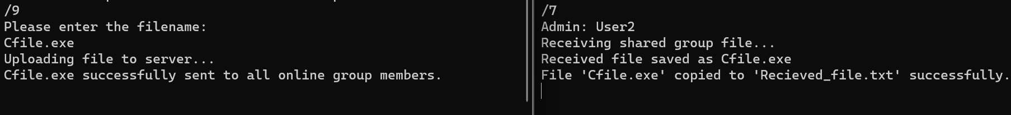 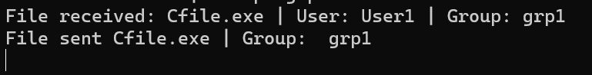

*Security:*The application uses SSL encryption for secure communication between the client and server, ensuring that the data transferred is protected against eavesdropping and tampering.

*Github link:*