Project title**:** Secure Data Hiding in Image Using Steganography

Output Scenarios are as follows:

1)When one says yes to Encryption, Decryption and enters correct passkey.

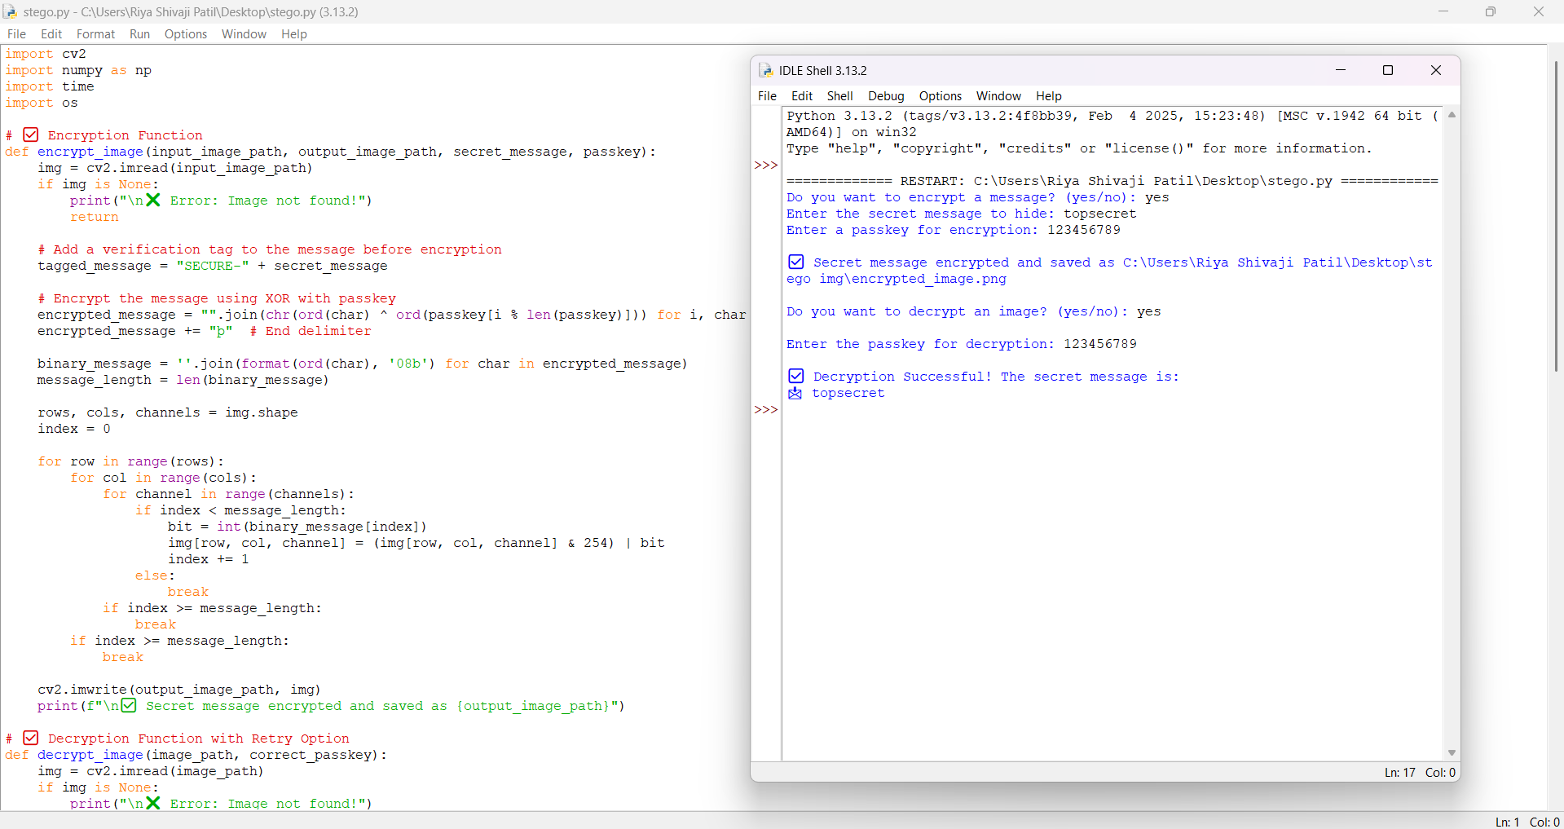

2) When one says yes to Encryption, Decryption and once enters incorrect passkey.

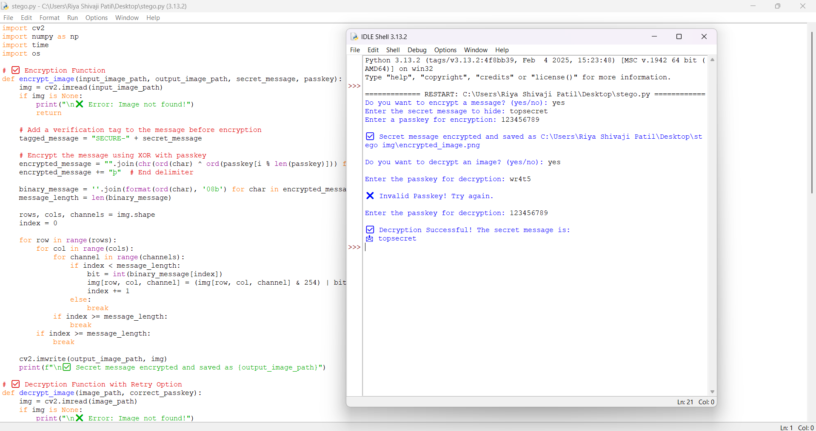

3) When one says yes to Encryption, Decryption and twice enters incorrect passkey.

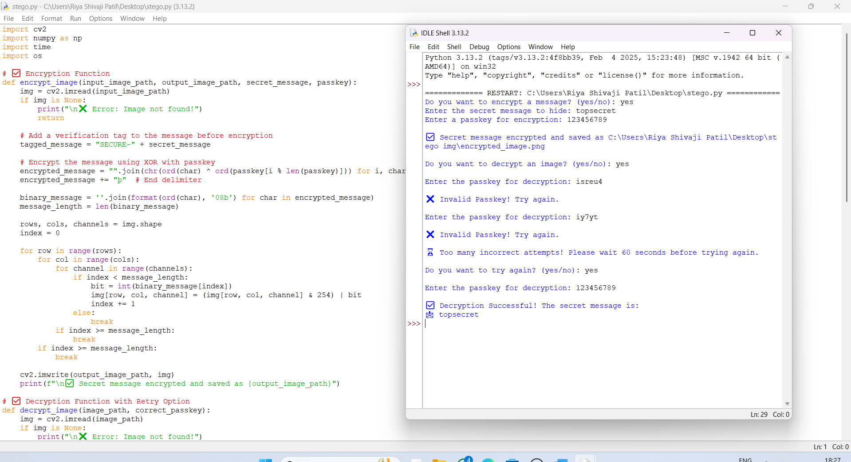

4) When one says yes to Encryption and no to Decryption after entering incorrect passkey twice.

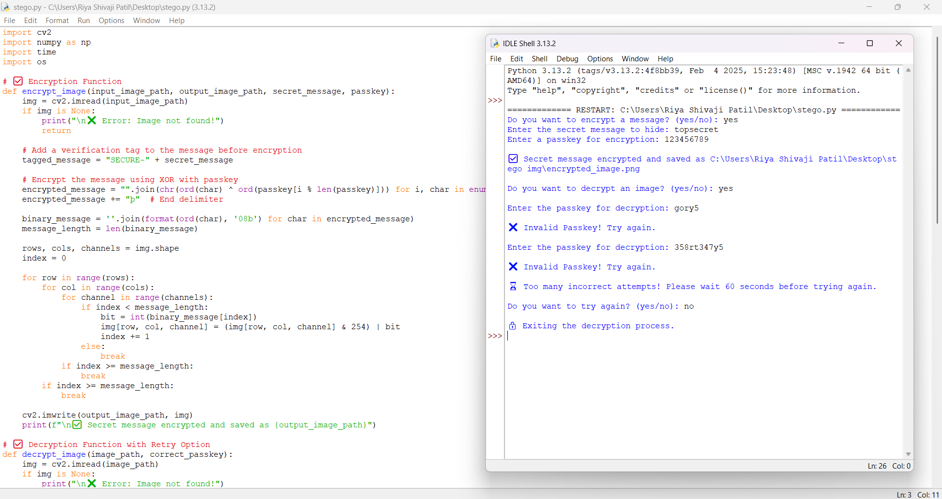

5) When one says yes to Encryption and no Decryption. 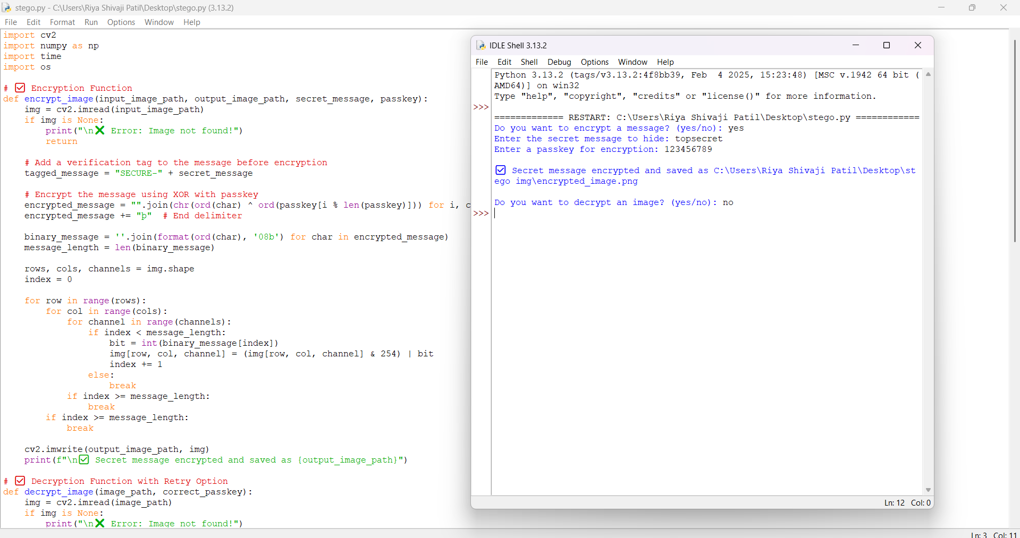

6) When one says no to Encryption and no to Decryption.

