# Building Real-time Google Play Store Data Analytics Using Python

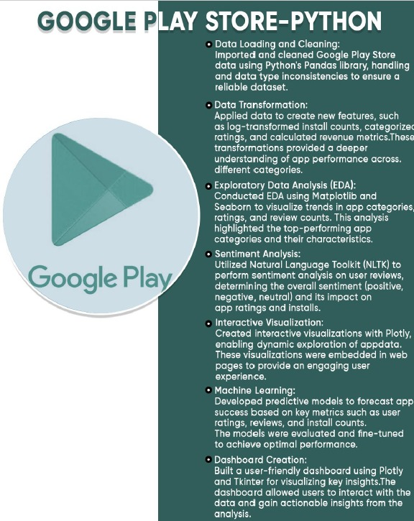

Prepared by: [Patil Riya Shivaji]

Date: [13/02/2025]

## Introduction

The Google Play Store is a vital ecosystem where millions of applications are available for download. With the ever-growing competition among app developers, analyzing app data in real time has become essential for businesses to make informed decisions. This project focuses on building a real-time data analytics system using Python, integrating web scraping, data processing, visualization, and machine learning techniques to extract meaningful insights from Google Play Store data.

Traditional data analysis methods rely on static datasets, which quickly become outdated in dynamic environments like the Play Store. This project aims to bridge this gap by implementing automated data pipelines that fetch, clean, analyze, and visualize app data in real-time, providing accurate and actionable insights for stakeholders.

## Background

The Google Play Store contains vast amounts of data related to app downloads, user ratings, reviews, and revenue. Understanding these patterns can help developers enhance app performance and improve user experience. However, given the continuous updates in the Play Store, static analysis methods are insufficient.

This project leverages Python's powerful data science ecosystem, including libraries such as Pandas for data handling, BeautifulSoup for web scraping, Matplotlib and Seaborn for visualization, and NLTK for natural language processing. By automating data extraction and processing, the system provides real-time insights, allowing businesses to react swiftly to emerging trends.

## Learning Objectives

This project aims to achieve the following learning objectives:

• Understand the fundamentals of real-time data analytics and its significance in the digital marketplace.

• Learn how to collect and clean Google Play Store data efficiently using Python.

• Apply data transformation techniques such as log transformations and categorical encoding.

• Conduct Exploratory Data Analysis (EDA) to extract trends and insights from app data.

• Perform sentiment analysis on user reviews to determine customer satisfaction and app performance.

• Develop interactive visualizations using Plotly and Tkinter to present data dynamically.

• Implement machine learning models to predict app success based on key metrics.

• Deploy and automate real-time analytics pipelines to ensure continuous data updates.

## Activities and Tasks

To successfully implement real-time Google Play Store analytics, the following activities and tasks were undertaken:

• Data Collection: Extracting real-time data using web scraping techniques and APIs.

• Data Cleaning and Transformation: Handling missing values, converting data types, and normalizing variables.

• Exploratory Data Analysis (EDA): Identifying key trends, visualizing distributions, and discovering correlations.

• Sentiment Analysis: Analyzing user reviews to determine sentiment trends using NLP techniques.

• Dashboard Development: Creating an interactive dashboard to display real-time insights.

• Machine Learning Model Training: Developing models to predict app performance based on past trends.

• Automation and Deployment: Implementing scheduled scripts for continuous data updates and visualization.

## Skills and Competencies

The following technical and analytical skills were developed during this project:

• Python Programming: Writing efficient and scalable scripts for data extraction and processing.

• Data Wrangling: Using Pandas to clean and manipulate large datasets.

• Statistical Analysis: Applying various statistical methods to analyze and interpret data.

• Natural Language Processing (NLP): Using NLTK for sentiment analysis of user reviews.

• Web Scraping & API Integration: Extracting structured data dynamically from web sources.

• Data Visualization: Creating meaningful charts and graphs using Matplotlib, Seaborn, and Plotly.

• Machine Learning: Training predictive models to assess app performance.

• Dashboard Development: Building interactive interfaces for data exploration using Tkinter.

## Feedback and Evidence

The system's effectiveness was assessed using various feedback mechanisms and validation methods:

• User Testing: Developers and analysts tested the dashboard for usability and effectiveness.

• Performance Metrics: The accuracy of sentiment analysis and machine learning predictions was measured.

• Real-time Data Validation: Play Store data updates were cross-checked against collected insights.

• Visualization Accuracy: Ensured that graphs and charts represented data trends correctly.

## Challenges and Solutions

Several challenges were encountered during the project, and appropriate solutions were implemented:

• Data Extraction Restrictions: Play Store's API limitations required implementing advanced web scraping methods and rotating proxies.

• Handling Large Data Volumes: Cloud-based databases and optimized queries were used for efficient data storage and retrieval.

• Ensuring Data Accuracy: Automated validation scripts and redundancy mechanisms were implemented to maintain accuracy.

## Outcomes and Impact

The implementation of real-time Google Play Store analytics yielded significant outcomes:

• Real-time Analytics System: A fully automated system providing up-to-date insights.

• Data-driven Decision-making: Businesses and developers can monitor trends and optimize strategies.

• Predictive Capabilities: AI-driven models offer forecasts on app success and user engagement.

• Scalability and Expansion: The framework can be adapted for other digital marketplaces and datasets.

## Conclusion

This project successfully demonstrates the power of real-time analytics in understanding Google Play Store trends. Using Python’s advanced data science libraries, we were able to extract, clean, analyze, and visualize app data dynamically. By integrating sentiment analysis and machine learning, we provided deeper insights into user preferences and app performance.

The interactive dashboard enhances usability, making data-driven decisions more accessible. Despite challenges related to data extraction and processing, the implemented solutions ensured accuracy and efficiency. This project serves as a foundation for future advancements in real-time market intelligence and data analytics.