Decode Labs Project 3

Customer Segmentation using PCA and K-Means Clustering
Name: Riya Singh
Internship: Decode Labs - Data Science Internship

1. Introduction
Customer segmentation is the process of dividing customers into different groups based on their purchasing behaviour and characteristics. This project uses Principal Component Analysis (PCA) and K-Means Clustering to identify meaningful customer segments for business decision making.

2. Objective
- Perform data preprocessing and cleaning.
- Perform Exploratory Data Analysis (EDA).
- Apply Feature Scaling.
- Apply Principal Component Analysis (PCA).
- Determine the optimal number of clusters using the Elbow Method.
- Evaluate clustering using the Silhouette Score.
- Perform Customer Segmentation using K-Means Clustering.
- Generate business insights.

3. Dataset Description
The dataset contains customer purchasing information. It includes numerical features that help identify customer behaviour and purchasing patterns for segmentation.

4. Data Cleaning
The dataset was inspected for missing values, duplicate records and incorrect data types. Missing values were handled and duplicate records were removed before further analysis.

5. Exploratory Data Analysis
Exploratory Data Analysis (EDA) was performed to understand the distribution of data and relationships among variables. Histograms, Boxplots and Correlation Heatmaps were generated.

6. Feature Scaling
Feature Scaling was performed using StandardScaler to ensure that all numerical features contributed equally during clustering.

7. Principal Component Analysis (PCA)
Principal Component Analysis (PCA) was used to reduce the dimensionality of the dataset while preserving most of the important information.

8. Elbow Method
The Elbow Method was used to determine the optimal number of clusters by analysing inertia values.

9. Silhouette Score
Silhouette Score was calculated to evaluate the quality of the clusters. Higher scores indicate better clustering.

10. K-Means Clustering
K-Means Clustering grouped customers into similar clusters based on their purchasing behaviour.

11. Business Insights
- High-value customers should receive loyalty rewards.
- Medium-value customers can be targeted with personalised offers.
- Low-value customers can be re-engaged through marketing campaigns.
- Customer segmentation helps improve marketing efficiency.

13. Project Graphs

Histogram
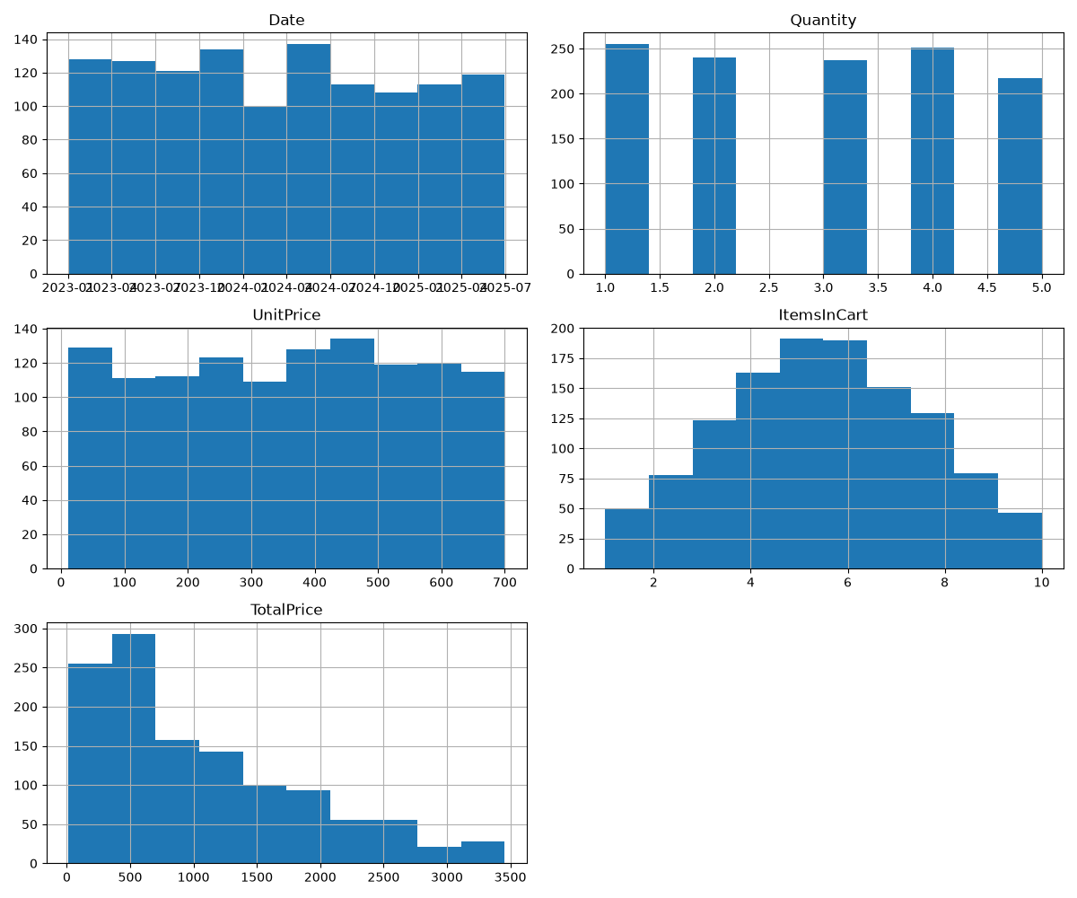

Correlation Heatmap
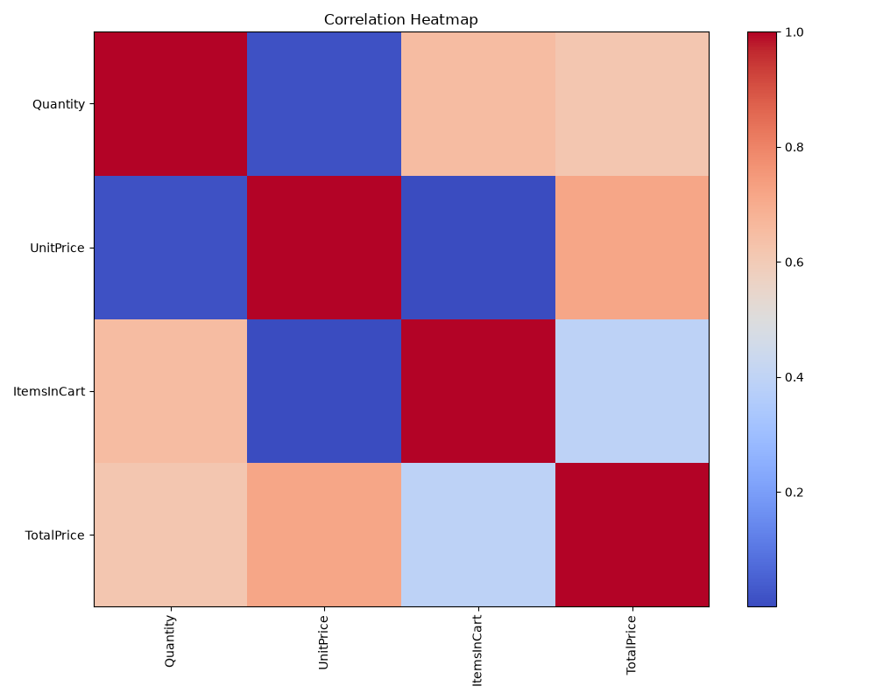

Explained Variance
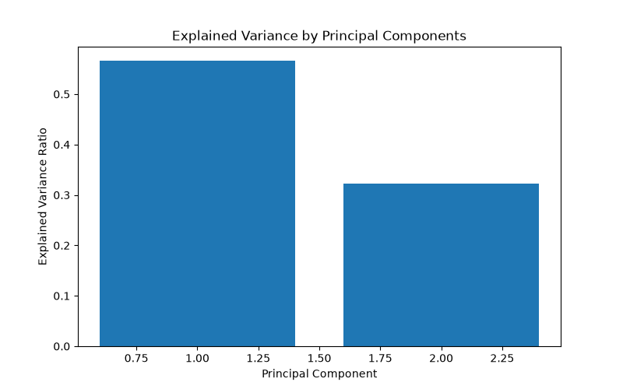

Cumulative Variance
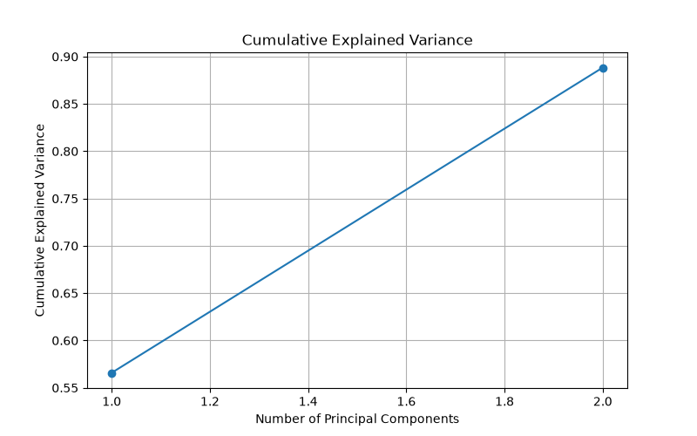

PCA Scatter Plot
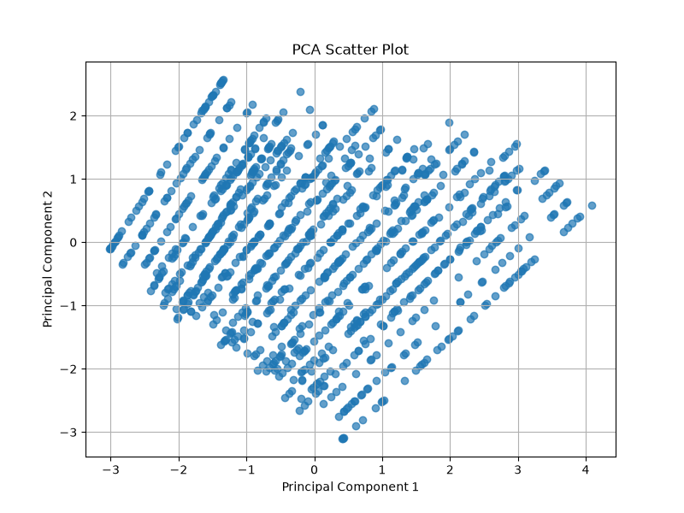

Elbow Method
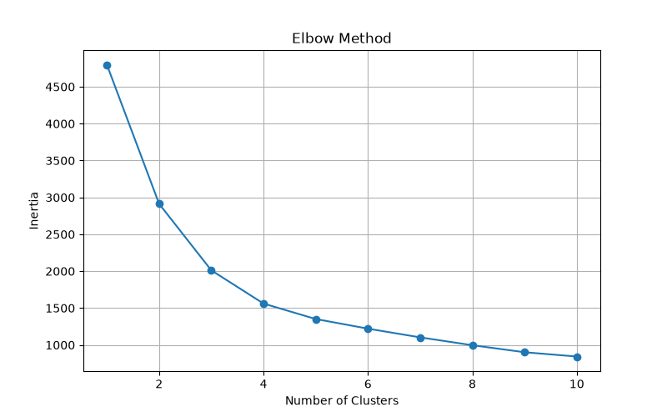

Customer Clusters
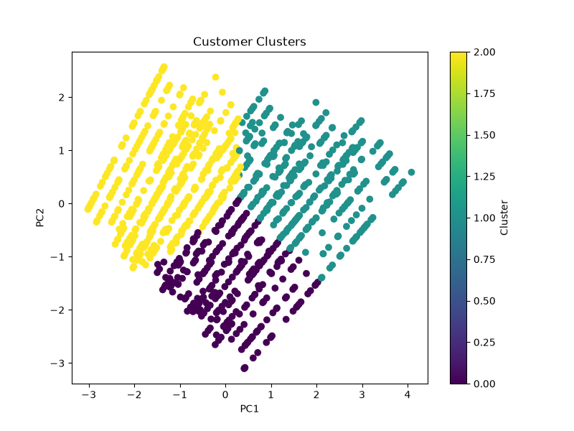

Cluster Distribution
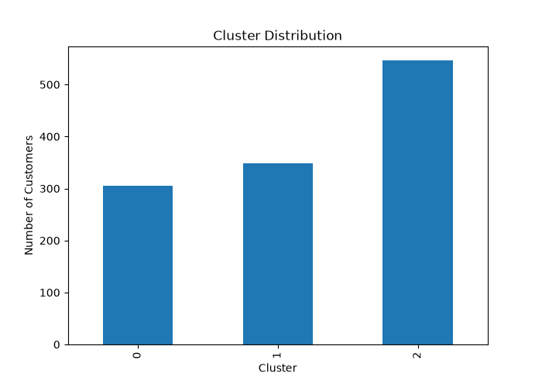

Silhouette Score
