*BIG DATA ANALYSIS WITH IBM CLOUD*

**Introduction:**

**Phase 4: Development Part 2 :**

**In this part you will continue building your project. Continue building the big data analysis solution by applying advanced analysis techniques and visualizing the results. Apply more complex analysis techniques, such as machine learning algorithms, time series analysis, or sentiment analysis, depending on the dataset and objectives. Create visualizations to showcase the analysis results. Use tools like Matplotlib, Plotly, or IBM Watson Studio for creating graphs and charts.**

**In today’s data-driven world, organizations are faced with an ever-increasing volume of data. To derive valuable insights from this wealth of information, advanced big data analysis techniques are essential. This article explores the next steps in building a robust big data analysis solution by applying advanced analytical methods and effectively visualizing the results.**

**The foundation of this analysis lies in the ability to extract meaningful patterns, predictions, and insights from large and complex datasets. We delve into the application of sophisticated techniques such as machine learning algorithms, time series analysis, and sentiment analysis, each chosen according to the unique nature of the dataset and the objectives of the analysis.**

**Furthermore, the visualization of these results is paramount. Effective visualization not only aids in comprehending complex data but also in conveying insights to stakeholders and decision-makers. To accomplish this, we will leverage powerful tools such as Matplotlib, Plotly, and IBM Watson Studio to create graphs and charts that convey the analysis outcomes clearly and intuitively.**

**This comprehensive guide will walk you through the process, from data preprocessing and feature engineering to selecting the right algorithms and conducting thorough testing. It will also explore the nuances of time series analysis for temporal data and sentiment analysis for textual data. Let’s embark on the journey of advanced big data analysis and visualization to unlock the hidden value within your data.**

***IBM Watson Studio :***

**IBM Watson Studio provides an integrated Jupyter Notebook environment as one of its key features. Here’s how you can use Jupyter Notebooks within IBM Watson Studio:**

***Creating Notebooks:* You can create Jupyter Notebooks directly within IBM Watson Studio. These notebooks are stored in your Watson Studio project and can be shared with your team members.**

***Selecting a Runtime:* When creating a Jupyter Notebook, you can choose the runtime environment. You can select the type of runtime based on your requirements, which can include Python and R environments.**

***Coding and Documentation:* Jupyter Notebooks in Watson Studio allow you to write and run code cells, just like a typical Jupyter Notebook. You can use various programming languages, including Python, R, and more. These notebooks are ideal for combining code, visualizations, and explanatory text to create a comprehensive and well-documented analysis.**

***Data Access:* You can easily access data stored in your Watson Studio project or connect to external data sources. The data can be loaded into your notebook for analysis and modeling.**

***Collaboration:* One of the strengths of using Jupyter Notebooks in Watson Studio is the collaboration aspect. Multiple team members can collaborate on the same notebook in real-time. You can leave comments, track changes, and work together on data analysis and model development.**

***Version Control:* IBM Watson Studio integrates with Git and GitHub, allowing you to manage version control for your Jupyter Notebooks. You can track changes and collaborate on notebooks using Git features.**

**Sharing and Deployment: Once your Jupyter Notebook is ready, you can share it with others, including stakeholders and decision-makers. You can also deploy the code and models within the notebook as web services, making it easier to integrate your work into applications and workflows.**

***Access to IBM Cloud Services:* You can seamlessly access and integrate other IBM Cloud services and AI capabilities within your Jupyter Notebooks in Watson Studio, such as Watson Machine Learning or Watson Discovery.**



***Ibm_watson_machine_learning:* This is the name of the Python package you are installing. It’s specifically related to IBM Watson Machine Learning and provides tools and functions to work with machine learning models and deployments on the IBM Cloud. This command will attempt to install or upgrade the “ibm-watson-machine-learning” package in your Python environment. Please ensure that you have the necessary permissions and dependencies to perform this installation.**

***Geopandas:*This command will install the geopandas package, which is used for working with geospatial data and allows you to read, write, and manipulate geographic and geospatial data formats in Python. Make sure you have the necessary permissions and dependencies to perform this installation.**

***Program and Output :***

***Data preprocessing:***

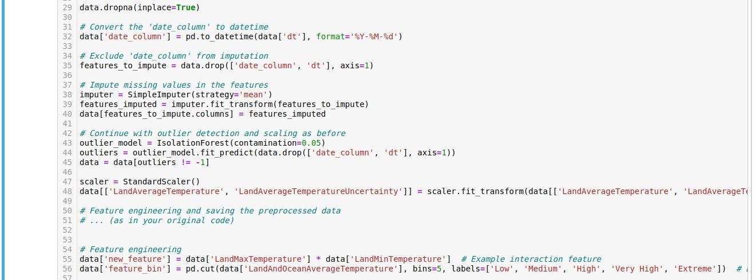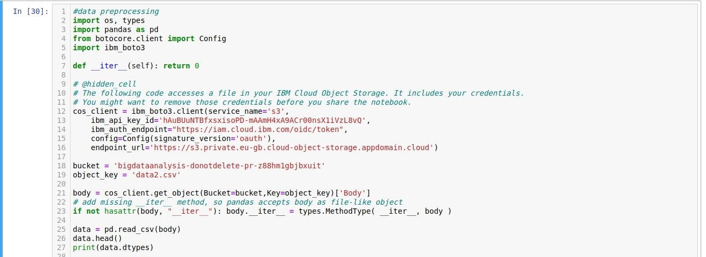



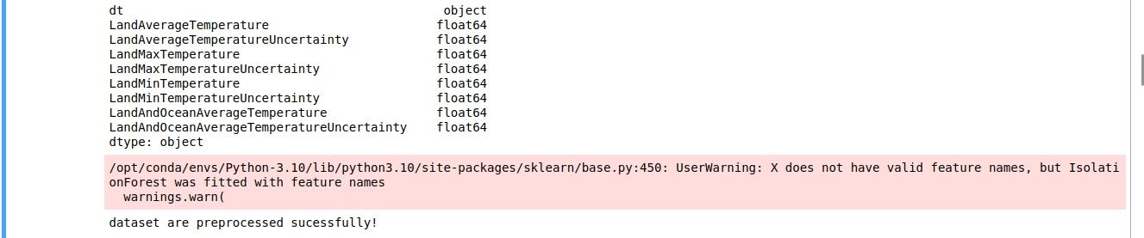***Output :***

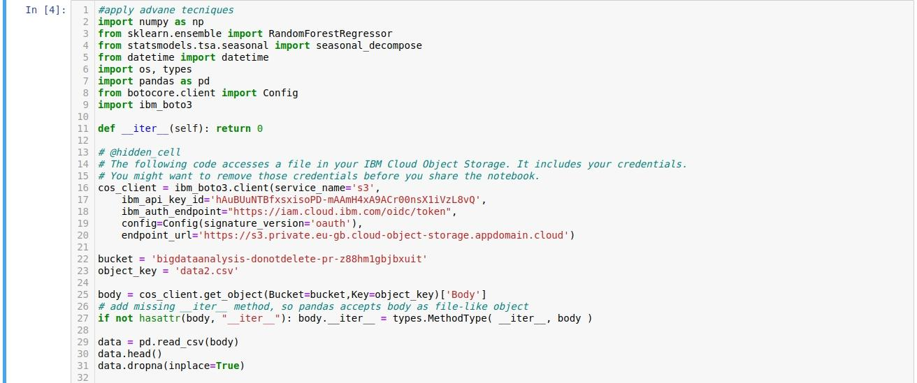***Apply Advance Techniques :***

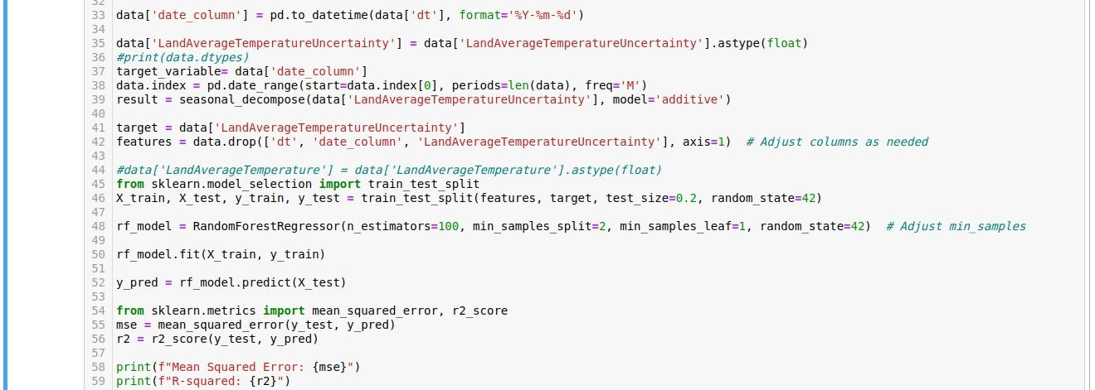***Output :***

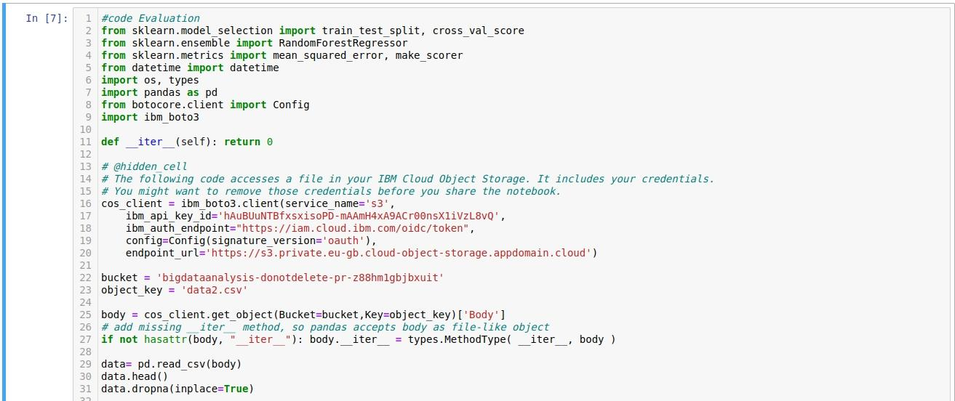***Code Evaluation :***

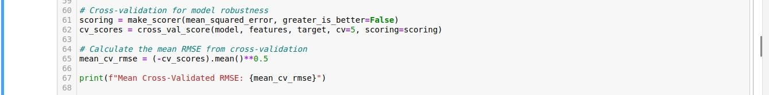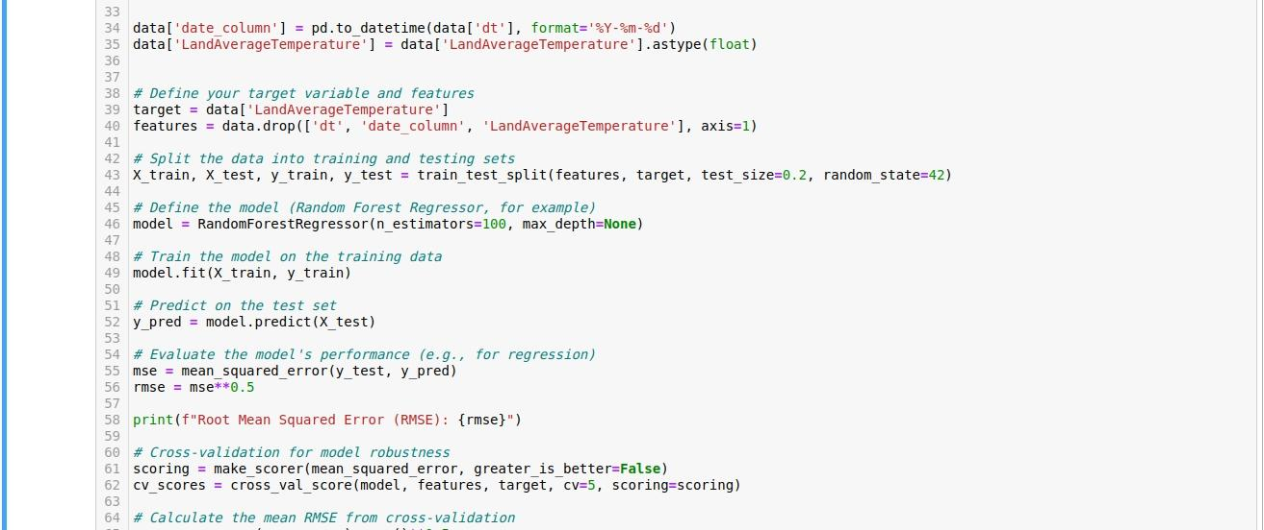***Output :***



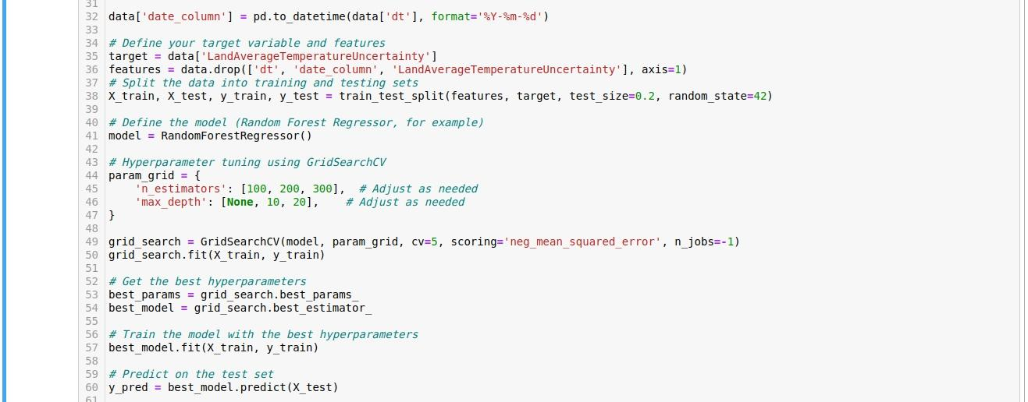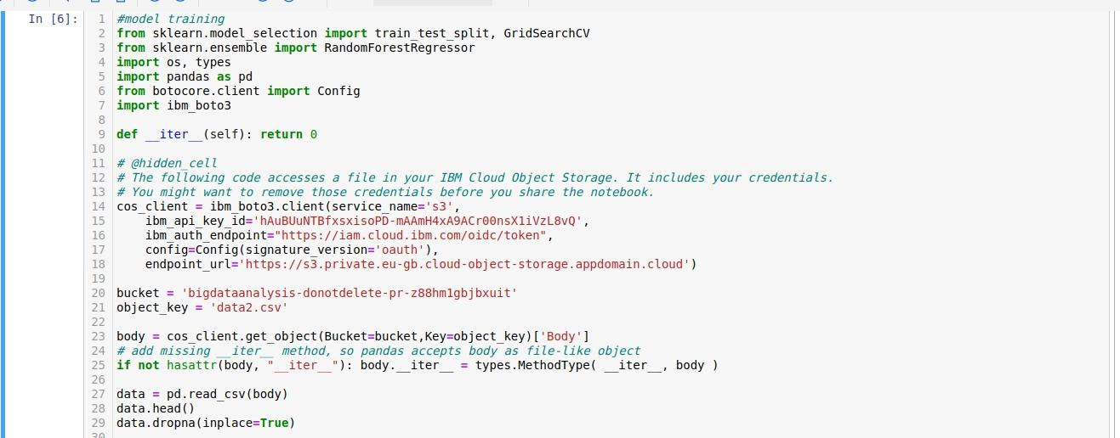***Model Training:***

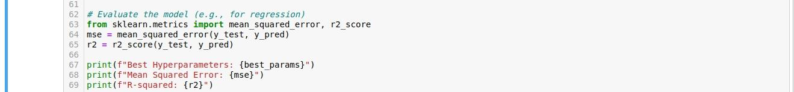***Output :***

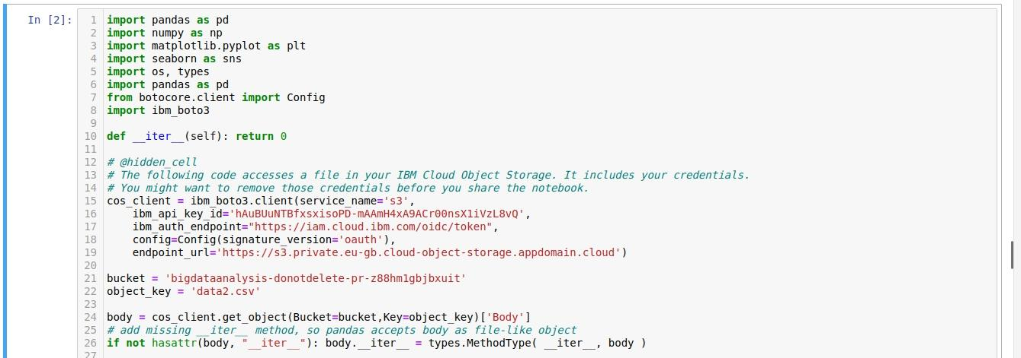 ***Visualization of Data :***

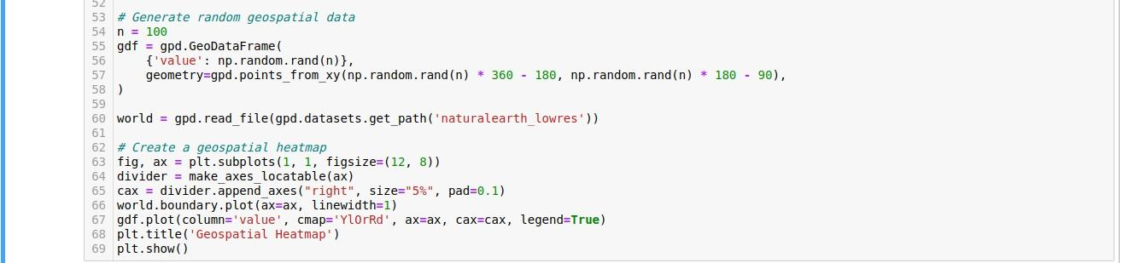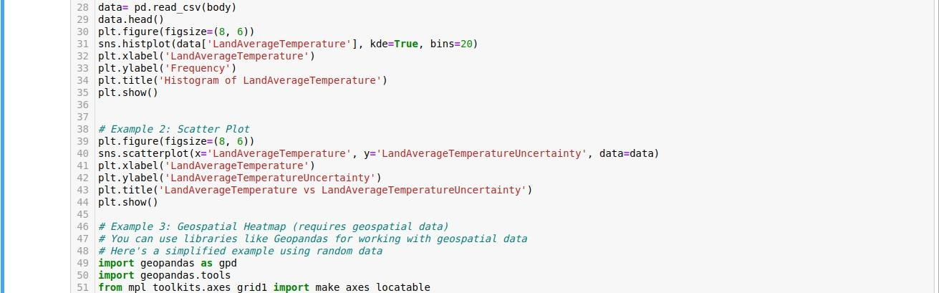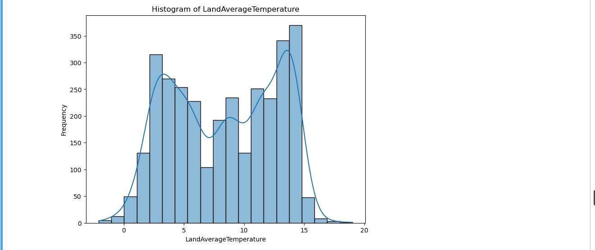***output :***

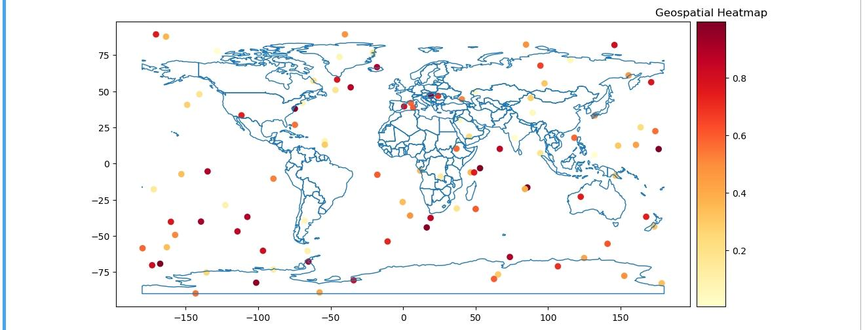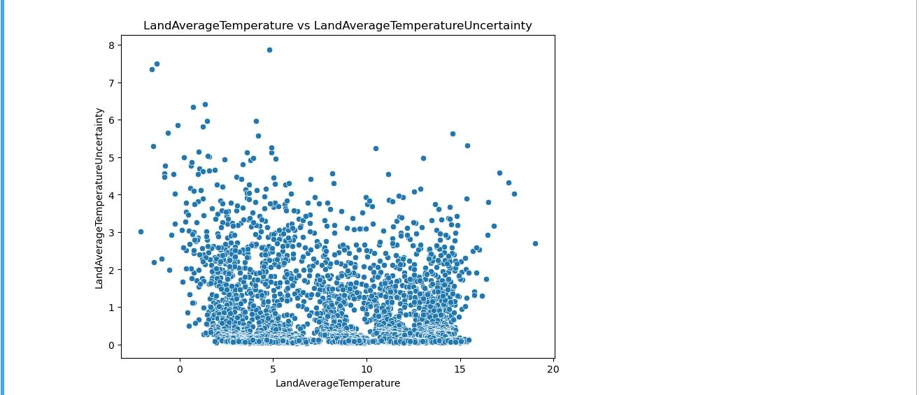

***conclusion:***

**In conclusion, leveraging IBM Watson Studio for data visualization is a strategic and powerful approach that enhances the entire data analysis lifecycle. The ability to effectively communicate insights and findings from complex datasets is paramount in making data-driven decisions and sharing knowledge across an organization. IBM Watson Studio offers a robust environment for creating visualizations that encapsulate the results of advanced data analysis techniques, and here are key takeaways:**

***Clarity and Insights:* Visualizations serve as a bridge between raw data and actionable insights. With Watson Studio’s visualization capabilities, you can transform complex data into clear and compelling charts, graphs, and interactive dashboards. This clarity aids in understanding trends, patterns, and outliers within the data.**

***Stakeholder Engagement:* Data-driven decisions often involve multiple stakeholders. Watson Studio facilitates collaboration by providing a shared workspace for data scientists, analysts, and business professionals. Visualizations become a common language that bridges the gap between technical experts and decision-makers.**

***Interactivity:* Interactive visualizations created in Watson Studio allow users to explore data, change parameters, and gain real-time feedback. This dynamic engagement enhances the decision-making process by enabling users to interact with the data and explore various scenarios.**

***Data-Driven Storytelling:* Effective visualizations go beyond numbers and statistics; they tell a story. With Watson Studio, you can craft data-driven narratives that convey the ‘what’ and ‘why’ behind the data, making it easier for stakeholders to grasp the significance of the findings.**

***Integration and Deployment:* IBM Watson Studio’s visualization tools seamlessly integrate with other components of the platform, such as machine learning models and deployment services. This enables you to create end-to-end solutions where insights are transformed into actionable applications and services.**

***Security and Governance:* Data security and governance are essential aspects of any data project. Watson Studio provides robust security features, ensuring that sensitive data remains protected during the visualization and sharing process.**