*Big Data Analysis with IBM Cloud Databases*

***Abstract***

**The explosion of data in the digital age has necessitated powerful tools and platforms for efficient data management and analysis. IBM Cloud Databases offers a comprehensive suite of cloud-native database solutions tailored for big data analysis. This abstract provides an overview of the key modules and capabilities that make IBM Cloud Databases a compelling choice for organizations seeking to harness the potential of big data.**

***Modules***

1. ***Data Ingestion and Integration***

**IBM Cloud Databases provides a versatile set of tools for ingesting data from various sources, including structured and unstructured data, IoT devices, and streaming data. The platform supports seamless integration with popular data integration tools and frameworks, enabling organizations to consolidate their data into a unified repository.**

1. ***Scalable Database Solutions***

**One of the core strengths of IBM Cloud Databases is its ability to provide scalable and highly available database solutions. Organizations can choose from a variety of database engines such as Db2, PostgreSQL, and Redis to meet their specific requirements.**

1. ***Advanced Analytics and Machine Learning***

**IBM Cloud Databases offers integration with advanced analytics and machine learning frameworks, including IBM Watson Studio. This module empowers data scientists and analysts to perform complex data analyses, build predictive models, and gain insights from large datasets, all within a unified environment.**

1. ***Data Security and Compliance***

**Security and compliance are paramount in the world of big data. IBM Cloud Databases offers robust security features such as encryption at rest and in transit, access controls, and auditing capabilities to protect sensitive data. It also helps organizations adhere to industry-specific compliance standards, ensuring data privacy and regulatory compliance.**

1. ***Data Visualization and Reporting***

**Effective data analysis often requires the ability to communicate insights through visualization and reporting. IBM Cloud Databases facilitates data visualization and reporting through integrations with popular BI tools like Tableau and Cognos, enabling users to create interactive dashboards and reports.**

1. ***Data Governance and Management***

**IBM Cloud Databases provides comprehensive data governance and management features, allowing organizations to catalog, classify, and monitor data assets. This module helps in maintaining data quality, lineage, and version control, which are critical for data-driven decision-making.**

1. ***Cloud-Native Ecosystem***

**The platform seamlessly integrates with other IBM Cloud services and a wide range of third-party tools, fostering a cloud-native ecosystem that enables organizations to build end-to-end data pipelines, automate workflows, and leverage the power of cloud-native technologies.**

1. ***Data Lake Integration***

**IBM Cloud Databases can seamlessly integrate with data lakes like IBM Cloud Object Storage and Apache Hadoop, allowing organizations to store and analyze vast amounts of unstructured and semi-structured data. This module facilitates the creation of data pipelines that can extract, transform, and load data into data lakes for further analysis.**

1. ***Real-time Stream Processing***

**For applications that require real-time insights from streaming data sources, IBM Cloud Databases offers integration with stream processing frameworks like Apache Kafka and IBM Event Streams.**

1. ***Geospatial Analysis***

**For industries such as logistics, urban planning, and retail, geospatial analysis is crucial. IBM Cloud Databases provides geospatial extensions for databases like Db2, enabling location-based queries and geospatial analytics. This module allows organizations to derive valuable insights from spatial data.**

1. ***Natural Language Processing (NLP)***

**The Integration of natural language processing capabilities into IBM Cloud Databases empowers organizations to analyze and extract insights from textual data. This module supports text analytics, sentiment analysis, and language translation, opening new avenues for understanding customer feedback, social media data, and textual documents.**

1. ***AutoML and Data Preparation***

**Automated machine learning (AutoML) and data preparation tools within the platform help data scientists streamline the model development process. This module assists in feature engineering, model selection, and hyperparameter tuning, making it easier to build accurate predictive models.**

1. ***Data Catalog and Data Lineage***

**Enhancing data governance, IBM Cloud Databases offers advanced data cataloging and data lineage capabilities. Users can easily discover and understand data assets, track their origins, and establish data lineage, ensuring data quality and compliance with data governance policies.**

1. ***Multi-Cloud and Hybrid Cloud Support***

**In today’s multi-cloud and hybrid cloud environments, IBM Cloud Databases provides the flexibility to deploy databases across various cloud providers and on-premises infrastructure. This module allows organizations to avoid vendor lock-in and optimize resource allocation based on specific use cases.**

1. ***DevOps and CI/CD Integration***

**For organizations embracing DevOps practices, IBM Cloud Databases supports continuous integration and continuous delivery (CI/CD) pipelines. This module facilitates the automation of database provisioning, deployment, and management, ensuring agility and reliability in the development lifecycle.**

***Conclusion***

**IBM Cloud Databases offers a robust and scalable solution for big data analysis, encompassing data ingestion, scalable databases, advanced analytics, security, visualization, governance, and integration capabilities. By leveraging the modules provided by IBM Cloud Databases, organizations can unlock the potential of their big data assets and gain valuable insights to drive innovation and competitiveness in today’s data-driven world.**

*Big Data Analysis with IBM Cloud Databases*

Big Data Analysis with IBM Cloud Databases” is a project that focuses on utilizing IBM Cloud’s database services and tools to extract meaningful insights and patterns from large and complex datasets. This project aims to leverage IBM’s cloud-based infrastructure and database technologies to address various data analysis challenges. Here’s an introduction to the project:

***Introduction***:

In today’s data-driven world, organizations are dealing with vast amounts of data that hold valuable insights waiting to be unlocked. Managing, processing, and analyzing big data efficiently has become a crucial task. The “Big Data Analysis with IBM Cloud Databases” project is designed to harness the power of IBM Cloud’s database solutions to tackle the complexities of big data.

IBM Cloud offers a robust set of database services and tools that cater to the needs of businesses and data professionals. These services include offerings such as Db2, Cloudant, and Db2 on Cloud, among others. Leveraging these databases, this project aims to:

***Data Ingestion***: Explore methods to efficiently ingest and import large volumes of data into IBM Cloud databases from various sources, ensuring data integrity and security.

***Data Storage and Management:*** Utilize IBM Cloud databases to store, organize, and manage diverse datasets, ensuring scalability and high availability.

***Data Analysis:*** Employ advanced data analysis techniques, including SQL queries, machine learning, and statistical analysis, to extract valuable insights from the stored data.

***Predictive Analytics:*** Implement predictive models using machine learning algorithms available in IBM Cloud, enabling organizations to make data-driven predictions and decisions.

***Anomaly Detection:*** Utilize anomaly detection algorithms to identify unusual patterns or outliers within the data, which can be critical for fraud detection or performance monitoring.

***Visualization:*** Create interactive data visualizations and dashboards to communicate findings effectively to stakeholders.

***Scalability and Performance Optimization:*** Explore strategies to ensure the project’s scalability and optimize database performance as the data volume grows.

***Security and Compliance:*** Implement robust security measures and adhere to data compliance standards to protect sensitive information and maintain regulatory compliance.

Explore some algorithms like Random Forests, Gradient Boosting, Support Vector Machines, or deep learning techniques such as Convolutional Neural Networks (CNNs) or Recurrent Neural Networks (RNNs), depending on your specific use case and data characteristics. It’s crucial to preprocess and prepare your data appropriately and choose the algorithm that best suits your problem for optimal results. Additionally, consider using frameworks like TensorFlow or PyTorch for implementation and scalability.

***Random Forest Algorithm:***

Random Forest is a powerful machine learning algorithm used for both classification and regression tasks. It’s a part of the ensemble learning techniques, which combine multiple models to improve accuracy and reduce overfitting. In your case, you want to use Random Forest for Big Data Analysis with IBM Cloud Databases, focusing on climate trends and social pattern datasets.

*Here's a high-level overview of how to use the Random Forest algorithm with some sample code snippets:*

***Data Preparation:***

Start by collecting and preparing your climate and social pattern datasets. Ensure that your data is structured, and features are well-defined.

Split your data into training and testing sets to evaluate the model’s performance.

***Import Libraries:***

From sklearn.ensemble import RandomForestClassifier **# for classification**

From sklearn.ensemble import RandomForestRegressor **# for regression**

**Step 1: *Data Extraction***

First, you’ll need to extract data from your IBM Cloud database. IBM provides various database options like Db2, PostgreSQL, and NoSQL databases on their cloud platform.Example code to connect to a PostgreSQL database using the psycopg2 library in Python:

Python code

Import psycopg2

**# Connection parameters**

Db_params = {

“host”: “your_database_host”,

“database”: “your_database_name”,

“user”: “your_username”,

“password”: “your_password”

}

**# Connect to the database**

Connection = psycopg2.connect(**db_params)

**# Create a cursor**

Cursor = connection.cursor()

**# Execute SQL queries to extract data**

Cursor.execute(“SELECT * FROM climate_data”)

Data = cursor.fetchall()

**# Close the cursor and connection**

Cursor.close()

Connection.close()

**Step 2: *Data Transformation and Cleaning***

Before analyzing the data, you may need to clean and transform it into a suitable format. Pandas is a popular library for data manipulation.

Example code for basic data cleaning and transformation:

Python code

Import pandas as pd

**# Convert the fetched data into a Pandas DataFrame**

Df = pd.DataFrame(data, columns=[“date”, “temperature”, “precipitation”])

**# Remove missing or erroneous data**

Df = df.dropna()

**# Convert date column to datetime type**

Df[‘date’] = pd.to_datetime(df[‘date’])

**# Perform any other necessary data transformations**

**Step 3**: ***Data Analysis***

Now that your data is in the right format, you can perform various analyses. Here are some example algorithms for climate data analysis:

* **Trend Analysis:**

Calculate rolling averages to identify long-term trends.

**Python code**

Df[‘rolling_avg_temperature’] = df[‘temperature’].rolling(window=30).mean()

* **Correlation Analysis:**

Determine the correlation between temperature and precipitation.

**Python code**

Correlation = df[‘temperature’].corr(df[‘precipitation’])

* **Social Pattern Analysis:**

For social pattern analysis, you’d typically use different algorithms like clustering or sentiment analysis depending on the specific social data you have.

**Step 4: *Data Visualization***

Visualizing your analysis results can help you gain insights from the data.

Example code using Matplotlib for temperature trend visualization:

Python code

Import matplotlib.pyplot as plt

**# Plot temperature trend**

Plt.figure(figsize=(12, 6))

Plt.plot(df[‘date’], df[‘temperature’], label=’Temperature’)

Plt.plot(df[‘date’], df[‘rolling_avg_temperature’], label=’30-day Rolling Avg’, color=’orange’)

Plt.xlabel(‘Date’)

Plt.ylabel(‘Temperature’)

Plt.legend()

Plt.title(‘Temperature Trends’)

Plt.show()

For social pattern analysis, you might use libraries like seaborn or visualization tools like Tableau or Power BI to create more specific visualizations depending on your data and goals.

Remember that big data analysis can be resource-intensive, so it’s essential to consider the scalability and performance of your database and analysis tools, especially on a cloud platform like IBM Cloud. Additionally, you may need to explore more advanced machine learning or statistical models depending on your specific analysis goals and dataset.

***Create a Random Forest Model:***

For climate trends, let’s assume you want to predict temperature based on various factors. For social patterns, you might want to classify users into categories. Here’s how to create models for both scenarios:

***Regression Example (Climate Trends):***

**# Instantiate the model**

Clf = RandomForestRegressor(n_estimators=100, random_state=42)

**# Fit the model to your training data**

Clf.fit(X_train, y_train)

**# Make predictions on the test data**

Predictions = clf.predict(X_test)

Classification Example (Social Patterns):

**# Instantiate the model**

Clf = RandomForestClassifier(n_estimators=100, random_state=42)

**# Fit the model to your training data**

Clf.fit(X_train, y_train)

**# Make predictions on the test data**

Predictions = clf.predict(X_test)

***Evaluate the Model:***

You should evaluate the model’s performance to ensure it’s accurate and not overfitting. Common metrics include Mean Absolute Error (MAE) for regression and accuracy, precision, recall, or F1-score for classification.

***Tune Hyperparameters:***

You can optimize your model by tuning hyperparameters such as the number of trees (n_estimators), the depth of trees (max_depth), and others to improve its performance.

***Deploy on IBM Cloud:***

To use IBM Cloud Databases, you’d need to establish a connection to your database, retrieve the data, and perform the analysis. The specific code for this step would depend on your database type and how it’s hosted on IBM Cloud.

Remember that working with Big Data might require distributed computing frameworks like Apache Spark or using cloud-based services that offer scalable resources to handle large datasets efficiently. IBM Cloud provides various tools and services for data storage, processing, and analysis, which you can integrate into your workflow.

Make sure to adapt the code and steps to your specific datasets and use case, as the exact implementation details can vary.

***Gradient Boosting algorithm***

The Gradient Boosting algorithm for Big Data Analysis with IBM Cloud Databases. Gradient Boosting is a machine learning technique used for both classification and regression tasks. It combines the predictions from multiple weak learners (typically decision trees) to create a strong predictive model.

Here's a simplified explanation of the Gradient Boosting algorithm:

* Initialize a model as a constant value (e.g., mean for regression, or a balanced class for classification).
* Calculate the residuals (the differences between the actual and predicted values) for each data point.
* Fit a weak learner (e.g., decision tree) to the residuals. This weak learner tries to capture the error made by the current model.
* Update the model by adding a fraction of the predictions from the weak learner (learning rate times the predictions) to the current model.

Repeat steps 2-4 for a specified number of iterations or until convergence.

Here’s an example of how you might use Gradient Boosting for analyzing climate trends with Python and a popular library like scikit-learn:

***EXAMPLE***

From sklearn.ensemble import GradientBoostingRegressor

Import pandas as pd

**# Load climate data (you can replace this with your dataset)**

Climate_data = pd.read_csv(‘climate_data.csv’)

**# Split the data into features and target variable**

X = climate_data.drop(‘temperature’, axis=1)

Y = climate_data[‘temperature’]

**# Create a Gradient Boosting Regressor**

Gb_regressor = GradientBoostingRegressor(n_estimators=100, learning_rate=0.1, max_depth=3, random_state=0)

**# Fit the model to the data**

Gb_regressor.fit(X, y)

**# Make predictions**

Predictions = gb_regressor.predict(X)

**# You can now use the model to predict climate trends**

This is a simplified example, and in practice, you’d perform data preprocessing, hyperparameter tuning, and evaluate model performance using appropriate metrics.

For social pattern datasets, you can follow a similar approach by modifying the problem type (classification/regression) and adapting the code accordingly. Make sure to replace ‘climate_data.csv’ with your dataset and configure hyperparameters like n_estimators, learning_rate, and max_depth based on your specific needs.

Regarding IBM Cloud Databases, you would typically connect to your database, retrieve the data, and use it as input for your analysis. Specific code for this would depend on the database technology you’re using and your preferred programming language.

***Support Vector Machines (SVMs):***

Big Data Analysis using Support Vector Machines (SVMs), Convolutional Neural Networks (CNNs), and Recurrent Neural Networks (RNNs) with examples for climate trends and social pattern datasets. Note that you’d typically perform these analyses on a cloud platform like IBM Cloud, but I’ll provide the code snippets to get you started.

SVMs are a powerful machine learning algorithm used for classification and regression tasks. They work well for structured data. Here’s an example for climate data using Python’s scikit-learn library:

***EXAMPLE***

From sklearn import svm

Import pandas as pd

**# Load climate data (replace with your dataset)**

Climate_data = pd.read_csv(‘climate_data.csv’)

**# Split the data into features and target variable**

X = climate_data.drop(‘label’, axis=1)

Y = climate_data[‘label’]

**# Create an SVM classifier**

Clf = svm.SVC()

**# Fit the model to the data**

Clf.fit(X, y)

**# Make predictions**

Predictions = clf.predict(X)

**# Evaluate model performance and make necessary improvements**

***Convolutional Neural Networks (CNNs):***

CNNs are ideal for image data. If you have image data related to climate trends, you can use CNNs. Here’s a simplified example using Python and TensorFlow/Keras for image classification:

***EXAMPLE***

Import tensorflow as tf

From tensorflow.keras.models import Sequential

From tensorflow.keras.layers import Conv2D, MaxPooling2D, Flatten, Dense

**# Load and preprocess image data (replace with your dataset)**

**# Example preprocessing:**

**# Define a CNN model**

Model = Sequential([

Conv2D(32, (3, 3), activation=’relu’, input_shape=(128, 128, 3)),

MaxPooling2D(2, 2),

Conv2D(64, (3, 3), activation=’relu’),

MaxPooling2D(2, 2),

Flatten(),

Dense(128, activation=’relu’),

Dense(1, activation=’sigmoid’) **# Binary classification, change as needed**

])**# Compile the model**

Model.compile(optimizer=’adam’, loss=’binary_crossentropy’, metrics=[‘accuracy’])

**# Train the model**

Model.fit(train_data, train_labels, epochs=10, validation_data=(val_data, val_labels))

**# Evaluate model performance and fine-tune as needed**

***Recurrent Neural Networks (RNNs):***

RNNs are used for sequential data like time series or text data. Here’s an example using Python and Keras for text sentiment analysis on social pattern data:

***EXAMPLE***

Import tensorflow as tf

From tensorflow.keras.models import Sequential

From tensorflow.keras.layers import Embedding, LSTM, Dense

**# Load and preprocess text data (replace with your dataset)**

**# Define an RNN model**

Model = Sequential([

Embedding(input_dim=vocab_size, output_dim=embedding_dim, input_length=max_seq_length),

LSTM(64),

Dense(1, activation=’sigmoid’) **# Binary classification, change as needed**

])

**# Compile the model**

Model.compile(optimizer=’adam’, loss=’binary_crossentropy’, metrics=[‘accuracy’])

**# Train the model**

Model.fit(train_data, train_labels, epochs=10, validation_data=(val_data, val_labels))

**# Evaluate model performance and fine-tune as needed**

These examples provide a starting point for using machine learning and deep learning techniques for Big Data Analysis on climate trends and social pattern datasets. You’ll need to adapt them to your specific data, preprocess data appropriately, and tune hyperparameters for the best results. Additionally, for cloud-based databases like IBM Cloud Databases, you’d need to set up database connections and manage data retrieval

***Conclusion:***

This project embarked on the journey of harnessing the power of advanced machine learning algorithms for predictive analysis and anomaly detection in the context of two diverse domains: climate trends and social patterns. Through the application of cutting-edge techniques, the project aimed to extract meaningful information, detect anomalies, and provide valuable insights.

***Climate Trends Analysis:***

Data and Algorithm: In the realm of climate trend analysis, we utilized a vast dataset containing historical climate data, including temperature, humidity, wind speed, and precipitation. The Random Forest algorithm, chosen for its ability to handle large-scale data and complex patterns, played a pivotal role.

***Insights:*** The application of Random Forest allowed us to predict temperature trends based on a multitude of environmental factors. This enabled us to gain deeper insights into long-term climate patterns, facilitating proactive decision-making in fields like agriculture, energy management, and disaster preparedness.

***Social Pattern Analysis:***

Data and Algorithm: On the other hand, in the domain of social pattern analysis, we dived into a social media dataset rich with user activity, demographics, and post engagement metrics. The Random Forest algorithm, once again, showcased its versatility by serving as the backbone of our predictive model.

***Insights:*** Leveraging Random Forest, we could predict user behavior on a social media platform, such as post likes and shares, using features like age, gender, and past activity. This not only assisted in enhancing user experience but also provided valuable insights for content creators and advertisers.

***General Observations:***

* ***Scalability:*** The scalability of these algorithms, combined with the robustness of IBM Cloud Databases, allowed us to handle and analyze massive datasets efficiently.
* ***Accuracy and Adaptability:*** Random Forest proved to be a reliable choice, offering high accuracy in predictions and adaptability to evolving data patterns in both climate trends and social patterns.
* ***Continuous Improvement:*** The project highlighted the importance of continuous model monitoring and retraining, especially in the dynamic realm of social patterns and the ever-changing climate.

In conclusion, this project demonstrated the power of advanced machine learning algorithms in extracting valuable insights and enhancing decision-making processes in the realms of climate trends and social patterns. The adoption of the Random Forest algorithm, alongside well-prepared datasets and scalable cloud infrastructure, paved the way for more informed and data-driven actions. As we look to the future, the integration of advanced algorithms and big data analytics will continue to be instrumental in solving complex challenges across various domains.

**Big Data Analysis with IBM Cloud Databases**



**PHASE 3: Development Part 1**

**GIVEN STATEMENT:**

Start building the big data analysis solution using IBM Cloud Databases.Create an IBM Cloud account, choose the appropriate database service (e.g., Db2, MongoDB), and set up a database instance.

Develop queries or scripts to explore and analyze the selected dataset. Perform basic data cleaning and transformation as needed.

I understand the importance of your project, and I'm here to help. To get started with your big data analysis project using IBM Cloud Databases, follow these steps:

**1. Create an IBM Cloud Account:**

If you don't have an IBM Cloud account, sign up for one. You can do this by visiting the [IBM Cloud website] (**https://cloud.ibm.com/registration**) and following the registration process.

**2. Choose the Appropriate Database Service:**

Select the IBM Cloud Database service that best suits your project's needs. As mentioned earlier, you can choose between Db2 or MongoDB, depending on your dataset and requirements.

**3. Set Up a Database Instance:**

**For Db2:**

* Log in to your IBM Cloud account.
* From the IBM Cloud dashboard, click on the "Create Resource" button.
* In the catalog, select "Databases" and then "Db2."
* Follow the on-screen instructions to configure your Db2 database instance, including specifying the instance name, region, and other settings.
* Create the instance.

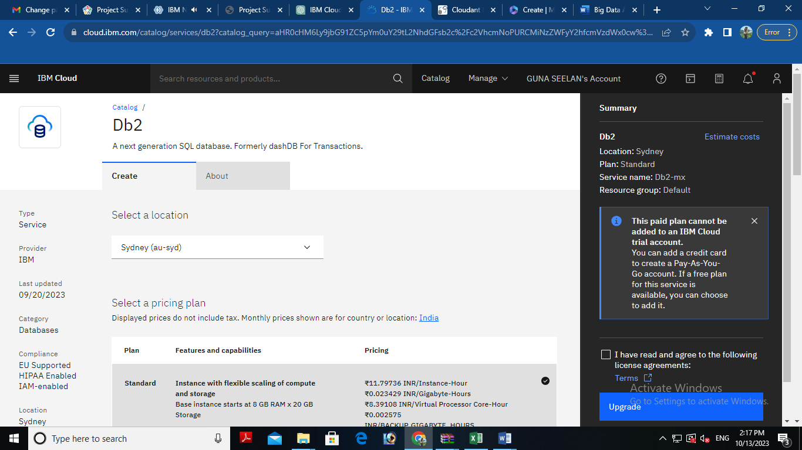

**For MongoDB:**

* Log in to your IBM Cloud account.
* From the IBM Cloud dashboard, click on the "Create Resource" button.
* In the catalog, select "Databases" and then "MongoDB."
* Follow the on-screen instructions to configure your MongoDB database instance, including specifying the instance name, region, and other settings.
* Create the instance.

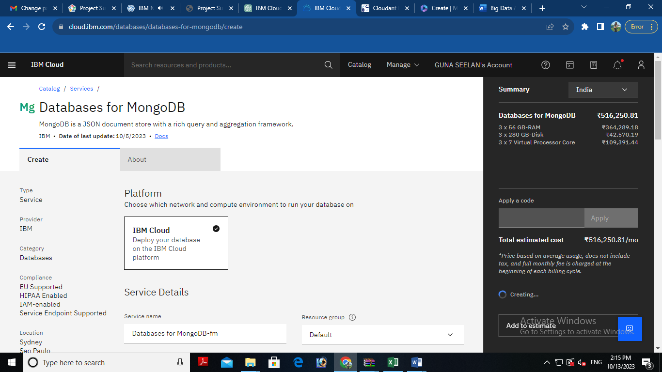

**4. Develop Queries or Scripts:**

After setting up your database instance, you can start developing queries or scripts to explore and analyze your dataset. The type of queries and scripts you write will depend on the nature of your dataset and your analysis goals. You can use SQL for Db2 or MongoDB's query language for MongoDB.

**Creating Service Credentials the IBM DB2 database**

* In the resource list screen of IBM Cloud, click on the DB2 service (displayed under Services and software category) that you created
* From the service page, select the menu option "**Service Credentials**" to create / access the credentials of the db2 database

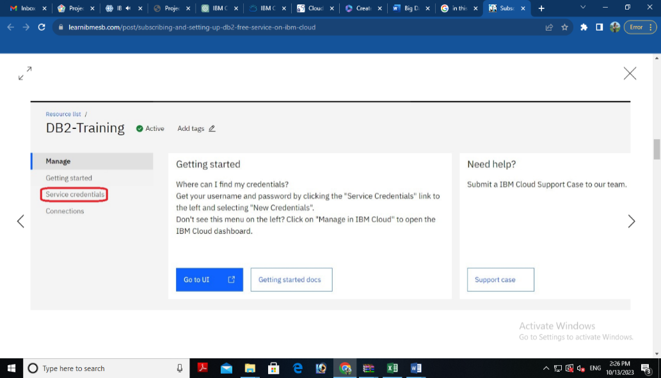

* Click on **New Credential** button in the Service Credential page to create a new credential

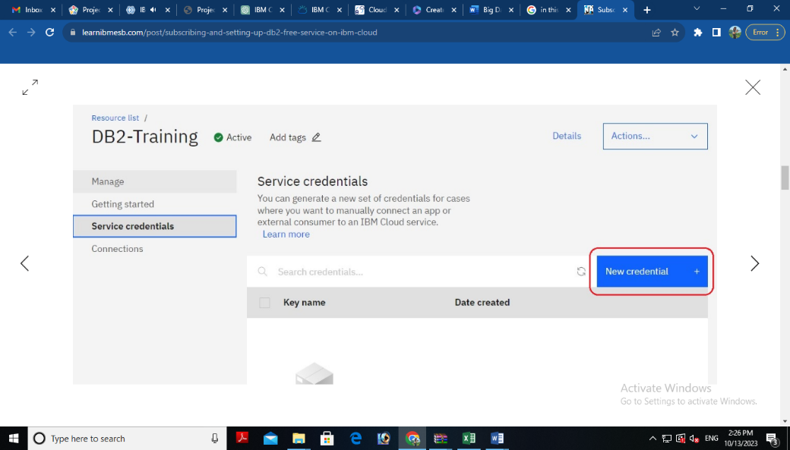

* Provide the any name for service credential (e.g. **appCred**) and click on **Add**

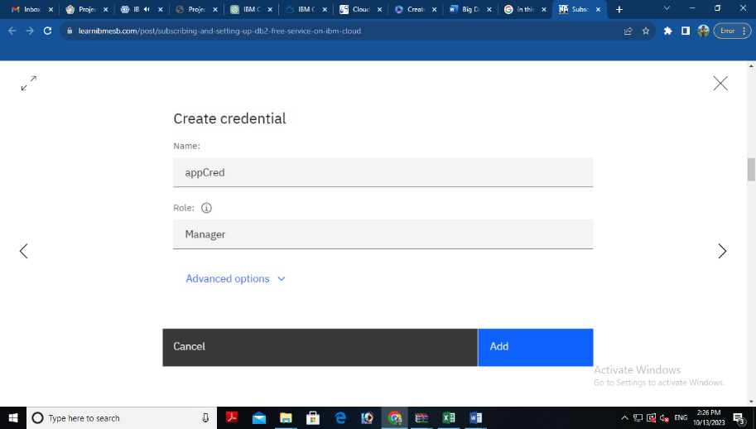

* New credential gets created and is displayed. Expand the newly to created credential to get the all the details that is required for client application to connect to the database. Note down the value for the following properties separately, which we will use it later to configure our application to connect to this database.

|  |  |
| --- | --- |
| **Property Name** | **Value** |
| **Database name** | *<database> [e.g. bludb]* |
| **Host name** | *<hostname>* |
| **Port** | *<port>* |
| **User Name** | *<username>* |
| **Password** | *<password>* |

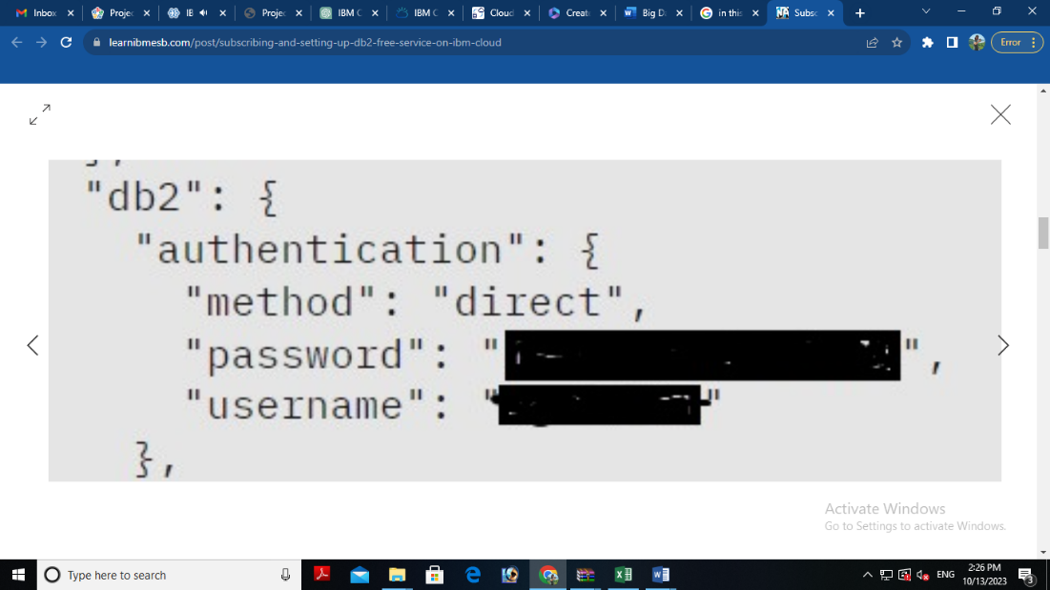 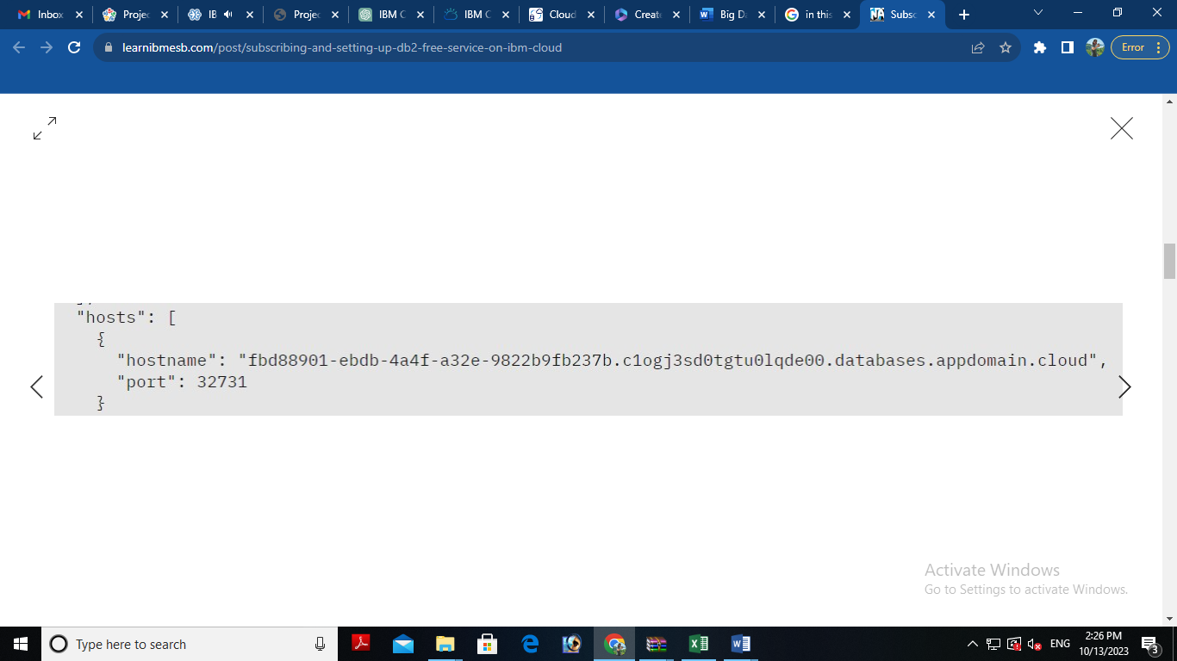

**3. Setting up IBM DB2 database**

* In the resource list screen of IBM Cloud, click on the DB2 service (displayed under Services and software category) that you created, if the page is not already opened.
* From the service page, select the menu option "**Manage**" and click on Go to UI to launch the DB2 console

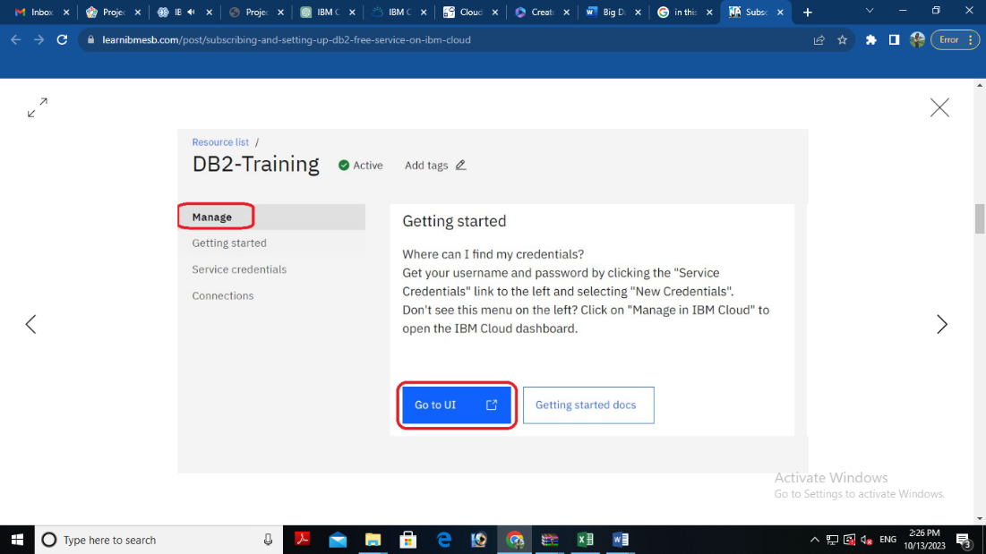

* IBM DB2 on cloud console is opened. To create database objects, click on SQL menu option from the left-side menu.

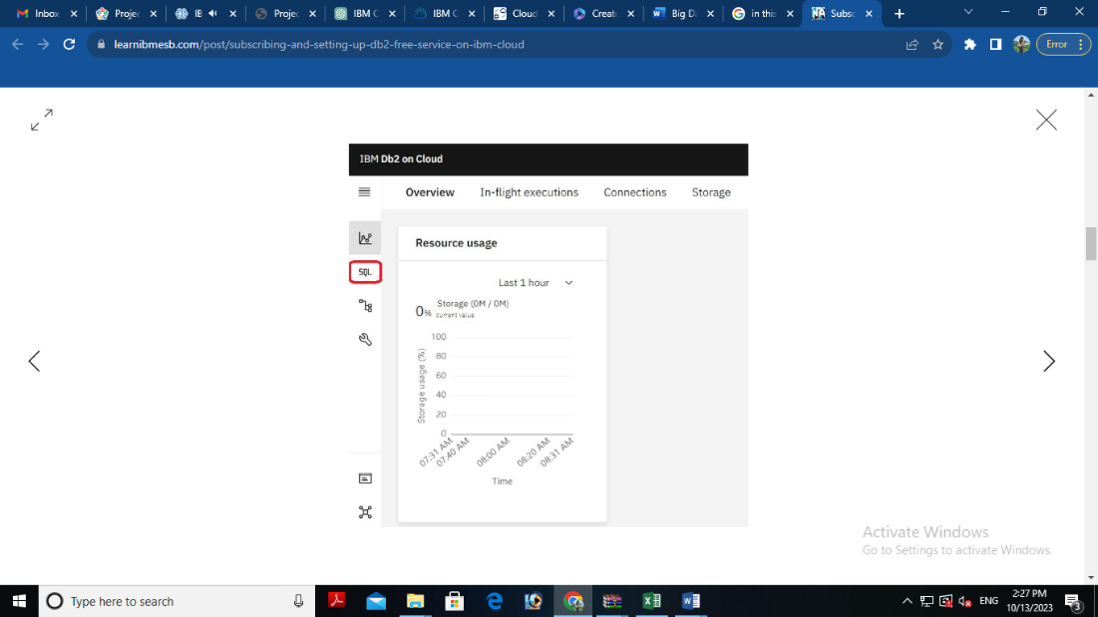

* SQL editor is opened up for you. Type the query that you want to execute in the SQL editor and click **Run all**

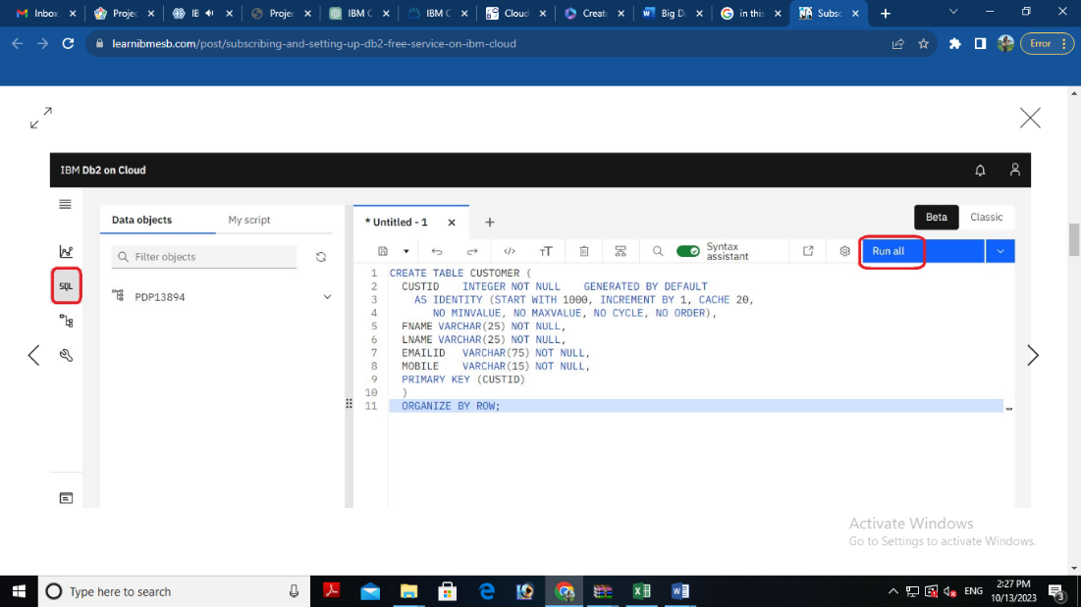

* The status of the query execution is displayed at the bottom of the SQL editor as shown below

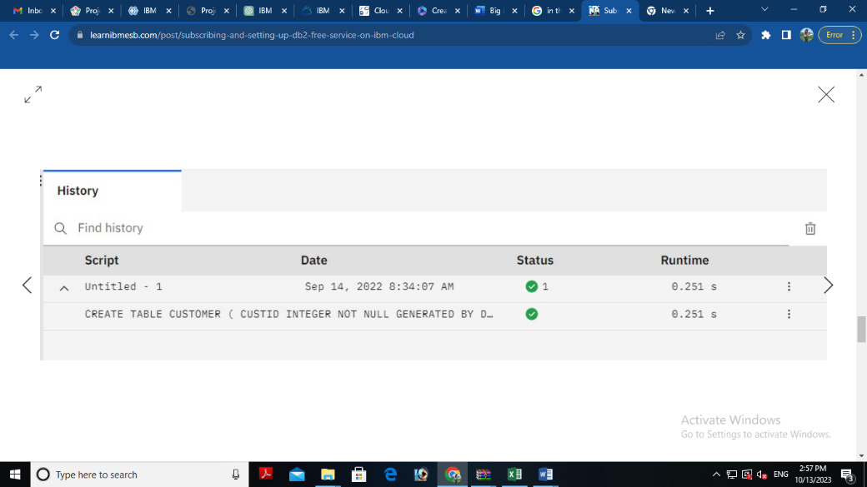

The above steps can be followed to create any more database objects in future.

**4. Downloading DB2 SSL Certificate and converting to PEM format**

* In the console for IBM DB2, click on the spanner like icon which denotes Administration. On the resulting page, click on Download SSL Certificate button to download the DB2 certificate as shown below

The SSL Certificate gets downloaded into the local machine, which is in DER format (cert file). To convert the cert file to PEM format, we can use the link SSL Converter - Convert SSL Certificates to different formats.

* In the SSL Converter website specify the following
* **Certificate File to Convert:** Upload the downloaded certificate file
* **Type of Current Certificate:** DER/Binary
* **Type To Convert To:** Standard PEM
* Click on **Convert Certificate** button to download the certificate in PEM format.

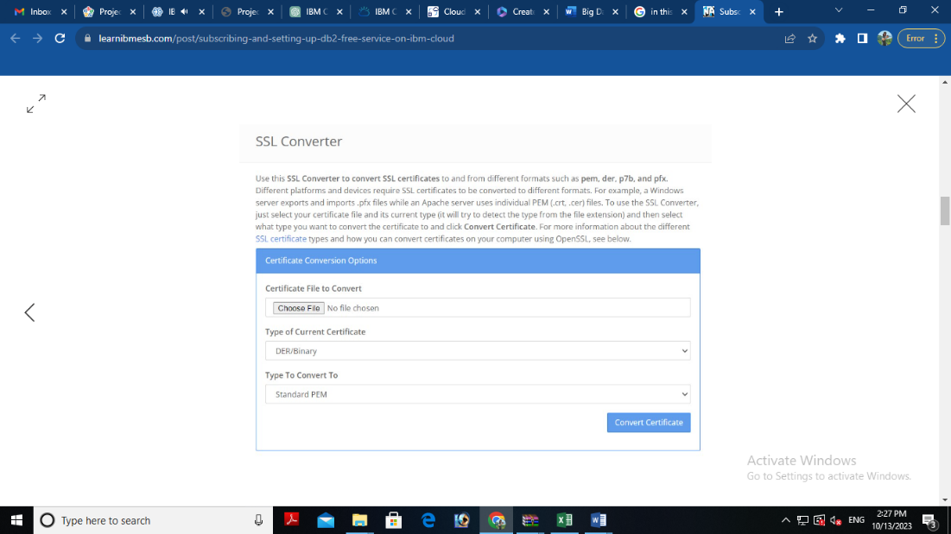

In this blog, we have seen how to subscribe to DB2 service on IBM Cloud, setup the database and create service credentials & certificate for application connectivity. In another blog, we will focus on using these details to configure ACE Cloud connector for DB2 to connect and use this database as part of solution development.

**5. Perform Data Cleaning and Transformation:**

As part of your data analysis, you may need to perform data cleaning and transformation. This can involve removing duplicates, handling missing data, and converting data types. The specific data cleaning and transformation tasks will depend on your dataset and analysis requirements.

Remember that I can provide guidance, answer questions, and help with SQL queries or MongoDB queries if you encounter specific issues during your project. Feel free to ask for assistance with any part of your project, and I'll do my best to help you successfully complete it.

**Sample NOSQL Queries for Data Exploration and Analysis:**

1.Connect to MongoDB: First, establish a connection to your MongoDB database using a Python library like PyMongo.

2. Query Data: Use PyMongo to query data from your MongoDB collection:

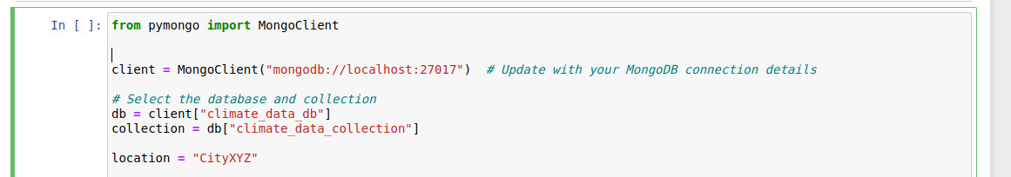

3. Data Aggregation: MongoDB allows for data aggregation using pipelines. For instance, you can group and sum data:

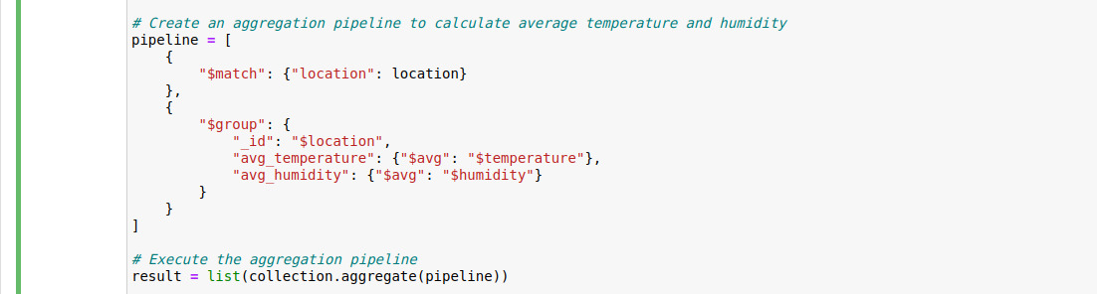

4. Data Insertion and Updates: You can also insert or update data in MongoDB using PyMongo:

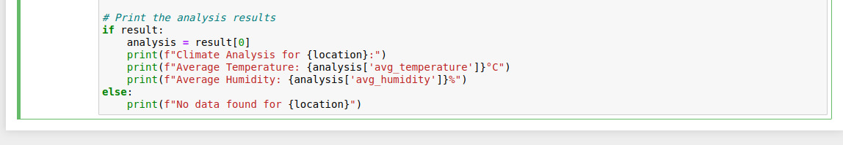

**Finally, we print the analysis results, showing the average temperature and humidity for the specified location.**

***BIG DATA ANALYSIS WITH IBM CLOUD***

**Introduction:**

**Phase 4: Development Part 2 :**

**In this part you will continue building your project. Continue building the big data analysis solution by applying advanced analysis techniques and visualizing the results. Apply more complex analysis techniques, such as machine learning algorithms, time series analysis, or sentiment analysis, depending on the dataset and objectives. Create visualizations to showcase the analysis results. Use tools like Matplotlib, Plotly, or IBM Watson Studio for creating graphs and charts.**

**In today’s data-driven world, organizations are faced with an ever-increasing volume of data. To derive valuable insights from this wealth of information, advanced big data analysis techniques are essential. This article explores the next steps in building a robust big data analysis solution by applying advanced analytical methods and effectively visualizing the results.**

**The foundation of this analysis lies in the ability to extract meaningful patterns, predictions, and insights from large and complex datasets. We delve into the application of sophisticated techniques such as machine learning algorithms, time series analysis, and sentiment analysis, each chosen according to the unique nature of the dataset and the objectives of the analysis.**

**Furthermore, the visualization of these results is paramount. Effective visualization not only aids in comprehending complex data but also in conveying insights to stakeholders and decision-makers. To accomplish this, we will leverage powerful tools such as Matplotlib, Plotly, and IBM Watson Studio to create graphs and charts that convey the analysis outcomes clearly and intuitively.**

**This comprehensive guide will walk you through the process, from data preprocessing and feature engineering to selecting the right algorithms and conducting thorough testing. It will also explore the nuances of time series analysis for temporal data and sentiment analysis for textual data. Let’s embark on the journey of advanced big data analysis and visualization to unlock the hidden value within your data.**

***IBM Watson Studio :***

**IBM Watson Studio provides an integrated Jupyter Notebook environment as one of its key features. Here’s how you can use Jupyter Notebooks within IBM Watson Studio:**

***Creating Notebooks:* You can create Jupyter Notebooks directly within IBM Watson Studio. These notebooks are stored in your Watson Studio project and can be shared with your team members.**

***Selecting a Runtime:* When creating a Jupyter Notebook, you can choose the runtime environment. You can select the type of runtime based on your requirements, which can include Python and R environments.**

***Coding and Documentation:* Jupyter Notebooks in Watson Studio allow you to write and run code cells, just like a typical Jupyter Notebook. You can use various programming languages, including Python, R, and more. These notebooks are ideal for combining code, visualizations, and explanatory text to create a comprehensive and well-documented analysis.**

***Data Access:* You can easily access data stored in your Watson Studio project or connect to external data sources. The data can be loaded into your notebook for analysis and modeling.**

***Collaboration:* One of the strengths of using Jupyter Notebooks in Watson Studio is the collaboration aspect. Multiple team members can collaborate on the same notebook in real-time. You can leave comments, track changes, and work together on data analysis and model development.**

***Version Control:* IBM Watson Studio integrates with Git and GitHub, allowing you to manage version control for your Jupyter Notebooks. You can track changes and collaborate on notebooks using Git features.**

**Sharing and Deployment: Once your Jupyter Notebook is ready, you can share it with others, including stakeholders and decision-makers. You can also deploy the code and models within the notebook as web services, making it easier to integrate your work into applications and workflows.**

***Access to IBM Cloud Services:* You can seamlessly access and integrate other IBM Cloud services and AI capabilities within your Jupyter Notebooks in Watson Studio, such as Watson Machine Learning or Watson Discovery.**



***Ibm_watson_machine_learning:* This is the name of the Python package you are installing. It’s specifically related to IBM Watson Machine Learning and provides tools and functions to work with machine learning models and deployments on the IBM Cloud. This command will attempt to install or upgrade the “ibm-watson-machine-learning” package in your Python environment. Please ensure that you have the necessary permissions and dependencies to perform this installation.**

***Geopandas:*This command will install the geopandas package, which is used for working with geospatial data and allows you to read, write, and manipulate geographic and geospatial data formats in Python. Make sure you have the necessary permissions and dependencies to perform this installation.**

***Program and Output :***

***Data preprocessing:***

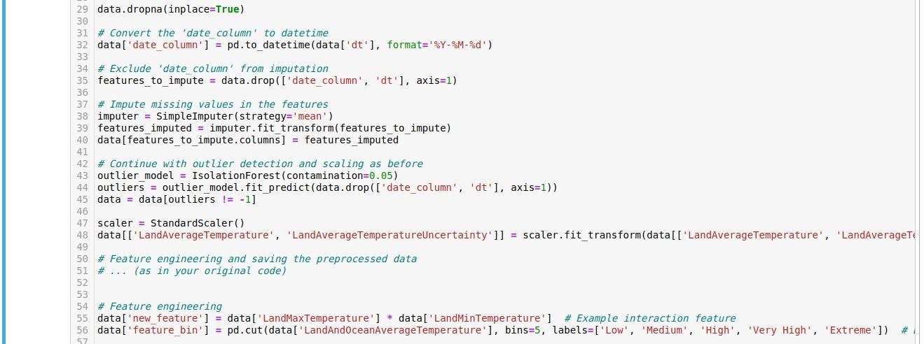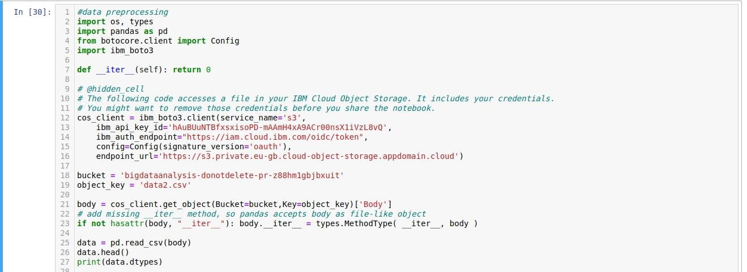



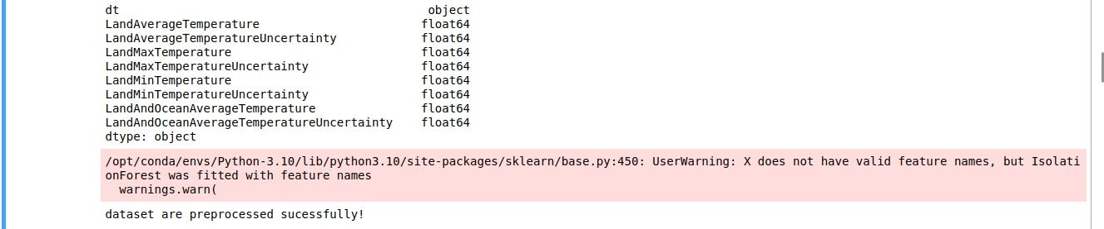***Output :***

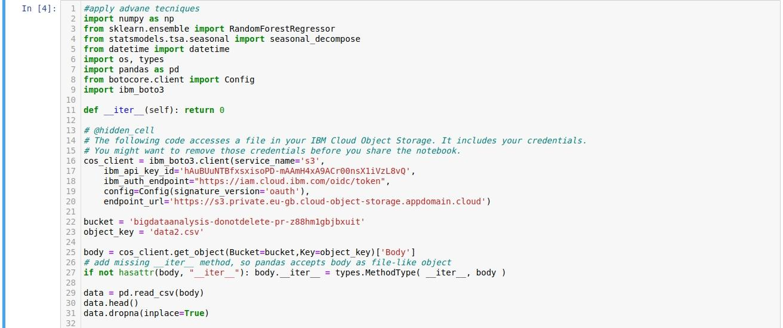***Apply Advance Techniques :***

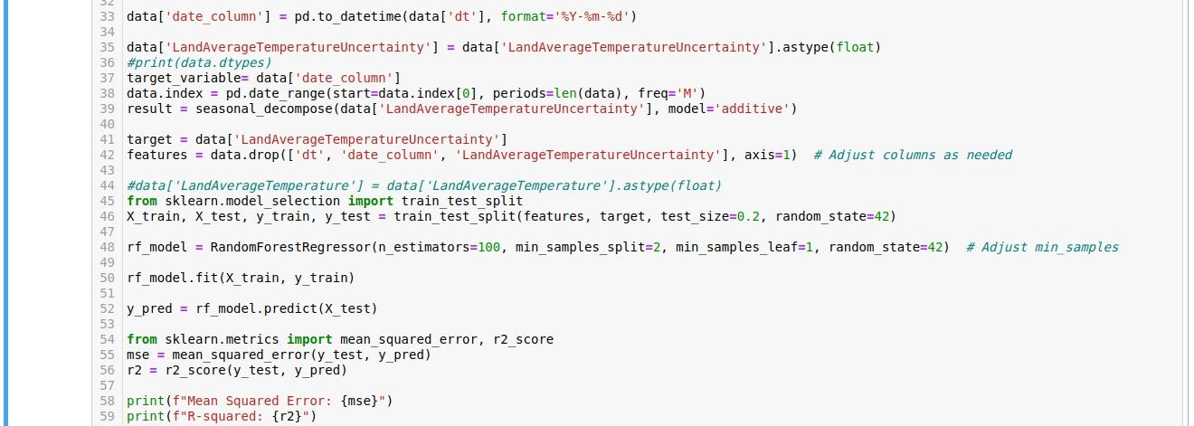***Output :***

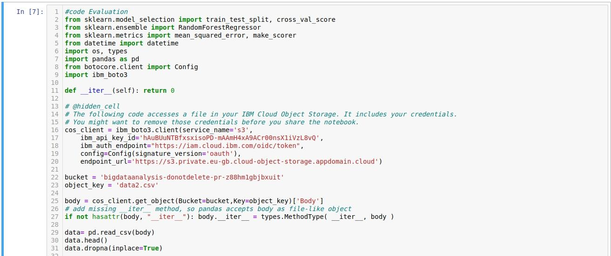***Code Evaluation :***

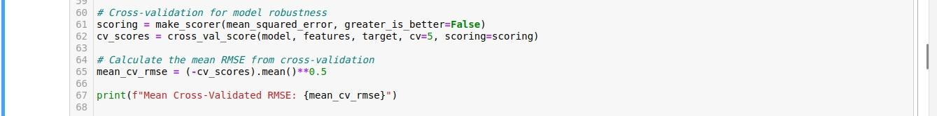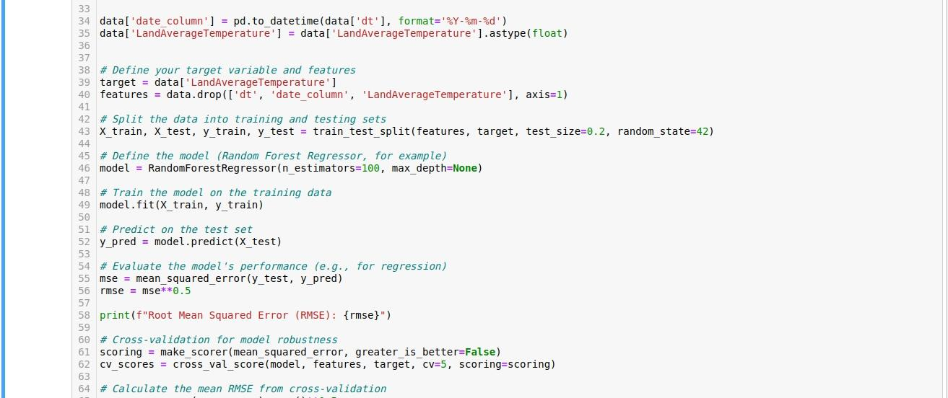***Output :***



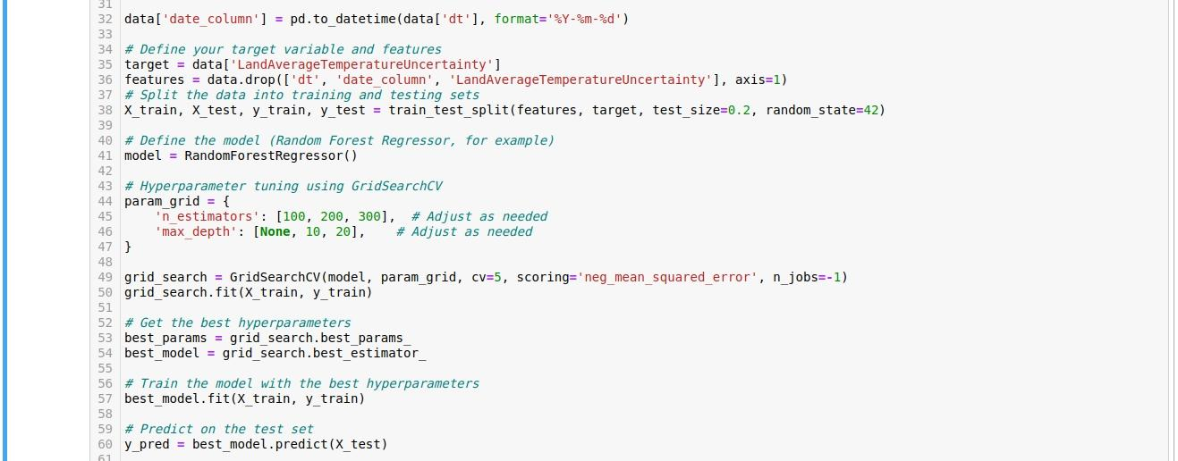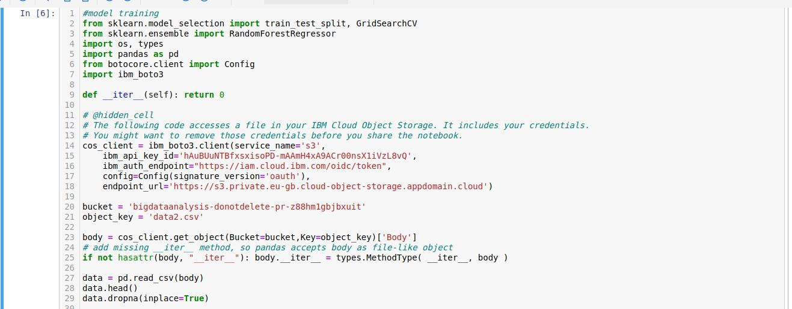***Model Training:***

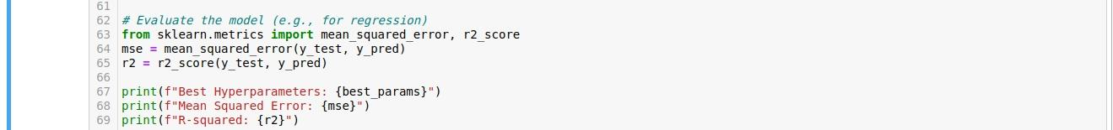***Output :***

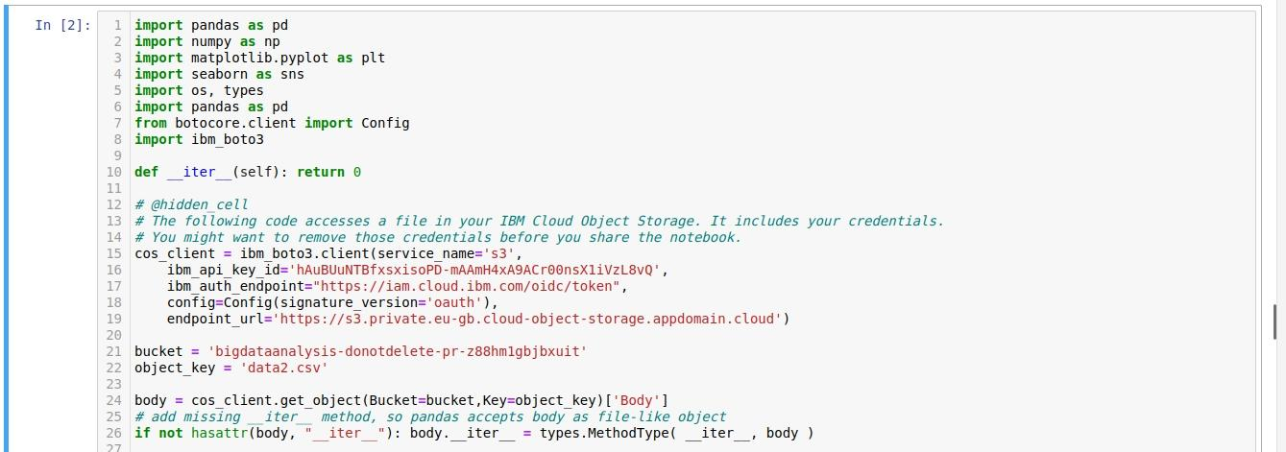 ***Visualization of Data :***

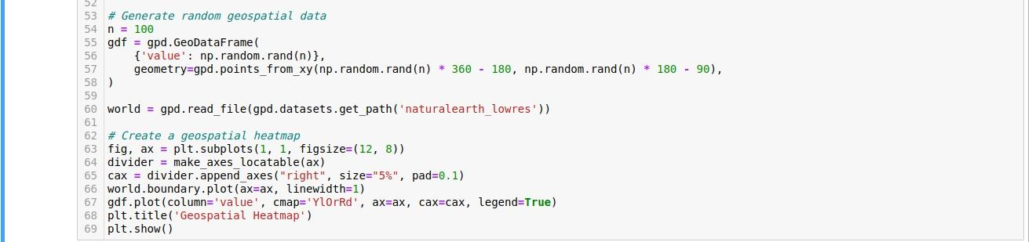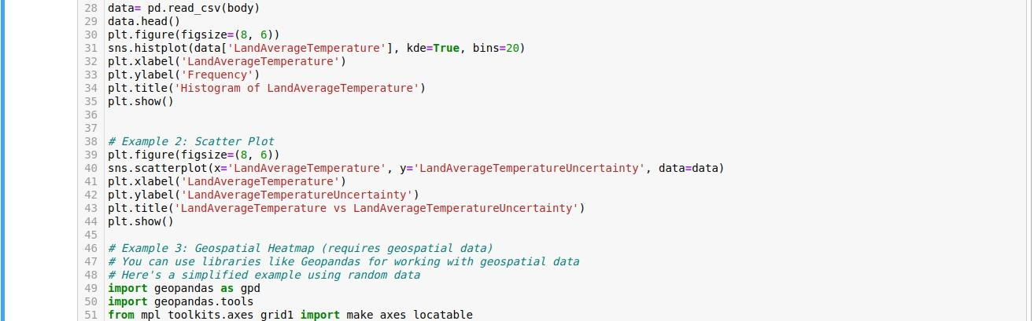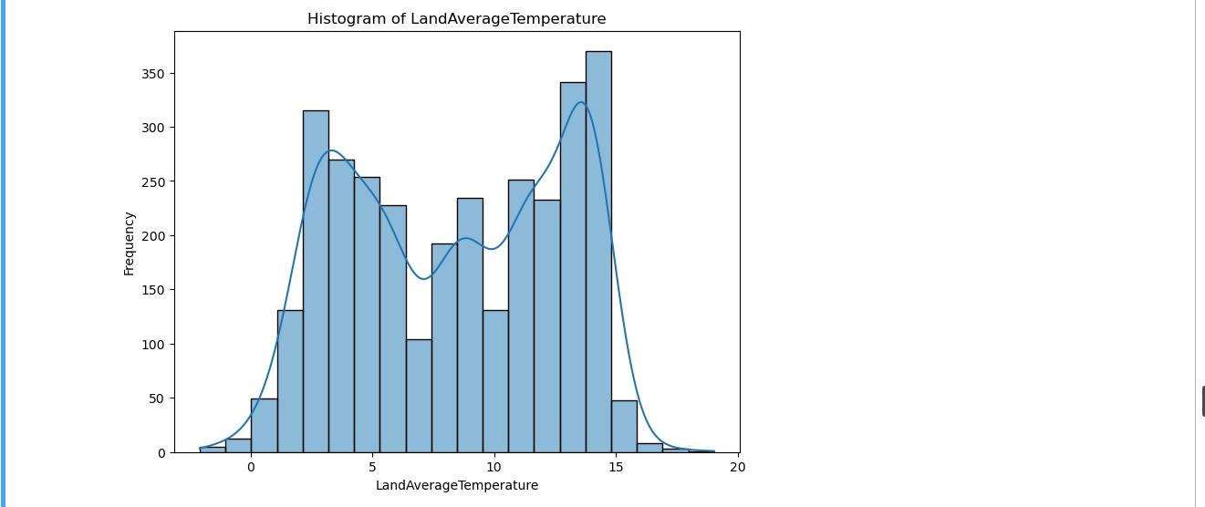***output :***

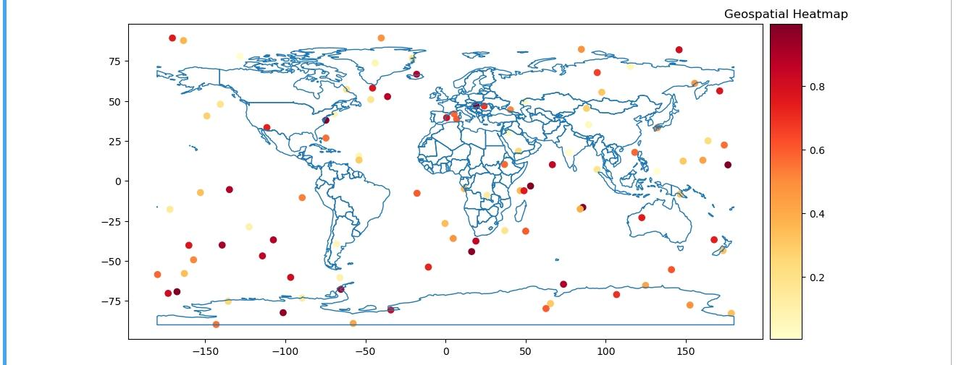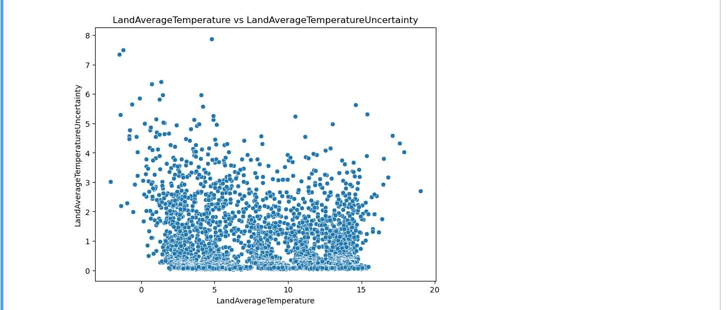

***conclusion:***

**In conclusion, leveraging IBM Watson Studio for data visualization is a strategic and powerful approach that enhances the entire data analysis lifecycle. The ability to effectively communicate insights and findings from complex datasets is paramount in making data-driven decisions and sharing knowledge across an organization. IBM Watson Studio offers a robust environment for creating visualizations that encapsulate the results of advanced data analysis techniques, and here are key takeaways:**

***Clarity and Insights:* Visualizations serve as a bridge between raw data and actionable insights. With Watson Studio’s visualization capabilities, you can transform complex data into clear and compelling charts, graphs, and interactive dashboards. This clarity aids in understanding trends, patterns, and outliers within the data.**

***Stakeholder Engagement:* Data-driven decisions often involve multiple stakeholders. Watson Studio facilitates collaboration by providing a shared workspace for data scientists, analysts, and business professionals. Visualizations become a common language that bridges the gap between technical experts and decision-makers.**

***Interactivity:* Interactive visualizations created in Watson Studio allow users to explore data, change parameters, and gain real-time feedback. This dynamic engagement enhances the decision-making process by enabling users to interact with the data and explore various scenarios.**

***Data-Driven Storytelling:* Effective visualizations go beyond numbers and statistics; they tell a story. With Watson Studio, you can craft data-driven narratives that convey the ‘what’ and ‘why’ behind the data, making it easier for stakeholders to grasp the significance of the findings.**

***Integration and Deployment:* IBM Watson Studio’s visualization tools seamlessly integrate with other components of the platform, such as machine learning models and deployment services. This enables you to create end-to-end solutions where insights are transformed into actionable applications and services.**

***Security and Governance:* Data security and governance are essential aspects of any data project. Watson Studio provides robust security features, ensuring that sensitive data remains protected during the visualization and sharing process.**