ADVANCE PYTHON PROGRAMMING

LAB TASK

NAME:MOHAMED RIYAS Y
REGNO: 22MID0218

vs code is a platform to devolop and deploy projects amd here i have used coderunner extension for running the codes

in vs code we have blackbox ai to help with

TEXTBLOB:

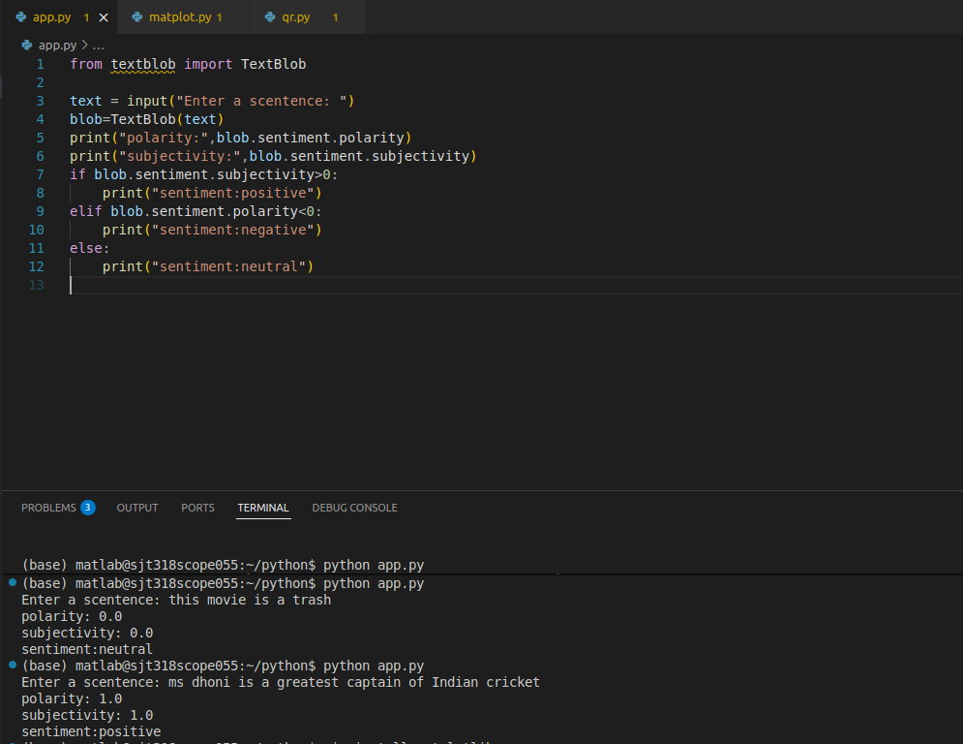

MATPLOTLIB:
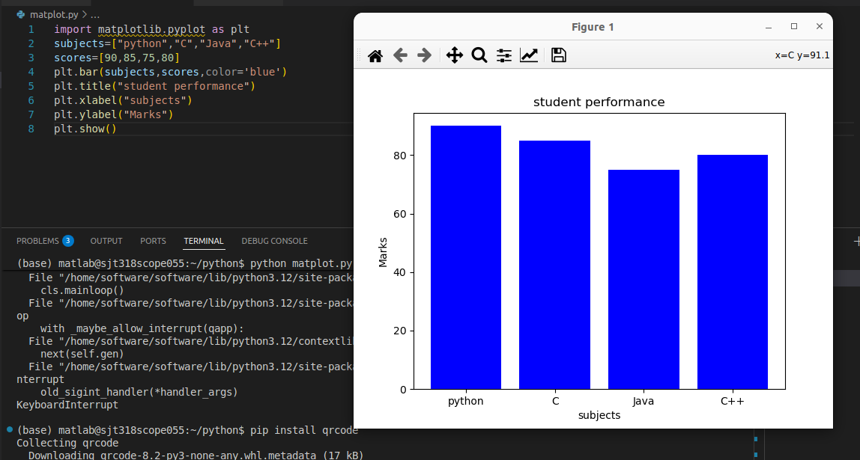
QRCODE:

