**Business Analyst**

**Introduction :**

Business analytics is the systematic use of data, statistical analysis, and technology to evaluate business performance and drive strategic decisions. It involves collecting, processing, and analyzing data to identify trends, optimize operations, and enhance decision-making across various domains like marketing, finance, and supply chain management. By leveraging tools such as **SQL, Power BI, and Tableau,** organizations can transform raw data into actionable insights, improving efficiency and competitiveness. Business analytics is essential for modern enterprises seeking to navigate market complexities, predict future trends, and maintain a data-driven approach to growth.

**Process Adopted by a Business Analyst**

1. Data Analysis & Research
2. Documentation & Modeling
3. Solution Design & Validation
4. Implementation & Support
5. Continuous Improvem
6. Conduct meetings

**Scrum**

Scrum is a simple and flexible Agile framework used by teams to develop and deliver products in a fast and organized way. It helps teams work together, break big tasks into smaller parts, and deliver results in short time periods called sprints

Scrum is based on teamwork, transparency, and continuous improvement. It allows teams to quickly respond to changes, solve problems faster, and give better value to the customer. In Scrum, the work is planned, discussed, and improved

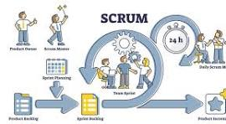

**Key Points of Scrum**

1. Short Work Cycles – Tasks are completed in small steps, usually in 2–4 weeks.
2. Three Main Roles – Product Owner sets goals, Scrum Master guides the team, and Development Team does the work.
3. Daily Meetings – A quick check-in every day to discuss progress and challenges.
4. Task Lists – A Product Backlog holds all tasks, while a Sprint Backlog focuses on the current sprint.
5. Review & Improve – At the end of a sprint, the team reviews their work and finds ways to improve.
6. Flexibility & Learning – Scrum helps teams adjust plans and improve over time.

**Jira**

Jira is a useful tool in business analytics that helps analysts organize tasks, track progress, and make better decisions. It allows teams to document business needs, manage workflows, and create reports to analyze trends and key performance indicators. With Jira, analysts can visualize project steps, monitor tasks, and ensure smooth collaboration among stakeholders. The tool is widely used in **agile environments,** where transparency and adaptability are important for managing sprints and refining business strategies. By using Jira, business analysts can enhance efficiency, streamline communication, and support data-driven decision-making.

**Kanban**

Kanban is a simple way to **organize work visually** and improve efficiency. It uses a board with columns like **"To Do," "In Progress," and "Completed",** where tasks move through each stage as they get worked on. This helps teams **see their processclearly** and avoid taking on too many tasks at once. Unlike Scrum, Kanban doesn't follow fixed time cycles like sprints. Instead, work flows **continuosly** , making it easy to adjust priorities whenever needed. It is flexible, helps teams stay focused, and allows businesses to track how long tasks take using metrics l commonly used in **business analytics** to organize data tasks, improve decision-making, and streamline reporting processes.

**Kanban Board**

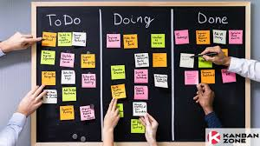

**What is kanban board**

A **Kanban board** is a simple tool used to track work visually. It has columns like **"To Do," "In Progress," and "Completed",** where tasks move from one stage to the next. Each task is represented by a card, making it easy to see progress at a glance. Kanban boards help teams stay organized, limit work overload, and improve efficiency. They can **be physical (**sticky notes on a board) or **digital (**tools like Jira or Trello), making them useful in **business analytics** for managing data tasks and improving workflows

**Jira board**

A **Jira board** is a tool used to organize and track tasks in **agile project management**. It visually represents work using columns like **"To Do," "In Progress," and "Done",** where tasks move as they are completed. There are two main types**: Scrum Board,** which follows structured sprints, and **Kanban Board,** which focuses on continuous workflow. Teams use Jira boards to prioritize tasks, monitor progress, and improve efficiency.

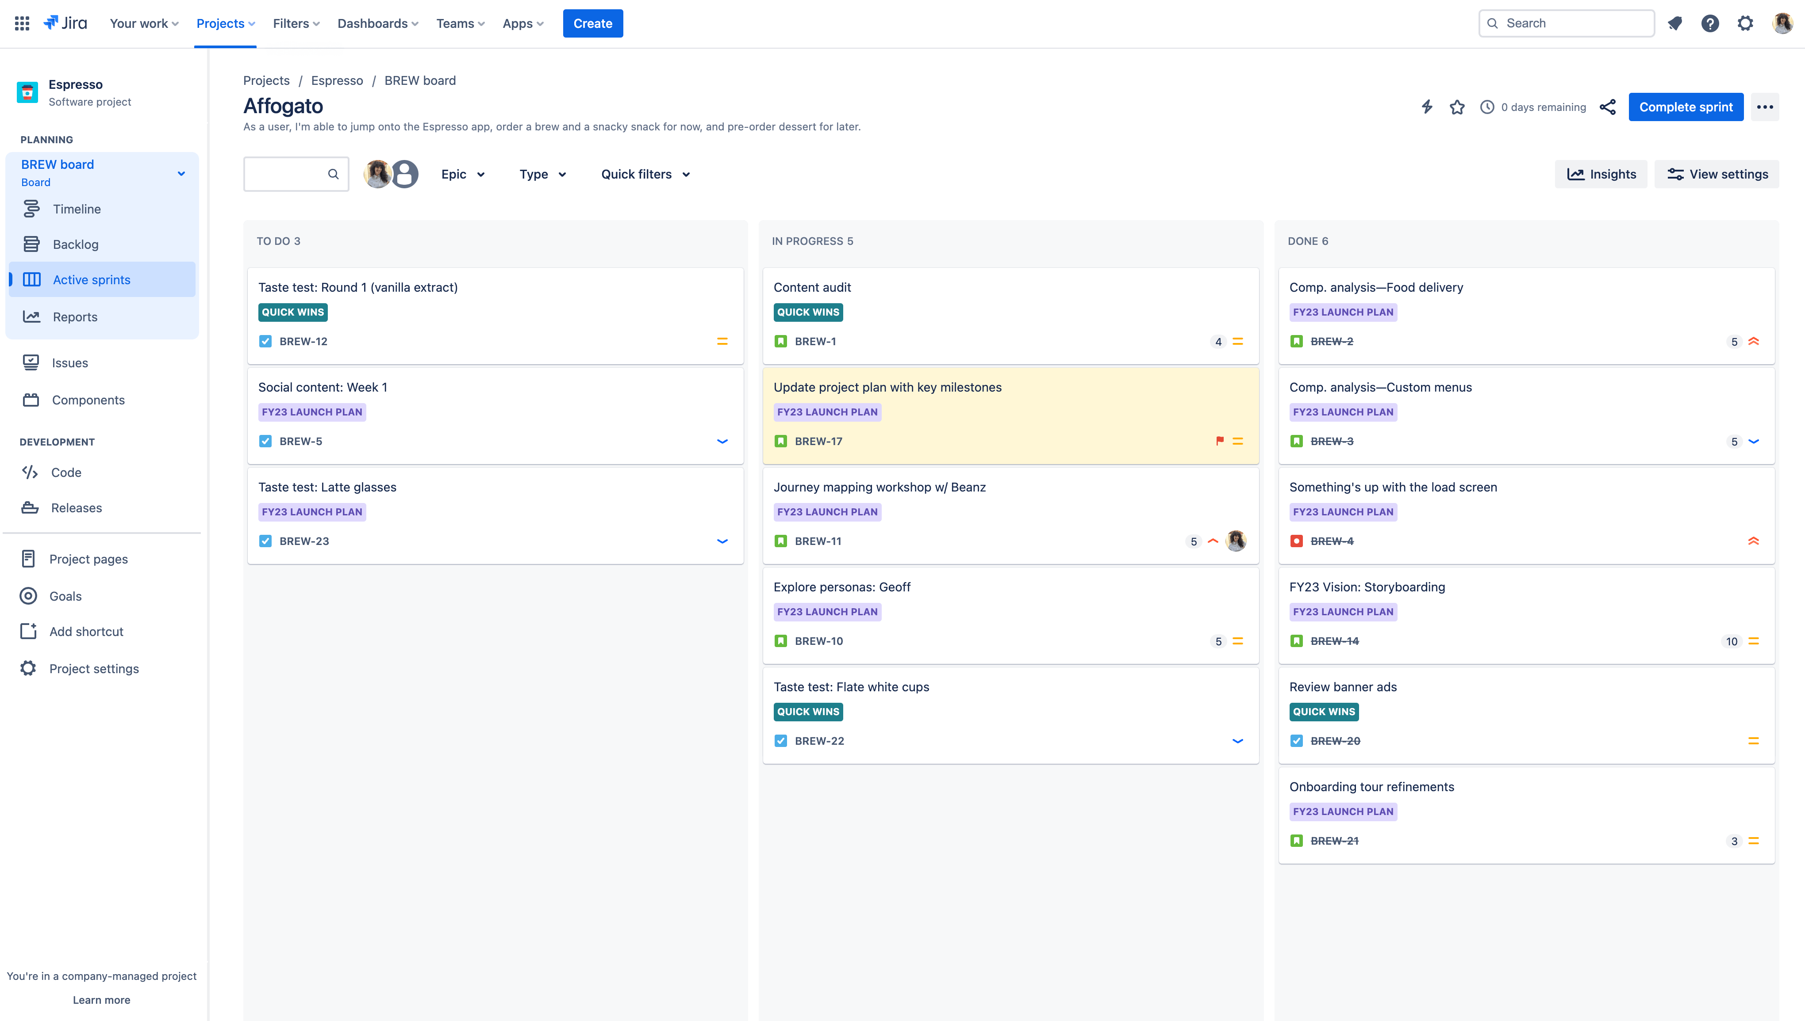.

**Storyand Story point**

A **story** represents a business requirement or problem that needs to be addressed, often framed from the perspective of stakeholders or end users.

**Story points**

It help estimate the effort required to analyze, process, and implement solutions for these business needs. Instead of measuring in hours, story points consider complexity, uncertainty, and dependencies. Higher story points indicate more challenging tasks, while lower points suggest simpler ones. This approach helps teams prioritize work, allocate resources efficiently, and improve forecasting for data-driven decision-making

Example :

**2 points**: Collect customer feedback.

**5 points**: Find patterns in what people say.

**8 points**: Use the data to improve services.

**Life Cycle of Scrum**

**1.Product Backlog**

This is a list of all the tasks, features, and improvements needed for the project. The **Product Owner** manages this list and prioritizes what’s most important.

2. **Sprint Planning**

The team selects tasks from the backlog to work on in a **Sprint** (a short work cycle, usually 2-4 weeks). They discuss what can be completed and set clear goals.

3. **Sprint Execution**

During the sprint, the team works on the selected tasks. Every day, they have a **Daily Stand-up Meeting (**a short meeting) to discuss progress, challenges, and next steps.

4. **Sprint Review**

At the end of the sprint, the team presents the completed work to stakeholders. They check if the work meets expectations and gather feedback.

5. **Sprint Retrospective**

The team reflects on the sprint—what went well, what could be improved, and how to work better in the next sprint.

**Scrum Methods**

Scrum methods are practices that help teams work efficiently using the **Scrum framework.** Here are the key methods:

**Three Scrum Pillars:**

1. **Transparency** – Everyone knows what’s happening in the project.
2. **Inspection** – Teams regularly check their work to find mistakes or improvements.
3. **Adaptation** – Teams adjust their approach based on feedback and changes.

**Five Scrum Values:**

1. **Commitment** – Team members stay dedicated to their goals.
2. **Courage** – They take bold steps to solve problems.
3. **Focus** – Everyone concentrates on the sprint goals.
4. **Openness** – Teams share progress and challenges honestly.
5. **Respect** – Members value each other’s contributions.

**Sprint Cycle**

A **Sprint Cycle** is a short, time-boxed work period in Scrum, usually lasting **2-4 weeks**, where teams focus on completing specific tasks. It starts with **Sprint Planning,** where the team selects work from the backlog. During the **Sprint Execution,** they collaborate daily to track progress. At the end, a **Sprint Review** is held to present completed work, followed by a **Sprint Retrospective** to discuss improvements. The cycle then repeats with new tasks, ensuring continuous progress and adaptability throughout the project. This structured approach helps teams stay efficient and deliver high-quality results

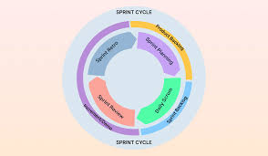

**Sprint Board**

Sprint Board is a visual tool used in Scrum to track tasks during a sprint. It helps teams organize work, monitor progress, and collaborate efficiently. The board is typically divided into columns such as To Do, In Progress, and Done, where tasks move as they are completed.

**Example:**

Imagine a team working on a website update:

* To Do: Add a new homepage design.
* In Progress: Developers are coding the new layout.
* Done: The design is tested and approved.

Sprint boards can be physical (whiteboards with sticky notes) or digital (tools like Jira or Trello). They improve transparency and help teams stay focused on sprint goals.

