Assignment – 0 (Course Insights)
Name :- Ayushi Jain
Roll no :- 24102B0002
Class :- CMPN – B
Subject :- EWEM
Semecter :- V

Q1
1a. How many buckets are there in VIT autonomous curriculum?
Answer: 7
The 7 buckets are:
- BSC/ESC (Basic Science & Engineering Science Courses)
- Program Courses (PC)
- Multidisciplinary Courses (MDC)
- Skill Courses
- HSSM (Humanities, Social Sciences & Management)
- Experiential Learning (ELC)
- Liberal Learning

1b. In which bucket is this course included?
Answer: HSSM (Value Education Course)
1c. How many credits need to be completed from this bucket?
Answer: -
1d. How many credits from this bucket have you completed till now?
Answer: -
1e. How many credits does this course have?
Answer: 2 Credits

Q2
2a. Have you gone through the curriculum of your course?
Answer: Yes
2b. Is there a pre-requisite of this course?
Answer: No
2c. If yes, do you clearly remember the concepts?
Answer: -
2d. Preparations required for this course:
Answer:
- Revise basic environmental studies.
- Understand E-waste and pollution concepts.
- Learn recycling and waste management.
- No software installation required.
2e. Future course(s) that build on this course?
Answer: Environmental Management
Sustainability Management

Q3
3a. List all Course Outcomes (COs). Which CO is most useful?
Answer:
CO1: Understand need and concept of E-waste management and recycling.
CO2: Gain knowledge of legislative rules and regulations related to E-waste management.
CO3: Recognize the tools and technologies required for E-waste recycling assessment and monitoring.
CO4: Address contemporary issues and analyze the local and global impact of engineering solutions on individuals, organizations and society.
CO5: Apply the knowledge of E-waste management in daily life to minimize hazards.
Most useful CO: CO5

3b. How are these COs mapped to the Program Outcomes (POs)?
Answer:
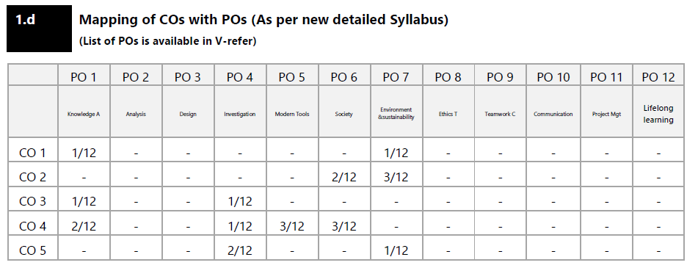

Q4
4. Where do you see the applications of this course in real life and industry?
Answer:
- E-waste recycling industries
- Pollution control
- Environmental monitoring
- Sustainable resource recovery
- Government environmental agencies
- Green technology

Q5
5a. Select one Top university outside India and mention the name of their similar course.
Answer: Delft University of Technology (TU Delft), Netherlands – Waste Management and Critical Raw Materials
5b. How does their curriculum compare with our course?
Answer: Both focus on e-waste management and recycling, but TU Delft also emphasizes the circular economy and advanced recycling technologies.

Q6
6a. How many lecture sessions are planned for this course?
Answer: 30 Hours
6b. List the suggested Textbooks, Reference books, E-books and Research papers related to the course. Are these resources available in our library? If yes, please mention their accession numbers.
Answer:
Textbook
- Environmental Science – G. Tyler Miller Jr. & Scott Spoolman, Brooks/Cole, 13th Edition
Reference Books
- Electronic Waste Management – Hester R.E. & Harrison R.M.
- Electronic Waste – Fowler B.
E-Books
- Electronic Waste Management Rules 2016 – Central Pollution Control Board
Research Papers
- E-Waste Management
- E-Waste Management: As a Challenge to Public Health in India

6c. What resources are currently uploaded on V-Refer?
Answer:
- Former IA question papers
- MU question papers
- Class notes
- Digital content
- Question bank
- PPTs
- Class tests
- Academic Administration Plan (AAP)
- Beyond syllabus activity report
6d. What are the stipulated office hours of faculty for doubt solving sessions?
Answer: Thursday, 4:00 PM – 5:00 PM, D101 Faculty Room

Q7
7a. What is the Evaluation Metric for this Theory Course i.e. What are the weightages for ISA, MSE and ESE?
Answer:
ISA: 75 Marks
MSE: Not Applicable (NA)
ESE: Not Applicable (NA)
7b. What does ISA comprise of?
Answer: Online game quiz – 5 Marks
Video task – 5 Marks
Carbon Footprint Calculator – 5 Marks
Device Anatomy – 5 Marks
Class Test – 10 Marks
Case Study – 10 Marks
Data Analysis Activity – 10 Marks
Sustainability Reel/Podcast – 10 Marks
Green Hackathon – 10 Marks
Campus Sustainability Consultancy (E-Waste Audit + Awareness Campaign) – 10 Marks
Total = 75 Marks
7c. What is the evaluation rubric for ISA?
Answer: Class Participation
Online Game Quiz
Video Task
Carbon Footprint Calculator
Device Anatomy
Class Test
Case Study
Data Analysis Activity
Sustainability Reel/Podcast
Green Hackathon
Campus Sustainability Consultancy (E-Waste Audit + Awareness Campaign)
7d. What are the dates of MSE for this course?
Answer: 17 September 2026 (HSSM-VEC)
19 October 2026 (HSSM-VEC)
7e. What is the date of ESE for this course?
Answer: 16 November – 4 December 2026

Q8
8a. Is there an allied Practical Course?
Answer: No
8b. If yes, how many credits does this Practical course have?
Answer: -
8c. What is the Evaluation Metric for this allied Practical Course i.e. Weightages for ISA and ESE?
Answer: -
8d. What are the dates of ESE exam for this allied Practical course?
Answer: -

Q9
9. What is the date of declaration of Result?
Answer: 19 December 2026 (Final Result Declaration)

Q10
10. When does the next Academic Term Start?
Answer: 4 January 2027

