Hydrometallurgy Process for E-Waste
Name : Riya Vartha
Roll No : 24102B0032
Class : SE CMPN B
E-Waste Metal Recovery – Detailed Process Flow
Figure 1: The Detailed Flow Diagram
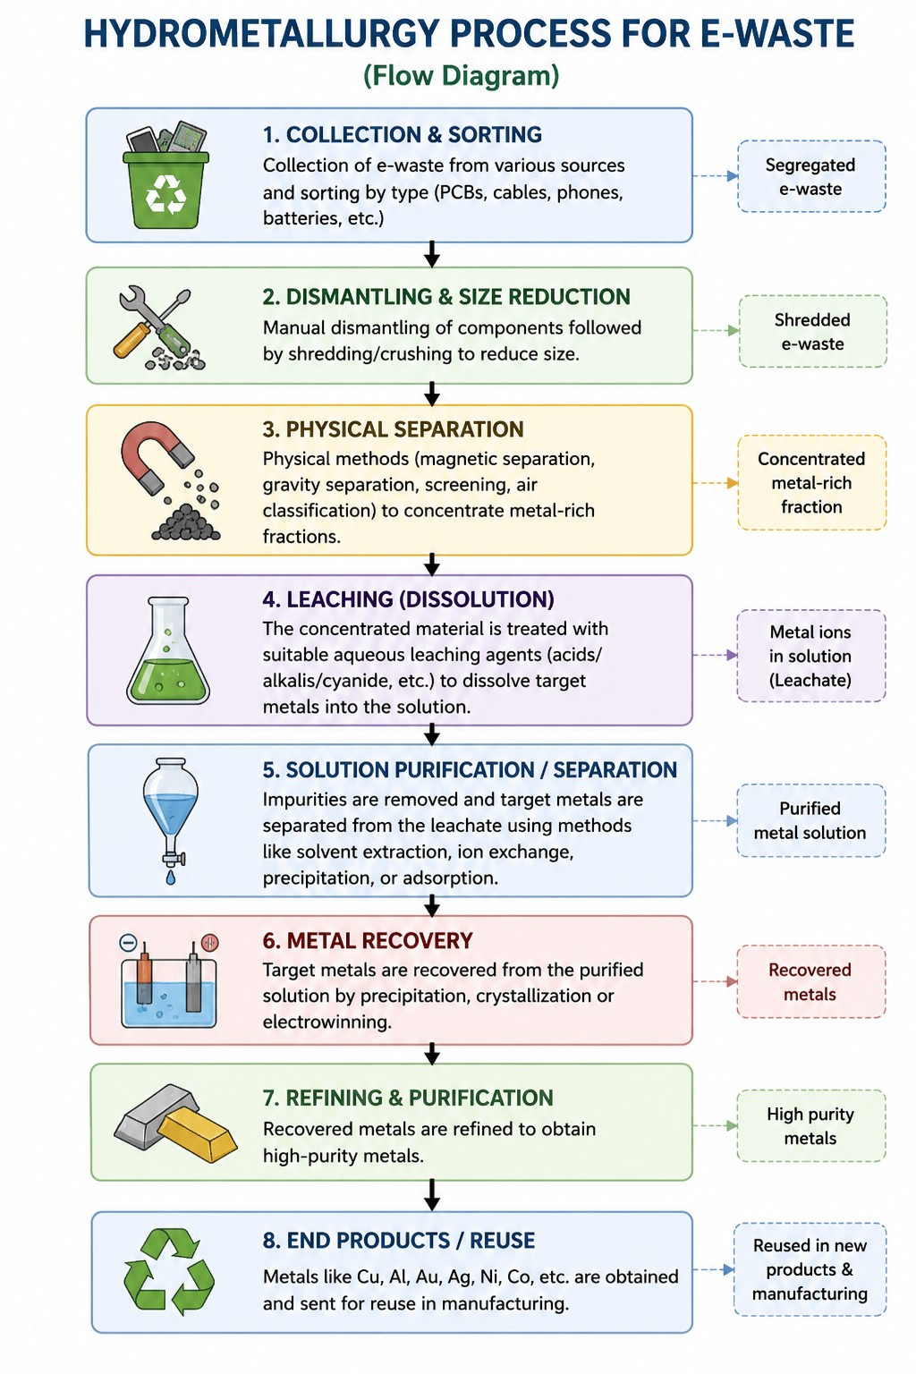
Figure 1 illustrates the detailed flow of hydrometallurgical metal recovery from e-waste. The process starts with collection and sorting of e-waste, followed by dismantling and size reduction. Physical separation is then used to concentrate the metal-rich fraction. The concentrated material undergoes leaching, where target metals are dissolved into an aqueous solution. The leach solution is purified, followed by metal recovery, refining and reuse of the recovered metals.
The detailed diagram contains eight stages: Collection & Sorting → Dismantling & Size Reduction → Physical Separation → Leaching → Solution Purification/Separation → Metal Recovery → Refining & Purification → End Products/Reuse.

Hydrometallurgy Process for E-Waste
E-Waste Metal Recovery – Improved Process Flow
Figure 2: The Shortened & Optimized Flow Diagram
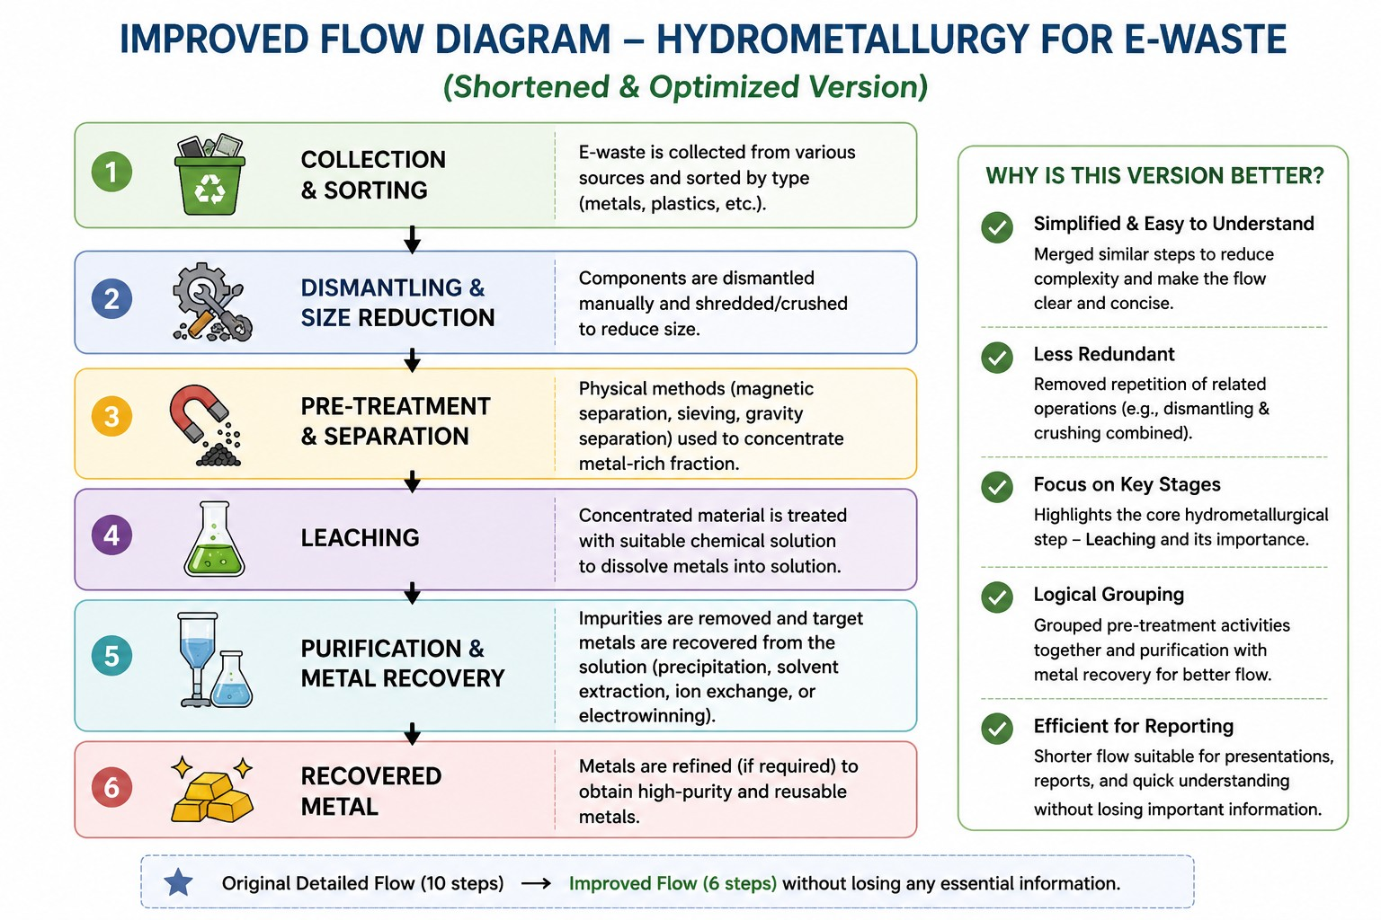
Figure 2 presents the improved version of the detailed flow. The original process is simplified by combining closely related operations while retaining the essential hydrometallurgical sequence.

Changes Made for Betterment
- Dismantling & Size Reduction: Dismantling and crushing are represented as one stage because both are material-preparation operations.
- Pre-treatment & Separation: Physical separation is grouped with pre-treatment because its purpose is to prepare and concentrate the metal-rich fraction before leaching.
- Leaching: Kept as a separate stage because it is the core hydrometallurgical extraction step where target metals are dissolved into solution.
- Purification & Metal Recovery: Solution purification and metal recovery are combined because both are downstream operations performed on the metal-containing solution.
- Recovered Metal: Refining is represented within the final output stage to keep the diagram concise while still showing the final high-purity/reusable metal.
Result: The flow is reduced from eight detailed stages to six optimized stages without removing the essential process logic. This makes the diagram simpler, less repetitive and easier to understand in a presentation or report.

Hydrometallurgy Process for E-Waste
Comparison of Detailed and Improved Flows

Process Comparison
Detailed Flow | Improved Flow | Reason for Change
Collection & Sorting | Collection & Sorting | Retained as the essential input stage.
Dismantling & Size Reduction | Dismantling & Size Reduction | Already grouped in the detailed diagram.
Physical Separation | Pre-treatment & Separation | Grouped with preparation/separation operations.
Leaching | Leaching | Retained as the core extraction stage.
Solution Purification / Separation | Purification & Metal Recovery | Combined to reduce repetition.
Metal Recovery | Purification & Metal Recovery | Included in the combined downstream stage.
Refining & Purification | Recovered Metal | Shown as part of the final recovered-metal output.
End Products / Reuse | Recovered Metal | Final output is represented more directly.

Conclusion
The detailed flow provides a complete representation of the hydrometallurgical e-waste recovery process, while the improved flow focuses on clarity and efficiency. By merging related operations, the improved diagram reduces visual complexity and avoids unnecessary repetition. The essential sequence—pre-treatment, leaching, purification and metal recovery—remains unchanged.
Note: The diagrams represent a general hydrometallurgical process for e-waste. Specific chemicals, operating conditions and company-specific extraction technologies should only be stated when supported by verified technical documentation.

