ASD&D – EXPERIMENT NO. 04
AIM
To understand Continuous Integration and Jenkins installation.
LO MAPPED
LO1, LO3

THEORY
Continuous Integration
Continuous Integration is a development practice that promotes collaboration, early issue detection, and automated testing to enhance the quality and efficiency of software development.
Jenkins
Jenkins is an open-source automation server that facilitates Continuous Integration and Continuous Delivery (CI/CD) of software projects.
It helps developers automate various stages of the software development lifecycle, from building and testing to deployment and monitoring.
Jenkins supports a wide range of plugins and integrations, making it a versatile tool for automating various tasks in software development.

STEPS TO BE FOLLOWED WHILE INSTALLING JENKINS
1. Java Installation
Ensure that Java Development Kit (JDK) is installed on your system.
Open the Command Prompt or Terminal and check the Java installation using:
java -version
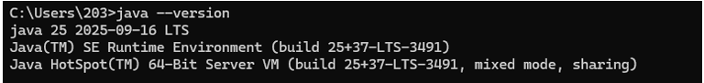

2. Download Jenkins
Download the latest Jenkins WAR file from the official Jenkins website or package manager.
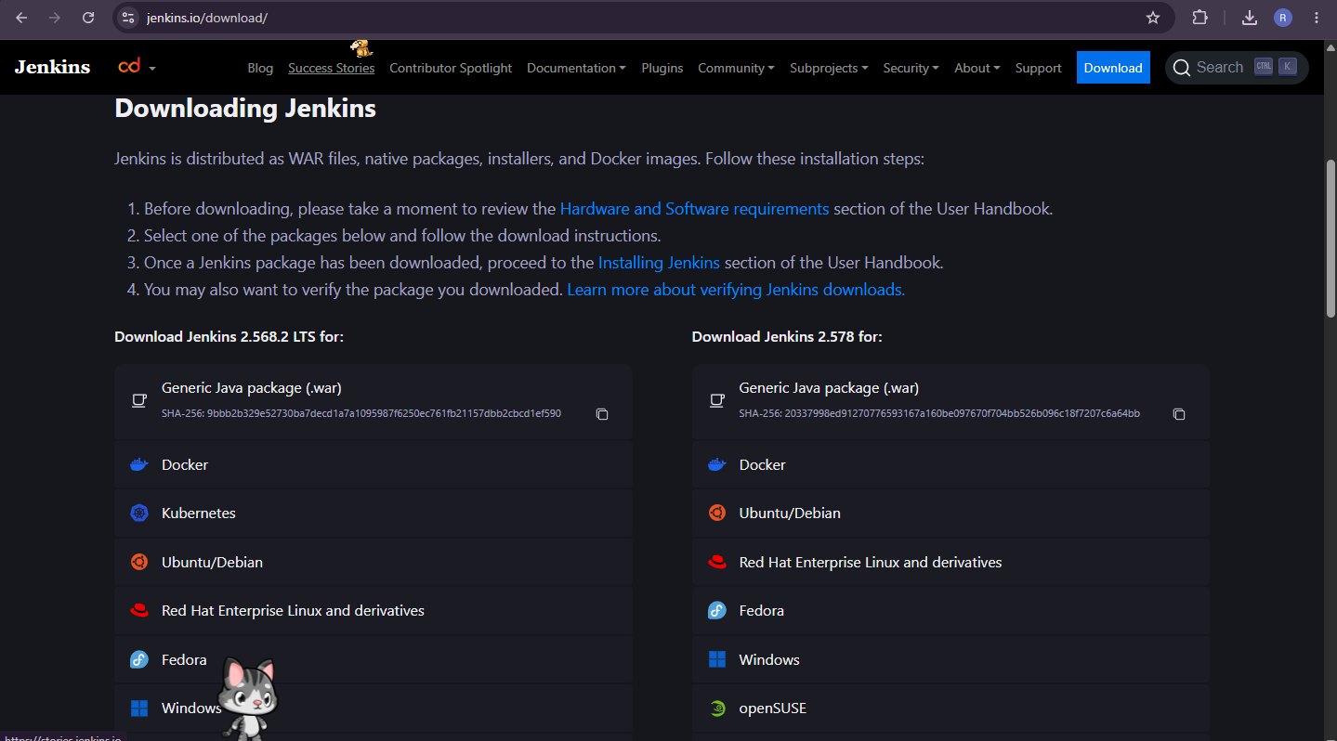

3. Launch Terminal
Open a terminal or Command Prompt on your system.
Navigate to the directory where the Jenkins WAR file has been downloaded.

4. Navigate to Directory
Use the cd command to navigate to the directory containing the Jenkins WAR file.

5. Start Jenkins
Run the following command to start the Jenkins server:
java -jar jenkins.war

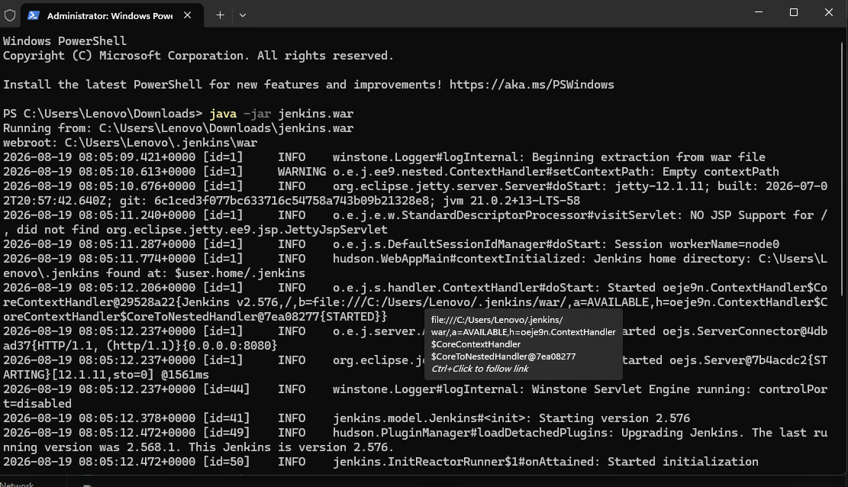

6. Access Web UI
Open a web browser and go to:
http://localhost:8080

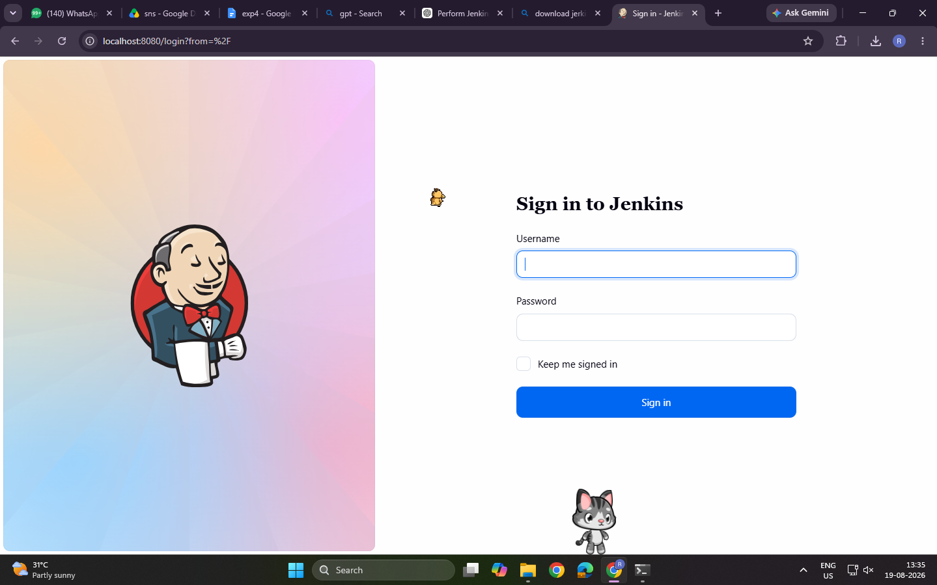

7. Unlock Jenkins
Retrieve the initial administrator password from the terminal and enter it into the Jenkins setup wizard.
The initial administrator password is stored in the Jenkins secrets directory.
On Windows, it can be found at:
%USERPROFILE%\.jenkins\secrets\initialAdminPassword
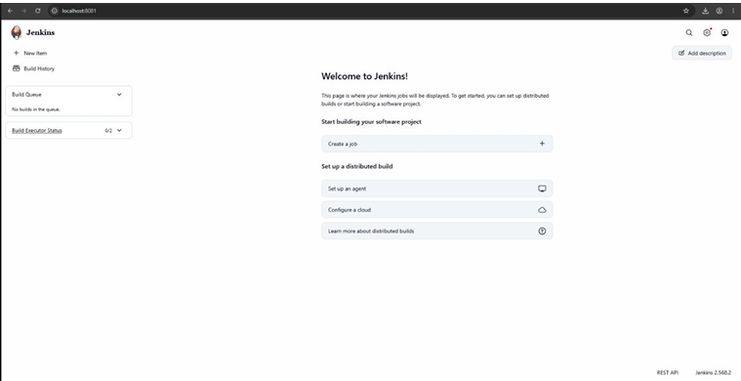
Copy the password and enter it in the Administrator password field.
Click Continue.

8. Customize Plugins
Jenkins provides options for installing plugins.
Choose either:
- Install suggested plugins
- Select plugins to install
For the basic setup, select
:
Install suggested plugins
Wait for the plugin installation to complete.

9. Create Admin User
Set up an administrator user account with the required credentials.
Enter:
- Username
- Password
- Confirm Password
- Full Name
- Email Address
Click Save and Continue.

10. Jenkins URL
Confirm the Jenkins URL and complete the setup process.
The default Jenkins URL is:
http://localhost:8080/
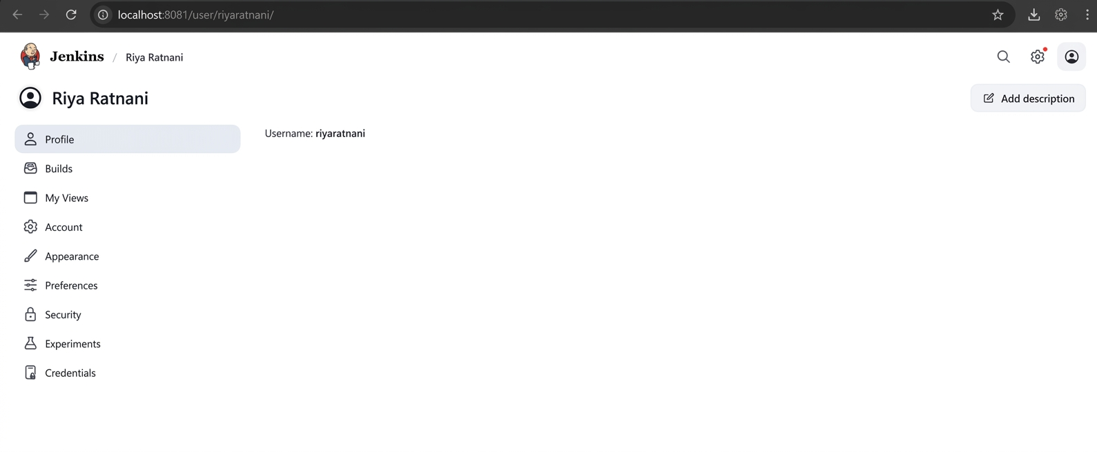
Click Save and Finish.

11. Dashboard
Log in using the administrator credentials to access the Jenkins Dashboard.
The Jenkins Dashboard will be displayed after successful installation and configuration.

CONCLUSION
By this assignment, we learned about Continuous Integration and the method of installing and configuring Jenkins.

EXPERIMENT: BUILD PIPELINE USING JENKINS
AIM
To build pipeline using Jenkins.

THEORY
What is a Pipeline in Jenkins?
A Jenkins Pipeline is a set of automated processes that help developers and DevOps teams build, test, and deploy code in a Continuous Integration/Continuous Delivery (CI/CD) environment.
In simple terms, it is a workflow that defines how software moves from code to production in an automated and repeatable manner.

KEY BENEFITS OF JENKINS PIPELINE
- Automates CI/CD processes.
- Provides better visibility into the build process.
- Offers version control of build logic using Pipeline as Code.
- Supports complex workflows such as parallel execution and conditional logic.

TYPES OF JENKINS PIPELINES
There are two main types of syntax used to define Jenkins Pipelines:
- Declarative Pipeline
- Scripted Pipeline

1. DECLARATIVE PIPELINE
Declarative Pipeline uses a simpler and more structured syntax.
It is designed for users who want an easy-to-read format.
It was introduced to make pipelines more readable and maintainable.
Key Features
- Uses the pipeline {} block.
- Organized into stages and steps.
- Provides easier error handling.
- Provides better validation in the Jenkins UI.

CREATION OF DECLARATIVE PIPELINE
Step 1: Open Jenkins
Open Jenkins in a web browser:
http://localhost:8080

Log in using your Jenkins credentials.

Step 2: Create a New Pipeline
From the Jenkins Dashboard, click:
New Item
Enter a suitable name for the pipeline.
Example:
pipeline1

Select:
Pipeline
Click OK.

Step 3: Enter Pipeline Code
Scroll down to the Pipeline section.
Select:
Pipeline script
Enter the following code:
pipeline {
agent any

stages {
stage('Hello') {
steps {
echo 'Hello, Jenkins!'
}
}
}
}

If you want the output to display your name, you can use:
pipeline {
agent any

stages {
stage('Hello') {
steps {
echo 'Hello, Vanshika!'
}
}
}
}

The reference document uses the personalized Hello, Vanshika! message in its pipeline example.

Step 4: Save the Pipeline
Click:
Save
The pipeline will now be created.

Step 5: Build the Pipeline
Click:
Build Now
Jenkins will execute the pipeline.
A build number will appear in the Build History section.
Example: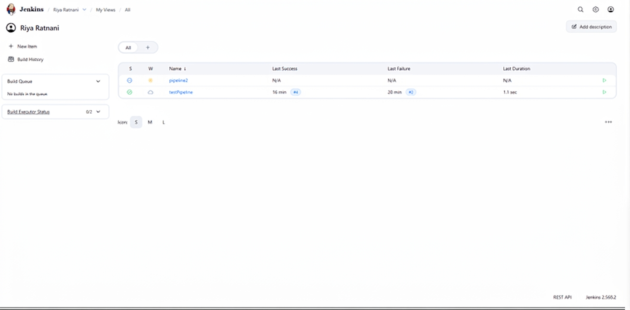
#1

Step 6: View Output
Click the build number.
Then click:
Console Output
The console will display the pipeline execution details.
The output should contain:
Hello, Vanshika!

The build should end with:
Finished: SUCCESS

This indicates that the Declarative Pipeline was executed successfully.

OUTPUT
Expected output:
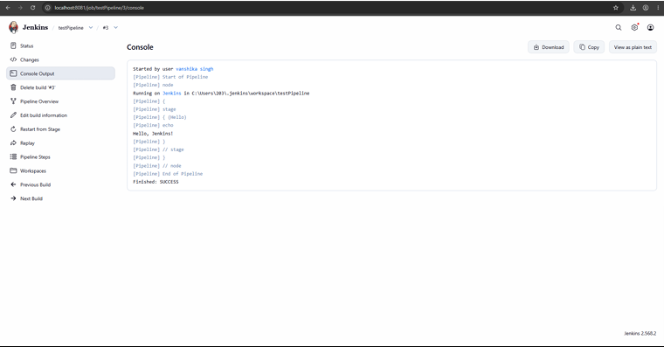

2. SCRIPTED PIPELINE
Scripted Pipeline is more flexible and powerful.
It is written using Groovy-based syntax and gives full control over the build process.
It is suitable for advanced users.
Key Features
- Uses the node {} block.
- Everything is written as code.
- Allows complex scripting and logic.
- Less user-friendly for beginners.

CREATION OF SCRIPTED PIPELINE
Step 1: Create a New Item
From the Jenkins Dashboard, click:
New Item
Enter a suitable pipeline name.
Example:
pipeline2

Select:
Pipeline
Click OK.

Step 2: Configure the Pipeline
Scroll down to the Pipeline section.
Select:
Pipeline script
Enter the Scripted Pipeline code.
Basic structure:
node {
stage('Hello') {
echo 'Hello, Jenkins!'
}
}

Step 3: Save the Pipeline
Click:
Save
The Scripted Pipeline will be created.

Step 4: Build the Pipeline
Click:
Build Now
Jenkins will execute the Scripted Pipeline.

Step 5: View Console Output
Click the build number and select:
Console Output
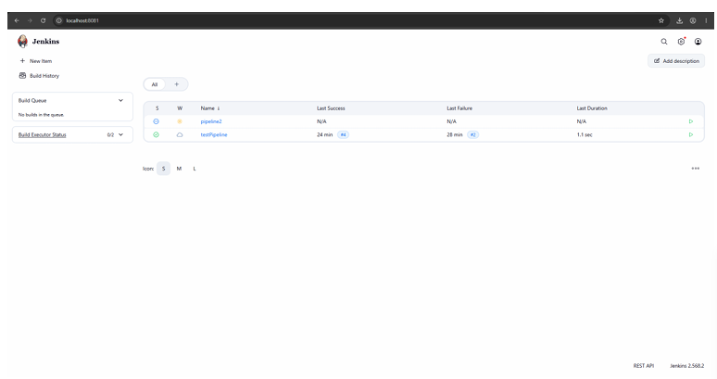

RESULT
The Jenkins server was successfully installed and configured.
The Declarative and Scripted Jenkins Pipelines were created and executed successfully. The pipeline demonstrated how Jenkins can automate software build, test, and deployment processes.

CONCLUSION
In this assignment, we learned how to create Jenkins Pipelines to automate the build, test, and deployment process.
We explored both Declarative and Scripted Pipelines, understanding their structure, benefits, and use cases.
By implementing different pipeline examples, we demonstrated how Jenkins enables efficient, repeatable, and reliable CI/CD workflows.

