BigData: Summerize DataSet In-terms of Position.

Nashidul Islam
Department of Computer Science, Georgia State University
33 Gilmor Stree, Atlanta, Georgia, USA.
nislam9@student.gsu.edu

Abstract—Map Reduce is a framework used to work with big amount of data that efficiently solves the big data analytics problem. Spark On the other hand is more efficient but hardware consuming tool for Big Data programming. This report is about how the map reduce paradigm and spark can be used to solve the same problem but will different run time and efficiency.
Keywords—Mapper: The class that maps the data set to representable format.
Reducer: The class that reduces the Map context that was passed as key value pair and it reduces by Key.
Algorithm: A format or a solution paradigm that describes how a set of problem could be addressed and solved.
RDD: Resilient Distributed Dataset (RDD), which is a collection of elements partitioned across the nodes of the cluster that can be operated on in parallel.

Introduction
Map Reduce Paradigm started from a paper published by google. The people working with Hadoop needed an algorithm that could utilize Hadoop and other large cluster data manipulation tool efficiently. Thus, in the year 2004, Google published a paper called as Map Reduce [1] – Simple Data Processing on Large Clusters.At first glance, many people do not realize that MapReduce is more of a framework than a tool. You have to fit your solution into the framework of map and reduce, which in some situations might be challenging[2]. MapReduce is not a feature, but rather a con‐ strain. The problem is summarizing the data fields and in process use a custom combiner which will take load off the reducer,

Analyzing the problem
Firstly , I would be required to design out a parser for parsing the CSV files. Parser has two parts. 1st part filters the data and sets the flag which then puts the substring into the string itself. This part basically cleans the data. Second part splits the data by delimiter and tokenizes it and puts it in as a map where key is the column number and value the data in that column. As data needed to be summarized, split and merge so I had to use 3 different algorithms. The two csv files contain two different information that’s why it needed merge and job chaining to use one output as input of another input. Initial analysis given an idea that I need to use file merge, job chaining and multiple output format.

filter and sort using map reduce

Sollution Algorithm Word Count
The solution is of this problem is split into 3 parts. First a mapper class needs to be defined to parse the values from the CSV file and save it in a Map as addressed before but before it writes the context it checks the longitude and latitude if it matches with the user input. The second mapper grabs the second file picks the data required and tags the value and passes it to context. Second part is to define a Reducer class that merges the two mappers and reduces by the key userHandle. Second Job is basically used for sorting it by tweets.
1.1) Tweets Mapper Code: The Mapper parses the input line. Stores it in a map. Then it gets the required values from keys. I selected userhandle and put it as key for the context when the other columns information was put in a single text then passed to the mapper context as values. The values are tagged as A for join purpose in the reducer section. But before all this process the latitude and longitude is taken from the user and stored in a configuration which is get in this mapper class. While importing the latitude and longitude column it is then checked with the user latitude and longitude. If it has matched, then only the previous state Key and Values are written in the context. So, in short, the tweets file is data cleaned then data imported, filtered and written by the mapper.
1.2) Users Mapper Code: The Mapper parses the input line. Stores it in a map. Then it gets the required values from keys. I selected userhandle and put it as key for the context when the other columns information was put in a single text then passed to the mapper context as values. So, all the user information is passed as values and just userhandle as key. The values are tagged as B for join purpose in the reducer phase.

1.2) Reducer: The reducer basically does the join operation. This segment is trivial. The join code from the book is used for joining the program. The userhandle is already filtered in terms of the latitude and longitude. Reducer only does the inner join by doing a nested loop and joining them by extracting in terms of tag and writing it in the context.
JOB2:
  - Top RT Mapper: Here the Top K implementation is done but instead of top k I just used a tree map to sort the data in terms of decrement. Data is extracted from the intermediate file then parsed by split delimiter then is passed as value. The value is then parsed to the tree where key is the Retweets. So the tree value is sorted in terms of re Tweets. The reason to use tree despite mapper doing sorting by default is to sort it in descending order where mapper sorts ascending order. Key is set as null writable as we are not required to pass RT as it is already in the value and it is formatted the way the question required.
  - Reducer: The reducer reduces the values. Summarizes the data then writes it in the context. It uses the same tree map strategy to sort.

1.4) Driver:
The driver part is interesting as it schedules two jobs. First job process two mapper class and one reducer class where job two just have single mapper and reducer. Intermediate output file from first job is used as input of the second job.

Experiemnt

I selected one random longitude and latitude value. The experiment went well. Here are the screenshots of the experiment that provides the count of the user handle. The fig 1.1 is on how the run command look like.
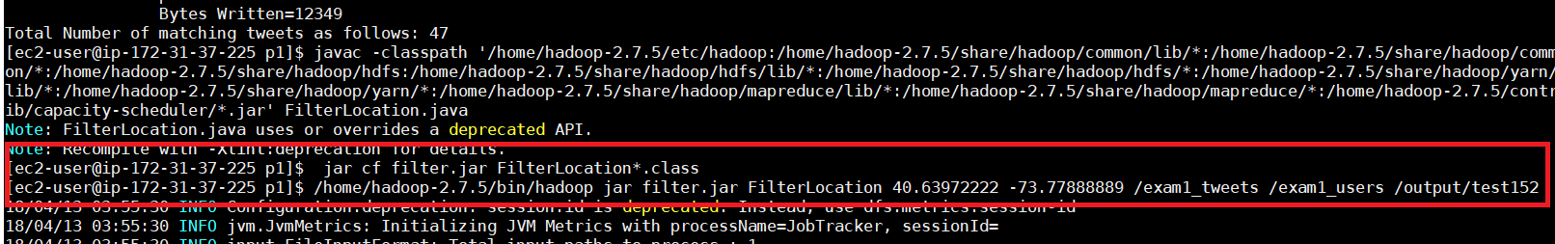
Fig:1.1
The fig 1.2 screenshot is the desired output.
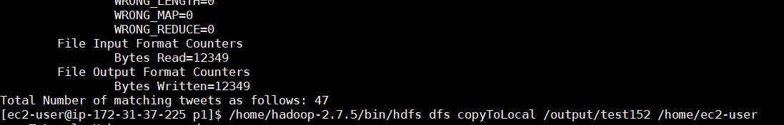
Fig: 2.2
The output made sense and wasn’t surprising at all. However, JVM options xms was changed to 256m to keep the jvm go out of memory as it was happening when it was processing job2.

Filter and sort with spark

Sollution Algorithm Word Count
The solution with spark was more straight forward as Spark uses RDD and it has vast library and easy functions more abstraction was used will less lines of code and simple and fast solution.
  - Parser: The same parser was used from the previous program to parse csv files.
  - Driver:
The driver part is where the program is defined and run at the same time. No separate class is required for class-based job. Here the spark context is created, and it is sued to extract the file and put it in the RDD. Now the first RDD consisting the tweet file is mapped and then filtered in terms of the matching longitude. Here in this RDD line by line is extracted then parsed and compared with longitude and latitude. It is true then is set true and filter method is used to transform the RDD. The String of column is passed and keys and the RDD is reduced only by keys.
The second RDD is used to map it to a Paired RDD where value is all the required columns and key as usehandle. The next RDD uses the second input rdd and extracts the required column data from the second file. It stores the userhandle as key and all other information as values.
Next both RDD is join by join function and stored in a new RDD. The RDD is reduced to values to only get the columns as required.
The next step is to sort in terms of RT. For this purpose, the rdd is mapped and columns are extracted in terms of the split delimiter and rt is set as key and rest columns as values. In this same rdd SortByKey() action is invoke and to sort the list by key. The parameter is set to false to sort it in descending order. It is also reduced to value to get only the column in order they are required. The final RDD is now saved as text file for output.

Experiemnt

I feed input in terms of this format
<Latitude> <Longitude> <Tweets file> <Users file> <output directory>.
As the spark context is design to import the files in that manner it is required to do it that way.
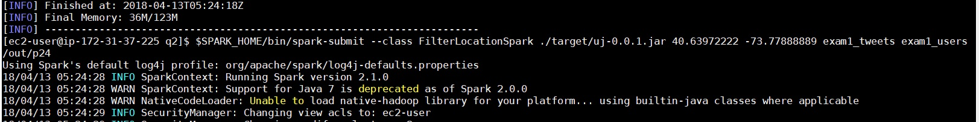
Fig: 2.1
The output was really looking good. I checked with custom search to check if the numbers aligned. The only drawback I didn’t took off the weird delimiter that I used (“::”). Next time I will replace them by ,”.
Fig: 2.2
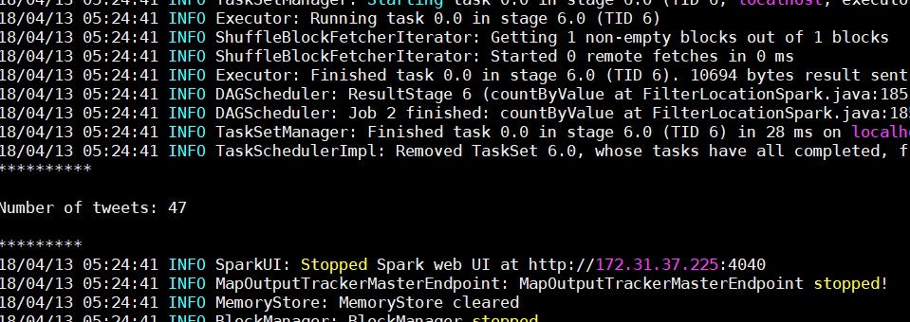

Challenges
The main challenge was to understand what the problem wants. Then find the right algorithm which will solve the problem. But the coding part wasn’t the headache. It was debugging the code and other errors that was faced. It was basically a test of java knowledge and Hadoop library use. I ran through JVM machine cannot allocate errors to array index out of bound errors. The job chain wasn’t closed so I had interrupted exception. Overall the challenge was used and time consuming, but It was a great learning experience.

References

- Donald Miner & Adam Shook, “Map Reduce Design Patterns,” Phil. O reily USA, First Edition, pp. 18–65, December 2012. (references)
- "Hadoop Counter." Counters (Apache Hadoop Main 2.7.0 API). N.p., 10 Apr. 2015. Web. 16 Feb. 2018..
- "History of Hadoop and Map Reduce." History of Hadoop and Map Reduce. N.p., 22 Sept. 2015. Web. 15 Feb. 2018

