* 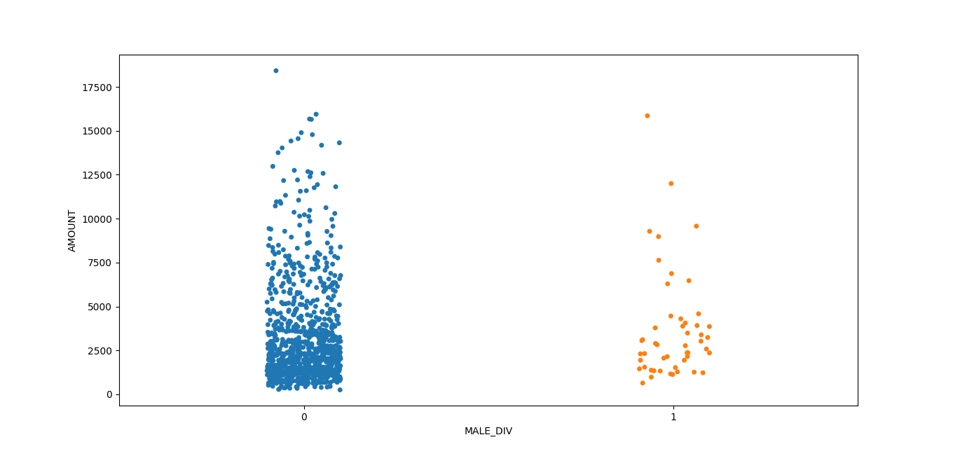The male and divorced applicants are less when compared to the non-divorced male applicants.
* 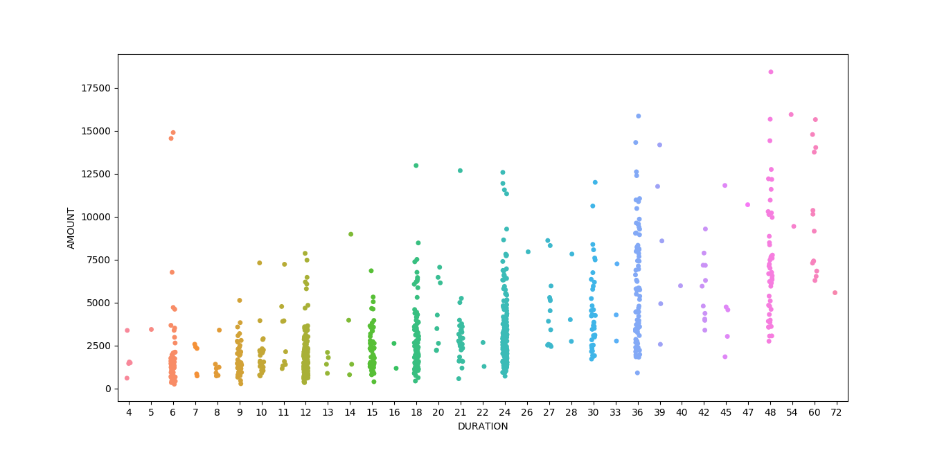The amount taken by the non-divorced male applicants is high when compared to the divorced applicants.
* As the duration of the months are increasing the amount is also increasing.

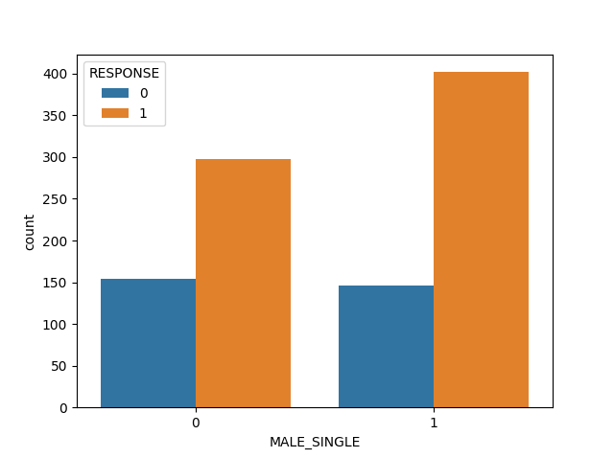

* The applicants who were male and single their credit score is good.

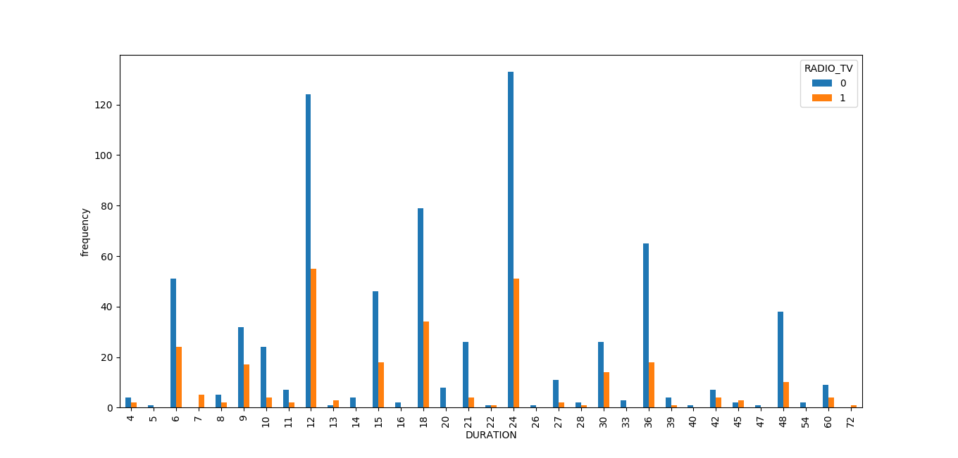

* More number of applicants who took the loan for radio/tv there duration period was 12months and 24 months .

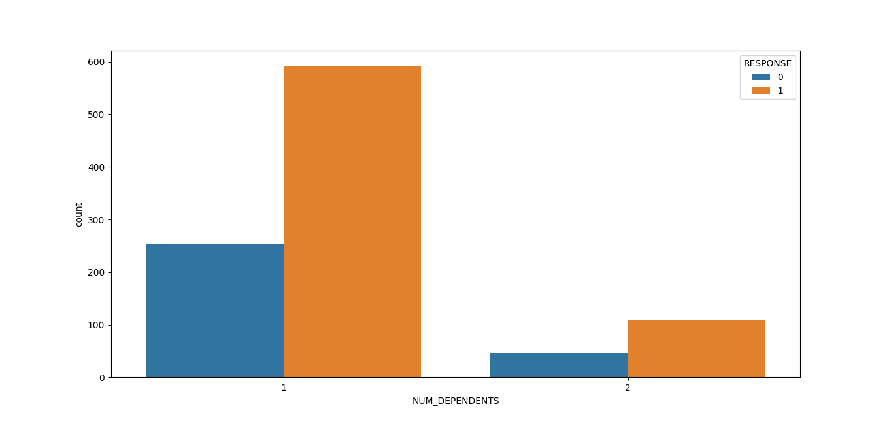

* The applicants with number of dependents =1 has good credit score.

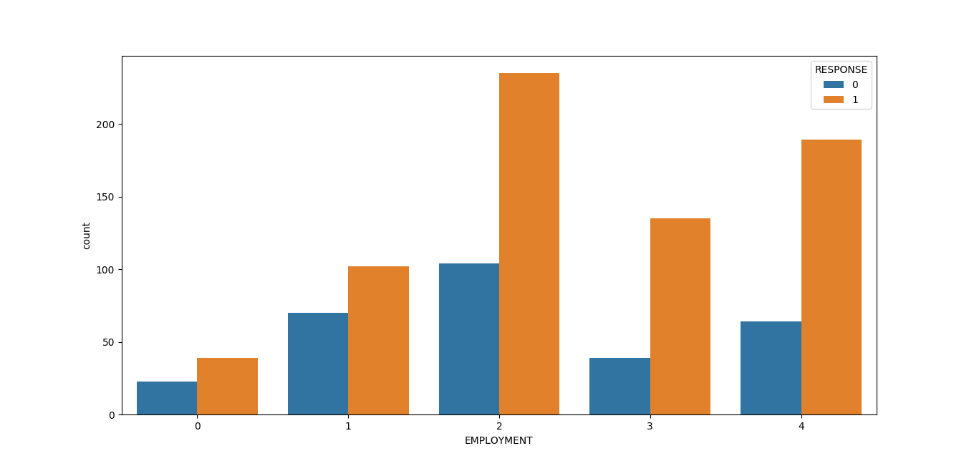

* Employment wise ,the applicants who have 1-4 years of employment their credit score is good.
* As well as the employee whose working years were beyond the 7 years their credit score is also good.

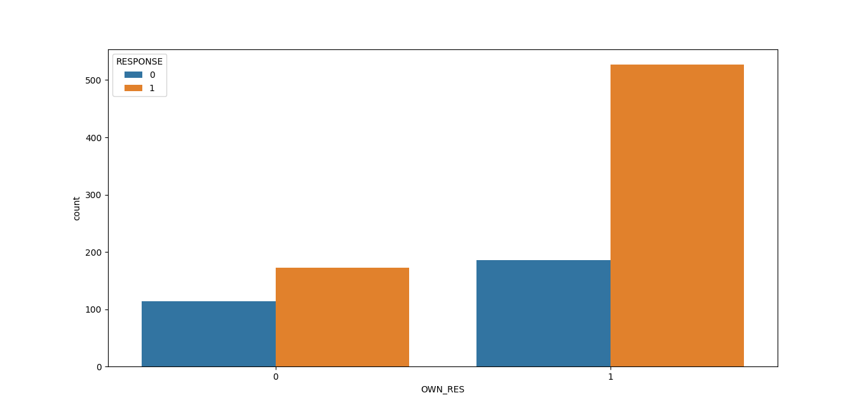

* The applicants who own the residence their credit score is good.

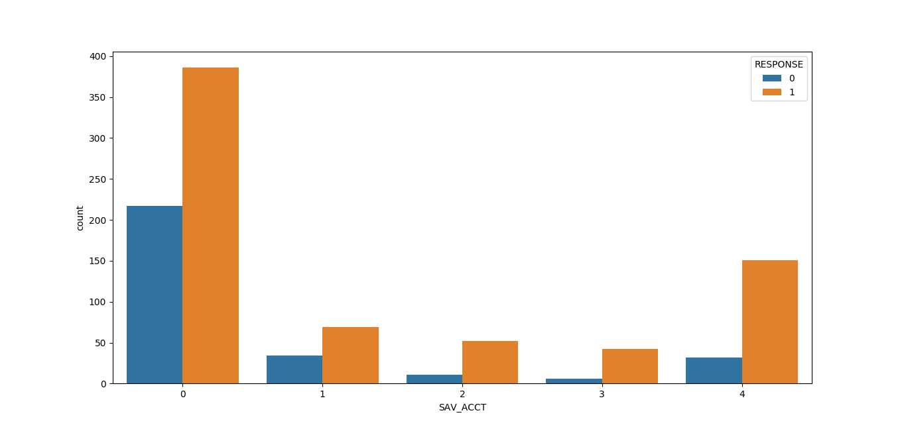

* The applicants whose savings account has less than 100DM their credit score is good.

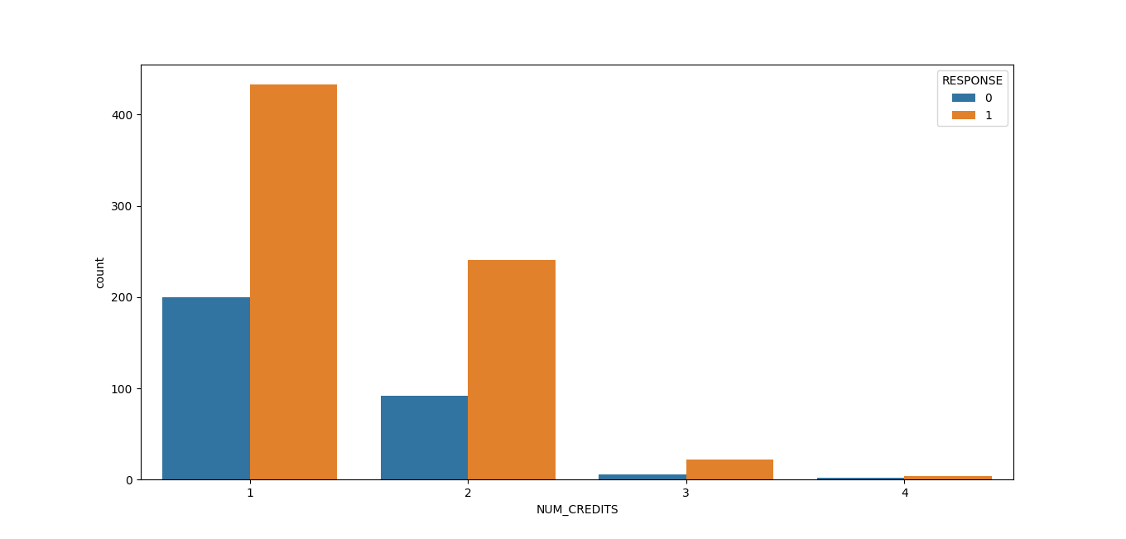

* The applicants with number of credits =1 and 2 their credit score is good .

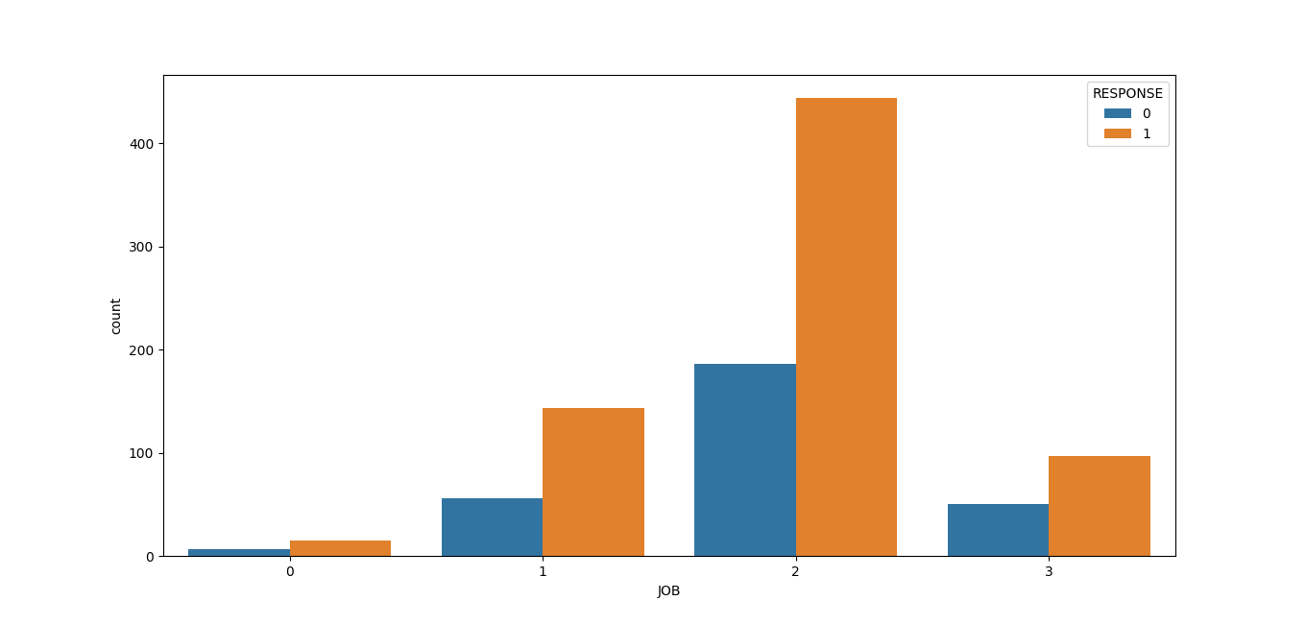

* The applicants with the job nature who are skilled employee/official their credit score is good.

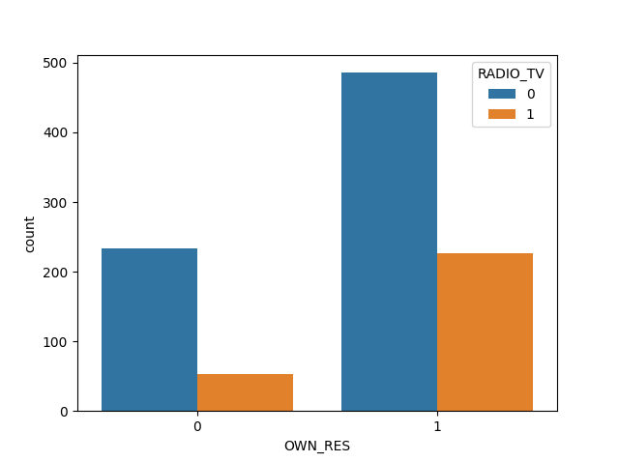

* The applicants who own the residence (more number of people)took loan for **Radio/Tv**

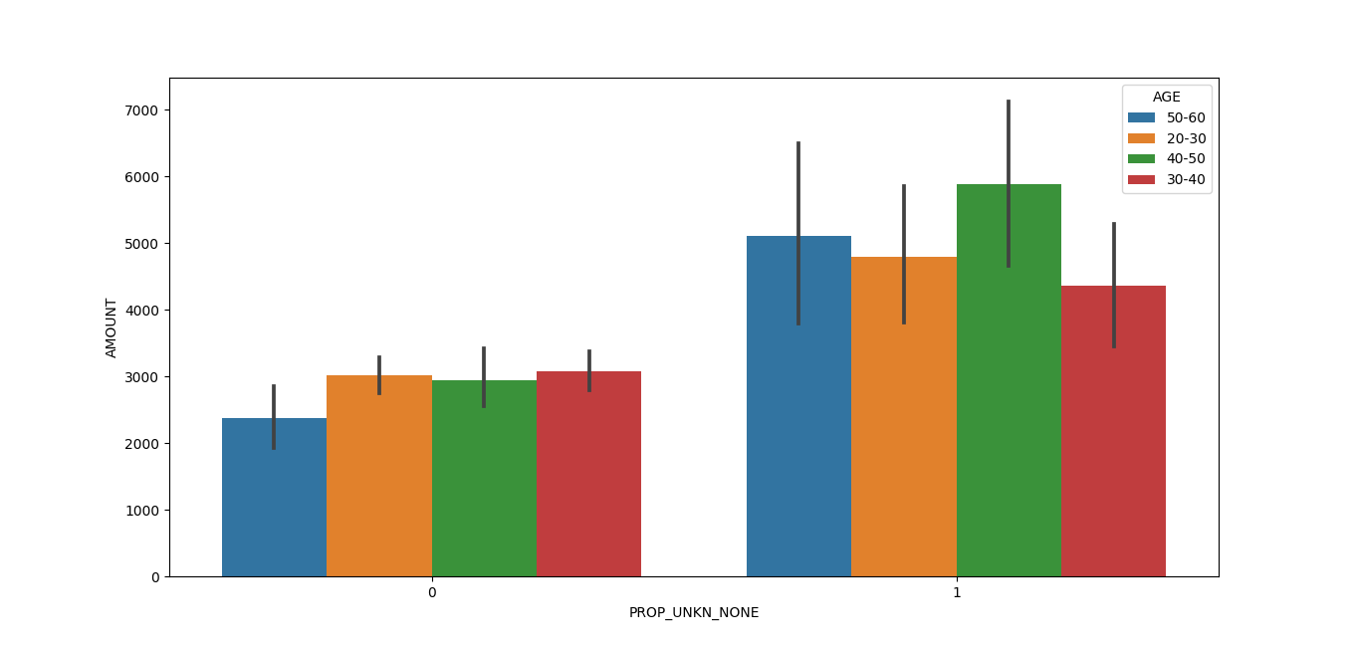

* The applicants who does not have property and their age range is between(40-50) they have took the loan amount close to 5,500.

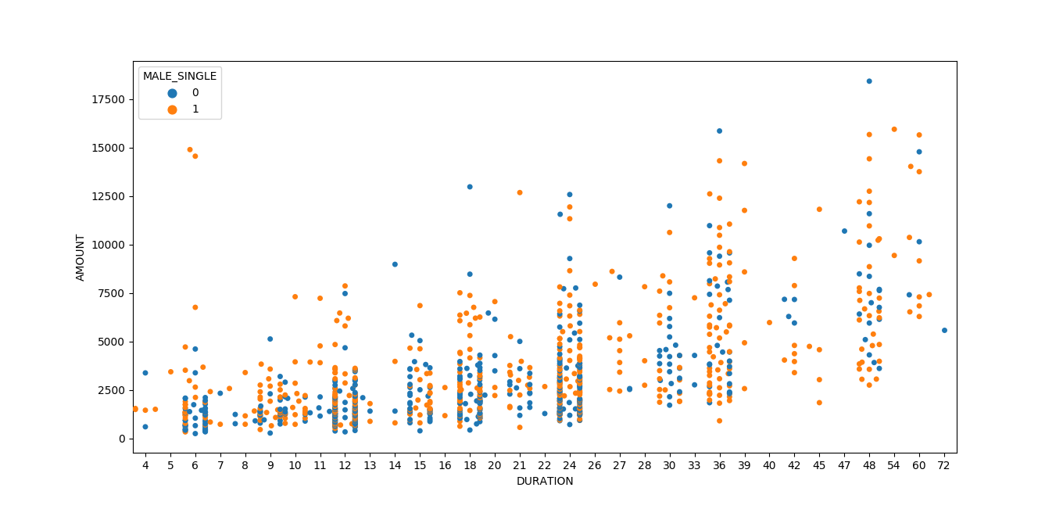

* The MALE who are single they have took the loan in each duration of months.

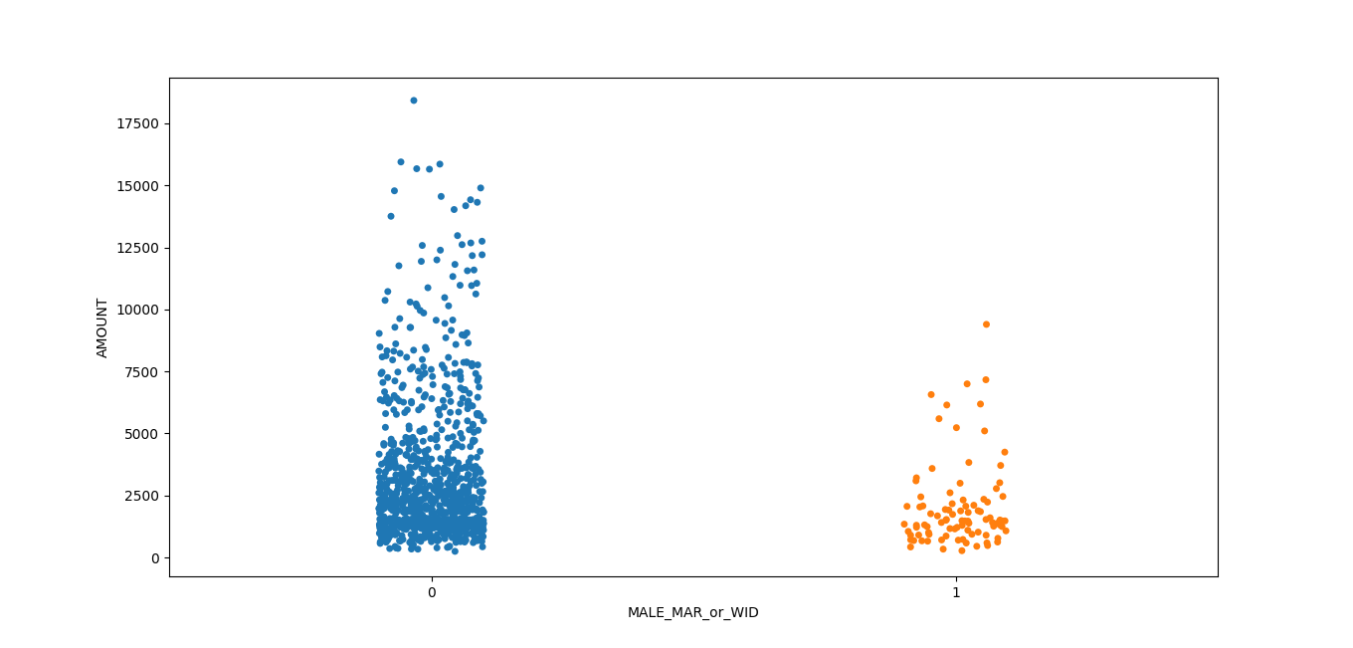

* The applicants who are male married or male widow their loan amount is concentrated to 5000.

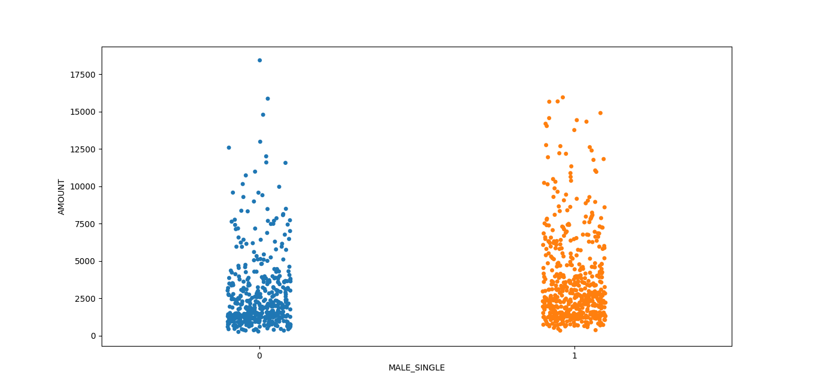

* Whereas for male single the amount range is close to 10000.



* MALE who are divorced their loan amount is less and the number of male who are divorced are less.

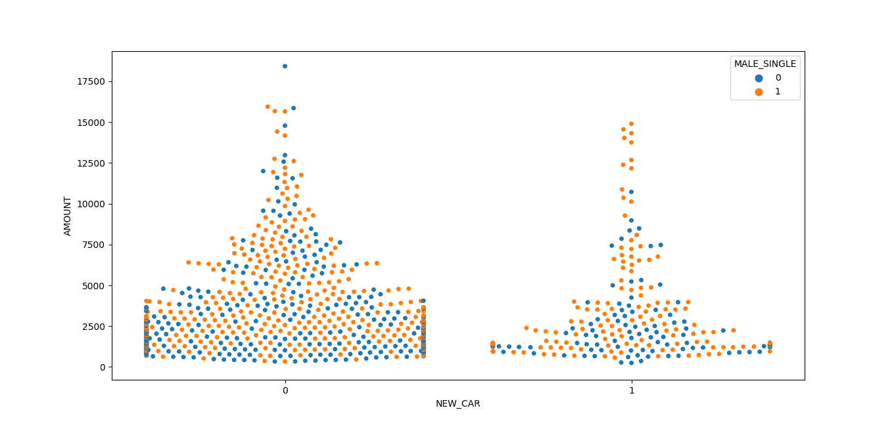

* Many of the single males have took the loan for buying the new cars.

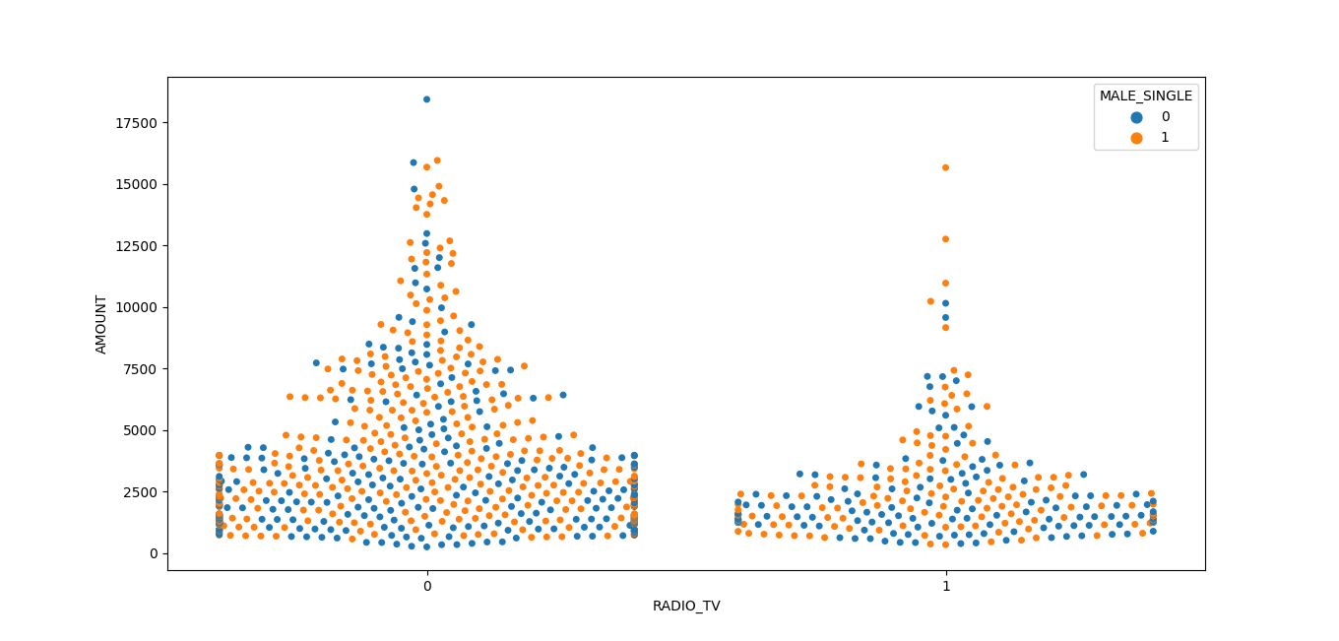

* MALE who are single they also took loan for buying the radio/tv their ratio is more.

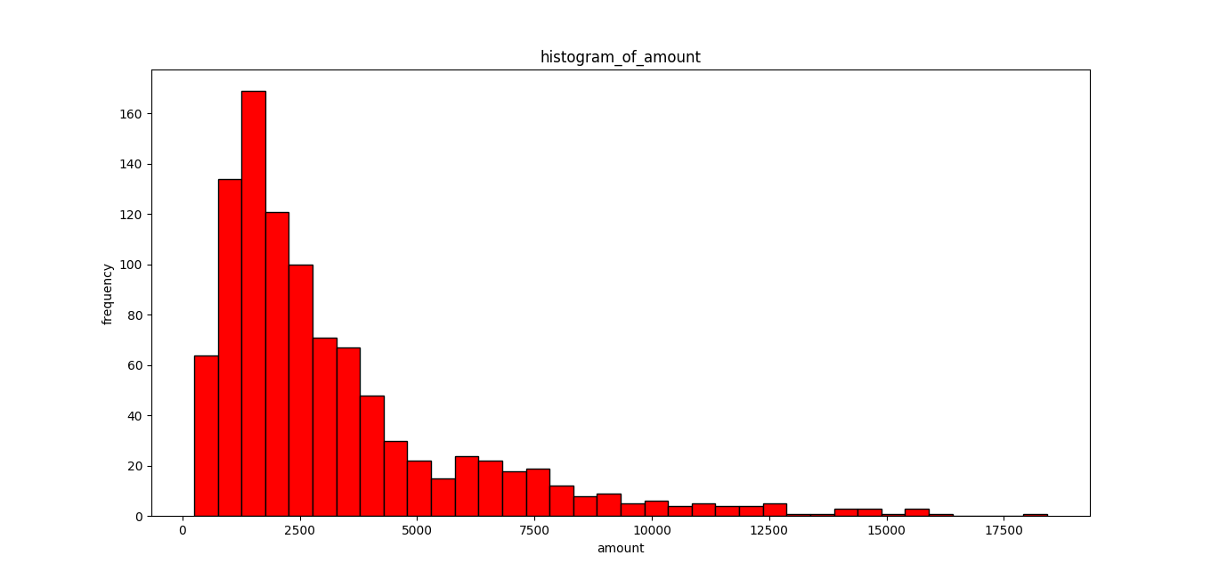

* The amount is right skewed ,more number of people have took loan of 5000.

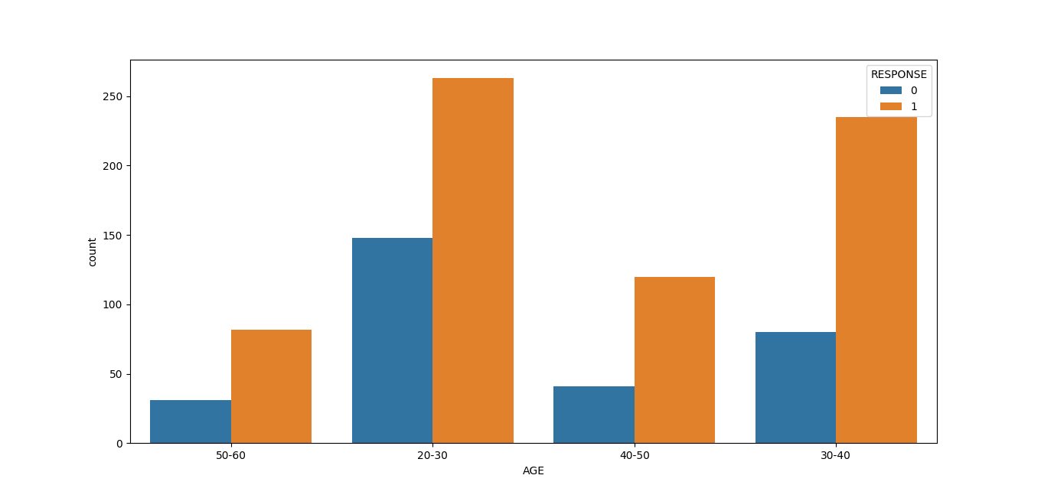

* The applicants whose age is between (20-30) and (30-40) their credit score is good .

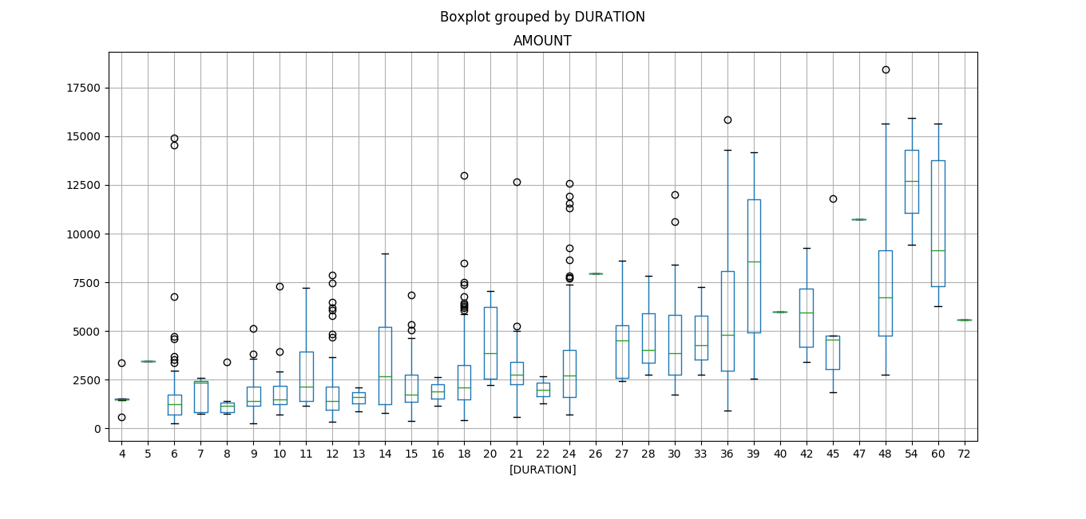

* This plot gives the outliers according to the amount and the duration.

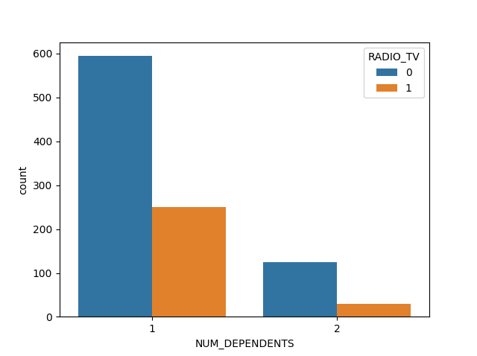

* The applicants who has the number of dependents 1 ,more number of people have took loan for the Radio/TV

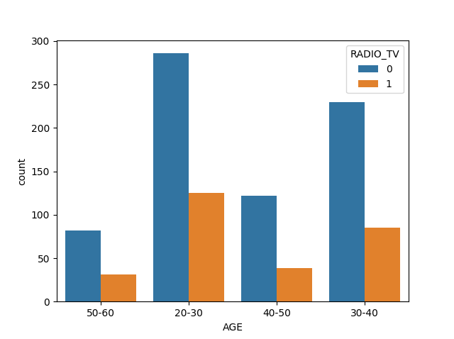

* The applicants whose age is between 20-30 they have took the loan for RADIO/TV

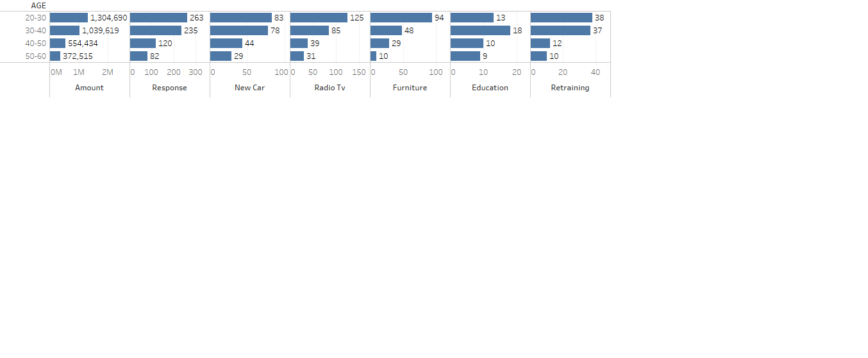

Results.

* **The target group customers are the applicants whose age is between 20-30 and 30-40.**
* **The total loan amount took by the age group 20-30 is 13, 04,690.**
* **The total loan amount took by the age group 30-40 is 10, 39,619.**
* **The total loan amount took by the age group 40-50 is 5, 54,434.**
* **The total loan amount took by the age group 50-60 is 3, 72,515.**
* The applicants with the age group **20-30** are buying **new car** (**83 applicants has purchased the** **new car out of 411** among the age group 20-30) i.e. **20% are taking loan for new car among 20-30age group**.
* The applicants with the age group **20-30** are buying RADIO/TV (**125 applicants has purchased the RADIO/TV out of 411** among the age group 20-30)i.e. **30% are taking loan for RADIO/TV**
* The applicants with the age group **20-30** are **buying furniture** (**94 applicants has purchased the furniture out 411 among the age group 20-30**) i.e. **22% are taking loan for furniture’s.**
* The applicants with the age group 20-30 are buying **USED CAR** (**37 applicants has purchased the USED CAR out 411 among the age group 20-30**) i.e. **9% are taking loan for used cars.**
* The applicants with the age group 20-30 are buying **EDUCATION** (**13 applicants has purchased the USED CAR out 411 among the age group 20-30**) i.e. **3% are taking loan for education.**
* The applicants with the age group 20-30 are buying **RETRAINING** (**38 applicants has purchased the USED CAR out 411 among the age group 20-30**)i.e. **9.24% are taking loan for RETRAINING.**
* The applicants with the age group 30-40 are buying **NEW CAR** (**78 applicants has purchased the NEW CAR out 315 among the age group 30-40**) i.e. **24 % are taking loan for NEW CAR.**
* The applicants with the age group 30-40 are buying **RADIO/TV** (**85 applicants has purchased the RADIO/TV out 315 among the age group 30-40**) I.e. **26 % are taking loan for RADIO/TV.**
* The applicants with the age group 30-40 are buying **FURNITURE** (**48 applicants has purchased the FURNITURE out 315 among the age group 30-40**) i.e. **15 % are taking loan for FURNITURE.**
* The applicants with the age group 30-40 are buying **EDUCATION** (**18 applicants has purchased the EDUCATION out 315 among the age group 30-40**) i.e. **5 % are taking loan for EDUCATION.**
* The applicants with the age group 30-40 are buying **RETRAINING** (**37 applicants has purchased the RETRAINING out 315 among the age group 30-40**) i.e. **11 % are taking loan for EDUCATION.**
* The applicants with the age group 30-40 are buying **USED CAR** (**32 applicants has purchased the USED CAR out 315 among the age group 30-40**) i.e. **10 % are taking loan for EDUCATION.**
* **THE CREDIT SCORE IS GOOD FOR THE AGE GROUP 20-30 (263) out of 411 which is 64%.**
* **THE CREDIT SCORE IS GOOD FOR THE AGE GROUP 30-40 (235) out of 315 which is 74%.**