**User Form**

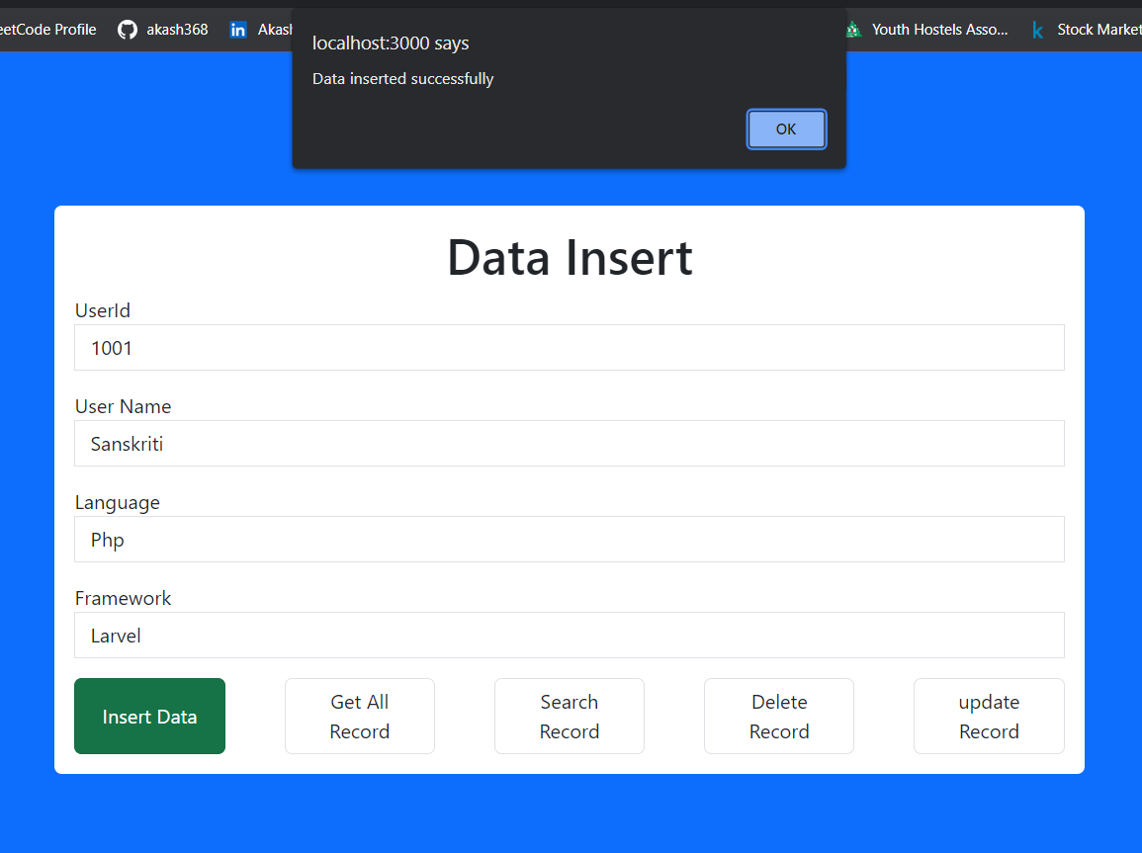

**Get All Data**

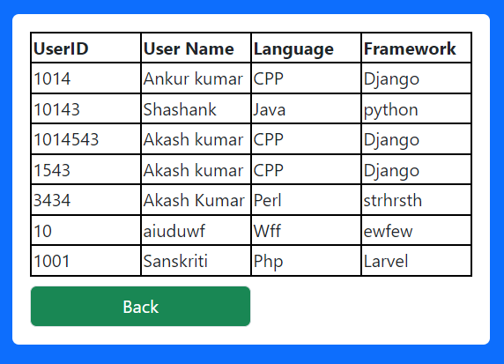

**Search by name**

**Search by name**

**Delete**

**Update data according to the given id**

