Abstract:
The primary objective of this project is to develop a prototype visual interface for Jackson Heights Mural (JHM), that can be leveraged to secure funding for future mural projects. Through iterative discussions with JHM, we identified a critical need for a centralized system that catalogs names of artists and public art across Queens and facilitates connections with other organizations.
By consolidating data on local organizations and existing installations, the visual interface allows JHM to effectively identify underserved regions and facilitate collaborative initiatives with other organizations. Additionally, the catalog of local artists offers a valuable resource for selecting talent for future projects. In summary, an integrated interface connecting organizations, public art, and artists functions as a significant strategic asset.
Our visual platform displays a geolocation map of Queens, segmented by zip codes. On this map, we layer information about public art and related organizations. Additionally, our platform features a search engine to find publicly accessible art – this engages with the overlayed public art in our geolocation map.

Data (Public Art):
NYC Open Data: Department of Transportation (DOT),
Public Design Commission (PDC).

Introduction to public art datasets:
Department of Transportation (DOT):
This dataset records temporary art installations on NYC DOT property, including the name, artist, coordinates, zip code, site, art type, installation date, and removal date. Since we focus on Queens, after calling NYC Open Data Api, we filter to only have Queens zip code.
Public Design Commission (PDC):
This dataset records inventory of City owned public monuments, memorials, artworks and markers installed outside on City-owned property. The key attribute we care for are primary artist, secondary artist, title, secondary title, coordinates, date created, artwork type, location, address, and zip code. Since we focus on Queens, after calling NYC Open Data Api, we filter to only have Queens zip code.
To handle data discrepancies across various sources, we implemented a normalization class in our Django backend. This class serves as a standardization layer, allowing developers to map differing column attributes into a uniform 'Public Art' object structure. This approach ensures that all data remains consistent for the frontend, regardless of the underlying differences in the raw data fields. For now, we only have data from DOT and PDC, we aim to continuously add different endpoints for publicly available art data.
Since DOT and PDC data may contain null values in all columns, we exclude records lacking either title or coordinate information, as coordinates are essential for mapping overlays and titles assist users in identifying each art piece. All 'Public Art' objects are then consolidated into a single list and provided to the front end as a JSON file. Using longitude and latitude, this data is displayed on the geolocation map as red markers. Additionally, a search engine feature is implemented to facilitate interaction with the list of 'Public Art'.

Data (Organization):
NYC Open Data: NYC Community Based Organizations and café data.

Introduction to NYC Community Based Organizations and café data:
NYC Community Based Organizations: This dataset records key information like organization’s name, their mission, description, coordinates, website, location and zip codes. This information can be used for users to directly be linked to each organization’s website after they read through the organization’s key information (mission and description). Since we focus on Queens, after calling NYC Open Data Api, we filter to only have Queens zip codes.
This project visualizes NYC cafe storefronts and community organizations in Queens using data from the NYC Open Data Socrata API. Django application fetches and transforms geometric data by parsing Multiline String/LineString coordinates for cafe boundaries and latitude/longitude points for organizations. Afterwards, it caches and serves it via REST endpoints. The React frontend implements client-side geographic filtering using a ray-casting point-in-polygon algorithm to restrict data to Queens, converts the data to GeoJSON format, and renders it on a MapLibre GL map with cafes displayed as cyan polygons and organizations as yellow triangle markers.

Data (Geolocation divide using zip code and census data):
Data City of New York: We divided our Queens region by zip codes. We got polygon data for different Queens zip codes.
Census API (Dataset): For census data, we used census library from python. We had to use census’s website to get key value for attributes we wanted to use.
Story:
Our visualization was created for Jackson Heights Mural Project (JHM); a none profit organization. Since their conception this year (2025), the JHM obtained funds from other local organizations and public businesses to commission their first mural on 84th street Jackson Heights. The group now aims to install more murals throughout Jackson Heights before potentially moving to another Queens neighborhood. In effort to help this organization, we wanted to focus on three criteria for growth:
- Allows a way to see how public art is spread throughout Queens.
- See key organizations in different regions in Queens.
- Have a catalog of artists.
For the first criterion, we discovered challenges to locate sources that list all public art in Queens. Various departments commission different art projects, resulting in multiple custodians of public art. However, there is no consolidated dataset collecting all these works, much less one that visualizes them collectively. To help users engage with all public art in Queens, we also decided to create a mini search engine to browse our aggregated art list. The search filter allows users to sort by title, artist name, and location. We color our public art objects as red as it was important to highlight these points. We have the search filter right next to the geolocation map since our search engine interacts with our map.
Regarding the second criterion, since JHM successfully commissioned its first mural in partnership with other organizations, it was essential to display each organization overlayed on a geolocation map. This approach enables JHM to identify which organizations are in specific areas and potentially collaborate with them to combine resources. We overlap the organization information alongside the public art data as showing those points together is crucial. However, we use different color and share to differentiate organization from public art. We also allow user to click on organization pin to get information on that organization.
THE END, JHM also wanted to feature a list of local artists on their website. Including a search function for artists would help make JHM a resource for other organizations seeking artist recommendations. Additionally, JHM could use this catalog for their own future projects.

Limitations:
There are several limitations at the data layer. It is challenging to obtain a comprehensive list of public art in Queens due to inconsistent data representations by various custodians. Although our backend can merge different endpoints into a single normalized object, we do not possess all available datasets for art in Queens, particularly those pieces that may not have been officially commissioned. One potential enhancement for our application would be to allow users to submit new art entries. However, this introduces risks regarding data accuracy and timeliness, as well as questions about custodianship of these user-generated records. Similar challenges exist for maintaining up-to-date lists of organizations and artists.
Extensions:
By extracting artist information from our public art list, we can build a graph that links each artist to their works. This approach helps JHM view the range of pieces created by each artist. However, our current dataset does not capture all artists and their artworks yet. We plan to continue searching for additional data sources and may eventually allow verified artists to directly submit their art and its location to our database.
Removal:
We currently have census data creating heatmap. We also allow users to view census data as pie chart (using rechart library). This feature is not needed and should be removed.

SCREENSHOTS:

Here is the overview of website:
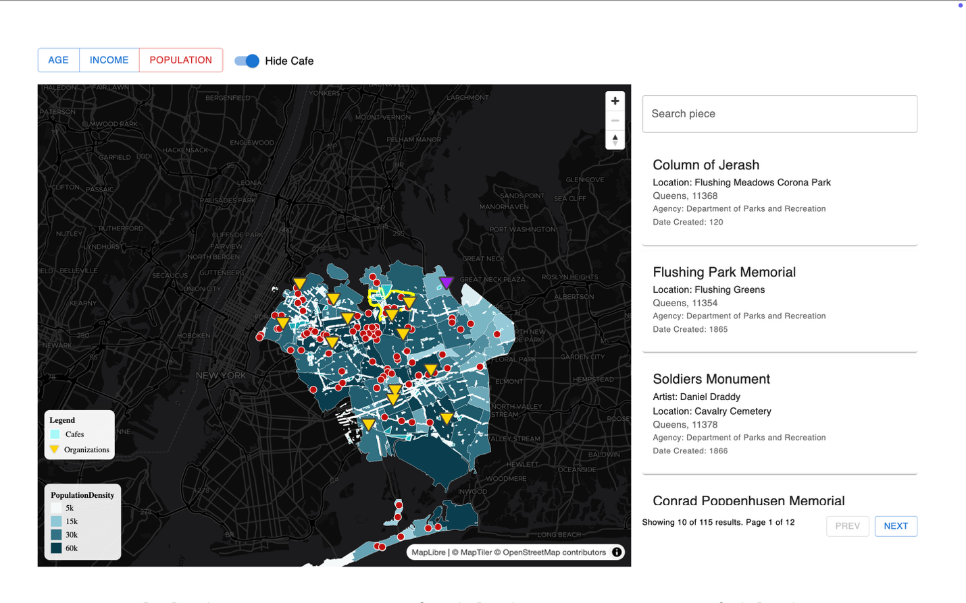
Plt1: Map
The total map shows the analysis of different indicators: AGE, INCOME, POPULATION
Search Engine: We can search which murals we might consider.
Café Street: The distribution of café organization.
Red points: Shows the distribution of murals
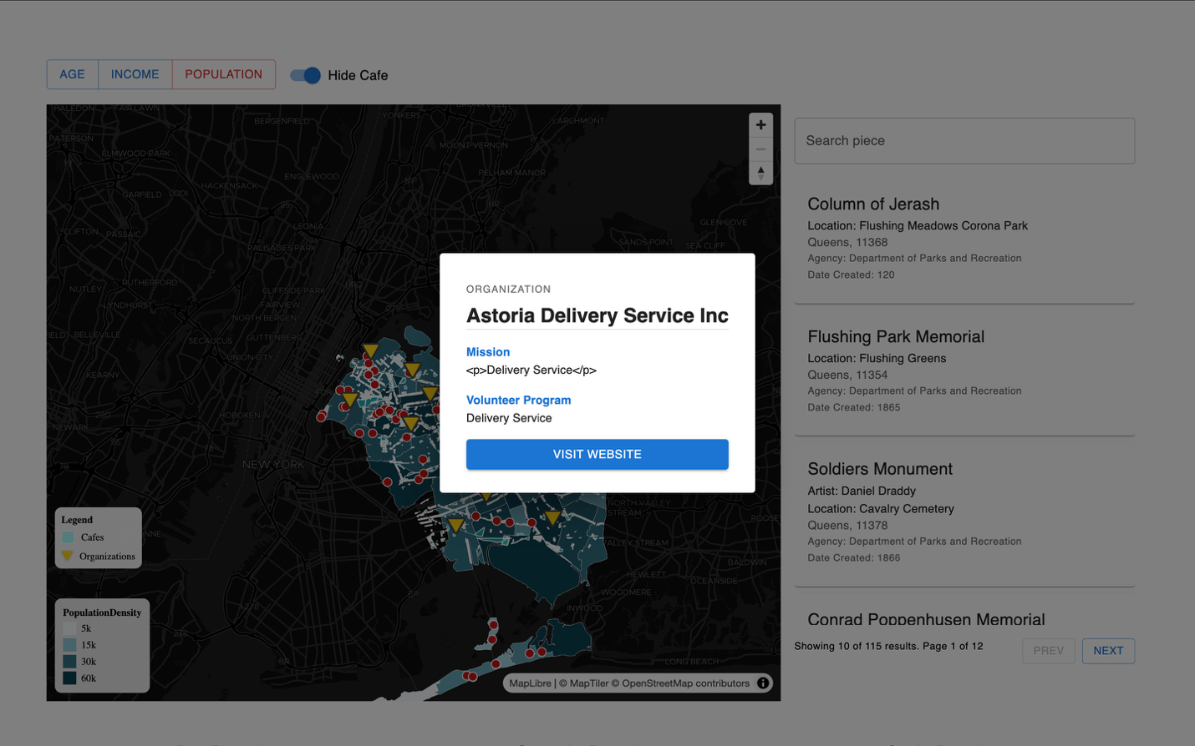
Plt2: Organization Information
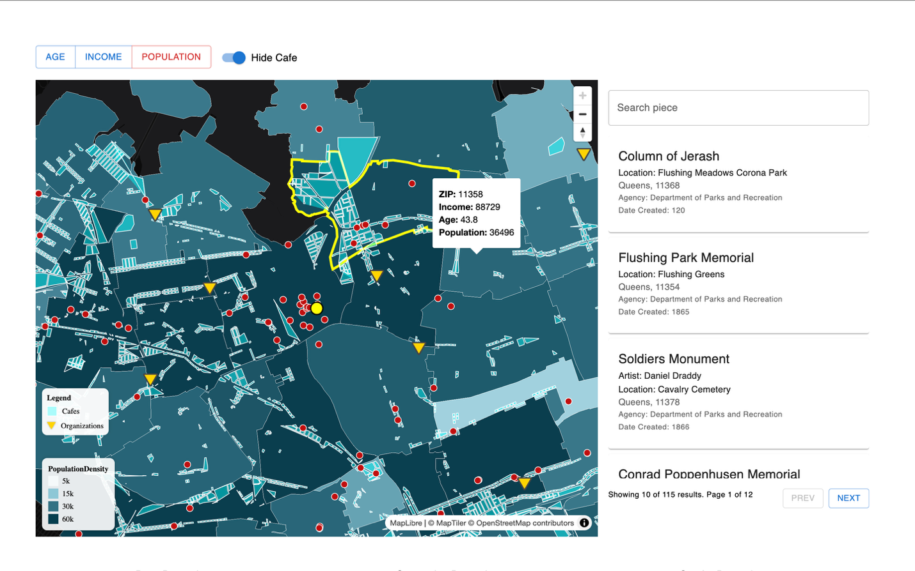
Plt3: Zip Code area Information

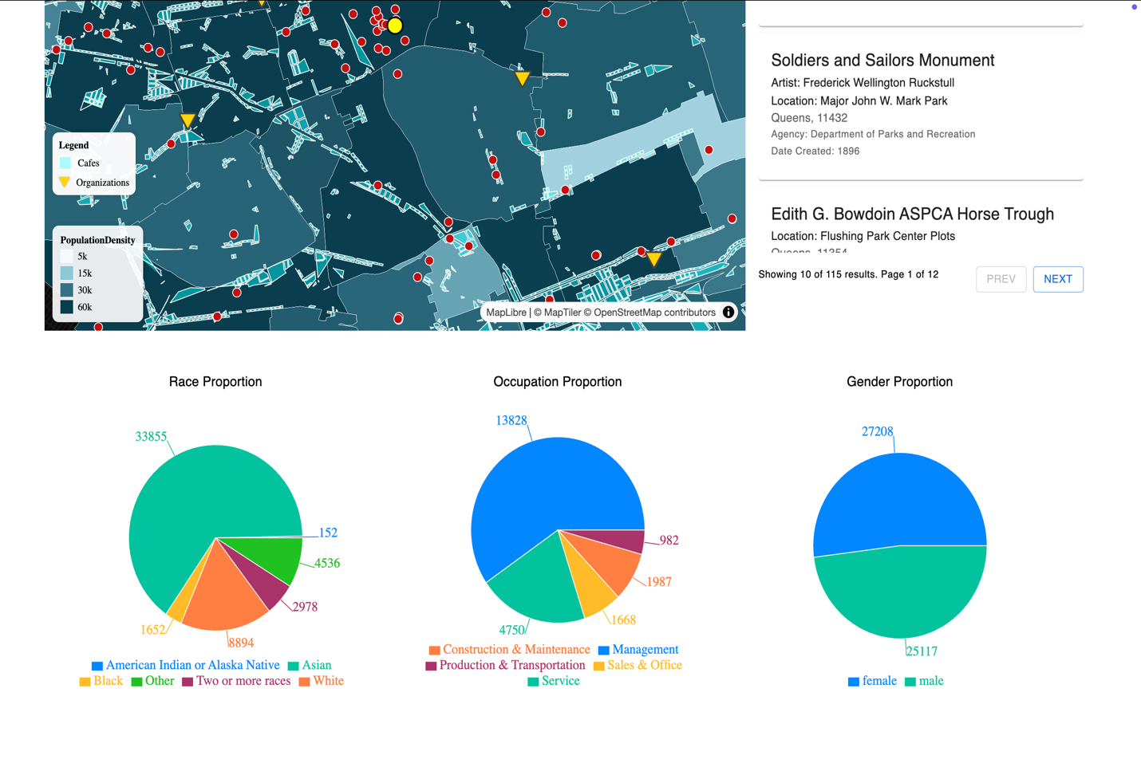
Plt4: Charts
DATA SOURCES:
- Organization Info: https://data.cityofnewyork.us/Social-Services/NYC-Community-Based-Organizations/i4kb-6ab6/data_preview
- Outdoor Commissioned Public Art: https://data.cityofnewyork.us/Housing-Development/Public-Design-Commission-Outdoor-Public-Art-Invent/2pg3-gcaa/about_data
- DOT Temporary Art: https://data.cityofnewyork.us/Transportation/Temporary-Art-Program/3r2x-bnmj/data_preview
- Census-Mapping: https://api.census.gov/data/2023/acs/acs5/variables.html#:~:text=Estimate!!Total:!!Europe:!!Europe%2C%20n.e.c.%2C%20PLACE%20OF%20BIRTH%20FOR%20THE,THE%20UNITED%20STATES%2C%20not%20required%2C%20B05006_046EA%2C%20B05006_046M
- Café Data: https://data.cityofnewyork.us/City-Government/nysidewalkcafe/ptd9-4c6m/about_data
- Queens zip code polygon: https://data.cityofnewyork.us/api/geospatial/pri4-ifjk?method=export&format=GeoJSON

