Homework 5

Riyo Moore

2/27/2021

library(tidyverse)

## ── Attaching packages ─────────────────────────────────────── tidyverse 1.3.0 ──

## ✓ ggplot2 3.3.3 ✓ purrr 0.3.4  
## ✓ tibble 3.0.5 ✓ dplyr 1.0.3  
## ✓ tidyr 1.1.2 ✓ stringr 1.4.0  
## ✓ readr 1.4.0 ✓ forcats 0.5.0

## ── Conflicts ────────────────────────────────────────── tidyverse_conflicts() ──  
## x dplyr::filter() masks stats::filter()  
## x dplyr::lag() masks stats::lag()

Stockreturns <- c(-8.36, 1.63, -2.27, -2.93, -2.70,   
 -2.93, -9.14, -2.64, 6.82, -2.35,   
 -3.58, 6.13, 7.00, -15.25, -8.66,  
 -1.03, -9.16, -1.25, -1.22, -10.27,  
 -5.11, -0.80, -1.44, 1.28, -0.65,  
 4.34, 12.22, -7.21, -0.09, 7.34,   
 5.04, -7.24, -2.14, -1.01, -1.41,   
 12.03, -2.53, 4.33, 1.35)  
 Stockreturns

## [1] -8.36 1.63 -2.27 -2.93 -2.70 -2.93 -9.14 -2.64 6.82 -2.35  
## [11] -3.58 6.13 7.00 -15.25 -8.66 -1.03 -9.16 -1.25 -1.22 -10.27  
## [21] -5.11 -0.80 -1.44 1.28 -0.65 4.34 12.22 -7.21 -0.09 7.34  
## [31] 5.04 -7.24 -2.14 -1.01 -1.41 12.03 -2.53 4.33 1.35

Problem 1

m=mean(Stockreturns)  
m

## [1] -1.124615

Problem 2

s=sd(Stockreturns)  
s

## [1] 5.977673

Problem 3

pnorm(q=-1.5, mean = m, sd=s)

## [1] 0.4749638

Problem 4

1-qnorm(p=.7, mean=m, sd=s)

## [1] -1.01008

Problem 5

quantile(Stockreturns)

## 0% 25% 50% 75% 100%   
## -15.250 -3.255 -1.410 1.490 12.220

Problem 6

boxplot(Stockreturns)

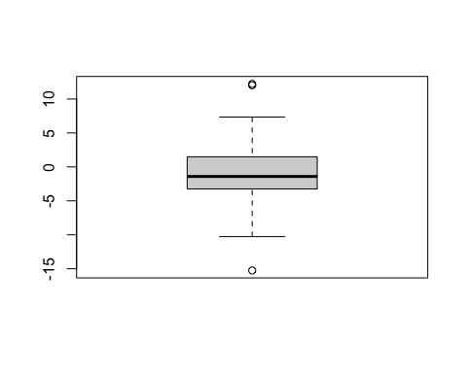

qqnorm(Stockreturns)  
qqline(Stockreturns)

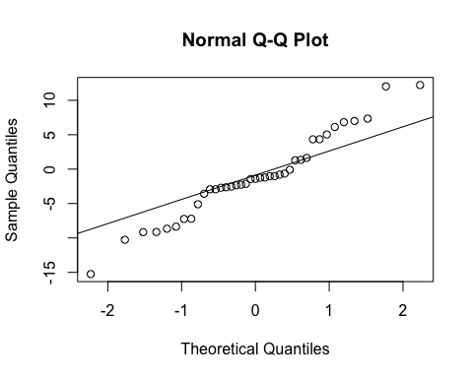 Problem 7 H(0) : population mean = .95 H(A) : population mean does not equal .95

Problem 8

t.test(Stockreturns, mu=.95, var.equal = FALSE)

##   
## One Sample t-test  
##   
## data: Stockreturns  
## t = -2.1674, df = 38, p-value = 0.03654  
## alternative hypothesis: true mean is not equal to 0.95  
## 95 percent confidence interval:  
## -3.0623529 0.8131221  
## sample estimates:  
## mean of x   
## -1.124615

The p-value is 0.03654, which is less than .05, which means that we reject the null hypothesis. There is significant statistical evidence to indicate that the population mean does not equal .95.

Problem 9 > According to the 95% confidence interval, the broker appears to perform worse than average because the average is above the confidence interval.