Homework 9

Riyo Moore

4/4/2021

Problem 1

census_api_key("f8c513ad8bc6fde0858ff1ba4aa9c2956333a345", install = TRUE, overwrite = TRUE)

## Your original .Renviron will be backed up and stored in your R HOME directory if needed.

## Your API key has been stored in your .Renviron and can be accessed by Sys.getenv("CENSUS_API_KEY").   
## To use now, restart R or run `readRenviron("~/.Renviron")`

## [1] "f8c513ad8bc6fde0858ff1ba4aa9c2956333a345"

Problem 2

Medinc2015<-get_acs(geography = "county",   
 variables = c(medincome = "B01001A_011"),   
 state = "CA",   
 year = 2015)

## Getting data from the 2011-2015 5-year ACS

Medinc2015

## # A tibble: 58 x 5  
## GEOID NAME variable estimate moe  
## <chr> <chr> <chr> <dbl> <dbl>  
## 1 06001 Alameda County, California medincome 51644 667  
## 2 06003 Alpine County, California medincome 50 26  
## 3 06005 Amador County, California medincome 1809 72  
## 4 06007 Butte County, California medincome 9962 128  
## 5 06009 Calaveras County, California medincome 1927 74  
## 6 06011 Colusa County, California medincome 1147 79  
## 7 06013 Contra Costa County, California medincome 42756 605  
## 8 06015 Del Norte County, California medincome 1629 90  
## 9 06017 El Dorado County, California medincome 8609 141  
## 10 06019 Fresno County, California medincome 34979 714  
## # … with 48 more rows

descestimate<-Medinc2015 %>% filter(estimate >= 30000) %>% arrange(desc(estimate))  
descestimate

## # A tibble: 13 x 5  
## GEOID NAME variable estimate moe  
## <chr> <chr> <chr> <dbl> <dbl>  
## 1 06037 Los Angeles County, California medincome 375435 2332  
## 2 06073 San Diego County, California medincome 150891 1008  
## 3 06059 Orange County, California medincome 126819 1152  
## 4 06065 Riverside County, California medincome 92346 1004  
## 5 06071 San Bernardino County, California medincome 80925 1160  
## 6 06085 Santa Clara County, California medincome 63036 879  
## 7 06067 Sacramento County, California medincome 56066 553  
## 8 06001 Alameda County, California medincome 51644 667  
## 9 06013 Contra Costa County, California medincome 42756 605  
## 10 06075 San Francisco County, California medincome 42307 542  
## 11 06029 Kern County, California medincome 42121 575  
## 12 06111 Ventura County, California medincome 41155 557  
## 13 06019 Fresno County, California medincome 34979 714

descestimate %>% filter(estimate==51644, moe==667)

## # A tibble: 1 x 5  
## GEOID NAME variable estimate moe  
## <chr> <chr> <chr> <dbl> <dbl>  
## 1 06001 Alameda County, California medincome 51644 667

ggplot(descestimate, aes(x=estimate)) + geom_boxplot(fill = "red")

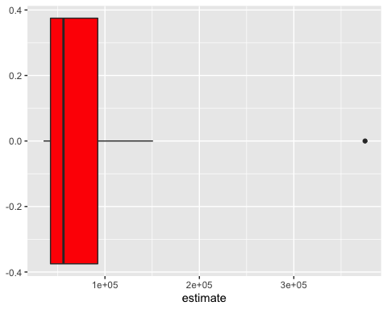

descestimate<-Medinc2015 %>% filter(estimate >= 30000) %>% arrange(desc(estimate)) %>% mutate(NAME = fct_reorder(NAME, estimate))  
  
ggplot(descestimate, aes(x=estimate, y= NAME)) +geom_point(col="blue")

