Amanda Rosado

Evidence of 3 Job Applications

Job Applications

*Bethesda Game Studios – Game Programmer*

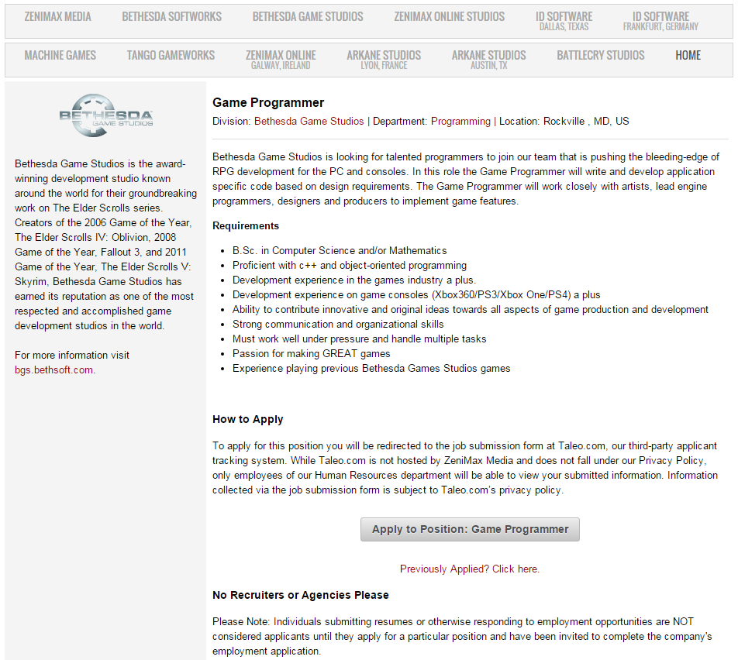

Job Posting and Description

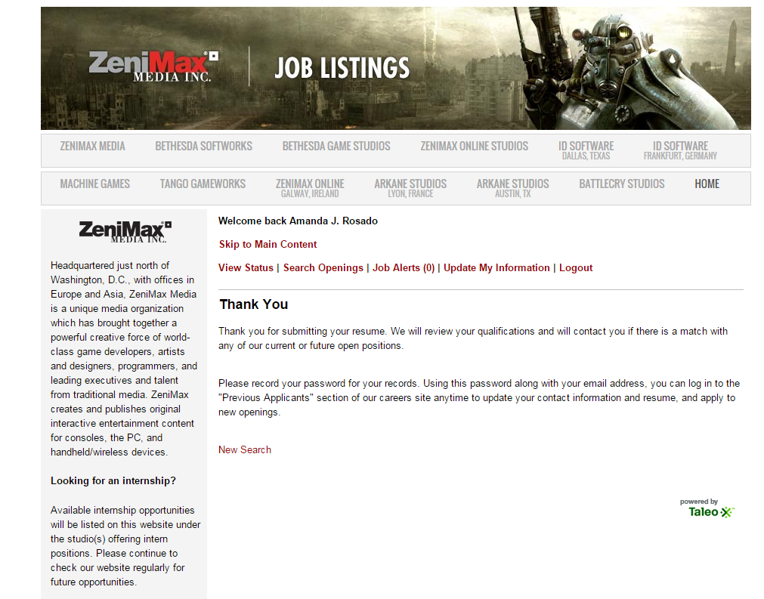

Evidence of Submission

*Klei Entertainment – Web Developer*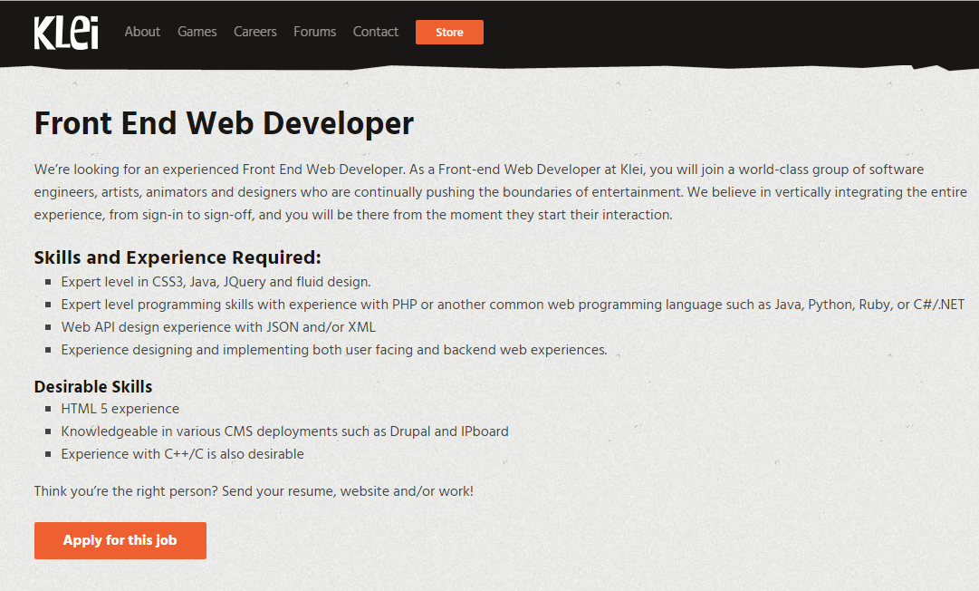

Job Posting and Description

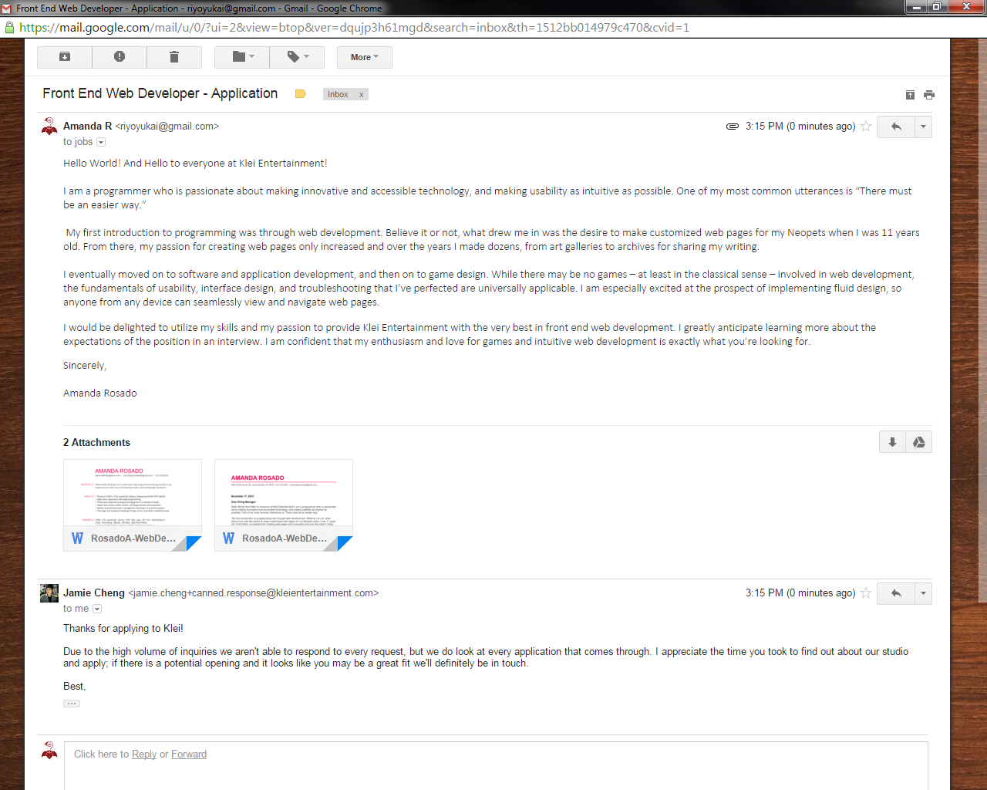

Evidence of Submission

*Spectrum Health – Web/Mobile Developer*

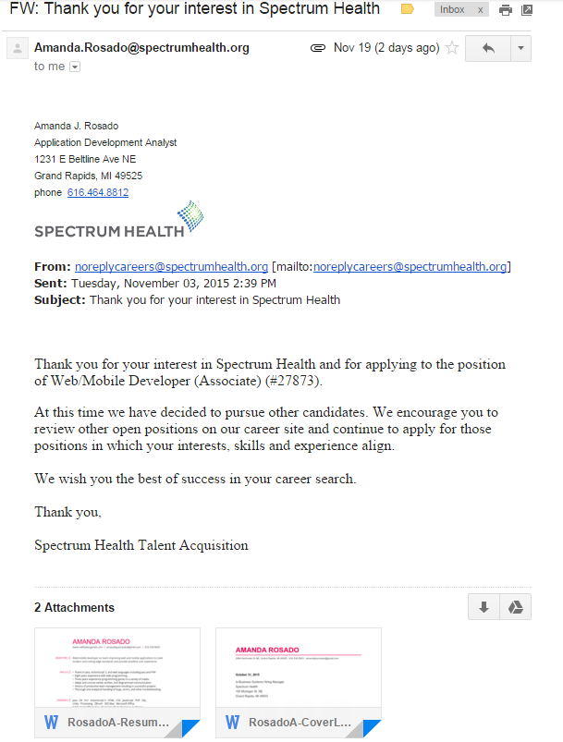

Evidence of Submission