Amanda Rosado

Networking Event

Mobile Monday Grand Rapids

For my networking event, I attended Mobile Monday GR, a networking event devoted to mobile technology, its advances, applications, and advantages.

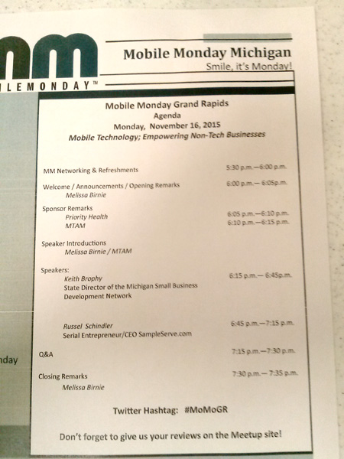

This particular event was focused on how small businesses can utilize mobile technology even if they are not tech-oriented business. The main speaker was Russel Schindler, who talked about his company, SampleServe, which monitors groundwater especially after oil spills and other toxic spills. The data that he collects with his equipment is reported to the state for environmental purposes.

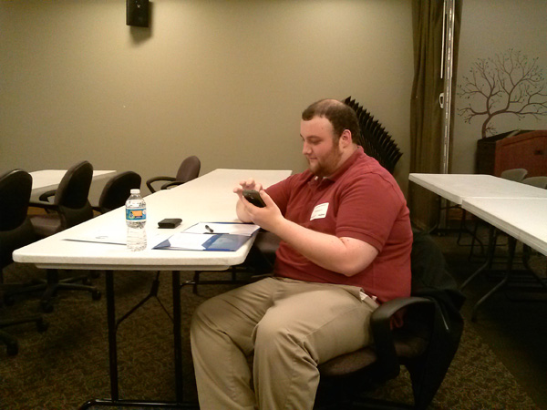

Cameron and Stephanie also attended.

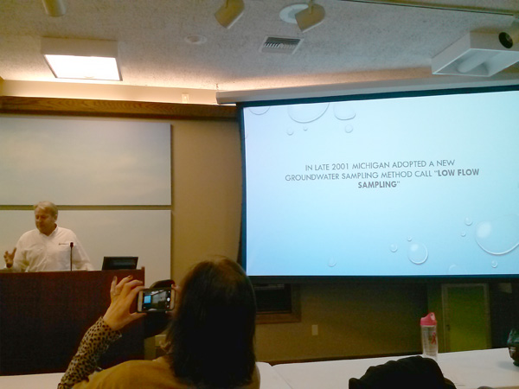

He told the story of how he (after a long struggle finding the right programmer) created web software which generates spreadsheets, maps, charts, and other statistics based on the data collected. Originally, he was marketing his company's services with this software as a perk - "Hire me, and you can use this stuff." But he kept running into people who already had their own ways of doing the sampling and just wanted to buy his software, and that was how he began selling software rather than his service of groundwater sampling.

He is currently working with mobile developer Renee McConahy, who was at the event as well. Once the presentation was over, I spent a long time talking with her, as most of the other participants were small business owners, not developers.

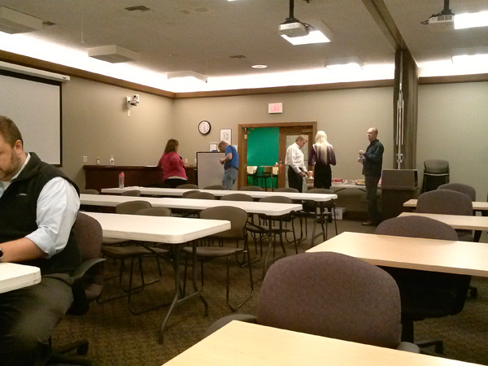

Overall, I think that Mr. Schindler had good points, but had trouble communicating them in a concise way. What I think he was trying to say was that, when you create technology to make things easier for yourself, it may be useful to others as well. And keeping it to yourself and trying to market yourself may not be as profitable as selling the technology that you created. I also took away his lesson about how mobile technology is making things more accessible and giving more opportunities to make doing business easier, in many different fields.