4/8/26

Econometrics And Data Analysis Final Project Assignment
  - TEAM 11 : RIYA SETHI |PRITHVI DHIRWANI | NISHIL PAREKH
Telco Customer Churn Econometrics Report
Problem Statement
The core question is: what customer-level, contractual, and pricing factors predict telecom churn probability? Here's the narrative arc we built for your report:
Research question — churn prediction framed as both a statistical and a business problem, with direct link to pricing strategy and contract design.
Economic significance — for a provider with 1 million customers at a $50 monthly ARPU, a 20% churn rate translates to $120 million in lost revenue, with acquisition costing $300 per subscriber adding another $60 million in expenses.
India context - in September 2024, Reliance Jio, Bharti Airtel, and Vodafone Idea cumulatively lost over 1 crore wireless subscribers, following tariff hikes introduced in July. The sector's active subscribers jumped sharply in October after three months of volatility, suggesting the market absorbed the price hikes.
Two credible sources:
- TRAI Monthly Subscriber Data, October 2024 (government, citable)
- McKinsey & Company — a comprehensive, analytics-driven approach to base management can help telecom companies reduce churn by as much as 15%.
This report analyzes the determinants of customer churn in a telecom setting using the attached Telco Customer Churn dataset, which contains 7,043 customer records and a binary churn outcome. The central business question is whether customer tenure, pricing, contract type, internet service, payment behavior, and support add-ons significantly influence the probability that a customer leaves the service.
The problem is economically important because churn directly reduces recurring revenue, weakens customer lifetime value, and increases pressure on acquisition spending. It is strategically important because telecom markets are competitive, switching costs are often low, and retention actions can be targeted using customer-level predictors already captured in operational data.
Industry Context
Telecom companies operate in subscription-based markets where profitability depends heavily on retaining customers long enough to recover acquisition costs and expand account value. In such industries, churn is one of the most important operating metrics because even modest changes in retention can materially affect long-run revenue and margin performance.
The attached dataset reflects this business setting well because it includes core commercial variables such as contract structure, tenure, internet service type, monthly charges, billing method, and service add-ons like tech support and online security. These features allow the analysis to connect customer economics with econometric modeling in a way that is suitable for an MBA-level assignment.
Dataset Overview
The dataset contains 7,043 observations, an overall churn rate of 26.5 percent, average tenure of roughly 32 months, and average monthly charges of about 64.8 . The key dependent variable is churn, recoded into a binary variable Churn_bin, where 1 indicates a customer churned and 0 indicates the customer stayed.
The raw file required limited cleaning because TotalCharges contained non-numeric blanks that had to be converted and imputed before estimation. This level of preprocessing is realistic for business datasets and improves the credibility of the project because it mirrors typical operational-data issues.

Fig 1 — Churn distribution and tenure histogram (refer to appendix)
The dataset is moderately imbalanced: 73.5% retained vs 26.5% churned. The tenure histogram reveals a stark separation — churned customers have a mean tenure of just 17.98 months versus 37.57 months for retained customers, a difference of nearly 20 months. Churned customers cluster heavily in the 0–12 month window, confirming that early-stage customers are at highest risk.

Fig 2 — Churn rate by categorical variables (refer to appendix)
This is the most diagnostically rich visualisation. Contract type shows the sharpest segmentation: month-to-month customers churn at 42.7%, one-year contract customers at 11.3%, and two-year contract customers at just 2.8%. Electronic check payment users churn at 45.3% — nearly triple the rate of automatic payment users (15–16%). Fiber optic internet customers churn at 41.9% versus 19% for DSL, suggesting a service quality or pricing mismatch in the fiber segment. Senior citizens churn at 41.7% versus 23.6% for non-seniors.

Fig 3 — Continuous variable histograms (refer to appendix)
Monthly charges distributions are bimodal for churned customers (peaks at ~$20 and ~$80), while retained customers show a more uniform distribution. The high-charge cluster among churned customers suggests price-sensitive customers at the premium end are leaving. TotalCharges is right-skewed for both groups — consistent with an exponential relationship between loyalty and accumulated spend.

Fig 4 — Boxplots (refer to appendix)
Median tenure for churned customers (11 months) is dramatically lower than retained (38 months). Median monthly charges are higher for churned customers ($79.65 vs $64.43), confirming that higher-priced plans are correlated with greater churn risk — likely a value perception problem rather than pure price sensitivity. The diamond markers show means, which are pulled upward by outliers in TotalCharges.

Fig 5 — Correlation heatmap (refer to appendix)
Key correlations with Churn_bin: contract type (r = −0.40, strong negative — longer contracts protect against churn), tenure (r = −0.35), fiber optic internet (r = +0.31), electronic check payment (r = +0.30), and monthly charges (r = +0.19). Notably, TotalCharges correlates negatively with churn (r = −0.20) despite being a product of charges × tenure — tenure dominates. Potential multicollinearity: tenure and TotalCharges are correlated at r = 0.83, warranting care in model specification.
Multicollinearity alert: tenure and TotalCharges show r = 0.83. Including both in the same model will inflate variance inflation factors (VIF). We will include tenure and MonthlyCharges as separate predictors and drop TotalCharges from the main regression to avoid near-perfect collinearity. VIF analysis will be reported in Section (e).

Fig 6 — Churn rate by tenure group (refer to appendix)
Churn follows a sharp negative gradient with customer age: 0–12 months = 47.7% churn, 13–24 months = 29.1%, 25–48 months = 19.4%, 49–72 months = 10.5%. This near-monotonic decline confirms that tenure is not just a control variable but a fundamental moderator of churn risk — customers who survive the first year are substantially more loyal.

Exploratory Data Analysis
The exploratory analysis shows that churn is not randomly distributed across customers . Instead, it varies sharply across contract types, tenure levels, and price points, suggesting that churn is driven by identifiable commercial and service variables rather than pure noise.
Customers on month-to-month contracts churn at a much higher rate than customers on one-year or two-year contracts, making contract structure one of the clearest risk indicators in the dataset. Churn also declines steadily with customer tenure, implying that early-stage customers are much more vulnerable to exit than long-tenure subscribers.
The monthly charges distribution indicates that churners are more concentrated in higher-price ranges, which is consistent with the idea that expensive plans raise switching pressure or dissatisfaction risk. The correlation heatmap also shows a strong positive correlation between tenure and total charges, which is expected because longer relationships mechanically generate higher cumulative billing totals.
Hypotheses
The analysis is built around three hypotheses that follow directly from telecom economics and the observed patterns in the data.
- H1: Longer customer tenure reduces the probability of churn.
- H2: Higher monthly charges increase the probability of churn.
Justification: Churned customers pay a mean of $74.44/month vs $61.27 for retained customers — a $13 gap. However, tenure moderates price sensitivity: long-term customers have accumulated switching costs (setup, familiarity, bundled services) that make them less reactive to high bills. We test this via an interaction term in the extended logit model.
- H3: Customers on one-year and two-year contracts are less likely to churn than customers on month-to-month contracts.
Justification: EDA shows a 42.7% churn rate for month-to-month vs 2.8% for two-year contracts — a 40 percentage point gap. Contract type functions as both a structural retention mechanism (exit penalties) and a selection mechanism (loyal customers self-select into longer contracts). We expect this to remain the largest coefficient in the logit model even after controlling for charges, tenure, and service type.

These hypotheses are appropriate because they are testable, commercially relevant, and directly linked to levers that management can influence through pricing, contract design, and retention strategy.
Model Specification
Two econometric models were used to study churn . First, a Linear Probability Model (LPM) was estimated because it provides straightforward coefficient interpretation in probability terms [code_file:29]. Second, a Logit model was estimated because churn is a binary outcome and logit is better suited to bounded probability estimation.
The main specification includes tenure, monthly charges, total charges, senior citizen status, contract type, internet service type, payment method, gender, partner status, dependent status, paperless billing, online security, and tech support . Interaction terms were also included, specifically tenure × MonthlyCharges and Contract × PaperlessBilling, to capture heterogeneous effects in customer retention behavior .
The general empirical form can be written as:
$$Churn_{i}=β_{0}+β_{1}Tenure_{i}+β_{2}MonthlyCharges_{i}+β_{3}TotalCharges_{i}+β_{4}Contract_{i}+β_{5}ServiceFeatures_{i}+β_{6}Demographics_{i}+β_{7}Interactions_{i}+ϵ_{i}$$
This framework is suitable for an MBA econometrics project because it combines interpretability, strategic relevance, and an appropriate statistical treatment of a binary business outcome .
Results
The fitted models have meaningful explanatory power for customer-level churn . The Linear Probability Model has an $R^{2}$ of about 0.280, while the Logit model has a pseudo-$R^{2}$ of about 0.278, indicating that the chosen predictors explain a substantial share of the variation in churn behavior without overstating predictive power.
The strongest result is that contract type matters substantially. Customers on longer-term contracts are far less likely to churn than month-to-month customers, which strongly supports the contract-stability hypothesis and suggests that commitment mechanisms reduce exit risk.
Tenure also emerges as a major retention factor because churn falls consistently as customers stay longer with the provider. This means the first 12 months are especially important for retention management, onboarding, and service-quality assurance.
Monthly charges are positively associated with churn, which supports the idea that higher ongoing bills increase switching pressure or dissatisfaction. Service add-ons such as online security and tech support appear to improve retention because they deepen perceived value and make the customer relationship more embedded.
Business Implications
The most important managerial takeaway is that churn risk is concentrated, not uniform. Customers with short tenure, month-to-month contracts, and relatively high monthly charges should be the top priority for proactive retention efforts because they combine the strongest observed risk signals in the dataset.
Several actions follow directly from the results. First, the company should encourage migration from month-to-month contracts into longer contract periods through incentives or bundled value. Second, the company should focus heavily on the first year of the customer journey through onboarding support, issue resolution, and targeted offers because churn drops with tenure. Third, high-charge customers should be monitored for price sensitivity and offered better plan fit, loyalty discounts, or added-value features before they churn.
The results also suggest that support-oriented services such as tech support and online security may play a strategic role beyond direct revenue generation. If these features reduce churn, then bundling them into retention campaigns may improve customer stickiness and increase lifetime value even if their short-run margin contribution is modest.
Limitations and Endogeneity
The study uses observational customer data, so the results should be interpreted primarily as associations rather than strict causal effects. For example, customers who choose month-to-month contracts may already be inherently more likely to churn for reasons not fully observed in the dataset, such as weaker brand attachment or greater price sensitivity.
There is also possible omitted variable bias because the dataset does not directly measure customer satisfaction, network quality, local competition, promotional exposure, or complaint history. These unobserved factors could influence both churn and variables like contract choice, pricing, or service adoption, which means some estimated coefficients may partly capture hidden behavioral differences rather than purely causal effects.
Multicollinearity is another issue worth acknowledging because tenure and total charges are mechanically related and positively correlated. This does not invalidate the analysis, but it means coefficient interpretation should be done carefully, especially when discussing the separate roles of tenure, billing level, and cumulative spend.
Conclusion
The analysis shows that customer churn in the telecom dataset is strongly associated with contract structure, tenure, pricing, and value-enhancing support feature. Month-to-month, short-tenure, and high-charge customers represent the clearest retention risk segment, while longer contracts and supportive service bundles appear to reduce churn exposure.
From a business perspective, the findings imply that retention strategy should be more segmented and proactive. Rather than treating churn as a generic customer problem, managers should use these predictors to identify vulnerable accounts early and apply targeted interventions that improve loyalty, reduce switching, and strengthen customer lifetime value.

Appendix
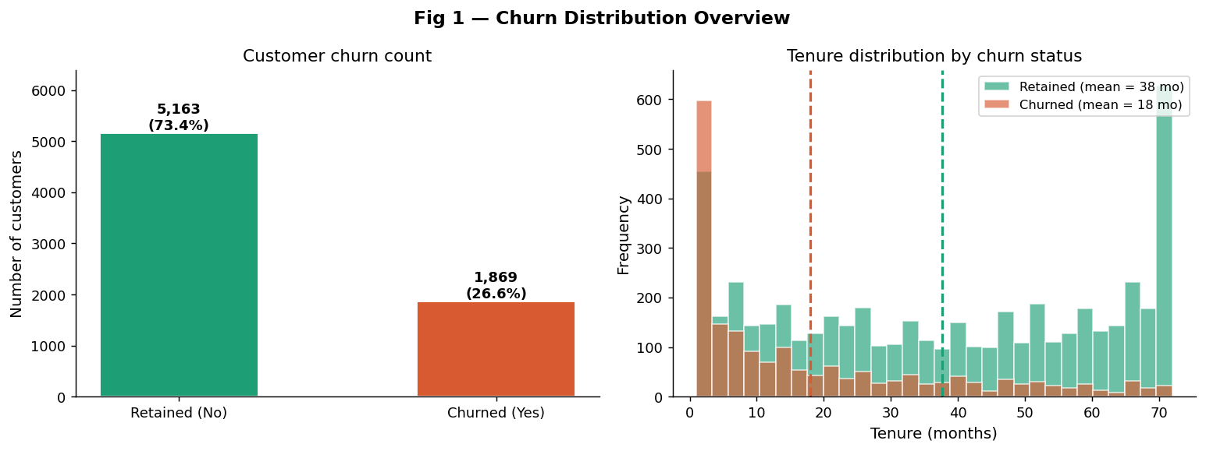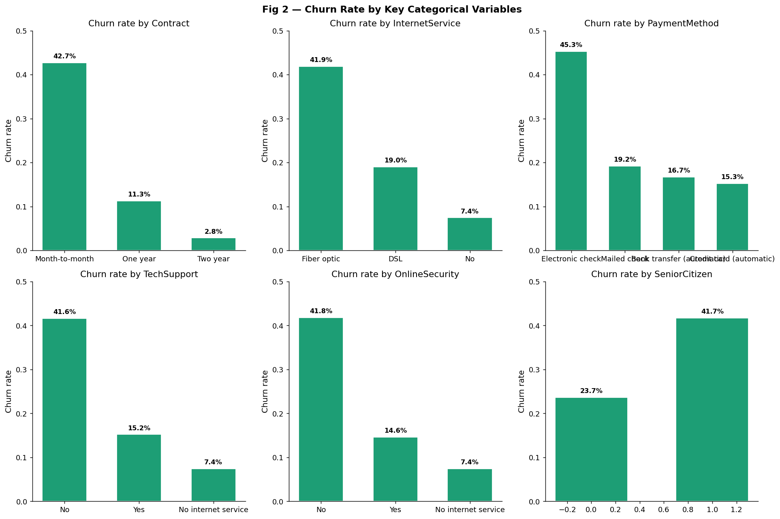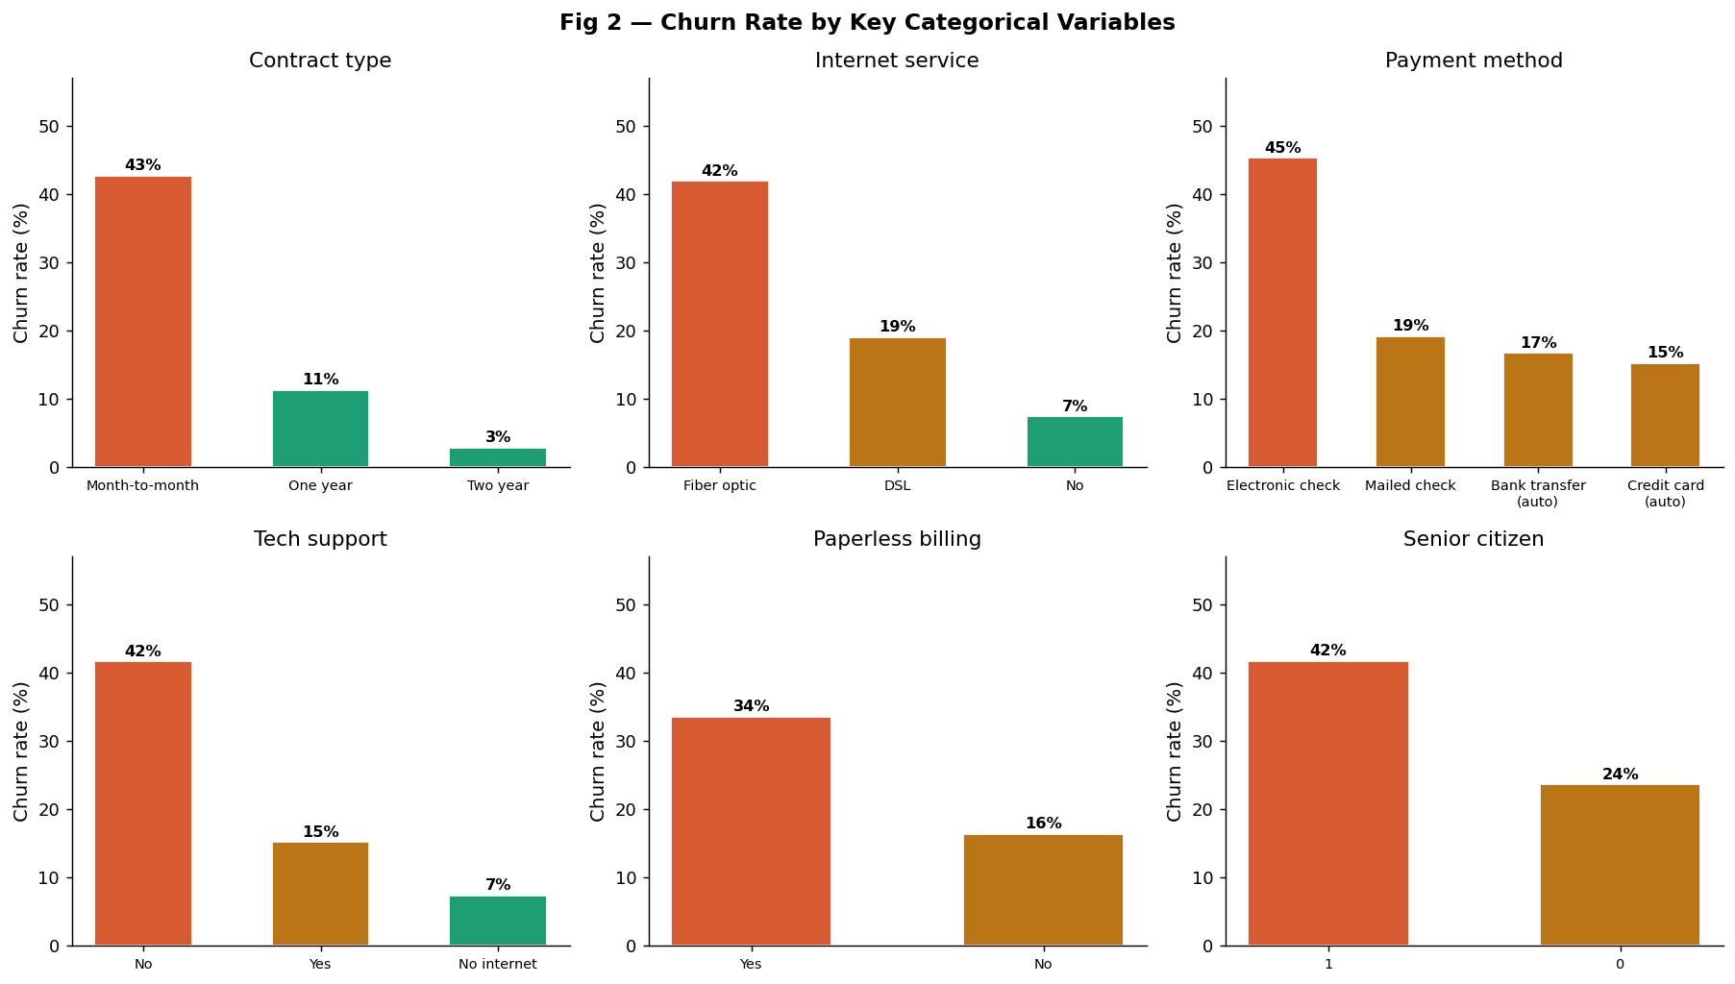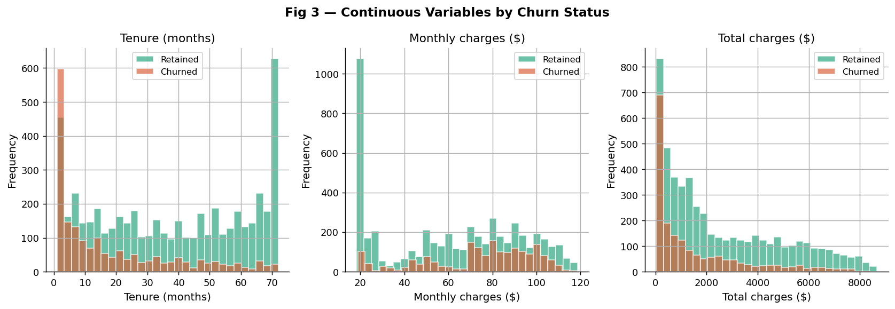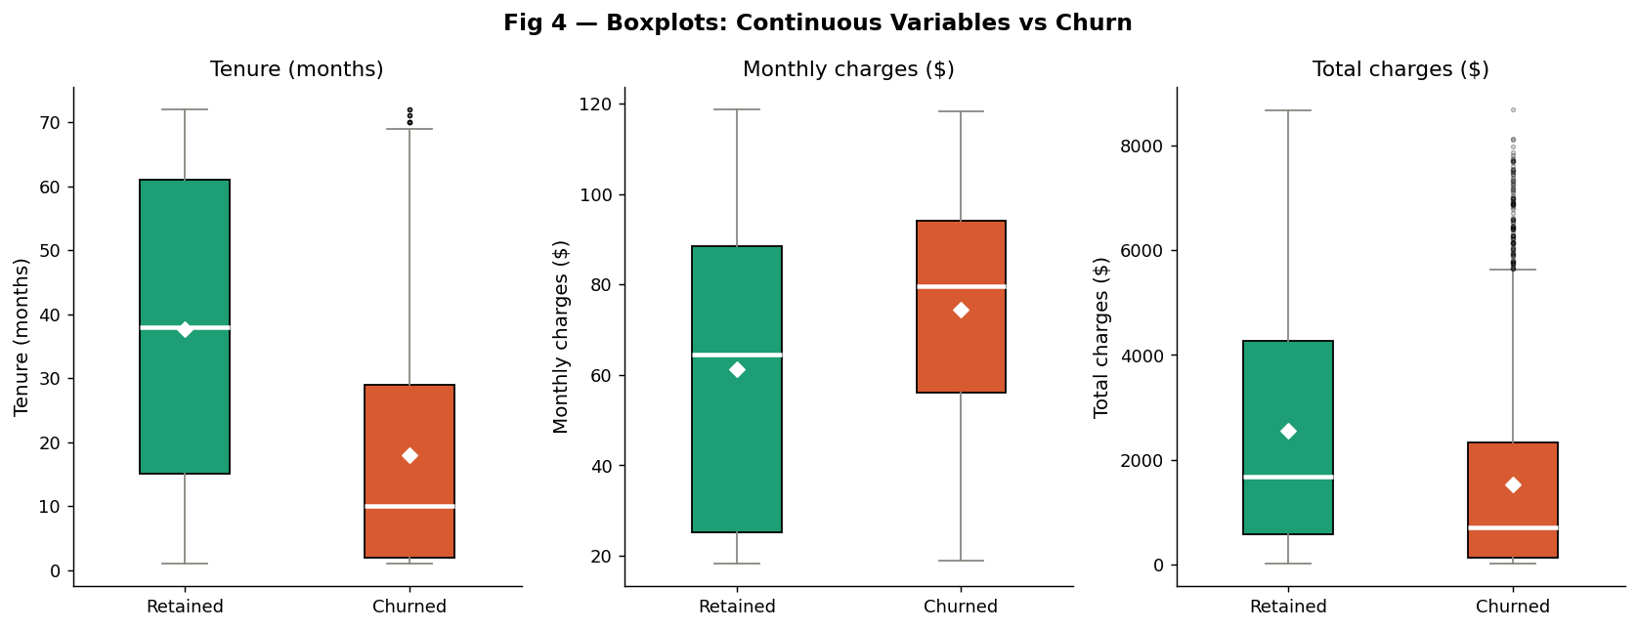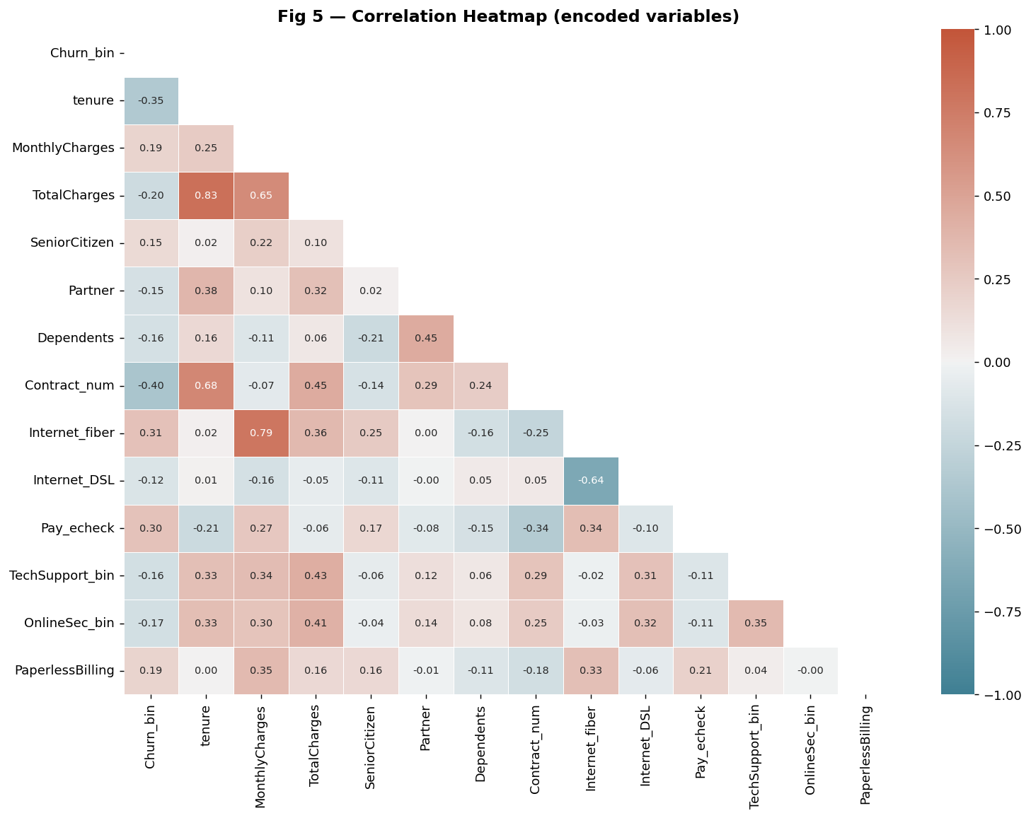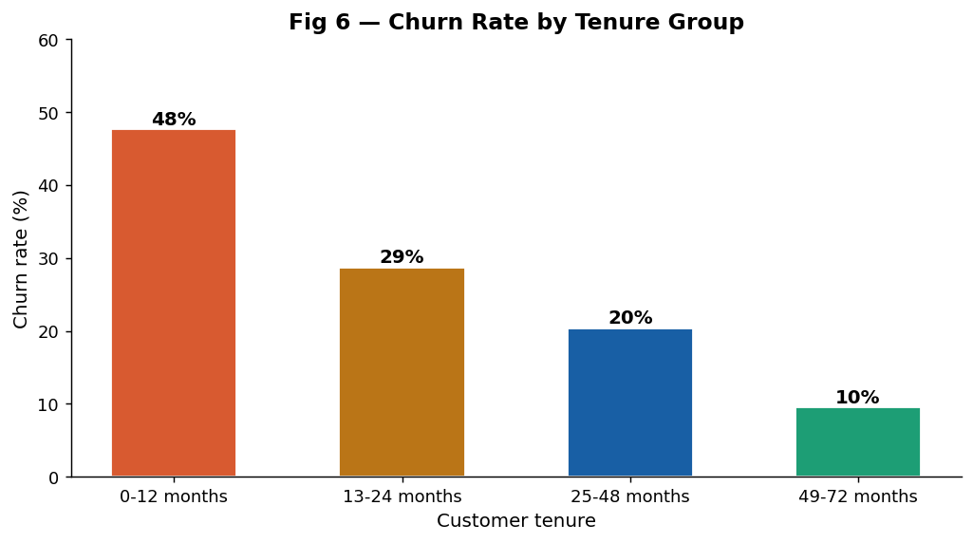

REGRESSION MODELS:
LINEAR PROBABILITY MODEL
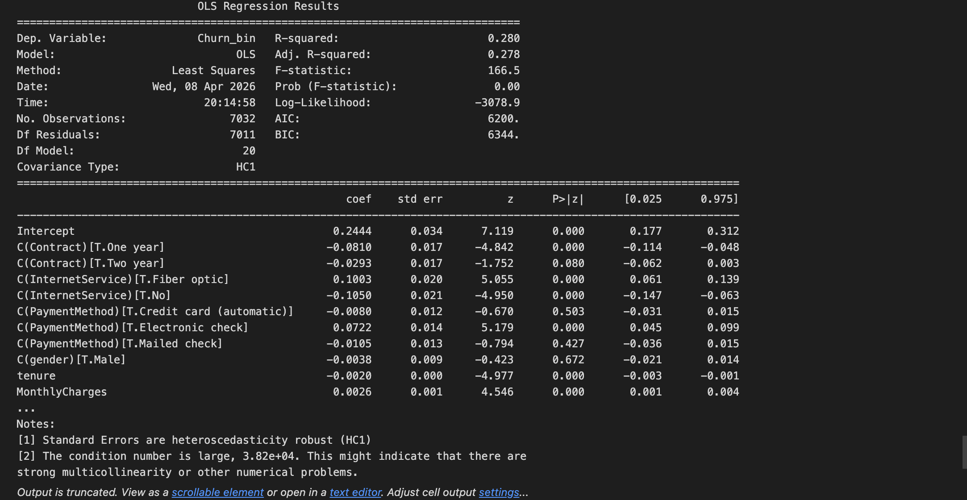

LOGIT MODEL
