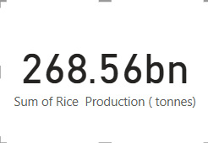

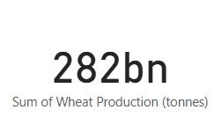

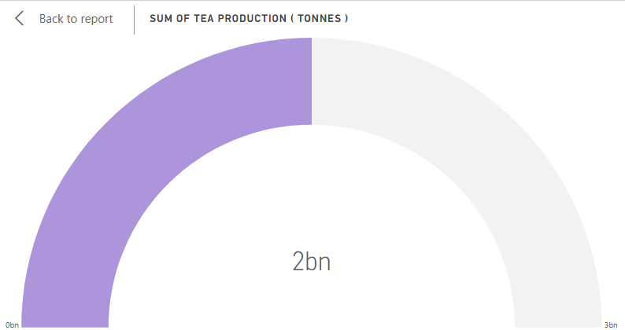

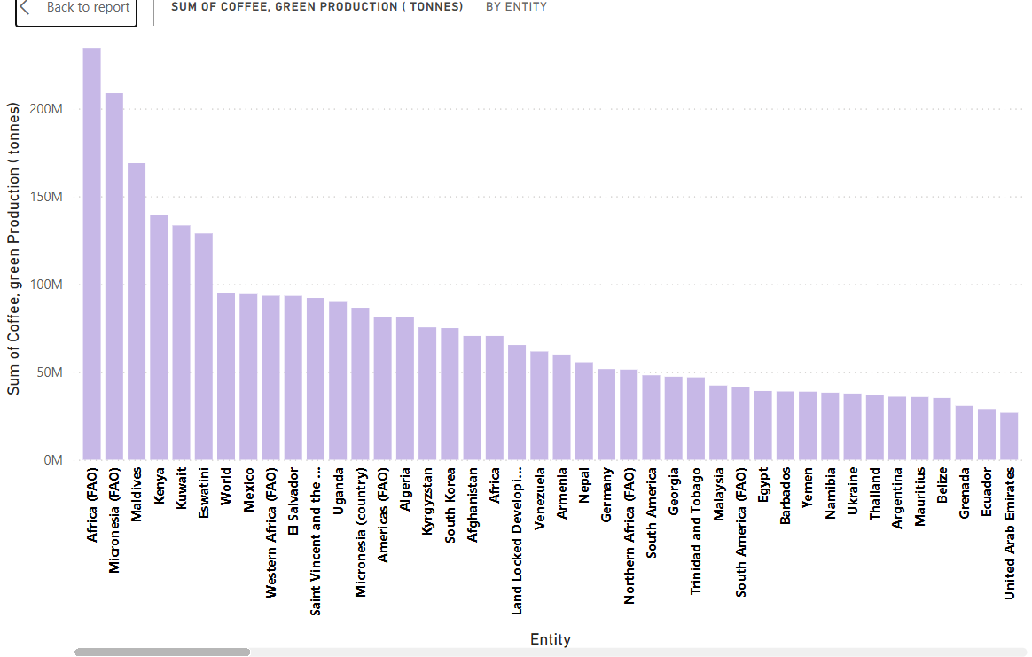

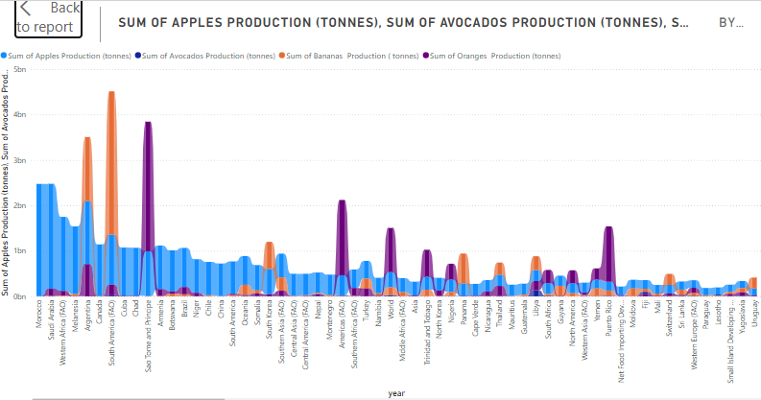

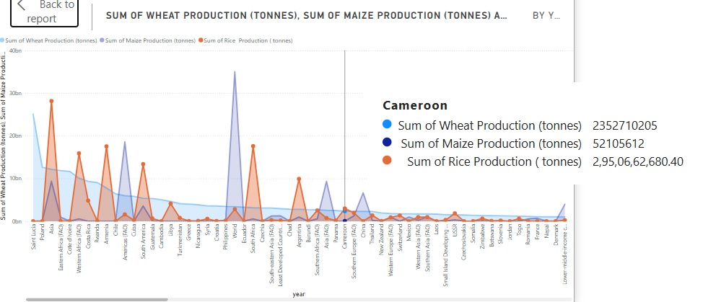

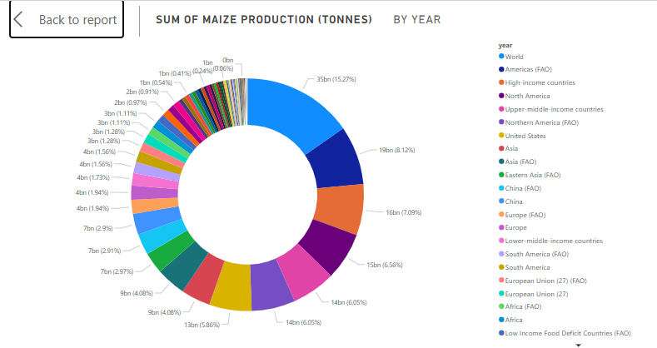

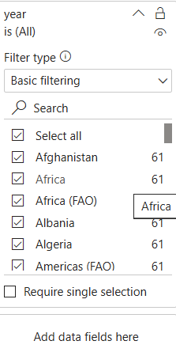

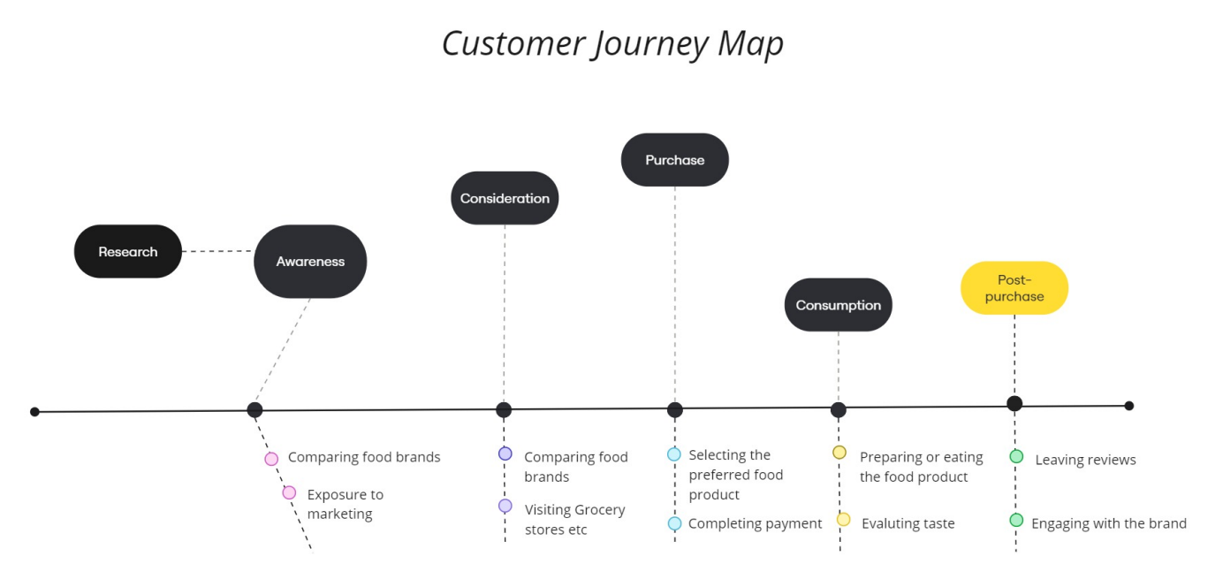

Data flow diagram

**Advantages of Global Food Production (1961–2023):**

1. **Increased Productivity**: Advancements like the Green Revolution, biotechnology, and improved farming techniques boosted crop yields and food availability.
2. **Diverse Food Access**: Global trade allowed countries to access a wide variety of foods, improving diet diversity.
3. **Economic Growth**: Expansion of agriculture created jobs, lifted millions out of poverty, and boosted economies, especially in developing countries.
4. **Famine Reduction**: Improved distribution and food security measures helped reduce famine and hunger.
5. **Sustainability Innovations**: Growing interest in sustainable farming practices, organic agriculture, and agroecology.

**Disadvantages of Global Food Production (1961–2023):**

1. **Environmental Damage**: Intensive farming caused soil degradation, deforestation, and water scarcity, contributing to biodiversity loss and climate change.
2. **Greenhouse Gas Emissions**: Agriculture became a major emitter of methane, nitrous oxide, and carbon dioxide.
3. **Vulnerable Supply Chains**: Global food systems became increasingly susceptible to disruptions (e.g., pandemics, trade wars, and climate events).
4. **Loss of Biodiversity**: Monoculture farming and GMOs reduced genetic diversity, making crops more vulnerable to pests and diseases.
5. **Health and Inequality Issues**: Processed foods contributed to diet-related diseases, and food insecurity persisted in many regions despite increased production.

**

**Conclusion: Global Food Production from 1961 to 2023**

From 1961 to 2023, global food production experienced significant advancements driven by technological innovations, such as the Green Revolution, biotechnology, and improved farming techniques. These developments led to increased productivity, greater food diversity, and expanded access to food across the globe. This transformation has helped reduce famine and poverty in many regions, while also fostering economic growth through agricultural exports.

However, the benefits of increased food production have come with notable environmental and social challenges. Intensive farming practices have contributed to soil degradation, deforestation, water scarcity, and a rise in greenhouse gas emissions. The overreliance on monoculture crops and global supply chains has made food systems vulnerable to disruptions. Additionally, while food availability increased, issues of food insecurity, inequality, and diet-related health problems have persisted in some areas.

Moving forward, balancing the need for increased food production with sustainability, environmental conservation, and equitable distribution will be critical in addressing the challenges faced by global food systems.

**

Future scope

The future scope of global food production, from 1961 to 2023, will focus on addressing sustainability, climate change, and food security. Key areas include:

1. **Sustainable Farming**: Emphasizing regenerative agriculture, precision farming, and eco-friendly practices to reduce environmental impacts.
2. **Technological Innovation**: Advancements in AI, gene editing (e.g., CRISPR), vertical farming, and automation will improve productivity and resource efficiency.
3. **Alternative Proteins**: Increased focus on plant-based and lab-grown proteins to reduce the environmental impact of traditional livestock farming.
4. **Climate Resilience**: Developing climate-resilient crops and adapting farming practices to cope with changing weather patterns.
5. **Waste Reduction**: Minimizing food waste through better preservation, packaging, and recycling in a circular food economy.

The future of global food production will balance technological growth with environmental sustainability, aiming to feed a growing population while protecting the planet.

**

**Appendix: Global Food Production from 1961 to 2023**

1. **1960s - Green Revolution:**
   * Introduction of high-yielding varieties (HYVs) of crops (e.g., wheat, rice, maize).
   * Use of chemical fertilizers, pesticides, and irrigation expanded.
   * Significant increases in food production, especially in developing countries (e.g., India, Mexico).
2. **1970s - Growth and Expansion:**
   * Agricultural productivity continued to rise with more mechanized farming.
   * The global food trade grew, allowing for a more diverse food supply worldwide.
   * The rise of industrial farming methods contributed to higher outputs.
3. **1980s-1990s - Biotechnology and GMOs:**
   * Genetic modification and biotechnological advancements began to play a role.
   * The first GMOs were developed, such as Bt cotton and Roundup-resistant crops.
   * Environmental concerns about monoculture farming and pesticide use grew.
4. **2000s - Technological Integration:**
   * Rise of precision farming using GPS, sensors, and data analytics for efficient resource use.
   * Increase in organic farming and sustainable practices in response to environmental concerns.
   * Growth of food exports, with some countries becoming major food producers and exporters.
5. **2010s - Sustainability and Climate Change Awareness:**
   * Heightened focus on climate change, water scarcity, and soil degradation in agriculture.
   * Introduction of vertical farming, hydroponics, and aquaponics to address land and water limitations.
   * Expansion of alternative protein sources like plant-based foods and lab-grown meat.
6. **2020s - Future-Oriented Innovations:**
   * Advances in AI, robotics, and drones to monitor crops and manage farming operations efficiently.
   * Increased interest in sustainable farming, circular food economies, and food waste reduction.
   * Focus on climate-smart agriculture and the development of climate-resilient crops.
   * The rise of lab-grown meat and plant-based protein alternatives to reduce the environmental impact of livestock farming.

