（高）HTML5跨源资源共享
Issue detail
The application implements an HTML5 cross-origin resource sharing (CORS) policy for this request which allows access from an arbitrary requested domain.
Allowing access from an arbitrary requested domain means that that domain (and most likely any other) can perform two-way interaction with the application via this request. Unless the response consists only of unprotected public content, this policy is likely to present a security risk.

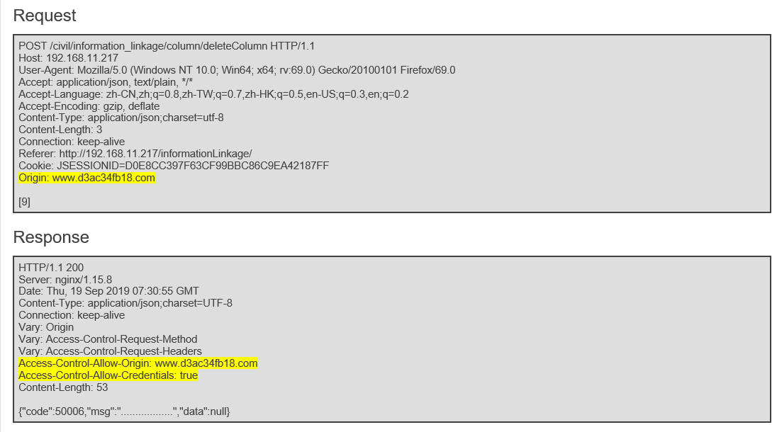

（低）跨站式脚本(Cross-Site Scripting)
In most situations where user-controllable data is copied into application responses, cross-site scripting attacks can be prevented using two layers of defenses:
- Input should be validated as strictly as possible on arrival, given the kind of content which it is expected to contain. For example, personal names should consist of alphabetical and a small range of typographical characters, and be relatively short; a year of birth should consist of exactly four numerals; email addresses should match a well-defined regular expression. Input which fails the validation should be rejected, not sanitized.
- User input should be HTML-encoded at any point where it is copied into application responses. All HTML metacharacters, including < > " ' and =, should be replaced with the corresponding HTML entities (&lt; &gt; etc).
In cases where the application's functionality allows users to author content using a restricted subset of HTML tags and attributes (for example, blog comments which allow limited formatting and linking), it is necessary to parse the supplied HTML to validate that it does not use any dangerous syntax; this is a non-trivial task.
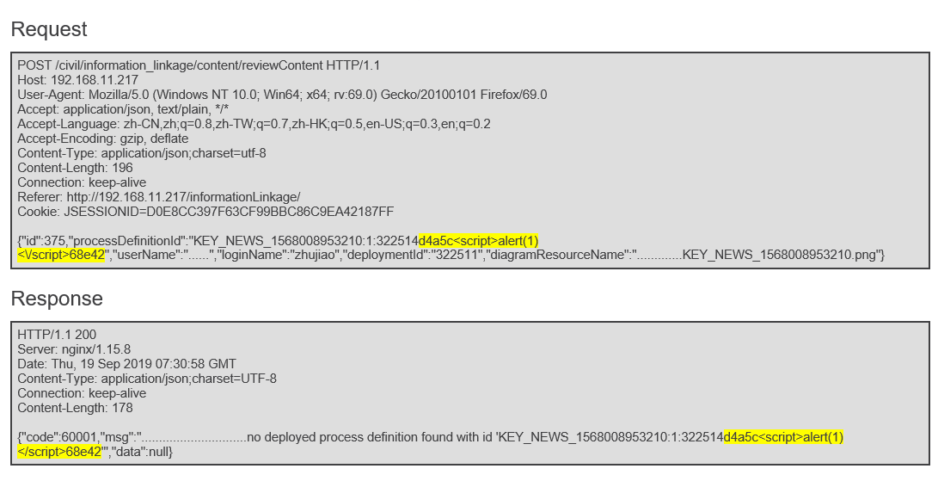

3.（低）源代码泄露
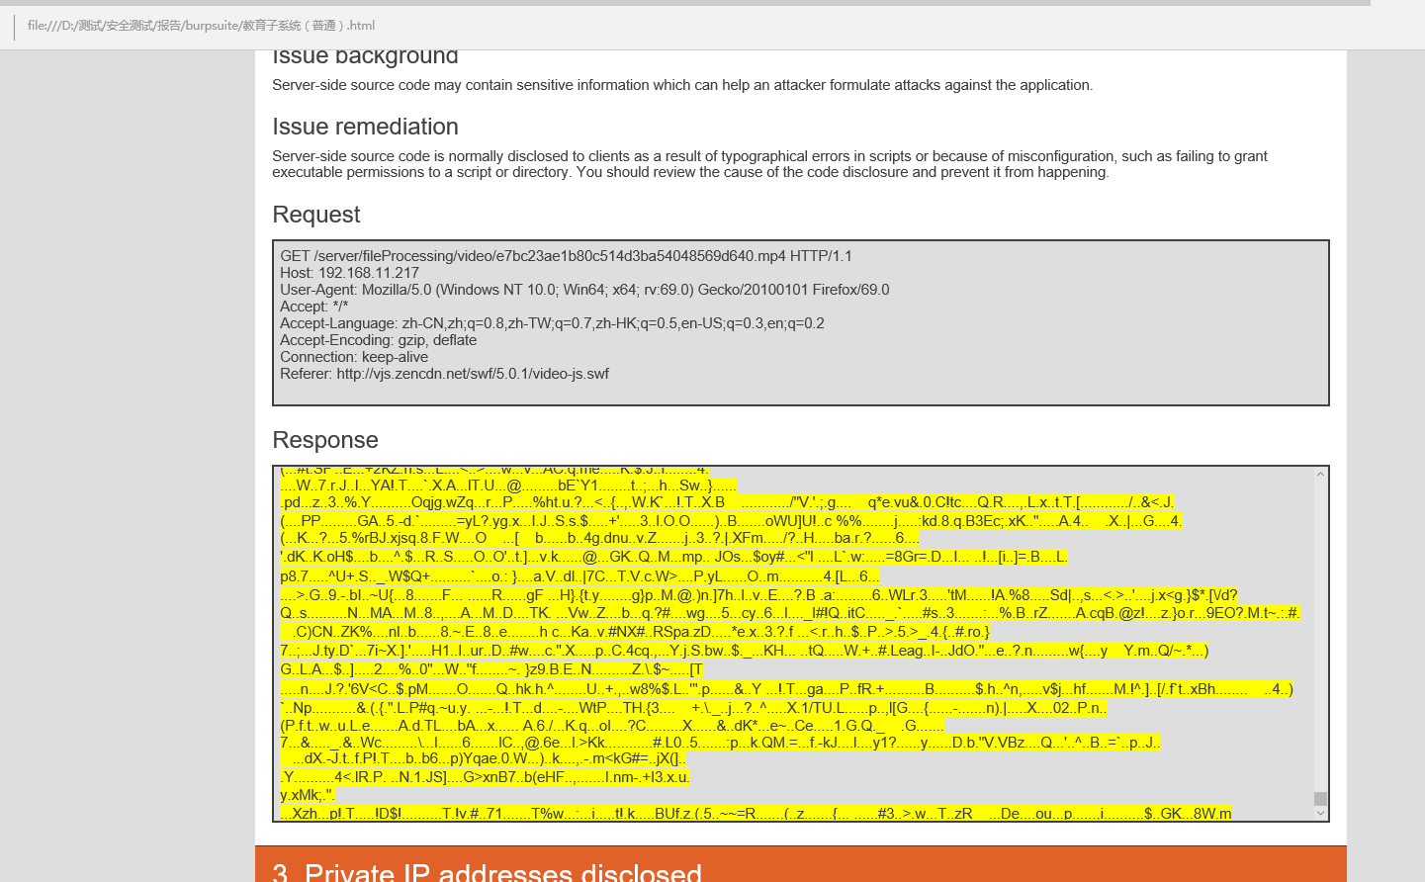

4.（建议）内容类型表述错误
The response contains the following Content-type statement:
- Content-Type: application/json;charset=UTF-8
The response states that it contains JSON. However, it actually appears to contain unrecognized content.

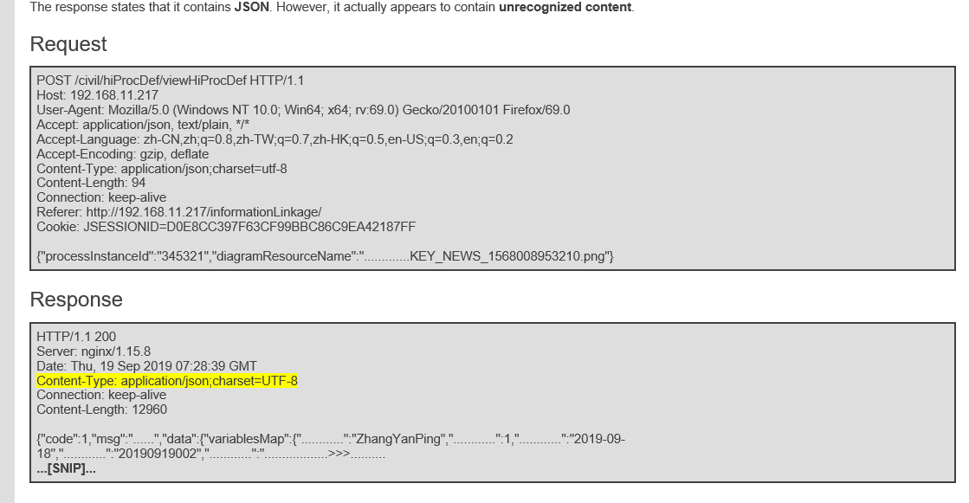

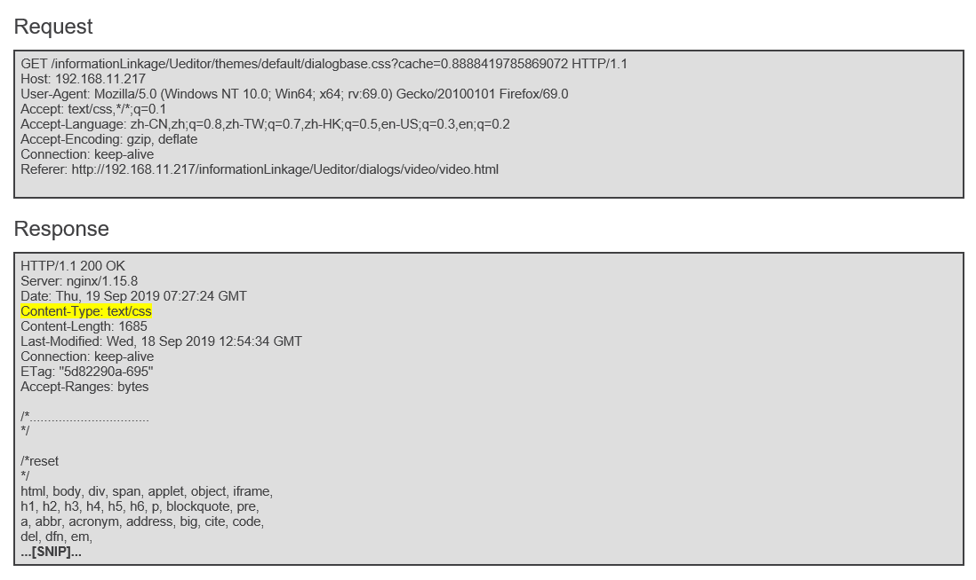

5.（建议）专用IP地址被公开
