

**sqlprj1**: This command creates a new database named sqlprj1. A database is a container that holds tables, views, procedures, and other database objects.

**use sqlprj1**: This command tells the SQL server to start using the sqlprj1 database for subsequent commands. It sets sqlprj1 as the active database, meaning any operations like

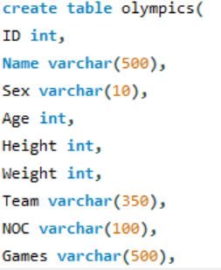

• **ID int**: An integer column to store a unique identifier for each entry (e.g., athlete ID).

• **Name varchar(500)**: A variable character string up to 500 characters long to store the name of the athlete.

• **Sex varchar(10)**: A variable character string up to 10 characters long to store the gender of the athlete (e.g., 'M' or 'F').

• **Age int**: An integer column to store the age of the athlete.

• **Height int**: An integer column to store the height of the athlete in centimeters.

• **Weight int**: An integer column to store the weight of the athlete in kilograms.

• **Team varchar(350)**: A variable character string up to 350 characters long to store the name of the team or country the athlete represents.

• **NOC varchar(100)**: A variable character string up to 100 characters long to store the National Olympic Committee code, a three-letter country code.

• **Games varchar(500)**: A variable character string up to 500 characters long to store the edition of the Games (e.g., 'Summer 2000').

• **Year int**: An integer column to store the year the games took place.

• **Season varchar(400)**: A variable character string up to 400 characters long to store the season of the games ('Summer' or 'Winter').

• **City varchar(300)**: A variable character string up to 300 characters long to store the city where the games were held.

• **Sport varchar(500)**: A variable character string up to 500 characters long to store the sport in which the athlete competed.

• **Event varchar(400)**: A variable character string up to 400 characters long to store the specific event (e.g., '100m Freestyle').

• **Medal varchar(200)**: A variable character string up to 200 characters long to store the type of medal won (e.g., 'Gold', 'Silver', 'Bronze'), or NULL if no medal was won.



• This command displays the value of the secure_file_priv system variable.

• secure_file_priv specifies a directory path where MySQL can read and write files for operations such as LOAD DATA INFILE. It ensures that only files in this directory can be accessed by the server, enhancing security.

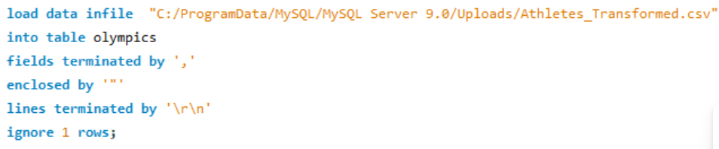

**load data infile**: This command is used to load data from a file into a table.

* + **"C:/ProgramData/MySQL/MySQL Server 9.0/Uploads/Athletes_Transformed.csv"**: This specifies the path to the CSV file containing the data you want to load.
  + **into table olympics**: This specifies that the data should be loaded into the olympics table.
  + **fields terminated by ','**: This specifies that the fields in the CSV file are separated by commas.
  + **enclosed by '"'**: This indicates that fields are enclosed by double quotes in the CSV file.
  + **lines terminated by '\r\n'**: This specifies that each line in the file ends with a carriage return followed by a newline (\r\n), which is typical for Windows-formatted text files.
  + **ignore 1 rows**: This tells MySQL to ignore the first row of the file, often used when the first row contains column headers rather than data.

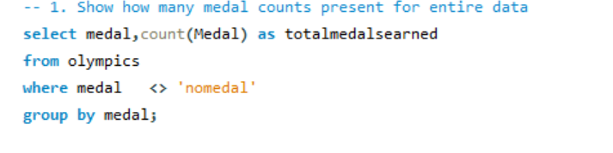

• **medal**: This specifies the column medal that contains the type of medal (e.g., 'Gold', 'Silver', 'Bronze').

* **count(Medal) as totalmedalsearned**: This counts the number of occurrences of each medal type and gives the result a name (totalmedalsearned). This count reflects the total number of medals of each type earned.

• **from olympics**:

* This indicates that the data is being selected from the olympics table.

• **where medal <> 'nomedal'**:

* This condition filters out rows where the medal column has the value 'nomedal', meaning only records where a medal was actually earned are included in the result.

• **group by medal**:

* This groups the results by the medal type. So, for each distinct type of medal (e.g., 'Gold', 'Silver', 'Bronze'), a separate count is generated.



• **Counts the number of unique sports** in the olympics table.

• **distinct(sport)** ensures that only different sports are counted (no duplicates).

• The result is labeled as countofsports.

• It gives you the total number of different sports represented in the data.

• **Counts the medals won by Team India**: It filters the data to only include rows where the team is 'india' and the medal is not 'nomedal'.

• **Groups by medal type**: It groups the results by each type of medal (e.g., Gold, Silver, Bronze).

• **Outputs the count** of each type of medal won by India, ignoring entries where no medal was won ('nomedal').

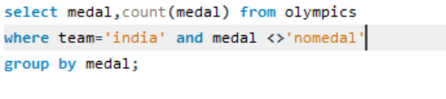

• **Counts medals by event**: It counts how many medals were won in each event by Team India.

• **Filters the data**: It only includes rows where the team is 'india' and the medal is not 'nomedal'.

• **Groups by event and medal type**: It groups the results by each specific event and medal type.

• **Orders by the number of medals**: The results are sorted in descending order based on the number of medals (countofmedal), so events with the most medals appear first.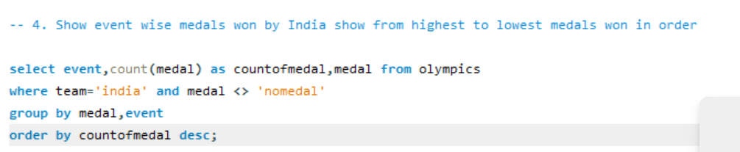

• **Counts medals won by India for each event**: It counts how many medals were won by Team India for each event.

• **Filters the data**: It only includes rows where the team is 'india' and excludes entries where no medal was won ('nomedal').

• **Groups by event, medal type, and year**: It groups the results based on each event, the type of medal won, and the year the event took place.

• **Orders by year**: The results are sorted in ascending order based on the year, showing the progression of medals won by India over time

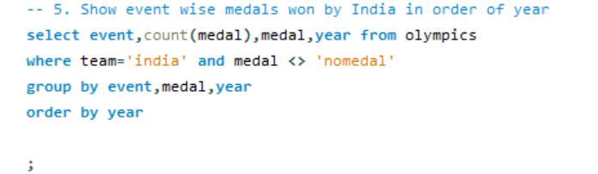 **each team**:

• **Counts medals for** It counts the total number of medals won by each team.

• **Filters out non-medal entries**: It only includes rows where a medal was actually won (medal <> 'nomedal').

• **Groups by team**: It groups the results by each team, so you get a count of medals per team.

• **Orders by medal count**: The results are sorted in descending order by the number of medals, with teams that won the most medals listed first.

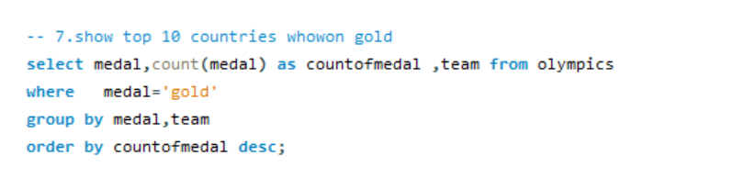

7 se upar pic niche desc

• **Counts gold medals for each team**: It counts the total number of gold medals won by each team.

• **Filters for gold medals**: It only includes rows where the medal is 'gold'.

• **Groups by team**: It groups the results by team, so you see the count of gold medals each team has won.

• **Orders by medal count**: The results are sorted in descending order, with the teams that won the most gold medals at the top.

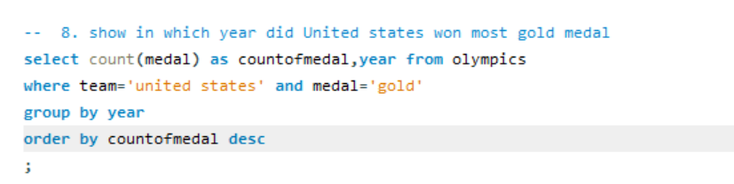

• **Counts gold medals by year**: It counts the total number of gold medals won by the United States for each year.

• **Filters for gold medals**: It only includes rows where the team is 'united states' and the medal is 'gold'.

• **Groups by year**: It groups the results by each year, showing the number of gold medals won in that year.

• **Orders by medal count**: The results are sorted in descending order, with the year in which the United States won the most gold medals appearing first.

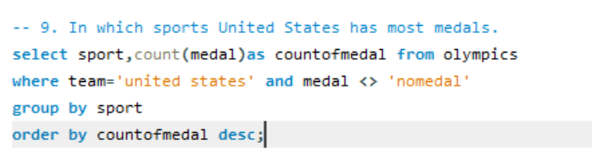

* **Counts total medals by sport**: It counts the number of medals won by the United States in each sport.
* **Filters out non-medal entries**: It only includes rows where the team is 'united states' and a medal was won (medal <> 'nomedal').
* **Groups by sport**: It groups the results by each sport, showing how many medals the United States won in each one.
* **Orders by medal count**: The results are sorted in descending order, with the sport in which the United States won the most medals appearing first.

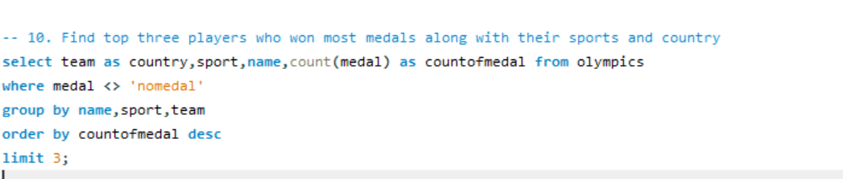

• **Counts medals won by each player**: It calculates the total number of medals won by each player.

• **Includes the player's sport and country**: The query retrieves the player's name, the sport they competed in, and the country (labeled as country).

• **Filters out non-medal entries**: It only considers entries where a medal was won (medal <> 'nomedal').

• **Groups by player, sport, and country**: It groups the results by player (name), sport, and country, so the count reflects the total medals each player has won in a specific sport for their country.

• **Orders by medal count**: The results are sorted in descending order, with players who won the most medals appearing first.

• **Limits the results to the top three**: The LIMIT 3 clause ensures that only the top three players with the most medals are shown.

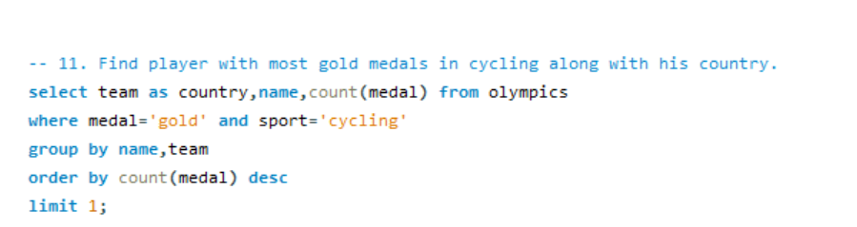

• **Counts gold medals in cycling**: It counts the number of gold medals won by each player specifically in the sport of cycling.

• **Filters for gold medals and cycling**: It only includes entries where the medal is 'gold' and the sport is 'cycling'.

• **Groups by player and country**: It groups the results by the player's name and their country (labeled as country).

• **Orders by gold medal count**: The results are sorted in descending order based on the number of gold medals won.

• **Limits to the top result**: The LIMIT 1 clause ensures that only the player with the most gold medals in cycling is shown.

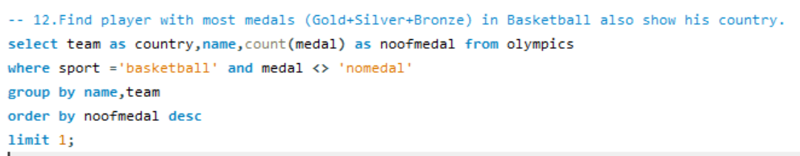

• **Counts medals in basketball**: It counts the total number of medals won by each player in the sport of basketball.

• **Filters for basketball and actual medals**: It only includes rows where the sport is 'basketball' and a medal was won (medal <> 'nomedal').

• **Groups by player and country**: It groups the results by the player's name and their country (labeled as country).

• **Orders by the number of medals**: The results are sorted in descending order, with players who won the most medals appearing first.

• **Limits to the top result**: The LIMIT 1 clause ensures that only the player with the most medals in basketball is shown.

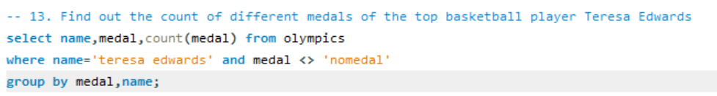

• **Counts different medals won by Teresa Edwards**: It counts the number of each type of medal (e.g., Gold, Silver, Bronze) won by the basketball player Teresa Edwards.

• **Filters for Teresa Edwards**: It only includes records where the player's name is 'teresa edwards' and where a medal was actually won (medal <> 'nomedal').

• **Groups by medal type and player**: It groups the results by the type of medal and the player's name, giving a count for each medal type.

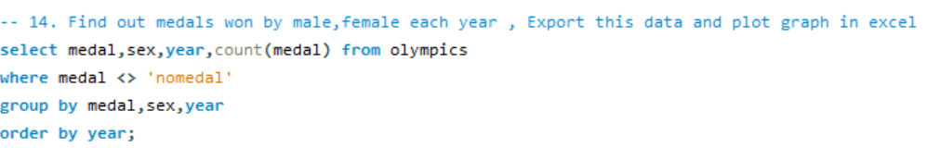

• **Run the SQL Query:** Make sure your query is executed in your SQL environment to get the results.

• **Export the Data:**

* In your SQL tool, there should be an option to export the query results. Typically, you can export the data as a CSV file.
* Save the CSV file to your computer.

• **Open in Excel:**

* Open Excel and import the CSV file.
* Go to File > Open and select your CSV file.

• **Plot the Graph:**

* Select the data you want to plot.
* Go to the Insert tab and choose the type of chart you want (e.g., Line Chart, Column Chart).
* Customize the chart as needed (e.g., add labels, title).